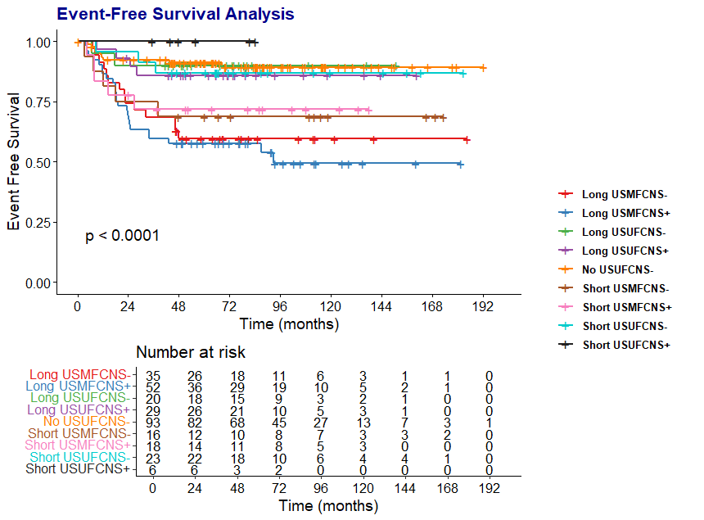
USUF: unisystem unifocal, USMF: unisystem multifocal, CNS-: non CNS risk , CNS+: CNS risk group, No: No induction
Long : Long induction Short short induction No: no induction
Supplement fig.1 EFS per Induction duration according to stratification

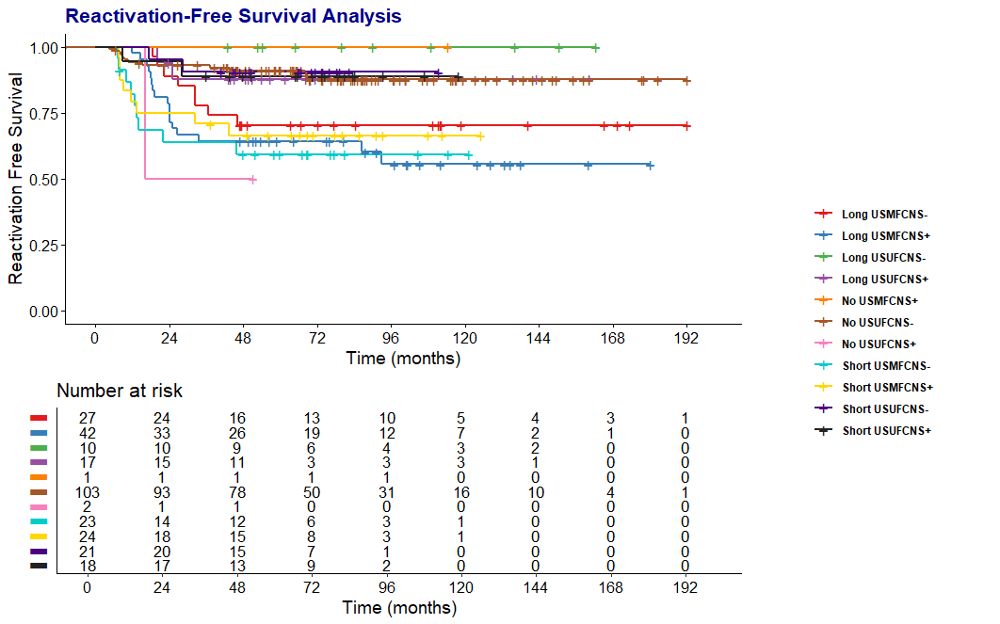
Long : long maintenance Short short maintenance
Supplement Fig. 2 RFS per maintenance duration according to stratification.

