Supplemental files for:
A reproducible and efficient inoculation system for rice false smut based on conidia-germinated hyphae
Guixin Yuan^{1,*}, Wenqian Zhu¹, Junyou Geng^{1,2}, Hongze Wang¹, Jing Fan¹, You-Liang Peng³, Jian-Min Zhou¹, Meng Yuan^{1,*}
¹Yazhouwan National Laboratory, Sanya 572024, China
²National Key Laboratory of Crop Genetic Improvement, Hubei Hongshan Laboratory, Huazhong Agricultural University, Wuhan 430070, China
³State Key Laboratory of Agricultural and Forestry Biosecurity and MARA Key Laboratory of Pest Monitoring and Green Management, China Agricultural University, Beijing 100193, China
*Correspondence: Meng Yuan (yuanmeng@yzwlab.cn) | Guixin Yuan (yuanguixin@yzwlab.cn)

This file contains 5 Supplemental figures, 1 Supplemental method and 1 Supplemental table.

Supplementary Figure
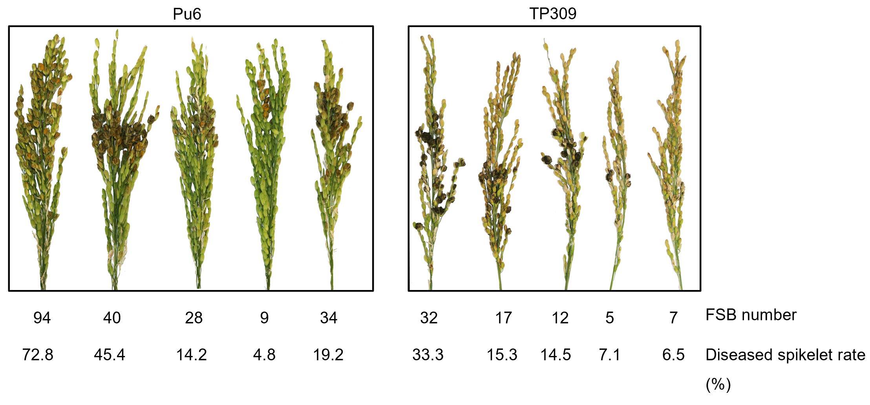Figure S1: Low efficiency and reproducibility of CH-based inoculation. Rice cultivars TP309 and Pu6 were inoculated with PJ52 at a concentration of 1 × 10⁶ conidia·mL⁻¹, and the number of false smut balls and diseased spikelet rate were quantified at 25 days post inoculation.

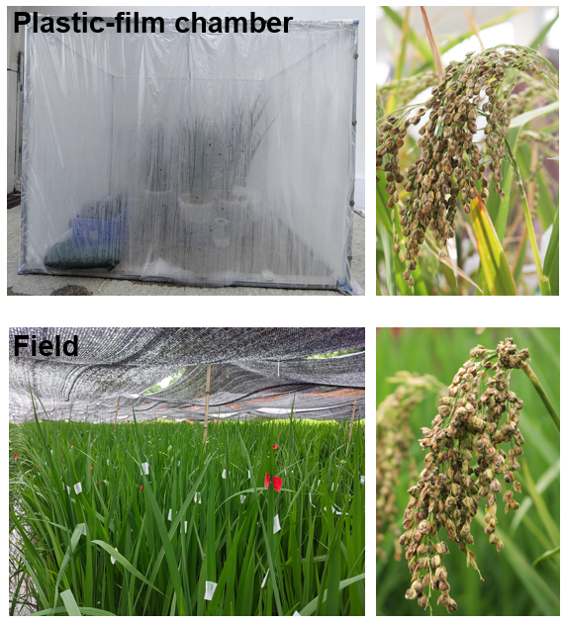
Figure S2: Artificial inoculation condition of U. virens conducted in a plastic-film chamber and field. A humidifier was used in the plastic-film chamber to maintain humidity, and black shade nets were applied in the field to reduce temperature and increase humidity.

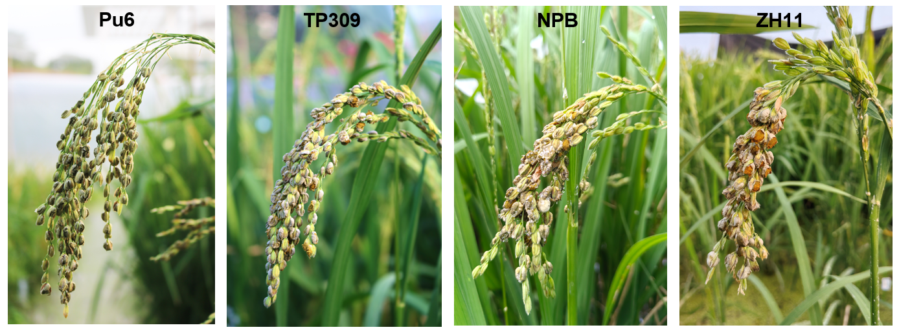
Figure S3: Field disease symptoms of representative rice varieties using CGH inoculation. Panicles of several rice cultivars were inoculated with U. virens strain PJ52 with a concentration of 5 × 10⁵ CGH·mL⁻¹ at the late booting stage, and photographs were taken approximately 25 days post inoculation.

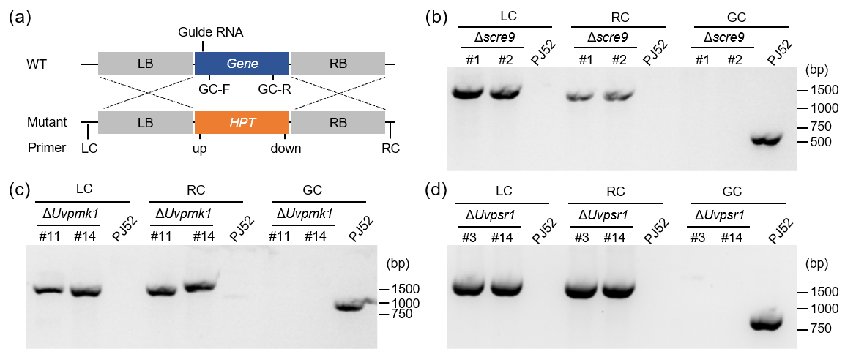
Figure S4: Knockout strategies and verification of U. virens mutants. a Schematic diagram for generating mutants in U. virens using CRISPR-Cas9 mediated homologous recombination strategy. Guide-RNA spacers in coding sequence of target genes were designed. Primer pairs LC/up (LC check), down/RC (RC check), and GC-F/GC-R (GC check) were used to verify the candidate knockout transformants. b-d The verification of Δscre9 (b), ΔUvpmk1 (c), and ΔUvpsr1 (d) mutants. Genomic DNA isolated from the mutants and wild type strain PJ52 were amplified by PCR using specific primers.

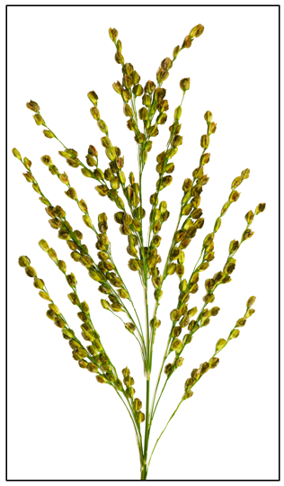
Figure S5: Disease phenotype of Pu6 panicles following CGH-based inoculation. Panicles of Pu6 inoculated with CGH at a concentration of 1 × 10⁶ CGH·mL⁻¹. Nearly all spikelets were successfully infected and developed false smut balls.

Supplementary Methods
1. CGH Inoculum Preparation of Ustilaginoidea virens
1.1 Frozen agar plugs or stored liquid cultures of U. virens were retrieved from -80 °C and streaked onto PSA plates, which were incubated at 28 °C for 7 days.
1.2 Mycelial blocks (~3 mm × 3 mm) were excised with a sterile scalpel and transferred into 100 mL of rice-leaf medium in a 250 mL Erlenmeyer flask. Cultures were shaken at 180 rpm, 28 °C for approximately 4 days.
Note: To prevent bacterial contamination, ampicillin (100 μg·mL⁻¹) may be added to the leaf medium. Incubation in leaf medium may be extended up to ~10 days if required. Prepared leaf medium cultures can be stored at 4 °C and used multiple times over a short period.
1.3 Using a pipette, 4 mL of the cultured rice-leaf medium was transferred into PSB medium and incubated at 180 rpm, 28 °C for ~4 days.
Note: The optimal shaking period in PSB was 4-7 days; prolonged incubation reduced spore viability. Prior to filtration, microscopic examination to estimate conidia abundance was recommended.
1.4 The shaken culture in PSB was filtered; the filtrate was transferred to 50 mL centrifuge tubes and centrifuged at 4,000 rpm for 10 min. The pellet was resuspended in PSB and transferred into 200 mL fresh PSB medium, then incubated at 180 rpm, 28 °C for 12-16 h.
Note: Mycelial residue retained on the filter could be returned to the Erlenmeyer flask; after centrifugation the supernatant may be returned to the flask and incubated an additional 1-2 days for one repeat use. Shaking time for conidia germination should be adjusted according to conidia viability and hyphal length; germ tube lengths of approximately 100-300 μm. During this incubation the flask walls often accumulated a ring of mycelium; avoid transferring this ring into the inoculum to prevent needle blockage.
1.5 Conidia-germinated hyphae concentration was adjusted using a hemocytometer to 5 × 10⁵ CGH·mL⁻¹. For samples intended for multi-omics analyses, the inoculum was transferred to 50 mL centrifuge tubes, centrifuged at 4,000 rpm for 10 min, washed once or twice with H₂O, and adjusted to the desired concentration; the resulting preparation was used as the inoculum.
Note: Count only germinated conidia. For multi-omics sampling, use CGH concentrations of ≥ 1 × 10⁶ CGH·mL⁻¹ to ensure high disease incidence. For field resistance assays or pathogenicity tests, use CGH concentrations of 2 × 10⁵ - 5 × 10⁵ CGH·mL⁻¹.
2. Artificial Inoculation in Plastic Greenhouse or Field
2.1 Panicle development was monitored in advance; inoculum preparation began one week prior to inoculation. The optimal inoculation stage corresponded to a boot-to-panicle distance (leaf sheath-to-panicle) of 5-8 cm, and the preferred injection site on the panicle sheath was the upper-central region of the panicle sheath.
Note: During injection, place the thumb over the needle entry point and inject slowly until inoculum exuded from the top of the panicle sheath. Rapid injection risked leakage from the lateral side of the sheath.
2.2 For samples intended for multi-omics analyses, plants were maintained in a humidified plastic greenhouse to facilitate sampling; humidifiers were used to maintain high humidity.
2.3 For field resistance screening or pathogenicity assays, install shade netting one day prior to inoculation and remove it approximately one week after inoculation; irrigate (spray water) once at midday and once in the afternoon each day for the week following inoculation to maintain humidity.

Table S1. Primers used in this study
Primer name | Sequence (5'–3') | Purpose
HPT F | AACTGATATTGAAGGAGC | knockout vector construction
HPT R | AACTGGTTCCCGGTCGGC | knockout vector construction
Pmk1 LB F | tcccccgggctgcaggaattcGGGCTTTGTTTCCCGCGAAG | knockout vector construction
Pmk1 LB R | GCTCCTTCAATATCAGTTAAAGCAGAGAGCAGCCTTGATCG | knockout vector construction
Pmk1 RB F | GCCGACCGGGAACCAGTTCAGGCAAAGATGACAATTGGA | knockout vector construction
Pmk1 RB R | gtcgacggtatcgataagcttAGCTTGCCTATGTTGATCCCT | knockout vector construction
Pmk1 sgRNA F | ACCTTCGCTCAAACCCCCCGAACG | knockout vector construction
Pmk1 sgRNA R | AAACCGTTCGGGGGGTTTGAGCGA | knockout vector construction
Psr1 LB F | tcccccgggctgcaggaattcGAGCCCAGAGTTGTAGTCGG | knockout vector construction
Psr1 LB R | GCTCCTTCAATATCAGTTCCTTTGGAAGTCCCCACCTC | knockout vector construction
Psr1 RB F | GCCGACCGGGAACCAGTTTTTCTCCGTTTCGTCACTC | knockout vector construction
Psr1 RB R | gtcgacggtatcgataagcttACGGCGTCCATAACAGTTG | knockout vector construction
sgRNA F | ACCTTGAGCTGTCACCCGATGAGG | knockout vector construction
sgRNA R | AAACCCTCATCGGGTGACAGCTCA | knockout vector construction
SCRE9 LB F | tcccccgggctgcaggaattcTATCCAGTTGACCGCTCA | knockout vector construction
SCRE9 LB R | GCTCCTTCAATATCAGTTGAGCGTCGTGATACAGTAGATG | knockout vector construction
SCRE9 RB F | GCCGACCGGGAACCAGTTAGAATCACGCTGAGACGACG | knockout vector construction
SCRE9 RB R | gtcgacggtatcgataagcttGACATTACGGAGCACACCT | knockout vector construction
SCRE9 sgRNA F | acctAATCACCGTAGCGTTCGCCA | knockout vector construction
SCRE9 sgRNA R | aaacTGGCGAACGCTACGGTGATT | mutant validation
HPT-up | TCTGACCAGTTGCCTAAATG | mutant validation
HPT-down | ACCGATGGCTGTGTAGAAG | mutant validation
Pmk1 LC | ACATTGGCAGCAGGACAT | mutant validation
Pmk1 RC | ACTTGTGTGTCTTCGGTCG | mutant validation
Pmk1 GC F | ACTTTCCCTTCCAACCTCC | mutant validation
Pmk1 GC R | GGCACCTTCTTCTTGAATGG | mutant validation
Psr1 LC | TGCGTTTGTAGGGTGACA | mutant validation
Psr1 RC | TGGCATCAGGAGAAGAGC | mutant validation
Psr1 GC F | CAACAAAGGAATCAGGCG | mutant validation
Psr1 GC R | GCGGTGAAGACCACAACTT | mutant validation
SCRE9 LC | GGAGGAAGGGAAAGAGTTTG | mutant validation
SCRE9 RC | TCATTCGGCAATAGCCAC | mutant validation
SCRE9 GC F | TACGCCCTCTCTTTCGCTA | mutant validation
SCRE9 GC R | TACGGGTAGGTCAGGAGACA | mutant validation

