Supporting Information

Highly dispersed Cobalt Catalyst in SBA-15 (Co@NC-SBA-15): A Promising Approach for Efficient, Mild and Selective C-H Bonds Oxidation Using Household Bleach

Malihe Nayamadi Mahmoodabadi, Batool Akhlaghinia*
Department of Chemistry, Faculty of Science, Ferdowsi University of Mashhad, Mashhad, Iran 9177948974

General
All chemical reagents and solvents were purchased from Merck Chemical Companies and were used as received without further purification. The purity determinations of the products were accomplished by TLC on silica gel polygram STL G/UV 254 plates. The melting points of the products were determined with an Electrothermal Type 9100 melting point apparatus. The FT-IR spectra were recorded on an Avatar 370 FT-IR Therma Nicolet spectrometer (Therma Nicolet spectrometer, USA) at room temperature in the range between 4000 and 400 cm⁻¹ with a resolution of 4 cm⁻¹. The NMR spectra were obtained in Brucker Avance 300 and 400 MHz instruments in CDCl₃. Mass spectra were recorded with a CH7A Varianmat Bremem instrument at 70 eV electron impact ionization, in m/z (rel %). All yields refer to isolated products after purification by flash chromatography with silica gel.

Acetophenone (Table 4 entry 1) ^{[1]}
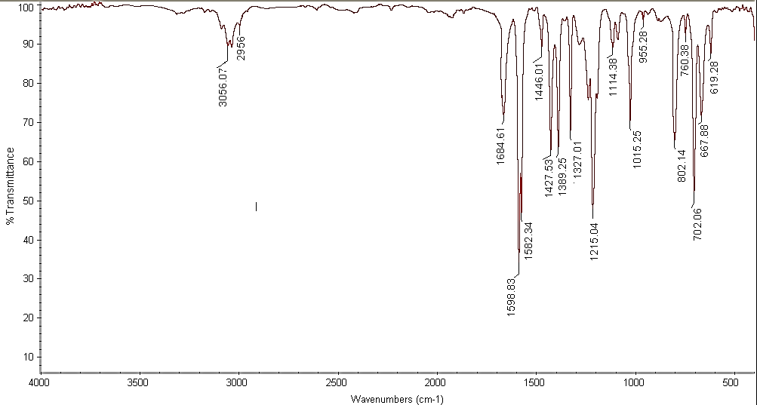
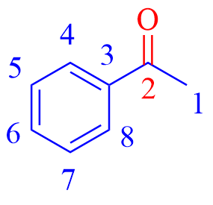
Colorless liquid; FT-IR (neat) )ν_{max} /cm⁻¹:( 3059 (aromatic C-H, stretching), 2956 (aliphatic C-H), 1684 (C=O), 1598 (C=C), 1582 (C-C), 1446 (C=C), 1359, 1266, 1176, 1081, 1015, 955, 760, 702 (aromatic C-H, bending); ¹H NMR (300 MHz, CDCl₃) δ_{H} (ppm)= 7.96 (d, 2 H, J = 7.2 Hz, ArH, H⁴, H⁸), 7.56 (t, 1 H, J = 7.2 Hz, ArH, H⁶), 7.46 (t, 2 H, J = 8.0 Hz, ArH, H⁵, H⁷), 2.61 (s, 3 H, H¹); ¹³C NMR (75 MHz, CDCl₃) δ_{C} (ppm)= 198.07 (C²), 137.05 (C³), 133.09 (C⁴, C⁸), 128.56 (C⁶), 128.28 (C⁵, C⁷), 26.56 (C1); MS, m/z (%): 120 [M⁺].
Figure 1a. FT-IR (neat) spectrum of Acetophenone.

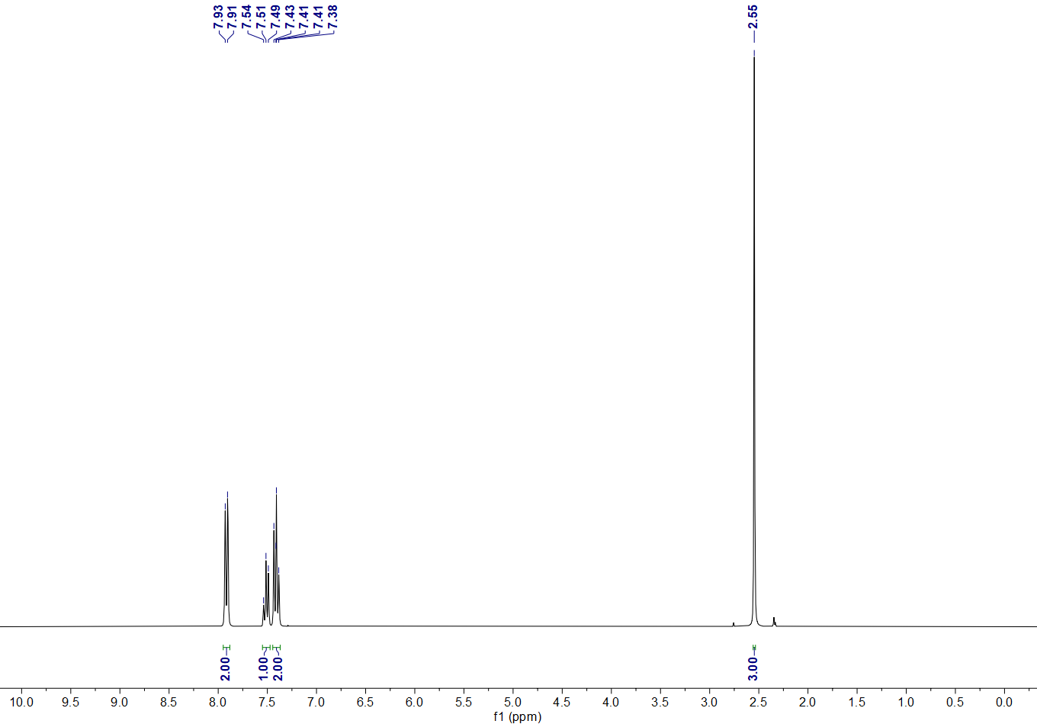
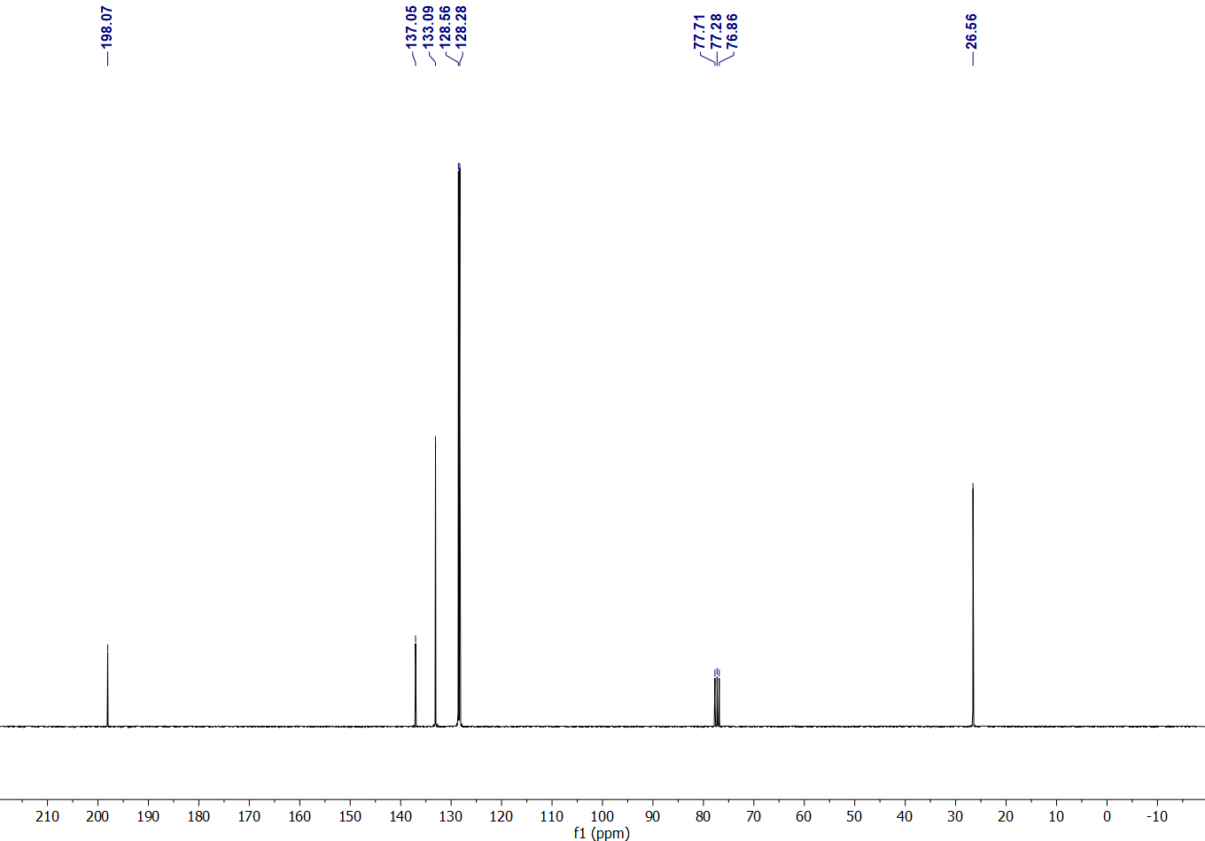
Figure 1b. ¹H NMR spectrum (300 MHz, CDCl₃) of Acetophenone.
Figure 1c. ¹³C NMR spectrum (75 MHz, CDCl₃) of Acetophenone.
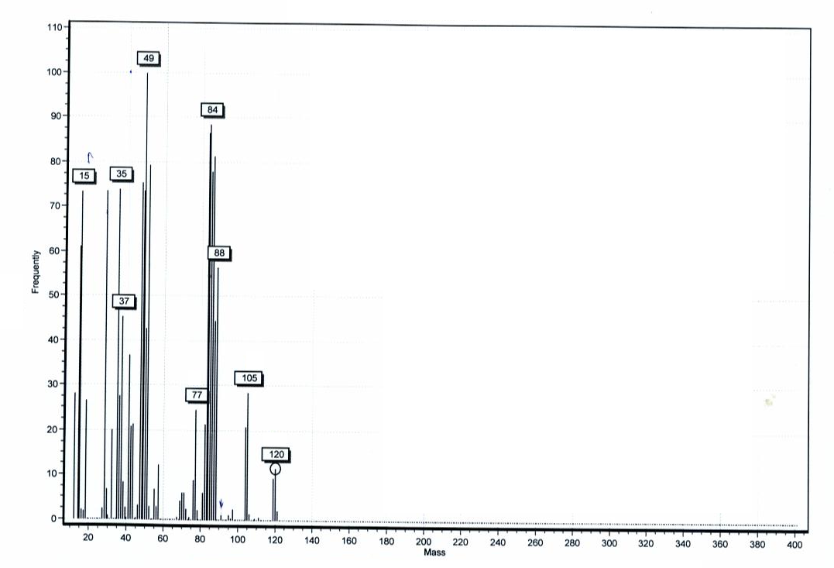
Figure 1d. Mass spectrum of Acetophenone.

Benzaldehyde (Table 4 entry 2) ^{[1]}
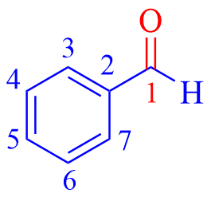
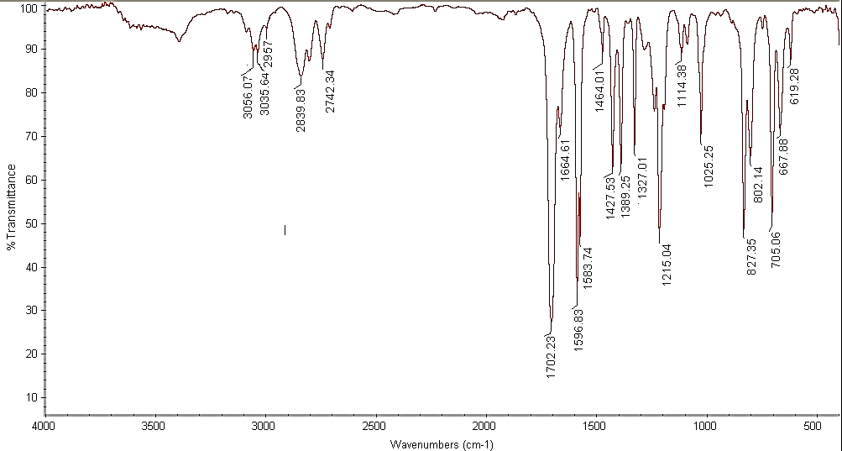
Colorless liquid; FT-IR (neat) (ν_{max} /cm⁻¹): 3056 (aromatic C-H, stretching), 3035, 2957, 2839, 2742 (aliphatic C-H), 2687, 1702 (C=O), 1596 (C=C), 1583, 1464 (C=C), 1389 (C-C), 1310, 1287, 1203, 1167, 827, 745, 705 (aromatic C-H, bending), 688, 649, 451; ¹H NMR (400 MHz, CDCl₃) δ_{H} (ppm)= 10.03 (s, 1 H, H¹), 7.90 (d, 2 H, J = 7.6 Hz, ArH, H³, H⁷ ), 7.65 (t, 1 H, J = 7.6 Hz, ArH, H⁵), 7.55 (t, 2 H, J = 7.6 Hz, ArH, H⁴, H⁶); ¹³C NMR (100 MHz, CDCl₃) δ_{C} (ppm)= 192.6 (C¹), 136.59 (C²), 134.67 (C³, C⁷), 129.94 (C⁵), 129.2 (C⁴, C⁶).
Figure 2a. FT-IR (neat) spectrum of Benzaldehyde.

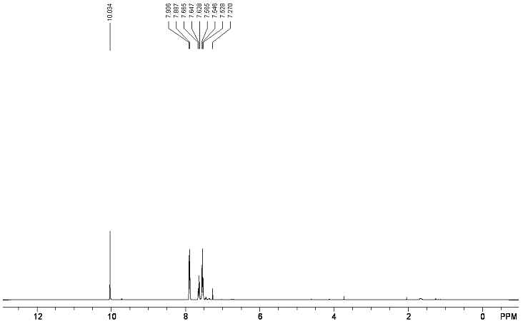
Figure 2b. ¹H NMR spectrum (400 MHz, CDCl₃) of Benzaldehyde.
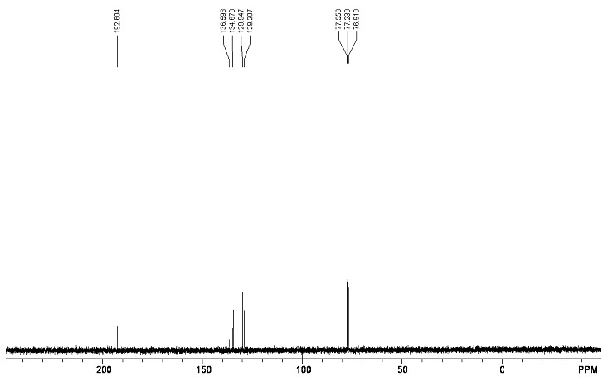

Figure 2c. ¹³C NMR spectrum (100 MHz, CDCl₃) of Benzaldehyde.

4-Ethylbenzaldehyde (Table 4 entry 3) ^{[2]}
Colorless liquid; ¹H NMR (300 MHz, CDCl₃) δ_{H} (ppm)= 9.95 (s, 1H, H¹), 7.85 (d, 2H, J = 8.2 Hz, ArH, H³, H⁷), 7.32 (d, 2H, J = 8.0 Hz, ArH, H⁴, H⁶), 2.70 (q, 2H, J = 7.6 Hz, H⁸), 1.22 (t, 3H, J = 7.2 Hz, H⁹); ¹³C NMR (75 MHz, CDCl₃) δ_{C} (ppm)= 192.06 (C¹), 148.71 (C²), 134.95 (C³, C⁷), 130.47 (C⁵), 129.08 (C⁴, C⁶), 28.96 (C⁸), 15.47 (C⁹).
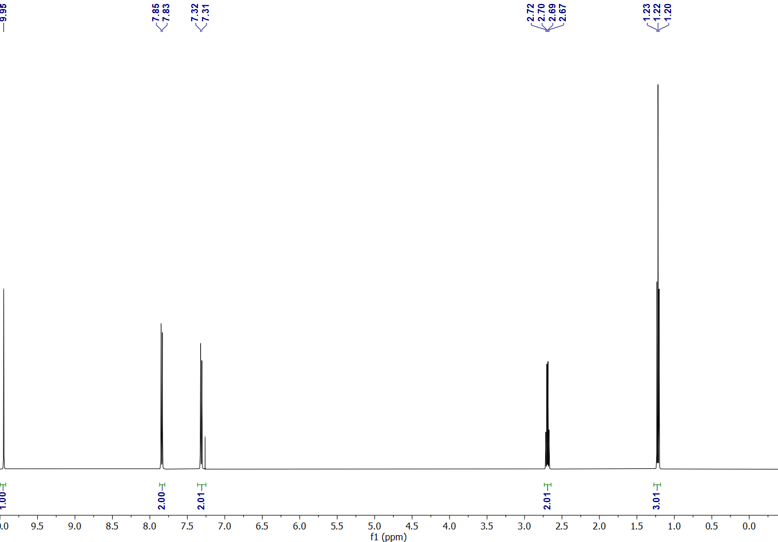
10.0
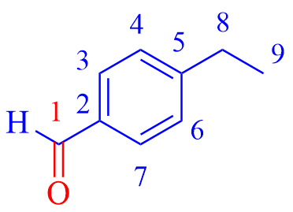

Figure 3a. ¹H NMR spectrum (300 MHz, CDCl₃) of 4-Ethylbenzaldehyde.

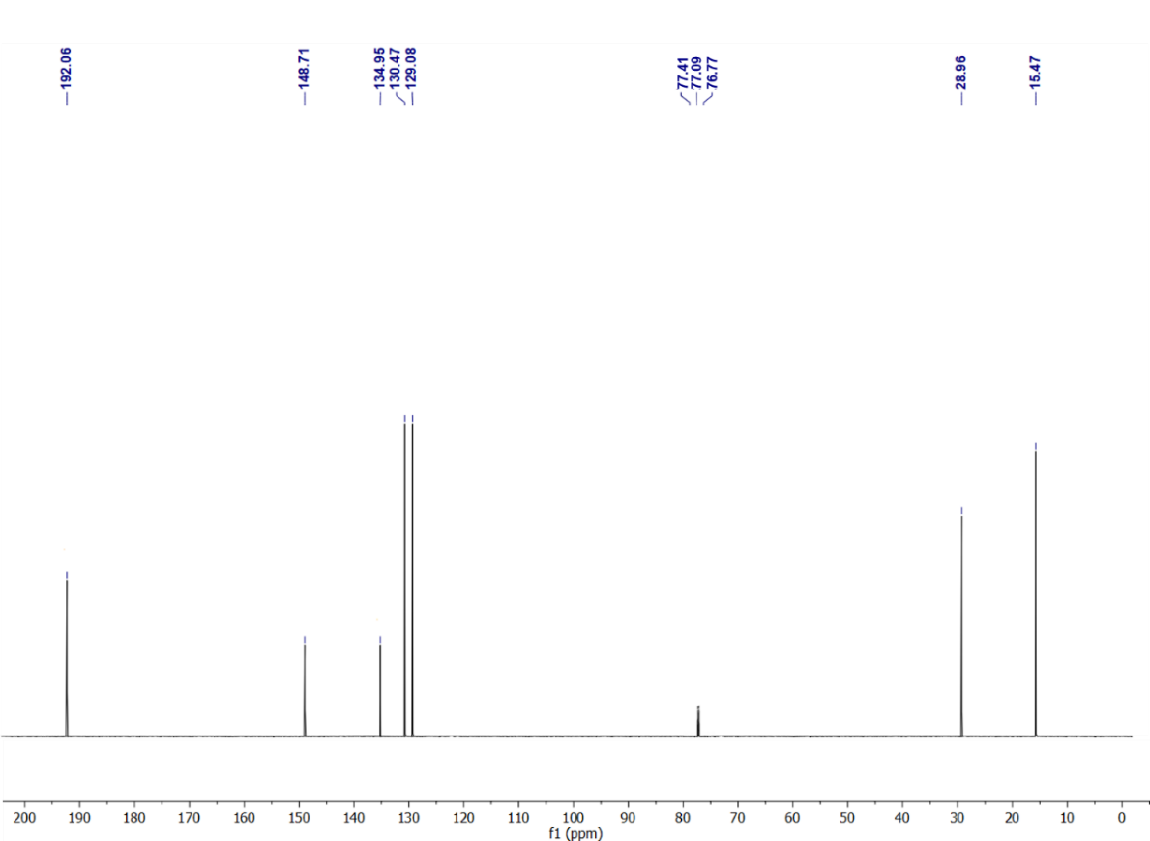
Figure 3b. ¹³C NMR spectrum (75 M Hz, CDCl₃) of 4-Ethylbenzaldehyde.

4-Methoxyacetophenone (Table 4 entry 4) ^{[3]}
White solid; ; Mp = 35-37 ºC (Lit. 36-38 ºC); ¹H NMR (400 MHz, CDCl₃) δ_{H} (ppm)= 7.95-7.96 (m, 2H, ArH, H⁴, H⁸), 6.94-6.96 (m, 2H, ArH, H⁵, H⁷), 3.89 (s, 3H, H⁹), 2.57 (s, 3H, H¹); ¹³C NMR (100 MHz, CDCl₃) δ_{C} (ppm)= 196.77 (C²), 163.48 (C⁶), 130.59 (C³), 130.36 (C⁵, C⁷), 113.68 (C⁴, C⁸), 55.47 (C⁹), 26.39 (C¹).
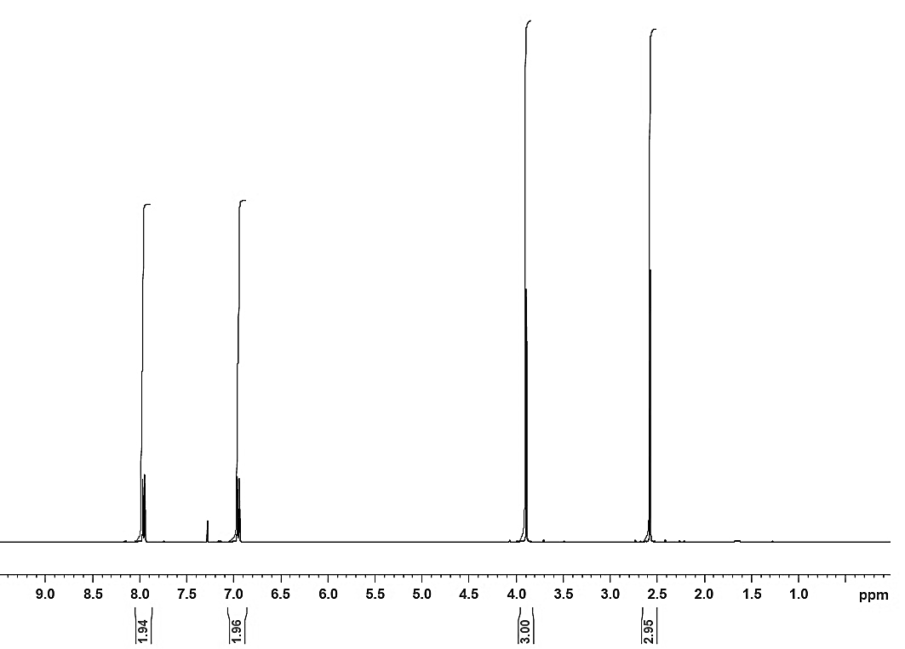
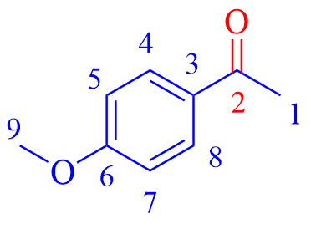
Figure 4a. ¹H NMR spectrum (400 MHz, CDCl₃) of 4-Methoxyacetophenone.
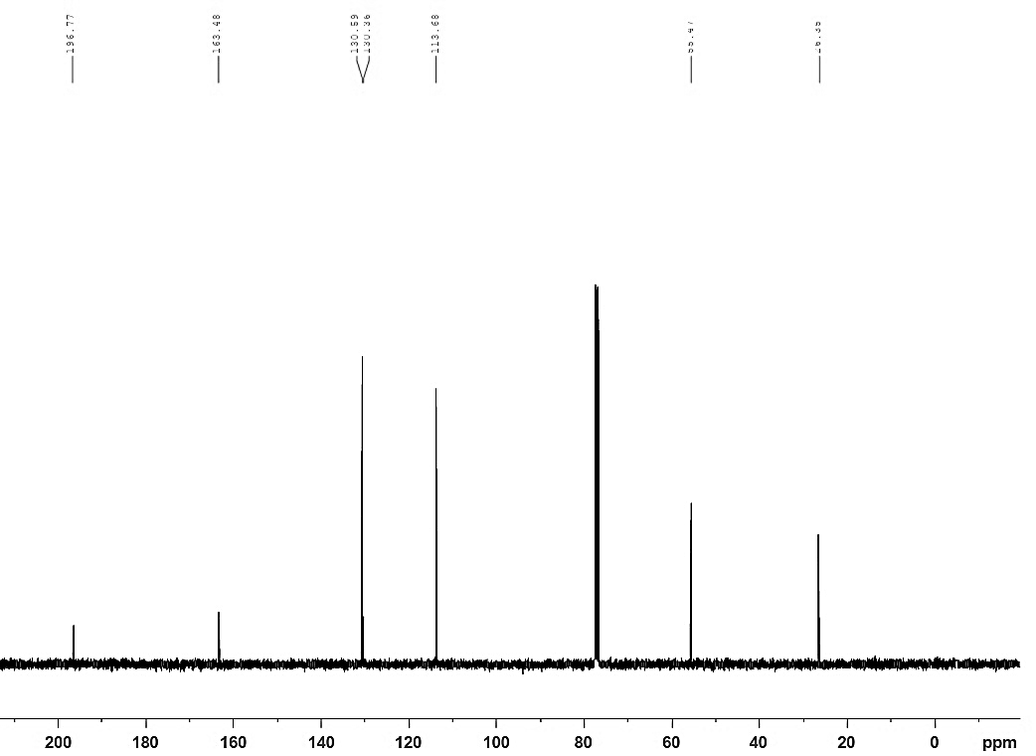

Figure 4b. ¹³C NMR spectrum (100 M Hz, CDCl₃) of 4-Methoxyacetophenone.

4-Bromoacetophenone (Table 4 entry 5) ^{[4]}
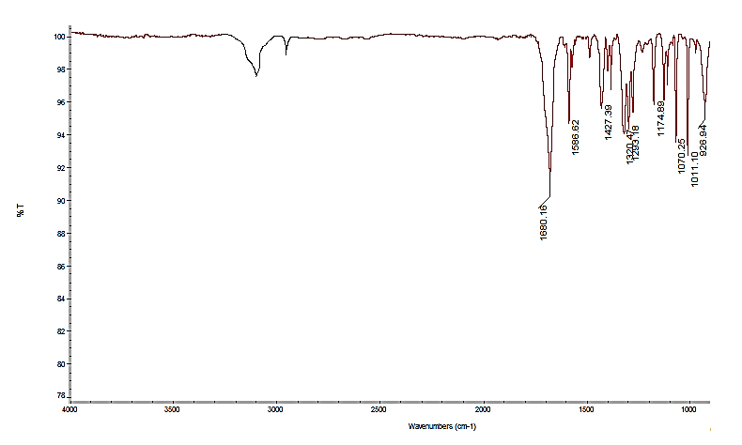
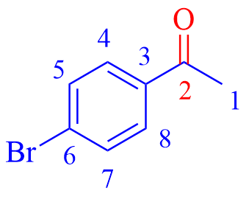
White solid; Mp = 48-49 ºC (Lit. 49-50 ºC); FT-IR (KBr) (ν_{max} /cm⁻¹): 3059 (aromatic C-H, stretching), 3026, 2957 (aliphatic C-H), 1680, 1586, 1427, 1320, 1293, 1174, 1070, 1011; ¹H NMR (400 MHz, CDCl₃) δ_{H} (ppm)= 7.82 (d, 2H, J = 8.7 Hz, ArH, H⁴, H⁸), 7.61 (d, 2H, J = 8.7 Hz, ArH, H⁵, H⁷), 2.59 (s, 3H, H¹); ¹³C NMR (100 MHz, CDCl₃) δ_{C} (ppm)= 197.0 (C²), 135.8 (C³), 131.9 (C⁶), 129.8 (C⁴, C⁸), 128.3 (C⁵, C⁷), 26.5 (C¹).
Figure 5a. FT-IR (KBr) spectrum of 4-Bromoacetophenone.

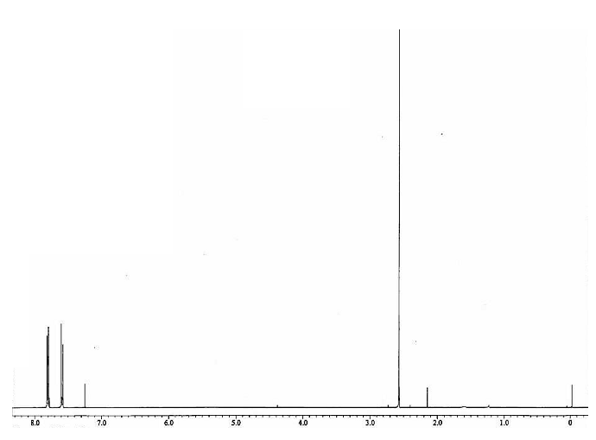
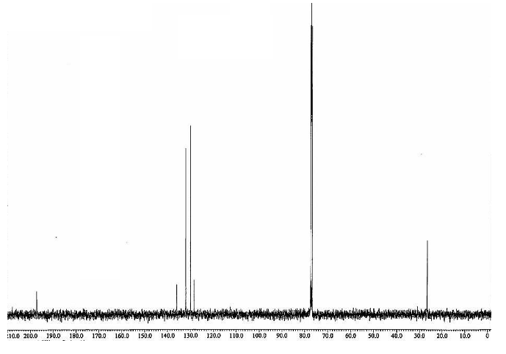
Figure 5b. ¹H NMR spectrum (400 MHz, CDCl₃) of 4-Bromoacetophenone.
Figure 5c. ¹³C NMR spectrum (100 MHz, CDCl₃) of 4-Bromoacetophenone.

4-Nitrobenzaldehyde (Table 4 entry 6) ^{[5]}
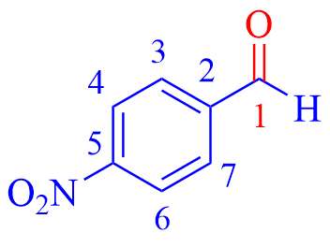
Pale yellow solid; Mp = 104-106 ºC (Lit. 104-106 ºC); FT-IR (KBr) (ν_{max} /cm⁻¹): 3056 (aromatic C-H, stretching), 3035, 2957, 2839, 2742, 1702 (C=O), 1664 (C=C), 1596 (NO₂), 1389 (C-C), 1325 (NO₂), 1287, 1197, 850, 817, 667 (aromatic C-H, bending); ¹H NMR (400 MHz, CDCl₃) δ_{H} (ppm)= 10.16 (s, 1H, H¹), 8.39 (d, 2H, J = 8.0 Hz, ArH, H³, H⁷), 8.08 (d, 2H, J = 8.0 Hz, ArH, H⁴, H⁶); ¹³C NMR (100 MHz, CDCl₃) δ_{C} (ppm)= 190.51 (C¹), 151.28 (C²), 140.22 (C⁵), 130.67 (C³, C⁷), 124.48 (C⁴, C⁶).
Figure 6a. FT-IR (KBr) spectrum of 4-Nitrobenzaldehyde.

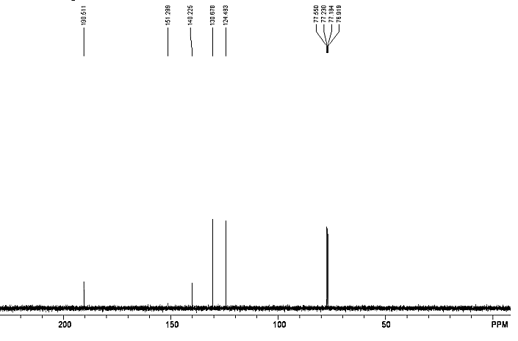
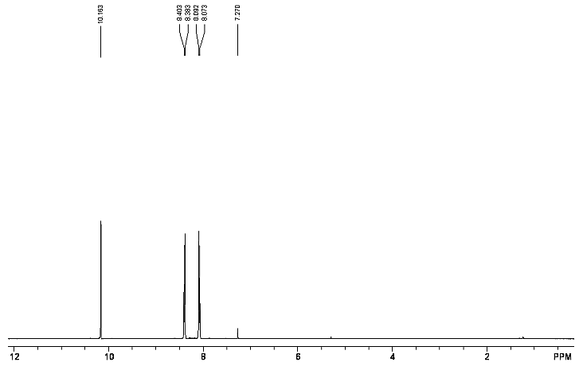
Figure 6b. ¹H NMR spectrum (400 MHz, CDCl₃) of 4-Nitrobenzaldehyde.
Figure 6c. ¹³C NMR spectrum (100 MHz, CDCl₃) of 4-Nitrobenzaldehyde.
Benzophenone (Table 4 entry 7) ^{[5]}
White solid; Mp = 47-48 ºC (Lit. 48-49 ºC); FT-IR (KBr) (ν_{max} /cm⁻¹): 3056(aromatic C-H, stretching), 1656 (C=O), 1593 (C=C), 1575, 1447 (C-C), 1322 (C-C), 1278, 1176, 1075, 1025, 944, 813, 764, 704, 694 (aromatic C-H, bending); ¹H NMR (400 MHz, CDCl₃) δ_{H} (ppm)= 7.82 (d, 4H, J = 8.0 Hz, ArH, H³, H⁷, H⁹, H¹³), 7.60 (t, 2H, J = 8.0 Hz, ArH, H⁵, H¹¹), 7.50 (t, 4H, J = 8.0 Hz, ArH, H⁴, H⁶, H¹⁰, H¹²); ¹³C NMR (100 MHz, CDCl₃) δ_{C} (ppm)= 197.16 (C¹), 137.97 (C², C⁸), 132.81 (C⁵, C¹¹), 130.45 (C³, C⁷, C⁹, C¹³), 128.66 (C⁴, C⁶, C¹⁰, C¹²).
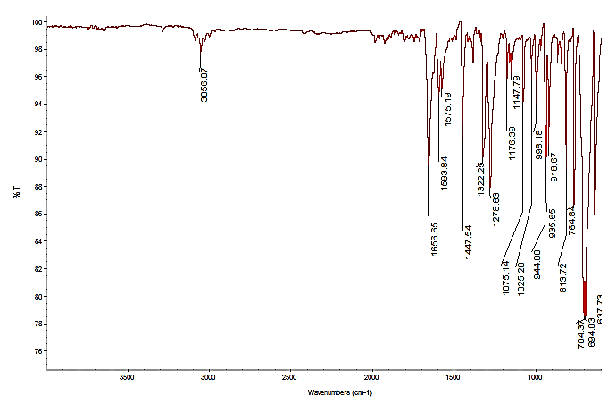

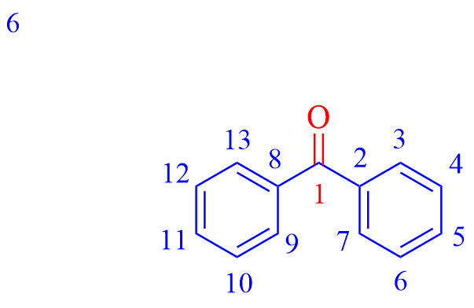

Figure 7a. FT-IR (KBr) spectrum of Benzophenone.

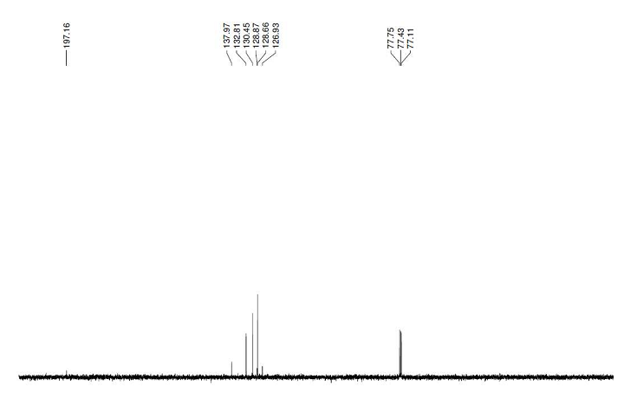
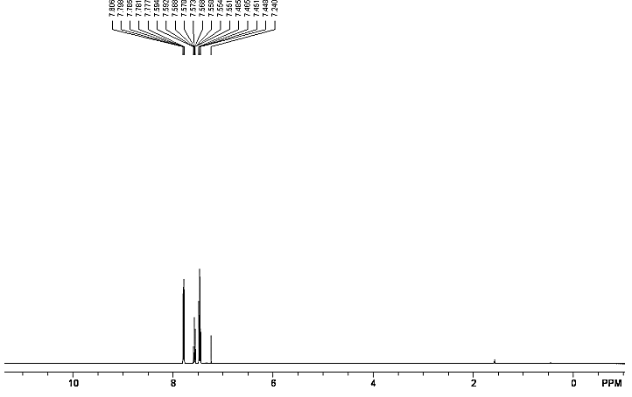
Figure 7b. ¹H NMR spectrum (400 MHz, CDCl₃) of Benzophenone.

Figure 7c. ¹³C NMR spectrum (100 MHz, CDCl₃) of Benzophenone.

2-Naphthaldehyde (Table 4 entry 8) ^{[6]}
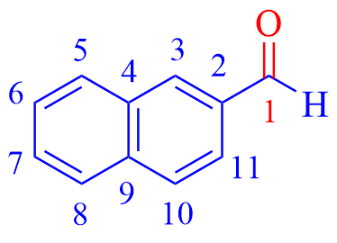
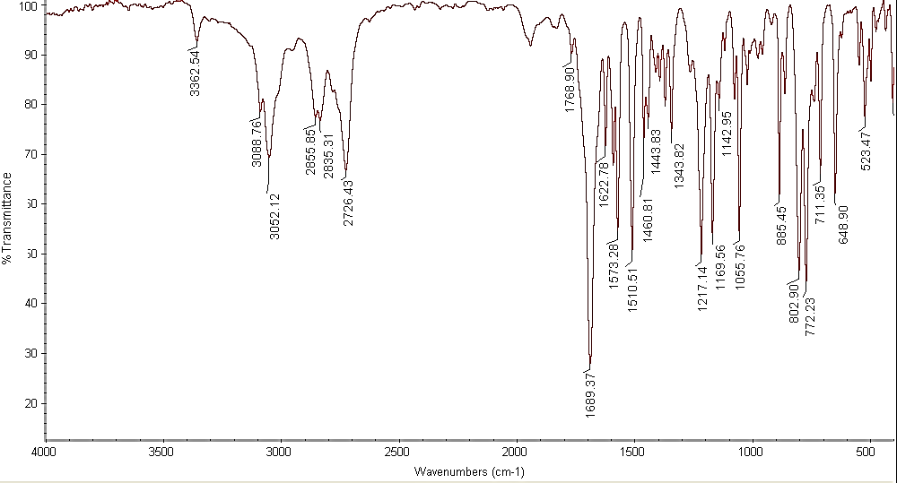
White solid; Mp = 57-59 ºC (Lit. 57-58 ºC); FT-IR (neat) (ν_{max} /cm⁻¹): 3088 (aromatic C-H, stretching), 3052, 2855, 2726, 1689 (C=O), 1573 (C=C), 1510, 1460 (C=C), 1343 (C-C), 1217, 1169, 1142, 1055, 802, 772, 711, 648 (aromatic C-H, bending), 523; ¹H NMR (400 MHz, CDCl₃) δ_{H} (ppm)= 10.1 (s, 1 H, H¹), 8.32 (s, 1 H, ArH, H³), 7.94 (m, 4 H, ArH, H⁵, H⁶, H⁷, H⁸), 7.61 (m, 2 H, ArH, H¹⁰, H¹¹); ¹³C NMR (100 MHz, CDCl₃) δ_{C} (ppm)= 192.3 (C¹), 136.4 (C²), 134.6 (C³), 134.0 (C¹¹), 132.5 (C¹⁰), 129.5 (C⁹), 129.1 (C⁴), 129.0 (C⁵), 128.0 (C⁸), 127.0 (C⁶), 122.7 (C⁷).
Figure 8a. FT-IR (neat) spectrum of 2-Naphthaldehyde.

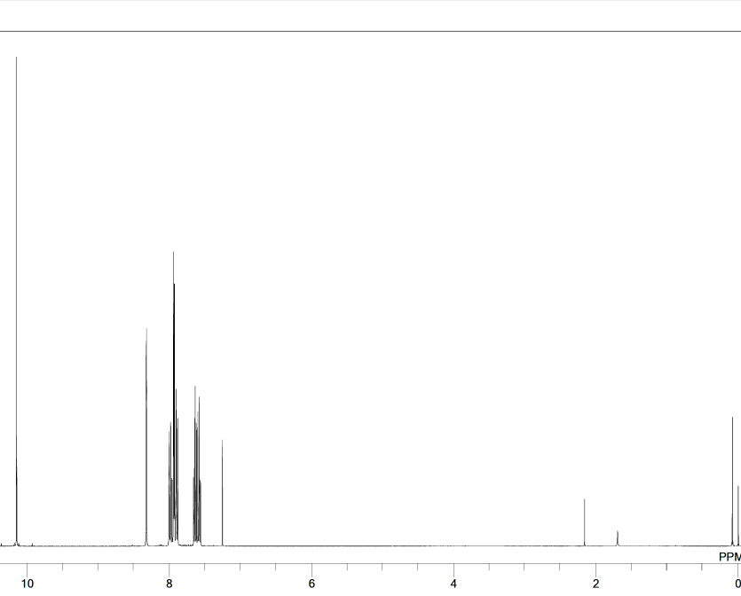

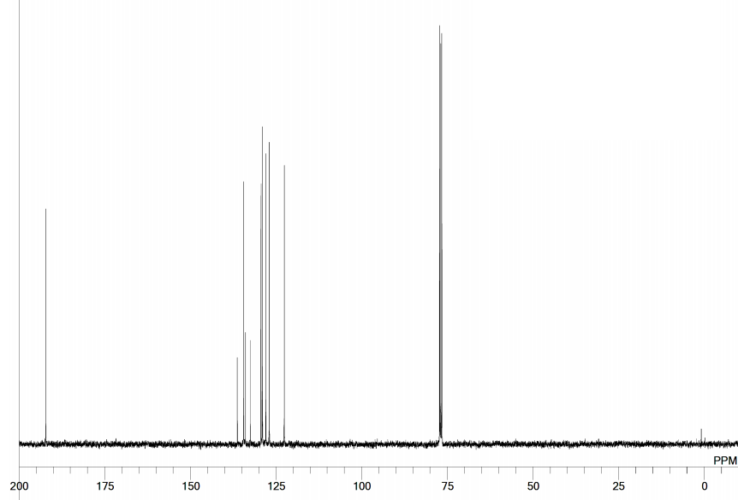
Figure 8b. ¹H NMR spectrum (400 MHz, CDCl₃) of 2-Naphthaldehyde.
Figure 8c. ¹³C NMR spectrum (100 MHz, CDCl₃) of 2-Naphthaldehyde.
3,4-Dihydronaphthalen-1(2H)-one (Table 4 entry 9) ^{[7]}
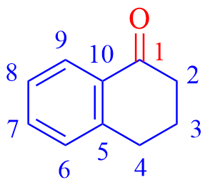
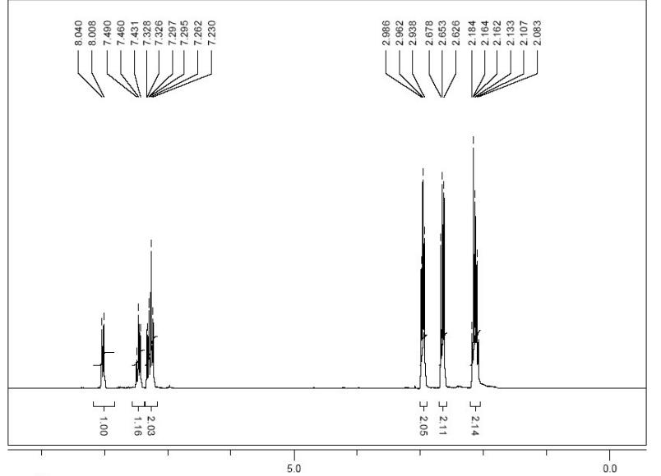
Yellowish liquid; ¹H NMR (300 MHz, CDCl₃) δ_{H} (ppm)= 8.02 (d, 1H, J = 8 Hz, ArH, H⁹), 7.46 (t, 1H, J = 7.4 Hz, ArH, H⁷), 7.32-7.23 (m, 2H, ArH, H⁶, H⁸), 2.96 (t, 2H, J = 6 Hz, H²), 2.65 (t, 2H, J = 6.5 Hz, H⁴), 2.18-2.08 (m, 2H, H³); ¹³C NMR (75 MHz, CDCl₃) δ_{C} (ppm)= 198.42 (C¹), 144.49 (C¹⁰), 133.38 (C⁹), 132.58 (C⁵), 128.76 (C⁶), 127.13 (C⁷), 126.6 (C⁸), 39.15 (C²), 29.68 (C⁴), 23.26 (C³).

Figure 9a. ¹H NMR spectrum (300 MHz, CDCl₃) of 3,4-Dihydronaphthalen-1(2H)-one.

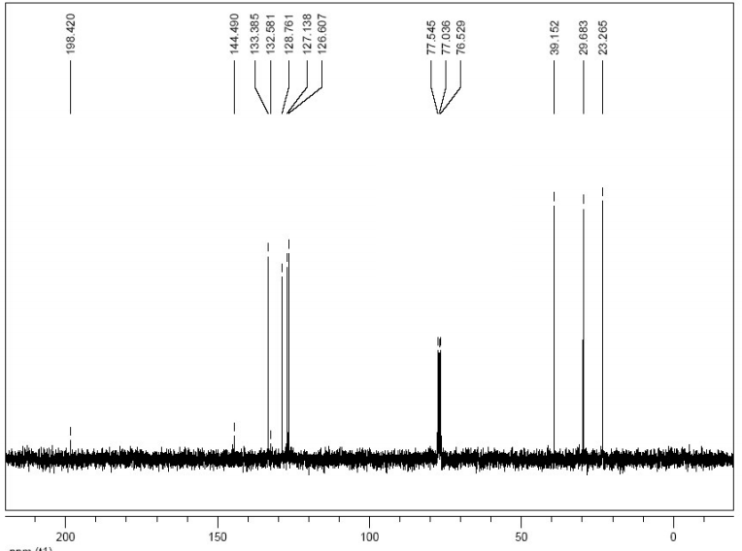

Figure 9b. ¹³C NMR spectrum (75 MHz, CDCl₃) of 3,4-Dihydronaphthalen-1(2H)-one.

Pyridine-3-carbaldehyde (Table 4 entry 10) ^{[8]}
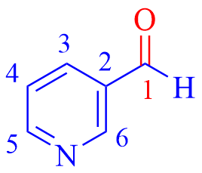
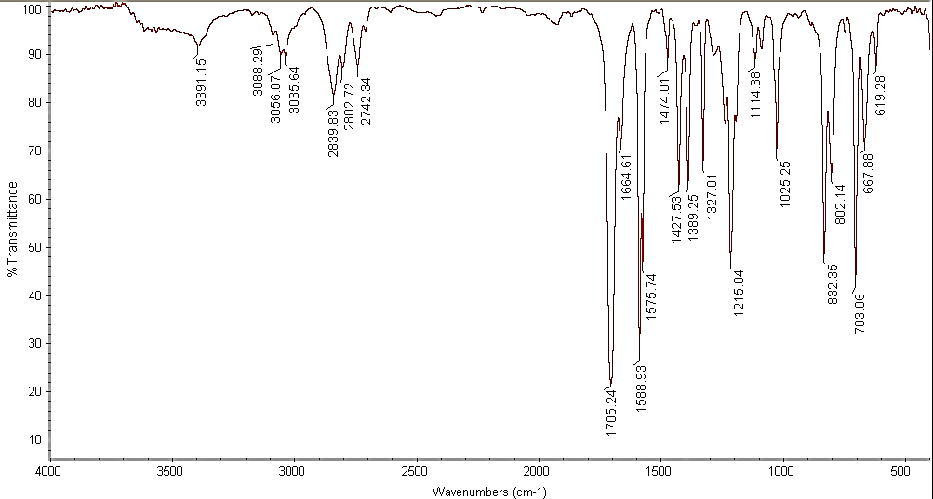
Yellowish liquid; FT-IR (neat) (ν_{max} /cm⁻¹): 3088 (aromatic C-H, stretching), 3056, 2839, 2742, 1705 (C=O), 1588 (C=C), 1575, 1427, 1389, 1327, 1215 (C-N), 1114, 1025, 832, 703 (aromatic C-H, bending), 667, 619; ¹H NMR (400 MHz, CDCl₃) δ_{H} (ppm)= 10.11 (s, 1H, H¹), 9.07 (d, 1H, J = 1.2 Hz, ArH, H⁶), 8.84 (dd, 1H, J = 4.8 Hz, J = 1.4 Hz, ArH, H³), 8.16 (td, 1H, J = 6.0 Hz, J = 2.0 Hz, ArH, H⁵), 7.48 (dd, 1H, J = 7.8 Hz, J = 4.9 Hz, ArH, H⁴); ¹³C NMR (100 MHz, CDCl₃) δ_{C} (ppm)= 190.7 (C¹), 154.69 (C⁵), 152.04 (C⁶), 135.78 (C³), 131.39 (C²), 124.06 (C⁴).
Figure 10a. FT-IR (neat) spectrum of Pyridine-3-carbaldehyde.

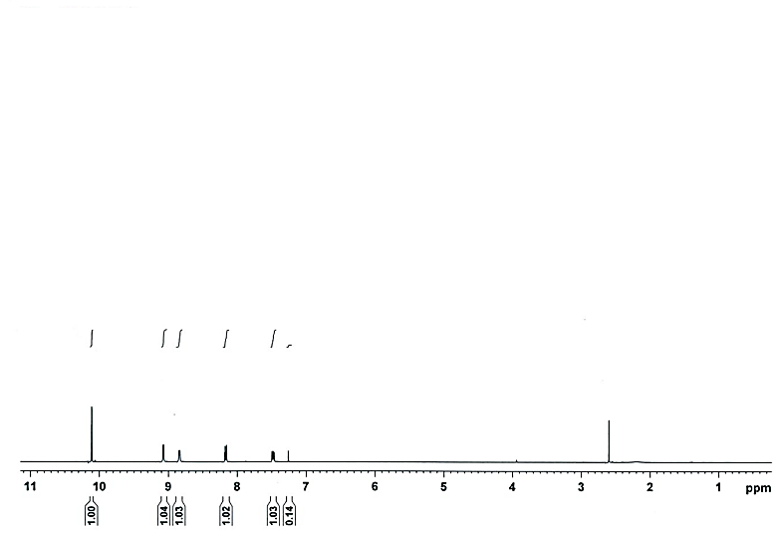
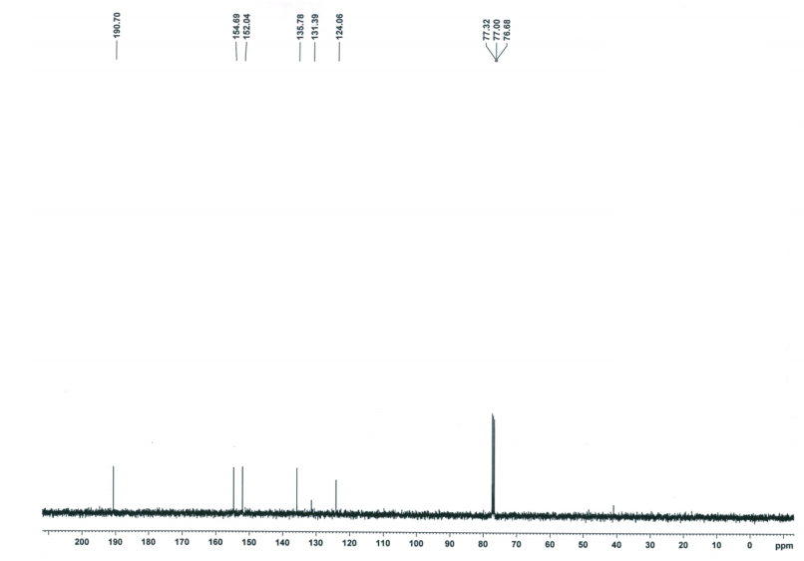
Figure 10b. ¹H NMR spectrum (400 MHz, CDCl₃) of Pyridine-3-carbaldehyde.
Figure 10c. ¹³C NMR spectrum (100 MHz, CDCl₃) of Pyridine-3-carbaldehyde
Phenyl[pyridin-2-yl]methanone (Table 4 entry 11) ^{[9]}
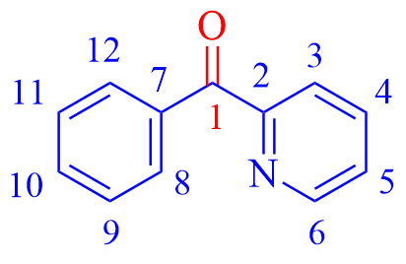
¹H NMR (400 MHz, CDCl₃) δ_{H} (ppm)= 8.68 (d, 1H, J= 1.2 Hz ArH, H¹²), 8.04-7.98 (m, 3H, ArH, H⁸, H⁹, H¹¹), 7.87-7.82 (m, 1H, ArH, H¹⁰), 7.57-7.52 (m, 1H, H³), 7.46-7.41 (m, 3H, H⁴, H⁵, H⁶); ¹³C NMR (100 MHz, CDCl₃) δ_{C} (ppm)= 193.8 (C¹), 154.9 (C²), 148.5 (C⁶), 137.0 (C⁴), 136.2 (C⁷), 132.9 (C¹⁰), 130.9 (C⁸, C¹²), 128.1 (C⁹, C¹¹), 126.1 (C⁵), 124.6 (C³).
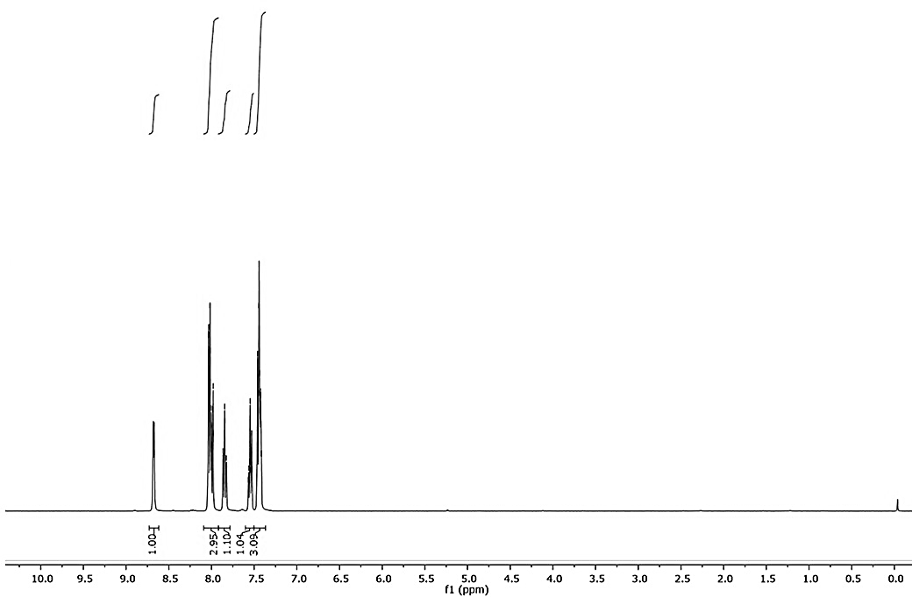
Figure 11a. ¹H NMR spectrum (400 MHz, CDCl₃) of Phenyl [Pyridin-2-yl]methanone.

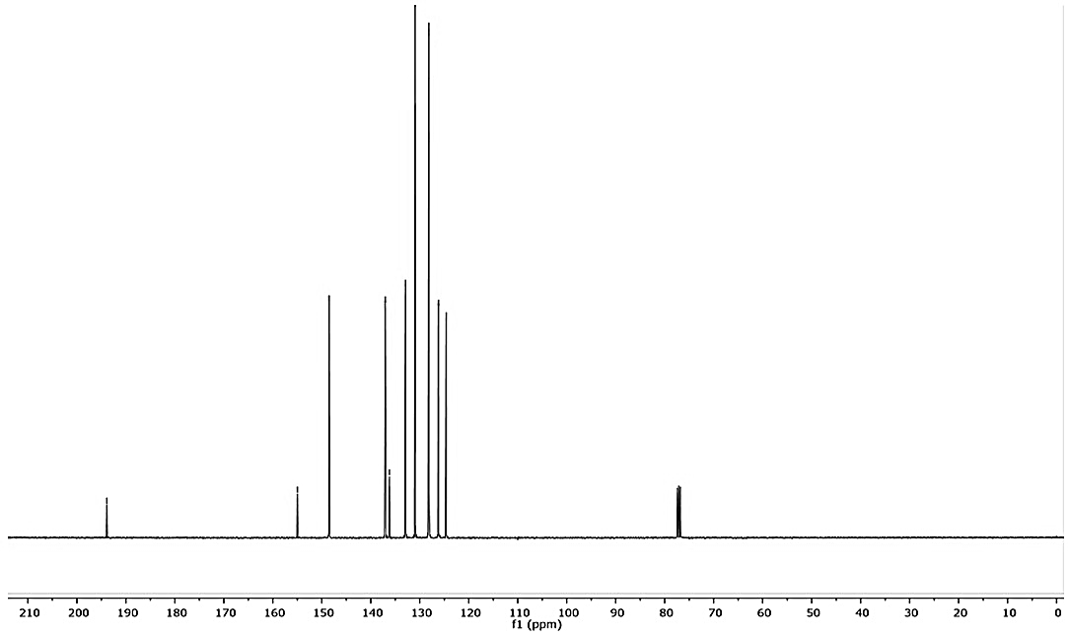
Figure 11b. ¹³C NMR spectrum (100 MHz, CDCl₃) of Phenyl[Pyridin-2-yl]methanone.

9,10-Phenanthrenquinone (Table 4 entry 12) ^{[10]}
White solid; Mp= 287-289 °С (Lit. mp 289-290 °С); ¹H NMR (400 MHz, CDCl₃) δ_{H} (ppm)= 8.35-8.31 (m, 4H, ArH, H³, H⁶, H¹⁰, H¹³), 7.83-7.79 (m, 4H, ArH, H⁴, H⁵, H¹¹, H¹²); ¹³C NMR (100 MHz, CDCl₃) δ_{C} (ppm)= 183.16 (C¹, C⁸), 134.11 (C², C⁷, C⁹, C¹⁴), 133.56 (C³, C⁶, C¹⁰, C¹³), 127.24 (C⁴, C⁵, C¹¹, C¹²).
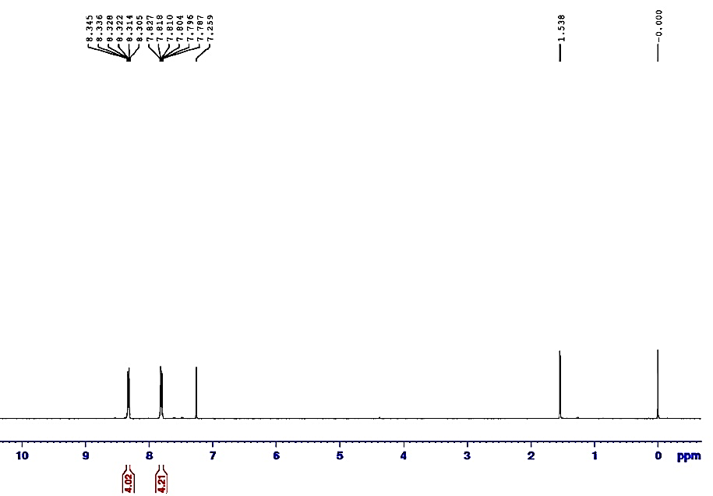

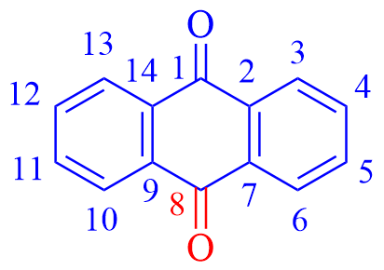

Figure 12a. ¹H NMR spectrum (400 MHz, CDCl₃) of 9,10-Phenanthrenquinone.

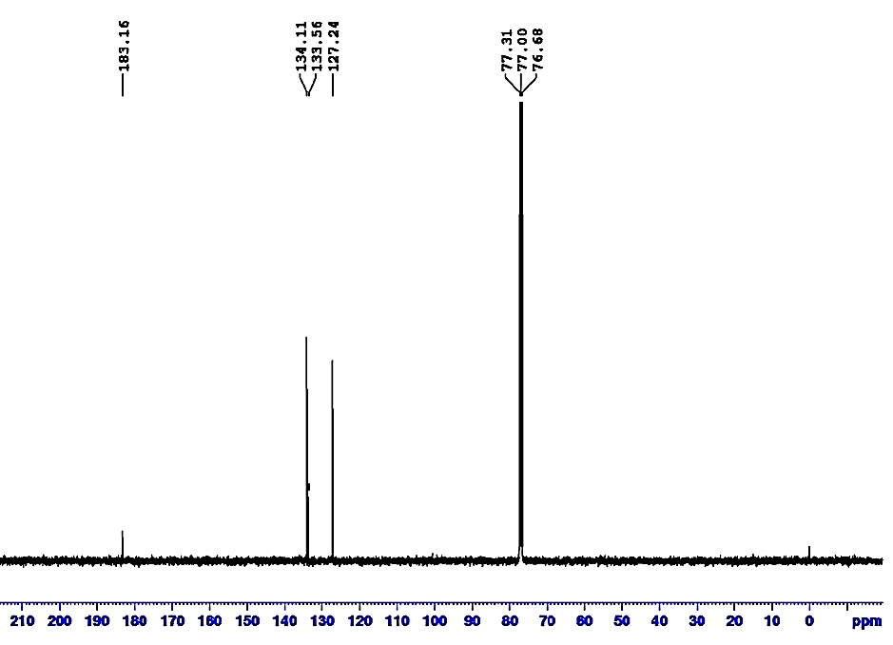
Figure 12b. ¹³C NMR spectrum (100 MHz, CDCl₃) of 9,10-Phenanthrenquinone.

Cyclohex-2-en-1-one (Table 5 entry 1) ^{[11]}
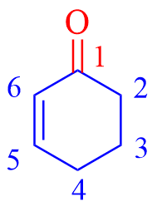
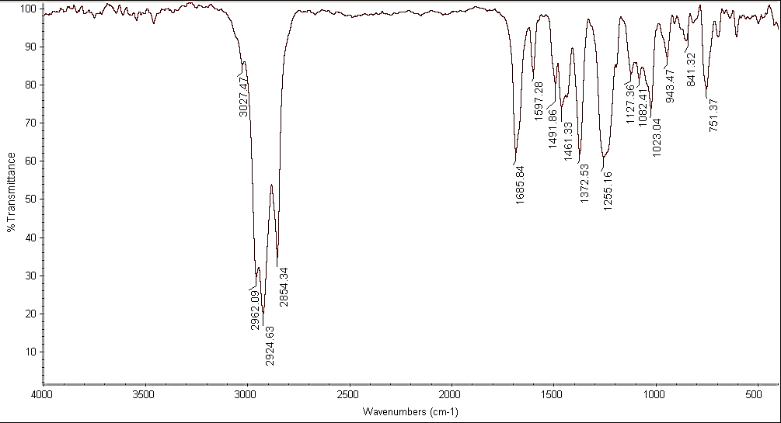
Colorless liquid; FT-IR (neat) (ν_{max} /cm⁻¹): 3027 (sp² C-H, stretching), 2962 (aliphatic C-H), 2924, 2854, 1658 (C=O), 1597 (C=C), 1491 (C-C), 1372, 1255, 1082, 1023, 841, 751 (sp² C-H, bending); ¹H NMR (400 MHz, CDCl₃) δ_{H} (ppm)= 6.98 (td, 1H, J =10.1 Hz, J = 4.2 Hz, ArH, H⁶), 6.00 (td, 1H, J = 10.1 Hz, J = 2.0 Hz, ArH, H⁵), 2.43-2.39 (m, 2H, H²), 2.36-2.32 (m, 2H, H⁴), 2.04-1.98 (m, 2H, H³); ¹³C NMR (100 MHz, CDCl₃) δ_{C} (ppm)= 199.75 (C¹), 150.68 (C⁵), 129.88 (C⁶), 38.06 (C²), 25.62 (C⁴), 22.67 (C³).
Figure 13a. FT-IR (neat) spectrum of Cyclohex-2-en-1-one.

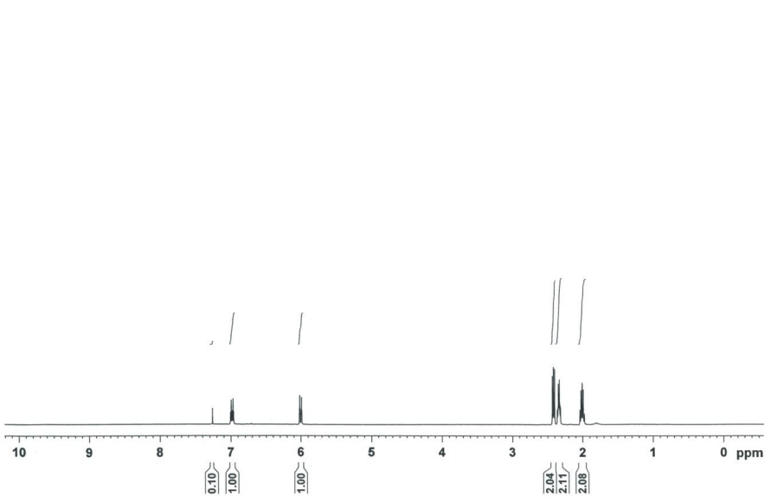
Figure 13b. ¹H NMR spectrum (400 MHz, CDCl₃) of Cyclohex-2-en-1-one.
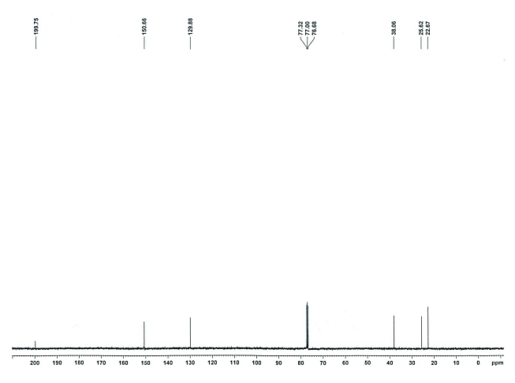

Figure 13c. ¹³C NMR spectrum (100 MHz, CDCl₃) of Cyclohex-2-en-1-one.
3-Phenyl-2-cyclohexen-1-one (Table 5 entry 2) ^{[12]}
White solid; Mp= 64-66 °С (Lit. mp 65-66 °С); FT-IR (neat) (ν_{max} /cm⁻¹): 2953 (aromatic C-H, stretching), 2925, 2872 (aliphatic C-H), 1667 (C=O), 1546 (C=C), 1496 (C=C), 1372 (C-C), 1244, 1048, 985, 749, 700 (aromatic C-H, stretching),; ¹H NMR (300 MHz, CDCl₃) δ_{H} (ppm)= 7.49-7.47 (m, 3H, ArH, H⁷, H⁹, H¹¹), 7.40-7.37 (m, 2H, ArH, H⁸, H¹⁰), 6.51 (s, 1H, H¹²), 3.32 (t, 2 H, J =6.5 Hz, H⁴), 2.71(t, 2 H, J = 6.5 Hz, H²), 1.69-1.63 (m, 2 H, H³); ¹³C NMR (75 MHz, CDCl₃) δ_{C} (ppm)= 199.84 (C¹), 157.69 (C⁵), 137.93 (C⁶), 129.58 (C¹²), 129.33 (C⁸, C¹⁰), 128.20 (C⁹), 127.07 (C⁷, C¹¹), 37.13 (C²), 27.69 (C⁴), 22.8 (C³); MS, m/z (%): 172 [M⁺].
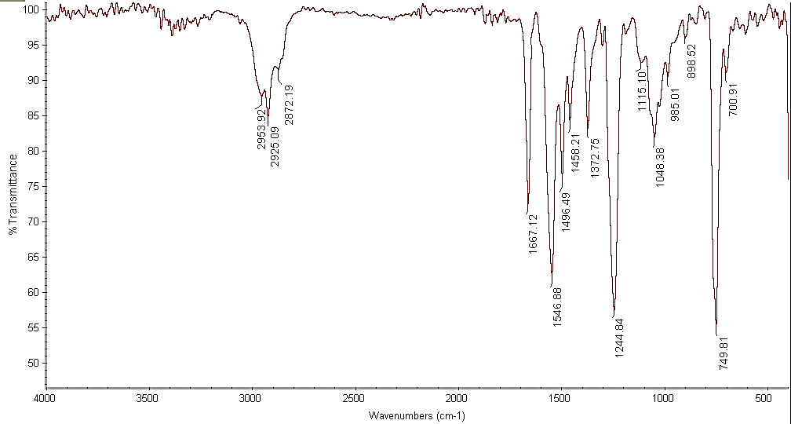

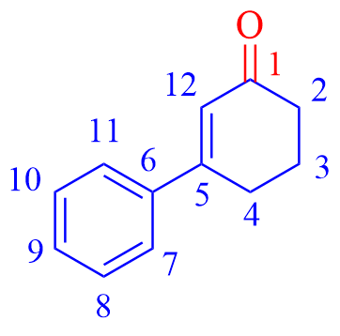

Figure 14a. FT-IR (neat) spectrum of 3-Phenyl-2-cyclohexen-1-one.

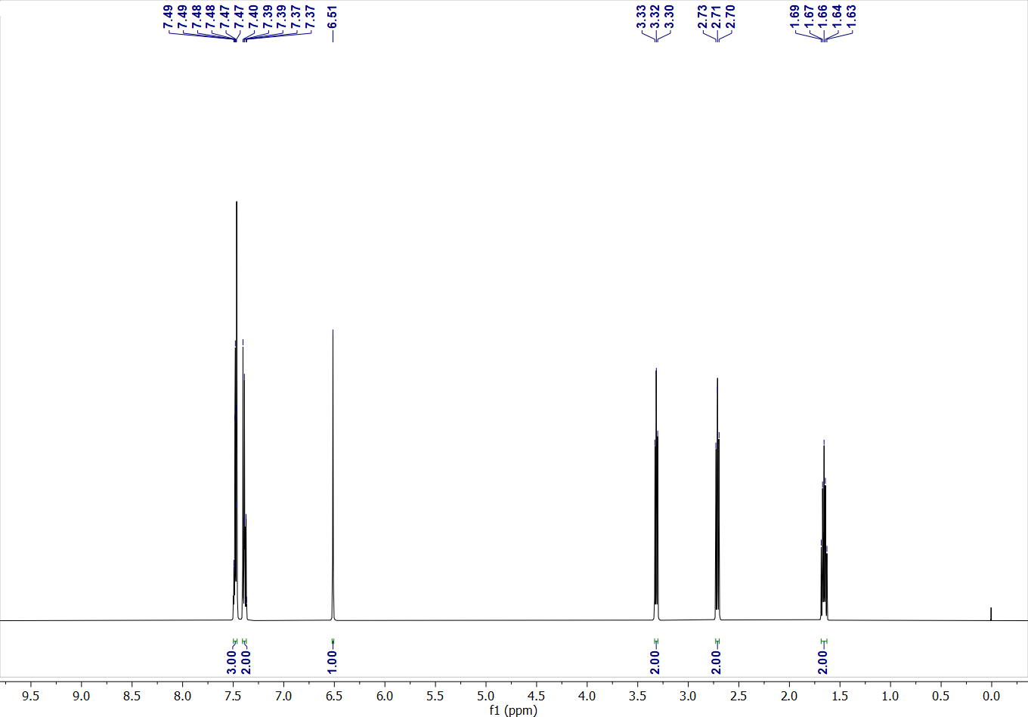

Figure 14b. ¹H NMR spectrum (400 MHz, CDCl₃) of 3-Phenyl-2-cyclohexen-1-one.
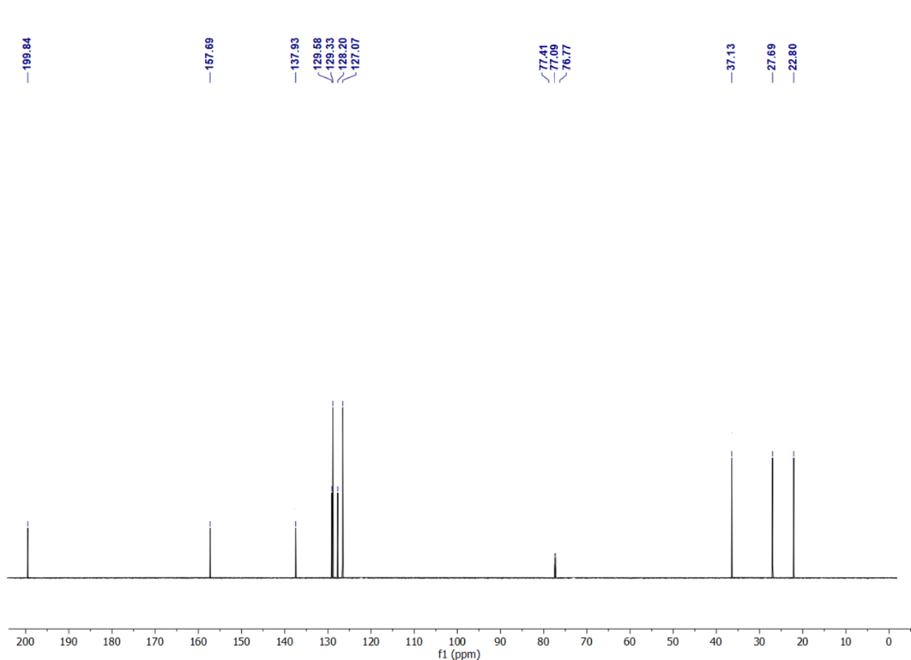
Figure 14c. ¹³C NMR spectrum (75 MHz, CDCl₃) of 3-Phenyl-2-cyclohexen-1-one.
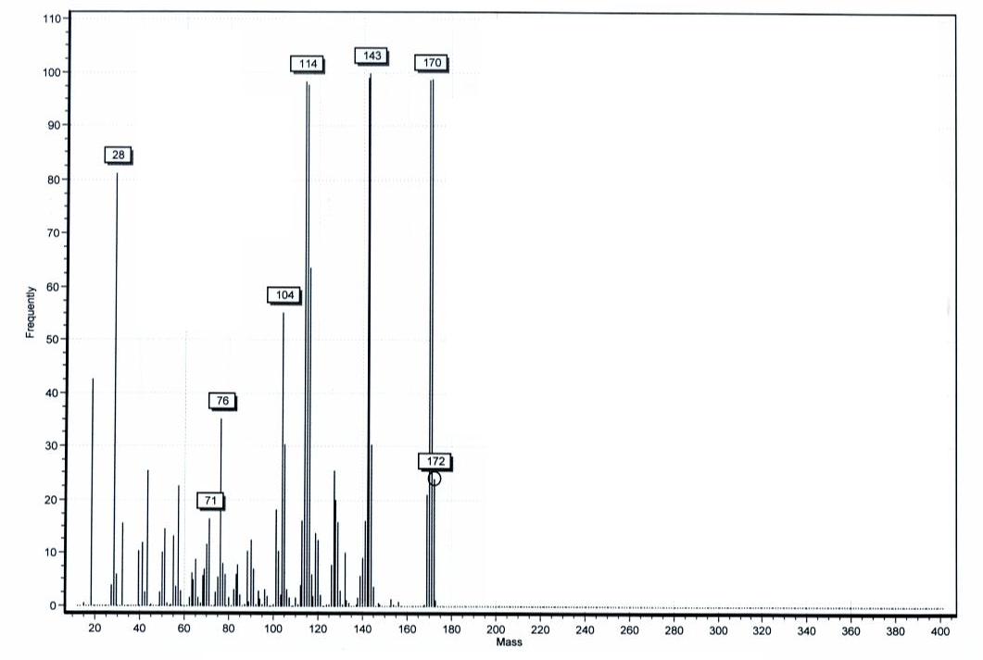

Figure 14d. Mass spectrum of 3-Phenyl-2-cyclohexen-1-one.

1-Cyclohexene-1-carboxaldehyde (Table 5 entry 3) ^{[12]}
Colorless oil; ¹H NMR (300 Mz, CDCl₃) δ_{H} (ppm)= 9.41 (s, 1H, H¹), 6.51-6.49 (m, 1H, H³), 2.44-2.41 (m, 2H, H⁷), 2.10-2.06 (m, 2H, H⁴), 1.72-1.66 (m, 2H, H⁶), 1.65-1.61 (m, 2H, H⁵). ¹³C NMR (75 MHz, CDCl₃) δ_{C} (ppm)= 194.04 (C¹), 140.76 (C³), 140.17 (C²), 26.32 (C⁷), 26.32 (C⁴), 24.37 (C⁶), 23.72 (C⁵).
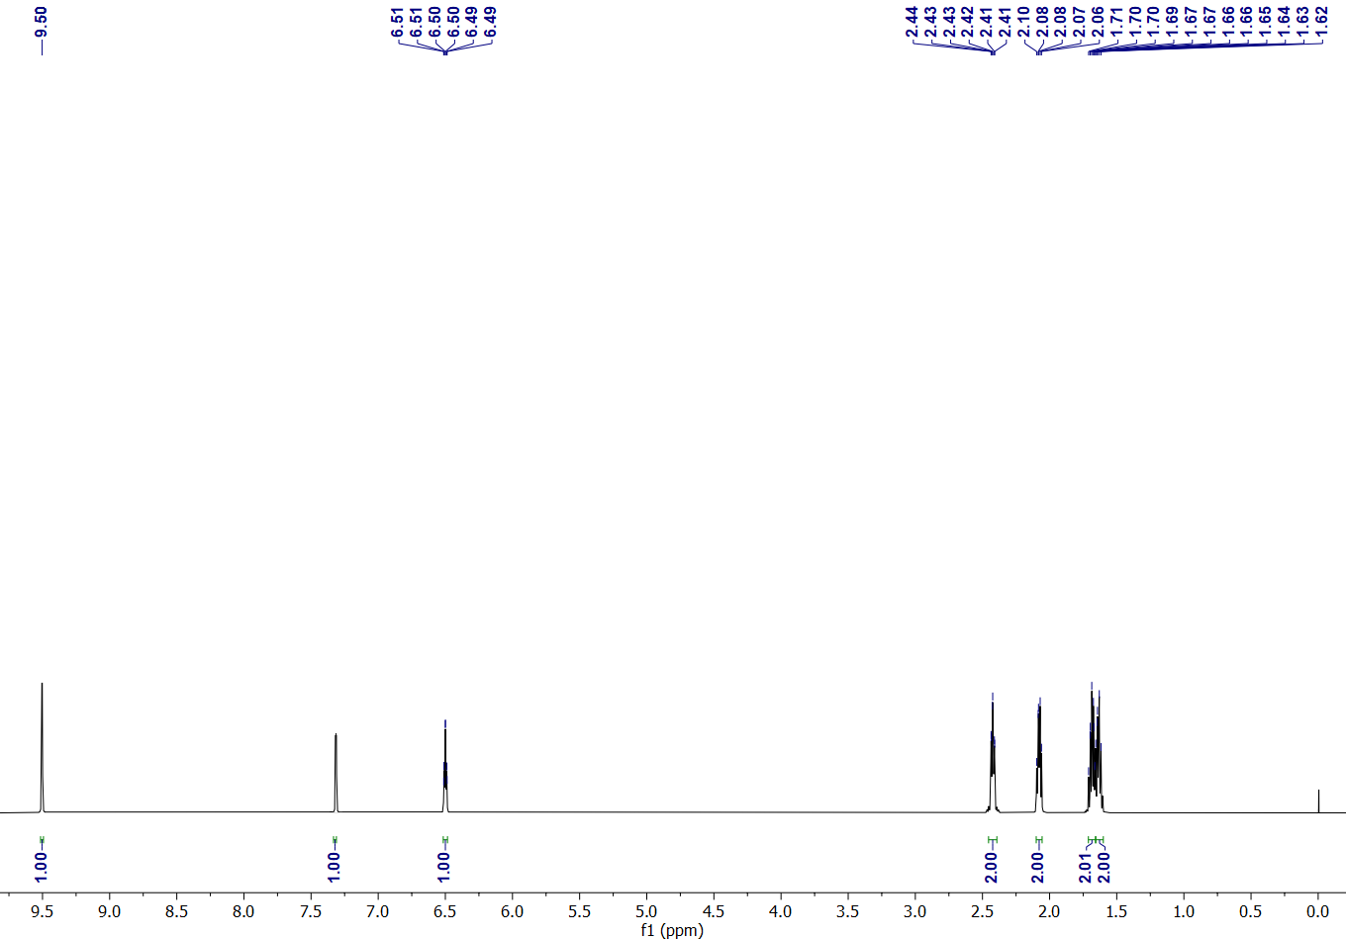

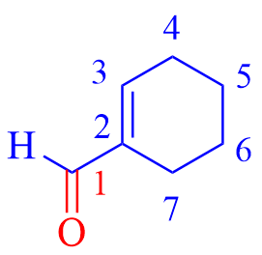

Figure 15a. ¹H NMR spectrum (300 MHz, CDCl₃) of 1-Cyclohexene-1-carboxaldehyde.

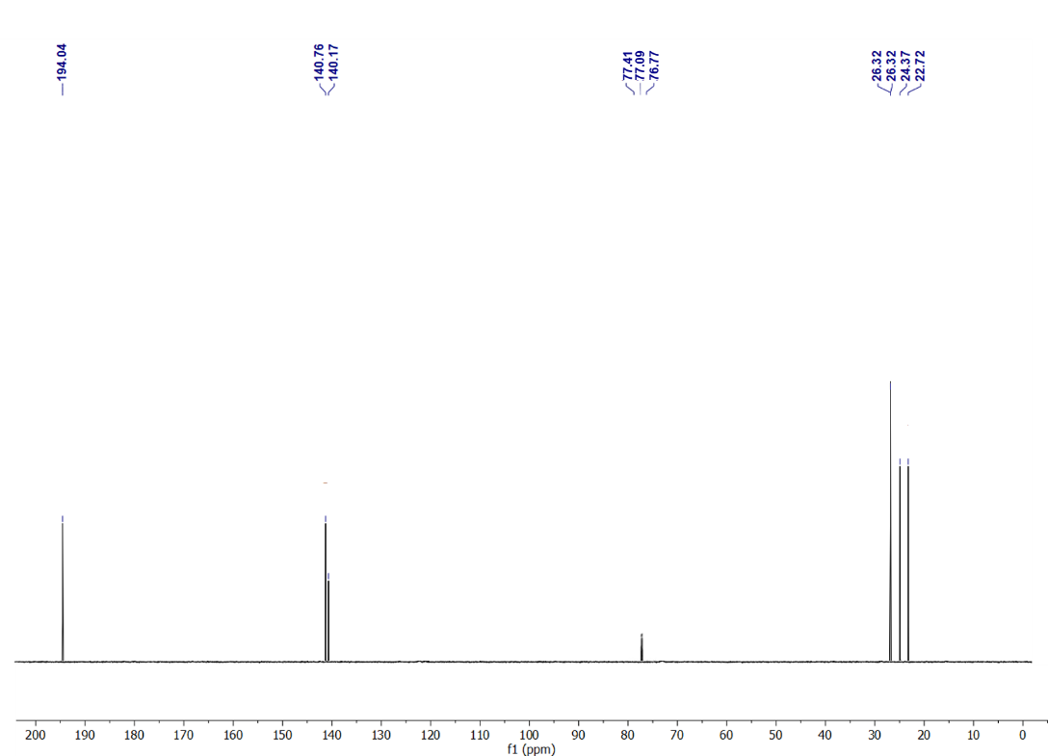

Figure 15b. ¹³C NMR spectrum (75 MHz, CDCl₃) of 1-Cyclohexene-1-carboxaldehyde.

3-Phenyl acrylaldehyde (Table 5 entry 5) ^{[13]}
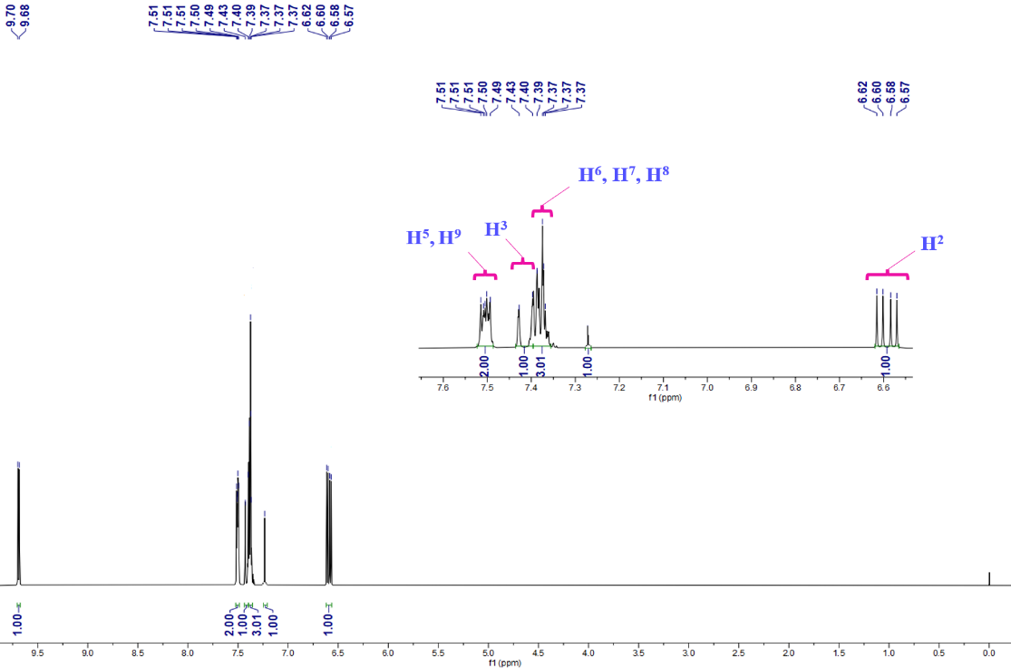
Yellow oil; ¹H NMR (300 MHz, CDCl₃) δ_{H} (ppm)= 9.70 (d, 1H, J = 8.0 Hz, H¹), 7.51- 7.49 (m, 2H, ArH, H⁵, H⁹), 7.43 (d, J = 16.0, 1H, H³), 7.40-7.37 (m, 3H, ArH, H⁶, H⁷, H⁸), 6.72 (dd, J = 16.0, J = 8.0 Hz, 1H, H²); ¹³C NMR (75 MHz, CDCl₃) δ_{C} (ppm)= 192.58 (C¹), 152.3 (C³), 134.82 (C⁴), 129.72 (C⁷), 128.9 (C⁶, C⁸), 128.64 (C⁵, C⁹), 128.2 (C²).
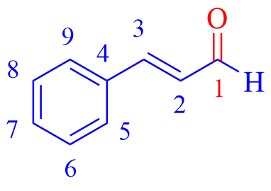

Figure 16a. ¹H NMR spectrum (300 MHz, CDCl₃) of 3-Phenyl acrylaldehyde.

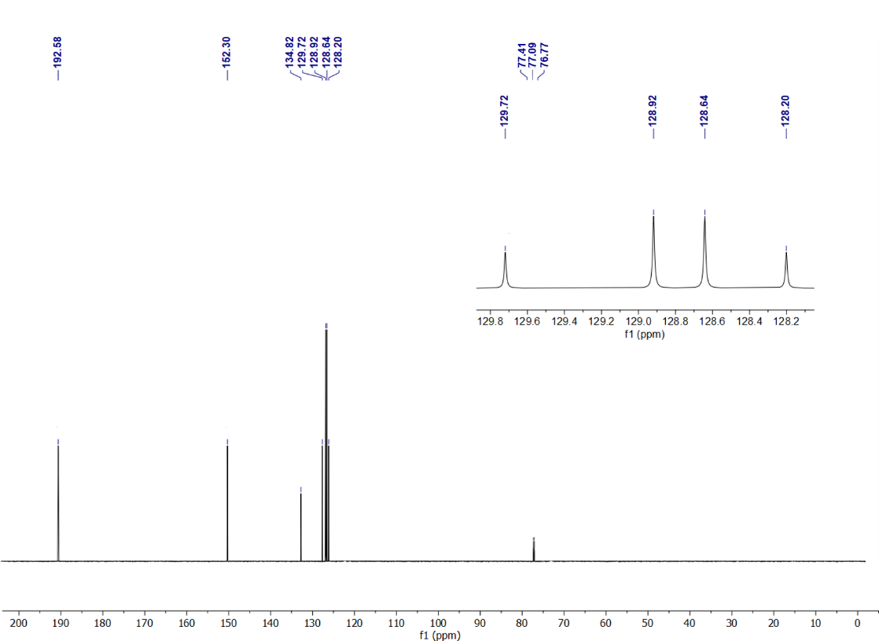

Figure 16b. ¹³C NMR spectrum (75 MHz, CDCl₃) of 3-Phenyl acrylaldehyde.

(E)-3-(4-Methoxyphenyl) acrylaldehyde (Table 5 entry 6) ^{[14]}
White solid; Mp= 172-173 °С (Lit. mp 171-174 °С); ¹H NMR (300 MHz, CDCl₃) δ_{H} (ppm)= 9.68 (d, 1H, J = 8.8 Hz, H¹), 7.51 (d, 2H, J = 8.8 Hz, ArH, H⁵, H⁹), 7.47 (d, 1H, J = 16.0 Hz, H³), 6.94 (d, 2H, J = 8.8 Hz, ArH, H⁶, H⁸), 6.60 (dd, 1H, J = 16.0 Hz, J = 8.8 Hz, H²), 3.80 (s, 3H, H¹⁰); ¹³C NMR (75 MHz, CDCl₃) δ_{C} (ppm)= 192.55 (C¹), 161.13 (C⁷), 152.69 (C³), 130.45 (C⁵, C⁹), 127.47 (C⁴), 126.73 (C²), 114.05 (C⁶, C⁸), 55.35 (C¹⁰).
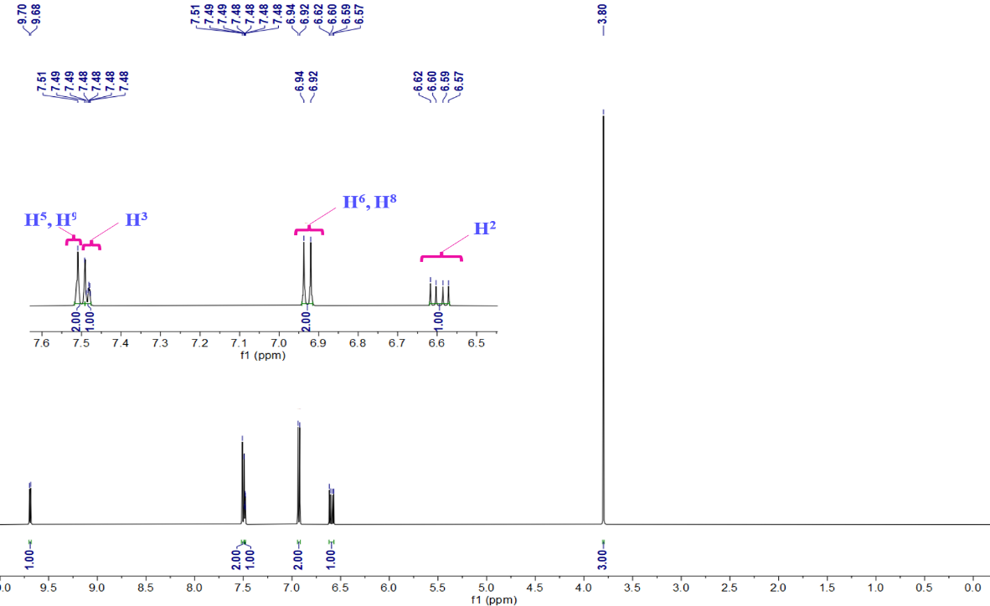

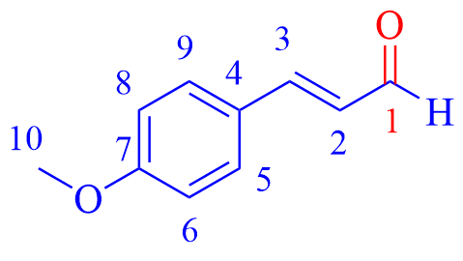

Figure 17a. ¹H NMR spectrum (300 MHz, CDCl₃) of (E)-3-(4-Methoxyphenyl) acrylaldehyde.

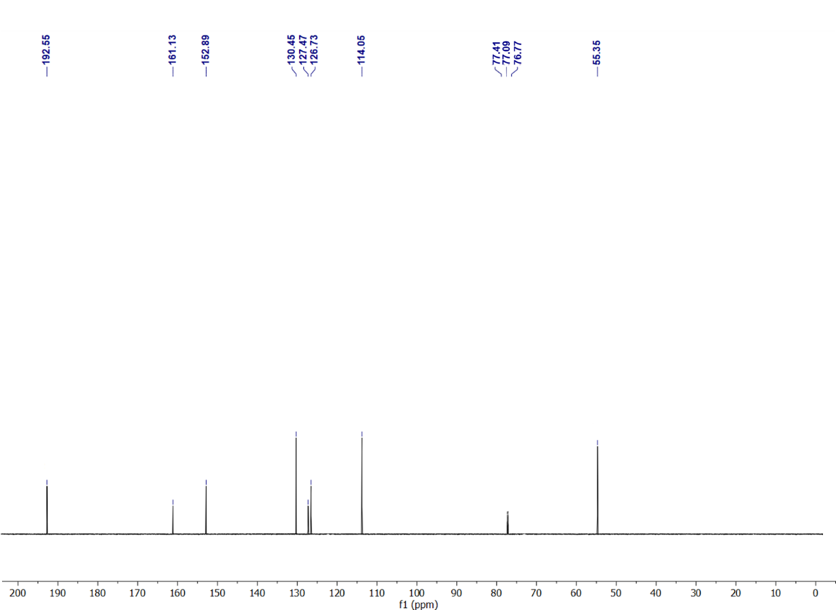

Figure 17b. ¹³C NMR spectrum (75 MHz, CDCl₃) of (E)-3-(4-Methoxyphenyl) acrylaldehyde.

Hex-1-en-3-one (Table 5 entry 7) ^{[15]}
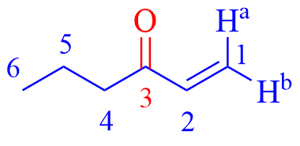
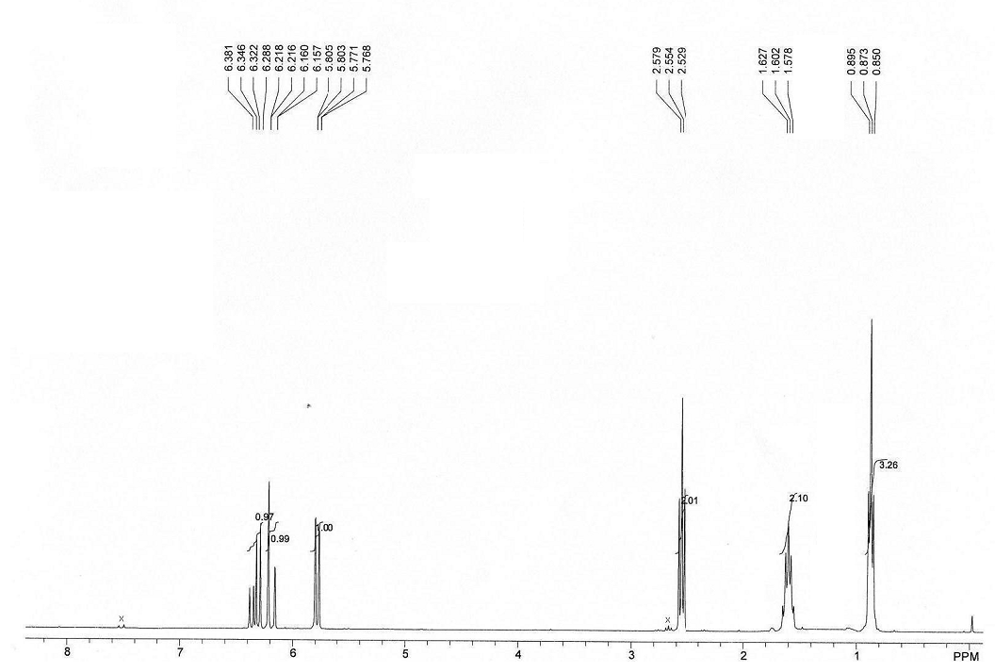
Colorless liquid; ¹H NMR (300 MHz, CDCl₃) δ_{H} (ppm)= 6.33 (dd, 1H, J = 17.6 Hz, J = 10.4 Hz, H²), 6.19 (dd, 1H, J = 17.6 Hz, J = 0.8 Hz, H^{1a}), 5.79 (dd, 1H, J = 10.4 Hz, J = 0.8 Hz, H^{1b}), 2.55 (t, 2H, J = 7.5 Hz, H⁴), 1.68-1.52 (m, 2H, H⁵), 0.87 (t, 3H, J = 6.8 Hz, H⁶); ¹³C NMR (75 MHz, CDCl₃) δ_{C} (ppm)= 201.06 (C³), 136.56 (C²), 127.77 (C¹), 39.55 (C⁴), 22.4 (C⁵), 13.84 (C⁶).
Figure 18a. ¹H NMR spectrum (300 MHz, CDCl₃) of Hex-1-en-3-one.

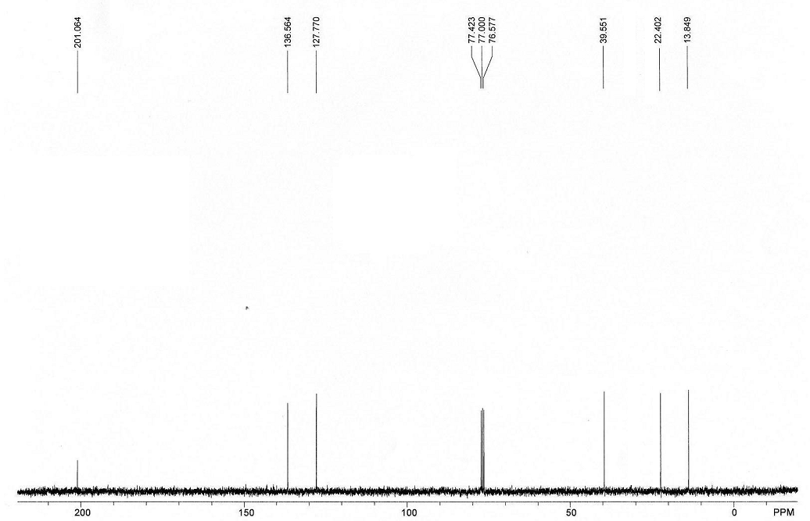
Figure 18b. ¹³C NMR spectrum (75 MHz, CDCl₃) of Hex-1-en-3-one.

References
[1] Hosseini S.M.; Ghiaci M.; Kulinich S.A.; Wunderlich W.; Ghaziaskar H.S.; Koupaei A.J. Ethyl Benzene Oxidation Under Aerobic Conditions Using Cobalt Oxide Imbedded in Nitrogen-Doped Carbon Fiber Felt Wrapped by Spiral TiO₂-SiO₂. Appl Catal. A: Gen. 2022, 630, 118456.
[2] Li P.; Wang Y.; Wang X.; Wang Y.; Liu Y.; Huang K.; Hu J.; Duan L.; Hu C.; Liu J. Selective Oxidation of Benzylic C-H bonds Catalyzed by Cu (II)/{PMo12}. J. Org. Chem. 2020, 85(5), 3101-3109.
[3] Cicco L.; Urselli S.; Favia C.; Perna F.M.; Vitale P.; Capriati V. Iron‐Based Deep Eutectic Solvents: Key Players for Amide and Sulfonamide Synthesis and Alcohol Oxidation. Eur. J. Org. Chem. 2024, 27(24), e202400300.
[4] Heijnen D.; Helbert H.; Luurtsema G.; Elsinga P.H.; Feringa B.L. Synthesis of Substituted Benzaldehydes via a Two-Step, One-Pot Reduction/Cross-Coupling Procedure. Org. Lett. 2019, 21(11), 4087-4091.
[5] Xie P.; Xue C.; Luo J.; Shi S.; Du D. Decatungstate-Mediated Solar Photooxidative Cleavage of C [double bond, length as m-dash] C Bonds Using Air as an Oxidant in Water. Green Chem. 2021, 23(16), 5936-5943.
[6] Li A.; Chen H.; Mi M.; Wang C.; Qi Y.; Liu Y. Synthesis of Aromatic Aldehydes via Silver(I)-Catalyzed Formylation of Aryl Bromides in DMF Promoted by Samarium Metal in Air. Synth. Commun. 2024, 54(13), 1060-1067.
[7] Xiang G.; Zhang L.; Yi C.; Liu Z. One-Pot Pyrolysis Method to Fabricate Co/N Co-Doped Hollow Mesoporous Spheres with Carbon/Silica Binary Shells for Selective Oxidation of Arylalkanes. Appl. Surf. Sci. 2022, 577, 151829.
[8] Yang X.; Guo Y.; Tong H.E.; Guo H.; Liu R.; Zhou R. Photochemical Hydrogen Atom Transfer Catalysis for Dehydrogenation of Alcohols to Form Carbonyls. Org. Lett. 2023, 25(29), 5486-5491.
[9] Qi X., Jiang L.B., Li H.P., Wu X.F. A Convenient Palladium‐Catalyzed Carbonylative Suzuki Coupling of Aryl Halides with Formic Acid as the Carbon Monoxide Source. Chem. Eur. J. 2015, 21(49), 17650-17656.
[10] Yusubov M.S., Soldatova N.S., Postnikov P.S., Valiev R.R., Yoshimura A., Wirth T., Nemykin V.N., Zhdankin V.V. 2-Iodoxybenzoic Acid Ditriflate: The Most Powerful Hypervalent Iodine (v) Oxidant. Chem. Commun. 2019, 55(54), 7760-7763.
[11] Katsina T.; Clavier L.; Giffard J.F.; Macedo Portela da Silva N.; Fournier J.; Tamion R.; Copin C.; Arseniyadis S.; Jean A. Scalable Aerobic Oxidation of Alcohols Using Catalytic DDQ/HNO₃. Org. Proc. Res. Dev. 2020, 24(5), 856-860.
[12] Lefarth J.; Griesbeck A.G. Photosensitized [2+2]-Cycloaddition of Complex Acceptor-Donor Combinations: A Regio/Diastereoselectivity Study. J. Org. Chem. 2022, 87(12), 8028-8033.
[13] Li J.; Duran C.; Pogrányi B.; Cornish K.A.; Cartwright J.; Osuna S.; Unsworth W.P.; Grogan G. Divergent Oxidation Reactions of E‐and Z‐Allylic Primary Alcohols by an Unspecific Peroxygenase. Angew. Chem. Int. Ed. 2025, 137(12), e202422241.
[14] Movassagh B.; Rezaei N. A Magnetic Porous Chitosan-Based Palladium Catalyst: A Green, Highly Efficient and Reusable Catalyst for Mizoroki-Heck Reaction in Aqueous Media. New J. Chem. 2015, 39(10), 7988-7997.
[15] Choudary B.M.; Prasad A.D.; Swapna V.; Valli V.L.; Bhuma V. Chromium Pillared Clay Catalysed Allylic Oxidation and Oxidative Deprotection of Allyl Ethers and Amines: A Simple and Convenient Procedure. Tetrahedron. 1992, 48(5), 953-962.

