Additional file 2
Supplementary Figures
The tumor microbiome is implicated in breast cancer prognosis
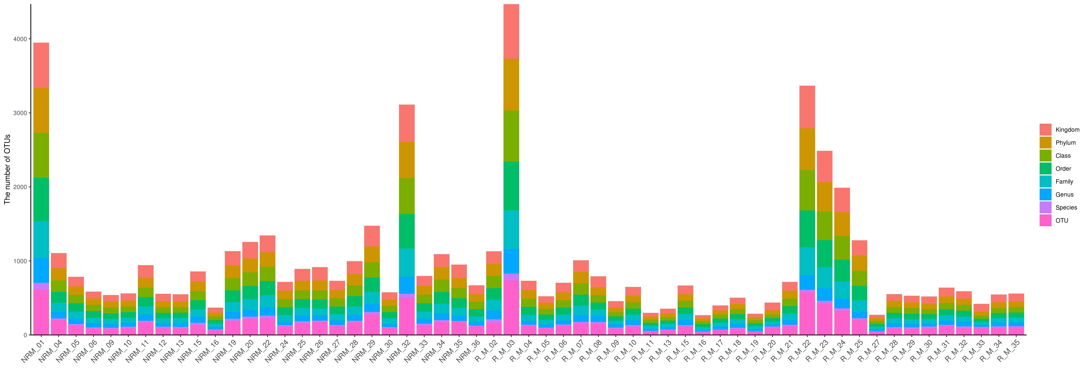
Figure S1, Number of operational taxonomic units (OTUs) in each sample.

a
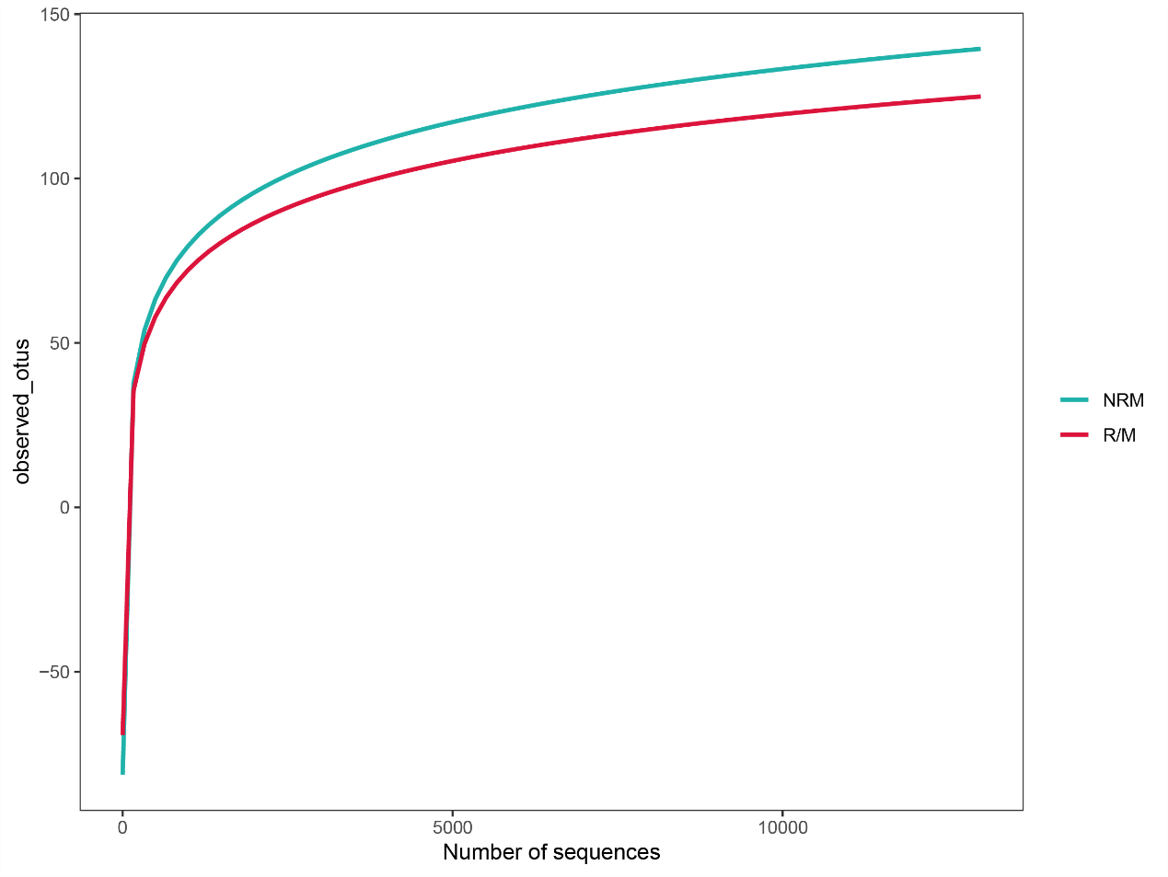
b
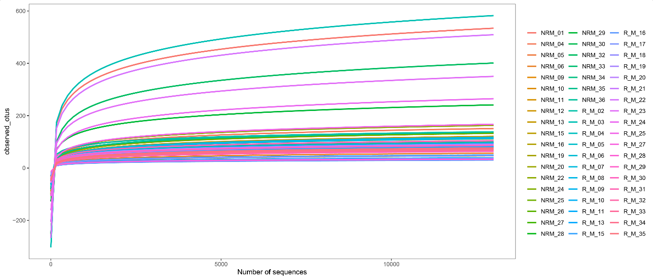
Figure S2, Rarefaction curve in observed_OTUs, (a) Rarefaction curve of patients experiencing no recurrence or metastasis (NRM) and patients experiencing recurrence or metastasis (R/M). (b) Rarefaction curve in observed_OTUs of all of the samples.
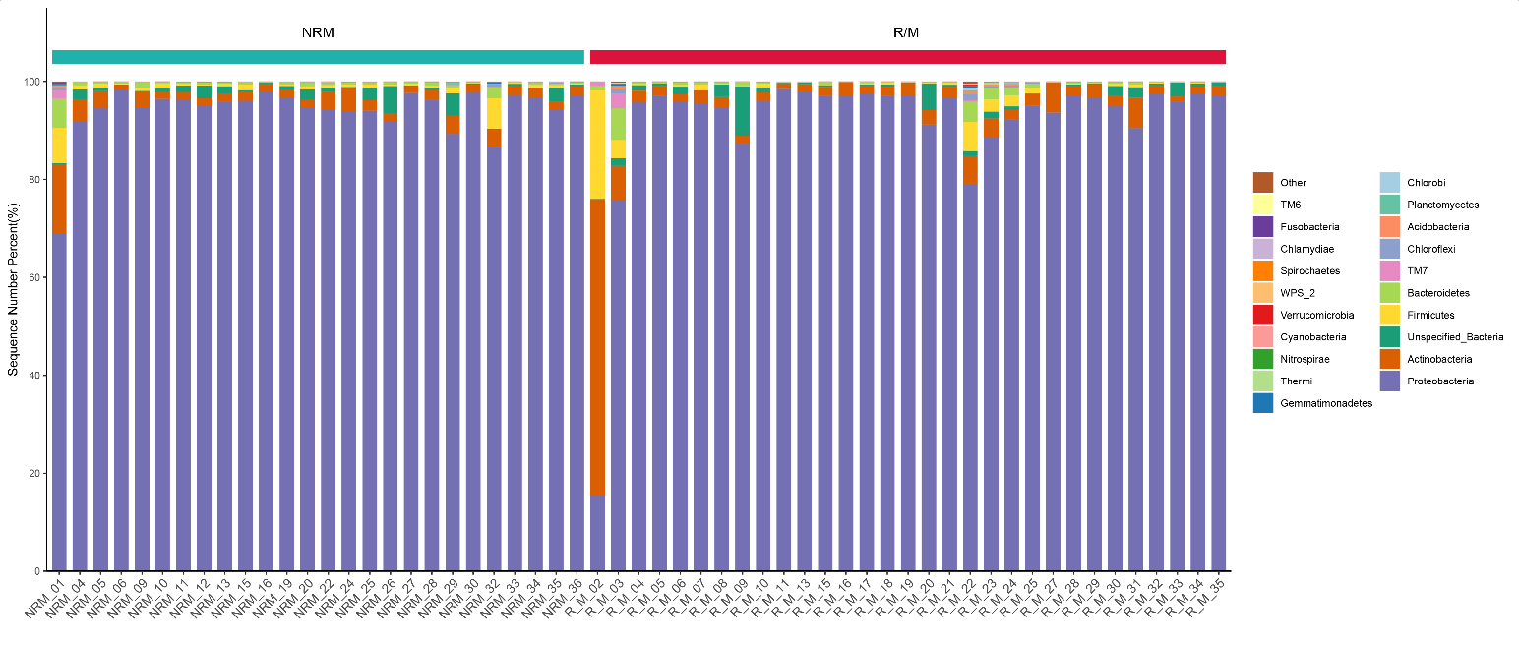
Figure S3, The top 20 most abundant bacteria in the two groups at the phylum level.
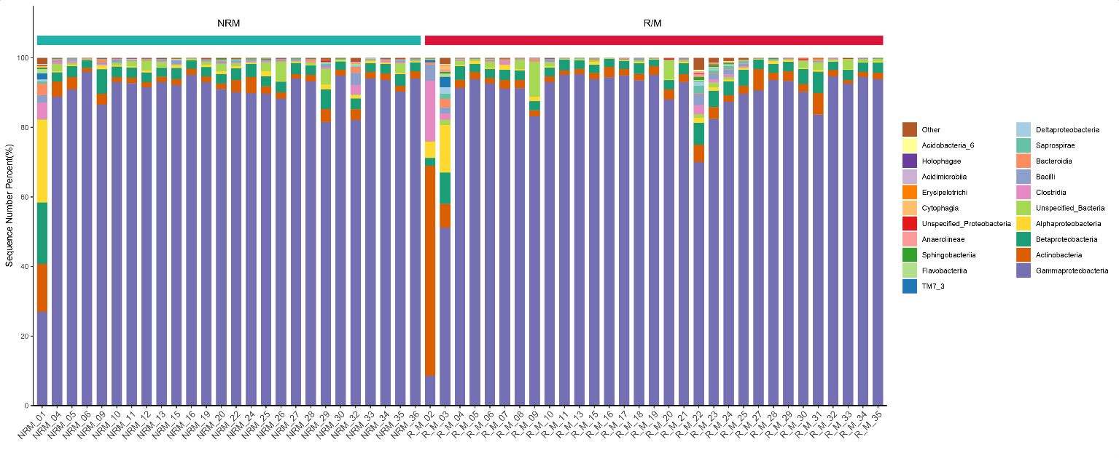
Figure S4, The top 20 most abundant bacteria in the two groups at the class level.

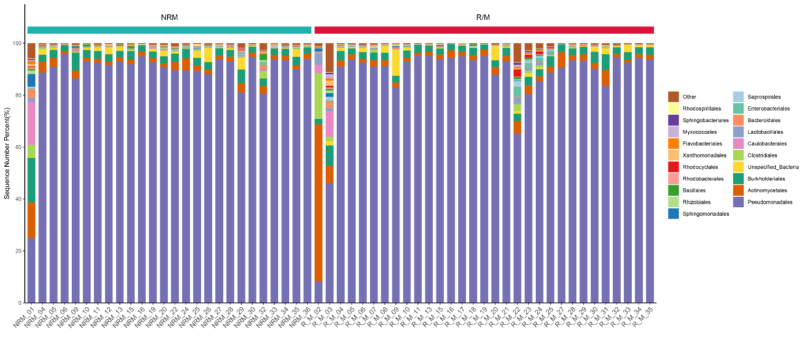
Figure S5, The top 20 most abundant bacteria in the two groups at the order level.

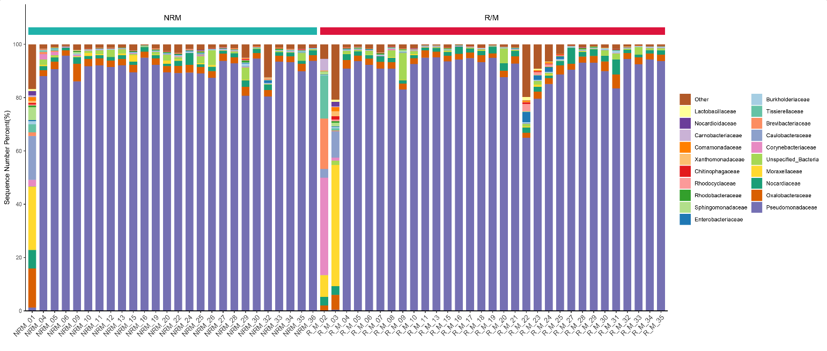
Figure S6, The top 20 most abundant bacteria in the two groups at the family level.

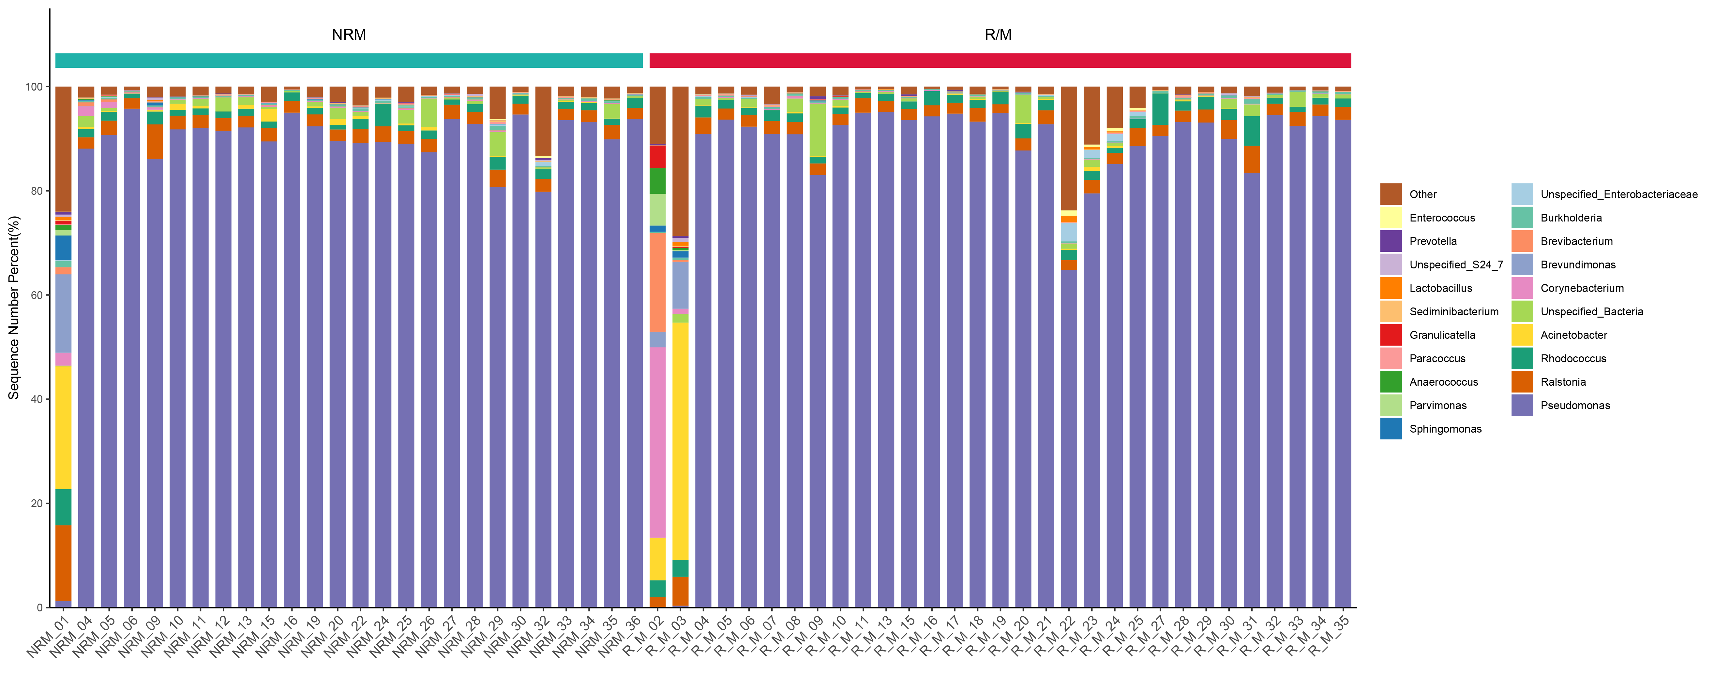

Figure S7, The top 20 most abundant bacteria in the two groups at the genus level.

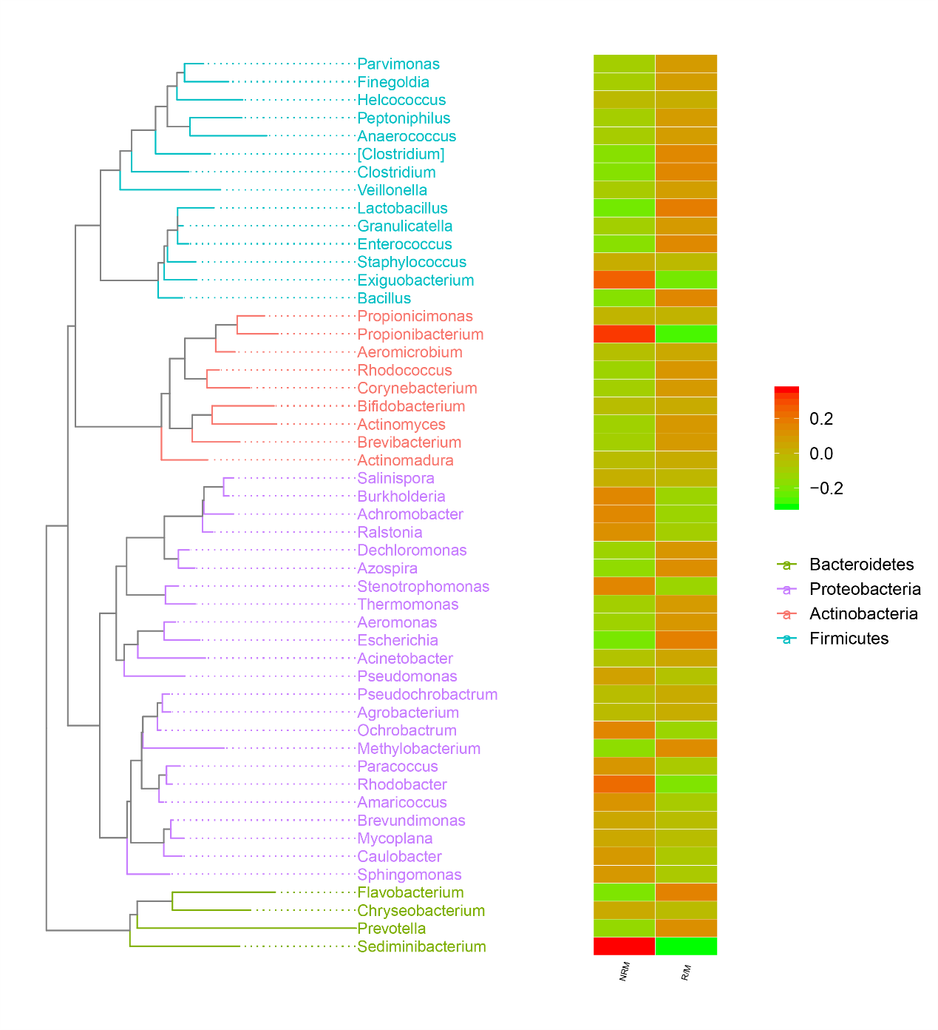
Figure S8, Phylogenetic tree were drawn with the two groups’ OTUs.

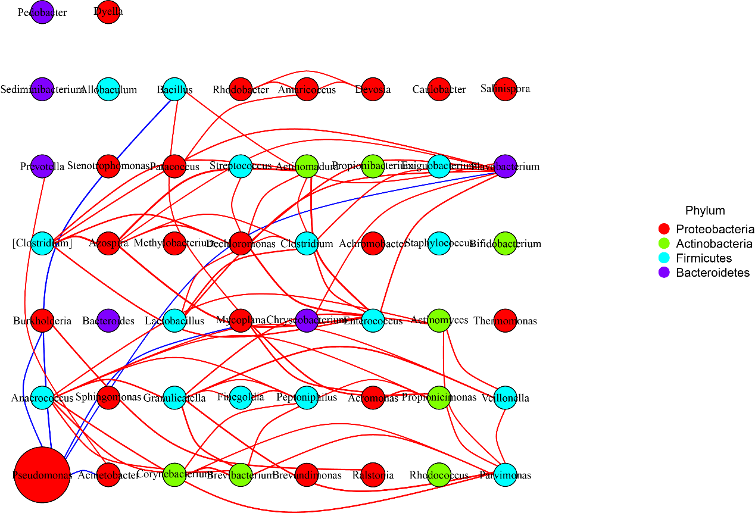
Figure S9, The map of bacterial network analysis. Each node represents one species, node size is proportional to mean relative abundance, different color represents different classification at phylum level, each line represents a significant positive (red) correlation or negative (blue) correlation.

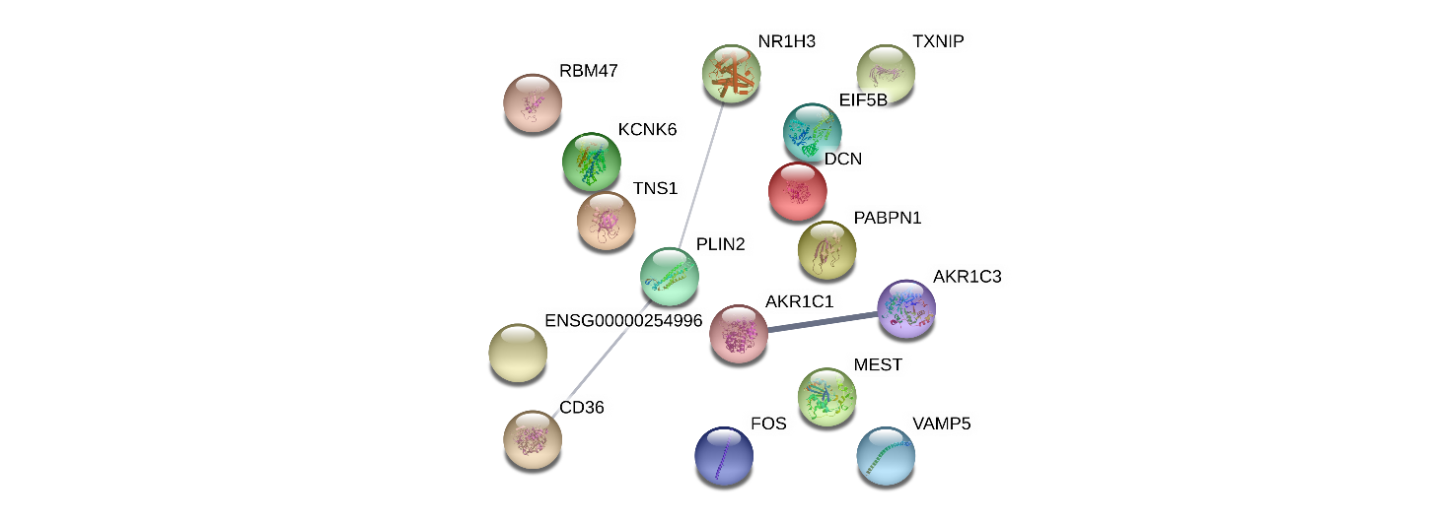

Figure S10, Protein-protein interaction (PPI) network for differentially expressed genes (DEGs). Each node represents one DEG, each line represents one interaction between DEGs, the thickness of the line reflects the strength of the interaction.
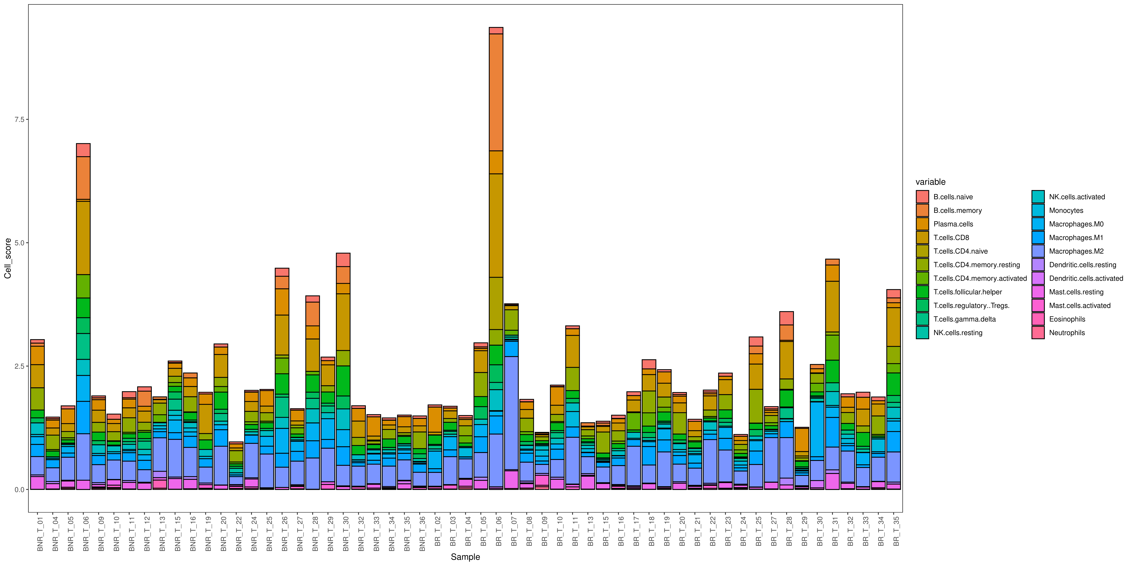
Figure S11, Fraction of 22 subpopulations of tumor-infiltrating immune cells.

