Supplementary material
A. The training curve of BGS-YOLOv8 is shown in Figure 6.
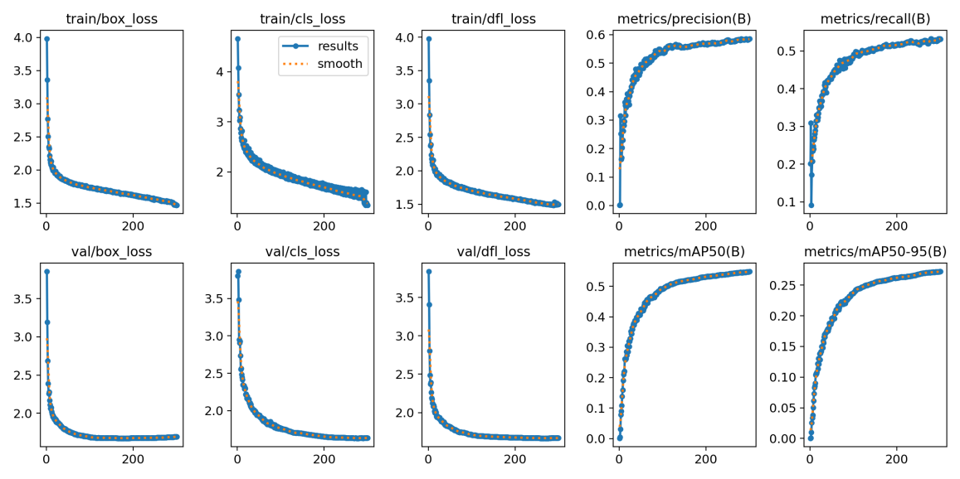
Figure 6 Curves of the model training process, including changes in loss function and evaluation metrics
B The training parameters used in this study are shown in Table 2.
Table 2 training parameters
Parameter Name | Setting
Image size | 640×640
Batch size | 4
Initial learning rate | 0.01
Training epochs | 300
Cosine annealing strategy | 0.01

