Suplementary Material
Supplementary Table S1: Immunophenotyping stains fluorochrome conjugated antibodies.
Marker | Fluorophore | Volume (uL) | Concentration | Isotype | Source
CD45 | eFluor450 | 0.34 | 1:150 | Rat IgG2b | eBioscience (48-0451-82)
CD11b | PE-Cy7 | 0.125 | 1:400 | Rat IgG2b | eBioscience (25-0112-81)
Ly6C | AF488 | 0.125 | 1:400 | Rat IgG2c | Biolegend (128022)
F4/80 | APC | 0.2 | 1:250 | Rat IgG2a | eBioscience (17-4801-82)
CD3 | AF700 | 0.2 | 1:250 | Rat IgG2b | eBioscience (56-0032-82)
Ly6G | AF700 | 0.1 | 1:500 | Rat IgG2a | eBioscience (56-5931-82)
CD4 | APCeFluor780 | 0.2 | 1:250 | Rat IgG2a | eBioscience (47-0042-82)
CD8 | AF488 | 0.2 | 1:250 | Rat IgG2a | eBioscience (53-0081-82)
CD19 | AF700 | 0.2 | 1:250 | Rat IgG2a | eBioscience (56-0193-82)
NK1.1 | AF700 | 0.2 | 1:250 | Mouse IgG2ak | eBioscience (56-5941-82)

Supplementary Table S2: Primer sequences used for real-time quantitative reverse transcriptase polymerase chain reaction (qRT-PCR).
Gene | Forward Primer (5'-3') | Reverse Primer (5'-3') | Accession Number
Ywhag | TGAAGAACGTGACCGAGCTGA | CGACAGGAGGTTCCGTTCC | NM_018871.3
B2m | CTCGGTGACCCTGGTCTTTC | TTGAGGGGTTTTCTGGATAGCA | NM_009735.3
Hprt | CAGTCCCAGCGTCGTGATTA | TCGAGCAAGTCTTTCAGTCCT | NM_013556.2
Tlr2 | ATGTCGTTCAAGGAGGTGCG | ATTTGACGCTTTGTCTGAGGTTT | NM_011905.3
Tlr4 | TCTGGGGAGGCACATCTTCT | TGCTCAGGATTCGAGGCTT | NM_021297.3
Ptafr | TCCTCCTACAGGCATATTCAGC | AATCCACACGAAAGGAGCCA | NM_001081211.2
Sftpa | GCAGTGTGATTGGGAGAAACC | TGTCCCATTGCACTTGATGC | NM_023134.5
Sftpb | CCAGAGCCAGATTAACCCCAA | AGAGGGTTTGGAACGGCATC | NM_147779.2
Sftpc | CTAGCATCCACAGGGTCGGT | GCCCGTAGGAGAGACACCTT | NM_011359.2
Pcyt1a | TCAAGGACGCAGGCATGTTT | CCCCTCTGTAGGTTCCGTCT | NM_001163159.1

Supplementary Table S3: Maternal excess adiposity is associated with changes in neonatal (P7) offspring parameters.
Parameters | Male |  |  | Female
Parameters | CTL | mHF |  | CTL | mHF | Statistical outcomes
Lee Index | 35.72 ± 0.27 | 38.96 ± 2.37 |  | 35.96 ± 0.52 | 37.27 ± 0.65 | DxS^{ns} / D* / S^{ns}
Glucose (mmol/L) | 7.28 ± 0.43 | 6.59 ± 0.42 |  | 7.23 ± 0.38 | 6.81 ± 0.36 | DxS^{ns} / D^{ns} / S^{ns}
Liver (mg) | 95.91 ± 3.50 | 98.48 ± 4.40 |  | 96.19 ± 4.22 | 86.72 ± 10.35 | DxS^{ns} / D^{ns} / S^{ns}
Heart (mg) | 18.59 ± 2.60 | 27.289 ± 1.64 |  | 24.079 ± 1.39 | 24.379 ± 1.04 | DxS*/ D*/ S^{ns}
Lung (mg) | 73.9 ± 4.00 | 79.34 ± 4.49 |  | 75.34 ± 5.06 | 77.87 ± 5.25 | DxS^{ns} / D^{ns} / S^{ns}
Spleen (mg) | 17.77 ± 0.47 | 14.48 ± 0.96 |  | 17.54 ± 0.96 | 14.64 ± 0.75 | DxS^{ns} / D*** / S^{ns}
Thymus (mg) | 22.97 ± 4.32 | 21.43 ± 6.18 |  | 16.68 ± 3.14 | 19.55 ± 4.41 | DxS^{ns} / D^{ns} / S^{ns}
Total Intestine (cm) | 14.2± 0.328 | 12.83± 0.372 |  | 14.33± 0.277 | 13.02± 0.315 | DxS^{ns} / D*** / S^{ns}
Small Intestine (cm) | 11.84± 0.318 | 10.81± 0.346 |  | 12.07± 0.285 | 11.01± 0.293 | DxS^{ns} / D** / S^{ns}
Colon (cm) | 2.36± 0.079 | 2.01± 0.082 |  | 2.24± 0.091 | 2.01± 0.067 | DxS^{ns} / D*** / S^{ns}
Cecum (mg) | 24.73 ± 4.37 | 16.02 ± 3.28 |  | 16.68 ± 3.14 | 19.55 ± 4.41 | DxS^{ns} / D^{ns} / S ^{ns}
Data are expressed as Mean ± SEM. CTL-M (n=10-19) mHF-M (n= 9-20), CTL-F (n=9-22), and mHF-F (9-22). Interaction between diet and sex factors (DxS); diet factor (D), and sex factor (S); *p < 0.05, **p < 0.01, ***p < 0.001, ****p < 0.0001, and non-significant (ns).

Supplementary Table S4: Maternal excess adiposity is associated with changes in adult mice offspring before pneumonia infection (P90).
Parameters | Male |  |  | Female |  | Statistical outcomes
Parameters | CTL | mHF |  | CTL | mHF | Statistical outcomes
Mesenteric Fat Mass (g) | 0.29 ± 0.03 | 0.36 ± 0.01 |  | 0.22 ± 0.01 | 0.29 ± 0.02 | DxS^{ns} / D* / S*
Liver Mass (g) | 1.34 ± 0.02 | 1.04 ± 0.14 |  | 0.97 ± 0.04 | 0.88 ± 0.04 | DxS^{ns} / D* / S**
Pancreas Mass (g) | 0.14 ± 0.01 | 0.18 ± 0.01 |  | 0.11 ± 0.01 | 0.1301 ± 0.01 | DxS^{ns} / D^{ns} / S**
Total Intestine (cm) | 44.74 ± 0.53 | 45.44 ± 1.30 |  | 44.36 ± 0.92 | 44.00 ± 0.77 | DxS^{ns} / D^{ns}/ S^{ns}
Small Intestine (cm) | 36.93 ± 0.32 | 38.01 ± 1.25 |  | 37.06 ± 0.86 | 36.77 ± 0.66 | DxS^{ns} / D^{ns}/ S^{ns}
Colon (cm) | 6.81 ± 0.37 | 7.12 ± 0.08 |  | 6.86 ± 0.25 | 6.5 ±0.35 | DxS^{ns} / D^{ns}/ S^{ns}
Cecum (g) | 0.54 ± 0.02 | 0.55 ± 0.01 |  | 0.43 ± 0.02 | 0.45 ± 0.02 | DxS^{ns} / D^{ns}/ S**
Data are expressed as Mean ± SEM. CTL-M (n=8–15) mHF-M (n= 7-8), CTL-F (n=8-14), and mHF-F (8-22). Interaction between diet and sex factors (DxS); diet factor (D), and Sex factor (S); *p<0.05, **p<0.01, ***p<0.001, ****p<0.0001 and non-significant (ns).

Supplementary Table S5: Maternal excess adiposity is associated with changes in adult mice offspring 30 days post pneumonia infection.
Parameters | Male – pre-infection |  |  | Male -30 days post-infection |  | Statistical outcomes
Parameters | CTL | mHF |  | CTL | mHF | Statistical outcomes
Mesenteric Fat Mass (g) | 0.29 ± 0.03 | 0.36 ± 0.01 |  | 0.40 ± 0.04 | 0.45 ± 0.02 | DxI^{ns} / D^{ns} / I**
Liver Mass (g) | 1.34 ± 0.02 | 1.04 ± 0.14 |  | 1.43 ± 0.07 | 1.18 ± 0.08 | DxI^{ns} / D* / I^{ns}
Pancreas Mass (g) | 0.14 ± 0.01 | 0.18 ± 0.01 |  | 0.18 ± 0.01 | 0.2 ± 0.02 | DxI^{ns} / D^{ns} / I^{ns}
Total Intestine (cm) | 44.74 ± 0.53 | 45.44 ± 1.30 |  | 45.86 ± 0.70 | 45.44 ± 0.74 | DxI^{ns} / D^{ns}/ I^{ns}
Small Intestine (cm) | 36.93 ± 0.32 | 38.01 ± 1.25 |  | 45.86 ± 0.70 | 45.44 ± 0.74 | DxI^{ns} / D^{ns}/ I****
Colon (cm) | 6.81 ± 0.37 | 7.12 ± 0.08 |  | 7.21 ± 0.15 | 7.49 ± 0.26 | DxI^{ns} / D^{ns}/ I^{ns}
Cecum (g) | 0.54 ± 0.02 | 0.55 ± 0.01 |  | 0.65 ± 0.02 | 0.65 ± 0.02 | DxI^{ns} / D^{ns}/ I**
 | Female – pre-infection |  | Female -30 days post-infection
Mesenteric Fat Mass (g) | 0.22 ± 0.01 | 0.29 ± 0.02 |  | 0.27 ± 0.01 | 0.35 ± 0.02 | DxI^{ns} / D* / I*
Liver Mass (g) | 0.97 ± 0.04 | 0.88 ± 0.04 |  | 1.34 ± 0.02 | 1.01 ± 0.05 | DxI^{ns} / D^{ns} / I*
Pancreas Mass (g) | 0.11 ± 0.01 | 0.1301 ± 0.01 |  | 0.15 ± 0.01 | 0.18 ± 0.02 | DxI^{ns} / D^{ns} / I*
Total Intestine (cm) | 44.36 ± 0.92 | 44.00 ± 0.77 |  | 43.73 ± 0.77 | 44.13 ± 0.53 | DxI^{ns} / D^{ns} / I*
Small Intestine (cm) | 37.06 ± 0.86 | 36.77 ± 0.66 |  | 37.04 ± 0.69 | 37.17 ± 0.45 | DxI^{ns} / D^{ns} / I^{ns}
Colon (cm) | 6.86 ± 0.25 | 6.5 ±0.35 |  | 6.55 ±0.21 | 6.83 ±0.13 | DxI^{ns} / D^{ns} / I^{ns}
Cecum (g) | 0.43 ± 0.02 | 0.45 ± 0.02 |  | 0.52 ± 0.013 | 0.53 ± 0.03 | DxI^{ns} / D^{ns} / I^{ns}
Data are expressed as Mean ± SEM. CTL-M (n=8–15), mHF-M (n= 7-8), CTL-F (n=8-14), and mHF-F (8-22). Interaction between diet and infection factors (DxI); diet factor (D), and infection factor (I); *p < 0.05, **p < 0.01, ***p < 0.001, ****p < 0.0001, and non-significant (ns).
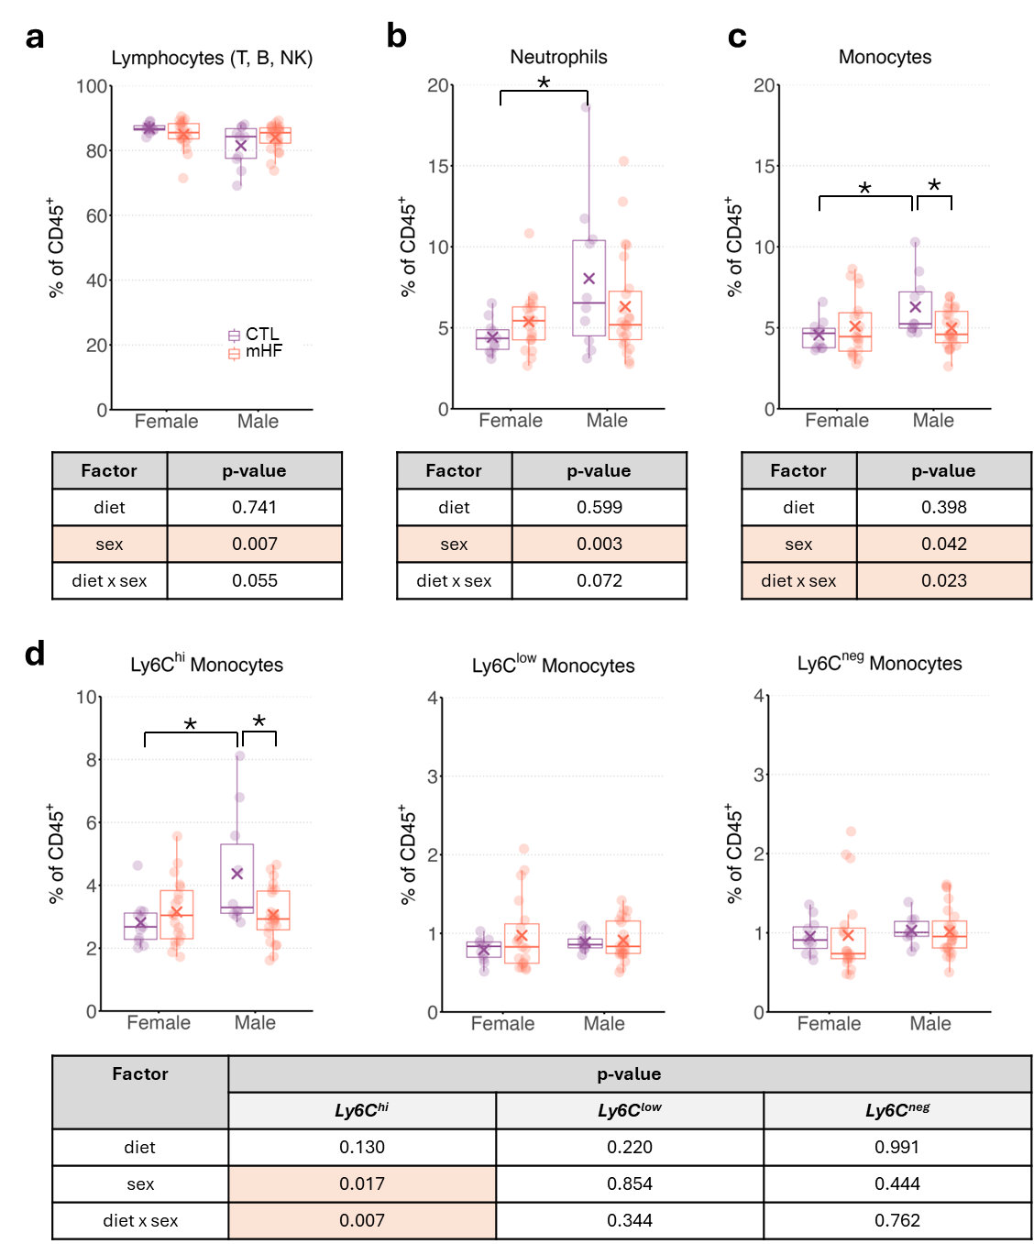
Supplementary Figure S1. Lineage/subpopulation frequencies of circulating immune cells pre-infection. Flow cytometry analysis of a), lymphocyte b) neutrophil and c) monocyte frequencies (% of total CD45⁺ cells) in female (F) and male (M) offspring from dams fed either a control (CTL) or a maternal high-fat (mHF) diet. d) Subsets of monocytes, including Ly6C^{hi}, Ly6C^{low}, and Ly6C^{neg}, were quantified as percentages of total CD45⁺ cells. Boxplots represent the median and interquartile range, with individual data points overlaid. Different letters indicate statistically significant differences (p < 0.05). The tables summarize p-values from statistical analyses assessing the effects of diet, sex, and their interaction (diet × sex), with statistically significant values (p < 0.05) highlighted.

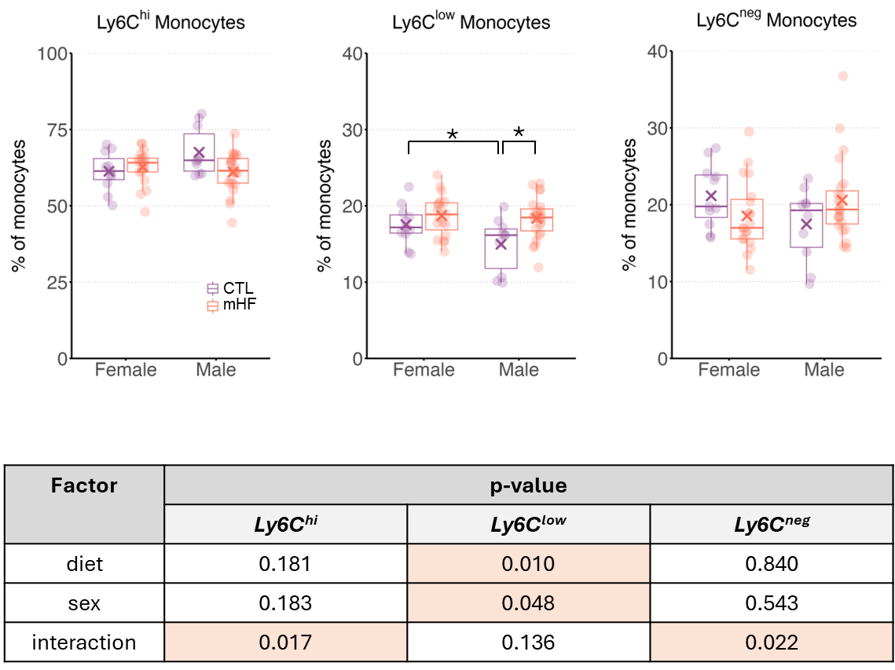
Supplementary Figure S2. Subpopulation frequencies of circulating monocytes pre-infection. Flow cytometry analysis of monocyte subsets, including Ly6C^{hi}, Ly6C^{low}, and Ly6C^{neg}, as percentages of total monocytes in female (F) and male (M) offspring from dams fed either a control (CTL) or a maternal high-fat (mHF) diet. Boxplots represent the median and interquartile range, with individual data points overlaid. Different letters indicate statistically significant differences (p < 0.05). The table summarizes p-values from statistical analyses assessing the effects of diet, sex, and their interaction (diet × sex), with statistically significant values (p < 0.05) highlighted.

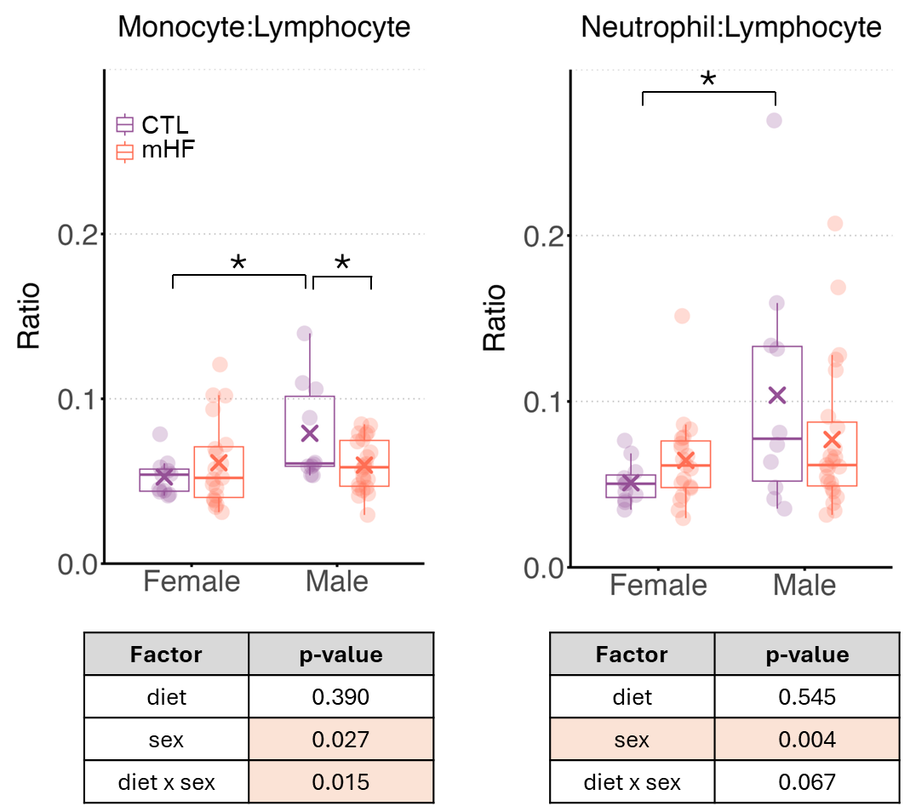
Supplementary Figure S3. Lineage ratios of circulating leukocytes pre-infection. Flow cytometry analysis of monocyte-to-lymphocyte and neutrophil-to-lymphocyte ratios in female (F) and male (M) offspring from dams fed either a control (CTL) or a maternal high-fat (mHF) diet. Boxplots represent the median and interquartile range, with individual data points overlaid. Different letters indicate statistically significant differences (p < 0.05). The table summarizes p-values from statistical analyses assessing the effects of diet, sex, and their interaction (diet × sex), with statistically significant values (p < 0.05) highlighted.

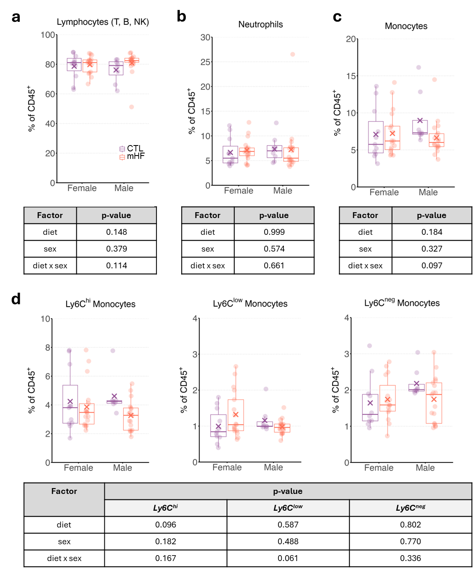
Supplementary Figure S4. Lineage and subpopulation frequencies of circulating leukocytes 30 days post-infection. Flow cytometry analysis of a) lymphocytes (T, B, NK cells) b) neutrophils, c) monocytes, d) monocyte, and in female (F) and male (M) offspring from dams fed either a control (CTL) or a maternal high-fat (mHF) diet. Boxplots represent the median and interquartile range, with individual data points overlaid. The tables summarize p-values from statistical analyses assessing the effects of diet, sex, and their interaction (diet × sex).
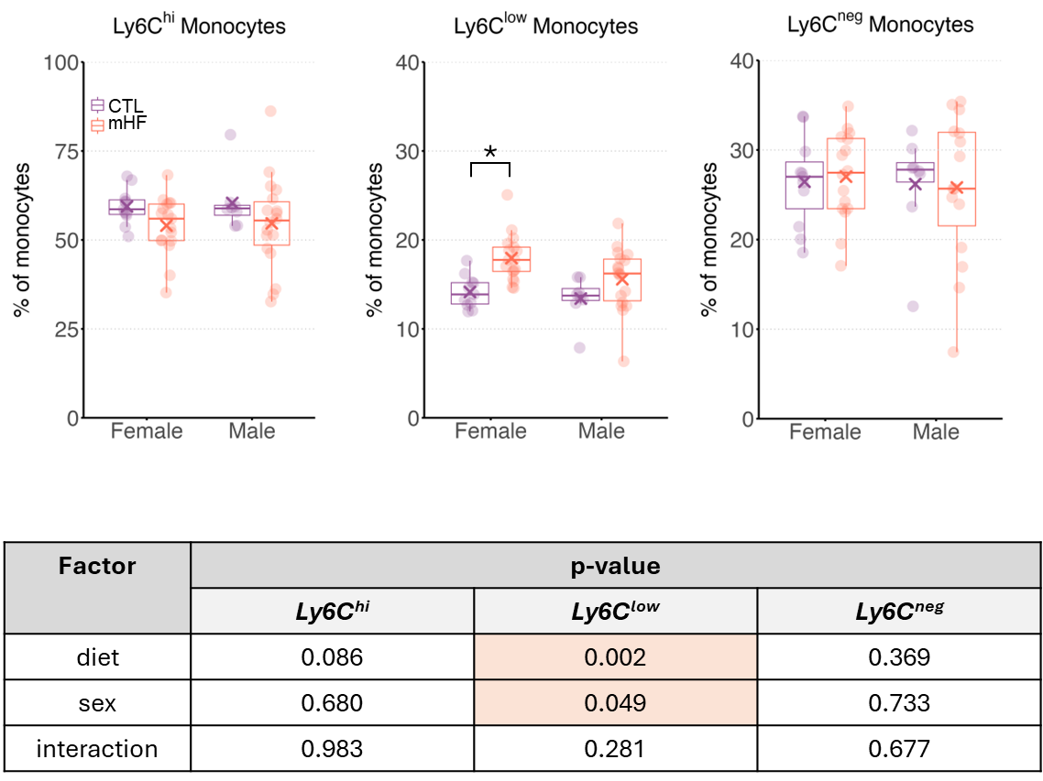
Supplementary Figure S5. Monocyte subpopulation frequencies 30 days post-infection.
Flow cytometry analysis of monocyte subsets, including Ly6C^{hi} (classical monocytes), Ly6C^{low} (intermediate monocytes), and Ly6C^{neg} (non-classical monocytes) in female (F) and male (M) offspring from dams fed either a control (CTL) or a maternal high-fat (mHF) diet. Boxplots represent the median and interquartile range, with individual data points overlaid. The table summarizes p-values from statistical analyses assessing the effects of diet, sex, and their interaction (diet × sex).

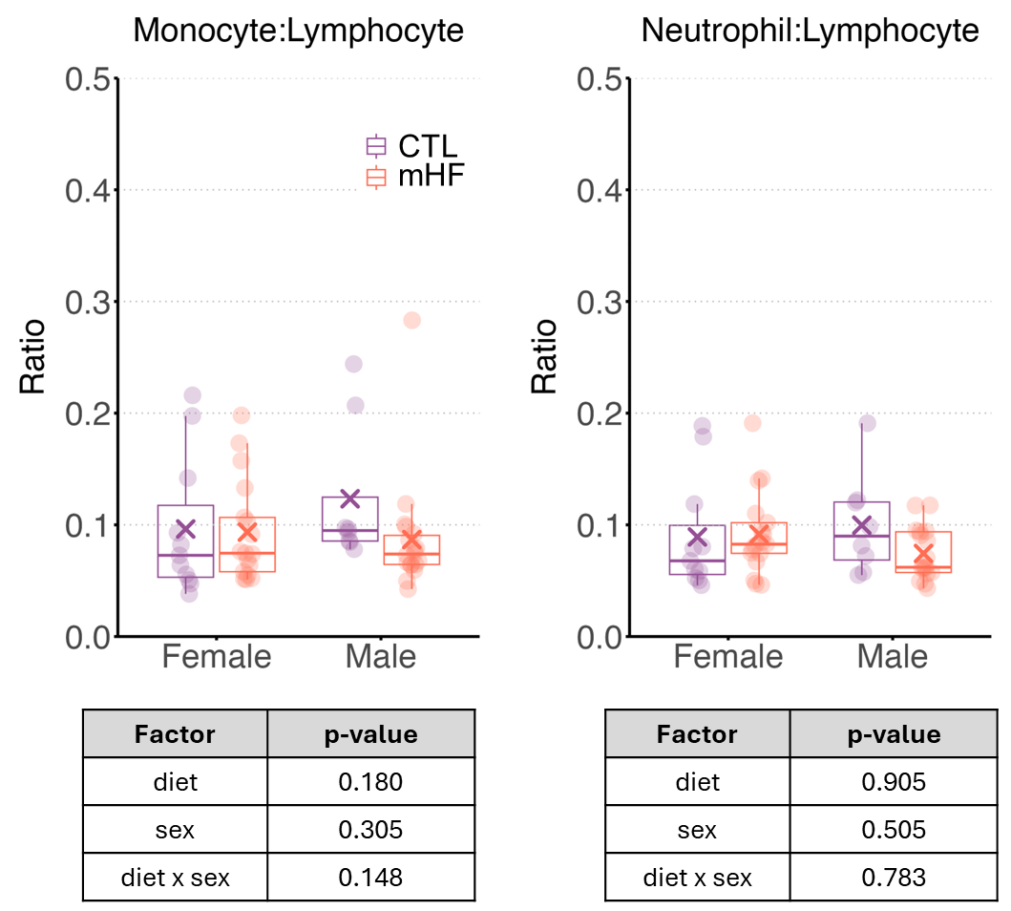
Supplementary Figure S6. Lineage ratios 30 days post-infection. Flow cytometry analysis of immune cell lineage ratios, including monocyte:lymphocyte and neutrophil:lymphocyte ratios in female (F) and male (M) offspring from dams fed either a control (CTL) or a maternal high-fat (mHF) diet. Boxplots represent the median and interquartile range, with individual data points overlaid. The table summarizes p-values from statistical analyses assessing the effects of diet, sex, and their interaction (diet × sex).

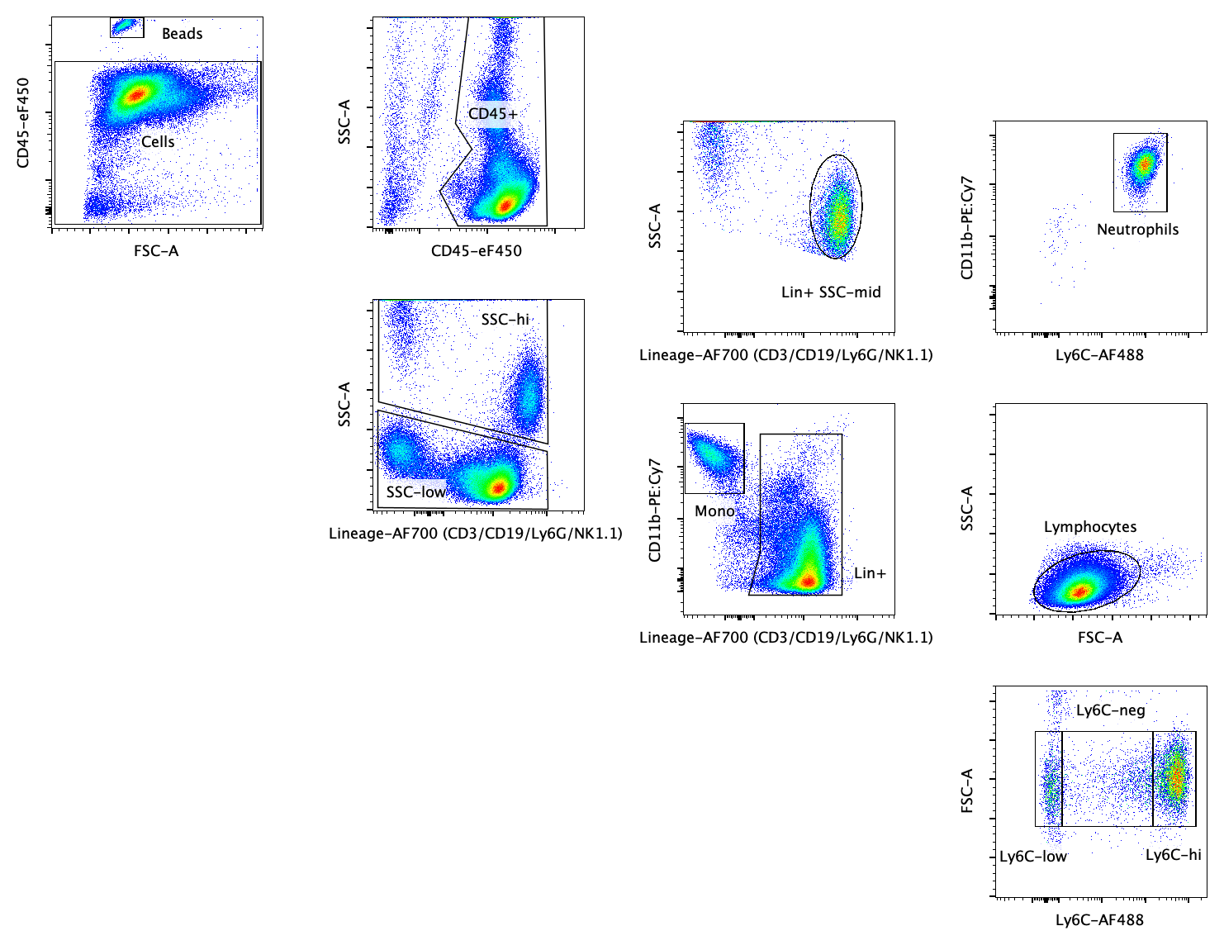
Supplementary Figure S7. Representative gating strategy for flow cytometry analysis of immune cell populations pre- and post-infection. Flow cytometry gating strategy used to identify immune cell subsets from samples collected before (Pre-Infection) and 30 days after pneumonia infection (Post-infection). Cells were first gated based on forward and side scatter (FSC-A vs. SSC-A) to exclude debris and identify beads. CD45+ leukocytes were then selected, followed by further gating to distinguish neutrophils (CD11b+Ly6G+), monocytes (CD11b+Ly6G−, further classified into Ly6C^{hi}, Ly6C^{low}, and Ly6C^{neg} subsets), and lymphocytes. This gating strategy ensures the accurate identification and quantification of immune cell populations in response to infection and diet conditions.

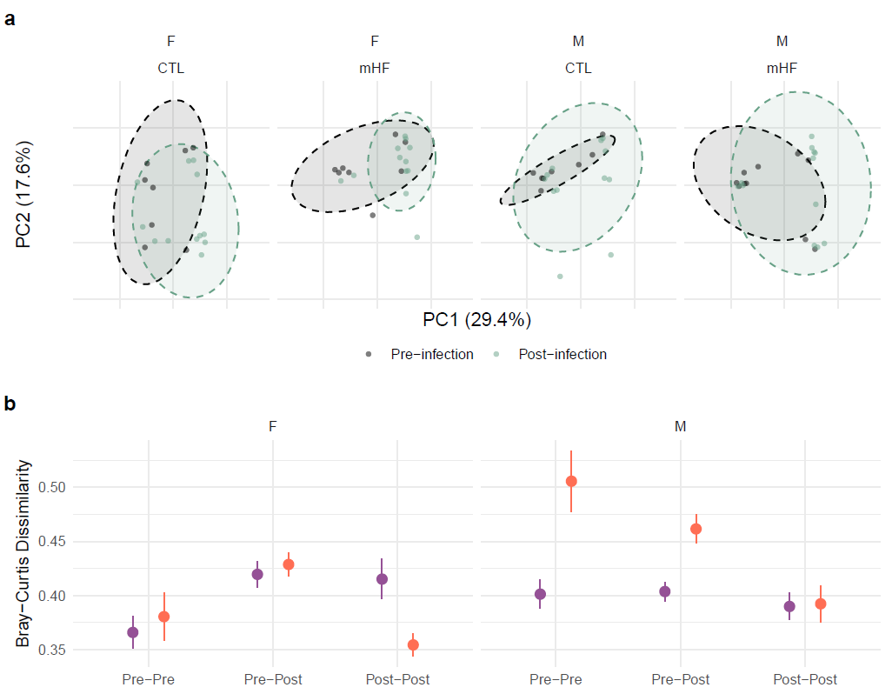
Supplementary Figure S8. Effects of maternal high-fat diet and pneumonia infection on cecal microbial community composition. a) Principal Coordinates Analysis (PCoA) based on Bray-Curtis dissimilarity of cecal microbial communities from female (F) and male (M) offspring of control, c) or maternal high-fat diet (mHF) dams, collected at P90 (pre-) and P120 (30 days post-infection). Ellipses represent 90% confidence intervals. b) Pairwise Bray-Curtis dissimilarity comparing samples within and across infection timepoints (Pre-Pre, Pre-Post, Post-Post) by maternal diet and offspring sex (mean ± SE).
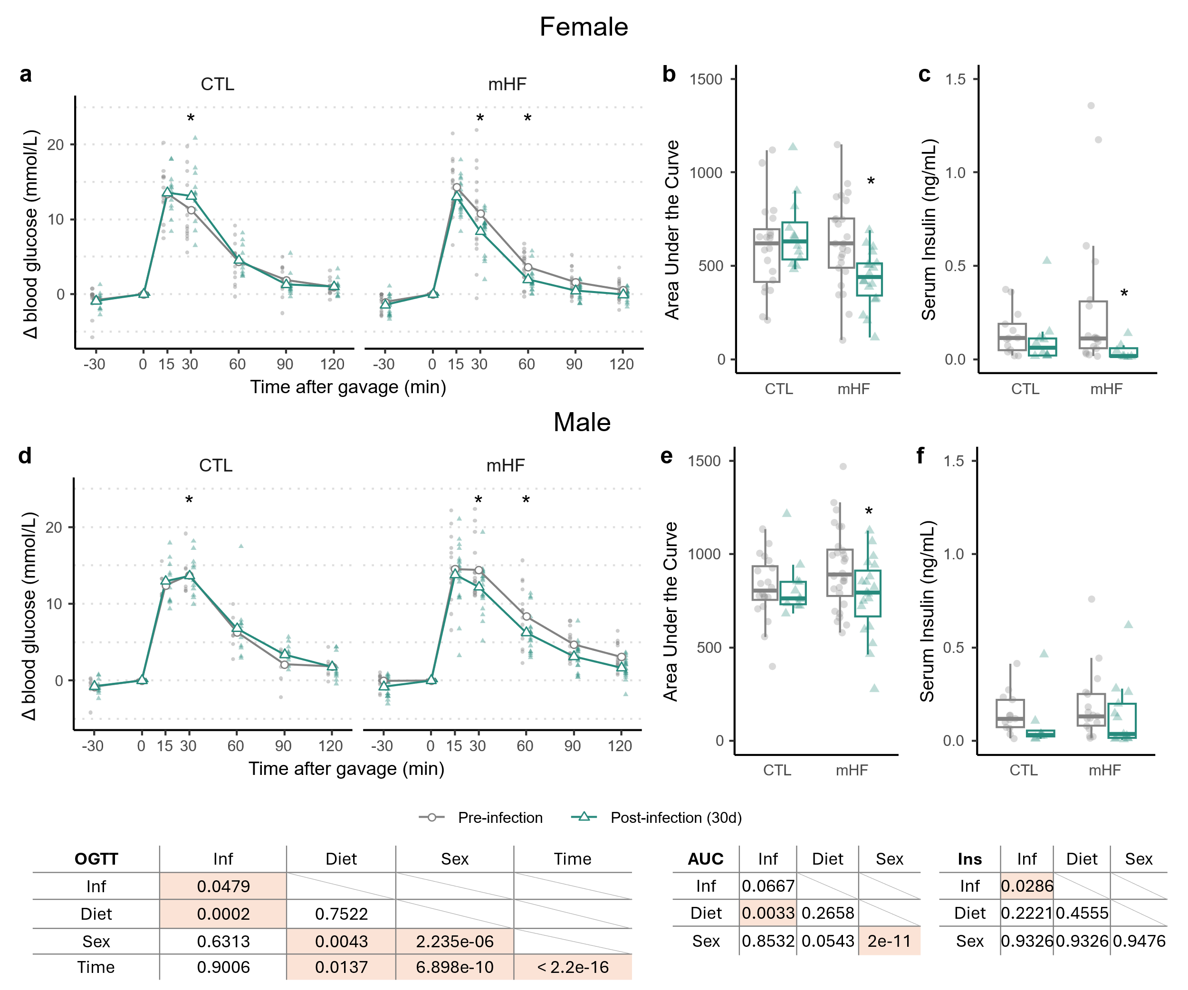Supplementary Figure S9. Oral Glucose Tolerance Test (OGTT) results in male and female mice. Change in blood glucose levels (Δ blood glucose, from 0) over time following glucose gavage in female (top) and male (bottom) offspring from dams fed either a control (CTL) or high-fat (mHF) diet (a,d). Data are represented as individual datapoints (closed circles and triangles) and means (open circle and triangles), with pre-infection in grey circles and 30 days post-infection in green triangles. b) Area under the curve (AUC) for glucose response in female (top) and male (bottom) mice, comparing CTL and mHF groups. c) Serum insulin (ng/mL) in female (top) and male (bottom) mice across CTL and mHF groups. AUC and insulin data are represented as box plots displaying median, interquartile range, and individual data points. Tables summarize main and interaction effects assessing the effects of infection (Inf), diet, sex, and time on OGTT glucose response (left), AUC (middle), and insulin levels (right), with p<0.05 highlighted. Asterisks (*) denote post-hoc differences compared to pre-infection (p<0.05) within diet, sex, and time groups, where applicable.
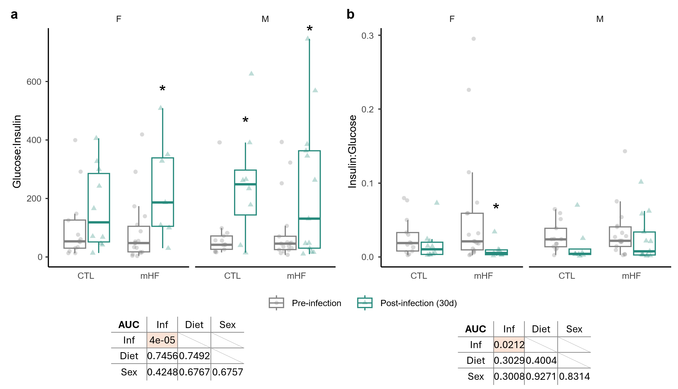
Supplementary Figure S10. Effects of maternal high-fat (mHF) diet and infection on glucose-insulin homeostasis in male and female offspring. a) Glucose-to-insulin ration, and b) insulin-to-glucose ratio in female (F) and male (M) offspring from dams fed either a control (CTL) or high fat diet (mHF) collected either pre-infection (gray circles) or 30 days post-infection (green triangles). Data are represented as box plots displaying median, interquartile range, and individual data points. Tables summarize main and interaction effect p-values from statistical analyses evaluating the effects of infection (Inf), diet, and sex, where p<0.05 are highlighted.

