Supplementary Information
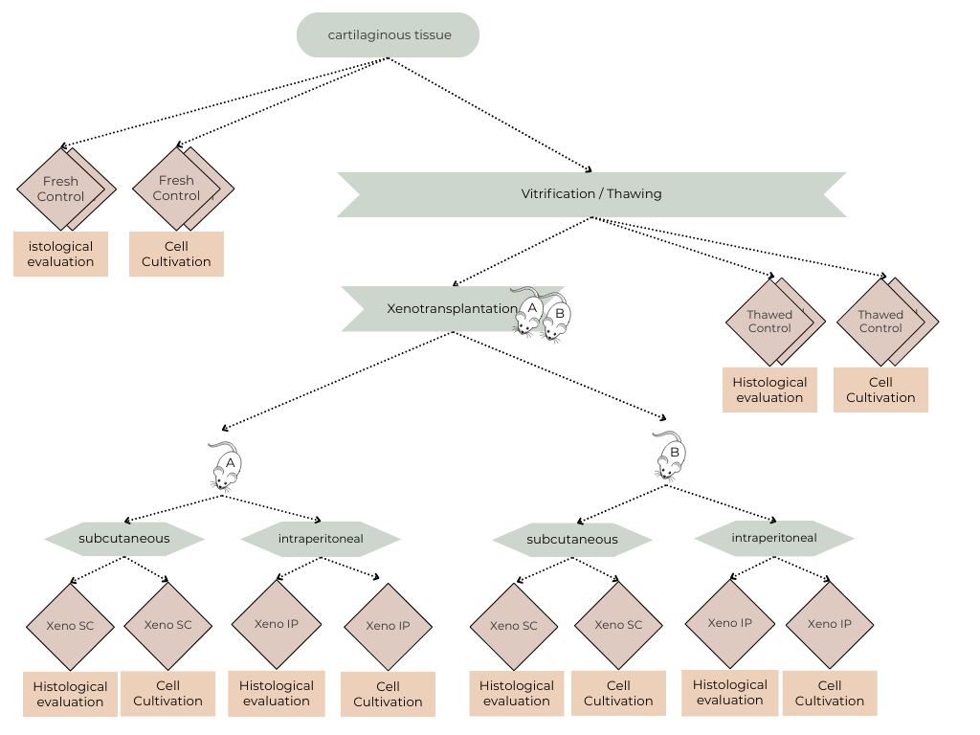
Schematic representation of the ear tissue processing workflow for each animal.

