Supplementary ROC curves and survival analysis curves for integration based machine learning algorithms
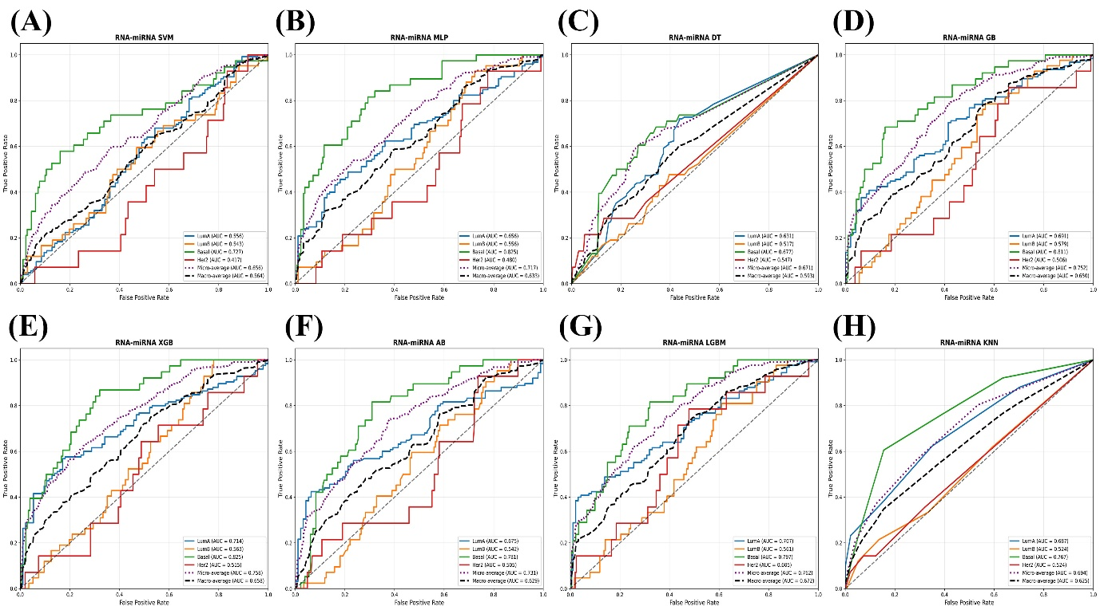
Fig. SF1: Supplementary ROC curves for RNA‑miRNA‑based machine learning algorithms: AUROC curves for the remaining eight classifiers (SVM, MLP, DT, GB, XGB, AB, LGBM, KNN) using RNA-miRNA integration.
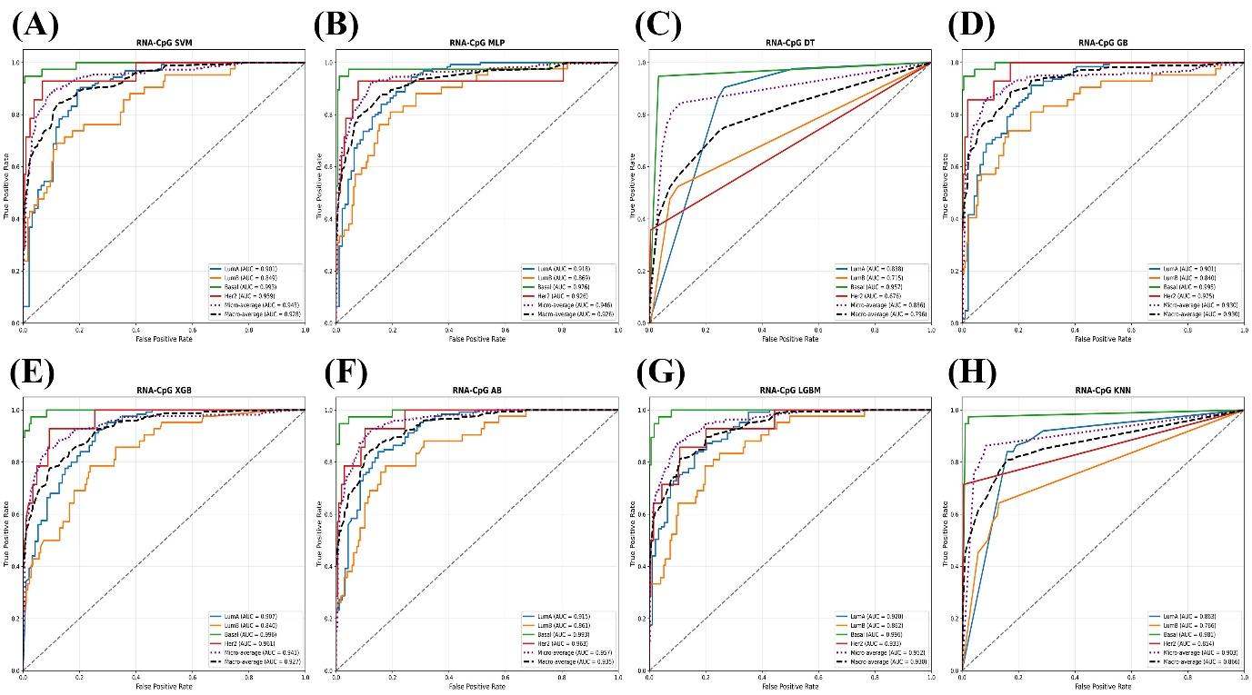
Fig. SF2: Supplementary ROC curves for RNA‑CpG‑based machine learning algorithms: Panels (A–H) correspond to: (A) SVM, (B) MLP, (C) Decision Tree, (D) Gradient Boosting, (E) XGBoost, (F) AdaBoost, (G) LightGBM, and (H) K-Nearest Neighbors
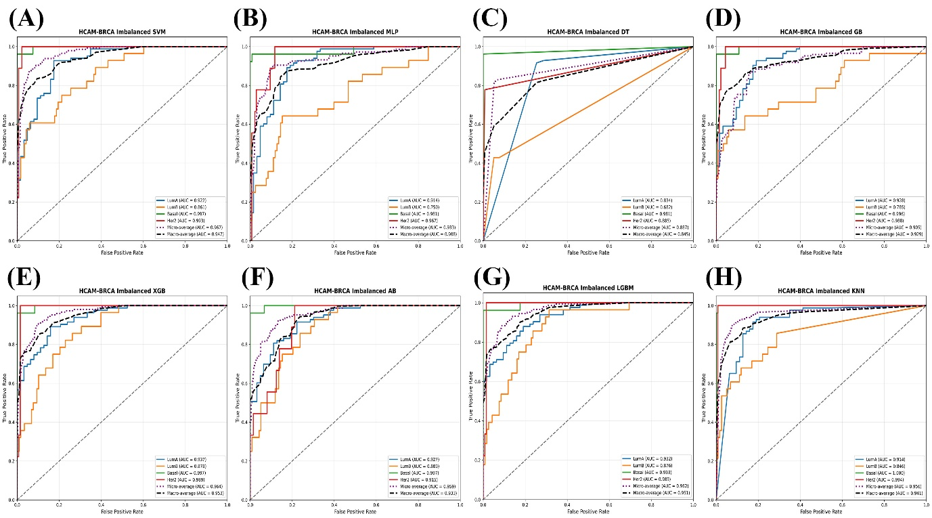
Fig. SF3: AUROC curves for eight ML models using HCAM‑BRCA Imbalanced integration: Panels (A–H) correspond to: (A) SVM, (B) MLP, (C) Decision Tree, (D) Gradient Boosting, (E) XGBoost, (F) AdaBoost, (G) LightGBM, and (H) K-Nearest Neighbors.
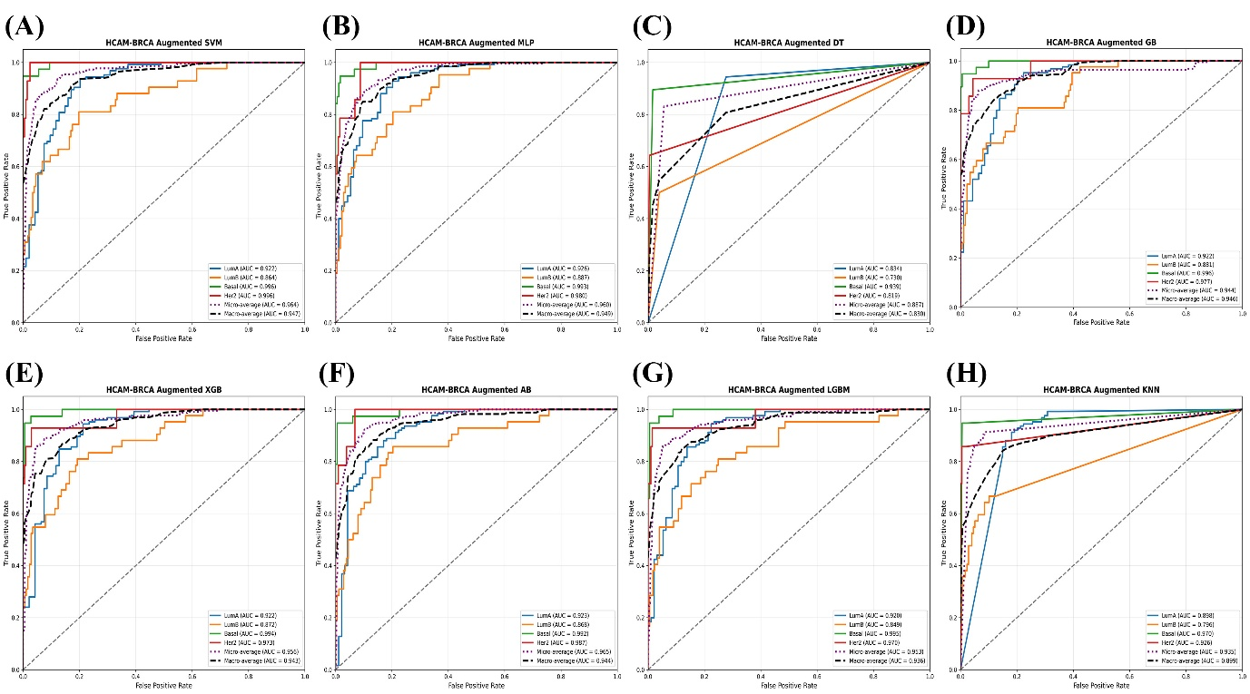
Fig. SF4: AUROC curves for eight ML models using HCAM‑BRCA Augmented integration: Panels (A–H) correspond to: (A) SVM, (B) MLP, (C) Decision Tree, (D) Gradient Boosting, (E) XGBoost, (F) AdaBoost, (G) LightGBM, and (H) K-Nearest Neighbors.
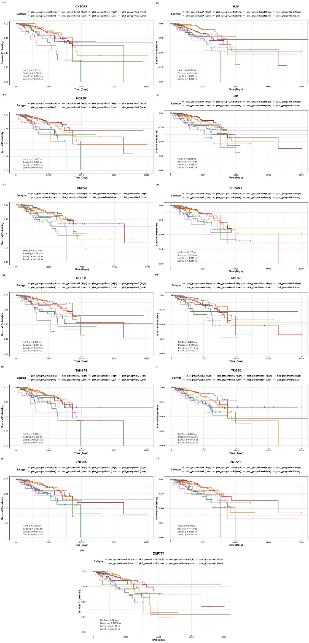
Fig. SF5: Kaplan-Meier survival curves showing the impact of HCAM-BRCA-prioritized gene expression on patient survival across breast cancer subtypes. Panels (A–G) correspond to: (A) CEBPA – Basal, (B) CUX1 – Basal, (C) GDF10 – Her2, (D) HLA-DQA2 – LumB, (E) HOXA10 – LumB, (F) MYZAP – Basal, (G) ZNF879 – Her2.

