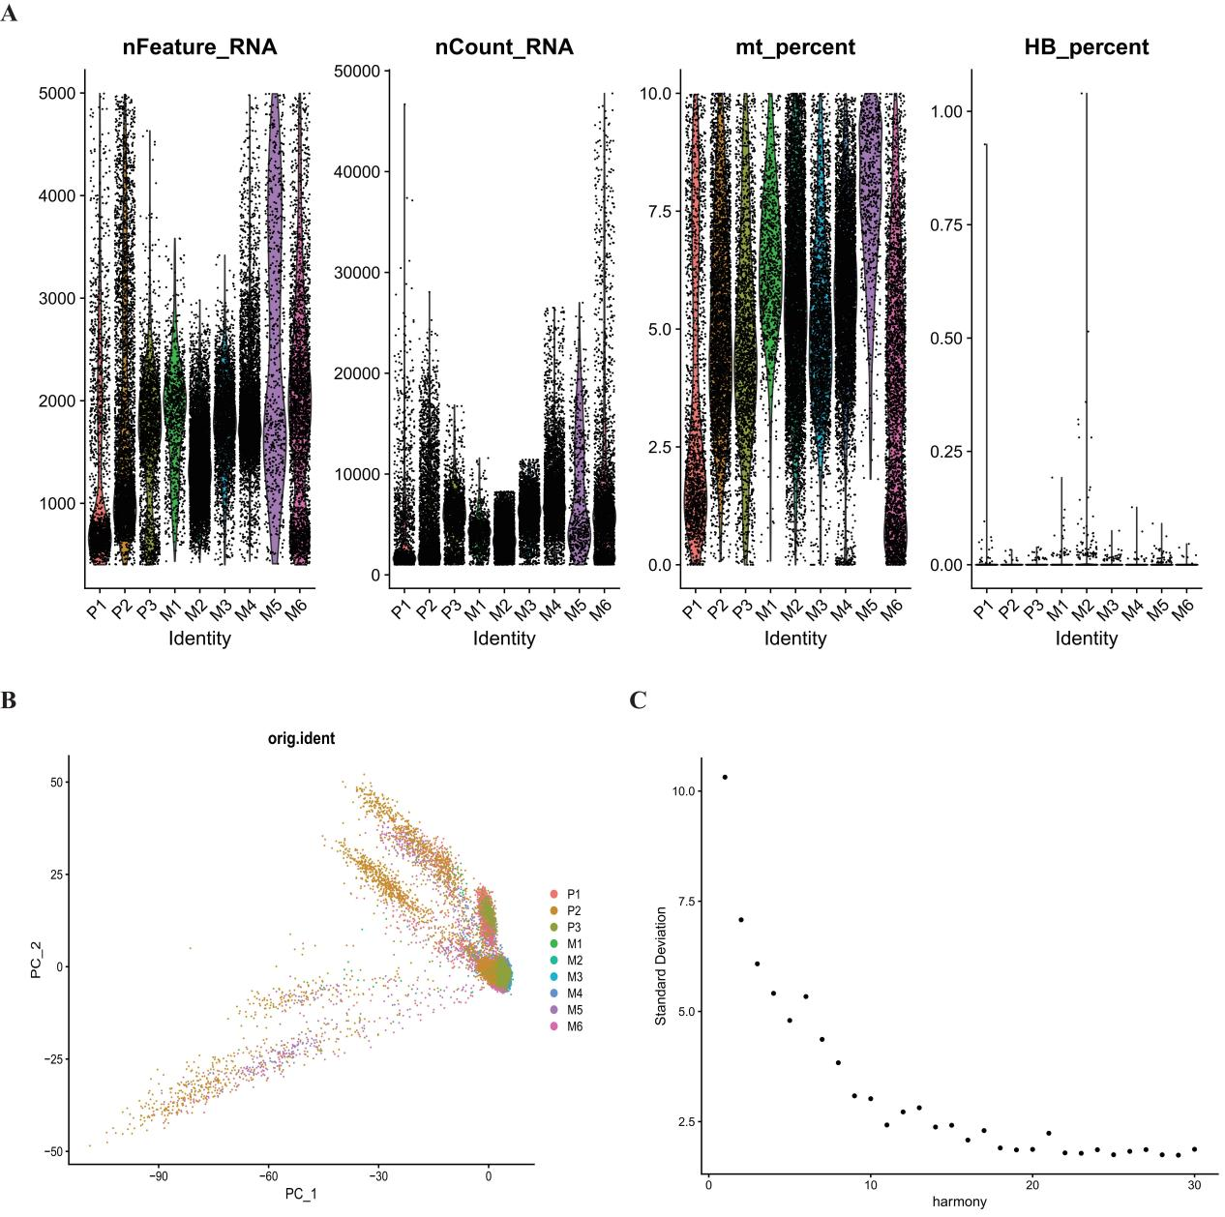
Figure S1. Quality Control and Integration Results of Single-Cell RNA Sequencing Data. (A) Distributions of nFeature_RNA, nCount_RNA, mitochondrial gene proportion (mt_percent), and hemoglobin gene proportion (HB_percent) are presented, which were used for filtering low-quality cells. (B-C) UMAP plots after Harmony batch correction show that cells from multiple samples (e.g., P1, P2) are successfully mixed without batch effects. Cells from different samples are evenly distributed under the coordinates of PC_1 and PC_2, indicating the reliability of subsequent analyses.
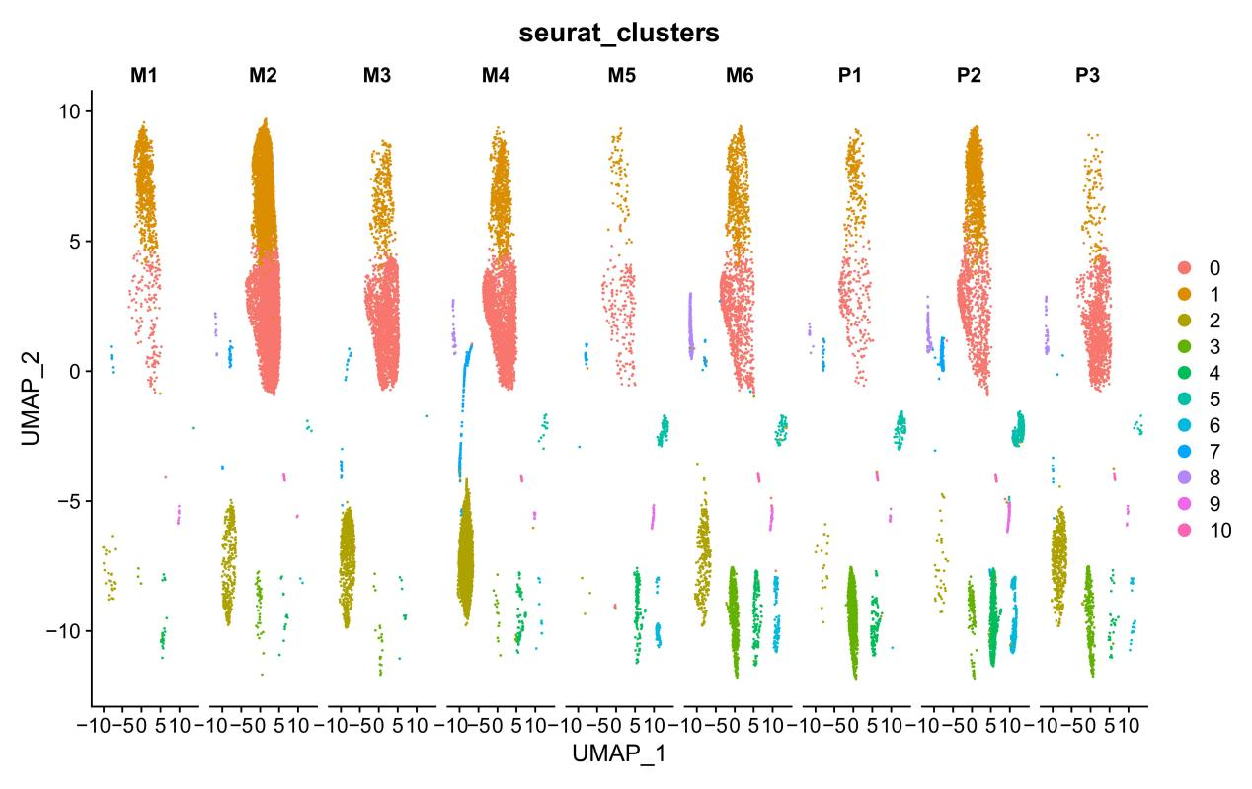
Figure S2. Seurat Clustering and Validation of Sample Origin Mapping. For the UMAP dimensionality reduction plots, the coloring schemes are as follows: The ‘seurat_clusters’ plot shows 10 cell clusters obtained via unsupervised clustering; These plots correspond to 9 clinical samples (M1–M6 for metastatic lesions, P1–P3 for primary lesions). It can be observed that cells from each sample are evenly distributed across multiple clusters, with no sample-specific clustering. This indicates that batch effects have been fully corrected, and the data are suitable for subsequent integration analyses.
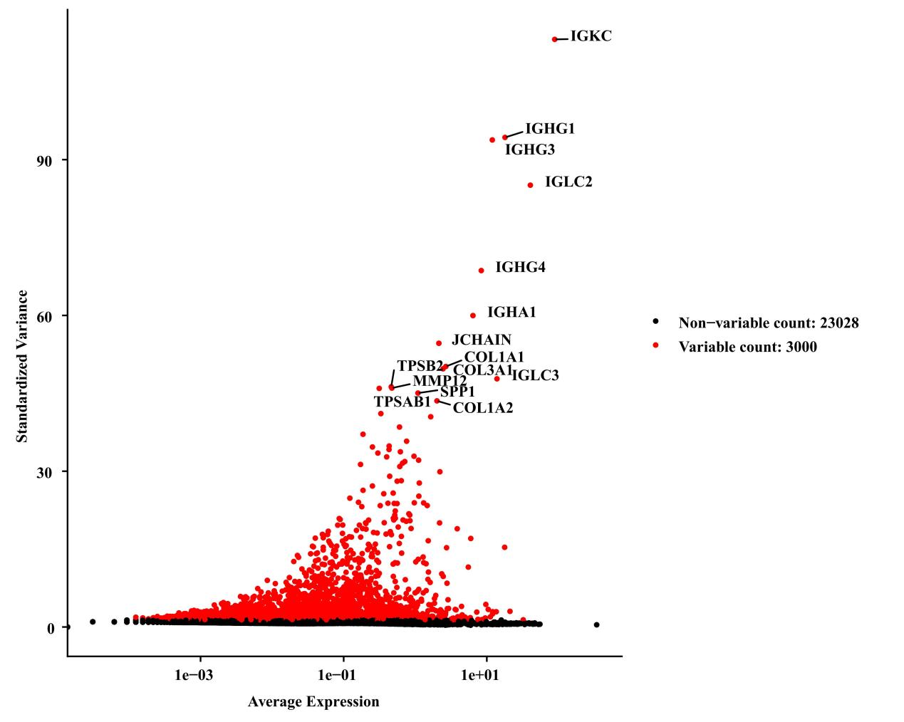
Figure S3. Validation of Cell Identity via Marker Gene Expression and Distribution of Non-Variable Genes. Dot plots show the expression levels of plasma cell-related immunoglobulin constant region genes (IGKC, IGHG1, IGHG3, IGLC2, IGHG4, IGHA1), the plasma cell marker JCHAIN, and fibroblast/mast cell-related collagen and protease genes (COL3A1, COL1A1, COL1A2, MMP12, TPSB2, TPSAB1) across different cell clusters. The color intensity represents the average expression level, and the dot size indicates the expression proportion. The bar chart below presents the count of non-variable genes (Non-variable count: 23028) and variable genes (Variable count: 3000) in each cluster, which was used to evaluate the saturation of gene expression detection and the reliability of cell identity annotation.
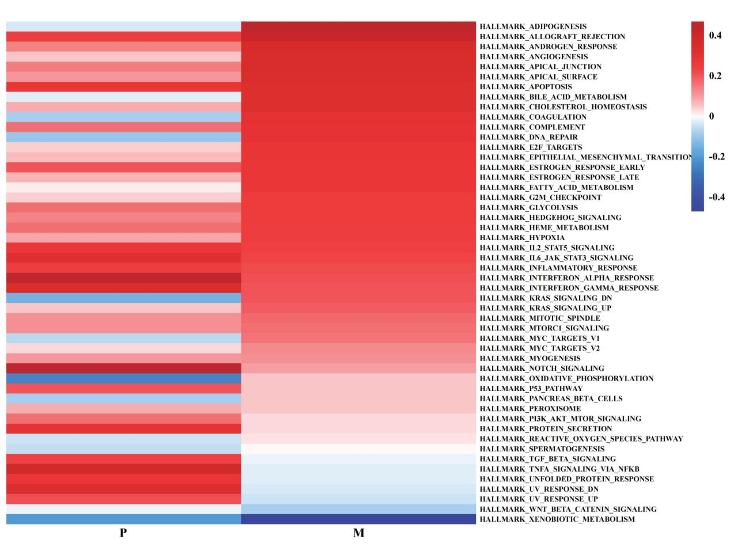
Figure S4. Single-Cell GSVA Heatmap for Hallmark Pathway Activity Evaluation. Rows represent 50 Hallmark pathways from the MSigDB database, and columns show the average ssGSEA scores grouped by primary lesions (P) and metastatic lesions (M). The color scale ranges from blue (-0.4, low activity) to red (+0.4, high activity). It can be observed that pathways such as EMT, TNFα-NF-κB, PI3K-Akt-mTOR, hypoxia, and glycolysis are significantly upregulated in metastatic lesions, while metabolism-related pathways including oxidative phosphorylation and DNA repair are relatively downregulated. These results suggest that cancer cells undergo metabolic reprogramming and activation of pro-metastatic signals during the primary-to-metastatic process.
Table 1. Relationship Between PrPC Expression in Gastric Cancer and Clinicopathological Features.
Clinicopathological Features |  | PrPC-Postive (n=66) | PrPC-Negative (n=28) | χ²/t | P
Age | ≥60 | 36 | 13 | 0.733 | 0.392
Age | <60 | 29 | 15 | 0.733 | 0.392
Gender | Male | 46 | 22 | 0.774 | 0.379
Gender | Female | 20 | 6 | 0.774 | 0.379
BMI(Kg/m²) |  | 21.29±3.04 | 21.74±2.93 | -0.655 | 0.514
Preoperative Hemoglobin (g/L) |  | 123.98±18.87 | 129.89±26.69 | -1.064 | 0.294
Preoperative Albumin (g/L) |  | 41.49±4.27 | 43.02±6.27 | -1.370 | 0.174
Tumor Size (cm) | ≥5 | 23 | 5 | 2.714 | 0.099
Tumor Size (cm) | <5 | 43 | 23 | 2.714 | 0.099
Invasion Depth | T1+T2 | 13 | 18 | 17.684 | 0.001
Invasion Depth | T3+T4 | 53 | 10 | 17.684 | 0.001
Lymph Node Metastasis | Yes | 50 | 7 | 21.220 | 0.001
Lymph Node Metastasis | No | 16 | 21 | 21.220 | 0.001
Vascular Invasion | Yes | 33 | 5 | 8.434 | 0.004
Vascular Invasion | No | 33 | 23 | 8.434 | 0.004
Neural Invasion | Yes | 46 | 8 | 13.602 | 0.001
Neural Invasion | No | 20 | 20 | 13.602 | 0.001
Differentiation Degree | moderately /well | 37 | 17 | 0.174 | 0.676
Differentiation Degree | poorly | 29 | 11 | 0.174 | 0.676
Notes: Categorical data were expressed as proportions (%), and the chi-square test (χ² test) was used for analysis. Continuous data were expressed as mean ± standard deviation (x̄ ± s), and the t-test was applied. A P-value of less than 0.05 (P < 0.05) was considered statistically significant.

