Supplemental Material

Investigating the Dynamic Relationship Between Anxiety and Spatial Memory Using Autonomous Ecological Momentary Assessment

Claire Z. Han¹, Kun C. Zhao¹, Linda M. Wang², Hongkun Zhu³, Yangjia Li³, Luca D. Kolibius³, Angela G. Velazquez⁴, Sandy Song⁴, Amy Cami⁴, Jerina Carmona⁴, Marla Hamberger⁴, Randy P. Auerbach⁵, Catherine A. Schevon^{2,4}, Joshua Jacobs³, Brett E. Youngerman²

Detailed methods

Baseline & follow-up standard neuropsychological assessment: To account for possible fluctuations in trait-level psychosocial wellbeing and spatial ability survey responses due to impending surgery or hospital stay, the baseline battery was administered twice: once at the beginning of hospitalization, typically on day following enrollment, and again at the end of hospitalization. Subjects were initially instructed to complete the second battery remotely within 2 weeks of discharge from the hospital; however, due to inadequate participation rates, subsequent patients were administered the second battery on the day prior to discharge.

The full-form Spielberger State-Trait Anxiety Inventory (STAI) is a 40-item assessment consisting of two 20-item questionnaires, one of which measures state anxiety (Form Y-1) and the other, trait anxiety (Form Y-2). State anxiety captures a person’s immediate level of anxiety within a particular context or moment in time, whereas trait anxiety reflects a person’s general predisposition to anxiety and can be influenced by both prior and potential future experiences with anxiety (Matthews, 2017). Each form of the STAI includes 20 statements that describe an individual, and subjects are asked to indicate the extent to which each statement applies to them, ranging from 1 (almost never) to 4 (almost always). Select items are reverse-scored, and the final score for each form is calculated by summing the scores across all 20 questions, using the corrected score for reverse-scored items. Scores for each form of the STAI can range from 20 to 80, with higher scores indicating a greater level of anxiety (Spielberger, 1983).

The Beck Anxiety Inventory (BAI) is a 21-item self-report questionnaire that assesses the severity of a subject’s anxiety. Unlike the STAI, this survey was specifically designed to discriminate between anxiety and depression, and to serve as a reliable measure of anxiety in clinical psychiatric populations (Beck et al., 1988). Each question describes a common symptom of anxiety, and subjects are asked to rate how much they have been bothered by each symptom during the past week. Responses range from 0 (“Not at all”) to 3 (“Severely – I could barely stand it”). Individual item scores are then summed to yield a total score ranging from 0-63, with 0-7 suggesting minimal anxiety, 8-15 mild anxiety, 16-25 moderate anxiety, and 26-63 severe anxiety (Carney et al., 2011).

The Beck Depression Inventory-II (BDI-II) is a 21-item self-report inventory used to assess the severity of a patient’s depression (Beck et al. 1996). Each item begins with a topical header that indicates the general area of focus for the statements to follow. Subjects are then presented with four statements listed in increasing severity and are asked to choose the one statement that best represents the way they have been feeling over the past two weeks. Individual items are scored from 0-3 and summed for a total score ranging from 0 to 63, with higher scores indicating greater severity of depression. Scores from 0-13 reflect minimal depression, 14-19 mild depression, 20-28 moderate depression, and 29-63 severe depression (Dozois & Covin, 2004).

The Quality of Life in Epilepsy Inventory (QOLIE-31) is a 31-item questionnaire that measures the health-related quality of life in adults with epilepsy. The survey includes 1 question that assesses overall health and 30 questions which each fall into one of seven categories or multi-item “scales”: seizure worry, overall quality of life, emotional well-being, energy/fatigue, cognitive, medication effects, and social function. Each multi-item scale produces a scale score that reflects the average response across all items within that category. The overall QOLIE-31 score is obtained using a weighted average of the multi-item scale scores and can range from 0-100, with a higher overall score indicating a higher quality of life (Vickrey et al., 1993).

The Santa Barbara Sense of Direction Scale is a 15-item self-report questionnaire that measures a subject’s perceived spatial orientation at the environmental level (Hegarty et al., 2002). Each item provides a statement about a subject’s spatial and navigational abilities, preferences, or experiences, and subjects are asked to indicate their level of agreement with the statement on a scale of 1 (strongly agree) to 7 (strongly disagree). Seven of 15 items are reverse-scored, and the final score is obtained by averaging the score across all 15 items, using the corrected score for reverse-scored items. A higher final score indicates a stronger perceived sense of direction.

Person-mean centering and within-person normalization: For analyses focused on within-person variation, each asm-EMA observation was transformed into a person-relative value:

$person relative measure = (raw - participant mean)/pooled population SD$
The participant mean was computed separately for each asm-EMA measure. The pooled within-person SD was computed from all person-mean-centered observations for that measure across participants. This transformation removed stable between-person differences in average level while preserving differences across participants in how much they fluctuated over time. Unless otherwise stated, within-person correlations, within-session mixed-effects models, and temporal dynamics analyses used these person-relative values.
Intraclass correlation coefficient: For each asm-EMA measure, we estimated the proportion of variance attributable to stable between-subject differences using a random-intercept linear mixed-effects model fit by restricted maximum likelihood:
$raw measure \sim 1 + (1 | participant)$
The intraclass correlation coefficient was computed as:
$ICC = participant level variance / (participant level variance + residual variance)$
Within-session associations To distinguish stable between-subject differences from momentary within-person fluctuations, we computed Spearman correlations at two levels. Between-subject correlations were computed using each participant’s mean value for each measure. Within-subject correlations were computed using person-relative values pooled across observations.
To test whether momentary affective state was related to concurrent memory performance, we fit linear mixed-effects models with Memory Accuracy and Memory RT as separate outcomes:
$memory measure \sim affective measure + (1 | participant)$
To test whether any affective measure explained unique variance beyond the others, we also fit multivariable models including all three affective predictors:
$memory measure \sim VAS Pain + VAS Anxiety + STAI6 Anxiety + (1 | participant)$
Temporal dynamics: Temporal analyses tested whether person-relative state deviations persisted across successive sessions. Only within-day lagged pairs were retained; cross-day pairs and same-day pairs separated by more than 5 hours were excluded.
We computed within-person Spearman autocorrelations for each asm-EMA measure at lags 1, 2, and 3, testing whether person-relative values of the same measure were correlated across adjacent and later sessions: $measure_{t} \sim measure_{t-k}$. We also computed within-person Spearman cross-correlations for all ordered pairs of asm-EMA measures: $outcome measure_{t} \sim predictor measure_{t-k}$.
To test whether lag-one autocorrelation reflected reliable self-prediction after accounting for timing-related covariates, we fit mixed autoregressive models separately for each asm-EMA measure:
$measure_{t} \sim measure_{t-1}+time of day + elapsed time + (1+ measure_{t-1}| participant)$
Models were fit by maximum likelihood and summarized using R².
To test whether one measure predicted later values of another beyond the outcome’s own short-term persistence, we extended the autoregressive model by adding lagged cross-measure predictors:
$outcome_{t} \sim outcome_{t-1}+other measure_{t-1}+time of day+elapsed time+(1+outcome_{t-1}| participant)$
The self-lag term was always retained, and only the self-lag term was assigned a random slope. Memory-related measures were excluded from cross-regression models because the overlap of valid lagged observations was substantially smaller.
Permutation testing: Statistical significance for all lagged analyses was assessed using 2,000 within-subject permutations. For within-person Spearman autocorrelations and cross-correlations, lagged predictor values were shuffled within participants. For mixed autoregression, the same-measure lag-one predictor was shuffled while the outcome and timing covariates were kept fixed. For cross-regression, lagged cross-measure predictors were shuffled while the outcome’s own lag-one term and timing covariates were kept fixed.

Supplemental Figures
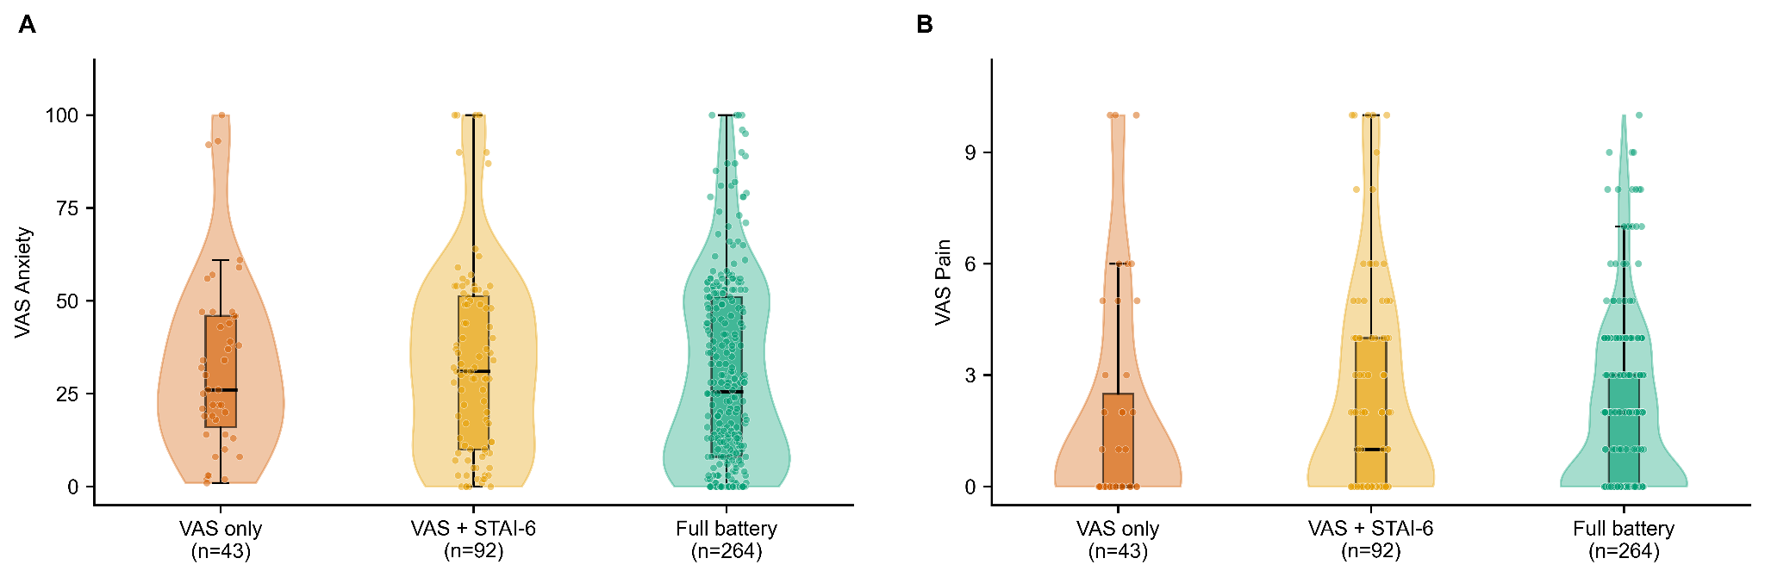
Supplementary Figure S1. VAS scores do not differ by session completion category. VAS Anxiety (A) and VAS Pain (B) ratings are shown for sessions in which participants completed only the initial VAS ratings (VAS only, n = 43), the VAS and STAI-6 (VAS + STAI-6, n = 92), or the full battery including the Treasure Hunt memory task (Full battery, n = 264). Each panel shows a violin plot of the score distribution, overlaid with a box plot (median, IQR, and 1.5× IQR whiskers) and jittered individual session data points. Groups did not differ significantly on either measure (Kruskal-Wallis: VAS Anxiety H = 1.49, p = .475; VAS Pain H = 2.02, p = .365), indicating that session-level affective state did not systematically predict within-session dropout.
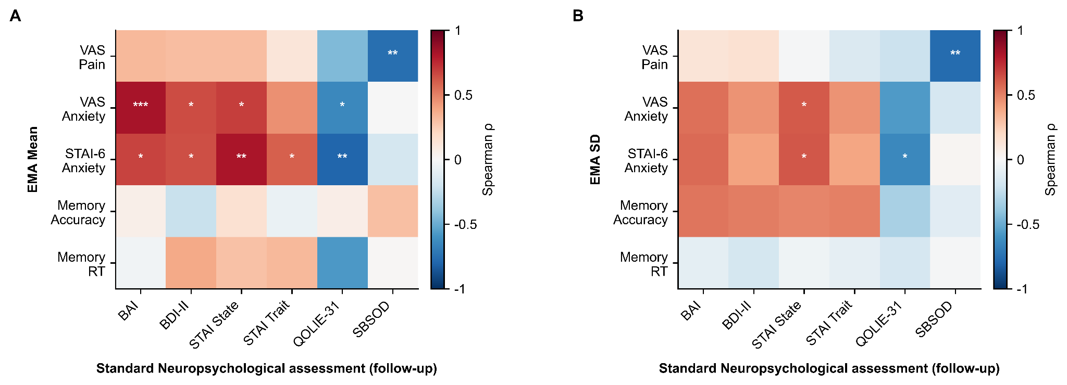
Supplementary Figure S2. Correspondence between asm-EMA measures and post-EMA clinical assessments. Spearman correlation matrices between post-EMA clinical assessment scores (x-axis: BAI, BDI, STAI State, STAI Trait, QOLIE-31, SBSOD) and subject-level asm-EMA means (A) and asm-EMA within-person standard deviations (B) for all five measures (VAS Pain, VAS Anxiety, STAI-6, Memory Accuracy, Memory RT). Color encodes the Spearman ρ value; asterisks indicate significance (* p < .05, ** p < .01, *** p < .001). These analyses parallel the pre-EMA assessment correlations reported in Figure 4, and should be interpreted cautiously given the reduced sample size at post-EMA period assessment.
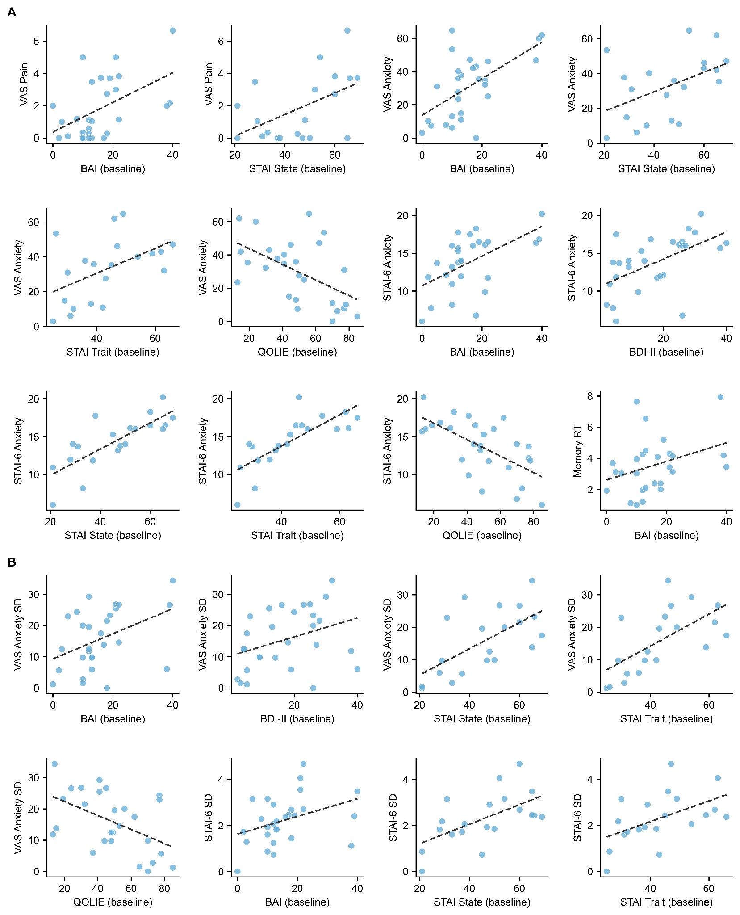
Supplementary Figure S3. Scatter plots of significant correlations between asm-EMA measures and standard neuropsychological assessments at baseline. Each panel shows the Spearman correlation between one asm-EMA measure (y-axis) and one standard clinical instrument administered before the monitoring period (x-axis). Dashed lines show ordinary least-squares fits. (A) show correlations with subject-level asm-EMA means; (B) show correlations with within-person standard deviations (SD). Only statistically significant pairs (p < 0.05) from the corresponding heatmaps (Figure 4A–B) are displayed. BAI, Beck Anxiety Inventory; BDI-II, Beck Depression Inventory; STAI State and Trait, State-Trait Anxiety Inventory; QOLIE, Quality of Life in Epilepsy; SBSOD, Santa Barbara Sense of Direction scale.

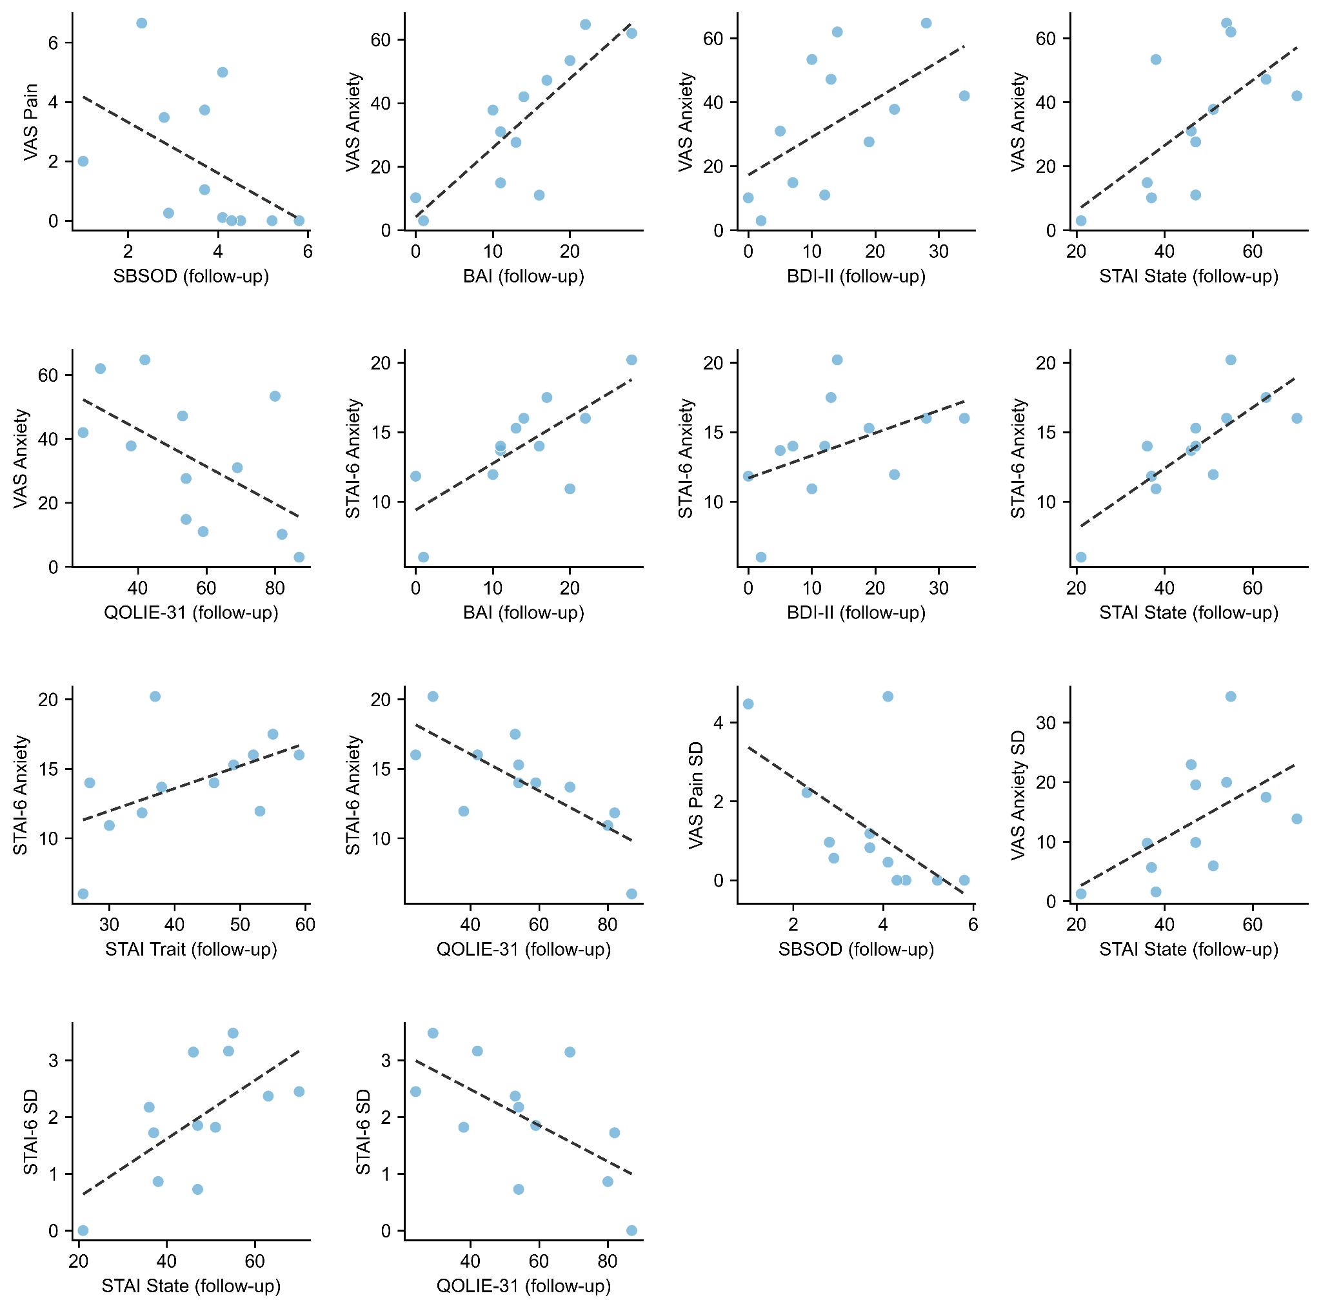
Supplementary Figure S3. Scatter plots of significant correlations between asm-EMA summary statistics and standard neuropsychological assessments at follow-up. Each panel shows the Spearman correlation between one asm-EMA measure (y-axis) and one standard clinical instrument administered after the monitoring period (x-axis). Dashed lines show ordinary least-squares fits. Panels in the upper portion show correlations with subject-level asm-EMA means (VAS Pain, VAS Anxiety, STAI-6 Anxiety); panels in the lower portion show correlations with within-person standard deviations (VAS Pain SD, VAS Anxiety SD, STAI-6 SD). Only statistically significant pairs (p < 0.05) from the corresponding follow-up heatmaps are displayed. Note that sample size is reduced relative to baseline analyses owing to missing follow-up assessments in a subset of participants.
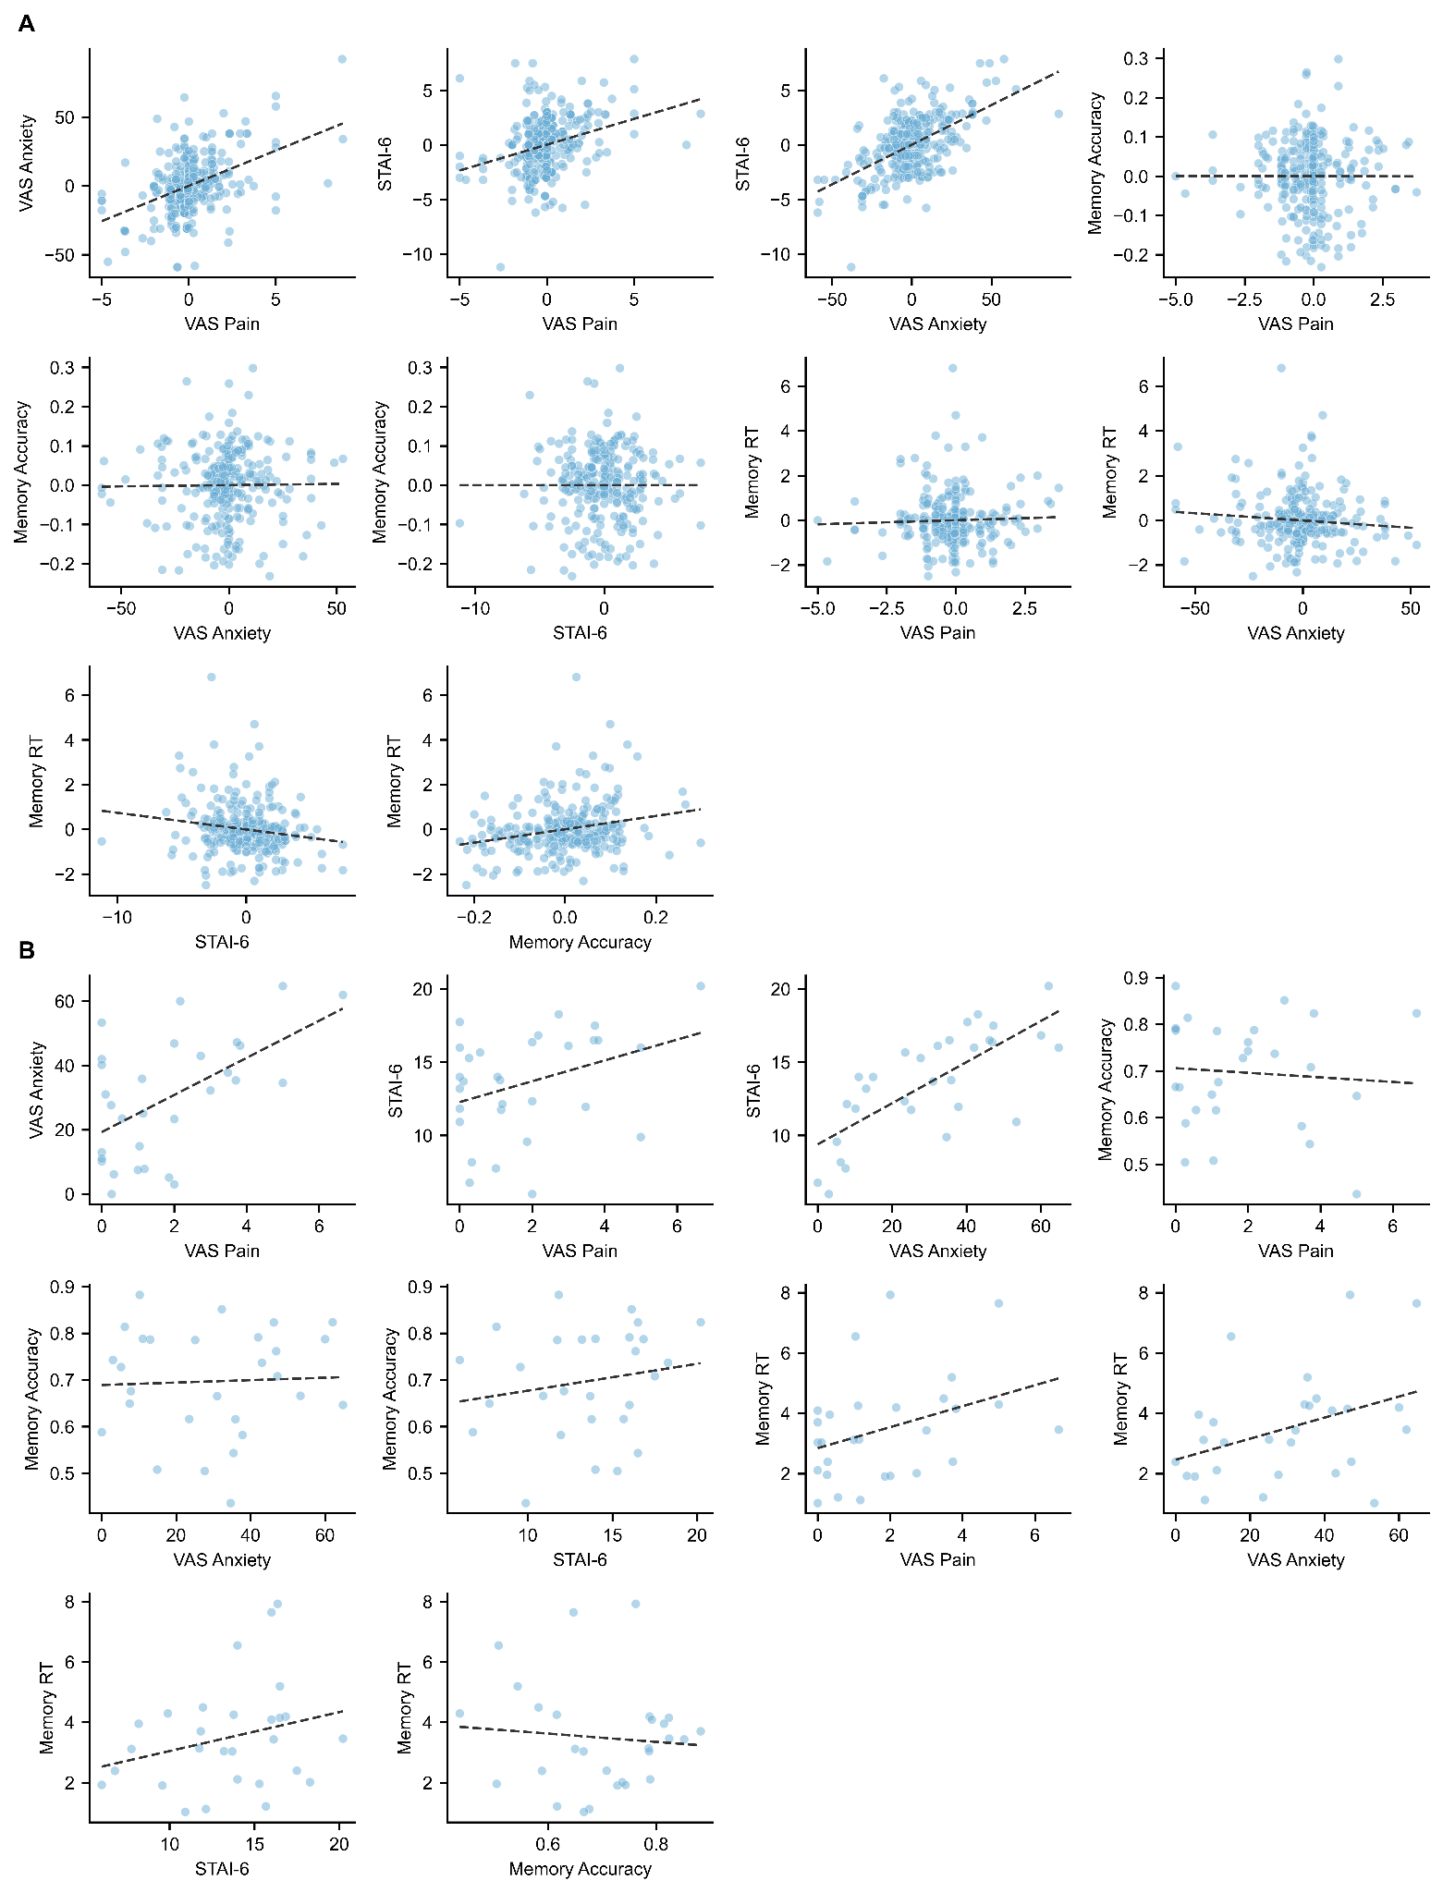
Supplementary Figure S5. Pairwise scatter plots of all asm-EMA measures at the within-person and between-person levels. Each panel shows the relationship between two asm-EMA measures with a least-squares regression line overlaid. Panel A shows within-person associations computed on person-mean centered session-level data, where each data point represents a single asm-EMA session expressed as a deviation from that participant's own mean. Panel B shows between-person associations computed on subject-level means, where each data point represents one participant's average across all their sessions. The 10 panels in each section correspond to all pairwise combinations of the five asm-EMA measures (VAS Pain, VAS Anxiety, STAI-6, Memory Accuracy, Memory RT), covering the lower triangle of the full correlation matrix. These scatter plots provide individual-level visualization of the Spearman correlations summarized in the heatmap in Figure 5A.

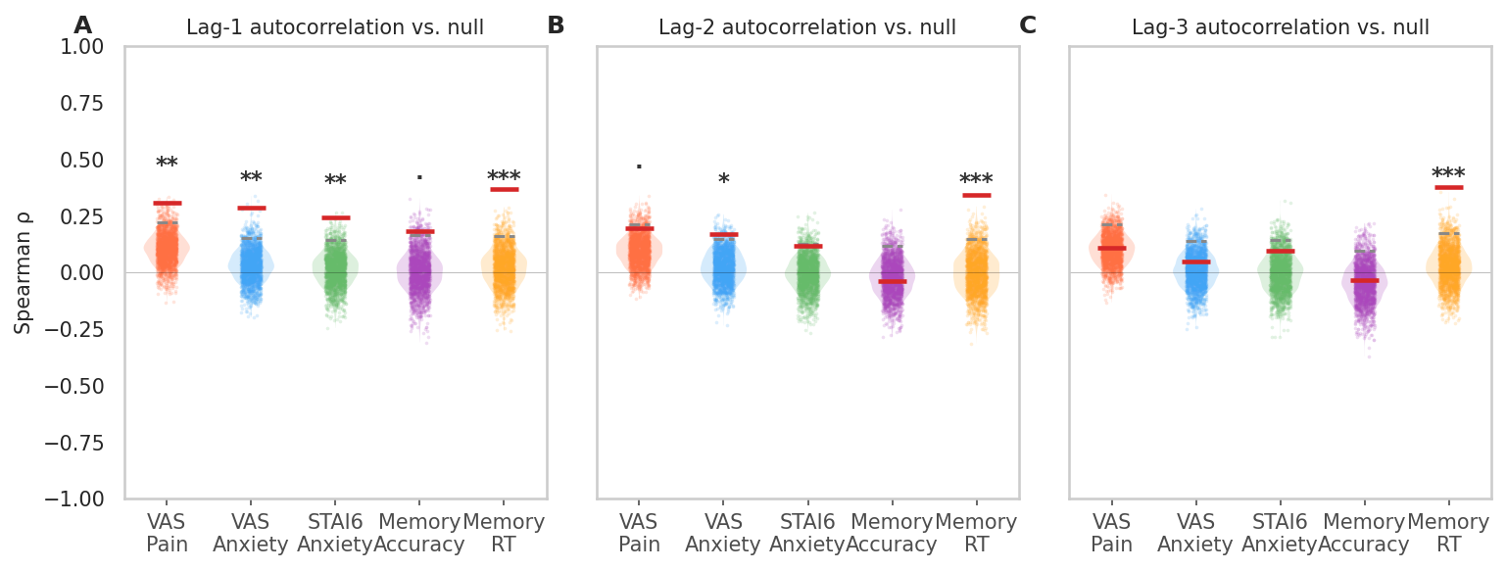
Supplementary Figure S6. Null distributions for lag-1, lag-2, and lag-3 autocorrelations. Each shaded area shows the permutation null distribution (N = 2000 within-subject shuffles) for pooled Spearman ρ for each measure. Red dashes indicate observed ρ; dashed grey lines indicate the 95th null percentile. Asterisks above violins indicate permutation significance (* p < .05, ** p < .01, *** p < .001). All five measures are shown; the y-axis is shared across lags.

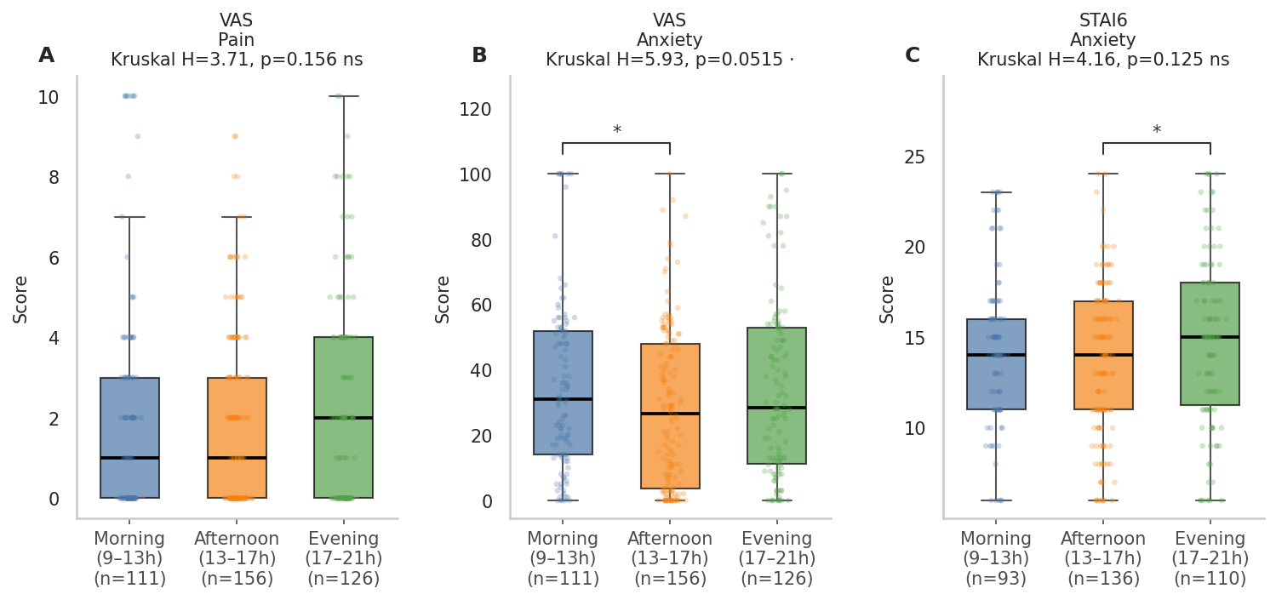
Supplementary Figure S7. Session-level asm-EMA scores by time of day (raw scores). Violins show the distribution of session scores in morning (9–13h), afternoon (13–17h), and evening (17–21h) windows. Medians are shown as horizontal bars; individual sessions are jittered. Brackets indicate pairwise Mann-Whitney comparisons significant at uncorrected p < .05 (* p < .05). Overall Kruskal-Wallis H and p are reported in each panel title.

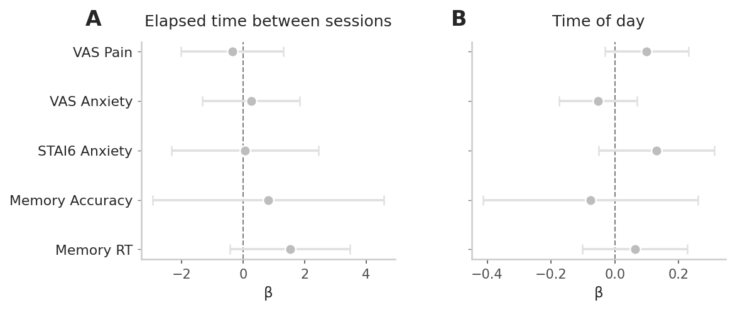
Supplementary Figure S8: β coefficients (± 95% CI) for elapsed time between sessions (A) and time of day (B) from mixed-effects lag-1 AR models fitted for each of the five measures. Predictors and outcomes were z-scored prior to modeling; coefficients reflect standardized effect sizes. Grey markers indicate non-significant effects (p ≥ .05); colored markers indicate p < .05. Neither covariate showed consistent significant associations with EMA outcomes across measures, confirming that lag-one self-prediction was not attributable to time-of-day pattern 7 or session spacing.

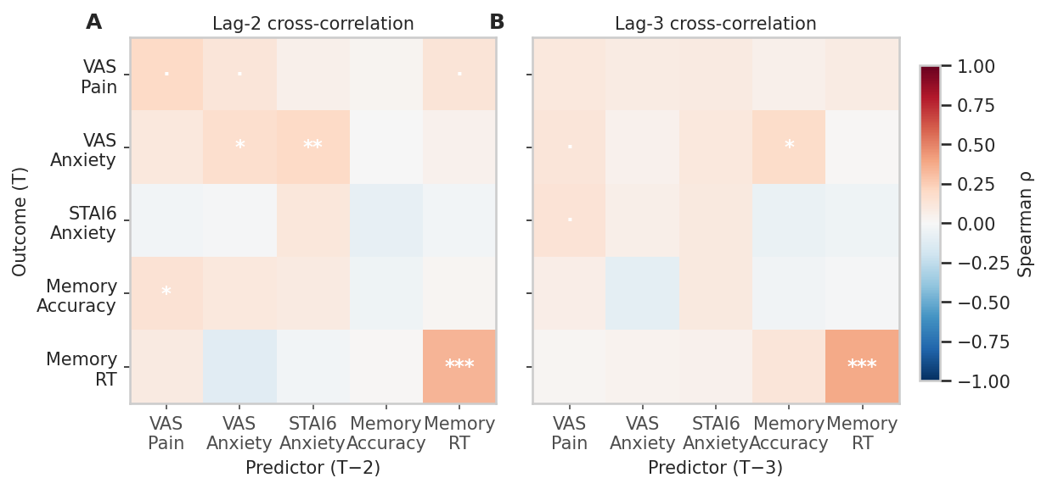

Supplementary Figure S9: Lag-2 and lag-3 cross-correlation matrices (pooled Spearman ρ). Same format as Figure 6B. Rows = outcome at T, columns = predictor at T−2 (left) or T−3 (right). Asterisks denote permutation significance (· p < .10, * p < .05, ** p < .01, *** p < .001).. Y-axis labels shown for lag-2 only; lag-3 shares the same row ordering.
Supplemental Tables

Lag-2 Autoregression Permutation Testing results
asm-EMA measures | Observed R² | Null 95 pct R² | P (shuffle)
VAS Pain | 0.471 | 0.505 | 0.691
VAS Anxiety | 0.394 | 0.418 | 0.970
STAI6 Anxiety | 0.221 | 0.248 | 0.296
Memory Acc | 0.184 | 0.230 | 0.523
Memory RT | 0.563 | 0.585 | 0.999

Lag-3 Autoregression Permutation Testing results
asm-EMA measures | Observed R² | Null 95 pct R² | P (shuffle)
VAS Pain | 0.487 | 0.493 | 0.092
VAS Anxiety | 0.361 | 0.386 | 0.810
STAI6 Anxiety | 0.253 | 0.317 | 0.727
Memory Acc | 0.212 | 0.278 | 0.814
Memory RT | 0.563 | 0.585 | 0.469

Supplementary Table ST1: Incremental contribution of lag-2 (keeping lag-1 intact) and lag-3 predictors. R² values are computed from the full multi-lag model (1 - RMSE²/Var(y)). Permutation p values test whether the additional lag coefficient (lag-2 or lag-3, shuffled independently while preserving other lags) significantly improves prediction. None of the additional lags significantly improved prediction beyond lag-1 (all p > .09).

Supplemental References

Beck, A. T., Brown, G., Epstein, N., & Steer, R. A. (n.d.). An Inventory for Measuring Clinical Anxiety: Psychometric Properties.
Carney, C. E., Moss, T. G., Harris, A. L., Edinger, J. D., & Krystal, A. D. (2011). Should We Be Anxious When Assessing Anxiety Using the Beck Anxiety Inventory in Clinical Insomnia Patients? Journal of Psychiatric Research, 45(9), 1243–1249. https://doi.org/10.1016/j.jpsychires.2011.03.011
Dozois, D., & Covin, R. (2004). The Beck Depression Inventory-II (BDI-II), Beck Hopelessness Scale (BHS), and Beck Scale for Suicide Ideation (BSS).
Matthews, G. (2017). State-trait anxiety inventory. In The sage encyclopedia of abnormal and clinical psychology (Vol. 7, pp. 3317-3317). SAGE Publications, Inc., https://doi.org/10.4135/9781483365817.n1316
Hegarty, M., Richardson, A. E., Montello, D. R., Lovelace, K., & Subbiah, I. (2002). Development of a self-report measure of environmental spatial ability. Intelligence, 30(5), 425–447. https://doi.org/10.1016/S0160-2896(02)00116-2
Spielberger, C. D. (1983). State-Trait Anxiety Inventory for Adults. https://doi.org/10.1037/t06496-000
Vickrey, B. G., Perrine, K. R., Hays, R. D., Hermann, B. P., Cramer, J. A., Meador, K. J., & Devinsky, O. (1993). Quality of life in epilepsy inventory (QOLIE-31), version 1.0: Scoring manual and patient inventory. RAND Corporation. https://www.rand.org/content/dam/rand/www/external/health/surveys_tools/qolie/qolie31_scoring.pdf

