Supplementary Material
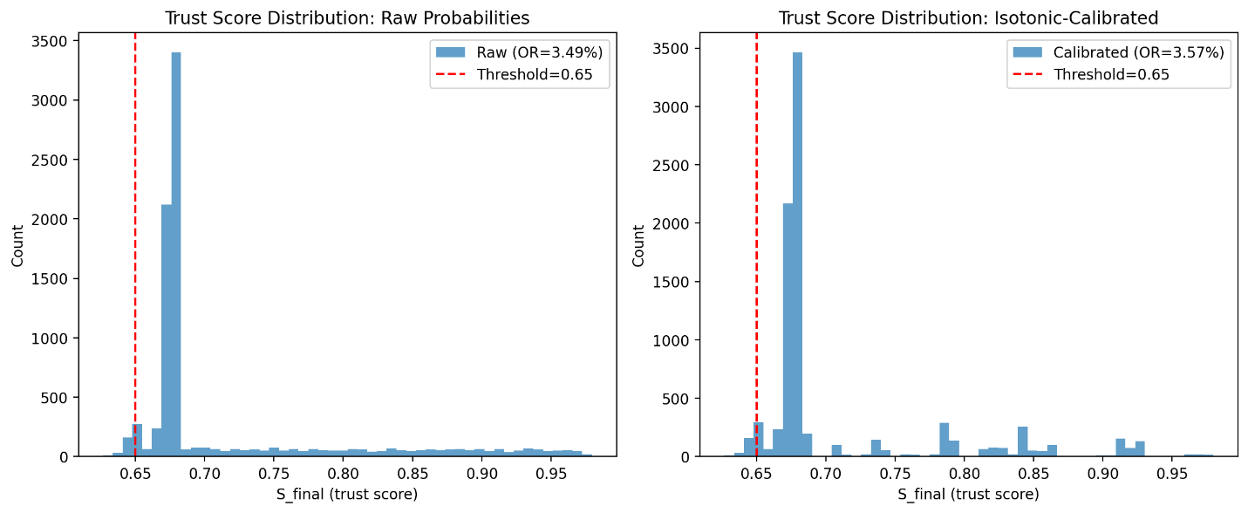Figure S1 (trust score distribution: raw vs. calibrated): Histogram comparing the distribution of composite trust scores (S_final) computed from raw (uncalibrated) probabilities vs. isotonic-calibrated probabilities for the Qwen3-Embedding-0.6B model at DMP level with logistic regression. The dashed red line indicates the moderate-transparency override threshold (θ = 0.65). Both distributions are nearly identical in central tendency (raw mean: 0.714 vs. calibrated mean: 0.710) and dispersion (raw std: 0.080 vs. calibrated std: 0.072), producing similar override rates (3.49% vs. 3.57%). The primary benefit of calibration is improved ECE (0.007 vs. 0.024), not altered override behavior.
Table S2. Systematic threshold calibration across models and data richness levels. Base threshold is the default transparency-conditioned value. Calibrated thresholds show values required to achieve target override rates (1%, 3%, 5%) at the DMP level using isotonic-calibrated LR probabilities.
Model | Level | Base Threshold | Base OR (%) | Threshold for 1% OR | Threshold for 3% OR | Threshold for 5% OR
Qwen3-Embedding-0.6B | D | 0.70 | 0.06 | 0.725 | 0.730 | 0.735
Qwen3-Embedding-0.6B | DMP | 0.65 | 3.57 | 0.645 | 0.650 | 0.655
Qwen3-Embedding-0.6B | ALL | 0.55 | 0.00 | 0.710 | 0.725 | 0.730
Qwen2.5-3B | D | 0.70 | 0.00 | 0.755 | 0.760 | 0.760
Qwen2.5-3B | DMP | 0.65 | 0.00 | 0.670 | 0.670 | 0.675
Qwen2.5-3B | ALL | 0.55 | 0.00 | 0.735 | 0.740 | 0.740
Qwen2.5-7B-4bit | D | 0.70 | 0.00 | 0.750 | 0.755 | 0.755
Qwen2.5-7B-4bit | DMP | 0.65 | 0.00 | 0.665 | 0.670 | 0.670
Qwen2.5-7B-4bit | ALL | 0.55 | 0.00 | 0.725 | 0.740 | 0.740
For models with 0% base override rate, the threshold must be raised above the base value to produce non-zero override rates. At the ALL level (high transparency, base threshold 0.55), thresholds must be raised substantially (to 0.71–0.74) to produce meaningful override rates because the high-transparency trust score distribution sits well above the default threshold. These calibrated thresholds demonstrate that model-specific adjustment is required for clinical deployment.

