CRISPRi loss-of-function mutations revealed through experimental evolution in Burkholderia cenocepacia
Zayra Batun¹, Erick Arroyo-Pérez², A.S.M. Zisanur Rahman¹, Marike Palmer¹, Andrew M. Hogan¹, Sion Yi¹, Yves Brun² and Silvia T. Cardona^{1, 3*}.

¹ Department of Microbiology, University of Manitoba, Winnipeg, MB, Canada.
² Department of Microbiology and Immunology, University of Montreal, Montreal, Canada.
³ Department of Medical Microbiology & Infectious Disease, University of Manitoba, Winnipeg, Canada.

*To whom correspondence should be addressed: silvia.cardona@umanitoba.ca

Supplementary Material

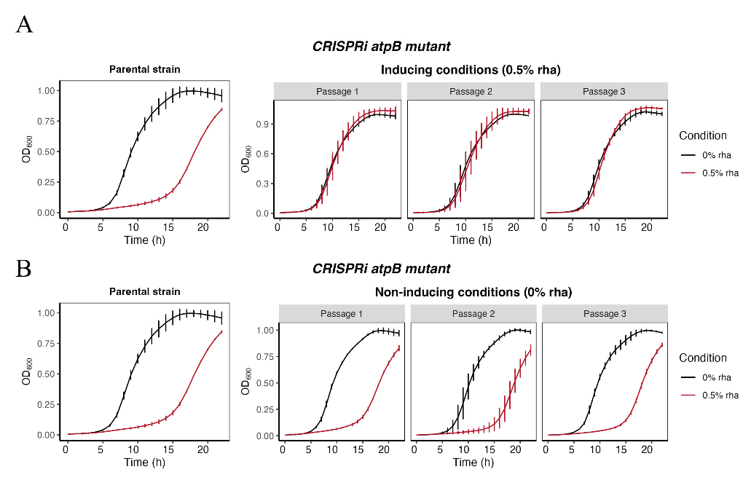
Supplementary Figure 1. Short-term evolution experiment for CRISPRi atpB mutant under dCas9-inducing and non-inducing conditions. (A) CGP loss is observed under consistent dCas9-inducing conditions after one bacterial passage. (B) CGP is maintained across bacterial passages under non-inducing conditions. Error bars represent the SD ± mean of three independent biological replicates.

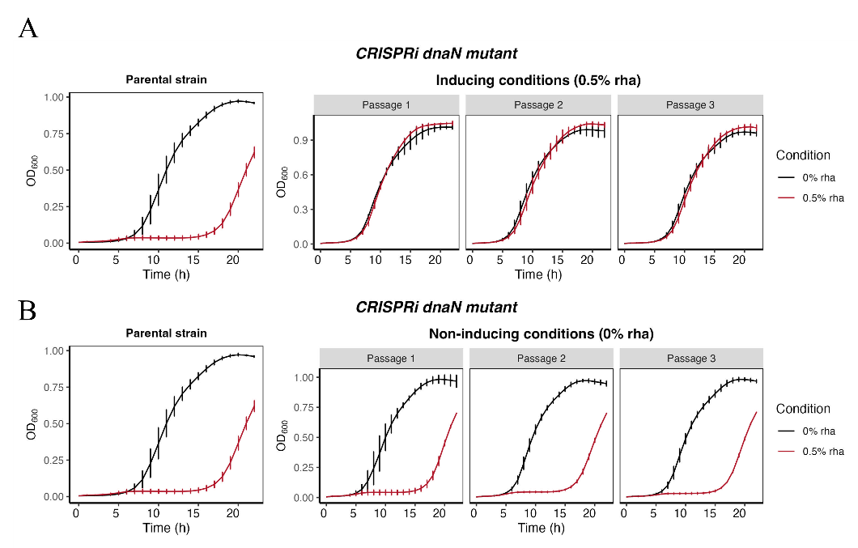
Supplementary Figure 1. Short-term evolution experiment for CRISPRi dnaN mutant under dCas9-inducing and non-inducing conditions. (A) CGP loss is observed under consistent dCas9-inducing conditions after one bacterial passage. (B) CGP is maintained across bacterial passages under non-inducing conditions. Error bars represent the SD ± mean of three independent biological replicates.
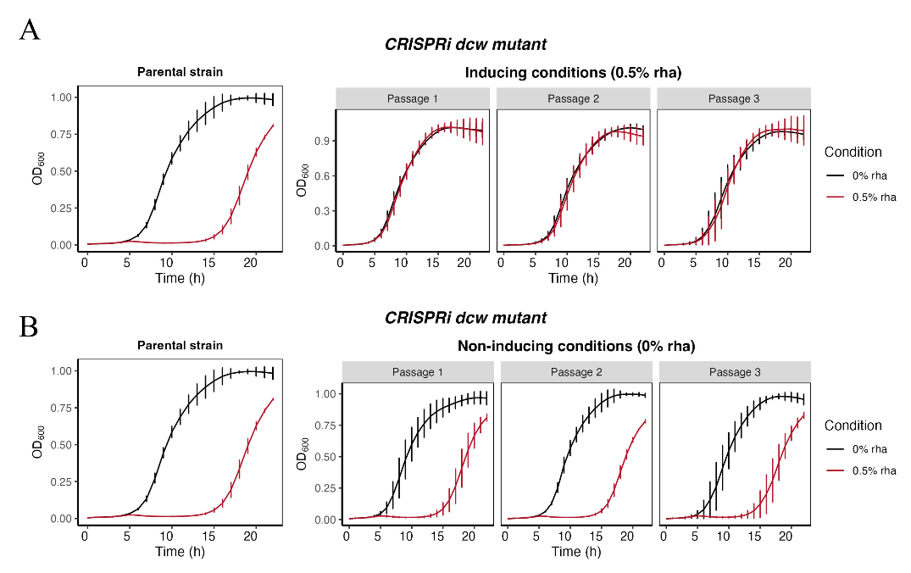
Supplementary Figure 2. Short-term evolution experiment for CRISPRi dcw mutant under dCas9-inducing and non-inducing conditions. (A) CGP loss is observed under consistent dCas9-inducing conditions after one bacterial passage. (B) CGP is maintained across bacterial passages under non-inducing conditions. Error bars represent the SD ± mean of three independent biological replicates.

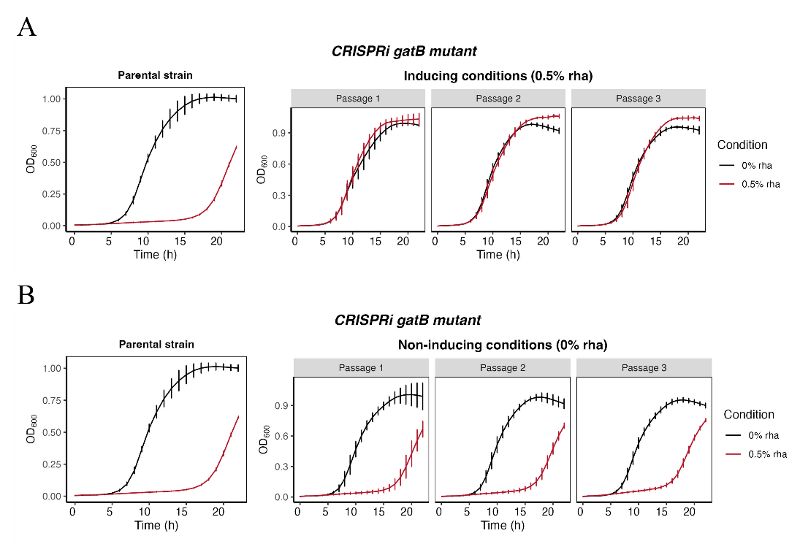
Supplementary Figure 3. Short-term evolution experiment for CRISPRi gatB mutant under dCas9-inducing and non-inducing conditions. (A) CGP loss is observed under consistent dCas9-inducing conditions after one bacterial passage. (B) CGP is maintained across bacterial passages under non-inducing conditions. Error bars represent the SD ± mean of three independent biological replicates.
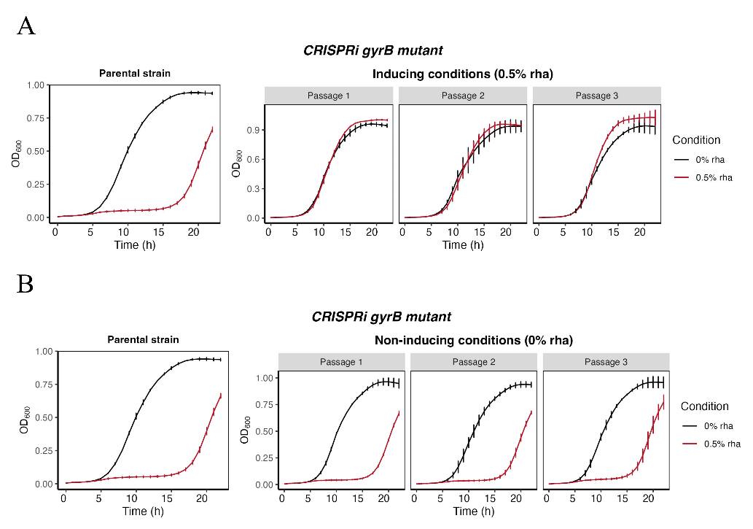
Supplementary Figure 4. Short-term evolution experiment for CRISPRi gyrB mutant under dCas9-inducing and non-inducing conditions. (A) CGP loss is observed under consistent dCas9-inducing conditions after one bacterial passage. (B) CGP is maintained across bacterial passages under non-inducing conditions. Error bars represent the SD ± mean of three independent biological replicates.

- 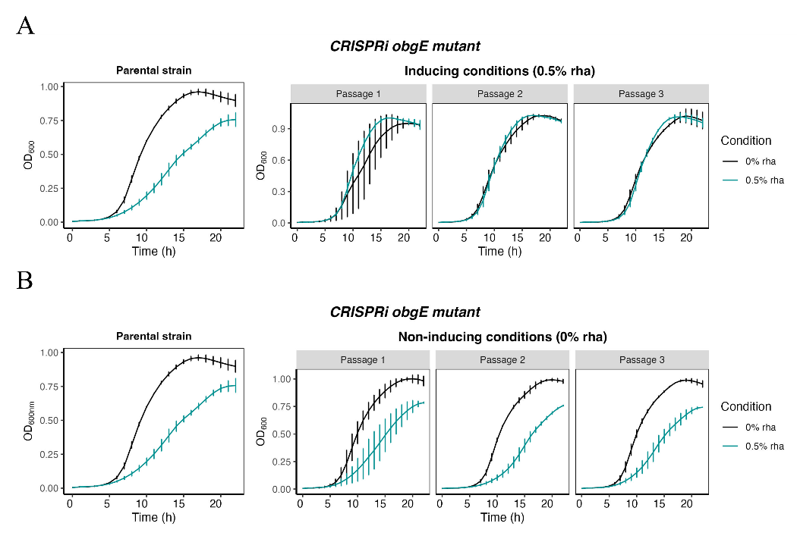
Supplementary Figure 6. Short-term evolution experiment for CRISPRi obgE mutant under dCas9-inducing and non-inducing conditions. (A) CGP loss is observed under consistent dCas9-inducing conditions after one bacterial passage. (B) CGP is maintained across bacterial passages under non-inducing conditions. Error bars represent the SD ± mean of three independent biological replicates.

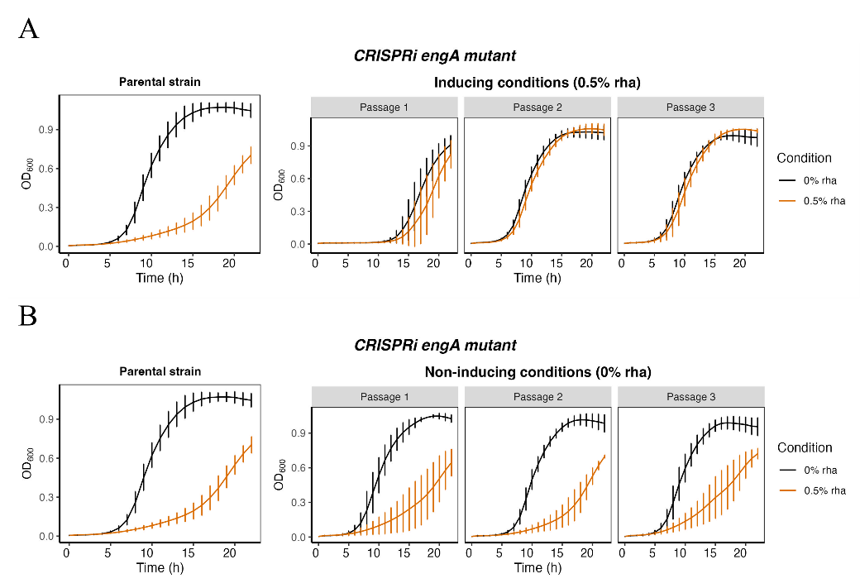
Supplementary Figure 7. Short-term evolution experiment for CRISPRi engA mutant under dCas9-inducing and non-inducing conditions. (A) CGP loss is observed under consistent dCas9-inducing conditions after two bacterial passages. (B) CGP is maintained across bacterial passages under non-inducing conditions. Error bars represent the SD ± mean of three independent biological replicates.
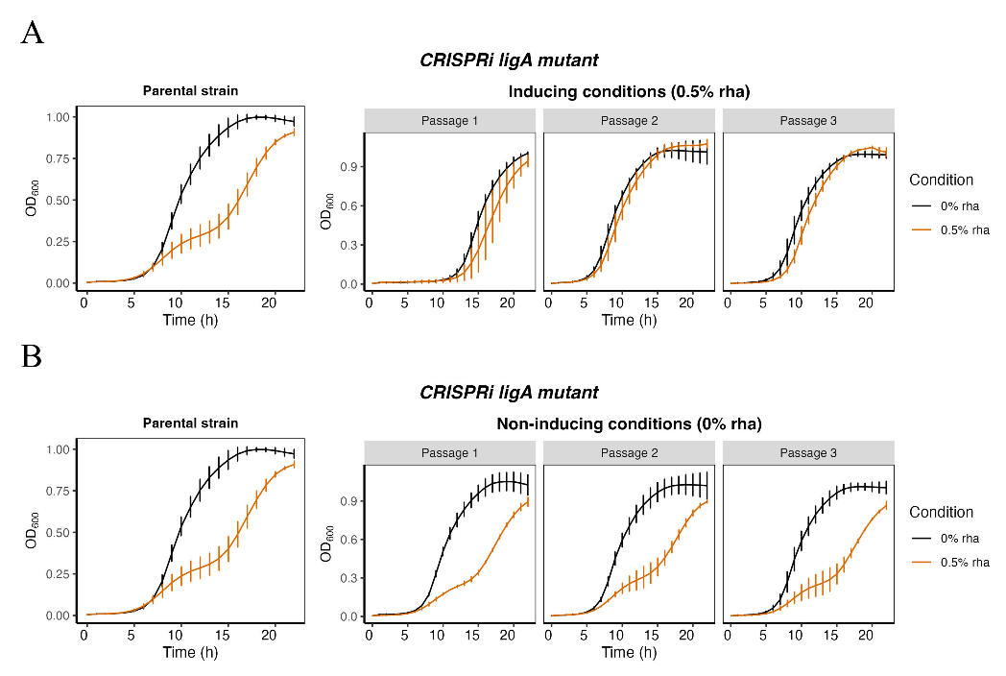
Supplementary Figure 8. Short-term evolution experiment for CRISPRi ligA mutant under dCas9-inducing and non-inducing conditions. (A) CGP loss is observed under consistent dCas9-inducing conditions after two bacterial passages. (B) CGP is maintained across bacterial passages under non-inducing conditions. Error bars represent the SD ± mean of three independent biological replicates.

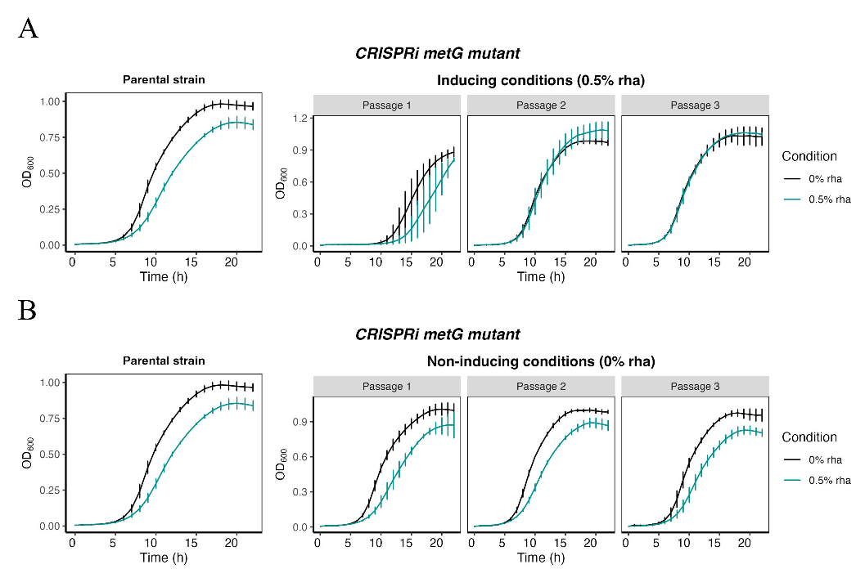
Supplementary Figure 9. Short-term evolution experiment for CRISPRi metG mutant under dCas9-inducing and non-inducing conditions. CGP loss is observed under consistent dCas9-inducing conditions after two bacterial passages. (B) CGP is maintained across bacterial passages under non-inducing conditions. Error bars represent the SD ± mean of three independent biological replicates.

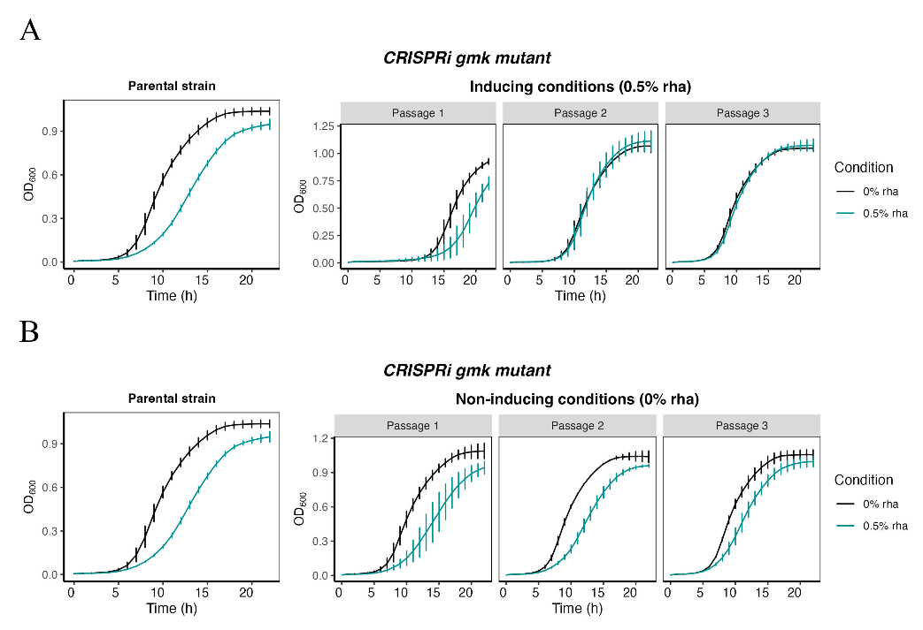
Supplementary Figure 10. Short-term evolution experiment for CRISPRi gmk mutant under dCas9-inducing and non-inducing conditions. (A) CGP loss is observed under consistent dCas9-inducing conditions after two bacterial passages. (B) CGP is maintained across bacterial passages under non-inducing conditions. Error bars represent the SD ± mean of three independent biological replicates.

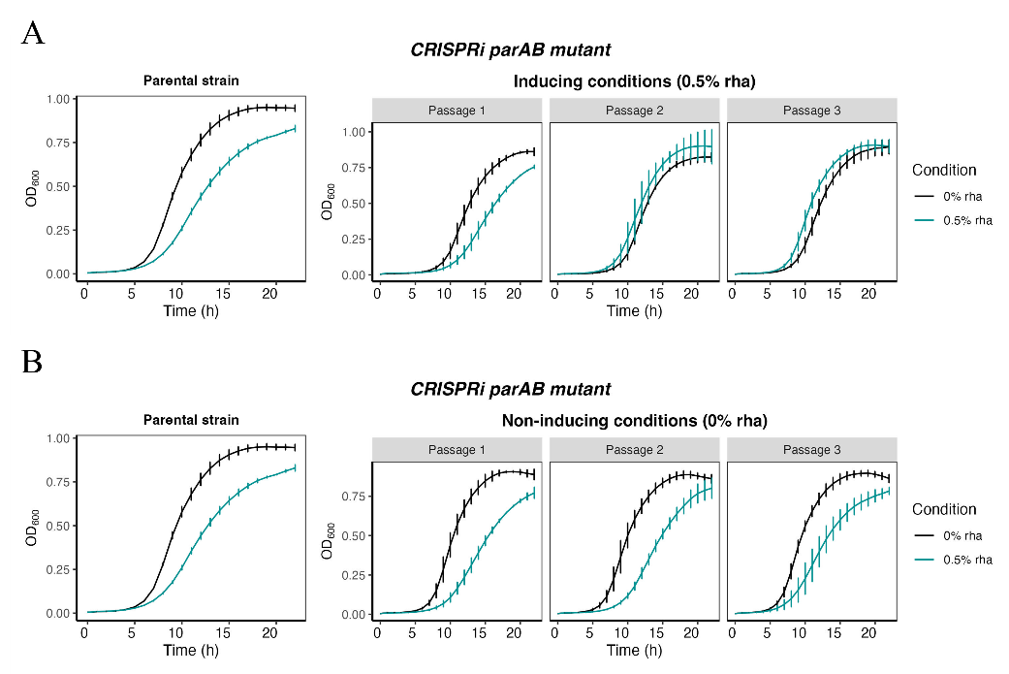
Supplementary Figure 11. Short-term evolution experiment for CRISPRi parAB mutant under dCas9-inducing and non-inducing conditions. (A) CGP loss is observed under consistent dCas9-inducing conditions after two bacterial passages. (B) CGP is maintained across bacterial passages under non-inducing conditions. Error bars represent the SD ± mean of three independent biological replicates.

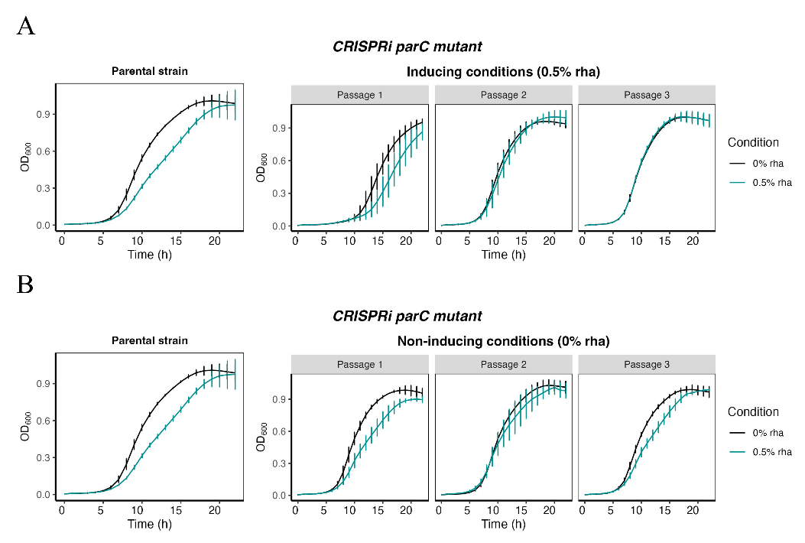
Supplementary Figure 12. Short-term evolution experiment for CRISPRi parC mutant under dCas9-inducing and non-inducing conditions. (A) CGP loss is observed under consistent dCas9-inducing conditions after two bacterial passages. (B) CGP is maintained across bacterial passages under non-inducing conditions. Error bars represent the SD ± mean of three independent biological replicates.

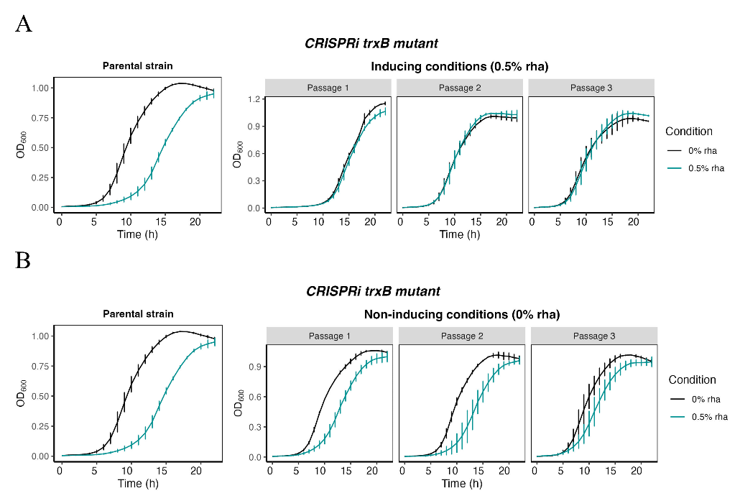
Supplementary Figure 13. Short-term evolution experiment for CRISPRi trxB mutant under dCas9-inducing and non-inducing conditions. (A) CGP loss is observed under consistent dCas9-inducing conditions after three bacterial passages. (B) CGP is maintained across bacterial passages under non-inducing conditions. Error bars represent the SD ± mean of three independent biological replicates.

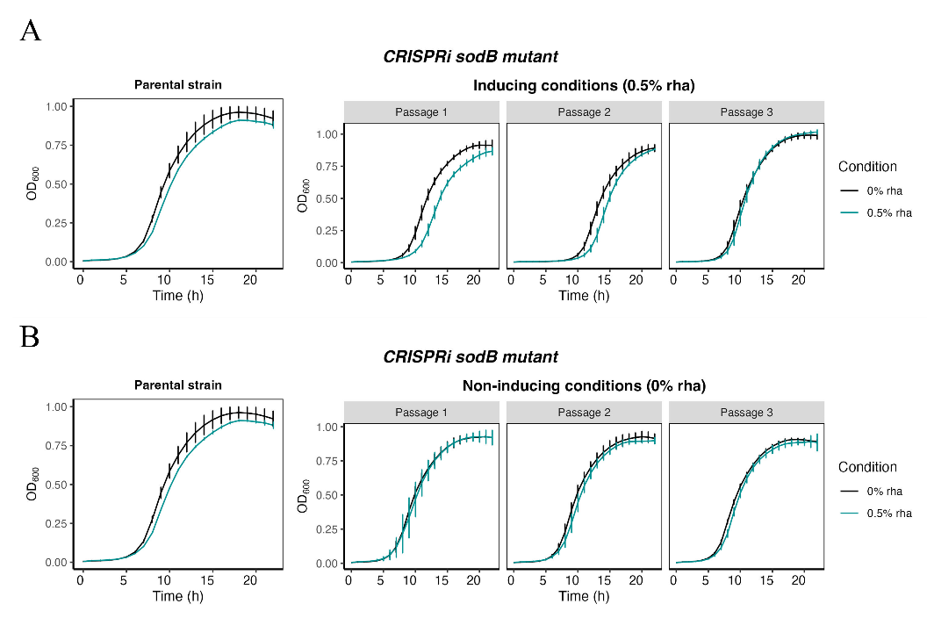
Supplementary Figure 14. Short-term evolution experiment for CRISPRi sodB mutant under dCas9-inducing and non-inducing conditions. (A) CGP loss is observed under consistent dCas9-inducing conditions after three bacterial passages. (B) CGP is maintained across bacterial passages under non-inducing conditions. Error bars represent the SD ± mean of three independent biological replicates.
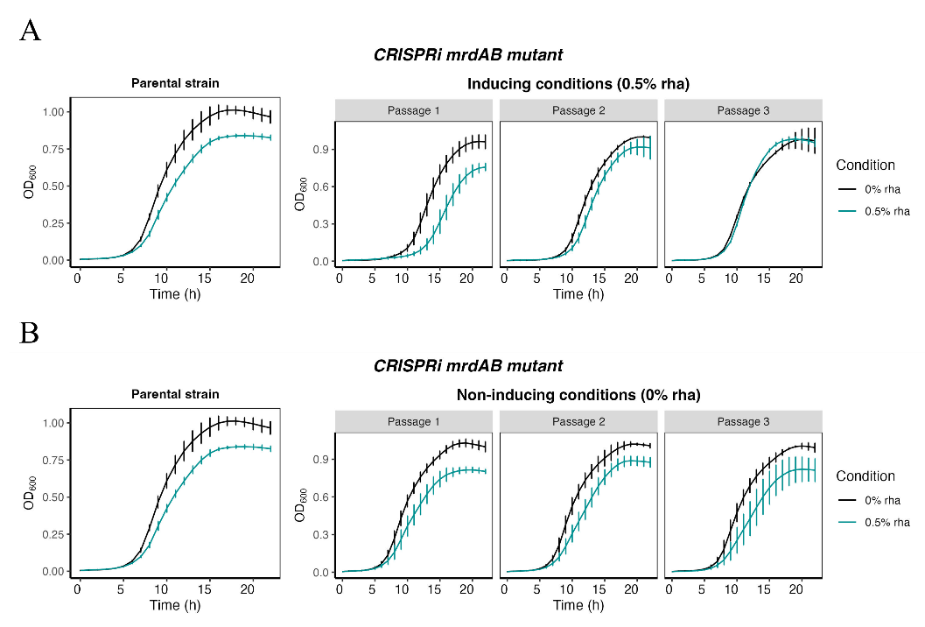
Supplementary Figure 15. Short-term evolution experiment for CRISPRi mrdAB mutant under dCas9-inducing and non-inducing conditions. (A) CGP loss is observed under consistent dCas9-inducing conditions after three bacterial passages. (B) CGP is maintained across bacterial passages under non-inducing conditions. Error bars represent the SD ± mean of three independent biological replicates.

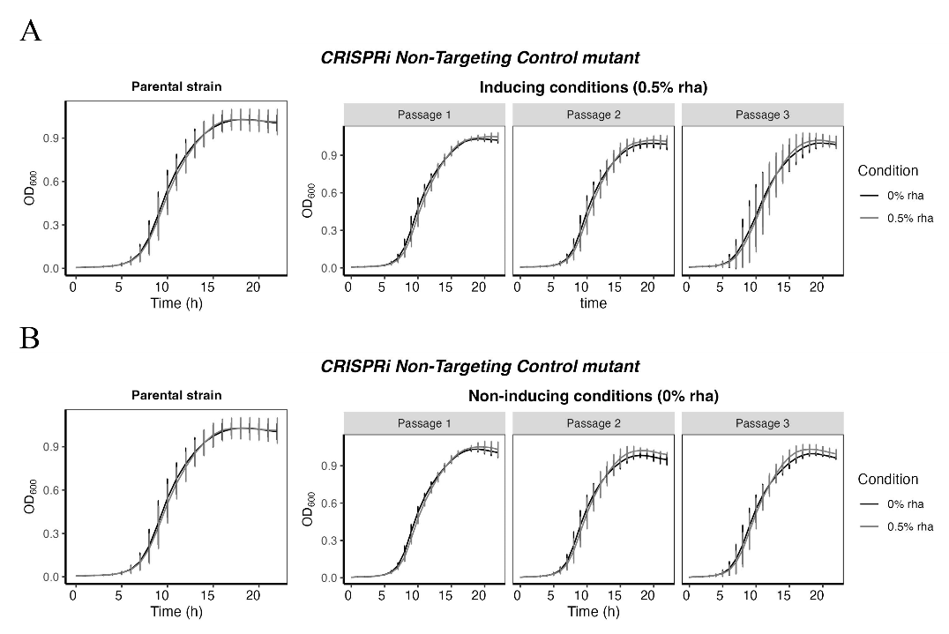
Supplementary Figure 16. Short-term evolution experiment for CRISPRi NTC mutant under dCas9-inducing and non-inducing conditions. (A-B) Growth is equivalent under consistent dCas9-inducing and non-inducing conditions after three bacterial passages with no CGP detected. Error bars represent the SD ± mean of three independent biological replicates.

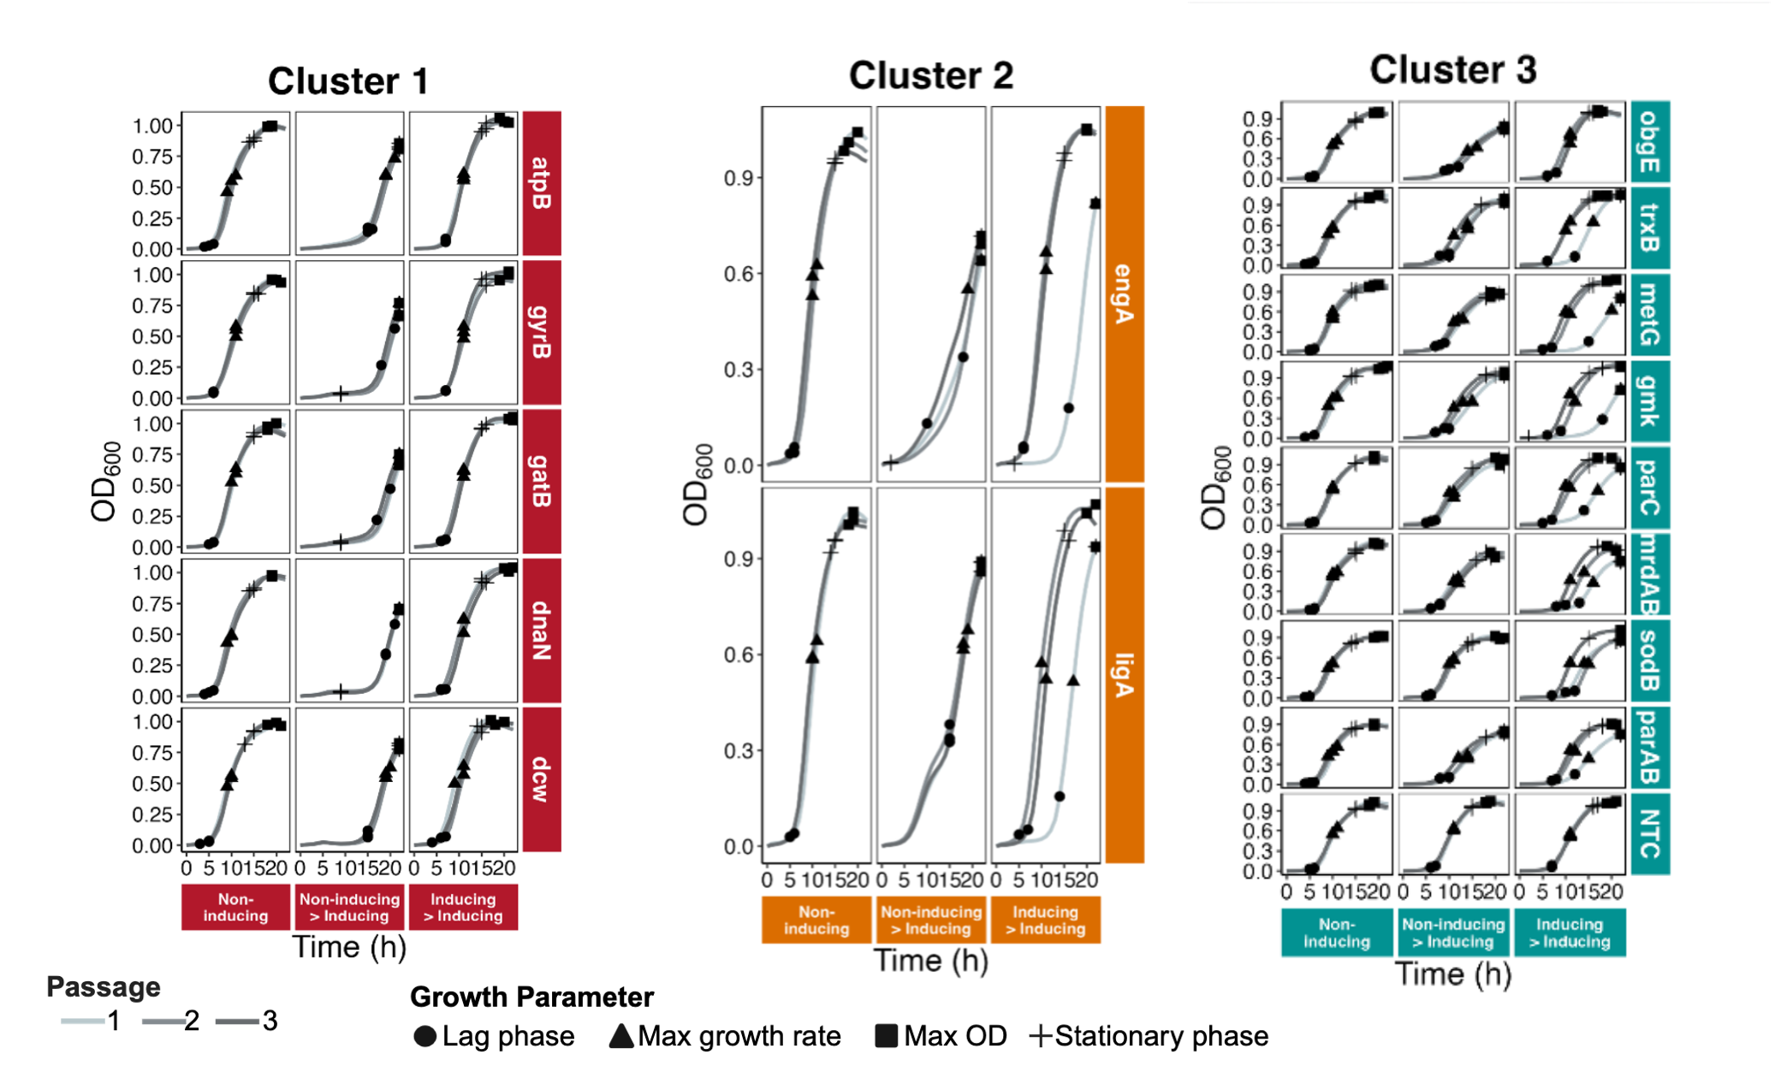

Supplementary Figure 17. Growth curves of CRISPRi mutants organized by cluster under dCas9-inducing and non-inducing conditions. Cluster 1, 2, and Cluster 3 mutants are shown as individual panels. Within each panel, genes are displayed as rows and conditions as columns: non-inducing throughout (left), non-inducing conditions overnight followed by induction (middle), and dCas9-inducing conditions overnight (right). Lines represent growth curves across three passages shown on a grey scale (light to dark; passages 1–3). Cluster 1 mutants display severe conditional growth phenotypes (CGPs), Cluster 2 mutants display intermediate CGPs, and Cluster 3 mutants display mild CGPs upon consistent dCas9 induction

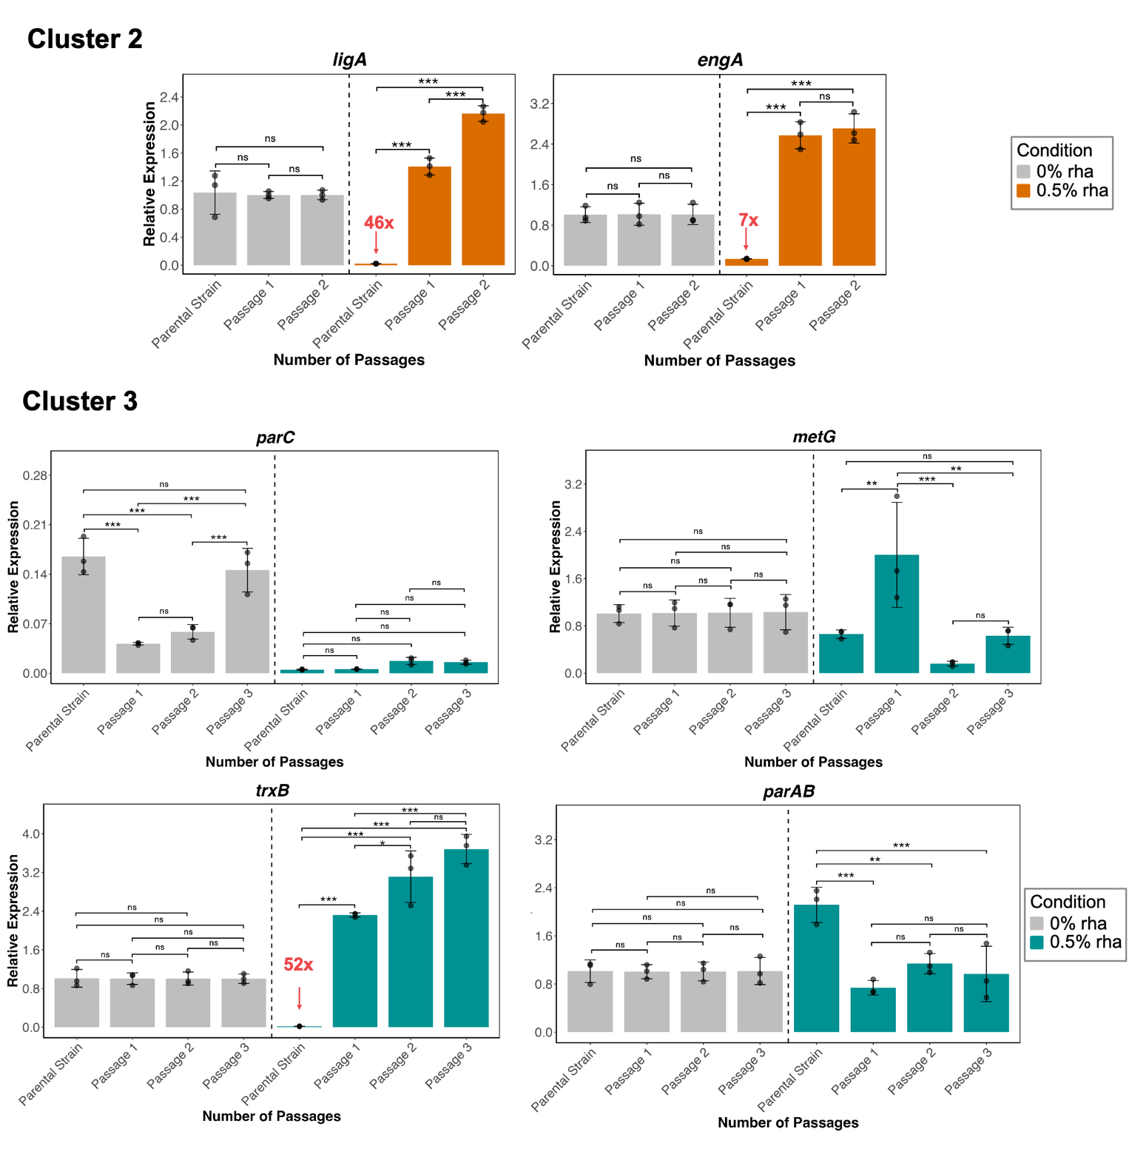
Supplementary Figure 18. Relative gene expression levels in CRISPRi mutants from Cluster 2 and 3. Expression levels were determined relative to sigE (sigma factor) and normalized to each parental strain under non-inducing conditions. Fold-change values were calculated using the 2^(ΔΔCt) method for data presentation. Statistical significance was assessed by two-way ANOVA performed on ΔΔCt values to evaluate the effects of passage and induction condition (***, p < 0.001; **, p < 0.01; *, p < 0.05). Black dots represent three independent biological replicates.

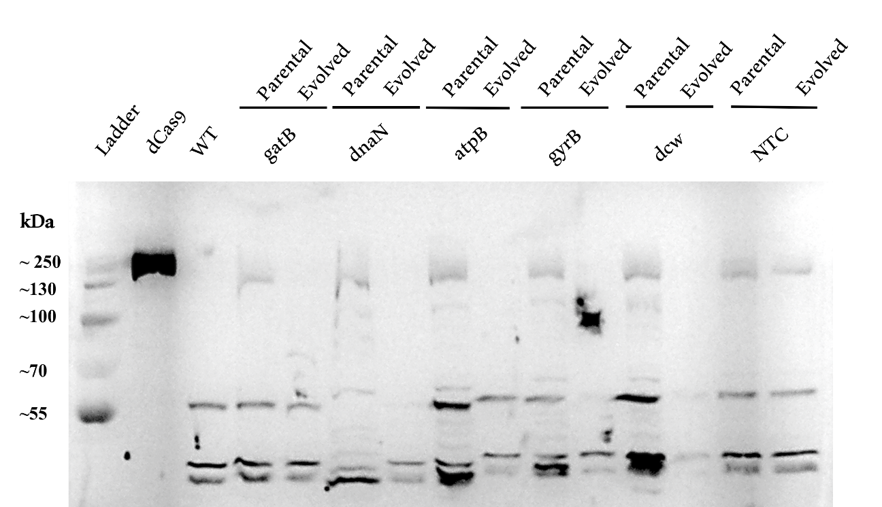
Supplementary Figure 19. Full Western Blot. Induction of dCas9 expression for parental and evolved strains is shown from left to right. Detection of dCas9 (~160 kDa) is shown in positive controls: purified dCas9 and parental strains induced with 0.5% rhamnose, a wild-type (WT) control was added as a negative control. Evolved CRISPRi mutants show a lack of dCas9 under dCas9-inducing conditions (0.5% rhamnose). In both parental and evolved CRISPRi NTC strains dCas9 protein was detected. Unspecific binding was detected in all strains, including the WT. Bacterial subcultures from overnights were grown in LB (trimethoprim 100μg/mL) until an OD_{600nm} of 0.7 was reached; after, 0.5% rhamnose was added to induce dCas9 expression for 4 hours. Then, cells were pelleted down and resuspended in TNG buffer (100 mM Tris-HCl, 150 mM NaCl, 10% glycerol, pH 7.4). Cell lysis was done in three sonication cycles of 5 seconds. Soluble proteins were run on an 8% SDS gel. Proteins were transferred by iBlot and blocked in 5% skim milk-TBST. The dCas9 protein was detected using a primary mouse monoclonal antibody (ThermoFisher 10C11A12) and detected by chemiluminescence using a second antibody (goat polyclonal anti-mouse - ThermoFisher G-21060) linked to alkaline phosphatase.

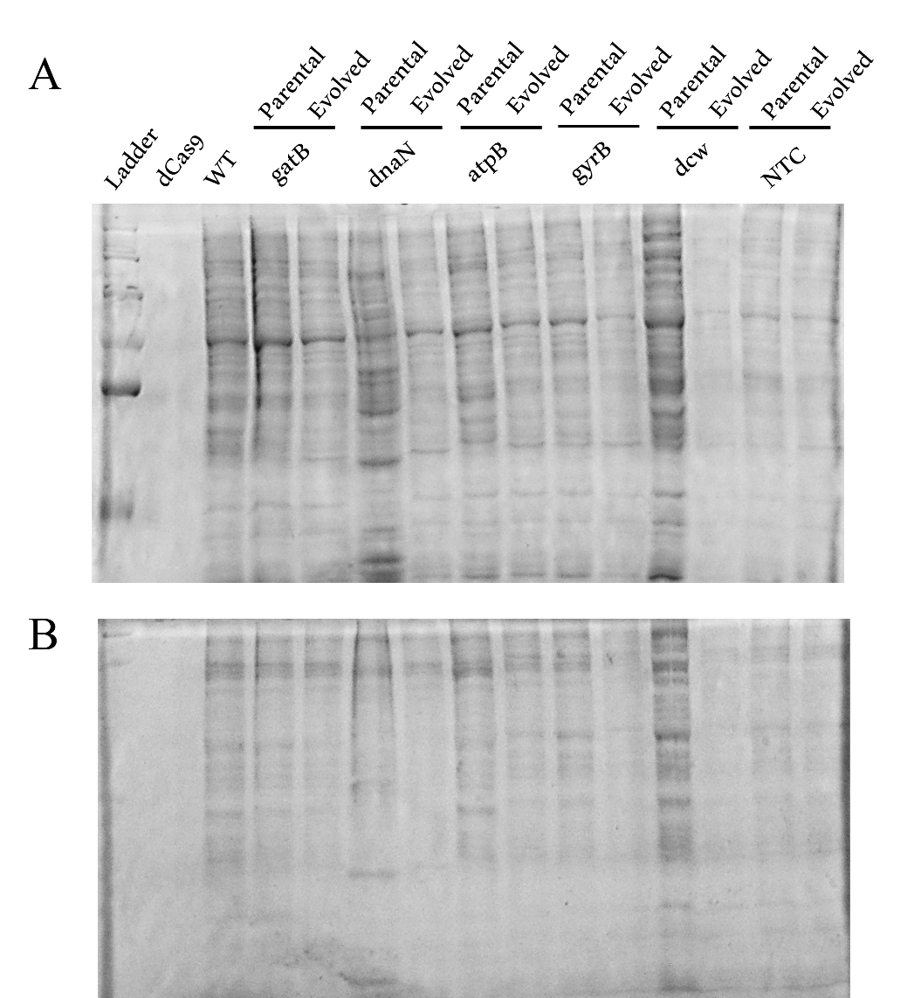
Supplementary Figure 20. SDS-PAGE loading controls for total protein confirmation.
(A) SDS-PAGE gel stained with Coomassie to demonstrate equal loading before transfer to the polyvinylidene difluoride (PVDF) membrane. (B) SDS-PAGE gel stained with Coomassie after transferring to the PVDF membrane presents the absence of the ladder, demonstrating successful transfer. The sample order for both gels is shown on the top.

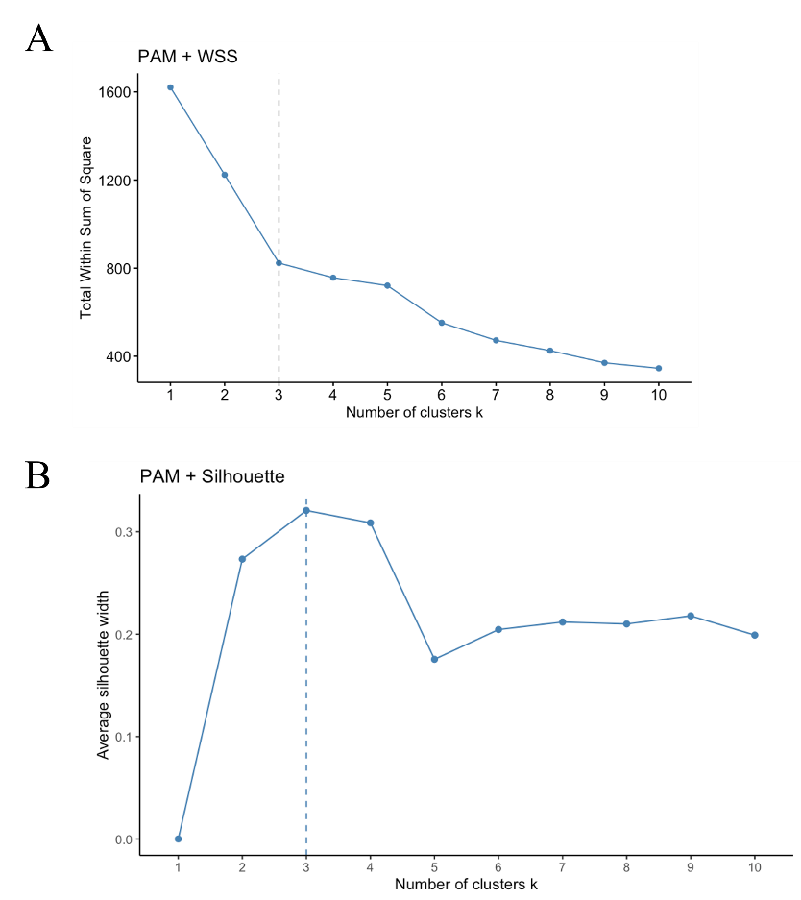
Supplementary Figure 21. Determination of the optimal number of clusters using WSS (Elbow) and Silhouette methods. The Within Sum of Squares (WSS) plot shows the “elbow” point, indicating three as the best number of clusters, marked by a sharp decrease in WSS. (B) The Silhouette method shows the average silhouette width for different cluster counts, with the highest score at three clusters.

Supplementary Tables
Supplementary Table 1. Strains used in this study.
Strain | Description* | Source
B. cenocepacia K56-2::dCas9/ pSCB2-sgRNAv2-atpB | Expressing sgRNA targeting atpB (K562_RS00155), dCas9 insertion, Tp^{R} | (Rahman et al., 2024)
B. cenocepacia K56-2::dCas9/ pSCB2-sgRNAv2-dnaN | Expressing sgRNA targeting dnaN (K562_RS02185), dCas9 insertion, Tp^{R} | (Rahman et al., 2024)
B. cenocepacia K56-2::dCas9/ pSCB2-sgRNAv2-gyrB | Expressing sgRNA targeting gyrB (K562_RS02180), dCas9 insertion, Tp^{R} | (Rahman et al., 2024)
B. cenocepacia K56-2::dCas9/ pSCB2-sgRNAv2-parC | Expressing sgRNA targeting parC (K562_RS06290), dCas9 insertion, Tp^{R} | (Rahman et al., 2024)
B. cenocepacia K56-2::dCas9/ pSCB2-sgRNAv2-metG | Expressing sgRNA targeting metG (K562_RS05945), dCas9 insertion, Tp^{R} | (Rahman et al., 2024)
B. cenocepacia K56-2::dCas9/ pSCB2-sgRNAv2-murC | Expressing sgRNA targeting murC (K562_RS16815), dCas9 insertion, Tp^{R} | (Rahman et al., 2024)
B. cenocepacia K56-2::dCas9/ pSCB2-sgRNAv2-mrdAB | Expressing sgRNA targeting mrdAB (K562_RS02475), Cas9 insertion, Tp^{R} | (Rahman et al., 2024)
B. cenocepacia K56-2::dCas9/ pSCB2-sgRNAv2-obgE | Expressing sgRNA targeting obgE (K562_RS16670), dCas9 insertion, Tp^{R} | (Rahman et al., 2024)
B. cenocepacia K56-2::dCas9/ pSCB2-sgRNAv2-trxB | Expressing sgRNA targeting trxB (K562_RS14600), dCas9 insertion, Tp^{R} | (Rahman et al., 2024)
B. cenocepacia K56-2::dCas9/ pSCB2-sgRNAv2-gatB | Expressing sgRNA targeting gatB operon(K62_RS02505), dCas9 insertion, Tp^{R} | (Rahman et al., 2024)
B. cenocepacia K56-2::dCas9/ pSCB2-sgRNAv2-parAB | Expressing sgRNA targeting parAB operon (K62_RS17180), dCas9 insertion, Tp^{R} | (Rahman et al., 2024)
B. cenocepacia K56-2::dCas9/ pSCB2-sgRNAv2-gmk | Expressing sgRNA targeting gmk (K562_RS14475), dCas9 insertion, Tp^{R} | (Rahman et al., 2024)
B. cenocepacia K56-2::dCas9/ pSCB2-sgRNAv2-ligA | Expressing sgRNA targeting ligA (K562_RS08175), dCas9 insertion, Tp^{R} | (Rahman et al., 2024)
B. cenocepacia K56-2::dCas9/ pSCB2-sgRNAv2-engA | Expressing sgRNA targeting engA (K562_RS09275), dCas9 insertion, Tp^{R} | (Rahman et al., 2024)
B. cenocepacia K56-2::dCas9/ pSCB2-sgRNAv2-sodB | Expressing sgRNA targeting sodB (K562_RS05385), dCas9 insertion, Tp^{R} | (Rahman et al., 2024)
B. cenocepacia K56-2::dCas9/ pSCB2-sgRNAv2-non target | Expressing pSCB2-sgRNAv2, dCas9 insertion, Tp^{R} | (Rahman et al., 2024)
* Tp^{R} = trimethoprim resistance.
Supplementary Table 2. Essential genes in Burkholderia cenocepacia K56-2 selected for this study, COG category, pathway, and function description.
COG category | Gene (product name) | Pathway | Function
Cycle Control, Cell Division, Chromosome Partitioning (D) | dcw cluster | Peptidoglycan biosynthesis | Division and cell wall cluster (dcw), of 15 genes responsible for peptidoglycan synthesis and cell division.
Cycle Control, Cell Division, Chromosome Partitioning (D) | engA | Ribosome associated | Necessary for normal cell division and for the maintenance of normal septation.
DNA Replication, Recombination and Repair (L) | dnaN | DNA Replication | DNA polymerase III subunit beta, confers DNA tethering and processivity to DNA polymerases and other proteins. Acts as a clamp, forming a ring around DNA which diffuses in an ATP-independent manner freely and bidirectionally along dsDNA.
DNA Replication, Recombination and Repair (L) | parC | DNA Replication | DNA topoisomerase IV, essential for chromosome segregation. It relaxes supercoiled DNA. Performs the decatenation events required during the replication of a circular DNA molecule.
DNA Replication, Recombination and Repair (L) | gyrB | DNA Replication | Type II topoisomerase (DNA gyrase) that negatively supercoils closed circular double-stranded (ds) DNA to modulate DNA topology and maintain chromosomes in an underwound state.
DNA Replication, Recombination and Repair (L) | ligA | Base excision repair | DNA ligase that catalyzes the formation of phosphodiester linkages between 5'-phosphoryl and 3'-hydroxyl groups in double-stranded DNA.
DNA Replication, Recombination and Repair (L) | parAB | Chromosome and associated proteins | parA parB operon, chromosome partitioning protein systems that ensure active segregation of plasmid copies prior to cell division.
Energy Production and Conversion (C) | atpB | Metabolic pathways | ATP synthase subunit A, key component of the proton channel; plays a direct role in the translocation of protons across the membrane
Energy Production and Conversion (C) | trxB | Pyrimidine metabolism | Thioredoxin reductase, belongs to the class-II pyridine nucleotide-disulfide oxidoreductase family.
Energy Production and Conversion (C) | sodB | Ethylene biosynthesis | Superoxide dismutase, destroys radicals which are normally produced within the cells and which are toxic to biological systems.
Translation (J) | gatB | Aminoacyl-tRNA biosynthesis | Amidotransferase subunit B, allows the formation of correctly charged Asn-tRNA(Asn) or Gln-tRNA(Gln).
Translation (J) | metG | Aminoacyl-tRNA biosynthesis | Methionine tRNA ligase, required not only for elongation of protein synthesis but also for the initiation of all mRNA translation through initiator tRNA(fMet) aminoacylation.
Translation (J) | obgE | Ribosome biogenesis biogenesis | GTPase, which plays a role in control of the cell cycle, stress response and ribosome biogenesis.
Nucleotide transport and metabolism (F) | gmk | Purine metabolism | Guanylate kinase, essential for recycling GMP and indirectly, cGMP.
Cell Wall, Membrane, Envelope Biogenesis (M) | mrdAB | Peptidoglycan biosynthesis | Cell wall shape-determining proteinC, catalyzes cross-linking of the peptidoglycan cell wall.
Supplementary Table 3. Growth parameters obtained with R package “growthcurver” for CGP characterization and cluster analysis.
Argument/Parameter | Description
Initial population size (n0) | Initial population size at the beginning of the growth curve.
Growth rate (r/µ) | Increase of cells proportional to the number of bacteria present at that time. The constant of proportionality, µ, is an index of the growth rate and is called the growth rate constant.
Deceleration phase (t_mid) | The time at the inflection point of the logistic curve (end of logarithmic phase), also known as deceleration or stationary phase.
Generation time (t_gen) | Defined by the time (or predictable time) needed under optimal conditions, for a population of cells (bacteria) to double in number.
Apparent lag time (lag) | Starting point of the S-curve, cells are adapting. Although cells are active, they do not start dividing during the lag phase. The length of the lag phase will also depend on the age and general viability of the cells in the inoculum.
Maximum OD (Max OD) | Maximum optical density (OD) at the end of the curve.

Supplementary Table 4. List of sgRNAs, locus tags and protein IDs used for essential-gene knockdown in Burkholderia cenocepacia K56-2.
Gene (product name) |  | sgRNA | sgRNA GC% content |  | PAM | Locus tag(s) | Protein ID(s)
dcw cluster | ACTTTCCGCTCTCCCGTTCA |  |  | 55 | GGG | K562_RS16815 | WP_006487098.1
 |  |  |  |  |  | K562_RS16810 | WP_006487084.1
 |  |  |  |  |  | K562_RS16805 | WP_006477019.1
 |  |  |  |  |  | K562_RS16800 | WP_006487155.1
 |  |  |  |  |  | K562_RS16790 | WP_006487111.1
 |  |  |  |  |  | K562_RS16785 | WP_006487095.1
 |  |  |  |  |  | K562_RS16780 | WP_006487105.1
 |  |  |  |  |  | K562_RS16775 | WP_006477014.1
 |  |  |  |  |  | K562_RS16770 | WP_006487138.1
 |  |  |  |  |  | K562_RS16765 | WP_006487140.1
engA | GGTTTCATCTGTGTTTTCTA |  |  | 35 | GCC | K562_RS09275 | WP_006493685.1
dnaN | GGCTCTTGGCCCGCCACCAC |  |  | 75 | GCC | K562_RS02185 | WP_006493926.1
parC | GCTGAATTTCGTCATTCATC |  |  | 40 | CCC | K562_RS06290 | WP_006487625.1
gyrB | GCCCGCCCCAAGTGCCGAAA |  |  | 70 | GGA | K562_RS02180 | WP_006490993.1
ligA | TTGGGTTCGGGCCATGCTGG |  |  | 65 | GCC | K562_RS08175 | WP_006484653.1
parAB | GGTTTATGCGCATAAACGAG |  |  | 45 | GCC | K562_RS17180 | WP_006485146.1
atpB | CGATAGTTGCAAGTGATTCA |  |  | 40 | TCC | K562_RS00155 | WP_012492242.1
trxB | GACATGTGCGAATCCGTAAA |  |  | 45 | TCC | K562_RS14600 | WP_006491171.1
sodB | CGGCGGGAGCGTATGAGCCA |  |  | 70 | GGT | K562_RS05385 | WP_006489396.1
gatB | GGTCAGGGCCATGCGATCAC |  |  | 65 | GCC | K562_RS02505 | WP_006494379.1
metG | TCGGATGCGGACATAGGGTC |  |  | 60 | GGT | K562_RS05945 | WP_006493649.1
obgE | TCCGCTATTGTGCCGCGCGC |  |  | 70 | GGC | K562_RS16670 | WP_006489254.1
gmk | TCATGGTTCGTCTCGCCGTC |  |  | 60 | GGT | K562_RS14475 | WP_006486663.1
mrdAB | CGTTGAATTCGGTCATTTAA |  |  | 35 | GGG | K562_RS02475 | WP_006482564.1
NTC* | CGCCGTGCACTCGCGCCGCC |  |  | 85 | NA | NA | NA
*NTC = Non-Targeting Control, NA = Not Applicable
Supplementary Table 5. SNP analysis all mutants. Provided as a separate Excel file

Supplementary Table 6. Unique mutation analysis. Provided as a separate Excel file

Supplementary Table 7. Unique mutations found in evolved CRISPRi mutants, relative to both NTC evolved control and wild type reference genome
Mutant | Locus affected | Encoded Product | Mutation
dcw | K562_RS18055 | malate:quinone oxidoreductase (Mqo) | insertion upstream of the start codon
dnaN | K562_RS32635 | hypothetical protein. | frameshift affecting reading frame
gatB | K562_RS12890 | IS66-like element ISBcen19 family transposase | insertion causing frameshift and early termination
gyrB | K562_RS10405 | sugar/ribose ABC transporter ATP-binding protein | insertion causing a frameshift affecting the stop codon
gyrB | K562_RS01770 | type VI secretion system baseplate subunit TssK | deletion causing frameshift and early termination
gyrB | K562_RS00260 | ABC transporter substrate-binding protein | deletion causing frameshift and early termination
gyrB | K562_RS18470 | 3-oxoacyl-ACP synthase | deletion causing frameshift and early termination
gyrB | K562_RS18055 | malate:quinone oxidoreductase (Mqo) | insertion upstream of start codon
gyrB | K562_RS31725 | IS3 family transposase | deletion causing frameshift affecting the stop codon

Supplementary Table 8. List of designed and validated primers for RT-qPCR targeting essential genes in Burkholderia cenocepacia K56-2.*
Target Gene | Primer sequences (5’- 3’) | Locus Tag | Efficiency (%) | R²
atpB | Forward:  CATGTGGAGCTTCGGTGG | K562_RS00155 | 94.90 | 0.997
atpB | Reverse: CCGAGATACACCAGCGTCAG | K562_RS00155 | 94.90 | 0.997
dnaN | Forward:  CGTGACGTTGAAGCCGATG | K562_RS02185 | 93.69 | 0.985
dnaN | Reverse:  GATCAGGAAGAGGCGCAGG | K562_RS02185 | 93.69 | 0.985
murC dcw cluster | Forward:  GATCAGGAAGAGGCGCAGG | K562_RS16765 | 97.03 | 0.996
murC dcw cluster | Reverse: CGAGATGGACAAGTGCTTCCAG | K562_RS16765 | 97.03 | 0.996
gatB | Forward:  GTCGGCCAGGAGAAGTTCG | K562_RS02510 | 100.34 | 0.995
gatB | Reverse: CTTCGTAATTGATCGCTTCCTCG | K562_RS02510 | 100.34 | 0.995
gyrB | Forward: GAAGATGAACGACAAGCACG | K562_RS02180 | 94.19 | 0.991
gyrB | Reverse:  CCTTGTAGCTGTTCTGGTCG | K562_RS02180 | 94.19 | 0.991
engA | Forward: GGAAACCTACAAGCGCTACC | K562_RS09275 | 96.52 | 0.989
engA | Reverse:  CGGAACTCTATGCGCAATGG | K562_RS09275 | 96.52 | 0.989
ligA | Forward:  GCTCGACTTCTTCCGCAAG | K562_RS08175 | 90.64 | 0.887
ligA | Reverse:  GTTGACCTTGTAGACGACGC | K562_RS08175 | 90.64 | 0.887
metG | Forward:  GAAGGATCGGACAAGCTGC | K562_RS05945 | 108.43 | 0.943
metG | Reverse:  GAAGGATCGGACAAGCTGC | K562_RS05945 | 108.43 | 0.943
parAB | Forward:  CGCCTGCTCCGGAATTCAC | K562_RS17180 | 90.07 | 0.982
parAB | Reverse:  GATTCTCGAGACGCCACGC | K562_RS17180 | 90.07 | 0.982
parC | Forward:  GCAGGCCGAGGACATTC | K562_RS06290 | 100.90 | 0.972
parC | Reverse: GAGTTCCTTCTCGATCTTGATC | K562_RS06290 | 100.90 | 0.972
trxB | Forward:  CACATCCACACCGCGAAAC | K562_RS14600 | 97.45 | 0.987
trxB | Reverse:  CGAATCGCACGTGTACTCG | K562_RS14600 | 97.45 | 0.987
*Note: linear regression analysis was performed to obtain primer efficiency and R².

