Supplimentary material

Images of various pants and animal species involve in this paper.

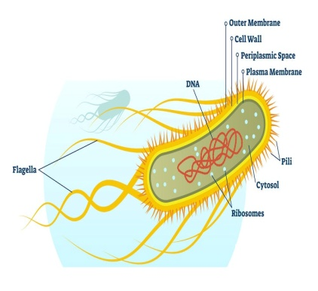
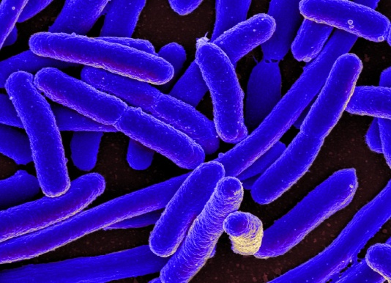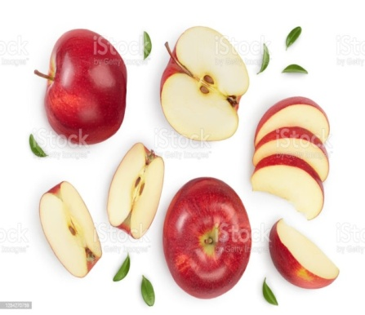
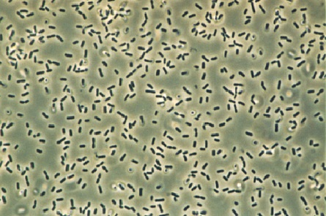

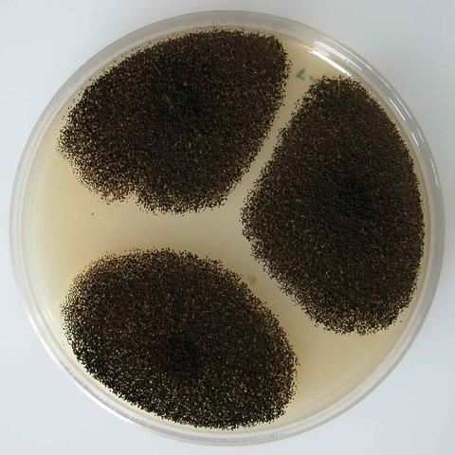

Energy dispersive X-ray spectroscopy
Element | Weight% | Atomic%
C K | 60.36 | 66.98
O K | 39.64 | 33.02
Totals | 100.00
Element | Weight% | Atomic%
C K | 75.84 | 80.70
O K | 24.16 | 19.30
Totals | 100.00
E-DAX analysis EDS analysis of rGO prepared
of graphene oxide by reduction with E coli
Element | Weight% | Atomic%
C K | 63.09 | 69.48
O K | 36.91 | 30.52
Totals | 100.00
EDS analysis of rGO prepared by reduction using Fruit extract

