SUPPLEMENTARY MATERIAL

Fungal and Plant Extracts Improve Germination and Early Development of Urochloa brizantha

Tiago de Oliveira Sousa (https://orcid.org/0000-0001-7855-348X)¹
Thalesram Izidoro Pinotti (https://orcid.org/0009-0004-5063-0606)^{1*}
Tamires Barreto Costa (https://orcid.org/0009-0006-9711-1840)²
Alzair de Sousa Mesquita (https://orcid.org/0009-0005-8592-3836)³
Sulimary Oliveira Gomes (https://orcid.org/0000-0003-2929-8456)¹
Alice Maria Gonçalves Santos (https://orcid.org/0000-0003-0672-1709)¹
Thiago Pajeú Nascimento (https://orcid.org/0000-0003-3480-6734)²

¹ Department of Agronomy, Federal University of Piauí, Bom Jesus, Piauí, Brazil.
² Department of Biological Sciences, Federal University of Piauí, Bom Jesus, Brazil.
³ Department of Animal Sciences, Federal University of Piauí, Bom Jesus, Piauí, Brazil.

*Corresponding author. Email address: thalesram@hotmail.com
Table S1. Mean squares from the analysis of variance for germination speed index (GSI), first germination count (FGC), germination percentage (G), shoot fresh mass (SFM), root fresh mass (RFM), total fresh mass (TFM), shoot dry mass (SDM), root dry mass (RDM), total dry mass (TDM), shoot length (SL), root length (RL), total seedling length (TSL), seedling vigor indices I and II (SVI I and SVI II), and seedling water content (WC) of Urochloa brizantha cv. MG-5 as affected by seed treatment, seed scarification, and their interaction.
Source of variation |  | Variables
Source of variation | DF | GSI | FGC | G | SFM | RFM | TFM | TFM
Seed treatment (ST) | 4 | 14.4* | 597.4* | 690.4* | 0.0086** | 0.0029^{ns} | 0.0132^{ns} | 3.43×10⁻⁵ **
Seed (S) | 1 | 189.6** | 5569.6** | 3496.9** | 0.0057^{ns} | 0.0089* | 0.0288* | 2.25×10^{-5 ns}
ST * S | 4 | 3.9^{ns} | 236.1^{ns} | 282.7^{ns} | 0.0005^{ns} | 0.0013^{ns} | 0.0019^{ns} | 9.69×10^{-6 ns}
Residue | 30 | 3.9 | 217.7 | 202.8 | 0.0018 | 0.0016 | 0.0054 | 6.72×10⁻⁶
C.V (%) |  | 24.7 | 27.02 | 23.95 | 18.01 | 29.02 | 19.79 | 10.06
Source of variation |  | Variables
Source of variation | DF | SDM | TDM | SL | RL | TSL | SV I | SV II | WC
Seed treatment (ST) | 4 | 1.89×10^{-5 ns} | 8.87×10⁻⁵ ** | 3.7407** | 1.3711** | 3.012^{ns} | 128,330.8* | 3.657* | 20.60 ^{ns}
Seed (S) | 1 | 0.0009 ** | 1.22×10⁻³ ** | 3.3178^{ns} | 9.5160** | 24.056** | 959,368.7** | 2.948 ^{ns} | 1.726 ^{ns}
ST * S | 4 | 2.43×10^{-5 ns} | 3.61×10^{-5 ns} | 1.3124^{ns} | 1.4027** | 2.706^{ns} | 67,415.6 ^{ns} | 1.389 ^{ns} | 11.636 ^{ns}
Residue | 30 | 1.03×10⁻⁵ | 1.83×10⁻⁵ | 0.9122 | 0.3367 | 1.45 | 32,894,2 | 1.146 | 11.713
C.V (%) |  | 7.80 | 6.39 | 13.15 | 11.88 | 9.91 | 24.7 | 27.2 | 4.20
C. V: coefficient of variation; * variable was significant at 5%; ** variable was significant at 1%; ^{ns} Not significant
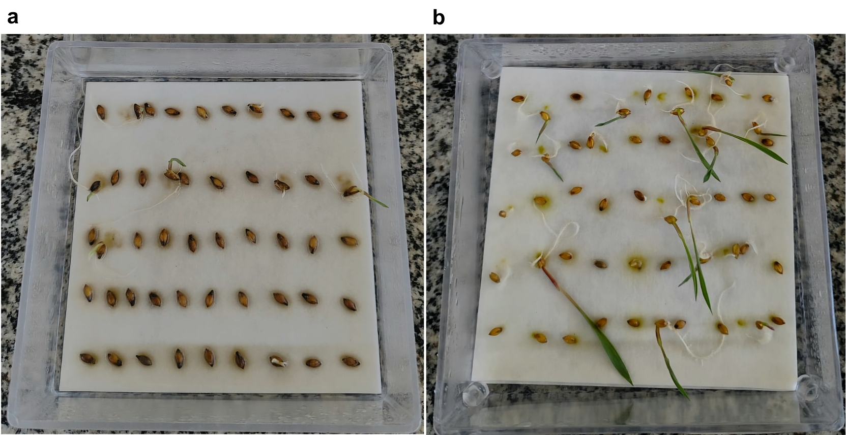
Fig. S1 Germination of non-scarified (A) and scarified (B) seeds of Urochloa brizantha cv. MG-5 under the control treatment (T1).

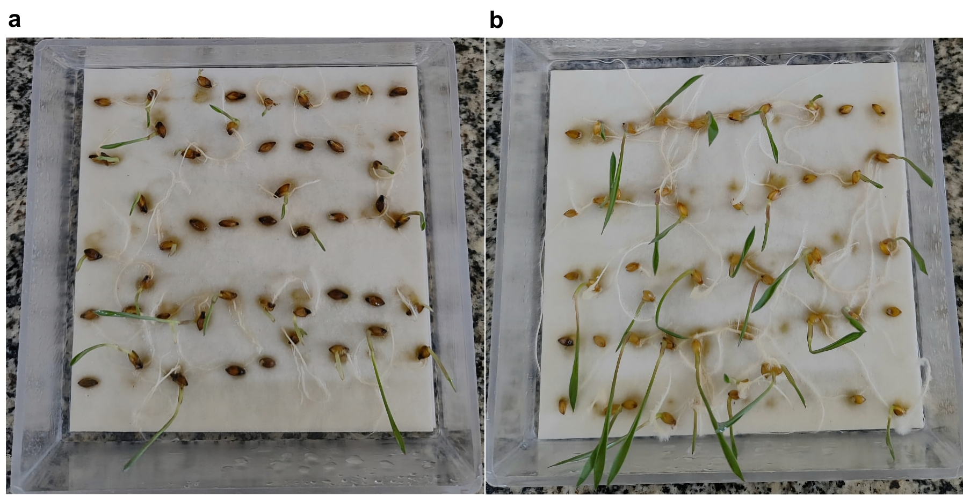
Fig S2 Germination of non-scarified (A) and scarified (B) seeds of Urochloa brizantha cv. MG-5 after treatment with the commercial product (T2)

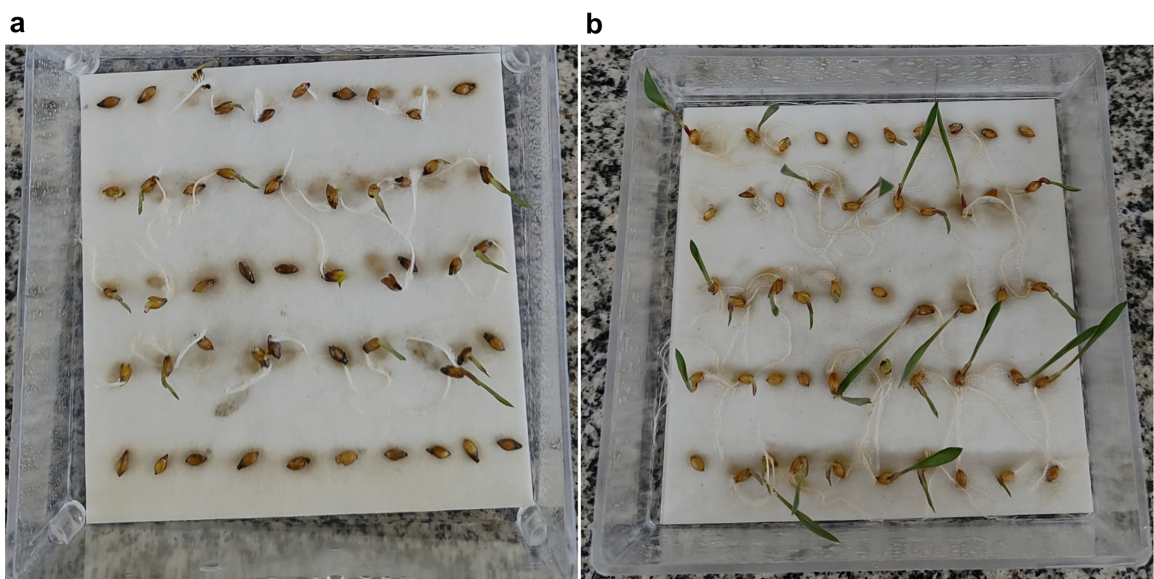
Fig S3 Germination of non-scarified (A) and scarified (B) seeds of Urochloa brizantha cv. MG-5 after treatment with the Trichoderma orientale extract produced on orange peel (T3)

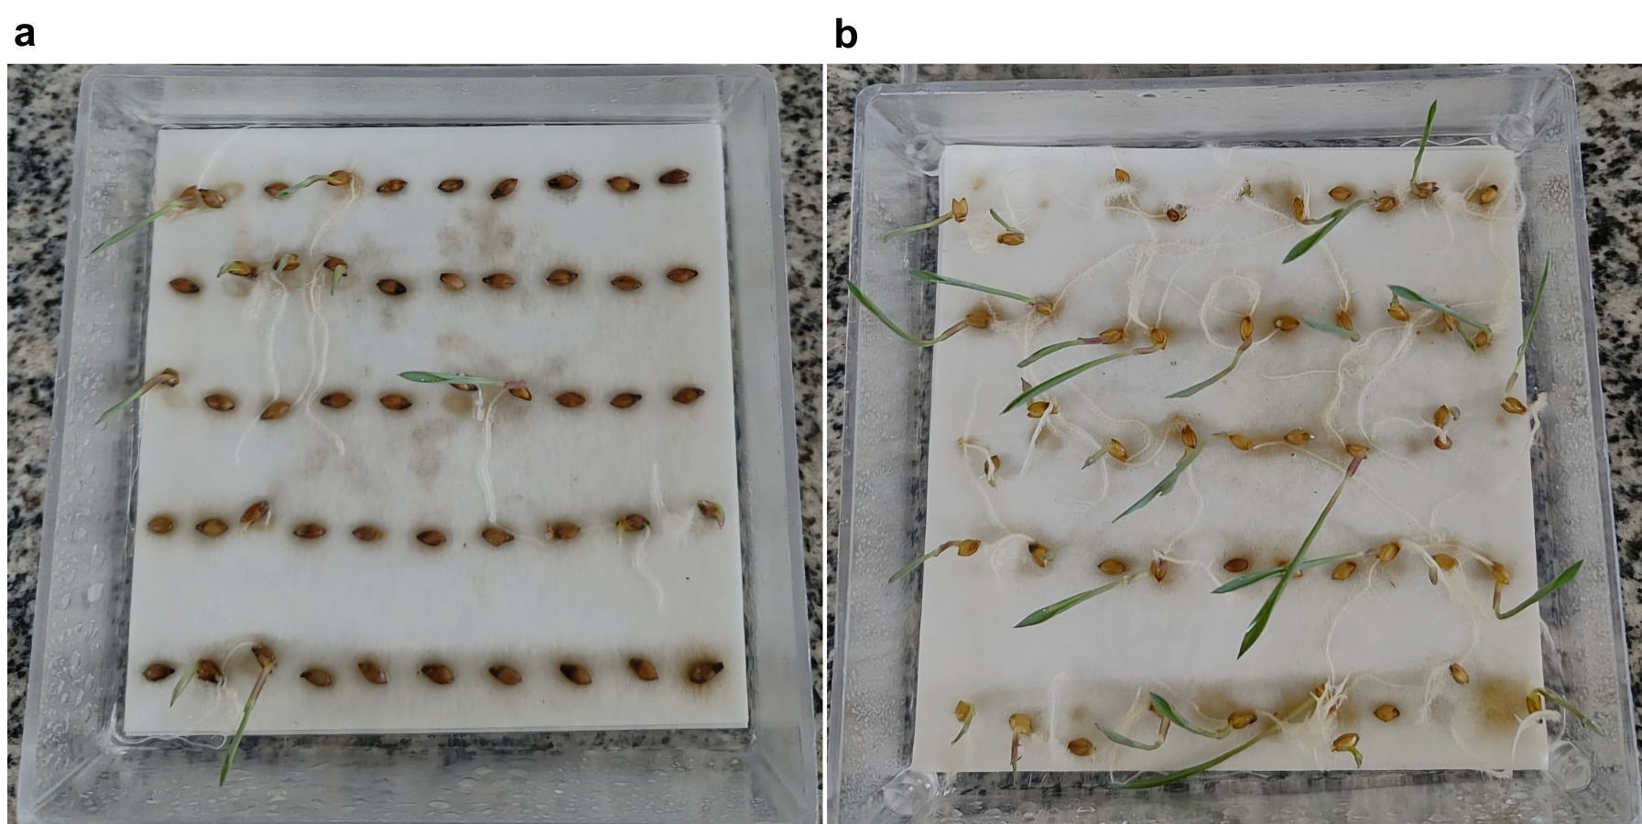
Fig S4 Germination of non-scarified (A) and scarified (B) seeds of Urochloa brizantha cv. MG-5 after treatment with the Trichoderma orientale extract produced on maize cob (T4)

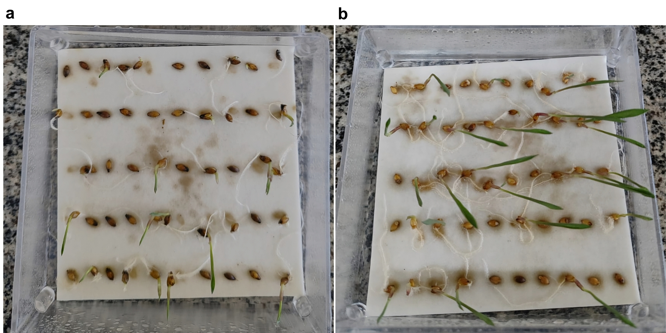
Fig S5 Germination of non-scarified (A) and scarified (B) seeds of Urochloa brizantha cv. MG-5 after treatment with the Pereskia aculeata leaf extract (T5)

