Crimean-Congo hemorrhagic fever virus protein GP38 from isolate M18-China confers broad immunological breadth SUPPLEMENTAL

Albert Wang,¹† Stephanie R. Monticelli,^{2,3}† Christy K. Hjorth,⁴* Thomas Batchelor,^{2,5}* Alexandra L. Tse,¹ Ana I. Keuhne,² Russell R. Bakken,² N. A. Saavedra-Avila,¹* Gorka Lasso,¹* Jacob Berrigan,¹ Steven A. Porcelli,¹ Jason S. McLellan,⁴ Andrew S. Herbert,²# Kartik Chandran¹#

¹ Department of Microbiology and Immunology, Albert Einstein College of Medicine, Bronx, NY, USA
² U.S. Army Medical Research Institute of Infectious Diseases, Fort Detrick, MD, USA
³ Henry M. Jackson Foundation for Military Advancement, Fort Detrick, MD, USA
⁴ Department of Molecular Biosciences, The University of Texas at Austin, Austin, Texas, USA
⁵ Oak Ridge Institute of Science Education, Oak Ridge, TN, USA

# Correspondence: kartik.chandran@einsteinmed.edu, andrew.s.herbert4.civ@health.mil

* Present addresses: Christy K. Hjorth, GlaxoSmithKline, Cambridge, MA, USA. Thomas Batchelor, Department of Molecular, Cell, and Developmental Biology, University of California, Santa Cruz, CA, USA. N. A. Saavedra-Avila, Gilead Sciences, Foster City, CA, USA. Gorka Lasso, Institute of Infection, Immunity and Transplantation, University College London, London, United Kingdom.

† Albert Wang and Stephanie R. Monticelli contributed equally to this work.

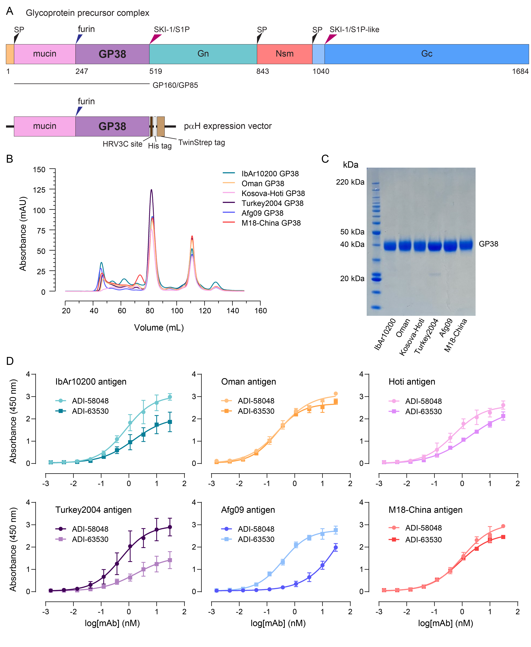
Supplemental Figure 1. Expression and purification of CCHFV-GP38 panel

S1A Schematic of M-segment encoded glycoprotein precursor complex (GPC) with cleavage sites and processed glycoproteins. Recombinant GP38 antigens were expressed with their mucin-like domains, affinity purified, and treated with HRV 3C protease to remove purification tags. S1B Size exclusion chromatography (SEC) traces of purified rGP38 antigens post-cleavage on a Superdex 200 column with (S1C) corresponding protein gel. S1D Folding of rGP38 antigens were interrogated by ELISA with previously characterized conformation-sensitive monoclonal antibodies (mAbs) ADI-58048 and ADI-63530 (N=3, n=6).
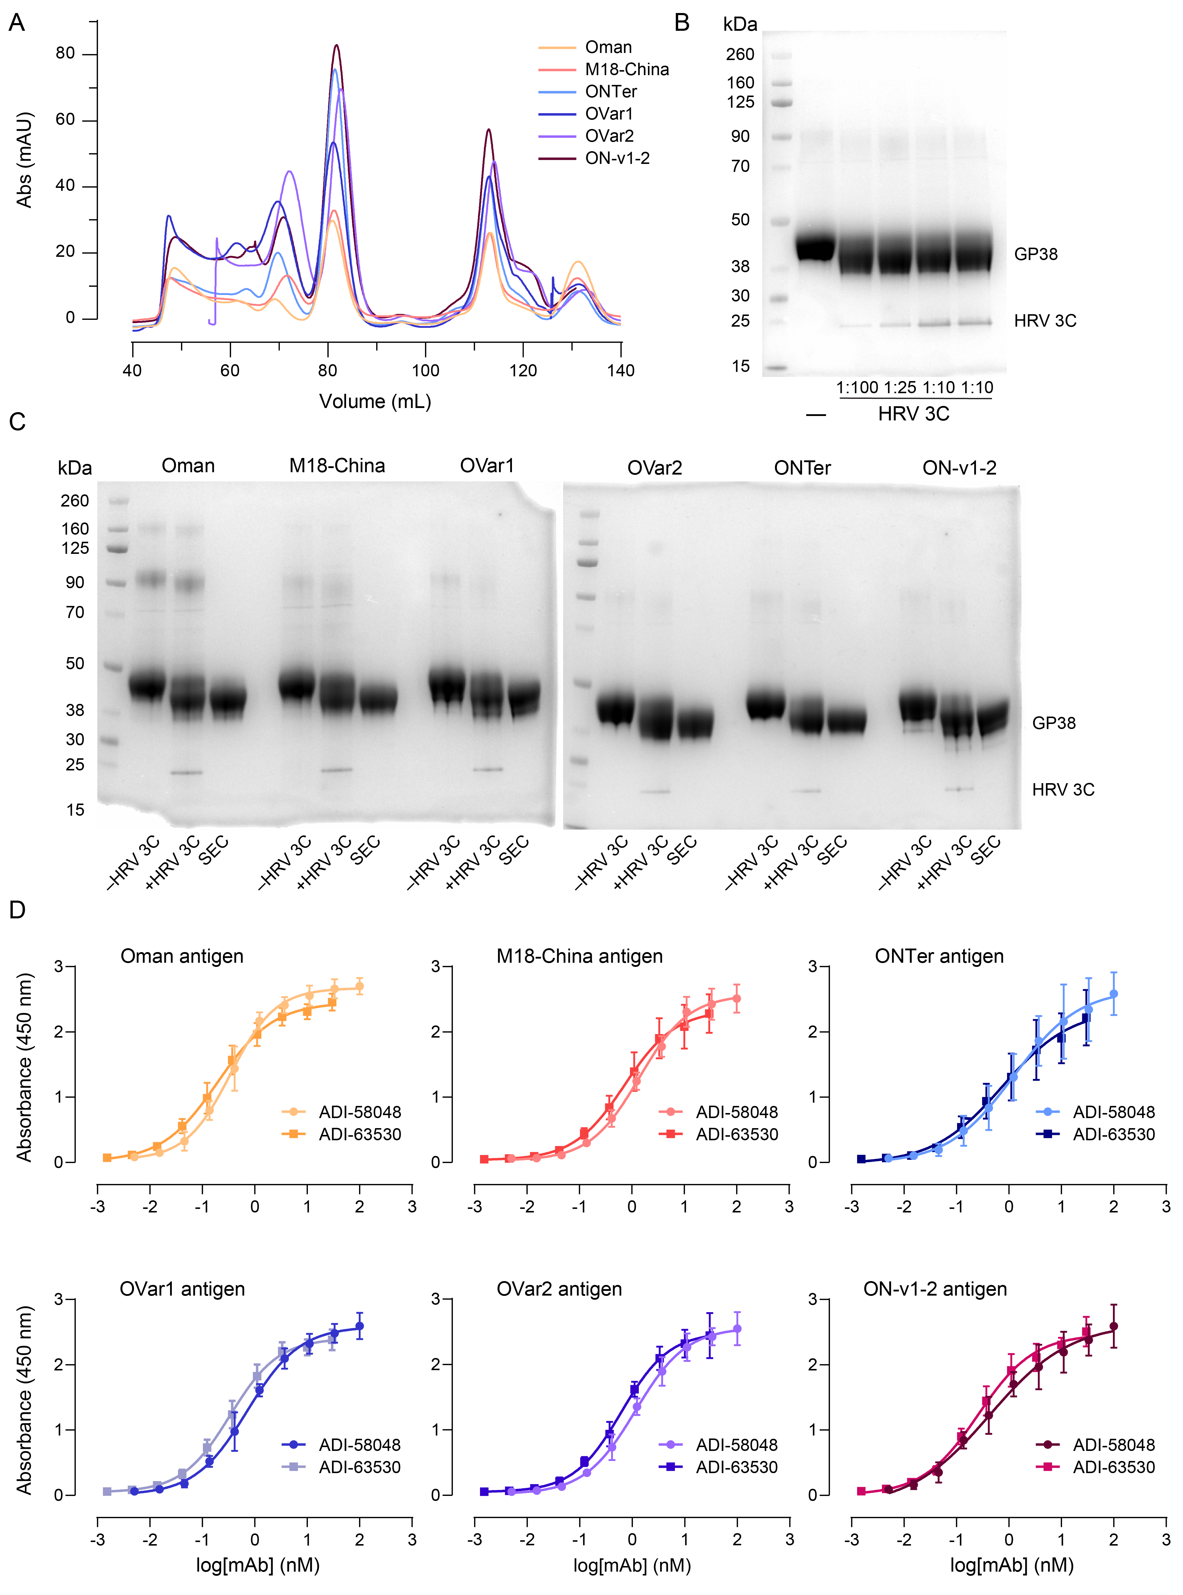
Supplemental Figure 2. Expression and purification of rGP38 chimeras

S2A SEC traces chimeric rGP38 antigens after HRV 3C protease treatment. S2B Protein gel of rGP38 with varying ratios of rGP38:HRV 3C protease and resulting cleavage. S2C Protein gel of chimeric rGP38 pre- and post- HRV 3C protease digestion and after SEC purification. S2D ELISAs of chimeric rGP38 antigens detected by conformationally sensitive antibodies (N=3; n=6).
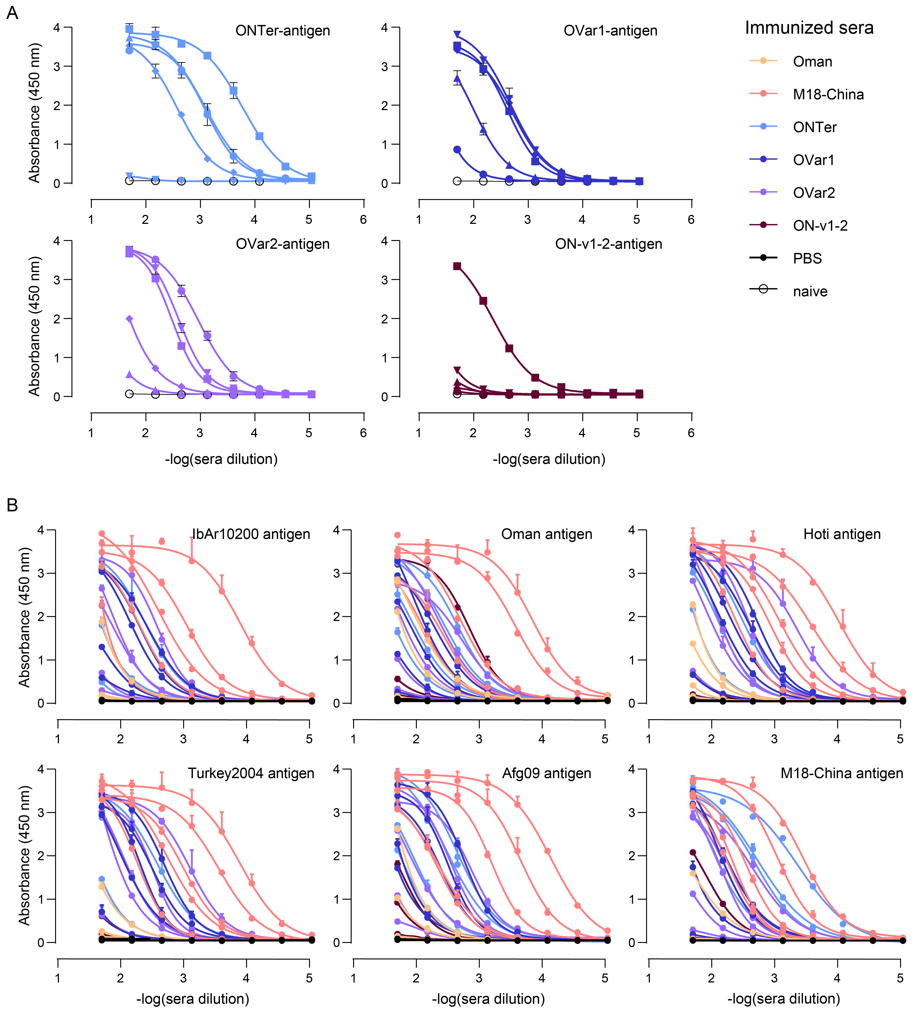
Supplemental Figure 3. Homotypic and heterotypic chimera rGP38 ELISAs

S3A Homotypic chimeric rGP38 sera ELISAs against respective antigens (N=1, n=2). Mouse sera within each group (5 mice / group) are individually plotted and delineated by separate shapes. S3B Heterotypic chimeric rGP38 sera ELISAs against original 6x rGP38 panel (N=1, n=2). Mouse sera within each group (5 mice / group) are individually plotted.

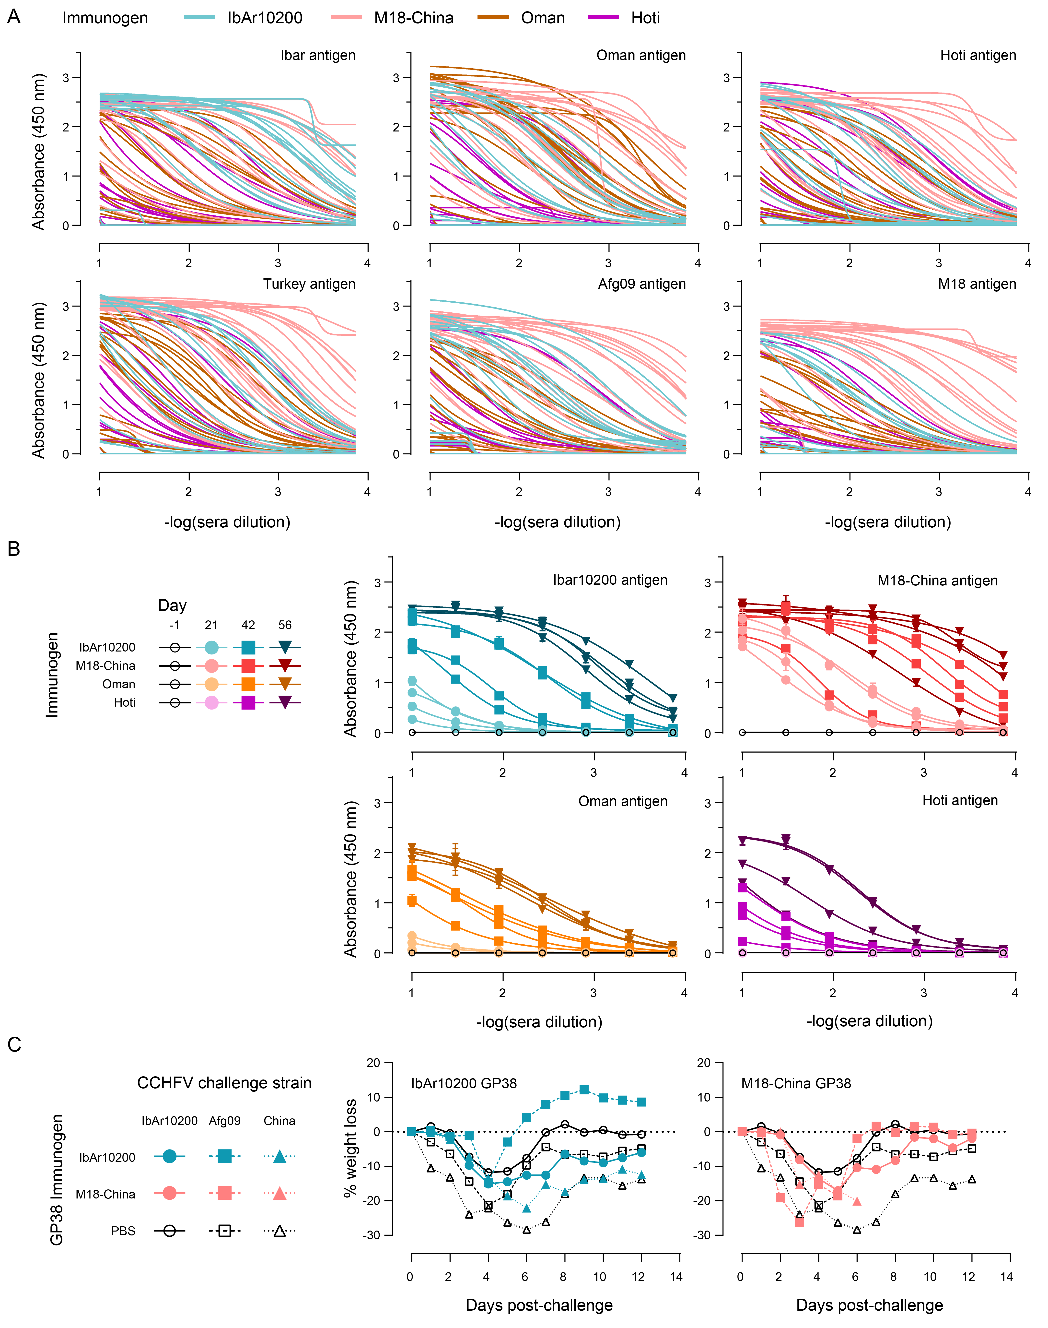Supplemental Figure 4. Homotypic and heterotypic rGP38 vaccination ELISAs

S4A Heterotypic rGP38-vaccinated mouse sera ELISAs against respective antigens (N=1, n=2). Mouse sera within each group (20 mice / group) are individually plotted. S4B Homotypic rGP38-vaccinated mouse sera ELISAs against self-antigens over time. Each curve represents 5 pooled sera samples / group. S4C Weight loss of rGP38 or PBS-vaccinated mice (n=10-15) against lethal CCHFV challenge. Points represent the average weight of surviving mice at each time point.
Supplementary Table 1: Figure 2D AUC descriptive statistics
Oman GP38 coating antigen binding AUC

Sera | Oman | IbAr | M18-China | PBS
n | 4 | 4 | 4 | 3
Minimum | 0.2621 | 0.2734 | 2.432 | 0.2048
Maximum | 2.488 | 1.559 | 8.318 | 0.2196
Range | 2.226 | 1.286 | 5.886 | 0.01480
Mean | 1.348 | 0.8095 | 5.877 | 0.2142
Std. Deviation | 1.033 | 0.6021 | 2.480 | 0.008171
IbAr10200 GP38 coating antigen binding AUC

Sera | Oman | IbAr | M18-China | PBS
n | 4 | 4 | 4 | 3
Minimum | 0.2259 | 0.8879 | 2.038 | 0.2808
Maximum | 1.107 | 5.329 | 6.858 | 0.3815
Range | 0.8811 | 4.441 | 4.820 | 0.1007
Mean | 0.4563 | 2.711 | 4.268 | 0.3171
Std. Deviation | 0.4340 | 1.898 | 2.164 | 0.05592
M18-China GP38 coating antigen binding AUC

Sera | Oman | IbAr | M18-China | PBS
n | 4 | 4 | 4 | 3
Minimum | 0.2029 | 0.2041 | 3.665 | 0.2278
Maximum | 0.2429 | 0.5215 | 6.959 | 0.3383
Range | 0.04000 | 0.3174 | 3.294 | 0.1105
Mean | 0.2183 | 0.3197 | 5.357 | 0.2667
Std. Deviation | 0.01769 | 0.1501 | 1.351 | 0.06211

Supplementary Table 2: Figure 3B MAGPIX MFI descriptive statistics
Week+2 PBS-immunized mouse sera binding MFI

Antigen (bead #) | IbAr (15) | Oman (18) | Hoti (21) | Turkey (27) | Afg09 (29) | M18 (33)
n | 6 | 6 | 6 | 6 | 6 | 6
Minimum | 138.4 | 67.00 | 70.50 | 120.0 | 91.25 | 63.76
Maximum | 269.8 | 265.5 | 25125 | 173763 | 664.4 | 999.5
Range | 131.4 | 198.5 | 25055 | 173643 | 573.1 | 935.7
Mean | 182.9 | 114.1 | 4260 | 49964 | 268.1 | 224.9
Std. Deviation | 48.67 | 75.15 | 10222 | 78372 | 209.1 | 379.5
Week+2 IbAr10200 rGP38-immunized mouse sera binding MFI

Antigen (bead #) | IbAr (15) | Oman (18) | Hoti (21) | Turkey (27) | Afg09 (29) | M18 (33)
n | 6 | 6 | 6 | 6 | 6 | 6
Minimum | 158.0 | 56.25 | 62.00 | 92.50 | 117.5 | 58.25
Maximum | 7805 | 2639 | 1707 | 2866 | 6212 | 1115
Range | 7647 | 2583 | 1645 | 2774 | 6095 | 1057
Mean | 4288 | 1746 | 1244 | 1921 | 3497 | 360.5
Std. Deviation | 3354 | 1037 | 600.8 | 958.8 | 2117 | 381.2
Week+2 Oman rGP38-immunized mouse sera binding MFI

Antigen (bead #) | IbAr (15) | Oman (18) | Hoti (21) | Turkey (27) | Afg09 (29) | M18 (33)
n | 6 | 6 | 6 | 6 | 6 | 6
Minimum | 182.0 | 96.25 | 72.25 | 77.00 | 174.5 | 66.25
Maximum | 279.3 | 1331 | 483.5 | 541.3 | 536.4 | 145.6
Range | 97.25 | 1235 | 411.3 | 464.3 | 361.9 | 79.38
Mean | 231.3 | 332.9 | 179.5 | 250.7 | 287.4 | 104.4
Std. Deviation | 43.30 | 490.2 | 155.1 | 179.4 | 141.1 | 38.19
Week+2 Hoti rGP38-immunized mouse sera binding MFI

Antigen (bead #) | IbAr (15) | Oman (18) | Hoti (21) | Turkey (27) | Afg09 (29) | M18 (33)
n | 6 | 6 | 6 | 6 | 6 | 6
Minimum | 149.3 | 83.63 | 114.3 | 129.3 | 120.5 | 69.75
Maximum | 425.0 | 168.0 | 277.0 | 558.5 | 492.8 | 130.6
Range | 275.8 | 84.37 | 162.8 | 429.3 | 372.3 | 60.88
Mean | 219.3 | 100.8 | 173.5 | 260.0 | 251.0 | 91.27
Std. Deviation | 105.1 | 33.00 | 62.26 | 153.8 | 144.7 | 20.96
Week+2 Turkey2004 rGP38-immunized mouse sera binding MFI

Antigen (bead #) | IbAr (15) | Oman (18) | Hoti (21) | Turkey (27) | Afg09 (29) | M18 (33)
n | 6 | 6 | 4 | 6 | 6 | 6
Minimum | 148.6 | 62.88 | 70.54 | 120.3 | 91.26 | 63.75
Maximum | 203.8 | 810.3 | 8262 | 1737 | 245.0 | 759.4
Range | 55.17 | 747.4 | 8192 | 1617 | 153.7 | 695.6
Mean | 181.6 | 303.8 | 2172 | 588.7 | 164.0 | 190.5
Std. Deviation | 22.45 | 344.1 | 4061 | 715.9 | 52.79 | 279.0
Week+2 Afg09 rGP38-immunized mouse sera binding MFI

Antigen (bead #) | IbAr (15) | Oman (18) | Hoti (21) | Turkey (27) | Afg09 (29) | M18 (33)
n | 6 | 6 | 6 | 6 | 6 | 6
Minimum | 132.0 | 83.50 | 100.1 | 108.3 | 294.8 | 75.25
Maximum | 503.6 | 438.3 | 514.4 | 791.0 | 4413 | 199.0
Range | 371.6 | 354.8 | 414.3 | 682.8 | 4118 | 123.8
Mean | 284.6 | 196.5 | 273.0 | 379.0 | 2482 | 131.1
Std. Deviation | 133.0 | 128.8 | 149.3 | 241.8 | 1675 | 55.35
Week+2 M18-China rGP38-immunized mouse sera binding MFI

Antigen (bead #) | IbAr (15) | Oman (18) | Hoti (21) | Turkey (27) | Afg09 (29) | M18 (33)
n | 6 | 6 | 6 | 6 | 6 | 6
Minimum | 410.4 | 403.0 | 335.9 | 690.3 | 922.9 | 94.00
Maximum | 2560 | 2582 | 3940 | 4548 | 10071 | 7893
Range | 2149 | 2179 | 3604 | 3858 | 9148 | 7799
Mean | 1443 | 1875 | 2896 | 3388 | 4751 | 2785
Std. Deviation | 720.3 | 819.5 | 1352 | 1390 | 2995 | 2659
Week+6 PBS-immunized mouse sera binding MFI

Antigen (bead #) | IbAr (15) | Oman (18) | Hoti (21) | Turkey (27) | Afg09 (29) | M18 (33)
n | 6 | 6 | 6 | 6 | 6 | 6
Minimum | 91.50 | 68.25 | 72.25 | 74.50 | 78.25 | 62.25
Maximum | 122.8 | 104.3 | 125.6 | 206.9 | 122.3 | 161.5
Range | 31.25 | 36.00 | 53.38 | 132.4 | 44.00 | 99.25
Mean | 111.1 | 82.69 | 88.90 | 110.6 | 107.1 | 87.25
Std. Deviation | 13.53 | 13.39 | 19.53 | 48.02 | 16.06 | 37.42
Week+6 IbAr10200 rGP38-immunized mouse sera binding MFI

Antigen (bead #) | IbAr (15) | Oman (18) | Hoti (21) | Turkey (27) | Afg09 (29) | M18 (33)
n | 6 | 6 | 6 | 6 | 6 | 6
Minimum | 101.5 | 64.50 | 68.75 | 76.00 | 89.25 | 78.00
Maximum | 11229 | 1227 | 1485 | 1792 | 7380 | 331.5
Range | 11128 | 1162 | 1416 | 1716 | 7291 | 253.5
Mean | 4667 | 813.0 | 481.5 | 704.3 | 2391 | 196.6
Std. Deviation | 4619 | 426.8 | 509.7 | 618.9 | 2616 | 102.9
Week+6 Oman rGP38-immunized mouse sera binding MFI

Antigen (bead #) | IbAr (15) | Oman (18) | Hoti (21) | Turkey (27) | Afg09 (29) | M18 (33)
n | 6 | 6 | 6 | 6 | 6 | 6
Minimum | 116.8 | 86.25 | 84.75 | 97.50 | 103.5 | 80.75
Maximum | 189.9 | 793.6 | 171.4 | 261.8 | 191.1 | 142.6
Range | 73.13 | 707.4 | 86.63 | 164.3 | 87.63 | 61.88
Mean | 134.4 | 224.8 | 121.0 | 148.0 | 141.5 | 101.9
Std. Deviation | 28.29 | 279.9 | 39.37 | 63.48 | 40.06 | 23.20
Week+6 Hoti rGP38-immunized mouse sera binding MFI

Antigen (bead #) | IbAr (15) | Oman (18) | Hoti (21) | Turkey (27) | Afg09 (29) | M18 (33)
n | 6 | 6 | 6 | 6 | 6 | 6
Minimum | 93.50 | 75.13 | 78.50 | 113.8 | 86.00 | 63.75
Maximum | 124.1 | 87.25 | 427.8 | 435.5 | 139.4 | 92.00
Range | 30.63 | 12.12 | 349.3 | 321.8 | 53.38 | 28.25
Mean | 112.9 | 81.46 | 179.5 | 199.5 | 109.5 | 79.50
Std. Deviation | 12.06 | 4.677 | 134.1 | 128.2 | 21.87 | 9.754
Week+6 Turkey2004 rGP38-immunized mouse sera binding MFI

Antigen (bead #) | IbAr (15) | Oman (18) | Hoti (21) | Turkey (27) | Afg09 (29) | M18 (33)
n | 6 | 6 | 6 | 6 | 6 | 6
Minimum | 78.25 | 55.00 | 70.00 | 83.00 | 72.50 | 54.50
Maximum | 224.8 | 231.8 | 1691 | 1515 | 2327 | 236.0
Range | 146.5 | 176.8 | 1621 | 1432 | 2255 | 181.5
Mean | 144.7 | 133.1 | 555.2 | 585.0 | 649.6 | 130.6
Std. Deviation | 64.86 | 73.58 | 625.0 | 579.9 | 862.1 | 70.84
Week+6 Afg09 rGP38-immunized mouse sera binding MFI

Antigen (bead #) | IbAr (15) | Oman (18) | Hoti (21) | Turkey (27) | Afg09 (29) | M18 (33)
n | 6 | 6 | 6 | 6 | 6 | 6
Minimum | 94.25 | 68.50 | 74.63 | 71.75 | 134.0 | 56.50
Maximum | 805.0 | 266.8 | 233.5 | 315.8 | 6730 | 108.4
Range | 710.8 | 198.3 | 158.9 | 244.0 | 6596 | 51.88
Mean | 256.1 | 125.5 | 141.8 | 178.1 | 2217 | 83.73
Std. Deviation | 270.6 | 72.70 | 67.15 | 91.84 | 2565 | 19.61
Week+6 M18-China rGP38-immunized mouse sera binding MFI

Antigen (bead #) | IbAr (15) | Oman (18) | Hoti (21) | Turkey (27) | Afg09 (29) | M18 (33)
n | 6 | 6 | 6 | 6 | 6 | 6
Minimum | 313.1 | 438.3 | 263.5 | 385.5 | 939.4 | 130.4
Maximum | 1326 | 2033 | 4106 | 4565 | 6108 | 5228
Range | 1013 | 1595 | 3842 | 4180 | 5169 | 5097
Mean | 696.0 | 1201 | 1924 | 2379 | 2800 | 1579
Std. Deviation | 445.5 | 655.5 | 1363 | 1501 | 2038 | 1892
Week+10 PBS-immunized mouse sera binding MFI

Antigen (bead #) | IbAr (15) | Oman (18) | Hoti (21) | Turkey (27) | Afg09 (29) | M18 (33)
n | 6 | 6 | 6 | 6 | 6 | 6
Minimum | 89.00 | 65.25 | 72.00 | 70.00 | 90.75 | 65.00
Maximum | 388.8 | 103.0 | 148.3 | 271.9 | 166.5 | 269.5
Range | 299.8 | 37.75 | 76.25 | 201.9 | 75.75 | 204.5
Mean | 188.0 | 85.67 | 96.96 | 129.7 | 129.0 | 111.0
Std. Deviation | 119.2 | 15.02 | 26.82 | 71.96 | 29.67 | 78.24
Week+10 IbAr10200 rGP38-immunized mouse sera binding MFI

Antigen (bead #) | IbAr (15) | Oman (18) | Hoti (21) | Turkey (27) | Afg09 (29) | M18 (33)
n | 6 | 6 | 6 | 6 | 6 | 6
Minimum | 125.8 | 72.88 | 96.25 | 118.3 | 118.6 | 72.75
Maximum | 9626 | 1833 | 515.4 | 695.1 | 7502 | 285.5
Range | 9501 | 1760 | 419.1 | 576.9 | 7383 | 212.8
Mean | 3243 | 633.3 | 221.4 | 329.6 | 2259 | 163.2
Std. Deviation | 3461 | 661.2 | 150.4 | 198.4 | 2813 | 72.14
Week+10 Oman rGP38-immunized mouse sera binding MFI

Antigen (bead #) | IbAr (15) | Oman (18) | Hoti (21) | Turkey (27) | Afg09 (29) | M18 (33)
n | 6 | 6 | 6 | 6 | 6 | 6
Minimum | 105.1 | 81.25 | 77.00 | 91.88 | 126.1 | 70.25
Maximum | 182.8 | 338.0 | 105.5 | 159.0 | 160.6 | 96.38
Range | 77.62 | 256.8 | 28.50 | 67.12 | 34.50 | 26.13
Mean | 138.6 | 138.8 | 90.84 | 116.0 | 139.5 | 85.13
Std. Deviation | 26.75 | 101.0 | 10.95 | 29.05 | 15.71 | 8.756
Week+10 Hoti rGP38-immunized mouse sera binding MFI

Antigen (bead #) | IbAr (15) | Oman (18) | Hoti (21) | Turkey (27) | Afg09 (29) | M18 (33)
n | 6 | 6 | 6 | 6 | 6 | 6
Minimum | 115.3 | 65.50 | 79.50 | 105.9 | 88.00 | 63.13
Maximum | 173.4 | 99.50 | 156.3 | 222.5 | 245.6 | 244.3
Range | 58.13 | 34.00 | 76.75 | 116.6 | 157.6 | 181.1
Mean | 137.4 | 85.48 | 122.8 | 170.8 | 138.8 | 105.1
Std. Deviation | 22.02 | 13.02 | 26.85 | 44.32 | 56.88 | 68.96
Week+10 Turkey2004 rGP38-immunized mouse sera binding MFI

Antigen (bead #) | IbAr (15) | Oman (18) | Hoti (21) | Turkey (27) | Afg09 (29) | M18 (33)
n | 6 | 6 | 6 | 6 | 6 | 6
Minimum | 84.88 | 55.75 | 65.13 | 71.38 | 104.8 | 56.75
Maximum | 250.5 | 305.3 | 1365 | 1296 | 1819 | 243.1
Range | 165.6 | 249.5 | 1300 | 1225 | 1714 | 186.4
Mean | 147.9 | 128.4 | 643.5 | 688.0 | 597.3 | 118.6
Std. Deviation | 63.98 | 92.72 | 509.9 | 490.8 | 678.7 | 68.24
Week+10 Afg09 rGP38-immunized mouse sera binding MFI

Antigen (bead #) | IbAr (15) | Oman (18) | Hoti (21) | Turkey (27) | Afg09 (29) | M18 (33)
n | 6 | 6 | 6 | 6 | 6 | 6
Minimum | 128.1 | 71.50 | 71.50 | 92.50 | 168.3 | 65.75
Maximum | 1048 | 299.3 | 327.0 | 377.5 | 6500 | 129.0
Range | 919.5 | 227.8 | 255.5 | 285.0 | 6331 | 63.25
Mean | 317.4 | 147.6 | 148.5 | 204.8 | 2170 | 95.23
Std. Deviation | 359.4 | 88.42 | 92.91 | 103.3 | 2358 | 25.48
Week+10 M18-China rGP38-immunized mouse sera binding MFI

Antigen (bead #) | IbAr (15) | Oman (18) | Hoti (21) | Turkey (27) | Afg09 (29) | M18 (33)
n | 5 | 5 | 5 | 5 | 5 | 5
Minimum | 320.3 | 469.1 | 625.5 | 1121 | 1030 | 408.3
Maximum | 1338 | 2069 | 3571 | 4484 | 5872 | 4451
Range | 1018 | 1599 | 2945 | 3363 | 4843 | 4043
Mean | 889.3 | 1506 | 2249 | 3072 | 3397 | 1544
Std. Deviation | 446.2 | 626.7 | 1107 | 1290 | 1783 | 1664
Week+14 PBS-immunized mouse sera binding MFI

Antigen (bead #) | IbAr (15) | Oman (18) | Hoti (21) | Turkey (27) | Afg09 (29) | M18 (33)
n | 6 | 6 | 6 | 6 | 6 | 6
Minimum | 93.63 | 97.50 | 110.5 | 113.9 | 113.3 | 102.0
Maximum | 577.3 | 266.4 | 223.3 | 256.8 | 284.3 | 413.5
Range | 483.6 | 168.9 | 112.8 | 142.9 | 171.0 | 311.5
Mean | 224.1 | 169.9 | 175.0 | 178.3 | 197.6 | 186.9
Std. Deviation | 176.7 | 57.08 | 49.02 | 61.17 | 63.21 | 118.9
Week+14 IbAr10200 rGP38-immunized mouse sera binding MFI

Antigen (bead #) | IbAr (15) | Oman (18) | Hoti (21) | Turkey (27) | Afg09 (29) | M18 (33)
n | 6 | 6 | 6 | 6 | 6 | 6
Minimum | 122.0 | 132.3 | 175.4 | 161.0 | 146.1 | 184.9
Maximum | 12473 | 2005 | 499.1 | 534.5 | 6013 | 589.5
Range | 12351 | 1873 | 323.8 | 373.5 | 5867 | 404.6
Mean | 4501 | 810.3 | 298.5 | 320.4 | 2260 | 337.1
Std. Deviation | 4778 | 697.5 | 112.2 | 123.2 | 2289 | 141.6
Week+14 Oman rGP38-immunized mouse sera binding MFI

Antigen (bead #) | IbAr (15) | Oman (18) | Hoti (21) | Turkey (27) | Afg09 (29) | M18 (33)
n | 6 | 6 | 6 | 6 | 6 | 6
Minimum | 131.3 | 146.4 | 132.1 | 166.4 | 160.3 | 120.8
Maximum | 940.0 | 439.8 | 191.4 | 194.1 | 1475 | 316.8
Range | 808.8 | 293.4 | 59.25 | 27.75 | 1314 | 196.0
Mean | 286.7 | 242.9 | 164.8 | 179.7 | 410.1 | 181.8
Std. Deviation | 320.6 | 106.9 | 19.60 | 10.43 | 522.1 | 69.79
Week+14 Hoti rGP38-immunized mouse sera binding MFI

Antigen (bead #) | IbAr (15) | Oman (18) | Hoti (21) | Turkey (27) | Afg09 (29) | M18 (33)
n | 6 | 6 | 6 | 6 | 6 | 6
Minimum | 87.63 | 71.88 | 124.0 | 106.5 | 95.25 | 72.63
Maximum | 216.9 | 248.3 | 282.3 | 368.3 | 334.4 | 307.0
Range | 129.3 | 176.4 | 158.3 | 261.8 | 239.1 | 234.4
Mean | 138.0 | 150.7 | 196.9 | 204.8 | 189.6 | 167.7
Std. Deviation | 50.91 | 72.43 | 64.40 | 104.4 | 103.0 | 88.73
Week+14 Turkey2004 rGP38-immunized mouse sera binding MFI

Antigen (bead #) | IbAr (15) | Oman (18) | Hoti (21) | Turkey (27) | Afg09 (29) | M18 (33)
n | 6 | 6 | 6 | 6 | 6 | 6
Minimum | 101.3 | 113.0 | 132.5 | 133.8 | 149.1 | 116.0
Maximum | 202.1 | 332.3 | 2102 | 1872 | 1185 | 294.5
Range | 100.9 | 219.3 | 1969 | 1739 | 1036 | 178.5
Mean | 162.2 | 202.6 | 1011 | 957.0 | 495.3 | 214.3
Std. Deviation | 35.41 | 81.76 | 785.4 | 703.3 | 383.5 | 78.22
Week+14 Afg09 rGP38-immunized mouse sera binding MFI

Antigen (bead #) | IbAr (15) | Oman (18) | Hoti (21) | Turkey (27) | Afg09 (29) | M18 (33)
n | 6 | 6 | 6 | 6 | 6 | 6
Minimum | 116.1 | 91.75 | 112.9 | 109.0 | 206.0 | 79.25
Maximum | 1007 | 513.3 | 480.5 | 435.4 | 6612 | 204.0
Range | 891.1 | 421.5 | 367.6 | 326.4 | 6406 | 124.8
Mean | 314.9 | 240.0 | 209.3 | 205.8 | 2079 | 158.6
Std. Deviation | 343.7 | 167.3 | 143.0 | 120.5 | 2411 | 49.22
Week+14 M18-China rGP38-immunized mouse sera binding MFI

Antigen (bead #) | IbAr (15) | Oman (18) | Hoti (21) | Turkey (27) | Afg09 (29) | M18 (33)
n | 5 | 5 | 5 | 5 | 5 | 5
Minimum | 132.8 | 278.3 | 325.9 | 358.6 | 402.0 | 519.5
Maximum | 822.1 | 1785 | 3312 | 2926 | 4325 | 3273
Range | 689.4 | 1507 | 2986 | 2567 | 3923 | 2753
Mean | 416.5 | 1077 | 1656 | 1643 | 2104 | 1482
Std. Deviation | 300.1 | 650.5 | 1221 | 1124 | 1539 | 1063

Supplementary Table 3: Figure 4D descriptive statistics
Chimera rGP38: Oman-immunized mouse sera binding AUC

Antigen | IbAr10200 | Oman | Hoti | Turkey | Afg09 | M18-China
n | 5 | 5 | 5 | 5 | 5 | 5
Minimum | 0.1611 | 0.1919 | 0.1594 | 0.1536 | 0.1589 | 0.1578
Maximum | 0.8932 | 1.882 | 1.052 | 0.6835 | 1.236 | 0.9604
Range | 0.7321 | 1.690 | 0.8926 | 0.5299 | 1.077 | 0.8026
Median | 0.1916 | 0.2170 | 0.2786 | 0.1870 | 0.1910 | 0.1702
Mean | 0.3301 | 0.7123 | 0.4780 | 0.2883 | 0.4631 | 0.3261
Std. Deviation | 0.3154 | 0.7557 | 0.3877 | 0.2227 | 0.4624 | 0.3546
Chimera rGP38: M18-China-immunized mouse sera binding AUC

Antigen | IbAr10200 | Oman | Hoti | Turkey | Afg09 | M18-China
n | 5 | 5 | 5 | 5 | 5 | 5
Minimum | 1.004 | 1.863 | 2.862 | 2.321 | 2.448 | 2.289
Maximum | 8.031 | 7.982 | 8.564 | 7.954 | 9.334 | 6.840
Range | 7.027 | 6.119 | 5.702 | 5.633 | 6.886 | 4.551
Median | 4.035 | 4.055 | 5.284 | 4.539 | 5.546 | 3.230
Mean | 4.087 | 4.628 | 5.597 | 5.065 | 5.457 | 4.071
Std. Deviation | 2.670 | 2.639 | 2.167 | 2.145 | 2.999 | 1.963
Chimera rGP38: OVar1-immunized mouse sera binding AUC

Antigen | IbAr10200 | Oman | Hoti | Turkey | Afg09 | M18-China
n | 5 | 5 | 5 | 5 | 5 | 5
Minimum | 0.4132 | 0.2767 | 0.4152 | 0.4156 | 0.9454 | 0.2092
Maximum | 2.763 | 2.372 | 4.019 | 3.678 | 4.133 | 2.489
Range | 2.350 | 2.095 | 3.604 | 3.262 | 3.188 | 2.280
Median | 2.101 | 1.378 | 2.711 | 2.454 | 2.552 | 2.228
Mean | 1.670 | 1.337 | 2.551 | 2.269 | 2.360 | 1.651
Std. Deviation | 1.053 | 0.9024 | 1.378 | 1.233 | 1.338 | 1.035
Chimera rGP38: OVar2-immunized mouse sera binding AUC

Antigen | IbAr10200 | Oman | Hoti | Turkey | Afg09 | M18-China
n | 5 | 5 | 5 | 5 | 5 | 5
Minimum | 0.2705 | 0.3139 | 0.4413 | 0.3952 | 0.3955 | 0.2628
Maximum | 3.290 | 3.134 | 5.621 | 4.860 | 4.093 | 3.378
Range | 3.020 | 2.820 | 5.180 | 4.465 | 3.698 | 3.115
Median | 1.312 | 1.195 | 2.051 | 1.843 | 1.628 | 1.818
Mean | 1.334 | 1.609 | 2.680 | 2.300 | 2.000 | 1.622
Std. Deviation | 1.212 | 1.297 | 1.992 | 1.680 | 1.644 | 1.248
Chimera rGP38: ONTer-immunized mouse sera binding AUC

Antigen | IbAr10200 | Oman | Hoti | Turkey | Afg09 | M18-China
n | 5 | 5 | 5 | 5 | 5 | 5
Minimum | 0.1672 | 0.1938 | 0.1765 | 0.1644 | 0.1746 | 0.1608
Maximum | 2.788 | 3.564 | 3.266 | 3.374 | 4.152 | 5.886
Range | 2.621 | 3.370 | 3.090 | 3.210 | 3.977 | 5.725
Median | 0.3175 | 1.577 | 1.043 | 0.7363 | 1.616 | 3.705
Mean | 0.8756 | 1.835 | 1.327 | 1.254 | 2.112 | 3.158
Std. Deviation | 1.115 | 1.402 | 1.304 | 1.356 | 1.657 | 2.168
Chimera rGP38: ONTer-v1-v2-immunized mouse sera binding AUC

Antigen | IbAr10200 | Oman | Hoti | Turkey | Afg09 | M18-China
n | 5 | 5 | 5 | 5 | 5 | 5
Minimum | 0.1761 | 0.2339 | 0.1684 | 0.1652 | 0.1846 | 0.1720
Maximum | 0.2254 | 4.106 | 0.3914 | 0.3955 | 0.9015 | 1.179
Range | 0.04930 | 3.872 | 0.2230 | 0.2303 | 0.7169 | 1.007
Median | 0.2070 | 0.2650 | 0.1835 | 0.1838 | 0.2328 | 0.1753
Mean | 0.2026 | 1.053 | 0.2285 | 0.2277 | 0.4103 | 0.3774
Std. Deviation | 0.02346 | 1.708 | 0.09406 | 0.09577 | 0.3037 | 0.4481
Chimera rGP38: PBS-immunized mouse sera binding AUC

Antigen | IbAr10200 | Oman | Hoti | Turkey | Afg09 | M18-China
n | 5 | 5 | 5 | 5 | 5 | 5
Minimum | 0.1610 | 0.1744 | 0.1571 | 0.1551 | 0.1619 | 0.1527
Maximum | 0.1868 | 0.2288 | 0.1720 | 0.1881 | 0.1850 | 0.1582
Range | 0.02580 | 0.05440 | 0.01490 | 0.03300 | 0.02310 | 0.005500
Median | 0.1756 | 0.1960 | 0.1691 | 0.1752 | 0.1714 | 0.1535
Mean | 0.1730 | 0.1972 | 0.1661 | 0.1740 | 0.1725 | 0.1548
Std. Deviation | 0.01005 | 0.02002 | 0.006001 | 0.01188 | 0.008624 | 0.002280

Supplementary Table 4: Figure 4D statistical testing and p-values
Two-way repeated measures ANOVA
Assume sphericity? | No
Alpha | 0.05
Source of Variation | % of total variation | F |  | df | P value summary |  | P value |  | Geisser-Greenhouse's epsilon
rGP38 Antigen x Sera | 3.287 | 2.906 |  | 30 | **** |  | 1.317E-05
rGP38 Antigen | 1.126 | 5.976 |  | 5 | ** |  | 1.686E-03 |  | 0.5264
Sera | 63.60 | 11.11 |  | 6 | **** |  | 2.470E-06
mouse | 26.71 | 25.31 |  | 28 | **** |  | <1E-15
Dunnett's multiple comparisons test
Number of families | 6
Number of comparisons per family | 6
Alpha | 0.05
Dunnett's multiple comparisons test | Mean Diff. |  | 95.00% CI of diff. |  |  | Below threshold? |  | Summary |  | Adjusted P Value
IbAr antigen
M18 China vs. Oman | 1.108 |  | 0.4441 to 1.772 |  |  | Yes |  | ** |  | 3.057E-03
M18 China vs. OVar1 | 0.3992 |  | -0.3271 to 1.125 |  |  | No |  | ns |  | 3.738E-01
M18 China vs. OVar2 | 0.5582 |  | -0.2643 to 1.381 |  |  | No |  | ns |  | 2.116E-01
M18 China vs. ONter | 0.8441 |  | -0.09856 to 1.787 |  |  | No |  | ns |  | 7.875E-02
M18 China vs. ON-v1-v2 | 1.214 |  | 0.5871 to 1.841 |  |  | Yes |  | ** |  | 4.421E-03
M18 China vs. PBS | 1.281 |  | 0.6491 to 1.913 |  |  | Yes |  | ** |  | 3.944E-03
Oman antigen
M18 China vs. Oman | 0.9592 |  | 0.1232 to 1.795 |  |  | Yes |  | * |  | 2.751E-02
M18 China vs. OVar1 | 0.5924 |  | -0.1151 to 1.300 |  |  | No |  | ns |  | 1.024E-01
M18 China vs. OVar2 | 0.5462 |  | -0.2238 to 1.316 |  |  | No |  | ns |  | 1.769E-01
M18 China vs. ONter | 0.5106 |  | -0.3824 to 1.404 |  |  | No |  | ns |  | 3.051E-01
M18 China vs. ON-v1-v2 | 0.9192 |  | -0.01094 to 1.849 |  |  | No |  | ns |  | 5.242E-02
M18 China vs. PBS | 1.309 |  | 0.8191 to 1.799 |  |  | Yes |  | ** |  | 1.203E-03
Hoti antigen
M18 China vs. Oman | 1.158 |  | 0.5313 to 1.784 |  |  | Yes |  | ** |  | 2.813E-03
M18 China vs. OVar1 | 0.4135 |  | -0.2839 to 1.111 |  |  | No |  | ns |  | 2.681E-01
M18 China vs. OVar2 | 0.4215 |  | -0.3152 to 1.158 |  |  | No |  | ns |  | 2.882E-01
M18 China vs. ONter | 0.8440 |  | -0.1758 to 1.864 |  |  | No |  | ns |  | 9.551E-02
M18 China vs. ON-v1-v2 | 1.385 |  | 1.042 to 1.728 |  |  | Yes |  | **** |  | 6.545E-06
M18 China vs. PBS | 1.499 |  | 1.168 to 1.831 |  |  | Yes |  | *** |  | 1.644E-04
Turkey antigen
M18 China vs. Oman | 1.284 |  | 0.8037 to 1.764 |  |  | Yes |  | *** |  | 1.500E-04
M18 China vs. OVar1 | 0.4073 |  | -0.2540 to 1.069 |  |  | No |  | ns |  | 2.551E-01
M18 China vs. OVar2 | 0.4309 |  | -0.2843 to 1.146 |  |  | No |  | ns |  | 2.641E-01
M18 China vs. ONter | 0.8360 |  | -0.1827 to 1.855 |  |  | No |  | ns |  | 9.944E-02
M18 China vs. ON-v1-v2 | 1.337 |  | 0.9634 to 1.710 |  |  | Yes |  | **** |  | 2.070E-05
M18 China vs. PBS | 1.430 |  | 1.059 to 1.800 |  |  | Yes |  | *** |  | 2.736E-04
Afg09 antigen
M18 China vs. Oman | 1.164 |  | 0.4616 to 1.867 |  |  | Yes |  | ** |  | 3.821E-03
M18 China vs. OVar1 | 0.3698 |  | -0.1837 to 0.9232 |  |  | No |  | ns |  | 2.266E-01
M18 China vs. OVar2 | 0.5361 |  | -0.2585 to 1.331 |  |  | No |  | ns |  | 2.030E-01
M18 China vs. ONter | 0.5436 |  | -0.4211 to 1.508 |  |  | No |  | ns |  | 3.075E-01
M18 China vs. ON-v1-v2 | 1.148 |  | 0.5796 to 1.716 |  |  | Yes |  | *** |  | 8.798E-04
M18 China vs. PBS | 1.440 |  | 0.9546 to 1.926 |  |  | Yes |  | *** |  | 8.919E-04
M18 antigen
M18 China vs. Oman | 1.195 |  | 0.5930 to 1.797 |  |  | Yes |  | ** |  | 1.526E-03
M18 China vs. OVar1 | 0.4895 |  | -0.3241 to 1.303 |  |  | No |  | ns |  | 2.567E-01
M18 China vs. OVar2 | 0.5121 |  | -0.2827 to 1.307 |  |  | No |  | ns |  | 2.160E-01
M18 China vs. ONter | 0.2797 |  | -0.8375 to 1.397 |  |  | No |  | ns |  | 8.411E-01
M18 China vs. ON-v1-v2 | 1.158 |  | 0.5084 to 1.807 |  |  | Yes |  | ** |  | 3.069E-03
M18 China vs. PBS | 1.381 |  | 1.003 to 1.758 |  |  | Yes |  | *** |  | 4.077E-04

Supplementary Table 5: Figure 5B descriptive statistics
rGP38-vaccinated mouse sera: IbAr10200 binding AUC

Antigen | IbAr10200 | Oman | Hoti | Turkey | Afg09 | M18-China
Number of values | 20 | 20 | 20 | 20 | 20 | 20
Minimum | 0.000 | 0.000 | 0.000 | 0.000 | 0.000 | 0.000
Maximum | 6.895 | 5.147 | 5.188 | 6.317 | 6.783 | 4.503
Range | 6.895 | 5.147 | 5.188 | 6.317 | 6.783 | 4.503
Median | 4.573 | 1.602 | 1.241 | 1.694 | 2.623 | 0.1150
Mean | 3.852 | 1.976 | 1.748 | 2.423 | 2.442 | 1.064
Std. Deviation | 2.574 | 1.943 | 1.921 | 2.573 | 2.214 | 1.487
rGP38-vaccinated mouse sera: M18-China binding AUC

Antigen | IbAr10200 | Oman | Hoti | Turkey | Afg09 | M18-China
Number of values | 20 | 20 | 20 | 20 | 20 | 20
Minimum | 0.1778 | 0.4073 | 0.3351 | 0.4662 | 0.2943 | 0.2294
Maximum | 7.081 | 7.285 | 7.236 | 8.528 | 7.336 | 7.004
Range | 6.903 | 6.878 | 6.901 | 8.062 | 7.042 | 6.775
Median | 4.041 | 4.373 | 4.514 | 5.841 | 4.520 | 5.209
Mean | 3.962 | 4.330 | 4.358 | 5.545 | 4.434 | 4.618
Std. Deviation | 2.264 | 2.171 | 2.070 | 2.515 | 2.317 | 2.282
rGP38-vaccinated mouse sera: Oman binding AUC

Antigen | IbAr10200 | Oman | Hoti | Turkey | Afg09 | M18-China
Number of values | 20 | 20 | 20 | 20 | 20 | 20
Minimum | 0.02382 | 0.06754 | 0.02308 | 0.03279 | 0.009670 | 0.000
Maximum | 5.011 | 6.866 | 4.514 | 5.687 | 3.715 | 2.845
Range | 4.987 | 6.798 | 4.491 | 5.654 | 3.705 | 2.845
Median | 1.069 | 4.419 | 0.9140 | 2.189 | 1.089 | 0.6547
Mean | 1.648 | 3.848 | 1.503 | 2.382 | 1.372 | 0.9183
Std. Deviation | 1.643 | 2.034 | 1.503 | 1.854 | 1.283 | 0.9395
rGP38-vaccinated mouse sera: Hoti binding AUC

Antigen | IbAr10200 | Oman | Hoti | Turkey | Afg09 | M18-China
Number of values | 20 | 20 | 20 | 20 | 20 | 20
Minimum | 0.000 | 0.000 | 0.000 | 0.000 | 0.000 | 0.000
Maximum | 4.516 | 4.566 | 5.457 | 5.985 | 4.730 | 3.496
Range | 4.516 | 4.566 | 5.457 | 5.985 | 4.730 | 3.496
Median | 0.3455 | 0.1275 | 0.3812 | 0.5061 | 0.07669 | 0.1173
Mean | 0.8769 | 0.8231 | 1.342 | 1.332 | 0.7799 | 0.5660
Std. Deviation | 1.327 | 1.338 | 1.853 | 1.851 | 1.440 | 1.042

Supplementary Table 6: Figure 5B statistical testing and p-values
Two-way repeated measures ANOVA
Assume sphericity? | No
Alpha | 0.05
Source of Variation | % of total variation |  | F |  | df | P value summary |  | P value |  | Geisser-Greenhouse's epsilon
rGP38 Antigen x Sera | 5.532 |  | 20.85 |  | 20 | **** |  | <1E-15
rGP38 Antigen | 1.629 |  | 24.55 |  | 5 | **** |  | <1E-15 |  | 0.7738
Sera | 42.31 |  | 22.72 |  | 4 | **** |  | 3.45E-13
mouse | 44.23 |  | 35.09 |  | 95 | **** |  | <1E-15
Dunnett's multiple comparisons test
Number of families |  | 6
Number of comparisons per family |  | 4
Alpha |  | 0.05
Dunnett's multiple comparisons test |  | Mean Diff. |  | 95.00% CI of diff. |  |  | Below threshold? |  | Summary |  | Adjusted P Value
IbAr antigen
M18-China vs. IbAr |  | 0.1102 |  | -1.845 to 2.065 |  |  | No |  | ns |  | 9.997E-01
M18-China vs. Oman |  | 2.314 |  | 0.7129 to 3.914 |  |  | Yes |  | ** |  | 2.746E-03
M18-China vs. Hoti |  | 3.085 |  | 1.574 to 4.596 |  |  | Yes |  | **** |  | 4.066E-05
M18-China vs. PBS |  | 3.962 |  | 2.614 to 5.310 |  |  | Yes |  | **** |  | 8.859E-07
Oman antigen
M18-China vs. IbAr |  | 2.354 |  | 0.6929 to 4.015 |  |  | Yes |  | ** |  | 3.242E-03
M18-China vs. Oman |  | 0.4817 |  | -1.214 to 2.177 |  |  | No |  | ns |  | 8.798E-01
M18-China vs. Hoti |  | 3.506 |  | 2.041 to 4.972 |  |  | Yes |  | **** |  | 2.882E-06
M18-China vs. PBS |  | 4.330 |  | 3.037 to 5.622 |  |  | Yes |  | **** |  | 1.231E-07
Hoti antigen
M18-China vs. IbAr |  | 2.610 |  | 1.000 to 4.220 |  |  | Yes |  | *** |  | 7.227E-04
M18-China vs. Oman |  | 2.856 |  | 1.391 to 4.320 |  |  | Yes |  | **** |  | 6.486E-05
M18-China vs. Hoti |  | 3.016 |  | 1.432 to 4.600 |  |  | Yes |  | **** |  | 8.257E-05
M18-China vs. PBS |  | 4.358 |  | 3.125 to 5.591 |  |  | Yes |  | **** |  | 5.309E-08
Turkey antigen
M18-China vs. IbAr |  | 3.122 |  | 1.071 to 5.172 |  |  | Yes |  | ** |  | 1.505E-03
M18-China vs. Oman |  | 3.163 |  | 1.376 to 4.950 |  |  | Yes |  | *** |  | 2.530E-04
M18-China vs. Hoti |  | 4.213 |  | 2.426 to 5.999 |  |  | Yes |  | **** |  | 2.758E-06
M18-China vs. PBS |  | 5.545 |  | 4.047 to 7.042 |  |  | Yes |  | **** |  | 2.545E-08
Afg09 antigen
M18-China vs. IbAr |  | 1.992 |  | 0.1654 to 3.819 |  |  | Yes |  | * |  | 2.892E-02
M18-China vs. Oman |  | 3.062 |  | 1.534 to 4.591 |  |  | Yes |  | **** |  | 5.698E-05
M18-China vs. Hoti |  | 3.654 |  | 2.086 to 5.222 |  |  | Yes |  | **** |  | 4.478E-06
M18-China vs. PBS |  | 4.434 |  | 3.054 to 5.814 |  |  | Yes |  | **** |  | 2.330E-07
M18-China antigen
M18-China vs. IbAr |  | 3.553 |  | 1.990 to 5.117 |  |  | Yes |  | **** |  | 6.354E-06
M18-China vs. Oman |  | 3.699 |  | 2.262 to 5.137 |  |  | Yes |  | **** |  | 1.849E-06
M18-China vs. Hoti |  | 4.052 |  | 2.595 to 5.508 |  |  | Yes |  | **** |  | 3.885E-07
M18-China vs. PBS |  | 4.618 |  | 3.259 to 5.977 |  |  | Yes |  | **** |  | 9.874E-08

Supplementary Table 7: Descriptive statistics for Figure 5C
day+21 sera homotypic binding AUC

Coating antigen | IbAr10200 | M18-China | Oman | Hoti
n | 4 | 4 | 4 | 4
Minimum | 0.1239 | 1.297 | 0.01389 | 0.000
Maximum | 0.5511 | 2.801 | 0.1738 | 0.000
Range | 0.4272 | 1.504 | 0.1599 | 0.000
Mean | 0.3666 | 2.105 | 0.07765 | 0.000
Std. Deviation | 0.1972 | 0.7821 | 0.07720 | 0.000
day+42 sera homotypic binding AUC

Coating antigen | Oman | IbAr | M18-China | PBS
n | 4 | 4 | 4 | 4
Minimum | 1.318 | 1.862 | 0.7193 | 0.1333
Maximum | 3.439 | 5.402 | 1.773 | 0.9056
Range | 2.121 | 3.540 | 1.054 | 0.7723
Mean | 2.419 | 4.273 | 1.358 | 0.5165
Std. Deviation | 1.091 | 1.636 | 0.4606 | 0.3188
day+56 sera homotypic binding AUC

Coating antigen | Oman | IbAr | M18-China | PBS
n | 4 | 4 | 4 | 4
Minimum | 4.710 | 4.059 | 2.812 | 0.9683
Maximum | 5.676 | 6.303 | 3.223 | 3.221
Range | 0.9660 | 2.244 | 0.4110 | 2.253
Mean | 5.155 | 5.690 | 2.995 | 2.289
Std. Deviation | 0.3991 | 1.091 | 0.1963 | 1.098

Supplementary Table 8: Comparison of survival curves following rGP38-vaccination and challenge
CCHFV challenge isolate | Χ₂ | df | Log-rank test p-value | p-value summary
CCHFV-IbAr10200 | 1.298 | 2 | 0.5227 | ns
CCHFV-China | 2.190 | 2 | 0.3346 | ns
CCHFV-Afg09 | 2.766 | 2 | 0.2508 | ns

Supplementary Table 9: Descriptive statistics for Figure 6B
rVSV rescue titers (IU/mL)

Virus | eGFP | M18 | M18-T | IbAr | IbAr-T
n | 6 | 6 | 6 | 6 | 6
Minimum | 4E+09 | 1.06E+09 | 5.8E+08 | 4.8E+08 | 6.8E+08
Maximum | 6.6E+09 | 2.14E+09 | 1.32E+09 | 1.02E+09 | 1.42E+09
Range | 2.6E+09 | 1.08E+09 | 7.4E+08 | 5.4E+08 | 7.4E+08
Mean | 5.267E+09 | 1.55E+09 | 9.73E+08 | 7.67E+08 | 9.9E+08
Std. Deviation | 968848113 | 5.11E+08 | 2.94E+08 | 2.06E+08 | 2.97E+08

Supplementary Table 10: Descriptive statistics for Figure 7B
rVSV-GP38-vaccinated mouse sera: M18-tethered binding AUC

Antigen | IbAr10200 | Oman | Hoti | Turkey | Afg09 | M18-China
Number of values | 20 | 20 | 20 | 20 | 20 | 20
Minimum | 0.000 | 0.000 | 0.000 | 0.000 | 0.000 | 0.000
Maximum | 6.119 | 3.926 | 4.218 | 4.520 | 4.250 | 8.055
Range | 6.119 | 3.926 | 4.218 | 4.520 | 4.250 | 8.055
Median | 2.951 | 0.9610 | 1.527 | 1.031 | 1.495 | 3.578
Mean | 2.512 | 1.335 | 1.634 | 1.526 | 1.503 | 3.435
Std. Deviation | 2.255 | 1.333 | 1.559 | 1.521 | 1.463 | 3.202
rVSV-GP38-vaccinated mouse sera: IbAr-tethered binding AUC

Antigen | IbAr10200 | Oman | Hoti | Turkey | Afg09 | M18-China
Number of values | 20 | 20 | 20 | 20 | 20 | 20
Minimum | 0.000 | 0.000 | 0.000 | 0.000 | 0.000 | 0.000
Maximum | 0.9516 | 0.2464 | 0.000 | 0.000 | 0.000 | 0.4402
Range | 0.9516 | 0.2464 | 0.000 | 0.000 | 0.000 | 0.4402
Median | 0.000 | 0.000 | 0.000 | 0.000 | 0.000 | 0.000
Mean | 0.04758 | 0.01232 | 0.000 | 0.000 | 0.000 | 0.02201
Std. Deviation | 0.2128 | 0.05510 | 0.000 | 0.000 | 0.000 | 0.09843

Supplementary Table 11: Figure 7B statistical testing and p-values
Two-way repeated measures ANOVA
Assume sphericity? | No
Alpha | 0.05
Source of Variation | % of total variation |  | F |  | df | P value summary |  | P value |  | Geisser-Greenhouse's epsilon
rGP38 Antigen x Sera | 5.277 |  | 15.68 |  | 10 | **** |  | <1E-15
rGP38 Antigen | 2.754 |  | 16.36 |  | 5 | **** |  | 2.66E-05 |  | 0.2631
Sera | 37.51 |  | 23.83 |  | 2 | **** |  | 3.01E-08
mouse | 44.86 |  | 23.38 |  | 57 | **** |  | <1E-15
Dunnett's multiple comparisons test
Number of families |  | 6
Number of comparisons per family |  | 2
Alpha |  | 0.05
Dunnett's multiple comparisons test |  | Mean Diff. |  | 95.00% CI of diff. |  |  | Below threshold? |  | Summary |  | Adjusted P Value
IbAr10200 antigen
M18-T vs. IbAr-T |  | 2.464 |  | 1.257 to 3.672 |  |  | Yes |  | *** |  | 1.982E-04
M18-T vs. PBS |  | 2.512 |  | 1.308 to 3.716 |  |  | Yes |  | *** |  | 1.604E-04
Oman antigen
M18-T vs. IbAr-T |  | 1.322 |  | 0.6102 to 2.035 |  |  | Yes |  | *** |  | 5.468E-04
M18-T vs. PBS |  | 1.335 |  | 0.6230 to 2.047 |  |  | Yes |  | *** |  | 4.974E-04
Hoti antigen
M18-T vs. IbAr-T |  | 1.634 |  | 0.8014 to 2.466 |  |  | Yes |  | *** |  | 3.105E-04
M18-T vs. PBS |  | 1.634 |  | 0.8014 to 2.466 |  |  | Yes |  | *** |  | 3.105E-04
Turkey antigen
M18-T vs. IbAr-T |  | 1.526 |  | 0.7135 to 2.338 |  |  | Yes |  | *** |  | 4.896E-04
M18-T vs. PBS |  | 1.526 |  | 0.7135 to 2.338 |  |  | Yes |  | *** |  | 4.896E-04
Afg09 antigen
M18-T vs. IbAr-T |  | 1.503 |  | 0.7220 to 2.285 |  |  | Yes |  | *** |  | 3.828E-04
M18-T vs. PBS |  | 1.503 |  | 0.7220 to 2.285 |  |  | Yes |  | *** |  | 3.828E-04
M18-China antigen
M18-T vs. IbAr-T |  | 3.413 |  | 1.702 to 5.124 |  |  | Yes |  | *** |  | 2.604E-04
M18-T vs. PBS |  | 3.435 |  | 1.725 to 5.145 |  |  | Yes |  | *** |  | 2.430E-04

Supplementary Table 12: Comparison of survival curves following rVSV-GP38-vaccination and challenge
CCHFV challenge isolate | Χ₂ | df | Log-rank test p-value | p-value summary
1.5 mg MAR1-5A3
CCHFV-IbAr10200 | 4.173 | 2 | 0.4661 | ns
CCHFV-China | 1.527 | 2 | 0.1241 | ns
0.1 mg MAR1-5A3
CCHFV-IbAr10200 | 8.314 | 2 | 0.0157 | *
rVSV-GP38_IbAr-T vs. PBS | 7.651 | 1 | 0.0057 | **

