Crimean-Congo hemorrhagic fever virus protein GP38 from isolate M18-China confers broad immunological breadth
SUPPLEMENTAL 2: Gels and Blots

Albert Wang,¹† Stephanie R. Monticelli,^{2,3}† Christy K. Hjorth,⁴* Thomas Batchelor,^{2,5}* Alexandra L. Tse,¹ Ana I. Keuhne,² Russell R. Bakken,² N. A. Saavedra-Avila,¹* Gorka Lasso,¹* Jacob Berrigan,¹ Steven A. Porcelli,¹ Jason S. McLellan,⁴ Andrew S. Herbert,²# Kartik Chandran¹#

¹ Department of Microbiology and Immunology, Albert Einstein College of Medicine, Bronx, NY, USA
² U.S. Army Medical Research Institute of Infectious Diseases, Fort Detrick, MD, USA
³ Henry M. Jackson Foundation for Military Advancement, Fort Detrick, MD, USA
⁴ Department of Molecular Biosciences, The University of Texas at Austin, Austin, Texas, USA
⁵ Oak Ridge Institute of Science Education, Oak Ridge, TN, USA

# Correspondence: kartik.chandran@einsteinmed.edu, andrew.s.herbert4.civ@health.mil

* Present addresses: Christy K. Hjorth, GlaxoSmithKline, Cambridge, MA, USA. Thomas Batchelor, Department of Molecular, Cell, and Developmental Biology, University of California, Santa Cruz, CA, USA. N. A. Saavedra-Avila, Gilead Sciences, Foster City, CA, USA. Gorka Lasso, Institute of Infection, Immunity and Transplantation, University College London, London, United Kingdom.

† Albert Wang and Stephanie R. Monticelli contributed equally to this work.

Supplemental figure 1C:
purification of rGP38 IbAr10200, Oman, Hoti, Turkey2004, Afg09, M18-China
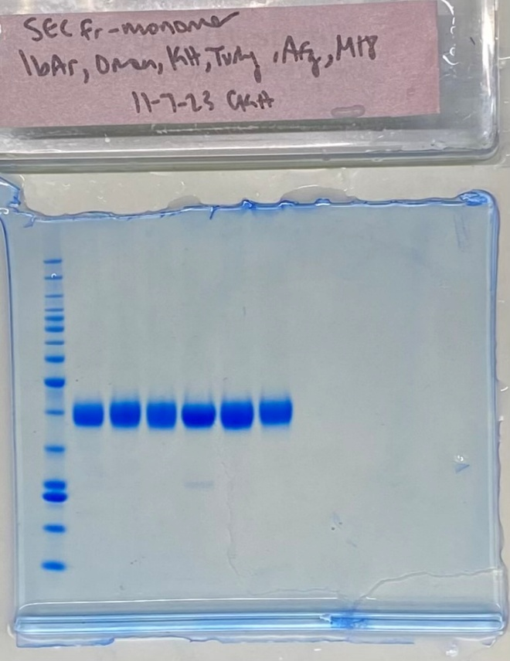
Supplemental Figure 2B: rGP38 treatment with HRV 3C protease
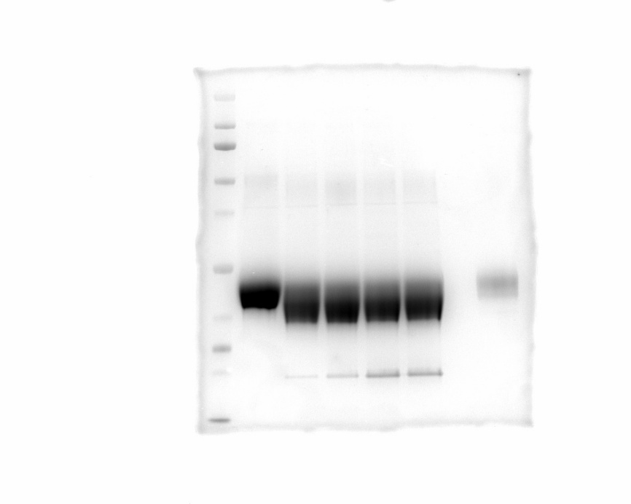

Supplemental Figure 2C
Chimera rGP38 purification: Oman, M18-China, OVar1
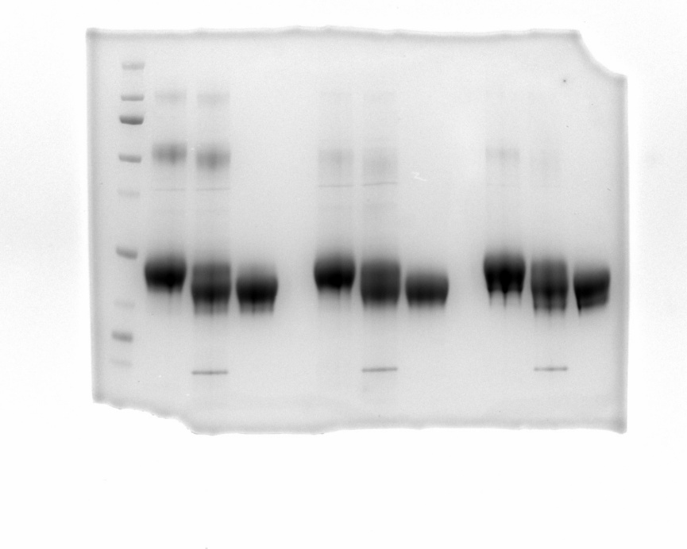
Chimera rGP38 purification: OVar2, ONTer, ON-v1-v2
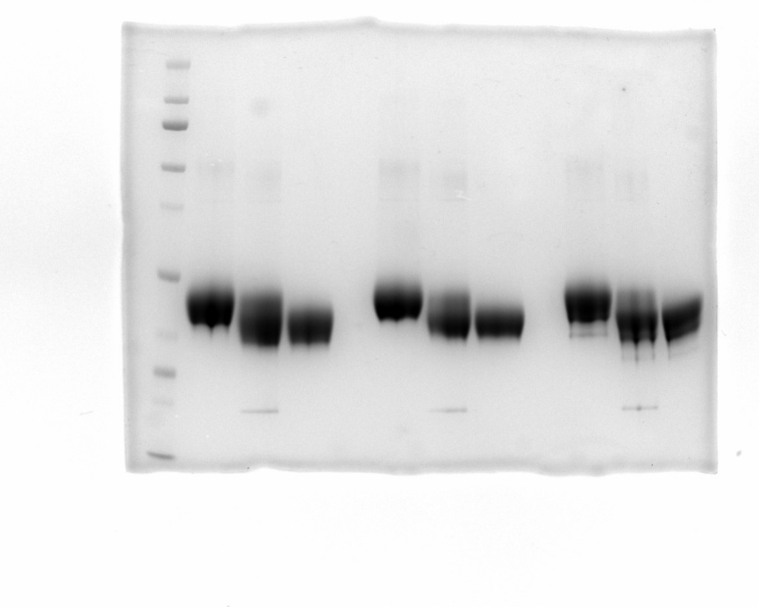

Main Figure 6C
rVSV-GP38_IbAr, IbAr-T
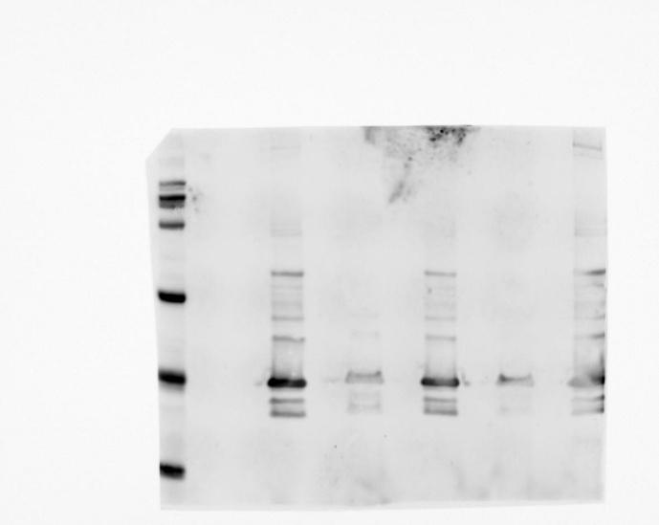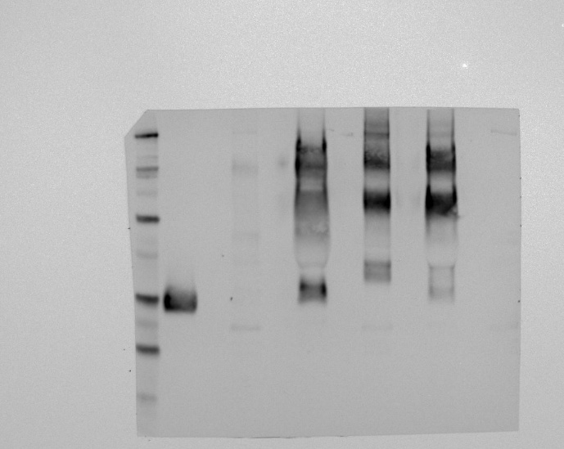
rVSV-GP38_M18, M18-T
