Supplementary material

Supplementary tables
Supplementary Table 1 Quantitative analysis of myenteric plexus characteristics
Morphometric and immunohistochemical parameters in patients with obstructive defecation syndrome (ODS, n=17), slow transit constipation (STC, n=24), combined ODS+STC (n=28), and controls (n=31). Data are presented as mean ± SD. Significant differences (p<0.05) are highlighted. Parameters include ganglionic morphology, MAP2-based neuronal content, and CD3+ lymphocytes infiltration. Corresponding data are visualized in Figures 2-4

Measurement | Overall  (N=100) | ODS  (N=17) | STC  (N=24) | ODS + STC  (N=28) | Controls  (N=31) | p-value
Mean ganglia/cm | 20.0 (5.3) | 23.8 (5.0) | 18.5 (4.4) | 20.5 (5.9) | 18.6 (4.7) | 0.002*
Mean ganglion area (μm²) | 16,313.9 (5,919.2) | 15,015.2 (5,138.2) | 15,424.0 (5,491.8) | 17,871.6 (5,394.5) | 16,308.3 (6,955.3) | 0.3
Mean ganglion circularity | 0.6 (0.1) | 0.6 (0.0) | 0.6 (0.1) | 0.6 (0.1) | 0.5 (0.1) | 0.045*
Maximum ganglion diameter (μm) | 940.3 (369.5) | 813.1 (306.2) | 939.3 (323.7) | 940.4 (264.8) | 1,010.7 (492.7) | 0.4
Mean MAP2 positivity (% of all ganglia) | 13.4 (5.1) | 12.4 (4.6) | 14.4 (6.1) | 13.1 (5.2) | 13.5 (4.6) | 0.6
MAP2-positive ganglia (% of all ganglia) | 89.5 (8.2) | 87.8 (6.8) | 90.9 (9.5) | 90.7 (7.6) | 88.4 (8.4) | 0.2
CD3-positive ganglia (% of all ganglia) | 46.1 (16.7) | 41.8 (15.2) | 40.5 (14.4) | 43.5 (16.2) | 55.2 (16.6) | 0.006*
Mean CD3+ cells per CD3+ ganglion (total) | 1.1 (0.8) | 0.8 (0.4) | 0.8 (0.5) | 1.0 (0.7) | 1.6 (1.1) | <0.001*
Mean CD3+ cells per CD3+ ganglion (ganglionic) | 0.5 (0.3) | 0.4 (0.2) | 0.4 (0.3) | 0.5 (0.3) | 0.6 (0.4) | 0.068
Mean CD3+ cells per CD3+ ganglion (periganglionic) | 0.6 (0.6) | 0.4 (0.2) | 0.4 (0.2) | 0.5 (0.4) | 1.0 (0.8) | <0.001*
Maximum intraganglionic CD3+ cells per ganglion | 4.1 (2.7) | 4.1 (1.6) | 3.1 (2.6) | 4.0 (2.6) | 4.9 (3.1) | 0.032*
Maximum periganglionic CD3+ cells per ganglion | 4.2 (3.8) | 3.5 (1.8) | 2.4 (1.1) | 4.3 (4.2) | 5.7 (4.7) | 0.001*

Supplementary figures
Supplementary Fig 1 Enteric ganglion characteristics stratified by age
Comparison of enteric ganglion parameters in obstructive defecation syndrome (ODS, n=17), slow transit constipation (STC, n=24), combined ODS+STC (n=28), and controls (n=31), stratified by age (<45, 45-65, and >65 years). a: Ganglionic density differed between patient groups (p=0.00145) but not by age. b and d: Mean ganglion area and maximum diameter varied by age (p=0.0441 and p=0.004) but not by patient group. c: Mean ganglion circularity showed differences between patient groups (p=0.0294) but not by age. Data are represented as boxplots (median, interquartile range) with individual data points
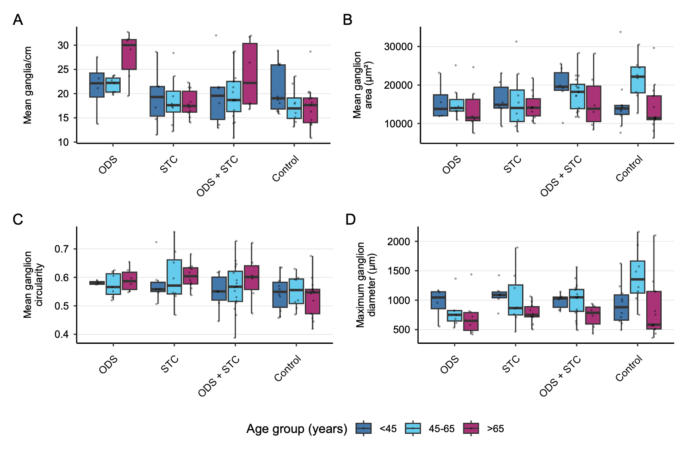
Supplementary Fig 2 Enteric ganglion characteristics stratified by sex
Comparison of enteric ganglion parameters in obstructive defecation syndrome (ODS, n=17), slow transit constipation (STC, n=24), combined ODS+STC (n=28), and controls (n=31), stratified by sex (male, female).
a: Ganglionic density differed between patient groups (p=0.004) but not by sexes, with no significant interaction. b and d: Mean ganglion area and maximum diameter showed no significant differences by group or sex. c: Mean ganglion circularity differed between patient groups (p=0.018) but not by sex. Data are presented as boxplots (median, interquartile range) and individual data points

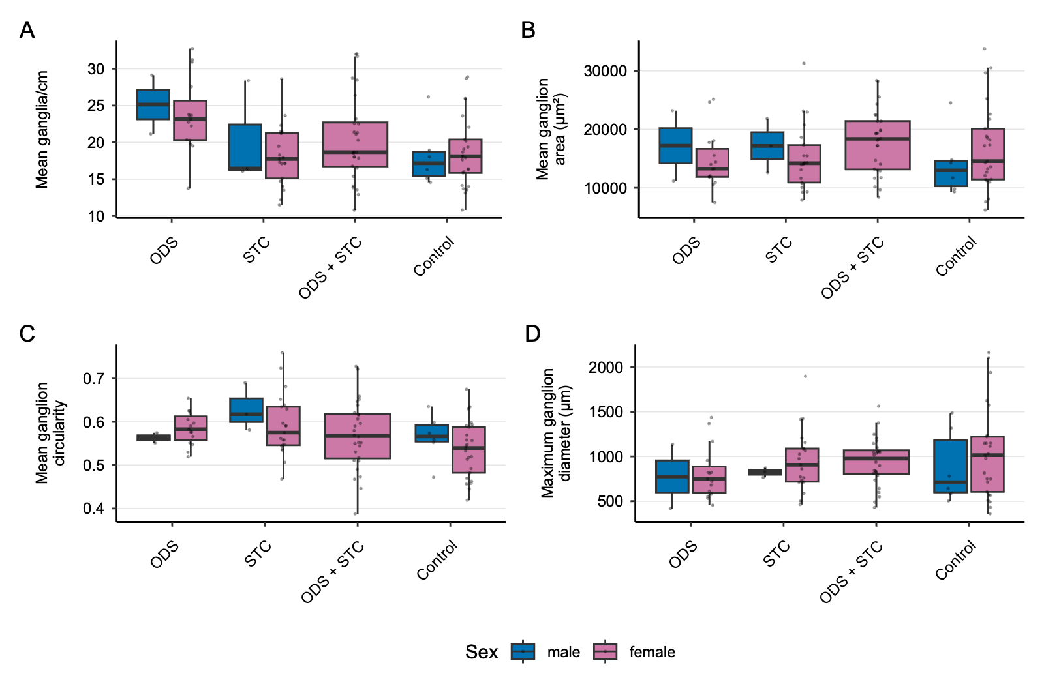
Supplementary Fig 3 MAP2 positivity stratified by age
Comparison of MAP2 immunoreactivity in obstructive defecation syndrome (ODS, n=17), slow transit constipation (STC, n=24), combined ODS+STC (n=28), and controls (n=31), stratified by age (<45, 45-65, and >65 years). a: Mean MAP2 positivity showed no differences between patient groups or age categories, with no significant interaction effect. b: Percentage of MAP2-positive ganglia showed a non-significant trend across age groups with no interaction effects. Data are presented as boxplots (median, interquartile range) and individual data points

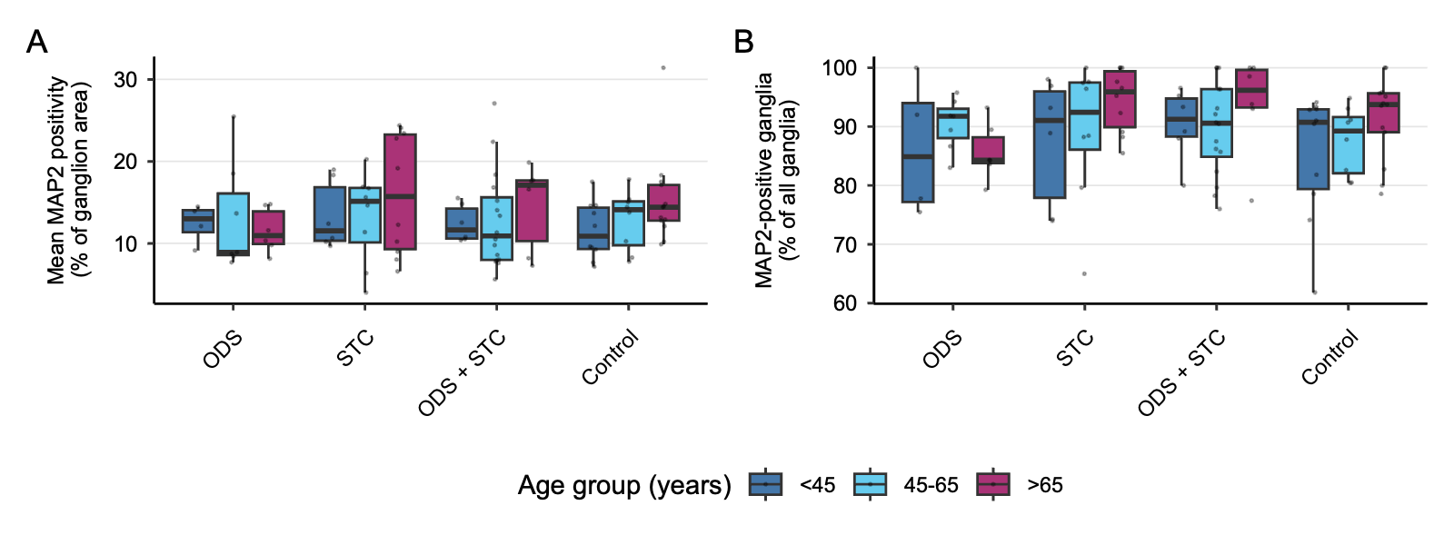
Supplementary Fig 4 MAP2 positivity stratified by sex
Comparison of MAP2 immunoreactivity in obstructive defecation syndrome (ODS, n=17), slow transit constipation (STC, n=24), combined ODS + STC (n=28), and controls (n=31), stratified by sex (male, female). a: Mean MAP2 positivity showed no differences between patient groups or sex, with no significant interaction effect. b: Percentage of MAP2-positive ganglia showed no group or sex differences, with a non-significant interaction.
Data are presented as boxplots (median, interquartile range) and individual data points
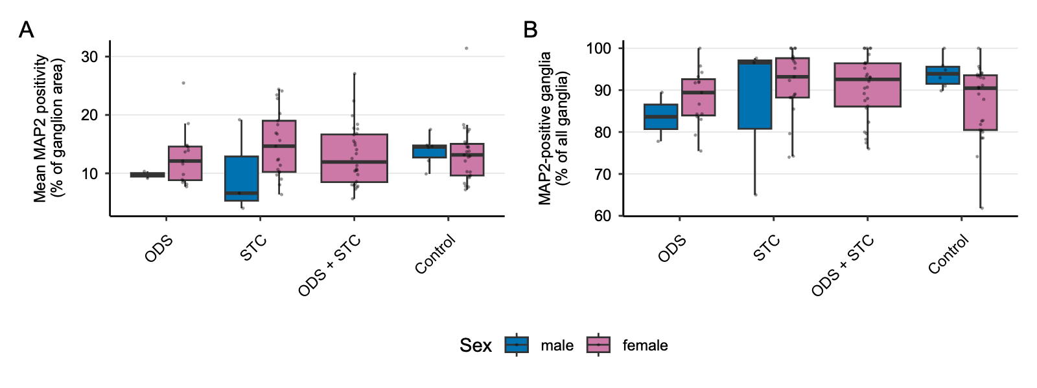
Supplementary Fig 5 Comparison of HuC/D immunoreactivity in a subset of patients
Comparison of neuronal nuclear marker HuC/D in ODS, STC, combined ODS+STC, and controls (5 per group) a: Mean HuC/D-positive cells per ganglion did not differ between groups p=0.18). b: Linear neuronal density (HuC/D-positive cells/mm) differed between groups (p=0.047), with elevated values in all constipation groups, although pairwise comparisons reached no significance after correction. Data are presented as violin plots with superimposed boxplots (median, interquartile range) and individual data points

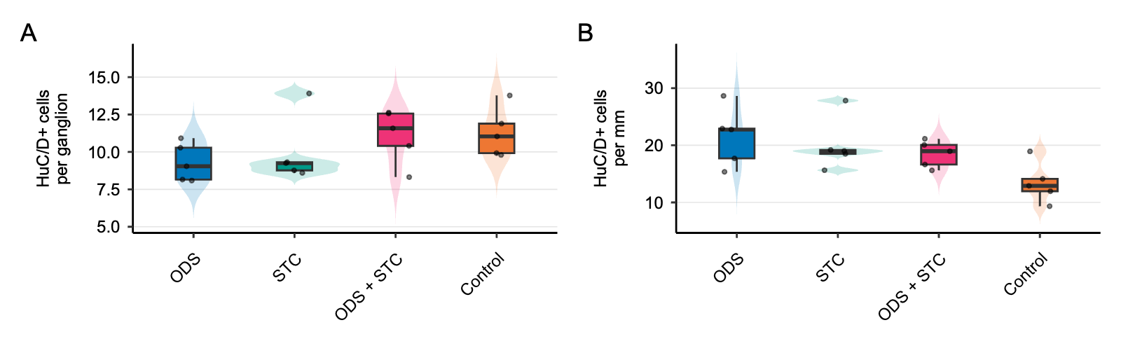
Supplementary Fig 6 CD3-positive lymphocytes stratified by age
Comparison of CD3+ T lymphocyte distribution in obstructive defecation syndrome (ODS, n=17), slow transit constipation (STC, n=24), combined ODS+STC (n=28), and controls (n=31), stratified by age (<45, 45-65, and >65 years). a and b: Percentage of CD3+ ganglia and mean CD3+ cells per ganglion differed between patient groups (p=0.004) but not by age, with no interaction effect. c: Maximum number of intraganglionic CD3+ cells showed no significant differences. d: Maximum number of periganglionic CD3+ cells differed between groups (p<0.01) but not by age. Data are presented as boxplots (median, interquartile range) with individual data points
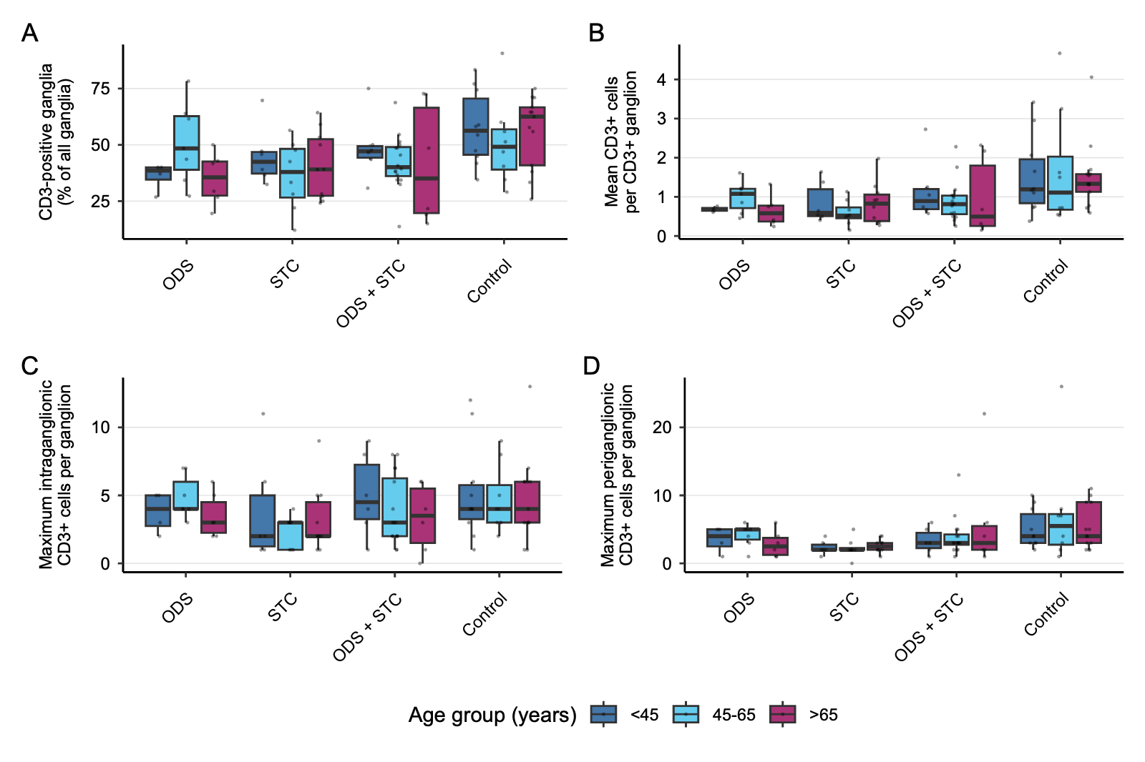
Supplementary Fig 7 CD3-positive lymphocytes stratified by sex
Comparison of CD3+ T lymphocyte distribution in obstructive defecation syndrome (ODS, n=17), slow transit constipation (STC, n=24), combined ODS +STC (n=28), and controls (n=31), stratified by sex (male, female).
A and B: Proportion of CD3+ ganglia and mean CD3+ cells per ganglion differed between patient groups (p=0.002 and p=0.0005) but not by sex, and with no interaction effect C: Maximum number of intraganglionic CD3+ cells showed no significant differences. D: Maximum number of periganglionic CD3+ cells differed between groups (p<0.01), with a non-significant interaction trend 8pbetween patient group and sex (p≈0.09) and no main effect of sex. Data are presented as boxplots (median, interquartile range) with individual data points

