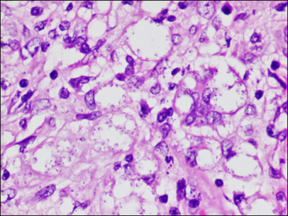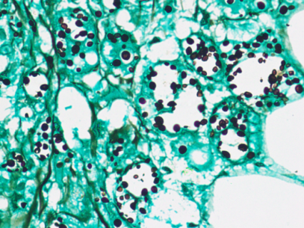
A
B
Supplementary Fig-A Supplementary Fig-B
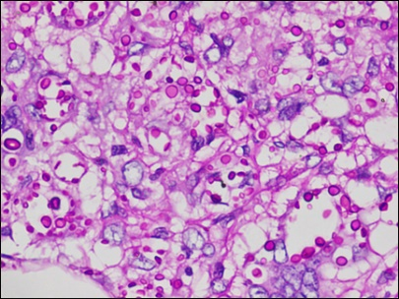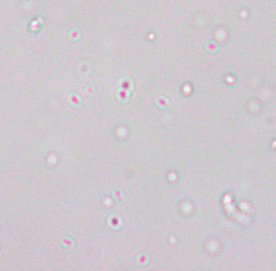
C
D
Supplementary Fig-C Supplementary Fig-D
Supplementary Figure-A: H&E staining on omental specimen showing transmural inflammation with many oval fungal infections, some showing clear halos suggestive of Cryptococcus
Supplementary Figure-B: Special stain- Grocott methenamine silver positivity, showing black-stained round-to-oval yeast cells with surrounding clear halos, suggestive of Cryptococcus.
Supplementary Figure-C: Special stain- Periodic Acid-Schiff positivity, showing magenta-colored yeast cells with prominent polysaccharide capsule(halo)
Supplementary Figure-D: Periodic Acid-Schiff stain positive in urine sample with prominent surrounding halos, suggesting cryptococcuria

