SUPPLEMENTARY INFORMATION
A STAGE-WISE FRAMEWORK FOR BURDEN ATTRIBUTION IN LCA OF MULTIFUNCTIONAL SYSTEMS
Jonathan Wheeler^{1,2}, Candelaria Colombres Garmendia², Ada Robinson Medici³, Fernando Daniel Mele^{1,2} & Stravos Papadokonstantakis³
¹ Consejo Nacional de Investigaciones Científicas y Técnicas, CONICET, Juan Crisóstomo Álvarez 722, AR T4000, San Miguel de Tucumán, Tucumán, Argentina
² Departamento de Ingeniería de Procesos y Gestión Industrial, FACET, Universidad Nacional de Tucumán, Av. Independencia 1800, T4002BLR, San Miguel de Tucumán, Tucumán, Argentina
³ Institute of Chemical, Environmental and Bioscience Engineering, TU Wien,1060 Wien, Austria
Corresponding author: Jonathan Wheeler, jwheeler@herrera.unt.edu.ar

S1 Foreground process model: flow diagram and life cycle inventory tables
This section provides supplementary information to ensure the completeness of the main manuscript. Figure S1 shows the full system topology, including the main process stages, intermediate material streams, final products, and internal energy flows (steam and electricity). Stream values reported in Figure S1 correspond to annual operating totals (t·y⁻¹ for materials and MWh·y⁻¹ for electricity) for the modeled facility. The figure is intended to provide an integrated view of the foreground system used in the study and to support the interpretation of the stage-wise modelling approach and the allocation scenarios discussed in the main manuscript.
The foreground life cycle inventories are reported in Tables S1–S9. These tables detail the material and energy flows used to calculate the stage-level (gate-to-gate) contributions for the stages involved in sugar, ethanol, and electricity production, and are provided to support transparency and reproducibility of the case study illustration. The inventories are not intended to represent a fully detailed or site-specific production model and should not be used as reference data for sugarcane ethanol production. Instead, they were constructed by combining selected process data, mass and energy balance calculations, and background datasets sourced from Ecoinvent (Frischknecht & Rebitzer, 2005). This hybrid approach was adopted to demonstrate the application of the proposed stage-wise framework while ensuring consistency across stages and scenarios.
Table S1. Inventory for sugarcane production.
Products | Compartment | Value | Unit
Sugarcane |  | 1 | kg
Resources
Water, well, AR | land | 0.0221 | m³
Carbon dioxide, in air | in air | 0.978 | kg
Materials/fuels
Urea {RoW}| market for urea | Cut-off, U |  | 0.00726 | kg
Atrazine {RoW}| atrazine production | Cut-off, U |  | 0.000029867 | kg
Inorganic phosphorus fertiliser, as P₂O₅ {RoW}| nutrient supply from ammonium nitrate phosphate | Cut-off, U |  | 0.00006275 | kg
Pesticide, unspecified {RoW}| pesticide production, unspecified | Cut-off, U |  | 7.8431 x 10⁻⁶ | kg
Pesticide, unspecified {RoW}| pesticide production, unspecified | Cut-off, U |  | 5.0196 x 10⁻⁶ | kg
2,4-dichlorophenol {GLO}| market for 2,4-dichlorophenol | Cut-off, U |  | 0.000010391 | kg
Metolachlor {GLO}| market for metolachlor | Cut-off, U |  | 0.000011294 | kg
Bipyridylium-compound {GLO}| market for bipyridylium-compound | Cut-off, U |  | 2.2588 x 10⁻⁶ | kg
Diesel {RoW}| market for diesel | Cut-off, U |  | 0.00175 | kg
Emissions to air
Carbon dioxide, fossil |  | 0.00766 | kg
Ammonia, AR |  | 0.000513 | kg
Carbon monoxide, fossil |  | 0.000014054 | kg
Dinitrogen monoxide |  | 0.000108 | kg
Nitrogen oxides, AR |  | 0.00011192 | kg
Sulfur dioxide, AR |  | 0.00001695 | kg
Methane, fossil |  | 0.000019464 | kg
Particulates, > 10 um |  | 0.00000302 | kg
Particulates, > 2.5 um, and < 10um |  | 4.7476 x 10⁻⁶ | kg
Carbon dioxide, biogenic |  | 0.0775 | kg
Carbon dioxide, fossil |  | 0.0053116 | kg
Emissions to water
Sulfate |  | 0.0001768 | kg
Chloride |  | 0.00013034 | kg
Ammonium, ion |  | 1.0167 x 10⁻⁶ | kg
BOD5 (Biological Oxygen Demand), AR |  | 0.000013068 | kg
Oils, unspecified |  | 2.5992 x 10⁻⁶ | kg
Suspended solids, unspecified |  | 2.0497 x 10⁻⁶ | kg
Atrazine |  | 7.4074 x 10⁻⁷ | kg
2,4-D |  | 1.7732 x 10⁻⁷ | kg
Metolachlor |  | 1.8974 x 10⁻⁷ | kg
Nitrate |  | 0.0001029 | kg
Phosphate, AR |  | 5.8537 x 10⁻⁶ | kg
Emissions to soil
Ametryn | agricultural | 1.7412 x 10⁻⁷ | kg
Acetochlor | agricultural | 8.4329 x 10⁻⁸ | kg
Monosodium acid methanearsonate | agricultural | 1.7405 x 10⁻⁷ | kg
Paraquat | agricultural | 5.0823 x 10⁻⁸ | kg
Oils, unspecified | agricultural | 2.7058 x 10⁻⁶ | kg
Atrazine | agricultural | 2.6323 x 10⁻¹⁴ | kg
2,4-D | agricultural | 2.2169 x 10⁻¹² | kg
Metolachlor | agricultural | 8.7237 x 10⁻¹² | kg
Table S2. Inventory for sugarcane transport.
Products | Value | Unit
Sugarcane transported | 1 | t
Materials/fuels
Transport, freight, lorry 16-32 metric ton, EURO5 {RoW}| market for transport, freight, lorry 16-32 metric ton, EURO5 | Cut-off, U | 50 | tkm
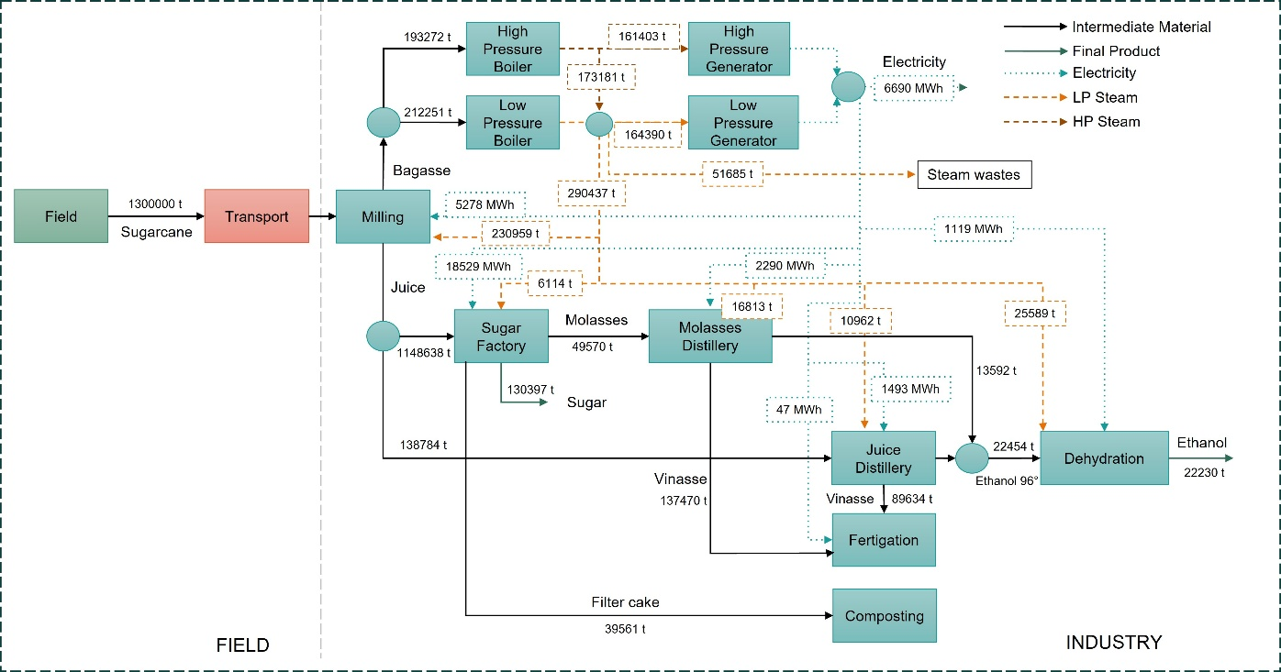
Figure S1. Complete process flow diagram of the sugarcane biorefinery case study (annual stream values: t·y⁻¹ for material/steam streams and MWh·y⁻¹ for electricity).

Table S3. Inventory for sugarcane milling process.
Products | Value | Unit
Sugarcane juice | 1 | kg
Resources
Water, well, AR | 0.0003052 | m³
Materials/fuels
Lubricating oil {RoW}| market for lubricating oil | Cut-off, U | 0.00307 | kg

Table S4. Inventory for sugar factory.
Products | Value | Unit
Sugar | 1 | kg
Materials/fuels
Hydrated lime, packed {RoW}| market for hydrated lime, packed | Cut-off, U | 0.01186538 | kg
Sulfuric acid {RoW} | market for sulfuric acid | Cut-off, U | 0.00082169 | kg
phosphoric acid, industrial grade, without water, in 85% solution state {GLO} | market for phosphoric acid, industrial grade, without water, in 85% solution state | Cut-off, U | 0.00091213 | kg
Polyacrylamide {GLO}| market for polyacrylamide | Cut-off, U | 0.00014223 | kg
Emissions to air
Sulfur dioxide | 0.00040777 | kg

Table S5. Inventory for HP steam production from bagasse.
Products | Value | Unit
High pressure steam, from bagasse | 1 | kg
Emissions to air
Dinitrogen monoxide | 0.0000156 | kg
Nitrogen oxides, AR | 0.01268 | kg
Carbon dioxide, biogenic | 1.7013 | kg
Carbon monoxide, biogenic | 0.092634 | kg

Table S6. Inventory for LP steam production from bagasse.
Products | Value | Unit
Low pressure steam, from bagasse | 1 | kg
Emissions to air
Dinitrogen monoxide | 1.6092 x 10⁻⁵ | kg
Nitrogen oxides | 0.013079 | kg
Carbon dioxide, biogenic | 1.7549 | kg
Carbon monoxide, biogenic | 0.095551 | kg

Table S7. Inventory for distilleries.
Products | Value | Unit
ethanol 96%, from sugarcane juice or molasses | 1 | kg
Resources
Water, well, AR | 0.00001123 | m³
Materials/fuels
Neutralising agent, sodium hydroxide-equivalent {GLO}| sodium hydroxide to generic market for neutralising agent | Cut-off, U | 0.003306 | kg
Urea {RoW}| market for urea | Cut-off, U | 0.00315 | kg
Manganese sulfate {GLO}| market for manganese sulfate | Cut-off, U | 0.00036 | kg
Magnesium sulfate {GLO}| market for magnesium sulfate | Cut-off, U | 0.00083 | kg
Diammonium phosphate {RoW}| market for diammonium phosphate | Cut-off, U | 0.0034886 | kg
Lubricating oil {RoW}| market for lubricating oil | Cut-off, U | 0.00024424 | kg
Emissions to air
Carbon dioxide, biogenic | 0.95528 | kg
Ammonia, AR | 0.000046297 | kg
Ethanol | 0.006 | kg

Table S8. Inventory for ethanol dehydration.
Products | Value | Unit
Dehydrated ethanol | 1 | kg
Materials/fuels
Zeolite, powder {GLO}| market for zeolite, powder | Cut-off, U | 0.000001953 | kg

Table S9. Inventory for vinasse fertigation.
Products | Value | Unit
Vinasse fertigated | 1 | kg
Materials/fuels
Diesel, burned in agricultural machinery {GLO}| market for diesel, burned in agricultural machinery | Cut-off, U | 0.068468 | MJ
Electricity, low voltage {AR}| market for electricity, low voltage | Cut-off, U | 0.000207 | kWh
Emissions to air
Methane, biogenic | 0.00000853 | kg
Carbon dioxide, biogenic | 0.11 | kg
Dinitrogen monoxide | 0.0000627 | kg

S2 Allocation profiles
This section summarizes the allocation profiles used in the case study. An allocation profile is defined here as the set of stage-wise partitioning and distribution rules (allocation basis and factors) applied at each relevant decision point of the process network under a given scenario.
Scenario A represents a fully aggregated (“black-box”) implementation in which the total system burden is partitioned among co-products by economic allocation at the system level, with shares of 78.58% for sugar, 20.67% for ethanol, and 0.75% for exported electricity. Because Scenario A does not rely on a stage-wise representation, it is reported as a single system-level allocation rule rather than as a node-by-node allocation profile.
Scenarios B–E implement stage-wise modelling choices and therefore require an explicit node-by-node specification. Table S10 reports the allocation profiles for Scenarios B–E, including (i) co-product partitioning rules applied at multifunctional stages (e.g., milling and sugar factory) and (ii) utility-network splitting/distribution rules used to propagate burdens through internal steam and electricity flows (e.g., internal use vs export, mixing/splitting nodes, and distribution to internal users). For utility nodes, reported factors represent flow shares used for burden propagation, whereas for co-product partitioning they represent burden partition coefficients. These profiles provide the necessary context for the equation-by-equation worked example of Scenario E presented in Section S3.

Table S10. Allocation profiles for Scenarios B–E. Stage-wise co-product partitioning rules at multifunctional nodes and utility-network distribution rules used for burden propagation.
Stage | Outputs/destinations | Rule type | Allocation basis | Factor | Note
Milling | Bagasse  Juice | Co-product partitioning | Carbon content | 51%  49% | Measurable proxy
Sugar Factory | Sugar  Molasses | Co-product partitioning | Sucrose content | 85.37%  14.63% | Measurable proxy  Filter cake is considered waste
Molasses  Distillery | Ethanol | No partitioning (Single output stage) |  | 100% | Vinasse is treated as waste
Juice Distillery | Ethanol | No partitioning (Single output stage) |  | 100% | Vinasse is treated as waste
Dehydration | Anhydrous ethanol | No partitioning (Single output stage) |  | 100% | -
Scenario B
Boiler-turbine | Electricity export  Electricity internal | Utility splitting node | Electricity flow shares (MWh) | 18.87%  81.13%
Internal electricity | Sugar  Ethanol | Internal utility distribution | Economic | 79.12%  20.88% | Benchmark practice
Scenario C
Boiler-turbine | Electricity export  Electricity internal | Utility splitting node | Electricity flow shares (MWh) | 18.87%  81.13%
Internal electricity | Sugar  Ethanol | Internal utility distribution | Mass | 85.44%  14.56% | Measurable proxy
Scenario D
Boiler-turbine | Electricity export  Milling electricity  Sugar fac. electricity  Molasse dist. electricity  Juice dist. electricity  Dehydration electricity  Fertigation electricity | Utility splitting node | Electricity flow shares (MWh) | 18.87%  14.89%  52.27%  6.46%  4.21%  3.16%  0.13%
Scenario E
High-pressure boiler | HP turbine steam  Low pressure steam | Utility splitting node | Steam mass flow shares (t) | 48.24%  51.76%
Low-pressure steam node  (LP steam from boiler + LP steam from HP steam) | LP turbine steam  LP milling steam  LP sugar factory steam  LP distillery steam | Utility splitting node | Steam mass flow shares (t) | 38.49%  54.08%  1.43%  5.99%
Electricity node  (from HP and LP turbines) | Electricity export  Milling electricity  Sugar fac. electricity  Molasse dist. electricity  Juice dist. electricity  Dehydration electricity  Fertigation electricity | Utility splitting node | Electricity flow shares (MWh) | 18.87%  14.89%  52.27%  6.46%  4.21%  3.16%  0.13%
Note: For co-product partitioning, factors are burden partition coefficients. For utility splitting/distribution nodes, factors are flow shares (MWh for electricity; t for steam) used for burden propagation; shares sum to 100% within rounding.

S3 Worked example - Scenario E
This section provides the numerical foreground representation of the process network used in the case study. The foreground process model was built from mass and energy balance calculations. Balance residuals were checked per stage and at the system level and were within rounding tolerance. The balanced annual technosphere flows underlying these checks are reported in Table S11 (and visualized in Fig. S1).
While Fig. S1 offers an integrated graphical view of the biorefinery topology, Table S11 reports the corresponding technosphere flow matrix $F_{ij}$ in a compact, reproducible form suitable for step-by-step calculations. Rows correspond to process nodes j (process stages) and columns correspond to intermediate material and energy streams i. All values are reported as annual flows, consistent with Fig. S1.
In Table S11, the sign convention follows the model definition: positive values denote inputs to a node and negative values denote outputs from a node. Internal technosphere streams therefore appear as outputs from upstream nodes and as inputs to downstream nodes, allowing the process network to be reconstructed and checked consistently. Exports (final products) and streams leaving the system boundary are reported as boundary outputs. Units are reported per stream (e.g., kt·y⁻¹ for material and steam mass flows and MWh·y⁻¹ for electricity). Table S11 provides the quantitative basis used in the subsequent equation-by-equation worked example of Scenario E, together with the allocation profile reported in Section S2.
The stage gate-to-gate impact intensities ${LI}_{j}$ (GWP100 per unit reference flow ${RF}_{j}$) used in Eq. 1 are reported in Table 1 of the main manuscript. Together with the allocation profile (Table S10) and the technosphere flow matrix $F_{ij}$ reported in Table S11, these values provide the complete numerical basis for the worked example of Scenario E presented in this section.
Table S11. Foreground technosphere flow matrix $F_{ij}$​ for the sugarcane biorefinery (annual flows: kt·y⁻¹ for material/steam streams and MWh·y⁻¹ for electricity). Rows are process nodes j and columns are intermediate material and energy streams i. Positive values denote inputs to a stage and negative values denote outputs. Exports and wastes are reported at the system boundary.
 | Streams (i)
 | Sugarcane | Juice | Bagasse | LP steam | HP steam | Molasses | Sugar | Ethanol 96 | Ethanol | Vinasse | Electricity
Stage (j) | kt·y⁻¹ |  |  |  |  |  |  |  |  |  | MWh·y⁻¹
Agriculture/ Transport | -1300
Milling | 1300 | -1287 | -405 | 231 |  |  |  |  |  |  | 5278
Sugar  factory |  | 1149 |  | 6 |  | -49.6 | -130 |  |  |  | 18529
Molasses distillery |  |  |  | 16.8 |  | 49.6 |  | -13.6 |  | -137 | 2290
Juice  distillery |  | 138 |  | 10.9 |  |  |  | -8.9 |  | -90 | 1493
Dehydration |  |  |  | 25.6 |  |  |  | 22.5 | -22.2 |  | 1119
LP boiler |  |  | 212 | -379
HP boiler |  |  | 193 |  | -334
Fertigation |  |  |  |  |  |  |  |  |  | 227 | 47
HP to LP |  |  |  | -173 | 173
LP generator |  |  |  | 216 |  |  |  |  |  |  | -14780
HP generator |  |  |  |  | 161 |  |  |  |  |  | -20667

S3.1 Stage-by-stage application for Scenario E (using Table S11 topology)
Below, each stage corresponds to a row (stage j) in Table S11, plus explicit split or mix points where needed.
STAGE 1. Agriculture and transport (produce sugarcane entering the plant)
Flows: sugarcane leaves this stage as an output. There are no incoming technosphere streams here.
The stage burden is computed with Eq. 1 using the local term LI_{j}×RF_{j} from Table 1 (main manuscript). This impact is directly attached to sugarcane with Eq. 2 (a = 1).
STAGE 2. Milling (splits sugarcane into juice + bagasse; consumes LP steam and electricity)
Flows: inputs are sugarcane, LP steam, and electricity; outputs are juice and bagasse (Table S11).
Allocation (Scenario E, Table S10): bagasse 51%, juice 49% (carbon-content proxy).
Using Eq. 1 we add local LI_{j}×RF_{j} plus burdens carried by incoming sugarcane, LP steam, and electricity. Then, using Eq. 2 the total burden GI_{j} is split into juice and bagasse using the 49%/51% factors, then divide by the outgoing flow amount to get an impact per unit of juice and bagasse.
JUICE SPLIT POINT. Juice split (juice to Sugar factory and to Juice distillery)
Rule type: juice mass flow share
Using Eq. 4 both juice branches carry the same impact per unit as the parent juice stream.
STAGE 3. Sugar factory (splits into sugar + molasses; consumes LP steam and electricity)
Flows: inputs are juice, LP steam, and electricity; outputs are sugar and molasses (Table S11).
Allocation (Scenario E, Table S10): sugar 85.37%, molasses 14.63% (sucrose proxy).
We use Eq. 1 to compute the total stage burden and Eq. 2 to attach burdens to sugar and molasses using 85.37% and 14.63% respectively.
STAGE 4. Molasses distillery (single-output stage producing ethanol 96%)
Flows: inputs include molasses, LP steam, and electricity; outputs include ethanol 96 and vinasse (waste stream).
Rule type: single-output stage (no co-product partitioning for the intermediate product).
The total burden is computed using Eq. 1, then attach all burden to ethanol 96 with Eq. 2 using a = 1.
STAGE 5. Juice distillery (single-output stage producing ethanol 96%)
Flows: inputs include juice, LP steam, and electricity; outputs include ethanol 96 and vinasse (waste stream).
Rule type: single-output stage (no co-product partitioning for the intermediate product).
Total burden is computed through Eq. 1, then attach all burden to ethanol 96 with Eq. 2 using a = 1.
MIX POINT ETHANOL 96. Ethanol 96 mixture before dehydration
Using Eq. 5, the mixed ethanol 96 stream has an impact per unit equal to the flow-weighted average of the two ethanol-96 contributions (from molasses distillery and juice distillery).
STAGE 6. Dehydration (single-output stage producing anhydrous ethanol)
Flows: inputs include ethanol 96, LP steam, and electricity; output is anhydrous ethanol.
Using Eq. 1 the total burden is computed and attached to anhydrous ethanol with Eq. 2 using a = 1.
STAGE 7. Fertigation (vinasse management inside the system boundary)
Fertigation is included as the management stage for vinasse generated by distillation and treated inside the same system boundary.
This burden is computed with Eq. 1 (local term plus electricity input, if any). In the Scenario E accounting, this burden is assigned to the ethanol product system because it is triggered by vinasse generation.
Utility network (steam and electricity)
BAGASSE SPLIT POINT. Bagasse split to HP boiler and LP boiler
Rule type: bagasse mass flow share
Through Eq. 4 both bagasse branches inherit the same bagasse impact per unit.
STAGE 8. HP boiler (bagasse to HP steam)
Flows: inputs include bagasse; outputs include HP steam.
Rule type: single-output stage (no co-product partitioning for the intermediate product).
Eq. 1 is used to compute the HP boiler stage burden (local term + bagasse input burden), then Eq. 2 to attach it to HP steam (a = 1).
STAGE 9. LP boiler (bagasse to LP steam)
Flows: inputs include bagasse; outputs include LP steam.
Rule type: single-output stage (no co-product partitioning for the intermediate product).
Eq. 1 is used to compute the LP boiler stage burden (local term + bagasse input burden), then Eq. 2 to attach it to LP steam (a = 1).
HP SPLIT POINT. HP steam split to HP generator and HP to LP conversion
Rule type: steam mass flow share
Using Eq. 4, both branches inherit the same HP steam impact per unit (t). Scenario E flow shares for this split are reported in Table S10.
STAGE 10. HP generator (HP steam to electricity)
Flows: inputs include HP steam; outputs include electricity.
Rule type: single-output stage (no co-product partitioning for the intermediate product).
Given that there is no gate-to-gate impact (LI_{j}) in this stage, HP steam burden converts into electricity burden using Eq. 1 and Eq. 2 (a = 1).
LP STEAM MIX POINT. LP steam mixture
Using Eq. 5, LP steam stream has an impact per unit equal to the flow-weighted average of the two LP contributions (from HP to LP conversion and LP boiler).
LP SPLIT POINT. LP steam split to users and to LP generator
Rule type: LP steam mass flow share
All LP-steam branches inherit the same LP-steam impact per unit. Scenario E flow shares are reported in Table S10 (Eq. 4).
STAGE 11. LP generator (LP steam to electricity)
Flows: inputs include LP steam; outputs include electricity.
Rule type: single-output stage (no co-product partitioning for the intermediate product).
Given that there is no gate-to-gate impact (LI_{j}) in this stage, LP steam burden converts into electricity burden using Eq. 1 and Eq. 2 (a = 1).
ELECTRICITY MIX POINT. Electricity mixture (from HP and LP generators)
Using Eq. 5, electricity burden is calculated as a mixture of electricity produced by the HP generator and the LP generator.
SPLIT POINT H. Electricity split to internal users and export
Rule type: electricity energy flow share
According to Eq. 4, all electricity branches (internal uses + exported electricity) inherit the same electricity impact per unit. Scenario E flow shares are reported in Table S10.
Final products and closure
Final products for Scenario E are sugar (from Sugar factory), anhydrous ethanol (from Dehydration), and exported electricity (from the electricity split node).
First, the product output flow P_{i} with Eq. 6 from the boundary outputs in Table S11. Then, the product intensities are computed with Eq. 7. In this case study illustration, each final product leaves the system at a single final node, so the product intensity equals the intensity attached to that boundary stream (with fertigation burden added to the ethanol product system as noted above).
Finally, the accounting closure is verified by comparing Eq. 8 (sum of all local terms LI_{j}×RF_{j} from Table 1) and Eq. 9 (sum of final product burdens P_{i}×I_{i}). The two totals must match within rounding tolerance.
For the present foreground network (12 stages and 11 intermediate streams; Table S11), applying Eqs. 1–9 yields the computed variables GI_{j} (stage burdens, one per stage), I_{ij} (stream-specific impact intensities attached to outgoing links), and the final product intensities I_{i}^{final} for sugar, anhydrous ethanol, and exported electricity, with global accounting closure verified by comparing TSI (total system environmental impact) from Eqs. 8 and 9. The resulting linear accounting system is implemented and solved in a mathematical software environment, and the burden-propagation patterns are visualized in Section S4 (Figure S2).

S4 Additional graphics: burden propagation
This section provides additional visualizations to support the interpretation of the stage-wise results. In particular, Figure S2 presents a Sankey-type diagram illustrating burden propagation through the biorefinery network for Scenario E. The diagram is built from the same numerical basis used in the worked example (Table S11 for annual technosphere flows, Table 1 of the manuscript for stage-level gate-to-gate impacts, and Table S10 for the Scenario E allocation profile). Link widths are proportional to the annual environmental burden carried by each intermediate stream, highlighting how burdens propagate through internal utility networks (steam and electricity), split/mix points, and downstream processing stages before being attributed to the final products.
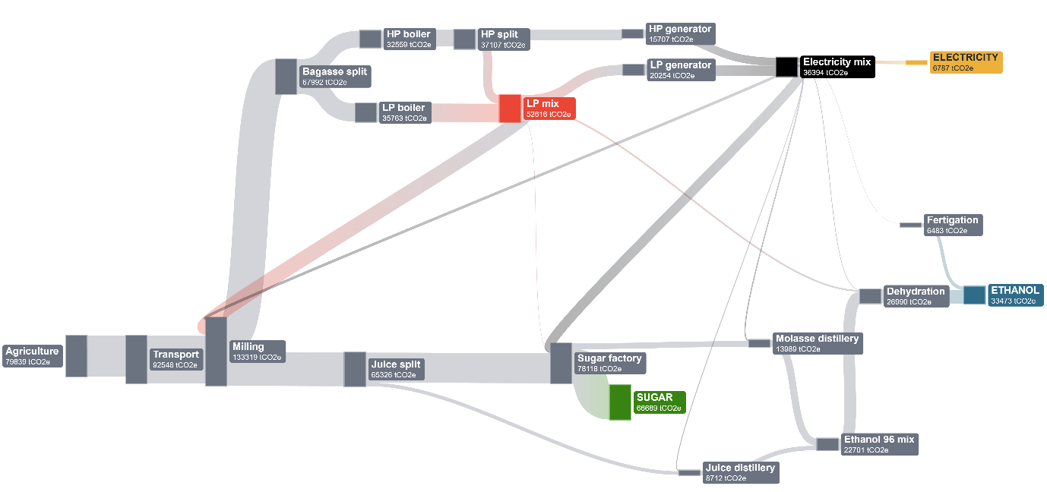
Figure S2. Burden propagation Sankey diagram for Scenario E (annual totals, GWP₁₀₀​). Link widths represent the annual environmental burden carried by intermediate material and utility streams as it propagates through the process network. Stage blocks report the cumulative burden associated with each stage, including incoming burdens and local gate-to-gate contributions. Colored end nodes report the final product burdens attributed to sugar, anhydrous ethanol, and exported electricity under the Scenario E allocation profile; utility splitting/mixing nodes (steam and electricity) are shown explicitly as internal-flow accounting elements.

References
Frischknecht, R., & Rebitzer, G. (2005). The ecoinvent database system: a comprehensive web-based LCA database. Journal of Cleaner Production, 13(13), 1337-1343. https://doi.org/10.1016/j.jclepro.2005.05.002

