Supplementary Information

Mitogenomic characterization and phylogenetic placement of the Mottled Wood-owl Strix ocellata with gene rearrangement patterns in Strigiformes

Amitava Majumder^{1,†*}, Angkasa Putra^{2,†}, Anindya Naskar^{1,3}, Agus Mohammad Hikam⁴, Dhriti Banerjee¹, Hyun-Woo Kim^{4,5,6,7}, Shantanu Kundu^{2,8,9,*}

¹Zoological Survey of India, ‘M’-Block, New Alipore, Kolkata – 700053, West Bengal, India.
²Interdisciplinary Program of Marine and Fisheries Sciences and Convergent Technology, Pukyong National University, Busan 48513, Republic of Korea.
³Department of Zoology, University of Calcutta, Kolkata – 700073, West Bengal, India.
⁴Department of Marine Biology, Pukyong National University, Busan 48513, Republic of Korea.
⁵Research Center for Marine Integrated Bionics Technology, Pukyong National University, Busan 48513, Republic of Korea.
⁶Marine Integrated Biomedical Technology Center, National Key Research Institutes in Universities, Pukyong National University, Busan 48513, Republic of Korea.
⁷Department of Biology, Faculty of Science and Technology, Airlangga University, Surabaya 60115, Indonesia.
⁸Ocean and Fisheries Development International Cooperation Institute, College of Fisheries Science, Pukyong National University, Busan 48513, Republic of Korea.
⁹International Graduate Program of Fisheries Science, Pukyong National University, Busan 48513, Republic of Korea.

†These authors contributed equally to this work.
*Correspondence: Amitava Majumder (amitavamajumder.eco@gmail.com) and Shantanu Kundu (shantanu1984@pknu.ac.kr or shantanu1984@gmail.com)

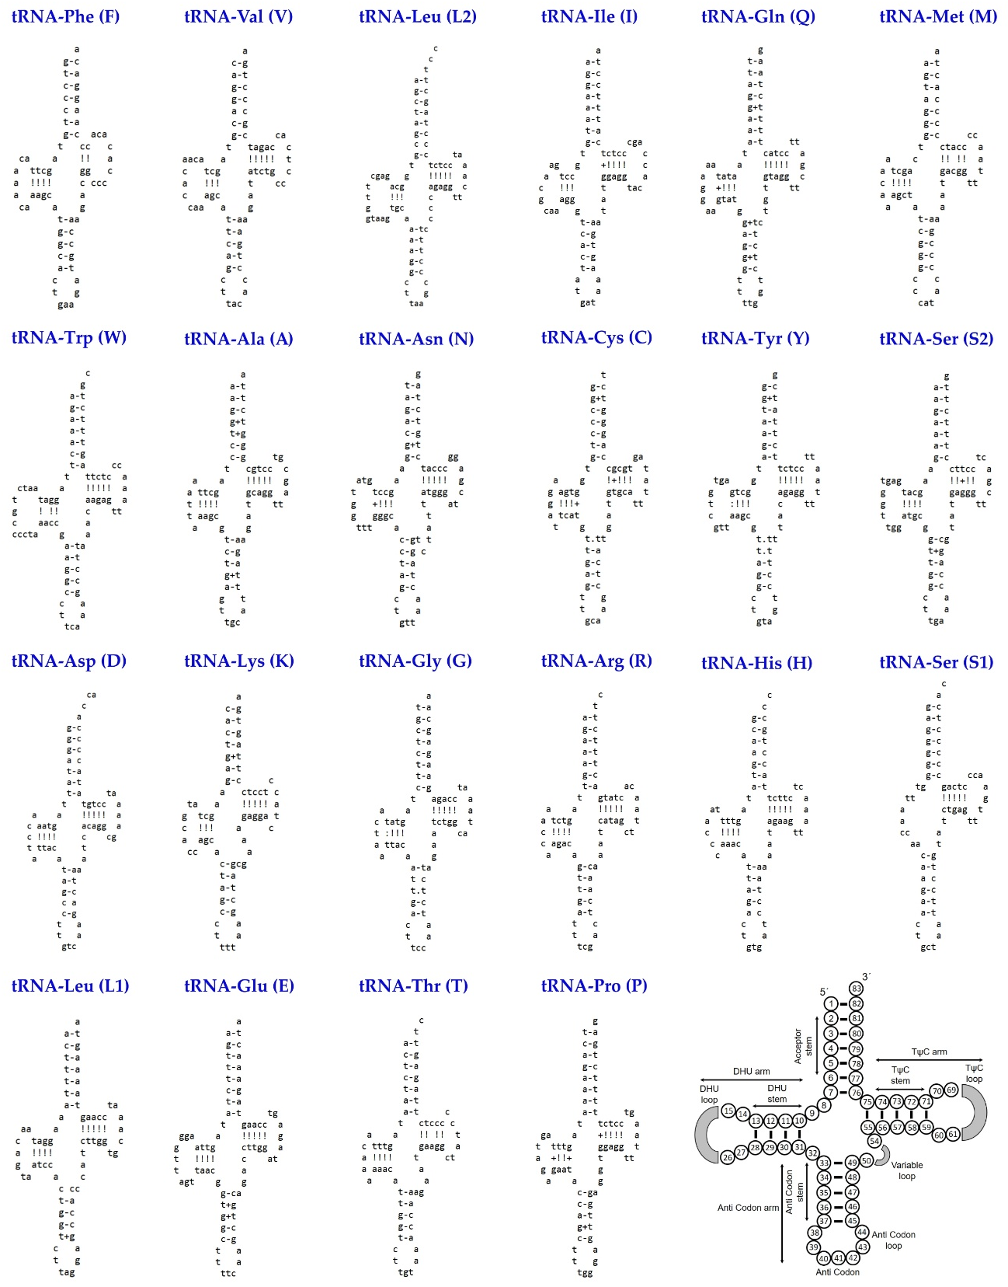

Supplementary Fig. S1 The cloverleaf secondary structures of the 22 tRNAs identified in S. ocellata, illustrating structural variations. Each tRNA is labeled with the standard three-letter amino acid abbreviation and its corresponding IUPAC–IUB single-letter code.
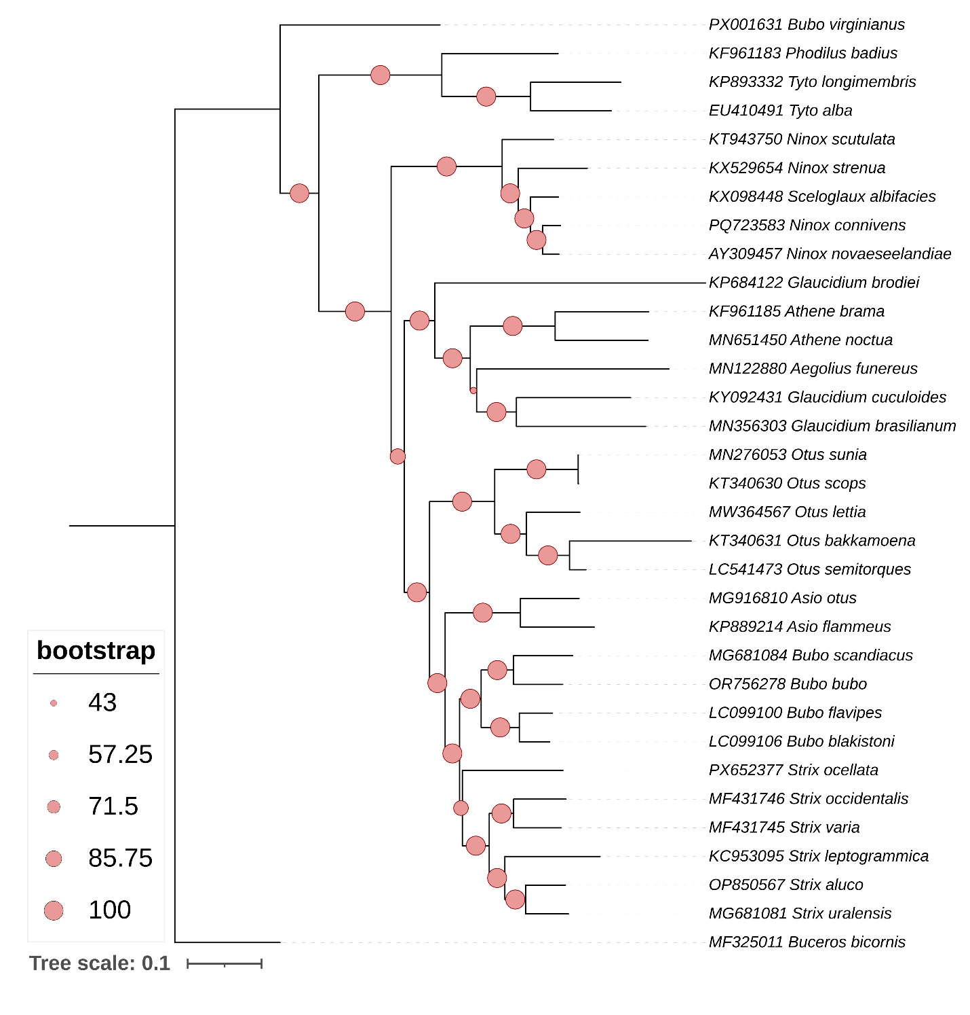

Supplementary Fig. S2 The ML phylogenetic tree based on concatenated sequences of 13 PCGs, illustrating matrilineal evolutionary relationships among 33 species within the order Strigiformes. The topology supports the monophyletic relationships among six species of the genus Strix and clearly distinguishes S. ocellata from other owl species. The bootstrap support values are indicated by coral-colored circles at each node in the topology.
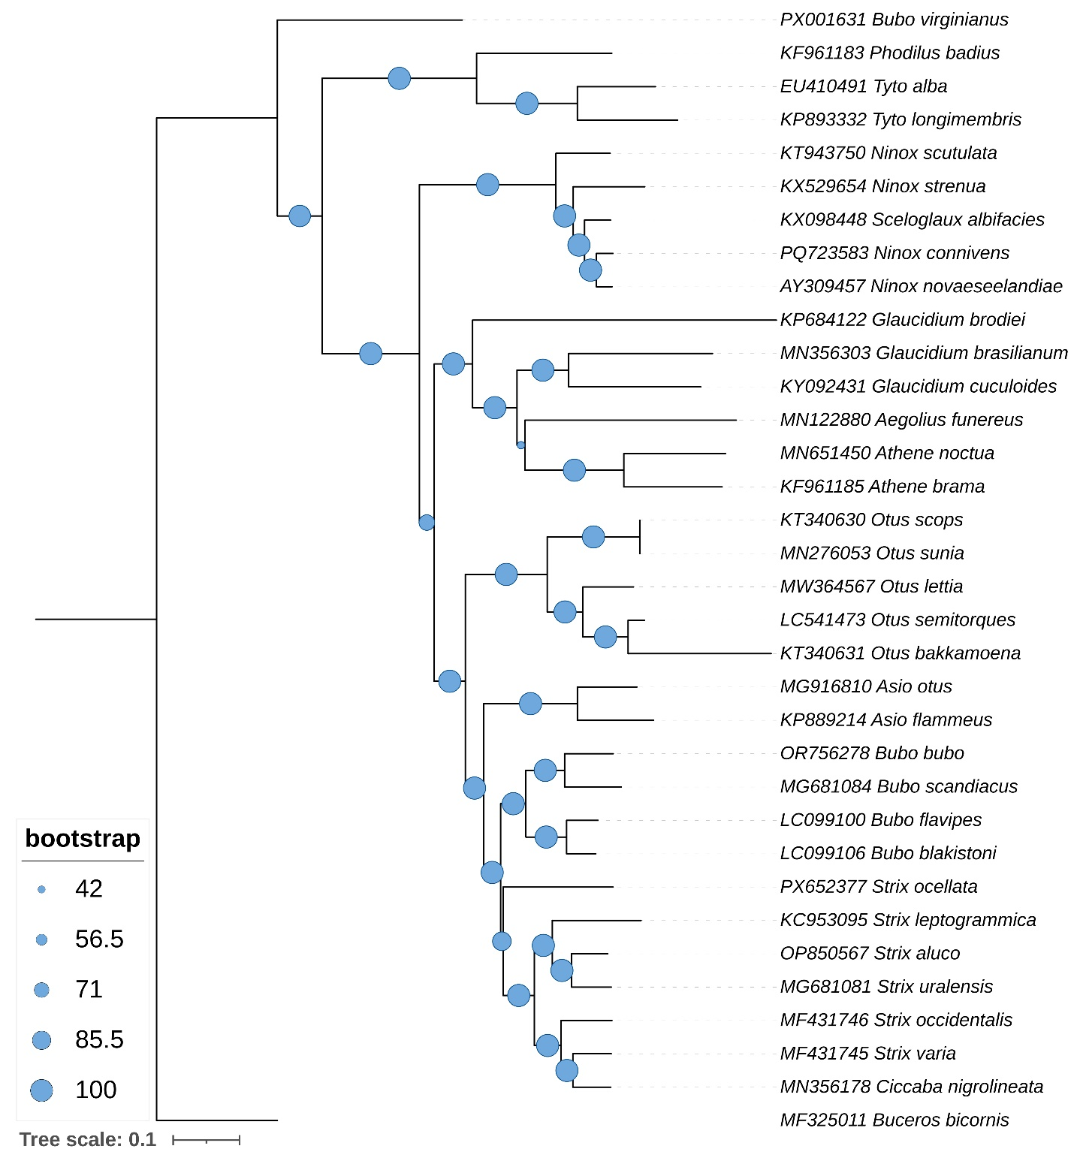

Supplementary Fig. S3 The ML phylogenetic tree based on concatenated sequences of 12 PCGs, illustrating matrilineal evolutionary relationships among 34 species within the order Strigiformes. The topology supports the monophyletic relationships among six species of the genus Strix and clearly distinguishes S. ocellata from other owl species. The bootstrap support values are indicated by blue-colored circles at each node in the topology.
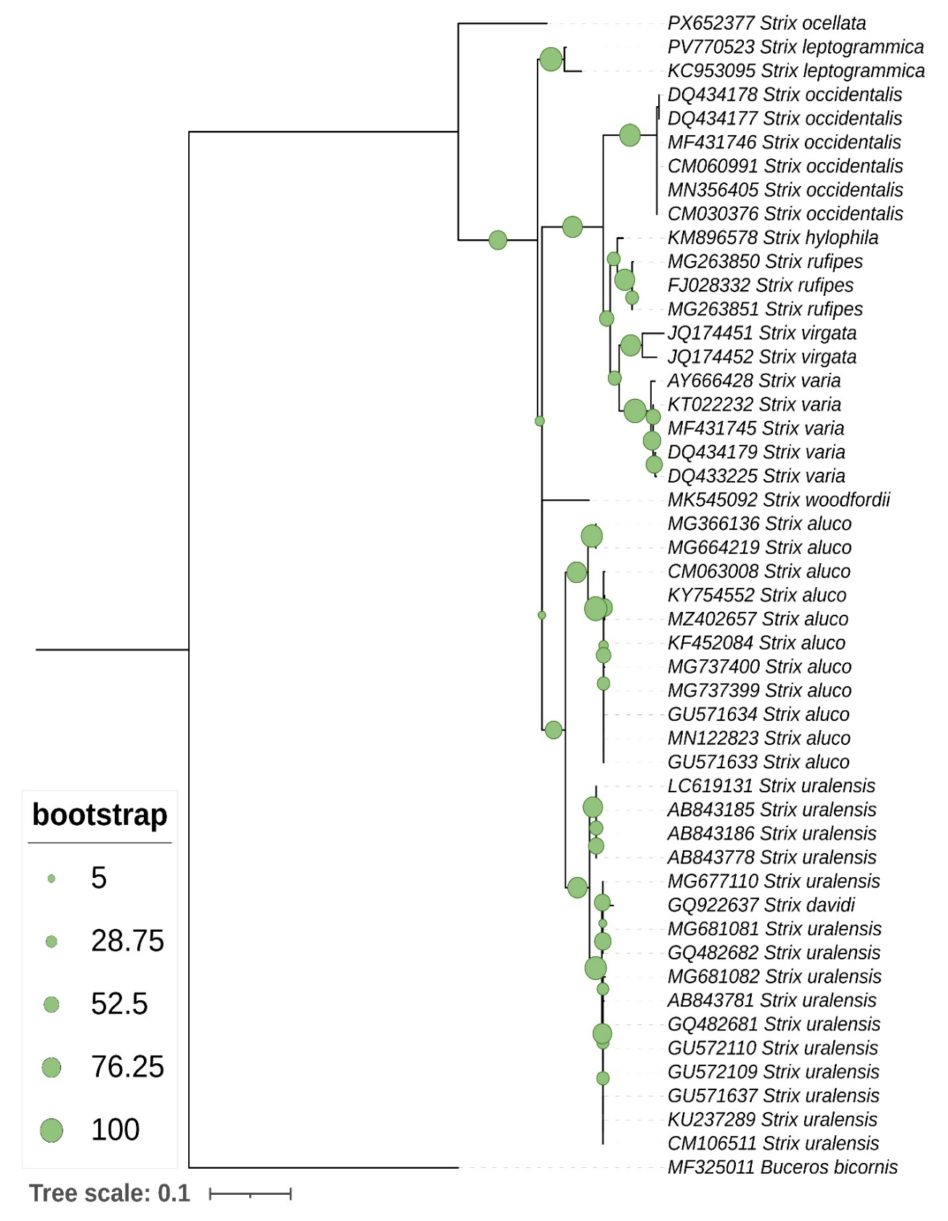

Supplementary Fig. S4 The ML phylogenetic tree based on partial mtCOI sequences, illustrating matrilineal evolutionary relationships among 11 species within the genus Strix. The topology clearly distinguishes S. ocellata from other congeners and the bootstrap support values are indicated by green-colored circles at each node in the topology.
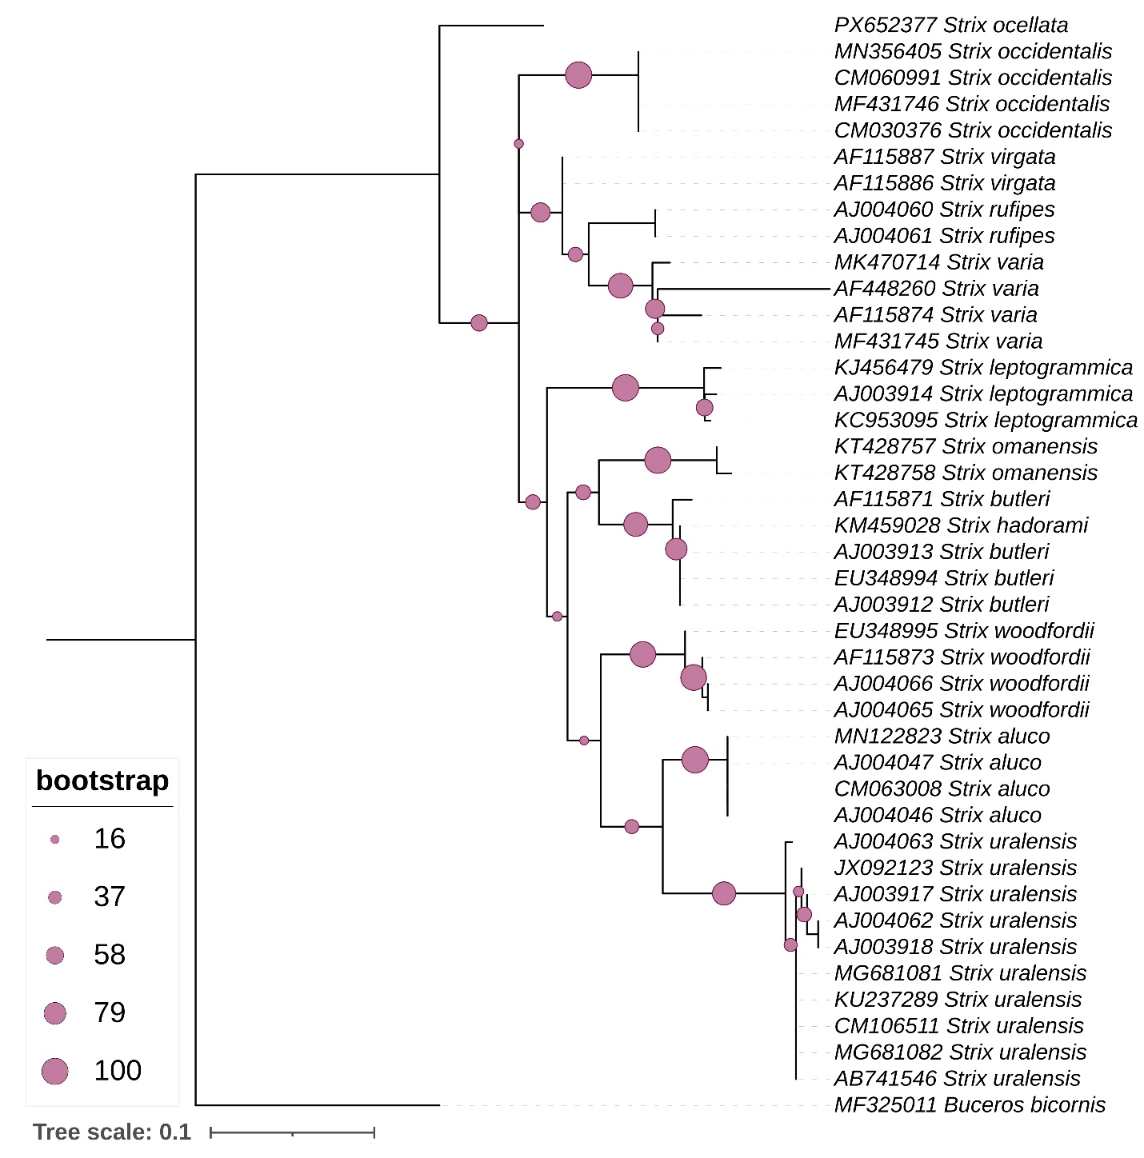

Supplementary Fig. S5 The ML phylogenetic tree based on partial mtCytb sequences, illustrating matrilineal evolutionary relationships among 12 species within the genus Strix. The topology clearly distinguishes S. ocellata from other congeners and the bootstrap support values are indicated by purple-colored circles at each node in the topology.

Supplementary Table S1. The mitogenome dataset of Strigiformes species, comprising newly generated sequences from this study and sequences retrieved from the GenBank database.

No. | Species Name | Accession No. | Reference
1 | Aegolius funereus | MN122880 | Unpublished
2 | Asio flammeus | KP889214 | Zhang et al. 2016
3 | Asio otus | MG916810 | Lee et al. 2018
4 | Athene brama | KF961185 | Mahmood et al. 2014
5 | Athene noctua | MN651450 | Sun et al. 2020
6 | Bubo blakistoni | LC099106 | Omote 2018
7 | Bubo bubo | OR756278 | Yoon et al. 2025
8 | Bubo flavipes | LC099100 | Omote 2018
9 | Bubo scandiacus | MG681084 | Kang et al. 2018
10 | Bubo virginianus | PX001631 | Unpublished
11 | Ciccaba nigrolineata | MN356178 | Feng et al. 2020
12 | Glaucidium brasilianum | MN356303 | Feng et al. 2020
13 | Glaucidium brodiei | KP684122 | Sun et al. 2016
14 | Glaucidium cuculoides | KY092431 | Liu et al. 2019
15 | Ninox connivens | PQ723583 | Lubbe et al. 2025
16 | Ninox novaeseelandiae | AY309457 | Harrison et al. 2004
17 | Ninox scutulata | KT943750 | Unpublished
18 | Ninox strenua | KX529654 | Sarker et al. 2016
19 | Otus bakkamoena | KT340631 | Park et al. 2019
20 | Otus lettia | MW364567 | Yu et al. 2021
21 | Otus scops | KT340630 | Park et al. 2019
22 | Otus semitorques | LC541473 | Unpublished
23 | Otus sunia | MN276053 | Zhong et al. 2020
24 | Phodilus badius | KF961183 | Mahmood et al. 2014
25 | Sceloglaux albifacies | KX098448 | Wood et al. 2016
26 | Strix aluco | OP850567 | Wang et al. 2023
27 | Strix leptogrammica | KC953095 | Liu et al. 2014
28 | Strix occidentalis | MF431746 | Hanna et al. 2017
29 | Strix ocellata | PX652377 | This Study
30 | Strix uralensis | MG681081 | Kang et al. 2018
31 | Strix varia | MF431745 | Hanna et al. 2017
32 | Tyto alba | EU410491 | Pratt et al. 2009
33 | Tyto longimembris | KP893332 | Xu et al. 2016

References
Feng, S. et al. Dense sampling of bird diversity increases power of comparative genomics. Nature 587, 252–257 (2020).
Hanna, Z. R., Henderson, J. B., Sellas, A. B., Fuchs, J., Bowie, R. C. K. & Dumbacher, J. P. Complete mitochondrial genome sequences of the northern spotted owl (Strix occidentalis caurina) and the barred owl (Strix varia; Aves: Strigiformes: Strigidae) confirm the presence of a duplicated control region. PeerJ 5, e3901 (2017).
Harrison, G. L., McLenachan, P. A., Phillips, M. J., Slack, K. E., Cooper, A. & Penny, D. Four new avian mitochondrial genomes help get to basic evolutionary questions in the Late Cretaceous. Mol. Biol. Evol. 21, 974–983 (2004).
Kang, H., Li, B., Ma, X. & Xu, Y. Evolutionary progression of mitochondrial gene rearrangements and phylogenetic relationships in Strigidae (Strigiformes). Gene 674, 8–14 (2018).
Lee, M. Y., Lee, S. M., Jeon, H. S., Lee, S. H., Park, J. Y. & An, J. Complete mitochondrial genome of the Northern Long-eared Owl (Asio otus Linnaeus, 1758) determined using next-generation sequencing. Mitochondrial DNA B 3, 494–495 (2018).
Liu, G., Zhou, L. & Gu, C. The complete mitochondrial genome of brown wood owl Strix leptogrammica (Strigiformes: Strigidae). Mitochondrial DNA A 25, 370–371 (2014).
Liu, G., Zhou, L. & Zhao, G. Complete mitochondrial genomes of five raptors and implications for the phylogenetic relationships between owls and nightjars. PeerJ Prepr. 7, e27478v1 (2019).
Lubbe, P., Rawlence, N. J., Dussex, N., Kardialsky, O. & Knapp, M. Plio-Pleistocene environmental changes drove the settlement of Aotearoa New Zealand by Australian open-habitat bird lineages. Mol. Ecol. 34, e17648 (2025).
Mahmood, M. T., McLenachan, P. A., Gibb, G. C. & Penny, D. Phylogenetic position of avian nocturnal and diurnal raptors. Genome Biol. Evol. 6, 326–332 (2014).
Omote, K. Phylogeography of continental and island populations of Blakiston’s Fish-Owl (Bubo blakistoni) in northeastern Asia. J. Raptor Res. 52, 31–41 (2018).
Park, C. E., Kim, M. C., Ibal, J. C. P., Pham, H. Q., Park, H. C. & Shin, J. H. The complete mitochondrial genome sequence of Otus bakkamoena (Aves, Strigiformes, Strigidae). Mitochondrial DNA B 4, 775–776 (2019).
Park, C. E., Kim, M. C., Ibal, J. C. P., Pham, H. Q., Park, H. C. & Shin, J. H. The complete mitochondrial genome sequence of Otus scops (Aves, Strigiformes, Strigidae). Mitochondrial DNA B 4, 764–765 (2019).
Pratt, R. C., Gibb, G. C., Morgan-Richards, M., Phillips, M. J., Hendy, M. D. & Penny, D. Toward resolving deep Neoaves phylogeny: Data, signal enhancement, and priors. Mol. Biol. Evol. 26, 313–326 (2009).
Sarker, S., Das, S., Forwood, J., Helbig, K. & Raidal, S. R. The complete mitochondrial genome sequence of an endangered powerful owl (Ninox strenua). Mitochondrial DNA B 1, 722–723 (2016).
Sun, C.-H., Liu, H.-Y., Min, X. & Lu, C.-H. Mitogenome of the little owl Athene noctua and phylogenetic analysis of Strigidae. Int. J. Biol. Macromol. 151, 924–931 (2020).
Sun, X., Zhou, W., Sun, Z., Qian, L., Zhang, Y., Pan, T. & Zhang, B. The complete mitochondrial genome of Glaucidium brodiei (Strigiformes: Strigidae). Mitochondrial DNA A 27, 2508–2509 (2016).
Wang, Y., Zhan, H., Zhang, Y., Long, Z. & Yang, X. Mitochondrial genome analysis, phylogeny, and divergence time evaluation of Strix aluco (Aves, Strigiformes, Strigidae). Biodivers. Data J. 11, e101942 (2023).
Wood, J. R., Mitchell, K. J., Scofield, R. P., De Pietri, V. L., Rawlence, N. J. & Cooper, A. Phylogenetic relationships and terrestrial adaptations of the extinct laughing owl, Sceloglaux albifacies (Aves: Strigidae). Zool. J. Linn. Soc. 178, 747–762 (2016).
Xu, P., Li, Y., Miao, L., Xie, G. & Huang, Y. Complete mitochondrial genome of the Tyto longimembris (Strigiformes: Tytonidae). Mitochondrial DNA A 27, 2481–2482 (2016).
Yoon, K. B., Han, Y. D., Jung, D. H., Kim, K. Y. & Park, Y. C. Complete mitochondrial genome sequence of the South Korean Eurasian eagle-owl, Bubo bubo spp. kiautschenis (Strigiformes; Strigidae). Mitochondrial DNA B 10, 1112–1115 (2025).
Yu, J. et al. Characterization of the complete mitochondrial genome of Otus lettia: Exploring the mitochondrial evolution and phylogeny of owls (Strigiformes). Mitochondrial DNA B 6, 3443–3451 (2021).
Zhang, Y., Song, T., Pan, T., Sun, X., Sun, Z., Qian, L. & Zhang, B. Complete sequence and gene organization of the mitochondrial genome of Asio flammeus (Strigiformes, Strigidae). Mitochondrial DNA A 27, 2665–2667 (2016).
Zhong, Y., Zhou, M., Ouyang, B., Zeng, C., Zhang, M. & Yang, J. Complete mtDNA genome of Otus sunia (Aves, Strigidae) and the relaxation of selective constrains on Strigiformes mtDNA following evolution. Genomics 112, 3815–3825 (2020).

Supplementary Table S2. The partial mitochondrial COI and Cytb gene sequences of S. ocellata generated in this study, along with comparative sequences of other Strix species obtained from GenBank database for phylogenetic investigations. ‘n’ denotes the number of sequences used in these analyses and ‘–’ indicates that locality information is unavailable.

No. | Species Name | Accession No. | n | Locality Information | Reference
mtCOI
1 | Strix ocellata | PX652377 | 1 | India | This Study
2 | Strix aluco | MZ402657 | 1 | Italy | Unpublished
2 | Strix aluco | CM063008 | 1 | Spain | Unpublished
2 | Strix aluco | MN122823 | 1 | – | Unpublished
2 | Strix aluco | MG737399, MG737400 | 2 | – | Low et al. 2020
2 | Strix aluco | GU571634, GU571633 | 2 | Norway | Unpublished
2 | Strix aluco | MG366136, MG664219 | 2 | South Korea | Unpublished
2 | Strix aluco | KY754552 | 1 | Austria | Schaffer et al. 2017
2 | Strix aluco | KF452084 | 1 | Italy | Pellegrino et al. 2014
3 | Strix leptogrammica | KC953095 | 1 | China | Liu et al. 2014
3 | Strix leptogrammica | PV770523 | 1 | Taiwan | Unpublished
4 | Strix occidentalis | MF431746 | 1 | USA | Hanna et al. 2017a
4 | Strix occidentalis | CM060991, CM030376 | 2 | USA | Hanna et al. 2017b
4 | Strix occidentalis | MN356405 | 1 | – | Feng et al. 2020
4 | Strix occidentalis | DQ434177, DQ434178 | 2 | USA | Kerr et al. 2007
5 | Strix uralensis | MG681081, MG681082 | 2 | China | Kang et al. 2018
5 | Strix uralensis | CM106511 | 1 | Finland | Winter et al. 2025
5 | Strix uralensis | KU237289 | 1 | – | Unpublished
5 | Strix uralensis | GU571637 | 1 | Norway | Johnsen et al. 2010
5 | Strix uralensis | GU572109, GU572110 | 2 | Sweden | Johnsen et al. 2010
5 | Strix uralensis | AB843185, AB843186, AB843781, AB843778 | 4 | – | Saitoh et al. 2014
5 | Strix uralensis | GQ482681, GQ482682 | 2 | Russia | Kerr et al. 2009a
5 | Strix uralensis | MG677110 | 1 | South Korea | Unpublished
5 | Strix uralensis | LC619131 | 1 | Japan | Unpublished
6 | Strix varia | MF431745 | 1 | USA | Hanna et al. 2017a
6 | Strix varia | AY666428 | 1 | – | Hebert et al. 2004
6 | Strix varia | DQ434179 | 1 | Canada | Kerr et al. 2007
6 | Strix varia | DQ433225 | 1 | USA | Kerr et al. 2007
6 | Strix varia | KT022232 | 1 | Canada | Unpublished
7 | Strix davidi | GQ922637 | 1 | China | Cai et al. 2010
8 | Strix hylophila | KM896578 | 1 | Brazil | Chaves et al. 2015
9 | Strix rufipes | MG263851, MG263850 | 2 | Chile | Colihueque et al. 2021
9 | Strix rufipes | FJ028332 | 1 | Argentina | Kerr et al. 2009b
10 | Strix virgata | JQ174452 | 1 | Brazil | Schindel et al. 2011
10 | Strix virgata | JQ174451 | 1 | Panama | Schindel et al. 2011
11 | Strix woodfordii | MK545092 | 1 | Kenya | Unpublished
Total |  |  | 48
No. | Species Name | Accession No. | n | Locality Information | Reference
mtCytb
1 | Strix ocellata | PX652377 | 1 | India | This Study
2 | Strix aluco | CM063008 | 1 | Spain | Unpublished
2 | Strix aluco | MN122823 | 1 | – | Unpublished
2 | Strix aluco | AJ004046, AJ004047 | 2 | – | Wink & Heidrich 1999
3 | Strix leptogrammica | KC953095 | 1 | China | Liu et al. 2014
3 | Strix leptogrammica | KJ456479 | 1 | – | Price et al. 2014
3 | Strix leptogrammica | AJ003914 | 1 | – | Wink & Heidrich 1999
4 | Strix occidentalis | MF431746, CM030376 | 2 | USA | Hanna et al. 2017a
4 | Strix occidentalis | CM060991 | 1 | USA | Unpublished
4 | Strix occidentalis | MN356405 | 1 | – | Feng et al. 2020
5 | Strix uralensis | MG681081, MG681082 | 2 | China | Kang et al. 2018
5 | Strix uralensis | CM106511 | 1 | Finland | Winter et al. 2025
5 | Strix uralensis | KU237289 | 1 | – | Unpublished
5 | Strix uralensis | JX092123 | 1 | – | Hausknecht et al. 2013
5 | Strix uralensis | AB741546 | 1 | – | Omote et al. 2013
5 | Strix uralensis | AJ004062, AJ004063, AJ003917, AJ003918 | 4 | – | Wink & Heidrich 1999
6 | Strix varia | MF431745 | 1 | USA | Hanna et al. 2017a
6 | Strix varia | MK470714 | 1 | – | Unpublished
6 | Strix varia | AF448260 | 1 | USA | Unpublished
6 | Strix varia | AF115874 | 1 | – | Roulin et al. 2011
7 | Strix butleri | AF115871 | 1 | – | Unpublished
7 | Strix butleri | EU348994 | 1 | – | Wink et al. 2009
7 | Strix butleri | AJ003913, AJ003912 | 2 | – | Unpublished
8 | Strix hadorami | KM459028 | 1 | – | Kirwan et al. 2015
9 | Strix omanensis | KT428757 | 1 | Oman | Robb et al. 2016
9 | Strix omanensis | KT428758 | 1 | Iran | Robb et al. 2016
10 | Strix rufipes | AJ004061, AJ004060 | 2 | – | Wink & Heidrich 1999
11 | Strix virgata | AF115887, AF115886 | 2 | – | Unpublished
12 | Strix woodfordii | AF115873 | 1 | – | Unpublished
12 | Strix woodfordii | AJ004066, AJ004065 | 2 | – | Wink & Heidrich 1999
12 | Strix woodfordii | EU348995 | 1 | – | Wink et al. 2009
Total |  |  | 41

References
Cai, Y., Yue, B., Jiang, W., Xie, S., Li, J. & Zhou, M. DNA barcoding on subsets of three families in Aves. Mitochondrial DNA A 21, 132–137 (2010).
Chaves, B. R. N., Chaves, A. V., Nascimento, A. C. A., Chevitarese, J., Vasconcelos, M. F. & Santos, F. R. Barcoding Neotropical birds: Assessing the impact of nonmonophyly in a highly diverse group. Mol. Ecol. Resour. 15, 921–931 (2015).
Colihueque, N., Gantz, A. & Parraguez, M. Revealing the biodiversity of Chilean birds through the COI barcode approach. ZooKeys 1016, 143–161 (2021).
Feng, S. et al. Dense sampling of bird diversity increases power of comparative genomics. Nature 587, 252–257 (2020).
Hanna, Z. R. et al. Northern Spotted Owl (Strix occidentalis caurina) genome: Divergence with the Barred Owl (Strix varia) and characterization of light-associated genes. Genome Biol. Evol. 9, 2522–2545 (2017b).
Hanna, Z. R., Henderson, J. B., Sellas, A. B., Fuchs, J., Bowie, R. C. K. & Dumbacher, J. P. Complete mitochondrial genome sequences of the northern spotted owl (Strix occidentalis caurina) and the barred owl (Strix varia; Aves: Strigiformes: Strigidae) confirm the presence of a duplicated control region. PeerJ 5, e3901 (2017a).
Hausknecht, R. et al. Phylogeographic analysis and genetic cluster recognition for the conservation of Ural Owls (Strix uralensis) in Europe. J. Ornithol. 155, 121–134 (2014).
Hebert, P. D., Stoeckle, M. Y., Zemlak, T. S. & Francis, C. M. Identification of birds through DNA barcodes. PLoS Biol. 2, e312 (2004).
Johnsen, A. et al. DNA barcoding of Scandinavian birds reveals divergent lineages in trans-Atlantic species. J. Ornithol. 151, 565–578 (2010).
Kang, H., Li, B., Ma, X. & Xu, Y. Evolutionary progression of mitochondrial gene rearrangements and phylogenetic relationships in Strigidae (Strigiformes). Gene 674, 8–14 (2018).
Kerr, K. C. R., Lijtmaer, D. A., Barreira, A. S., Hebert, P. D. N. & Tubaro, P. L. Probing evolutionary patterns in Neotropical birds through DNA barcodes. PLoS ONE 4, e4379 (2009b).
Kerr, K. C. R., Stoeckle, M. Y., Dove, C. J., Weigt, L. A., Francis, C. M. & Hebert, P. D. N. Comprehensive DNA barcode coverage of North American birds. Mol. Ecol. Notes 7, 535–543 (2007).
Kerr, K. C., Birks, S. M., Kalyakin, M. V., Red'kin, Y. A., Koblik, E. A. & Hebert, P. D. Filling the gap—COI barcode resolution in eastern Palearctic birds. Front. Zool. 6, 29 (2009a).
Kirwan, G. M., Schweizer, M. & Copete, J. L. Multiple lines of evidence confirm that Hume’s Owl Strix butleri (A. O. Hume, 1878) is two species, with description of an unnamed species (Aves: Non-Passeriformes: Strigidae). Zootaxa 3904, 1 (2015).
Liu, G., Zhou, L. & Gu, C. The complete mitochondrial genome of Brown wood owl Strix leptogrammica (Strigiformes: Strigidae). Mitochondrial DNA A 25, 370–371 (2014).
Löw, K. et al. Molecular evolution of the proopiomelanocortin system in Barn owl species. PLoS ONE 15, e0231163 (2020).
Omote, K., Nishida, C., Dick, M. H. & Masuda, R. Limited phylogenetic distribution of a long tandem-repeat cluster in the mitochondrial control region in Bubo (Aves, Strigidae) and cluster variation in Blakiston’s fish owl (Bubo blakistoni). Mol. Phylogenet. Evol. 66, 889–897 (2013).
Pellegrino, I. et al. Phylogeography and Pleistocene refugia of the Little Owl Athene noctua inferred from mtDNA sequence data. Ibis 156, 639–657 (2014).
Price, T. D. et al. Niche filling slows the diversification of Himalayan songbirds. Nature 509, 222–225 (2014).
Robb, M. S. et al. The rediscovery of Strix butleri (Hume, 1878) in Oman and Iran, with molecular resolution of the identity of Strix omanensis Robb, van den Berg & Constantine, 2013. Avian Res. 7, 7 (2016).
Roulin, A., Burri, R. & Antoniazza, S. Owl melanin-based plumage redness is more frequent near than away from the equator: Implications on the effect of climate change on biodiversity. Biol. J. Linn. Soc. 102, 573–582 (2011).
Saitoh, T. et al. DNA barcoding reveals 24 distinct lineages as cryptic bird species candidates in and around the Japanese Archipelago. Mol. Ecol. Resour. 15, 177–186 (2015).
Schäffer, S., Zachos, F. E. & Koblmüller, S. Opening the treasure chest: A DNA-barcoding primer set for most higher taxa of Central European birds and mammals from museum collections. PLoS ONE 12, e0174449 (2017).
Schindel, D. E. et al. Project description: DNA barcodes of bird species in the National Museum of Natural History, Smithsonian Institution, USA. ZooKeys 152, 87–92 (2011).
Wink, M. & Heidrich, P. Molecular evolution and systematics of owls (Strigiformes). In Owls of the World (eds König, C., Weick, F. & Becking, J. H.) 39–57 (Pica Press, 1999).
Wink, M., El-Sayed, A.-A., Sauer-Gürth, H. & González, J. Molecular phylogeny of owls (Strigiformes) inferred from DNA sequences of the mitochondrial cytochrome b and the nuclear RAG-1 gene. Ardea 97, 581–591 (2009).
Winter, S. et al. Chromosome-level genome assembly and transcriptome analysis of the Ural owl, Strix uralensis Pallas, 1771. J. Hered. 117, 107–114 (2026).

Supplementary Table S3. The intergenic and overlapping nucleotide regions in the mitogenomes of different Strix species.

Gene | Strix ocellata |  |  | Strix aluco |  |  | Strix leptogrammica |  |  | Strix occidentalis |  |  | Strix uralensis |  |  | Strix varia
Gene | Start | End | IN | Start | End | IN | Start | End | IN | Start | End | IN | Start | End | IN | Start | End | IN
tRNA-Phe (F) | 1 | 67 | -2 | 1 | 68 | -1 | 1 | 66 | 0 | 1 | 68 | 0 | 1 | 69 | 0 | 1 | 68 | 0
12S rRNA | 66 | 1051 | -2 | 68 | 1050 | -1 | 67 | 1052 | 0 | 69 | 1054 | 0 | 70 | 1044 | 0 | 69 | 1065 | 0
tRNA-Val (V) | 1050 | 1122 | 1 | 1050 | 1121 | 12 | 1053 | 1124 | 0 | 1055 | 1126 | 0 | 1045 | 1116 | 0 | 1066 | 1137 | 0
16S rRNA | 1124 | 2706 | -2 | 1134 | 2709 | -1 | 1125 | 2709 | 0 | 1127 | 2722 | 0 | 1117 | 2697 | 0 | 1138 | 2741 | 0
tRNA-Leu (L2) | 2705 | 2779 | 13 | 2709 | 2783 | 14 | 2710 | 2784 | 0 | 2723 | 2795 | 11 | 2698 | 2772 | 14 | 2742 | 2816 | 11
ND1 | 2793 | 3752 | -3 | 2798 | 3757 | -2 | 2785 | 3759 | -2 | 2807 | 3766 | -2 | 2787 | 3746 | -2 | 2828 | 3787 | -2
tRNA-Ile (I) | 3750 | 3822 | 10 | 3756 | 3827 | 11 | 3758 | 3829 | 11 | 3765 | 3836 | 11 | 3745 | 3816 | 11 | 3786 | 3857 | 11
tRNA-Gln (Q) | 3833 | 3904 | -1 | 3839 | 3909 | -1 | 3841 | 3911 | -1 | 3848 | 3918 | -1 | 3828 | 3898 | -1 | 3869 | 3939 | -1
tRNA-Met (M) | 3904 | 3973 | 0 | 3909 | 3977 | 0 | 3911 | 3979 | 0 | 3918 | 3986 | 0 | 3898 | 3966 | 0 | 3939 | 4007 | 0
ND2 | 3974 | 5014 | -3 | 3978 | 5016 | 0 | 3980 | 5018 | 0 | 3987 | 5025 | 0 | 3967 | 5005 | 0 | 4008 | 5046 | 0
tRNA-Trp (W) | 5012 | 5088 | 0 | 5017 | 5091 | 1 | 5019 | 5093 | 1 | 5026 | 5101 | 1 | 5006 | 5080 | 1 | 5047 | 5122 | 1
tRNA-Ala (A) | 5089 | 5158 | 0 | 5093 | 5161 | 1 | 5095 | 5163 | 1 | 5103 | 5171 | 1 | 5082 | 5150 | 1 | 5124 | 5192 | 1
tRNA-Asn (N) | 5159 | 5234 | 1 | 5163 | 5236 | 2 | 5165 | 5238 | 2 | 5173 | 5246 | 2 | 5152 | 5225 | 2 | 5194 | 5267 | 2
tRNA-Cys (C) | 5236 | 5305 | -2 | 5239 | 5305 | -1 | 5241 | 5309 | -1 | 5249 | 5317 | 0 | 5228 | 5294 | 0 | 5270 | 5338 | 0
tRNA-Tyr (Y) | 5304 | 5377 | 1 | 5305 | 5376 | 1 | 5309 | 5380 | 1 | 5318 | 5388 | 1 | 5295 | 5365 | 1 | 5339 | 5409 | 1
COI | 5379 | 6929 | -10 | 5378 | 6928 | -9 | 5382 | 6932 | -9 | 5390 | 6940 | -9 | 5367 | 6917 | -9 | 5411 | 6961 | -9
tRNA-Ser (S2) | 6920 | 6994 | 2 | 6920 | 6991 | 3 | 6924 | 6994 | 4 | 6932 | 7003 | 3 | 6909 | 6980 | 3 | 6953 | 7024 | 3
tRNA-Asp (D) | 6997 | 7066 | 2 | 6995 | 7063 | 2 | 6999 | 7067 | 2 | 7007 | 7075 | 2 | 6984 | 7052 | 3 | 7028 | 7096 | 2
COII | 7069 | 7752 | 8 | 7066 | 7749 | 9 | 7070 | 7771 | 1 | 7078 | 7761 | 9 | 7056 | 7739 | 9 | 7099 | 7782 | 9
tRNA-Lys (K) | 7761 | 7829 | 1 | 7759 | 7828 | 1 | 7773 | 7842 | 1 | 7771 | 7841 | 1 | 7749 | 7818 | 1 | 7792 | 7860 | 1
ATP8 | 7831 | 7998 | -10 | 7830 | 7997 | -1 | 7844 | 8011 | -10 | 7843 | 8010 | -10 | 7820 | 7987 | -10 | 7862 | 8029 | -10
ATP6 | 7989 | 8672 | -1 | 7997 | 8671 | -1 | 8002 | 8685 | -1 | 8001 | 8684 | -1 | 7978 | 8661 | -1 | 8020 | 8703 | -1
COIII | 8672 | 9455 | -1 | 8671 | 9454 | -1 | 8685 | 9468 | 0 | 8684 | 9467 | 0 | 8661 | 9444 | 0 | 8703 | 9486 | -1
tRNA-Gly (G) | 9455 | 9524 | 0 | 9454 | 9523 | 0 | 9469 | 9537 | 0 | 9468 | 9536 | 0 | 9445 | 9513 | 0 | 9486 | 9555 | 0
ND3 | 9525 | 9876 | 1 | 9524 | 9875 | 2 | 9538 | 9889 | 2 | 9537 | 9888 | 2 | 9514 | 9865 | 2 | 9556 | 9907 | 2
tRNA-Arg (R) | 9878 | 9947 | 1 | 9878 | 9946 | 1 | 9892 | 9960 | 1 | 9891 | 9960 | 1 | 9868 | 9936 | 1 | 9910 | 9979 | 1
ND4L | 9949 | 10245 | -7 | 9948 | 10244 | -7 | 9962 | 10258 | -7 | 9962 | 10258 | -7 | 9938 | 10234 | -7 | 9981 | 10277 | -7
ND4 | 10239 | 11616 | -1 | 10238 | 11615 | 0 | 10252 | 11629 | 0 | 10252 | 11629 | 0 | 10228 | 11605 | 0 | 10271 | 11648 | 0
tRNA-His (H) | 11616 | 11686 | 2 | 11616 | 11685 | 2 | 11630 | 11699 | 2 | 11630 | 11699 | 2 | 11606 | 11675 | 2 | 11649 | 11718 | 2
tRNA-Ser (S1) | 11689 | 11754 | -2 | 11688 | 11753 | 2 | 11702 | 11767 | 2 | 11702 | 11767 | 2 | 11678 | 11743 | 2 | 11721 | 11786 | 2
tRNA-Leu (L1) | 11753 | 11824 | 0 | 11756 | 11826 | 0 | 11770 | 11840 | 0 | 11770 | 11840 | 0 | 11746 | 11816 | 0 | 11789 | 11859 | 0
ND5 | 11825 | 13645 | 3 | 11827 | 13647 | 5 | 11841 | 13663 | 6 | 11841 | 13661 | 4 | 11817 | 13637 | 5 | 11860 | 13680 | 4
Cytb | 13649 | 14791 | 0 | 13653 | 14795 | 1 | 13670 | 14812 | 1 | 13666 | 14808 | 1 | 13643 | 14785 | 1 | 13685 | 14827 | 1
tRNA-Thr (T) | 14792 | 14861 | 0 | 14797 | 14866 | 728 | 14814 | 14882 | 0 | 14810 | 14878 | 0 | 14787 | 14855 | 74 | 14829 | 14898 | 0
Control region | 14862 | 16555 | 0 | 15595 | 15792 | 616 |  |  |  | 14879 | 16899 | 0 | 14930 | 16394 | 0 | 14899 | 16584 | 0
tRNA-Pro (P) | 16556 | 16626 | 6 | 16409 | 16478 | 6 | 14883 | 14952 | 13 | 16900 | 16969 | 6 | 16395 | 16464 | 6 | 16585 | 16654 | 4
ND6 | 16633 | 17154 | 2 | 16485 | 17006 | 3 | 14966 | 15490 | 3 | 16976 | 17494 | 3 | 16471 | 16992 | 3 | 16659 | 17180 | 3
tRNA-Glu (E) | 17157 | 17230 | 0 | 17010 | 17083 | 584 | 15494 | 15566 | 0 | 17498 | 17570 | 0 | 16996 | 17068 | 0 | 17184 | 17256 | 0
Control region | 17231 | 19135 | . | 17668 | 17865 | . | 15567 | 16307 | . | 17571 | 19889 | . | 17069 | 18708 | . | 17257 | 18975 | .

Supplementary Table S4. The comparative analysis of start and stop codons in 13 PCGs across different Strix species.

Gene | Strix ocellata |  | Strix aluco |  | Strix leptogrammica |  | Strix occidentalis |  | Strix uralensis |  | Strix varia
Gene | Start | Stop | Start | Stop | Start | Stop | Start | Stop | Start | Stop | Start | Stop
ATP6 | ATG | TAA | ATG | TAA | ATG | TAA | ATG | TAA | ATG | TAA | ATG | TAA
ATP8 | ATG | TAA | ATG | TAA | ATG | TAA | ATG | TAA | ATG | TAA | ATG | TAA
COI | ATG | AGG | ATG | AGG | ATG | AGG | ATG | AGG | ATG | AGG | ATG | AGG
COII | ATG | TAA | ATG | TAA | ATG | TAA | ATG | TAG | ATG | TAA | ATG | TAA
COIII | ATG | T-- | ATG | T-- | ATG | T-- | ATG | T-- | ATG | T-- | ATG | T--
Cytb | ATG | TAA | ATG | TAA | ATG | TAG | ATG | TAA | ATG | TAA | ATG | TAA
ND1 | ATG | AGG | ATG | AGG | ATG | AGG | ATG | AGG | ATG | AGG | ATG | AGG
ND2 | ATG | T-- | ATG | T-- | ATG | T-- | ATG | T-- | ATG | T-- | ATG | T--
ND3 | ATA | TAA | ATA | TAA | ATA | TAG | ATA | TAA | ATA | TAA | ATA | TAG
ND4 | ATG | T-- | ATG | T-- | ATG | T-- | ATG | T-- | ATG | T-- | ATG | T--
ND4L | ATG | TAA | ATG | TAA | ATG | TAA | ATG | TAA | ATG | TAA | ATG | TAA
ND5 | ATG | TAA | TTG | TAA | ATG | TA- | ATG | TAA | TTG | TAA | ATG | TAA
ND6 | ATG | TAG | ATG | TAG | ATG | TAG | ATG | TAG | ATG | TAG | ATG | TAG

Supplementary Table S5. The Ka/Ks ratios of 13 PCGs across different Strix species.

Species Name | PCGs
Species Name | ND1 | ND2 | COI | COII | ATP8 | ATP6 | COIII | ND3 | ND4L | ND4 | ND5 | ND6 | Cytb
S. aluco | 0.0681 | 0.1188 | 0.0179 | 0.0460 | 0.1558 | 0.0652 | 0.0395 | 0.6376 | 0.0787 | 0.1082 | 0.2146 | 0.1065 | 0.0535
S. leptogrammica | 0.0667 | 0.1217 | 0.0344 | 0.0422 | 0.2791 | 0.0780 | 0.0373 | 0.5296 | 0.0978 | 0.1324 | 0.2094 | 0.2191 | 0.2092
S. occidentalis | 0.0426 | 0.0986 | 0.0203 | 0.0394 | 0.2327 | 0.1133 | 0.0446 | 0.6404 | 0.0818 | 0.1147 | 0.1767 | 0.1300 | 0.0582
S. uralensis | 0.0530 | 0.1314 | 0.0179 | 0.0297 | 0.3449 | 0.0783 | 0.0426 | 0.5144 | 0.0861 | 0.0950 | 0.2324 | 0.1035 | 0.0517
S. varia | 0.0416 | 0.1161 | 0.0187 | 0.0347 | 0.1528 | 0.0857 | 0.0383 | 0.6458 | 0.0995 | 0.0854 | 0.1732 | 0.0945 | 0.0564
Average | 0.0544 | 0.1173 | 0.0219 | 0.0384 | 0.2331 | 0.0841 | 0.0405 | 0.5936 | 0.0888 | 0.1071 | 0.2013 | 0.1307 | 0.0858
STDEV | 0.0127 | 0.0119 | 0.0071 | 0.0064 | 0.0822 | 0.0179 | 0.0030 | 0.0656 | 0.0094 | 0.0182 | 0.0255 | 0.0511 | 0.0690

Supplementary Table S6. The RSCU values of 13 PCGs across different Strix species.

Strix ocellata
Codon | Count | RSCU | Codon | Count | RSCU | Codon | Count | RSCU | Codon | Count | RSCU
UUU(F) | 32 | 0.70 | UCU(S) | 39 | 0.70 | UAU(Y) | 58 | 0.97 | UGU(C) | 38 | 1.01
UUC(F) | 60 | 1.30 | UCC(S) | 51 | 0.92 | UAC(Y) | 61 | 1.03 | UGC(C) | 37 | 0.99
UUA(L) | 38 | 0.43 | UCA(S) | 53 | 0.96 | UAA(*) | 29 | 1.04 | UGA(*) | 47 | 1.68
UUG(L) | 9 | 0.10 | UCG(S) | 13 | 0.23 | UAG(*) | 8 | 0.29 | UGG(W) | 42 | 1.00
CUU(L) | 120 | 1.34 | CCU(P) | 203 | 1.76 | CAU(H) | 124 | 0.97 | CGU(R) | 35 | 0.75
CUC(L) | 144 | 1.61 | CCC(P) | 119 | 1.03 | CAC(H) | 131 | 1.03 | CGC(R) | 41 | 0.88
CUA(L) | 168 | 1.88 | CCA(P) | 118 | 1.02 | CAA(Q) | 92 | 1.79 | CGA(R) | 43 | 0.92
CUG(L) | 57 | 0.64 | CCG(P) | 21 | 0.18 | CAG(Q) | 11 | 0.21 | CGG(R) | 35 | 0.75
AUU(I) | 101 | 1.03 | ACU(T) | 128 | 1.38 | AAU(N) | 105 | 0.99 | AGU(S) | 50 | 0.90
AUC(I) | 108 | 1.11 | ACC(T) | 138 | 1.48 | AAC(N) | 107 | 1.01 | AGC(S) | 126 | 2.28
AUA(I) | 84 | 0.86 | ACA(T) | 92 | 0.99 | AAA(K) | 85 | 1.67 | AGA(R) | 60 | 1.29
AUG(M) | 51 | 1.00 | ACG(T) | 14 | 0.15 | AAG(K) | 17 | 0.33 | AGG(R) | 66 | 1.41
GUU(V) | 19 | 1.25 | GCU(A) | 31 | 0.95 | GAU(D) | 14 | 0.82 | GGU(G) | 23 | 0.75
GUC(V) | 12 | 0.79 | GCC(A) | 60 | 1.85 | GAC(D) | 20 | 1.18 | GGC(G) | 38 | 1.24
GUA(V) | 24 | 1.57 | GCA(A) | 31 | 0.95 | GAA(E) | 31 | 1.68 | GGA(G) | 35 | 1.14
GUG(V) | 6 | 0.39 | GCG(A) | 8 | 0.25 | GAG(E) | 6 | 0.32 | GGG(G) | 27 | 0.88
Strix aluco
Codon | Count | RSCU | Codon | Count | RSCU | Codon | Count | RSCU | Codon | Count | RSCU
UUU(F) | 47 | 0.71 | UCU(S) | 46 | 0.76 | UAU(Y) | 67 | 0.89 | UGU(C) | 25 | 0.82
UUC(F) | 86 | 1.29 | UCC(S) | 94 | 1.56 | UAC(Y) | 84 | 1.11 | UGC(C) | 36 | 1.18
UUA(L) | 50 | 0.57 | UCA(S) | 92 | 1.53 | UAA(*) | 46 | 1.04 | UGA(*) | 56 | 1.26
UUG(L) | 22 | 0.25 | UCG(S) | 22 | 0.37 | UAG(*) | 31 | 0.70 | UGG(W) | 33 | 1.00
CUU(L) | 86 | 0.99 | CCU(P) | 124 | 1.21 | CAU(H) | 85 | 0.92 | CGU(R) | 27 | 0.86
CUC(L) | 138 | 1.58 | CCC(P) | 142 | 1.39 | CAC(H) | 100 | 1.08 | CGC(R) | 28 | 0.89
CUA(L) | 171 | 1.96 | CCA(P) | 110 | 1.07 | CAA(Q) | 88 | 1.59 | CGA(R) | 28 | 0.89
CUG(L) | 56 | 0.64 | CCG(P) | 34 | 0.33 | CAG(Q) | 23 | 0.41 | CGG(R) | 27 | 0.86
AUU(I) | 76 | 0.90 | ACU(T) | 90 | 1.04 | AAU(N) | 78 | 0.87 | AGU(S) | 30 | 0.50
AUC(I) | 112 | 1.32 | ACC(T) | 135 | 1.56 | AAC(N) | 102 | 1.13 | AGC(S) | 77 | 1.28
AUA(I) | 66 | 0.78 | ACA(T) | 104 | 1.20 | AAA(K) | 85 | 1.73 | AGA(R) | 41 | 1.30
AUG(M) | 43 | 1.00 | ACG(T) | 17 | 0.20 | AAG(K) | 13 | 0.27 | AGG(R) | 38 | 1.21
GUU(V) | 24 | 0.87 | GCU(A) | 48 | 0.91 | GAU(D) | 24 | 0.81 | GGU(G) | 12 | 0.34
GUC(V) | 25 | 0.91 | GCC(A) | 104 | 1.98 | GAC(D) | 35 | 1.19 | GGC(G) | 49 | 1.37
GUA(V) | 33 | 1.20 | GCA(A) | 47 | 0.90 | GAA(E) | 41 | 1.34 | GGA(G) | 40 | 1.12
GUG(V) | 28 | 1.02 | GCG(A) | 11 | 0.21 | GAG(E) | 20 | 0.66 | GGG(G) | 42 | 1.17
Strix leptogrammica
Codon | Count | RSCU | Codon | Count | RSCU | Codon | Count | RSCU | Codon | Count | RSCU
UUU(F) | 34 | 0.64 | UCU(S) | 57 | 0.94 | UAU(Y) | 57 | 0.78 | UGU(C) | 31 | 0.90
UUC(F) | 73 | 1.36 | UCC(S) | 98 | 1.62 | UAC(Y) | 90 | 1.22 | UGC(C) | 38 | 1.10
UUA(L) | 43 | 0.53 | UCA(S) | 87 | 1.43 | UAA(*) | 71 | 1.48 | UGA(*) | 30 | 0.63
UUG(L) | 33 | 0.41 | UCG(S) | 26 | 0.43 | UAG(*) | 43 | 0.90 | UGG(W) | 60 | 1.00
CUU(L) | 76 | 0.94 | CCU(P) | 145 | 1.27 | CAU(H) | 111 | 1.02 | CGU(R) | 34 | 1.03
CUC(L) | 118 | 1.46 | CCC(P) | 160 | 1.40 | CAC(H) | 107 | 0.98 | CGC(R) | 29 | 0.88
CUA(L) | 156 | 1.93 | CCA(P) | 117 | 1.02 | CAA(Q) | 98 | 1.43 | CGA(R) | 36 | 1.09
CUG(L) | 58 | 0.72 | CCG(P) | 36 | 0.31 | CAG(Q) | 39 | 0.57 | CGG(R) | 22 | 0.67
AUU(I) | 72 | 0.90 | ACU(T) | 97 | 1.10 | AAU(N) | 80 | 0.88 | AGU(S) | 31 | 0.51
AUC(I) | 103 | 1.29 | ACC(T) | 136 | 1.54 | AAC(N) | 101 | 1.12 | AGC(S) | 65 | 1.07
AUA(I) | 64 | 0.80 | ACA(T) | 101 | 1.14 | AAA(K) | 78 | 1.64 | AGA(R) | 39 | 1.18
AUG(M) | 43 | 1.00 | ACG(T) | 20 | 0.23 | AAG(K) | 17 | 0.36 | AGG(R) | 38 | 1.15
GUU(V) | 8 | 0.44 | GCU(A) | 47 | 1.02 | GAU(D) | 25 | 1.02 | GGU(G) | 22 | 0.63
GUC(V) | 21 | 1.17 | GCC(A) | 80 | 1.73 | GAC(D) | 24 | 0.98 | GGC(G) | 46 | 1.32
GUA(V) | 30 | 1.67 | GCA(A) | 45 | 0.97 | GAA(E) | 45 | 1.43 | GGA(G) | 38 | 1.09
GUG(V) | 13 | 0.72 | GCG(A) | 13 | 0.28 | GAG(E) | 18 | 0.57 | GGG(G) | 33 | 0.95
Strix occidentalis
Codon | Count | RSCU | Codon | Count | RSCU | Codon | Count | RSCU | Codon | Count | RSCU
UUU(F) | 46 | 0.75 | UCU(S) | 68 | 1.05 | UAU(Y) | 66 | 0.87 | UGU(C) | 20 | 0.73
UUC(F) | 76 | 1.25 | UCC(S) | 91 | 1.41 | UAC(Y) | 85 | 1.13 | UGC(C) | 35 | 1.27
UUA(L) | 66 | 0.75 | UCA(S) | 100 | 1.55 | UAA(*) | 49 | 1.13 | UGA(*) | 49 | 1.13
UUG(L) | 32 | 0.36 | UCG(S) | 15 | 0.23 | UAG(*) | 32 | 0.74 | UGG(W) | 37 | 1.00
CUU(L) | 93 | 1.06 | CCU(P) | 103 | 1.05 | CAU(H) | 93 | 0.94 | CGU(R) | 26 | 0.86
CUC(L) | 128 | 1.45 | CCC(P) | 137 | 1.40 | CAC(H) | 104 | 1.06 | CGC(R) | 28 | 0.92
CUA(L) | 161 | 1.83 | CCA(P) | 123 | 1.26 | CAA(Q) | 90 | 1.58 | CGA(R) | 32 | 1.05
CUG(L) | 48 | 0.55 | CCG(P) | 29 | 0.30 | CAG(Q) | 24 | 0.42 | CGG(R) | 21 | 0.69
AUU(I) | 89 | 0.96 | ACU(T) | 105 | 1.21 | AAU(N) | 83 | 0.86 | AGU(S) | 33 | 0.51
AUC(I) | 120 | 1.29 | ACC(T) | 131 | 1.51 | AAC(N) | 109 | 1.14 | AGC(S) | 80 | 1.24
AUA(I) | 70 | 0.75 | ACA(T) | 101 | 1.16 | AAA(K) | 86 | 1.72 | AGA(R) | 39 | 1.29
AUG(M) | 42 | 1.00 | ACG(T) | 11 | 0.13 | AAG(K) | 14 | 0.28 | AGG(R) | 36 | 1.19
GUU(V) | 21 | 0.83 | GCU(A) | 40 | 0.88 | GAU(D) | 19 | 0.67 | GGU(G) | 16 | 0.48
GUC(V) | 17 | 0.67 | GCC(A) | 83 | 1.82 | GAC(D) | 38 | 1.33 | GGC(G) | 38 | 1.13
GUA(V) | 35 | 1.39 | GCA(A) | 50 | 1.10 | GAA(E) | 44 | 1.40 | GGA(G) | 42 | 1.25
GUG(V) | 28 | 1.11 | GCG(A) | 9 | 0.20 | GAG(E) | 19 | 0.60 | GGG(G) | 38 | 1.13
Strix uralensis
Codon | Count | RSCU | Codon | Count | RSCU | Codon | Count | RSCU | Codon | Count | RSCU
UUU(F) | 40 | 0.62 | UCU(S) | 53 | 0.88 | UAU(Y) | 60 | 0.84 | UGU(C) | 20 | 0.70
UUC(F) | 90 | 1.38 | UCC(S) | 84 | 1.40 | UAC(Y) | 83 | 1.16 | UGC(C) | 37 | 1.30
UUA(L) | 39 | 0.43 | UCA(S) | 92 | 1.53 | UAA(*) | 52 | 1.21 | UGA(*) | 47 | 1.09
UUG(L) | 30 | 0.33 | UCG(S) | 22 | 0.37 | UAG(*) | 30 | 0.70 | UGG(W) | 34 | 1.00
CUU(L) | 97 | 1.08 | CCU(P) | 117 | 1.16 | CAU(H) | 88 | 0.92 | CGU(R) | 35 | 1.07
CUC(L) | 138 | 1.54 | CCC(P) | 141 | 1.40 | CAC(H) | 103 | 1.08 | CGC(R) | 28 | 0.85
CUA(L) | 169 | 1.88 | CCA(P) | 119 | 1.18 | CAA(Q) | 81 | 1.50 | CGA(R) | 34 | 1.04
CUG(L) | 65 | 0.72 | CCG(P) | 26 | 0.26 | CAG(Q) | 27 | 0.50 | CGG(R) | 27 | 0.82
AUU(I) | 72 | 0.84 | ACU(T) | 106 | 1.20 | AAU(N) | 75 | 0.84 | AGU(S) | 29 | 0.48
AUC(I) | 117 | 1.36 | ACC(T) | 129 | 1.47 | AAC(N) | 103 | 1.16 | AGC(S) | 81 | 1.35
AUA(I) | 69 | 0.80 | ACA(T) | 101 | 1.15 | AAA(K) | 78 | 1.54 | AGA(R) | 37 | 1.13
AUG(M) | 42 | 1.00 | ACG(T) | 16 | 0.18 | AAG(K) | 23 | 0.46 | AGG(R) | 36 | 1.10
GUU(V) | 26 | 0.96 | GCU(A) | 41 | 0.82 | GAU(D) | 22 | 0.77 | GGU(G) | 12 | 0.33
GUC(V) | 19 | 0.70 | GCC(A) | 99 | 1.97 | GAC(D) | 35 | 1.23 | GGC(G) | 49 | 1.33
GUA(V) | 39 | 1.44 | GCA(A) | 50 | 1.00 | GAA(E) | 42 | 1.42 | GGA(G) | 40 | 1.09
GUG(V) | 24 | 0.89 | GCG(A) | 11 | 0.22 | GAG(E) | 17 | 0.58 | GGG(G) | 46 | 1.25
Strix varia
Codon | Count | RSCU | Codon | Count | RSCU | Codon | Count | RSCU | Codon | Count | RSCU
UUU(F) | 43 | 0.68 | UCU(S) | 51 | 0.82 | UAU(Y) | 66 | 0.81 | UGU(C) | 23 | 0.87
UUC(F) | 83 | 1.32 | UCC(S) | 93 | 1.50 | UAC(Y) | 97 | 1.19 | UGC(C) | 30 | 1.13
UUA(L) | 34 | 0.38 | UCA(S) | 90 | 1.45 | UAA(*) | 50 | 1.18 | UGA(*) | 52 | 1.23
UUG(L) | 31 | 0.35 | UCG(S) | 24 | 0.39 | UAG(*) | 25 | 0.59 | UGG(W) | 33 | 1.00
CUU(L) | 90 | 1.02 | CCU(P) | 113 | 1.16 | CAU(H) | 92 | 0.96 | CGU(R) | 20 | 0.60
CUC(L) | 126 | 1.42 | CCC(P) | 141 | 1.45 | CAC(H) | 100 | 1.04 | CGC(R) | 35 | 1.06
CUA(L) | 190 | 2.15 | CCA(P) | 113 | 1.16 | CAA(Q) | 85 | 1.55 | CGA(R) | 35 | 1.06
CUG(L) | 60 | 0.68 | CCG(P) | 23 | 0.24 | CAG(Q) | 25 | 0.45 | CGG(R) | 30 | 0.90
AUU(I) | 75 | 0.85 | ACU(T) | 97 | 1.16 | AAU(N) | 78 | 0.84 | AGU(S) | 37 | 0.60
AUC(I) | 118 | 1.34 | ACC(T) | 137 | 1.64 | AAC(N) | 108 | 1.16 | AGC(S) | 78 | 1.25
AUA(I) | 72 | 0.82 | ACA(T) | 87 | 1.04 | AAA(K) | 81 | 1.71 | AGA(R) | 42 | 1.27
AUG(M) | 38 | 1.00 | ACG(T) | 14 | 0.17 | AAG(K) | 14 | 0.29 | AGG(R) | 37 | 1.12
GUU(V) | 25 | 0.88 | GCU(A) | 48 | 0.92 | GAU(D) | 19 | 0.73 | GGU(G) | 16 | 0.45
GUC(V) | 19 | 0.67 | GCC(A) | 90 | 1.72 | GAC(D) | 33 | 1.27 | GGC(G) | 46 | 1.29
GUA(V) | 43 | 1.52 | GCA(A) | 57 | 1.09 | GAA(E) | 40 | 1.31 | GGA(G) | 35 | 0.98
GUG(V) | 26 | 0.92 | GCG(A) | 14 | 0.27 | GAG(E) | 21 | 0.69 | GGG(G) | 46 | 1.29

Supplementary Table S7. The amino acid composition of 13 PCGs across different Strix species.

Amino acid | Strix ocellata | Strix aluco | Strix leptogrammica | Strix occidentalis | Strix uralensis | Strix varia
Ala | 130 | 210 | 185 | 182 | 201 | 209
Arg | 280 | 189 | 198 | 182 | 197 | 199
Asn | 212 | 180 | 181 | 192 | 178 | 186
Asp | 34 | 59 | 49 | 57 | 57 | 52
Cys | 75 | 61 | 69 | 55 | 57 | 53
Gln | 103 | 111 | 137 | 114 | 108 | 110
Glu | 37 | 61 | 63 | 63 | 59 | 61
Gly | 123 | 143 | 139 | 134 | 147 | 143
His | 255 | 185 | 218 | 197 | 191 | 192
Ile | 293 | 254 | 239 | 279 | 258 | 265
Leu | 536 | 523 | 484 | 528 | 538 | 531
Lys | 102 | 98 | 95 | 100 | 101 | 95
Met | 51 | 43 | 43 | 42 | 42 | 38
Phe | 92 | 133 | 107 | 122 | 130 | 126
Pro | 461 | 410 | 458 | 392 | 403 | 390
Ser | 332 | 361 | 364 | 387 | 361 | 373
Thr | 372 | 346 | 354 | 348 | 352 | 335
Trp | 42 | 33 | 60 | 37 | 34 | 33
Tyr | 119 | 151 | 147 | 151 | 143 | 163
Val | 61 | 110 | 72 | 101 | 108 | 113
Stp | 84 | 133 | 144 | 130 | 129 | 127

Supplementary Table S7. The mean inter- and intra-specific genetic divergences among 11 Strix species based on K2P distances estimated from partial mtCOI sequences.

Species Name | Inter- |  |  |  |  |  |  |  |  |  | Intra-
Strix ocellata |  |  |  |  |  |  |  |  |  |  | n/c
Strix occidentalis | 11.264 |  |  |  |  |  |  |  |  |  | 0.000
Strix woodfordii | 14.517 | 12.292 |  |  |  |  |  |  |  |  | n/c
Strix rufipes | 14.770 | 4.226 | 12.536 |  |  |  |  |  |  |  | 0.004
Strix hylophila | 15.365 | 4.701 | 13.118 | 2.180 |  |  |  |  |  |  | n/c
Strix virgata | 15.796 | 7.977 | 12.719 | 5.282 | 3.667 |  |  |  |  |  | 0.033
Strix varia | 16.045 | 8.666 | 12.113 | 6.527 | 7.275 | 8.900 |  |  |  |  | 0.063
Strix davidi | 17.104 | 11.479 | 6.130 | 11.721 | 13.959 | 15.263 | 14.363 |  |  |  | n/c
Strix aluco | 17.121 | 11.407 | 5.955 | 10.194 | 12.358 | 13.339 | 12.885 | 3.146 |  |  | 0.014
Strix uralensis | 17.533 | 11.911 | 5.552 | 10.968 | 13.169 | 14.452 | 13.719 | 0.776 | 3.886 |  | 0.008
Strix leptogrammica | 19.793 | 15.599 | 10.974 | 15.398 | 16.012 | 17.361 | 16.624 | 9.432 | 8.359 | 10.336 | 0.053

Supplementary Table S8. The mean inter- and intra-specific genetic divergences among 12 Strix species based on K2P distances estimated from partial mtCytb sequences.

Species Name | Inter- |  |  |  |  |  |  |  |  |  |  | Intra-
Strix ocellata |  |  |  |  |  |  |  |  |  |  |  | n/c
Strix virgata | 10.028 |  |  |  |  |  |  |  |  |  |  | 0.000
Strix omanensis | 12.370 | 11.610 |  |  |  |  |  |  |  |  |  | 0.010
Strix rufipes | 12.496 | 4.844 | 14.155 |  |  |  |  |  |  |  |  | 0.000
Strix occidentalis | 13.142 | 8.355 | 13.826 | 10.784 |  |  |  |  |  |  |  | 0.000
Strix butleri | 13.488 | 8.094 | 9.658 | 11.735 | 11.105 |  |  |  |  |  |  | 0.008
Strix aluco | 13.744 | 14.053 | 11.928 | 13.981 | 12.007 | 13.402 |  |  |  |  |  | 0.000
Strix hadorami | 13.656 | 8.247 | 9.514 | 11.904 | 11.271 | 0.391 | 13.252 |  |  |  |  | n/c
Strix uralensis | 14.089 | 11.113 | 11.663 | 11.064 | 14.317 | 12.611 | 11.160 | 12.462 |  |  |  | 0.004
Strix woodfordii | 14.299 | 9.447 | 13.380 | 14.507 | 11.896 | 8.990 | 12.430 | 8.991 | 13.901 |  |  | 0.011
Strix varia | 15.390 | 7.135 | 14.858 | 8.476 | 10.763 | 12.421 | 13.901 | 12.351 | 11.976 | 15.014 |  | 0.055
Strix leptogrammica | 17.054 | 12.656 | 17.718 | 17.364 | 13.252 | 12.163 | 16.036 | 12.334 | 16.166 | 18.521 | 16.857 | 0.007

