Supplemental Material
Efficacy of Antihypertensive Drugs of Diverse Categories after Unilateral Adrenal Chemical Ablation in Spontaneously Hypertensive Rats
Tao Luo ^{1,2,3,4#}, Qianwei Yang ^{1,2,3,4#}, Xinquan Wang ^{1,2,3,4#}, Jindong Wan ^{1,2,3,4#}, Sen Liu ^{1,2,3,4}, Dan Wang ^{1,2,3,4}, Yaqiong Zhou ^{1,2,3,4}, Jixin Hou ^{1,2,3,4}, Ruixue Duan ^{1,2,3,4}, Yidan Wang ^{1,2,3,4}, Yuhang Lv ^{1,2,3,4}, Peijian Wang ^{1,2,3,4}*, Yi Yang^{1,2,3,4}*
¹ Department of Cardiology, School of Clinical Medicine, The First Affiliated Hospital of Chengdu Medical College, Chengdu, Sichuan 610500, China
² Clinical Research Center for Geriatrics of Sichuan Province, Chengdu, Sichuan 610500, China
³ Key Laboratory of Aging and Vascular Homeostasis at Chengdu Medical College of Sichuan Province, Chengdu, Sichuan 610500, China
⁴ School of Clinical Medicine, Chengdu Medical College, Chengdu, Sichuan 610500, China.

#These authors contributed equally to this work.
* Corresponding author: Department of Cardiology, Clinical Medical College and The First Affiliated Hospital of Chengdu Medical College, 278 Baoguang Avenue, Chengdu, Sichuan 610500, China. E-mail: wpjmed@aliyun.com (Peijian Wang) and vangla246@outlook.com(Yi Yang)

Supplementary Fig.1. Change in systolic blood pressure in the treatment groups.
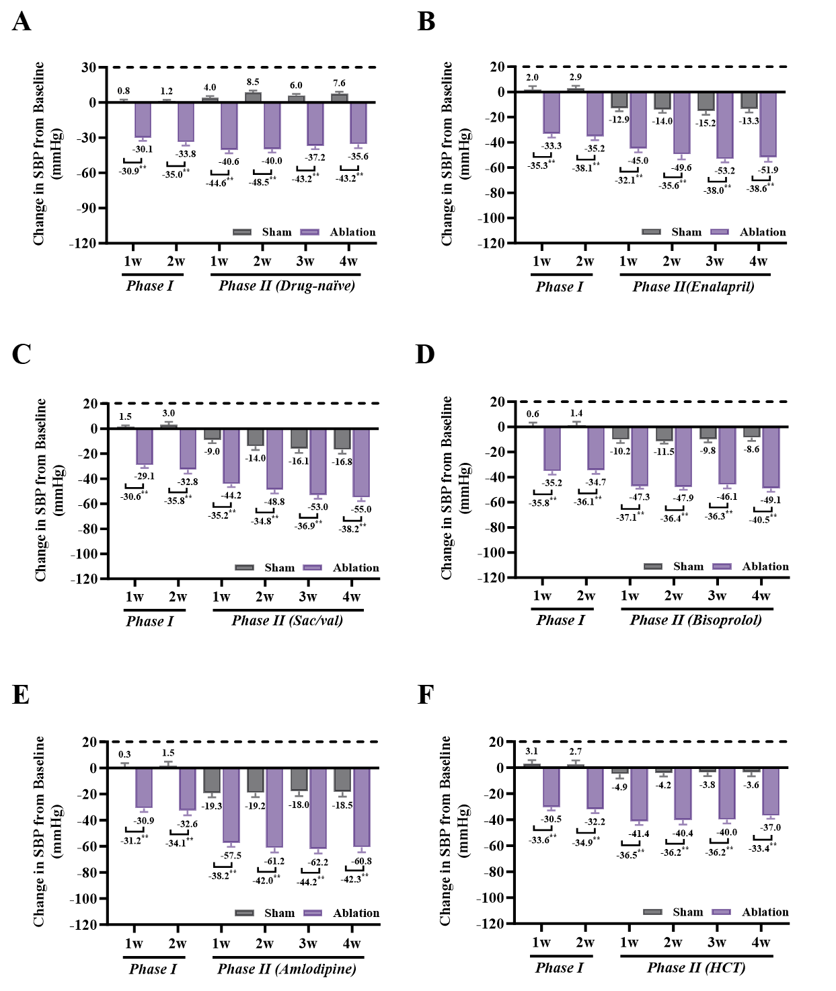
Fig.S1 The effects of different classes of antihypertensive drugs on the SBP of SHRs after ablation or sham operation. SBP was measured in each group of SHRs at 2 weeks postoperatively and 4 weeks after drug intervention to evaluate the differences between the SBP and baseline mean arterial pressure at different experimental stages. SBP was measured after 6 weeks in SHRs without antihypertensive treatment (A), and in SHRs treated with enalapril (B), sacubitril/valsartan (C), bisoprolol (D), amlodipine (E), or hydrochlorothiazide (F). The data are presented as the means ± SEMs (n=8 per group). **P<0.01.

Supplementary Fig.2. Change in diastolic blood pressure in the treatment groups.
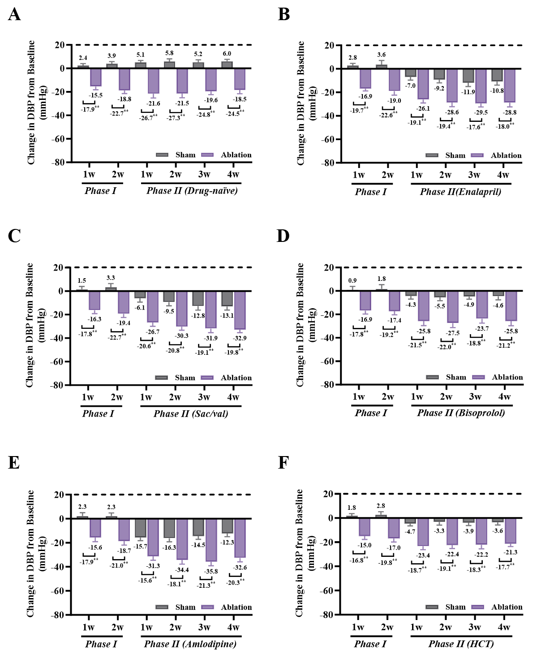
Fig.S2 The effects of different classes of antihypertensive drugs on the DBP of SHRs after Ablation or sham operation. DBP was measured in each group of SHRs at 2 weeks postoperatively and 4 weeks after drug intervention to evaluate the differences between the DBP and baseline mean arterial pressure at different experimental stages. DBP was measured after 6 weeks in SHRs without antihypertensive treatment (A), and in SHRs treated with enalapril (B), sacubitril/valsartan (C), bisoprolol (D), amlodipine (E), or hydrochlorothiazide (F). The data are presented as the means ± SEMs (n=8 per group). **P<0.01.

Supplementary Fig.3. Adrenal ablation induced adrenal gland fibrosis and atrophy.
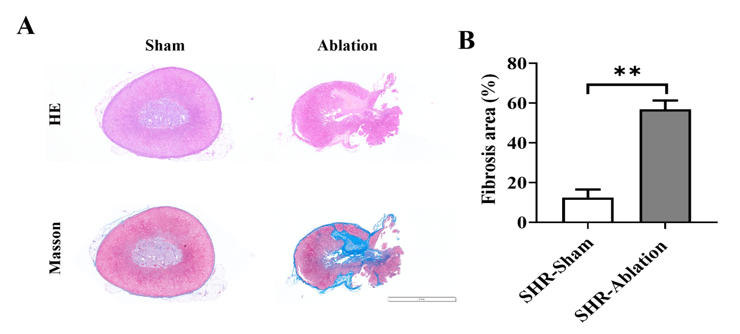
Fig.S3 Adrenal ablation causes structural damage to the adrenal glands in SHRs. (A) Representative hematoxylin and eosin (H&E) and Masson’s trichrome staining images of adrenal glands from ablation group and sham group rats. (B) The percentage of fibrotic area in the adrenal gland was quantified.

