2 3 4 5 6 7 8 9

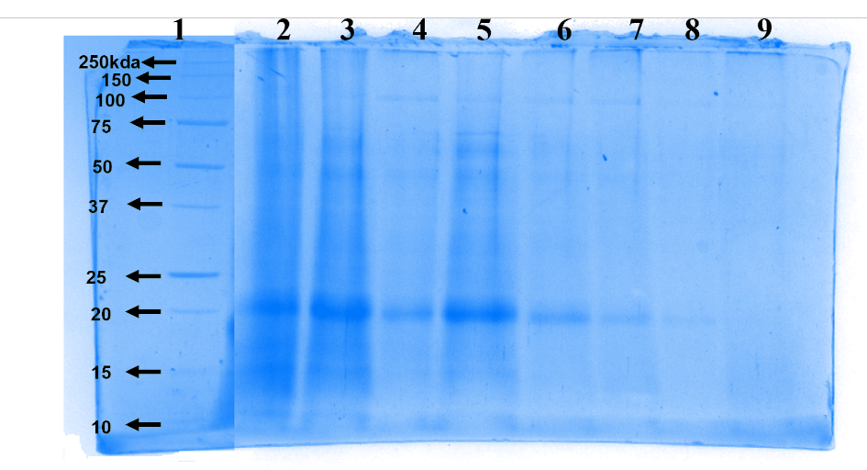
SDS–PAGE revealed a prominent protein band corresponding to approximately 20 kDa, confirming the presence of phycoerythrin. Lane 1: protein marker; lane 2: crude extract; lane 3: flow-through; lane 4: PBS wash; lane 5: eluent 1; lane 6: eluent 2; lane 7: eluent 3; lane 8: eluent 4; lane 9: NaOH wash. The distinct band observed in the elution fractions indicates successful purification of PE.

