Supplementary Information for
An artificial intelligent nanopore platform
for SARS-CoV-2 virus detection

Masateru Taniguchi, Shohei Minami, Chikako Ono, Rina Hamajima, Ayumi Morimura, Shigeto Hamaguchi, Yukihiro Akeda, Yuta Kanai, Takeshi Kobayashi, Wataru Kamitani, Yutaka Terada, Koichiro Suzuki, Nobuaki Hatori, Yoshiaki Yamagishi, Nobuei Washizu, Hiroyasu Takei, Osamu Sakamoto, Norihiko Naono, Kenji Tatematsu, Takashi Washio, Yoshiharu Matsuura & Kazunori Tomono

The Supplementary Information includes:
- Supplementary Figures (Figs. S1-S5)
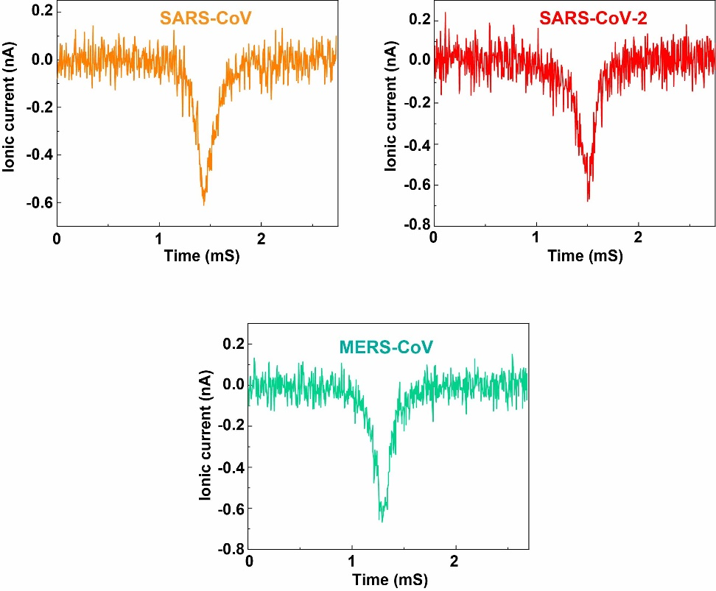

Figure S1. Typical ionic current-time profiles of SARS-CoV, SARS-CoV-2, and MERS-CoV. All waveforms were obtained using a NanoScouter with a -0.1 V applied, using a 300 nm diameter nanopore. DMEM was used as a buffer.

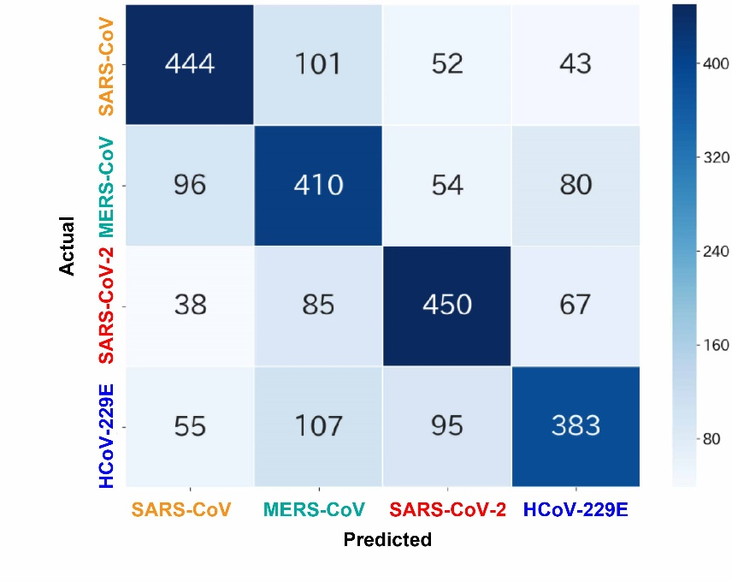

Figure S2. Confusion matrix 4 types of cultured viruses. The numbers in the matrix elements indicate the number of waveforms obtained by measurement. The darker the diagonal line, the higher the identification accuracy. The F-value was calculated from these confusion matrices.

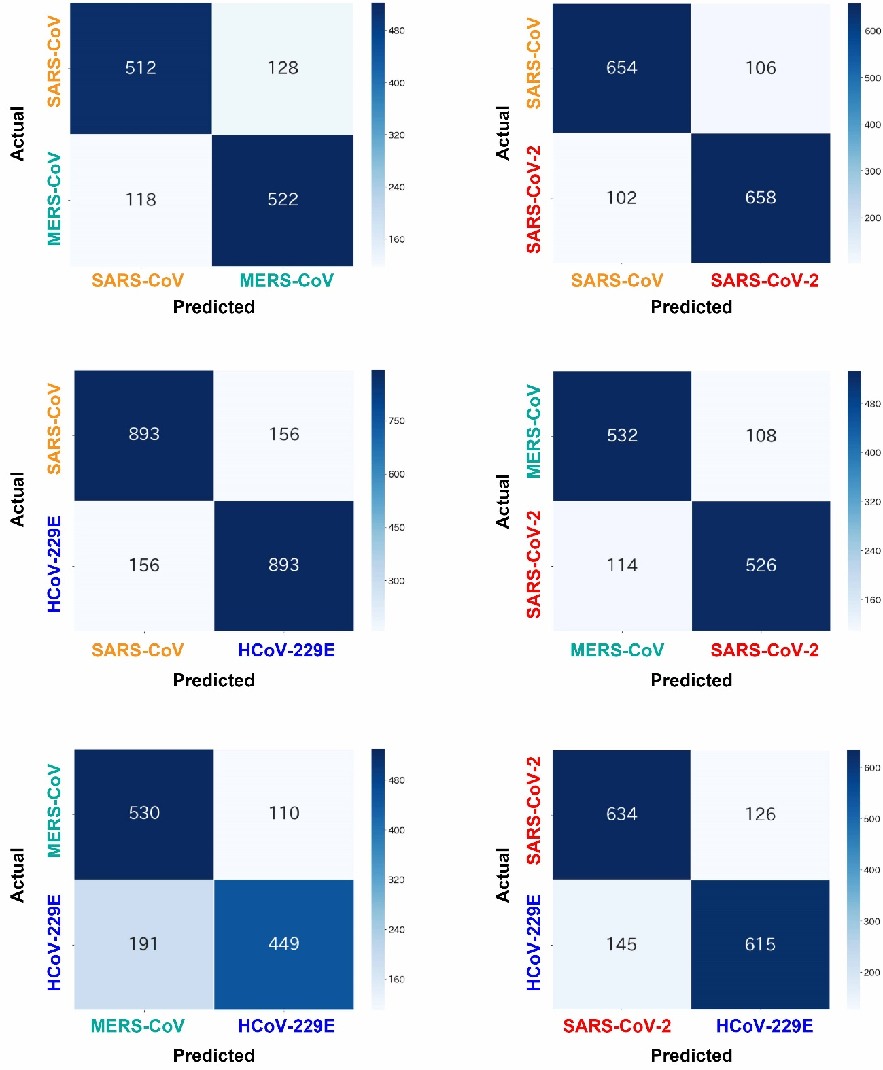
Figure S3. Confusion matrixes 2 types of cultured viruses. The numbers in the matrix elements indicate the number of waveforms obtained by measurement. The darker the diagonal line, the higher the identification accuracy. The F-value was calculated from these confusion matrices.
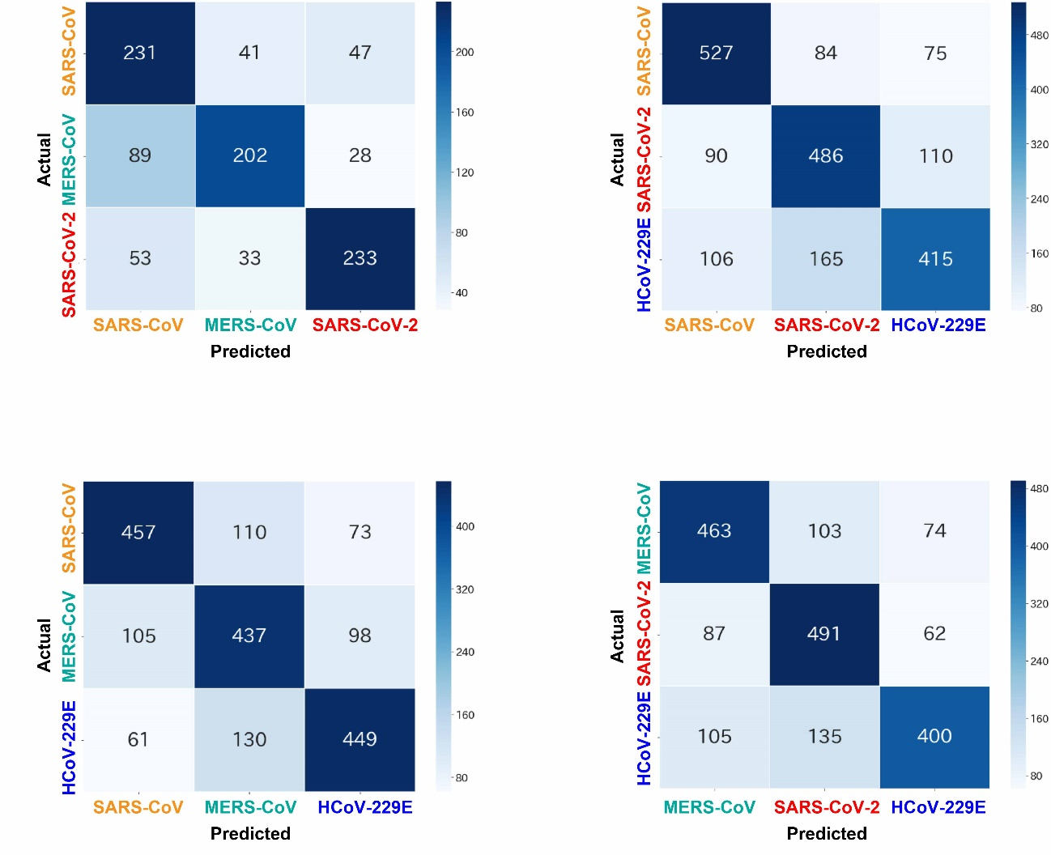
Figure S4. Confusion matrixes 3 types of cultured viruses. The numbers in the matrix elements indicate the number of waveforms obtained by measurement. The darker the diagonal line, the higher the identification accuracy. The F-value was calculated from these confusion matrices.

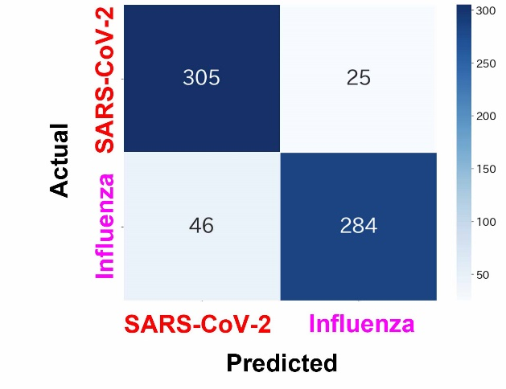

Figure S5. Confusion matrix of cultured SARS-CoV-2 and influenza A virus (N1H1). The numbers in the matrix indicate the number of waveforms obtained by measurement. The F-value was calculated from this confusion matrix.

