Supplementary Data for

Displacement-Induced OFF-ON-OFF Detection of Aluminum and Cyanide in Water: Environmental Monitoring, Bioimaging, and In Vitro/In Vivo Analysis

Kemal Yararli^{¥, a}, Abdullah S. Hussein^{¥, b}, Funda Keteci^{c}, Ozge Turbedaroglu^{d}, Buket Bakan^{c}, Turgay Sisman^{c}, Ozkan Aksakal^{c}, Sinan Bayindirª*, and Ferruh Lafzi^{d}*

ªDepartment of Chemistry, Faculty of Sciences and Arts, Bingol University, 12000, Bingol, Türkiye

^{b}College of Education Chemistry Department, Salahaddin University-Erbil, 44001, Erbil, Iraq

^{c}Department of Molecular Biology and Genetics, Faculty of Science, Atatürk University, 25240, Erzurum, Türkiye

^{d}Department of Chemistry, Faculty of Sciences, Atatürk University, 25240, Erzurum, Türkiye

¥ Contributed equally

*Corresponding author:
Sinan Bayindir (sbayindir@bingol.edu.tr)
Feruh Lafzi (farrokh.lafzi@atauni.edu.tr)

General methods

All chemicals, reagents, and solvents were commercially available from Sigma-Aldrich or Merck. ¹H NMR and ¹³C NMR spectra were recorded on a 400 (100)-MHz Bruker spectrometer and are reported in terms of chemical shift (δ, ppm) with SiMe₄ as an internal standard. Data for ¹H NMR are recorded as follows: chemical shift (δ, ppm), multiplicity (s: singlet, d: doublet, t: triplet, q: quartet, p: pentet, m: multiplet, bs: broad singlet, bd: broad doublet, qd: quasi doublet), and coupling constant (s) in Hz, integration. Elemental analyses were carried out on a LECO CHNS-932 instrument. Column chromatography was performed on silica gel 60 (230–400 mesh ASTM). The reaction progress was monitored by thin-layer chromatography (TLC) using 0.25-mm-thick precoated silica plates (Merck Fertigplatten Kieselgel (60 F254)). HRMS were acquired using a QTOF (Quadrupole time-of-flight) spectrometry instrument. UV-Vis absorption and fluorescence spectra of samples were recorded on a Shimadzu UV-3101PL UV-Vis-NIR spectrometer and Perkin–Elmer (Model LS 55) Fluorescence Spectrophotometer, respectively.
Synthesis of Rh-NH₂: Ethylenediamine (1.0 mL, 15.08 mmol) was added dropwise to a solution of rhodamine B (1.0 g, 2.01 mmol) in 25 mL of ethanol. The solution was heated to reflux for 16 h and evaporated to dryness. The resulting residue was dissolved in water and extracted with DCM (2x 15 mL). The combined organic phases were washed with water and dried over Na₂SO₄. The solvent was removed by evaporation, and the remaining solid was dried in vacuo, affording 2-(2-aminoethyl)-3',6'-bis(diethylamino)spiro[isoindoline-1,9'-xanthen]-3-one (Rh-NH₂) as a pinkish powder (0.96 g, 99%). ¹H NMR (400 MHz, CDCl₃) δ 7.89 (dd, J = 5.6, 3.1 Hz, 1H), 7.43 (dd, J = 5.6, 3.1 Hz, 2H), 7.08 (dd, J = 5.9, 2.7 Hz, 1H), 6.42 (d, J = 8.9 Hz, 2H), 6.36 (d, J = 2.6 Hz, 2H), 6.26 (dd, J = 8.9, 2.7 Hz, 2H), 3.32 (q, J = 7.3 Hz, 8H), 3.18 (t, J = 6.7 Hz, 2H), 2.40 (t, J = 6.6 Hz, 2H), 1.15 (t, J = 7.0 Hz, 12H). ¹³C NMR (100 MHz, CDCl₃) δ 168.9, 153.7, 153.5, 149.0, 132.6, 131.4, 128.9, 128.3, 124.0, 123.0, 108.3, 105.8, 97.9, 65.1, 44.6, 44.1, 41.1, 12.8 (Figure S1). [1.2]
Synthesis of probe (Rh-Ph-Rh): To a solution of rhodamine B ethylenediamine (Rh-NH₂, 100 mg, 2 equiv.) in ethanol (10 mL), either 1,1'-(1,4-phenylene)bis(ethan-1-one) (Ph(CMeO)₂, 17 mg, 1 equiv.) was added. The reaction mixture was stirred under reflux in ethanol. As monitored by TLC, the solvent was removed under reduced pressure upon completion of the reaction. The crude product was purified by recrystallization to yield the desired probe as a pale-yellow solid (88 mg, 78% yield). ¹H NMR (400 MHz, DMSO-d6) δ 7.81-7.79 (m, 3H, =CH), 7.61 (m, 3H, =CH), 7.51 (m, 4H, =CH), 7.05 (m, 2H, =CH), 6.32 (m, 12H, =CH), 3.35-3.10 (m, 30H, CH₂, CH₃), 1.88 (s, 6H, CH₂), 1.05 (m, 18H, CH₂, CH₃); ¹³C NMR (100 MHz, DMSO-d6) δ 167.3, 165.2, 153.8, 153.1, 148.8, 141.2, 131.1, 128.9, 128.4, 127.2, 126.6, 124.1, 122.8, 108.6, 105.5, 97.7, 64.5, 49.9, 44.2, 41.2, 15.2, 12.8 (Figure S2); HRMS (ESI-TOF) m/z: [M]⁺ calcd for C₇₀H₇₈N₈O₄, 1094.6141; found, 1094.6166 (Figure S4A).
Scheme S1. Synthesis and sensing strategies of Rh-Ph-Rh

Methodology for Recognition Evaluation
UV-Vis and fluorescence studies of probe with various ions: To explore how the probe interacts with various ions, an aqueous solution of Rh-Ph-Rh (1 × 10⁻² M) was prepared in a quartz cuvette. Baseline UV-Vis absorbance and fluorescence spectra were first recorded. Next, a 1 × 10⁻² M aqueous solution of the selected ions was gradually added, with one equivalent introduced at each stage. After each addition, the UV-Vis and fluorescence were measured at room temperature to track any changes resulting from the interaction.
UV-Vis and fluorescence titration probes with AlCl₃ /[Bu₄N]CN: Fresh stock solutions were prepared for the probe Rh-Ph-Rh (1 × 10⁻² M in DMSO) and the analytes AlCl₃ / [Bu₄N]CN (both at 1 × 10⁻² M in water). For the titration experiments, a 10 µM working solution of the probe was prepared in water to detect Al³⁺ and CN⁻ ions. During the titration, the analyte solution was added gradually to the probe, and after each step, both the UV-Vis absorbance and fluorescence spectra were recorded. To ensure the reliability and consistency of the results, all titrations were repeated at least twice.
Job’s plot measurement: Stock solutions of the probe Rh-Ph-Rh (1 × 10⁻² M) were first prepared in ethanol. To create the dilution series, different volumes of the stock solution, ranging from 0.00 to 5.00 mL in 0.50 mL increments, were measured out and placed into separate volumetric containers. Each was then topped up with the appropriate solvent to reach a final volume of 5.00 mL. At the same time, aqueous stock solutions of AlCl₃ (1 × 10⁻² M) were also prepared in water. For every probe dilution, a matching (but inverse) volume of the AlCl₃ solution was added, so that the sum of the probe and metal ion volumes always totaled 5.00 mL. After thorough mixing of each solution, fluorescence spectra were measured at room temperature to characterize the interaction between the probe and the ion.
Determination of detection limit: To assess the probe's sensitivity to each analyte, detection limits were calculated from fluorescence titration data. This was done with the standard formula: LOD = 3.3σ/k, where σ is the standard deviation from the measurements of the probe alone (without any analyte), and k is the slope from the linear fit of fluorescence intensity against analyte concentration.
Determination of Association Constant: To determine how strongly the probe Rh-Ph-Rh binds to metal ions, the association constant (K_{a}) was calculated using the Benesi–Hildebrand method with fluorescence titration data. This involved using the following relationship:

$$\frac{1}{F-F_{0}}=\frac{1}{\left\{K_{a}(F_{max}-F_{0}){\left[M^{x+}\right]}^{n}\right\}}+\frac{1}{F_{max}-F_{0}}$$
In this formula, F₀ denotes the fluorescence intensity of the probe alone, F denotes the intensity after the metal ion is added, and Fmax denotes the intensity when binding is complete. K_{a} is the association constant, and n indicates how many ions bind to each probe molecule. By plotting 1/(F-F₀) against 1/[M], a straight line is obtained, and the K_{a} value is calculated from the slope of this plot.
The pH measurement: To assess the probes' performance in real-world conditions, their fluorescence response was tested over a wide pH range (2-12). Solutions of the probe Rh-Ph-Rh (10 µM) were prepared both with and without AlCl₃ (30 µM in water). Ten separate samples were adjusted to different pH levels using either dilute HCl or NaOH, depending on whether the pH needed to be lowered or raised. The final pH of each sample was verified using a calibrated pH meter or pH indicator strips. After the pH was set, fluorescence measurements were taken to assess the probes' responses at each pH.
The reversible switching studies: The experiments involved preparing stock solutions of the probe Rh-Ph-Rh, along with Al³⁺ ions and CN⁻ anions, in DMSO and water. This process entailed repeatedly adding metal ions and their counter-anions to the probe solution and monitoring the resulting fluorescence changes. Initially, a 10 µM solution of the probe in water was prepared, and its baseline fluorescence spectrum was recorded. Next, a measured amount of Al³⁺ ions, either stoichiometric or slightly in excess (1.0-1.5 equivalents), was added to the probe solution. After incubation for 2 minutes, any changes in color or fluorescence were observed. Subsequently, an equivalent or excess amount of the competing CN⁻ anion was introduced to the metal-probe complex. After waiting 1-2 minutes, the fluorescence was measured again to determine whether the signal had reversed. This cycle of adding metal ions, followed by anions, was repeated 10 times to evaluate the probe’s switching reliability and consistency, providing insights into the system’s reversibility and stability.
Preparation of Filter Paper: To create colorimetric cards, filter paper was soaked in the probe solution and incubated at room temperature for 5 hours. Subsequently, the papers were rinsed with water and dried at 50 °C. Once prepared, these cards were tested by either dipping them into metal-ion solutions or by applying small drops of the samples directly onto the paper. Any resulting color changes were carefully observed and documented. Each test was performed three times to ensure consistent, reliable results.
Real-world sample tests: To assess how well the probe Rh-Ph-Rh performs under real-world conditions, we analyzed tap water, groundwater, and drinking water. A stock solution of aluminum ions was prepared, and small aliquots were added to separate 5 mL samples of each water type, yielding final concentrations of 0.0, 0.8, 1.3, and 2.0 µmol L⁻¹. Each mixture also contained the Rh-Ph-Rh probe. After allowing the mixtures to sit at room temperature for a period, we measured their fluorescence to assess how the probe responded in these real water samples. To check how accurate the probe was, we calculated the percentage recovery by comparing how much aluminum was detected to how much was actually added, using the formula:
Recovery (%) = (Measured value – Original value / Added amount) × 100

Biological measurement
Cytotoxicity and Anticancer Activity: MCF-7 (human breast cancer cell line; ATCC HTB-22) was cultured in Dulbecco's modified Eagle medium (DMEM) supplemented with 10% fetal bovine serum (FBS) and 100 U/ml penicillin/streptomycin at 37°C in a 5% CO₂ incubator.
In vitro cytotoxicity and anticancer potential of the tested compound were evaluated using the WST-1 assay following a standard procedure.47 Cells were seeded into 96-well plates at a density of 2 × 10⁴ cells/mL and incubated for 24 h at 37 °C in a humidified atmosphere containing 5% CO₂. After incubation, the cells were treated with various concentrations of the test compound (6.25–500 μg/mL) prepared in serum-free medium, based on previously reported in vitro studies, and maintained for an additional 24 h to assess dose-dependent effects. Subsequently, WST-1 reagent (120 μL per well) was added, and the plates were incubated for 2 h at 37 °C. Absorbance was then measured at 450 nm using a microplate reader (Thermo Scientific). In addition, cellular morphology was examined using an inverted microscope [3].
Cell viability was calculated according to the formula below;
(%) Viability= ([(Absorbance of treated cell) - (absorbance of blank)]) / ([(Absorbance of control) - (absorbance of blank)) x100
Imaging in living cells: Based on test compound cytotoxicity results, the concentration selected as nontoxic to MCF-7 cells for imaging was 50 μg/mL. Firstly, MCF-7 cells were incubated with the test compound in w/o phenol red culture medium for 30 min at 37 ºC, then washed three times with PBS (1X). Subsequently, the cells were incubated with Al3+ (100 μM) for 30 min, and a clear concentration-dependent green fluorescence was observed by confocal microscopy [4,5].
Daphnia magna imaging: Daphnia magna were selected as an animal model for in vivo imaging due to their optical transparency. D. magna had been cultured in our laboratory for more than two years according to the OECD guidelines (Test no 202 and 211) [6,7]. Cultures were maintained in aquaria containing aerated tap water (pH 7.5 ± 0.5, dissolved oxygen 6.2 ± 0.5 mg/L) at room temperature (22 ± 0.5 °C), with 20 D. manga per liter, under a 12 h light:12 h dark photoperiod [8]. For the experiment, newborn daphnids (neonates) were randomly divided into three groups. The control group was not treated. In one experimental group, neonates were incubated with the probe (50 μg/mL) for 30 min. In the other experimental group, the neonates were pretreated with the probe, and Al³⁺ (100 μM) was then added for an additional 30 min. After treatment, neonates in both experimental groups were washed three times with phosphate-buffered saline (PBS, 0.01 M, pH 7.4). Imaging was performed using a confocal fluorescence microscope. The probe was excited at 720 nm, and fluorescence was collected in the green channel (460–500 nm). The concentrations and corresponding fluorescence emission changes were recorded for the test material and for Al3+ concentrations similar to those used in the MCF-7 cell model.

Figure S1. The NMR spectrums of 2-(2-aminoethyl)-3',6'-bis(diethylamino)spiro[isoindoline-1,9'-xanthen]-3-one (Rh-NH₂) in CDCl₃.
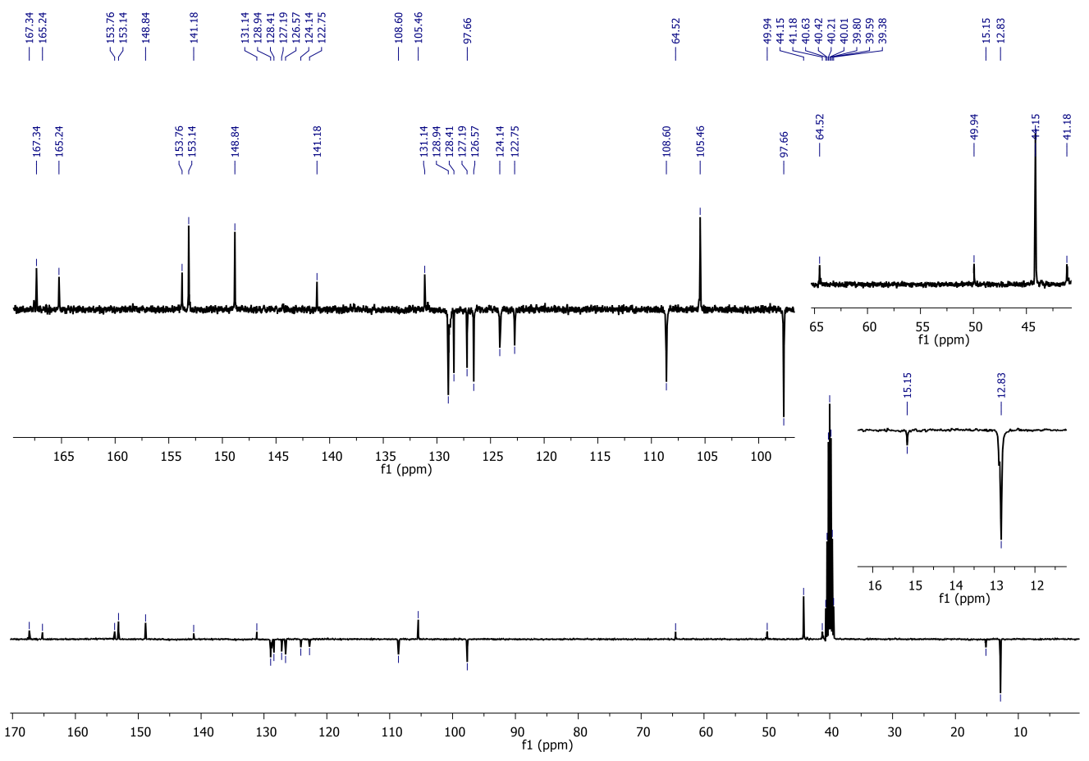
Figure S2. The NMR spectras of Rh-Ph-Rh in DMSO-d6.
Figure S3. Change in partial ¹H-NMR (400 MHz) spectra of Rh-Ph-Rh with AlCl₃ in DMSO-d6.

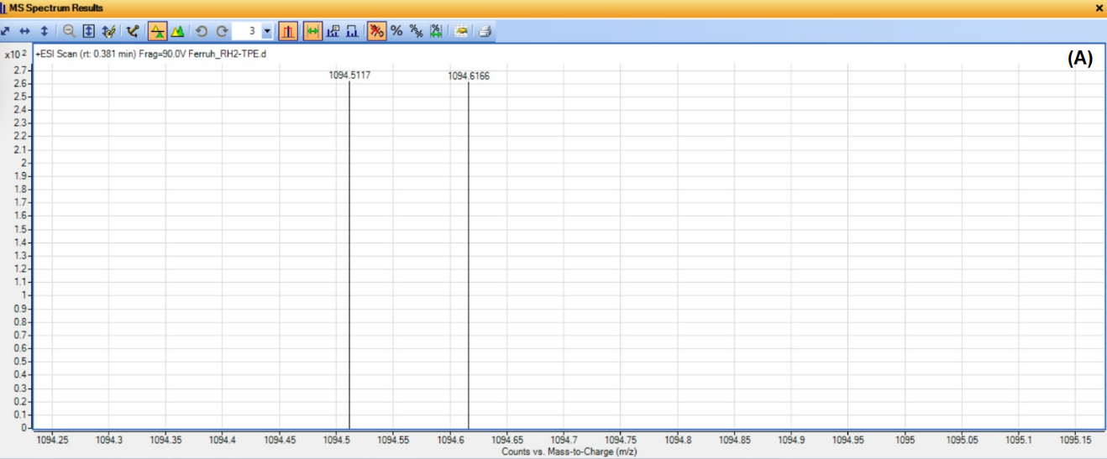
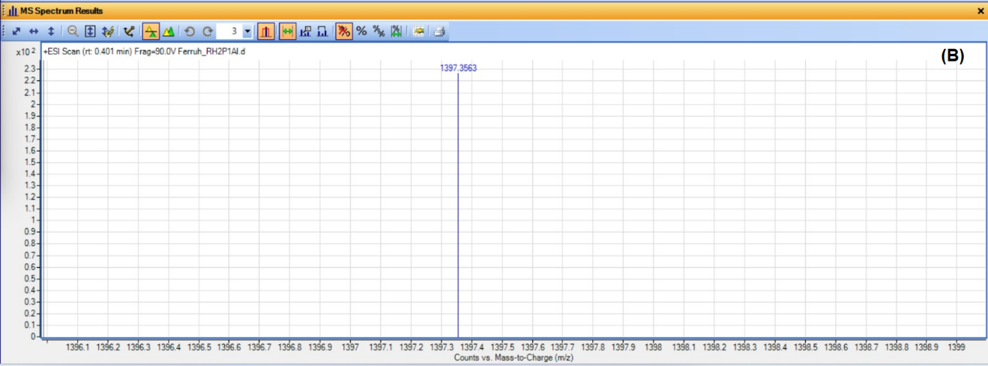
Figure S4. HRMS (ESI-TOF) spectras of Rh-Ph-Rh (A) and Rh-Ph-Rh-Al³⁺ complex (B)

Figure S5. (A) The absorbance spectras of Rh-Ph-Rh in H₂O with various anions (over 15 min.). The fluorescence spectra of Rh-Ph-Rh-Al³⁺ at different exposure times (B) and different pH (3–11) (C) in selected solvent systems, and (D) their bar graphics.

Figure S6. The fluorescence titration spectra and the change in fluorescence intensity of (A) Rh-Ph-Rh with Al³⁺, and (B) Rh-Ph-Rh-Al³⁺ with [Bu₄N]CN.

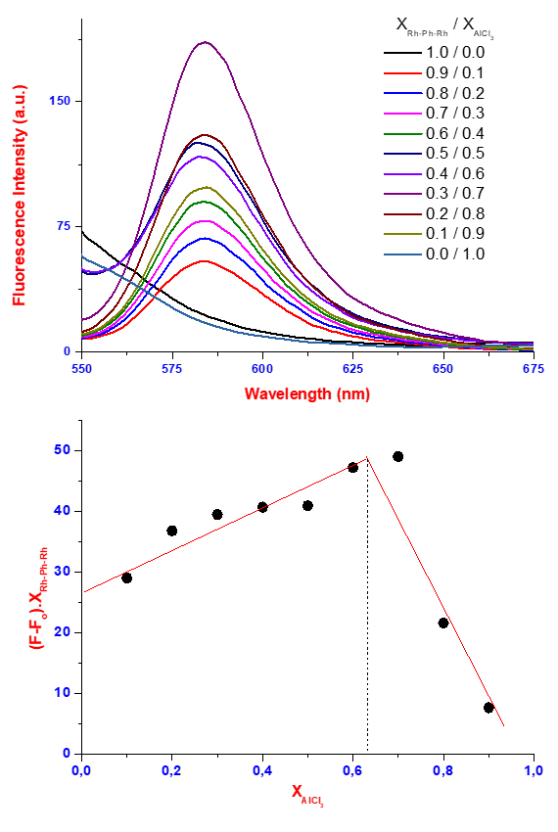
Figure S7. The Job plot fluorescence spectras of Rh-Ph-Rh/AlCl₃

Figure S8. Benesi–Hildebrand plot based on a 1:2 association stoichiometry between Rh-Ph-Rh with Al³⁺ ions



Figure S9. Color changes of Rh-Ph-Rh with varying Al³⁺ concentrations (from 0 μM to 1.6 μM)

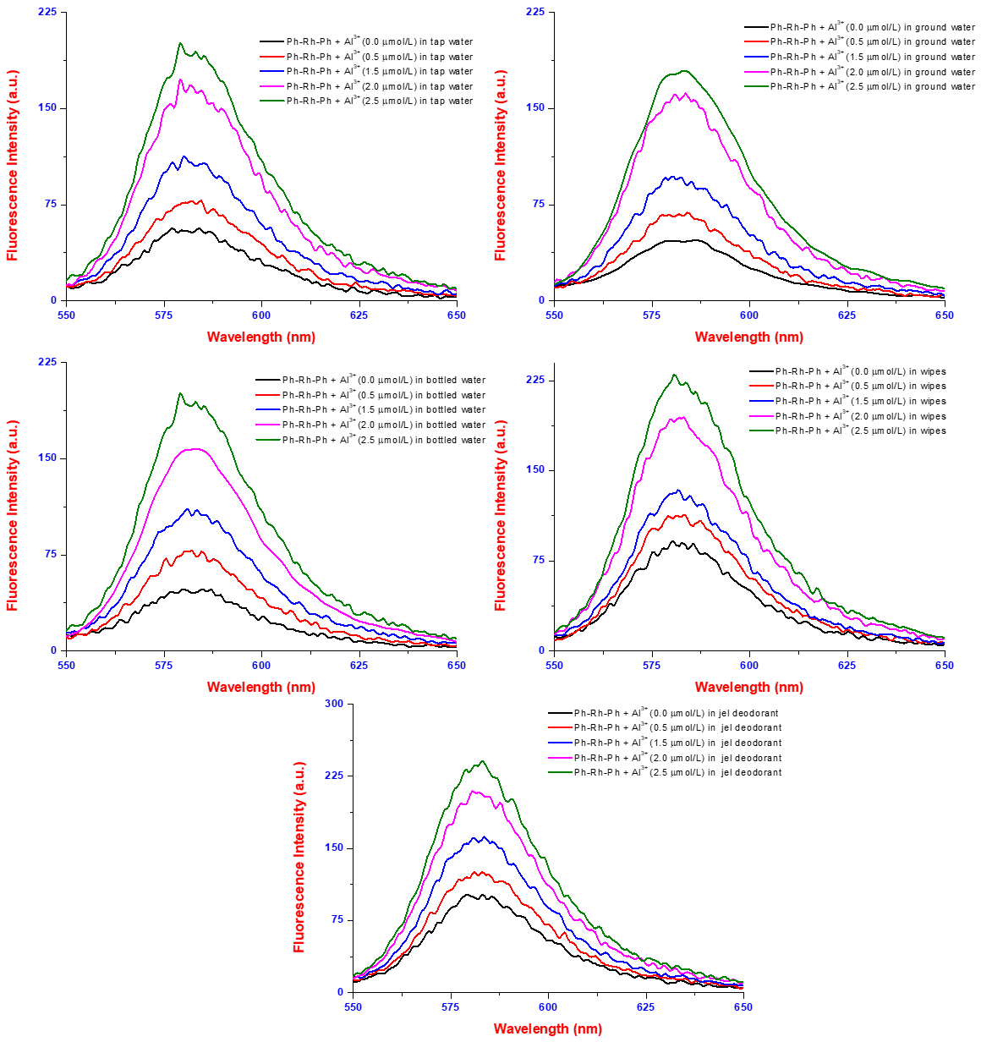
Figure S10. The fluorescence intensity of Rh-Ph-Rh for the determination of AI³⁺ in real-world samples

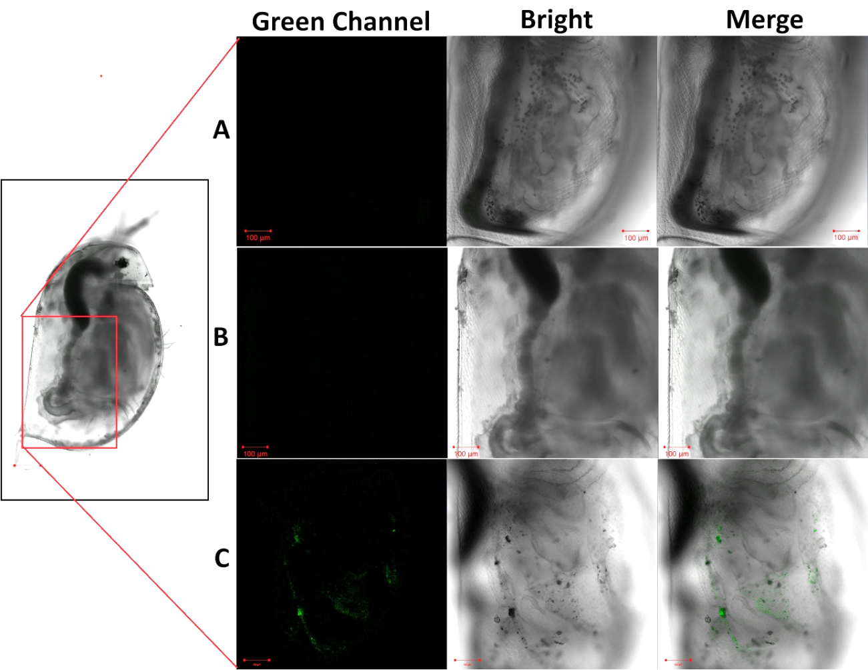
Figure S11. Fluorescence images of Daphnia magna: (A) control group, (B) incubated with 50 μg/mL of the Rh-Ph-Rh only, and (C) incubated with 50 μg/mL of the probe followed by 100 μM Al³⁺ (Scale bar for neonates = 200 µm; scale bars for magnified images = 100 µm).

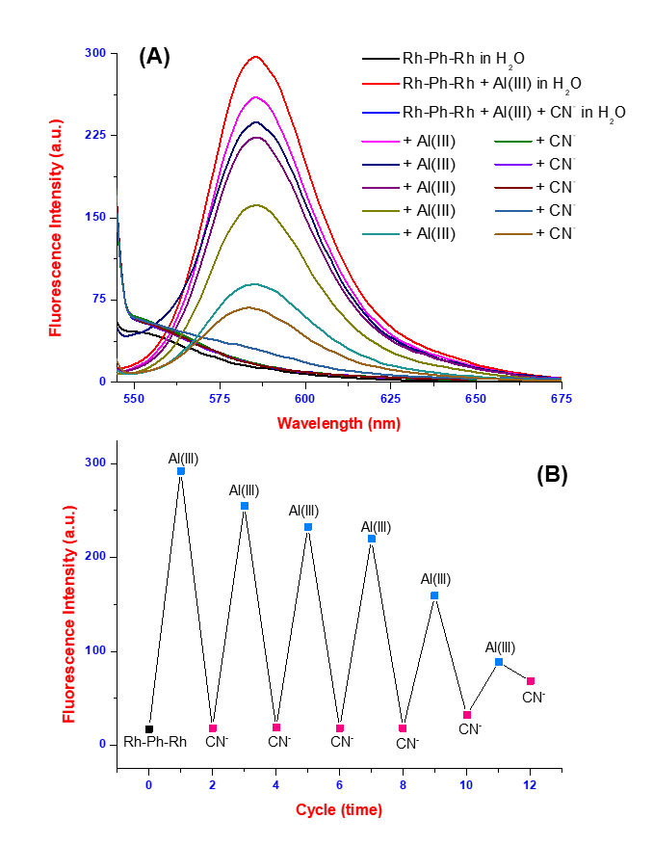

Figure S12. (A) Reversible switching of the fluorescence spectrum of Rh-Ph-Rh with alternate addition of AlCl₃ and [Bu₄N]CN, and (B) the “IMPLICATION” logic gate for Rh-Ph-Rh-Al³⁺ with [Bu₄N]CN.

References

- Kilic, H., & Bozkurt, E. (2018). A rhodamine-based novel turn-on trivalent ions sensor. Journal of Photochemistry and Photobiology A: Chemistry, 363, 23-30.
- Jarava-Barrera, C., Parra, A., López, A., Cruz-Acosta, F., Collado-Sanz, D., Cárdenas, D. J., & Tortosa, M. (2016). Copper-catalyzed borylative aromatization of p-quinone methides: enantioselective synthesis of dibenzylic boronates. ACS catalysis, 6(1), 442-446.
- Bakan, B., Gülcemal, S., Akgöl, S., Hoet, P. H., & Yavaşoğlu, N. Ü. K. (2020). Synthesis, characterization and toxicity assessment of a new polymeric nanoparticle, l-glutamic acid-gp (HEMA). Chemico-Biological Interactions, 315, 108870.
- Xu, J., Pan, J., Jiang, X., Qin, C., Zeng, L., Zhang, H., & Zhang, J. F. (2016). A mitochondria-targeted ratiometric fluorescent probe for rapid, sensitive and specific detection of biological SO₂ derivatives in living cells. Biosensors and Bioelectronics, 77, 725-732.
- Ping, Y., Liu, M., Yu, Y. et al. A Long-wavelength Colorimetric and Fluorescent Chemodosimeter for Monitoring Cu²⁺ in the Environment and Living Systems. J Fluoresc 35, 10551–10560 (2025).
- OECD. (2004). Test No. 202: Daphnia sp. Acute Immobilisation Test. OECD Publishing
- OECD. (2012). Test No. 211: Daphnia magna reproduction test, OECD guidelines for the testing of chemicals, section 2.
- Aksakal, O., Dane, H., Gur, C., & Sisman, T. (2025). Chronic toxicity of tetraconazole and penconazole to Daphnia magna: Insights of growth, reproduction and gene expression changes. Science of The Total Environment, 967, 178774.

