Supplementary information

Topography, microclimate and fine-scale thermal heterogeneity modulate pollinator foraging behavior

Elena Kaminskaia* and Nicole E. Rafferty
School of BioSciences, The University of Melbourne, Parkville, Victoria 3010, Australia

*To whom correspondence may be addressed. Email: ekaminskaia@student.unimelb.edu.au

Table S1. List of all flower species recorded through flower surveys conducted at each site.

Family | Genus | Species | Pollinator interaction observed
Brassicaceae | Raphanus | Raphanus raphanistrum | Yes
Brassicaceae | Hirschfeldia | Hirschfeldia incana | Yes
Asteraceae | Bellis | unknown | No
Brassicaceae | Capsella | Capsella bursa-pastoris | Yes
Asteraceae | Taraxacum | unknown | Yes
Papaveraceae | Fumaria | Fumaria muralis | Yes
Geraniaceae | Erodium | Erodium moschatum | Yes
Caryophyllaceae | Cerastium | Cerastium glomeratum | No
Fabaceae | Trifolium | Trifolium subterraneum | Yes
Primulaceae | Lysimachia | Lysimachia arvensis | No
Asteraceae | Arctotheca | Arctotheca calendula | Yes
Fabaceae | Trifolium | unknown | Yes
Ranunculaceae | Ranunculus | unknown | Yes
Violaceae | Viola | Viola arvensis | No
Asteraceae | Leucanthemum | unknown | Yes

Table S2. Coefficients for visitation rate pSEM. Significance codes: <0.001 '***' <0.01 '**' <0.05 '*'

Response | Predictor | Estimate | Std.Error | DF | Crit.Value | P.Value | Std.Estimate
log_vis_rate | SHDI_TIR | -0.306 | 0.116 | 122 | -2.648 | 0.008 | -0.269 | **
log_vis_rate | iTemp_value | 0.070 | 0.019 | 122 | 3.616 | <0.001 | 0.317 | ***
log_vis_rate | GTI | 0.001 | <0.001 | 122 | 3.451 | <0.001 | 0.350 | ***
log_vis_rate | elevation | -0.003 | 0.001 | 122 | -3.411 | <0.001 | -0.383 | ***
log_vis_rate | TPI_scaled | 0.173 | 0.057 | 122 | 3.047 | 0.002 | 0.266 | **
iTemp_value | rh | -0.102 | 0.012 | 122 | -8.245 | <0.001 | -0.429 | ***
iTemp_value | GTI | 0.004 | 0.001 | 122 | 3.599 | <0.001 | 0.255 | ***
iTemp_value | elevation | 0.019 | 0.008 | 122 | 2.372 | 0.018 | 0.473 | *
iTemp_value | avg_wind_speed | -1.402 | 0.332 | 122 | -4.228 | <0.001 | -0.541 | ***
iTemp_value | eastness | 3.423 | 1.268 | 122 | 2.699 | 0.007 | 0.593 | **
SHDI_TIR | iTemp_value | -0.091 | 0.015 | 122 | -6.209 | <0.001 | -0.458 | ***
SHDI_TIR | GTI | 0.001 | 0.000 | 122 | 10.993 | <0.001 | 0.457 | ***
SHDI_TIR | rh | -0.011 | 0.003 | 122 | -4.186 | <0.001 | -0.232 | ***
SHDI_TIR | TPI_scaled | -0.230 | 0.080 | 122 | -2.871 | 0.004 | -0.412 | **
SHDI_TIR | elevation | 0.003 | 0.001 | 122 | 2.171 | 0.030 | 0.332 | *
SHDI_TIR | eastness | 0.478 | 0.194 | 122 | 2.466 | 0.014 | 0.417 | *

Table S3. Coefficients for handling time pSEM. Significance codes: <0.001 '***' <0.01 '**' <0.05 '*'

Response | Predictor | Estimate | Std.Error | DF | Crit.Value | P.Value | Std.Estimate
log_duration | SHDI_TIR | 0.505 | 0.182 | 122 | 2.776 | 0.006 | 0.277 | **
log_duration | iTemp_value | -0.113 | 0.030 | 122 | -3.702 | <0.001 | -0.317 | ***
log_duration | GTI | -0.002 | 0.001 | 122 | -3.338 | 0.001 | -0.342 | ***
log_duration | elevation | 0.005 | 0.001 | 122 | 3.404 | 0.001 | 0.373 | ***
log_duration | TPI_scaled | -0.236 | 0.090 | 122 | -2.629 | 0.009 | -0.226 | **
iTemp_value | rh | -0.102 | 0.012 | 122 | -8.245 | <0.001 | -0.429 | ***
iTemp_value | GTI | 0.004 | 0.001 | 122 | 3.599 | <0.001 | 0.255 | ***
iTemp_value | elevation | 0.019 | 0.008 | 122 | 2.372 | 0.018 | 0.473 | *
iTemp_value | avg_wind_speed | -1.402 | 0.332 | 122 | -4.228 | <0.001 | -0.541 | ***
iTemp_value | eastness | 3.423 | 1.268 | 122 | 2.699 | 0.007 | 0.593 | **
SHDI_TIR | iTemp_value | -0.091 | 0.015 | 122 | -6.209 | <0.001 | -0.458 | ***
SHDI_TIR | GTI | 0.001 | <0.001 | 122 | 10.993 | <0.001 | 0.457 | ***
SHDI_TIR | rh | -0.011 | 0.003 | 122 | -4.186 | <0.001 | -0.232 | ***
SHDI_TIR | TPI_scaled | -0.230 | 0.080 | 122 | -2.871 | 0.004 | -0.412 | **
SHDI_TIR | elevation | 0.003 | 0.001 | 122 | 2.171 | 0.030 | 0.332 | *
SHDI_TIR | eastness | 0.478 | 0.194 | 122 | 2.466 | 0.014 | 0.417 | *

Key:
Code | Description
log_vis_rate | log+1 transformed visitation rate
iTemp_value | Air temperature data obtained from iButton data loggers
SHDI_TIR | thermal heterogeneity of the flower patch surface
GTI | Global tilted irradiance
elevation | Elevation (m)
avg_wind_speed | Average wind speed (miles/hour)
eastness | Aspect values converted into “eastness” through cos transformation

Table S4. Model coefficients obtained from GLMM with Gaussian distribution on pollinator operative body temperature (Te) when foraging on the flower in relation to air temperature, solar radiation (scaled and centered), elevation and wind speed.

 | Estimate | Std. Error | z value | Pr(>|z|)
(Intercept) | 25.289 | 3.006 | 8.413 | 0.000
iTemp_value | 0.265 | 0.107 | 2.471 | 0.013
GTI_scaled | 1.411 | 0.271 | 5.216 | <0.001
elevation | -0.030 | 0.005 | -5.550 | <0.001
avg_wind_speed | 0.624 | 0.348 | 1.790 | 0.073

Table S5. Model coefficients obtained from GLMM with Gaussian distribution on visitation rate (log+1 transformed) in relation to pollinator operative body temperature (Te) on a flower.

 | Estimate | Std. Error | z value | Pr(>|z|)
(Intercept) | 0.229 | 0.584 | 0.393 | 0.695
Te_flower | 0.044 | 0.019 | 2.315 | 0.021

Table S6. Model coefficients obtained from LMM on visitation rate (log+1 transformed) in relation to thermal heterogeneity, air temperature, solar radiation, elevation and TPI (scaled and centered around the mean).

 | Estimate | Std. Error | z value | Pr(>|z|)
(Intercept) | -0.434 | 0.559 | -0.778 | 0.437
SHDI_TIR | -0.311 | 0.117 | -2.659 | 0.008
iTemp_value | 0.073 | 0.019 | 3.825 | <0.001
GTI | 0.001 | <0.001 | 3.643 | <0.001
elevation | -0.003 | 0.001 | -4.159 | <0.001
TPI_scaled | 0.172 | 0.057 | 2.995 | 0.003

Table S7. Model coefficients obtained from LMM on handling time (log+1 transformed) in relation to thermal heterogeneity, air temperature, solar radiation, elevation and TPI (scaled and centered around the mean).

 | Estimate | Std. Error | z value | Pr(>|z|)
(Intercept) | 6.850 | 0.880 | 7.785 | <0.001
SHDI_TIR | 0.514 | 0.183 | 2.809 | 0.005
iTemp_value | -0.117 | 0.030 | -3.878 | <0.001
GTI | -0.002 | 0.001 | -3.549 | <0.001
elevation | 0.005 | 0.001 | 4.135 | <0.001
TPI_scaled | -0.234 | 0.090 | -2.585 | 0.010

Table S8. Model coefficients obtained from LMM on air temperature in relation to relative humidity, solar radiation, elevation, wind speed, and aspect (“eastness”).

 | Estimate | Std. Error | z value | Pr(>|z|)
(Intercept) | 26.794 | 1.591 | 16.841 | <0.001
rh | -0.102 | 0.012 | -8.245 | <0.001
GTI | 0.004 | 0.001 | 3.599 | <0.001
elevation | 0.019 | 0.008 | 2.372 | 0.018
avg_wind_speed | -1.402 | 0.332 | -4.228 | <0.001
eastness | 3.423 | 1.268 | 2.699 | 0.007

Table S9. Model coefficients obtained from LMM on thermal heterogeneity in relation to air temperature, solar radiation, relative humidity, TPI (scaled and centered around the mean), elevation and aspect (“eastness”).

 | Estimate | Std. Error | z value | Pr(>|z|)
(Intercept) | 3.225 | 0.485 | 6.646 | <0.001
iTemp_value | -0.091 | 0.015 | -6.209 | <0.001
GTI | 0.001 | <0.001 | 10.992 | <0.001
rh | -0.011 | 0.003 | -4.186 | <0.001
TPI_scaled | -0.230 | 0.080 | -2.871 | 0.004
elevation | 0.003 | 0.001 | 2.170 | 0.030
eastness | 0.478 | 0.194 | 2.466 | 0.014

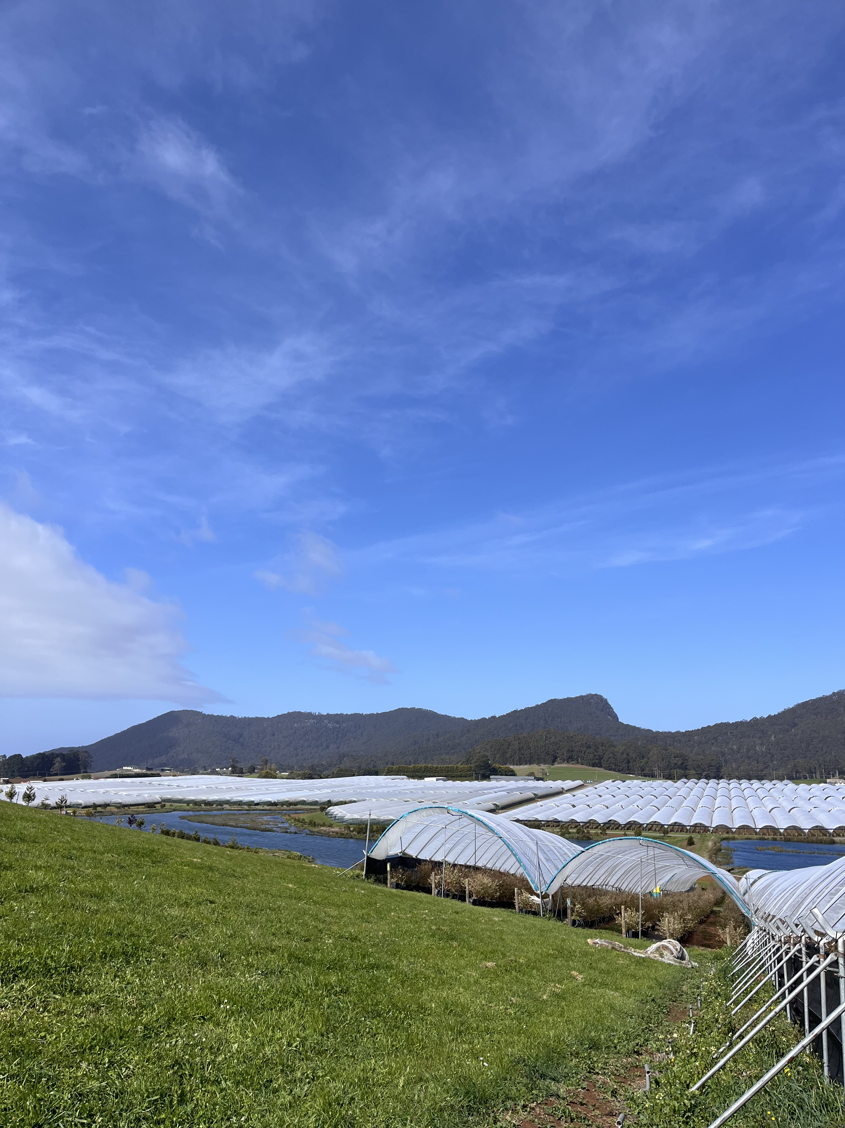
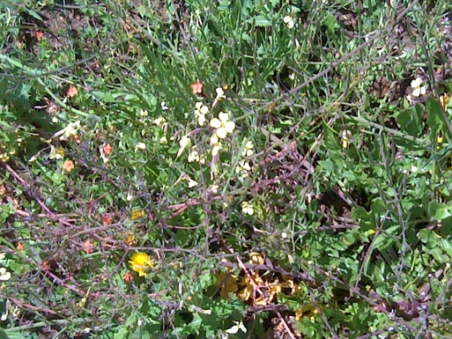
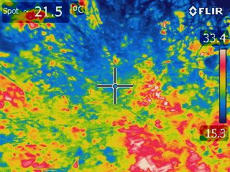
(b)

Fig. S1 (a) Landscape surrounding Westerway Raspberry Farm study site and (b) an example of a regular photograph (top) of a flower patch and an infrared version of the photograph (bottom), used to quantify thermal heterogeneity of the flower patch surface.

(a)

