Table 4. Interaction of potential drugs with TPX2, TTK, CKS2, and MYC receptors.
Hub protein | Drugs | Affinity  (kcal/mol) | Two-dimensional depiction of interactions | Three-dimensional depiction of interactions
TPX2 | Dacomitinib | -8.3 | 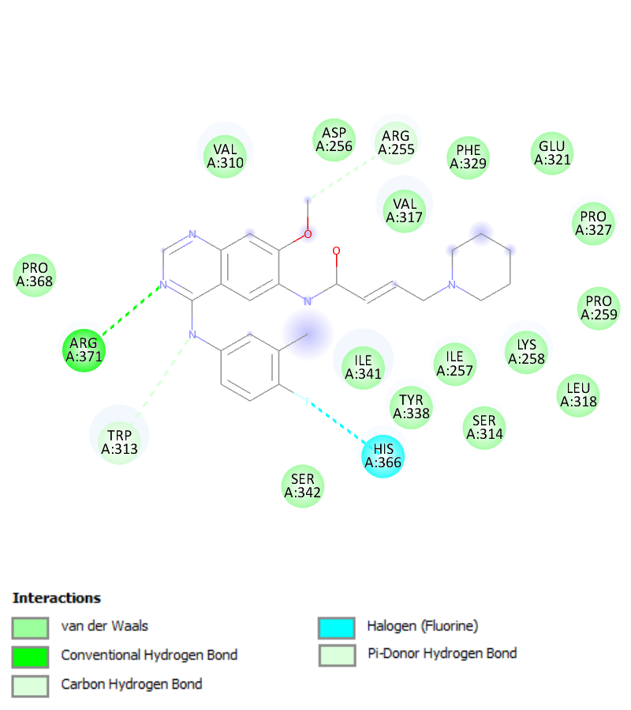 | 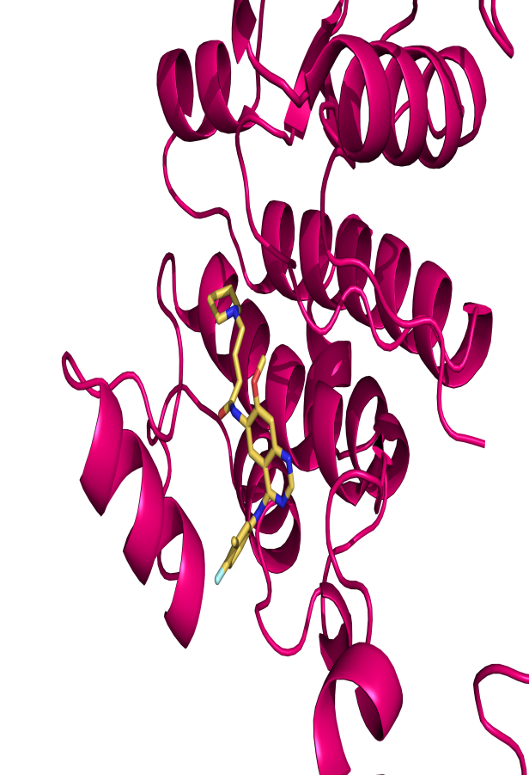
TTK | Fostamatinib | -9.5 | 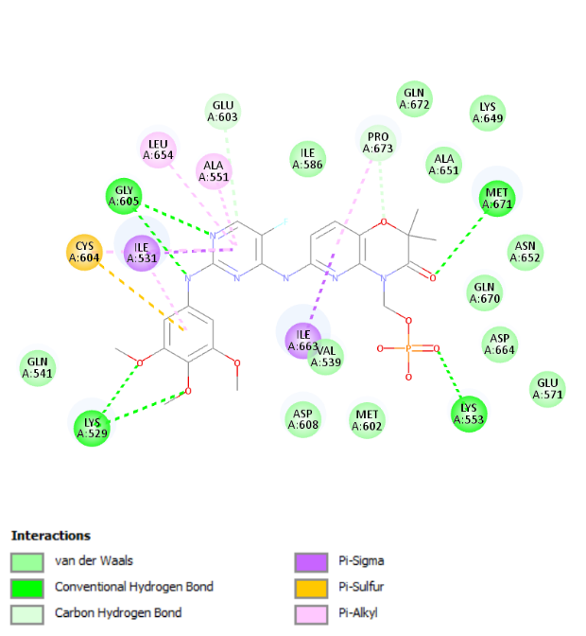 | 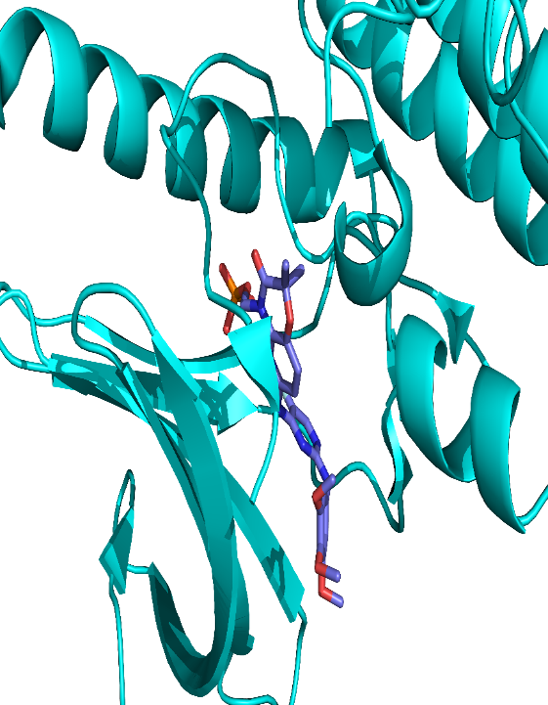
TTK | Pyrazolanthrone | -8.8 | 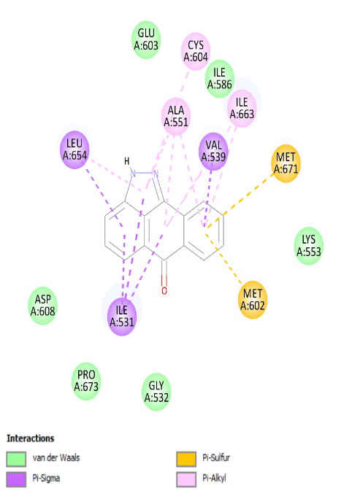 | 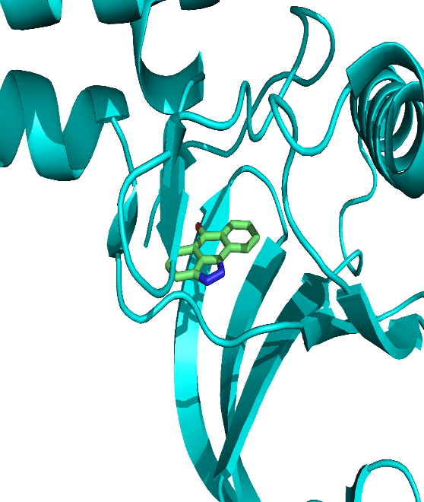
TTK | BOS172722 | -9.0 | 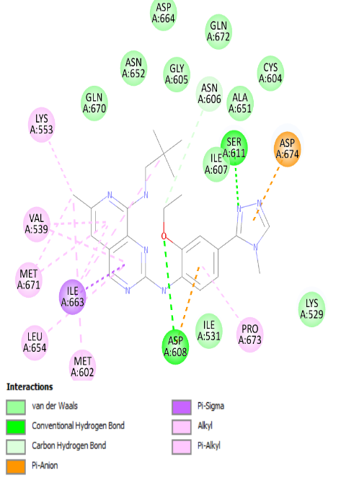 | 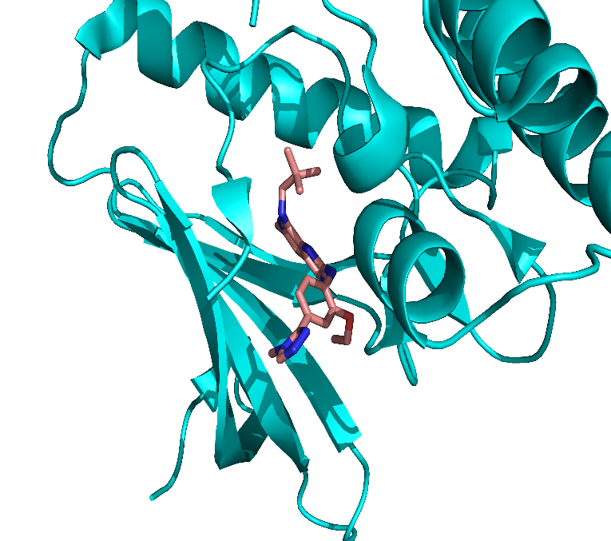
TTK | BAY-1161909 (Bay-11) | -10.0 | 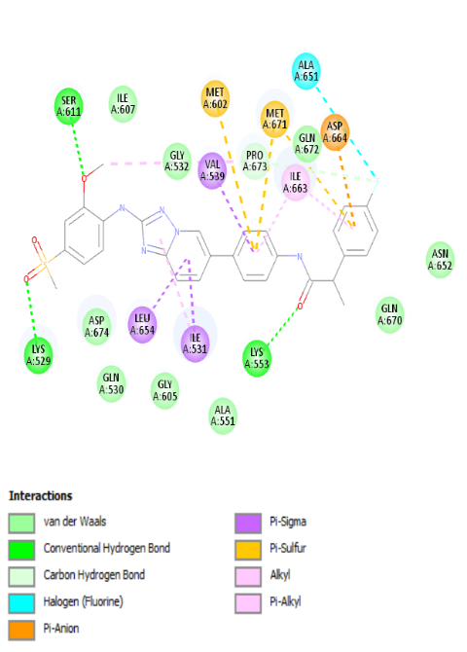 | 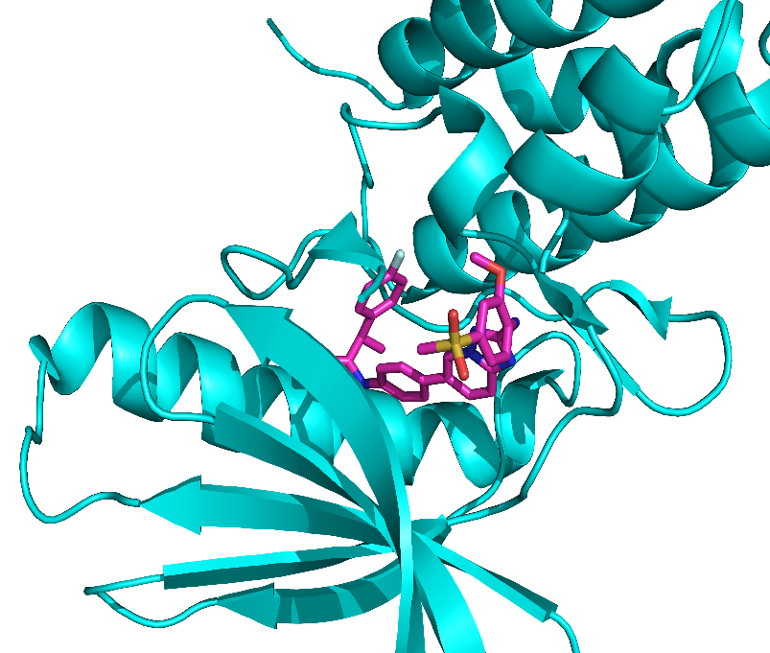
TTK | BAY-1217389 (Bay-12) | -11.0 | 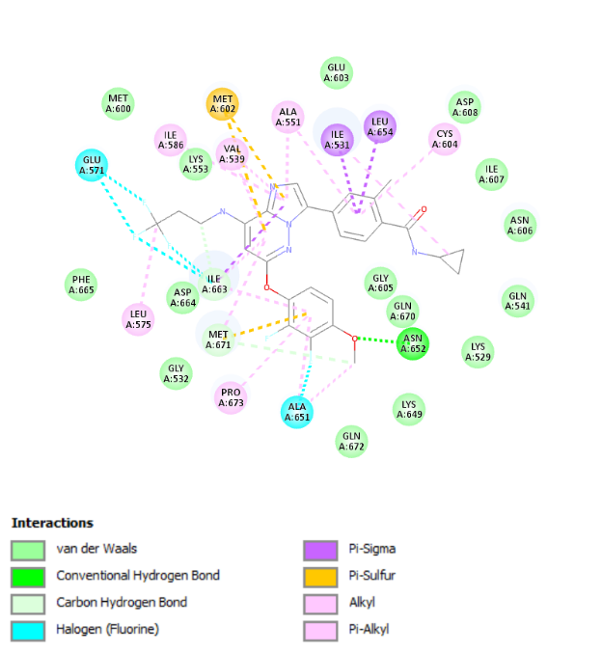 | 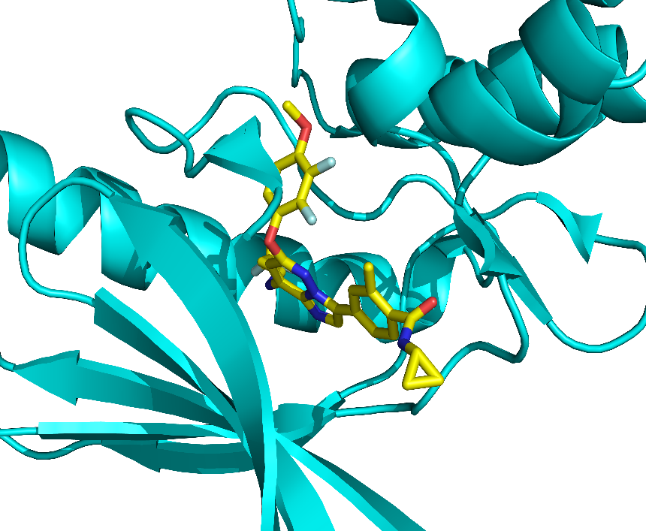
TTK | Hesperadin (HES) | -9.8 | 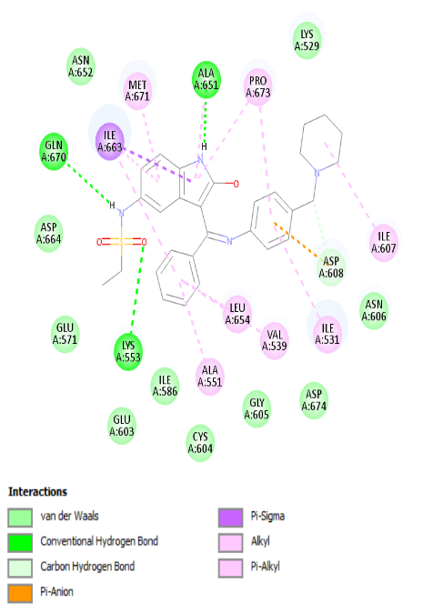 | 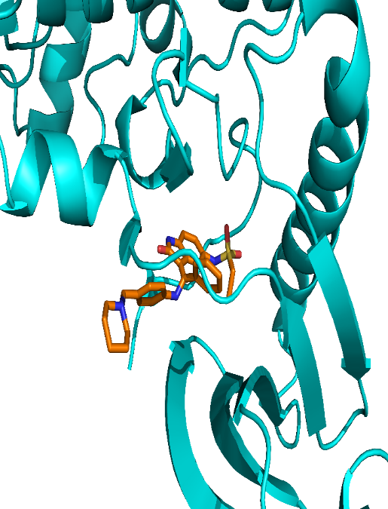
CKS2 | (Silmitasertib) CX-4945 | -10.5 | 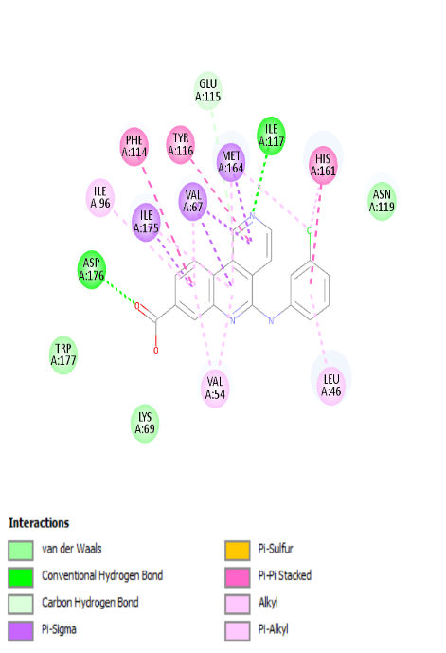 | 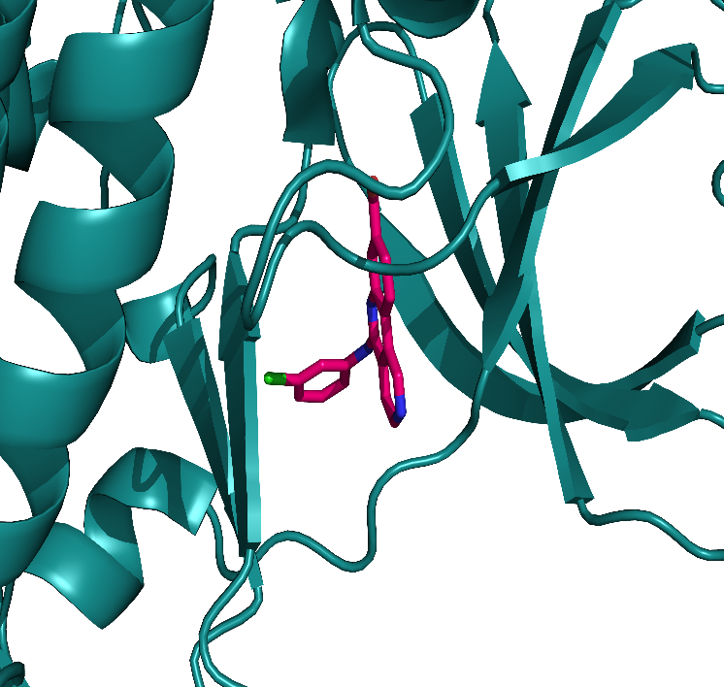
MYC | Nadroparin | -8.0 | 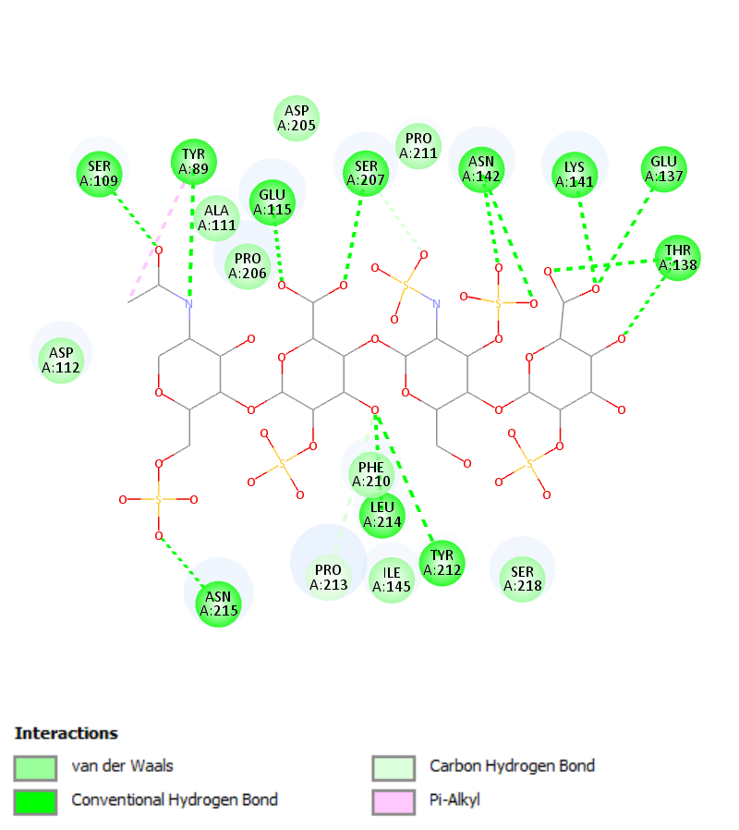 | 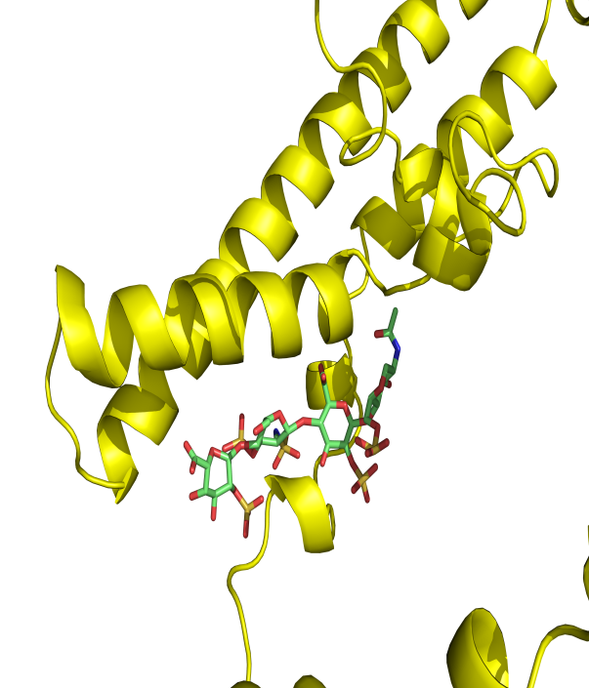
MYC | Doconexent | -4.9 | 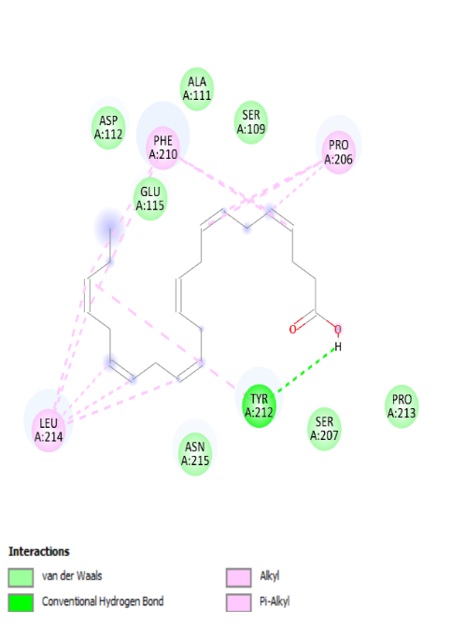 | 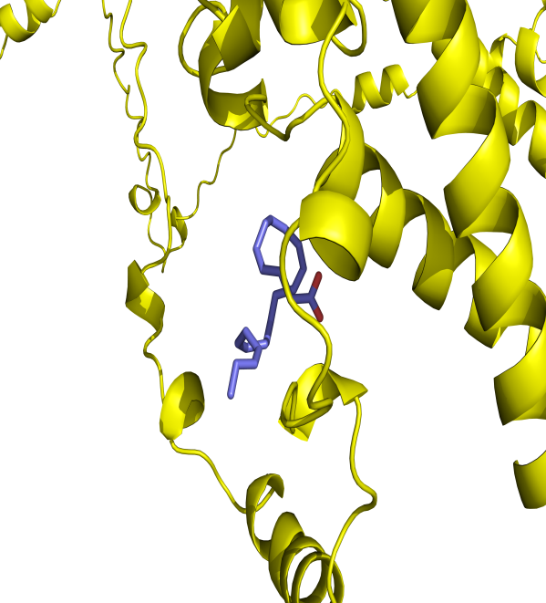
MYC | Acetylsalicylic acid | -5.9 | 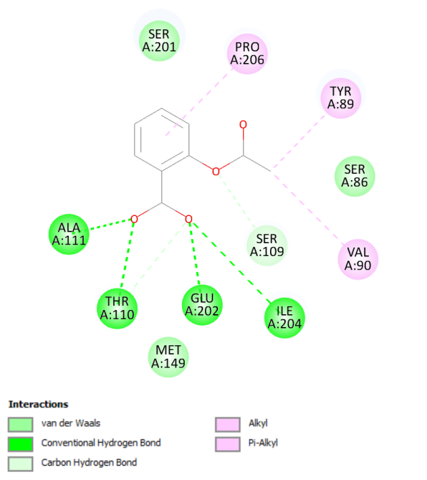 | 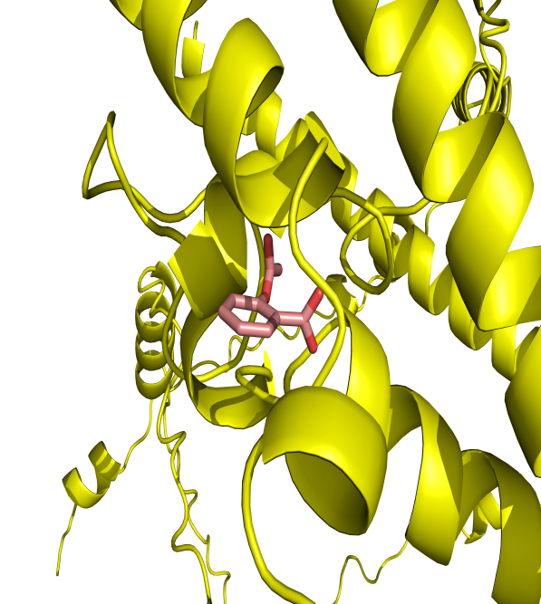
MYC | MYCi975 | -9.0 | 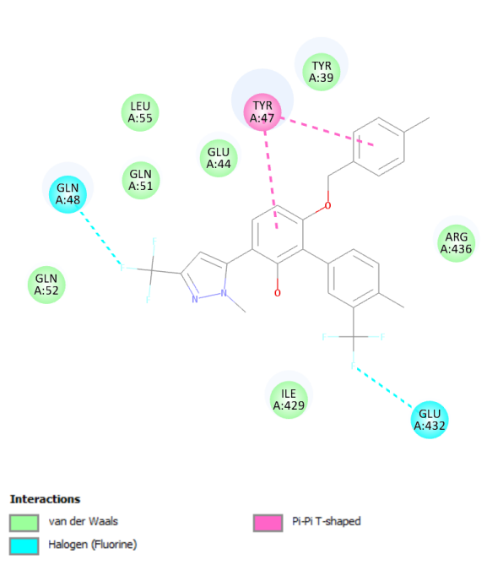 | 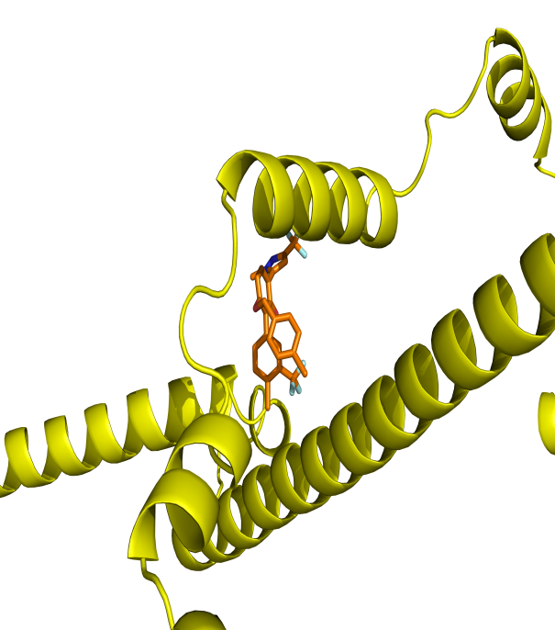
MYC | PROTAC-targeted degraders | -8.7 | 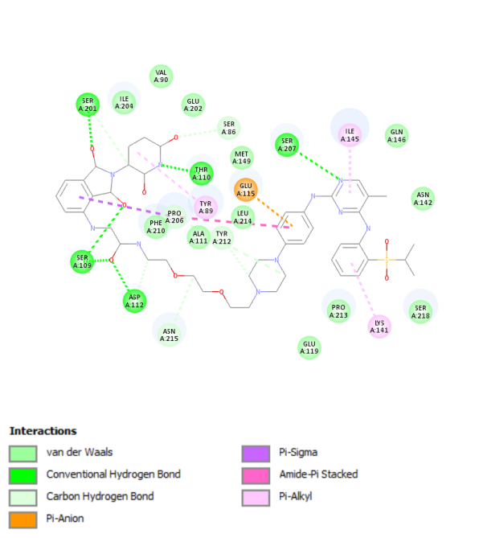 | 