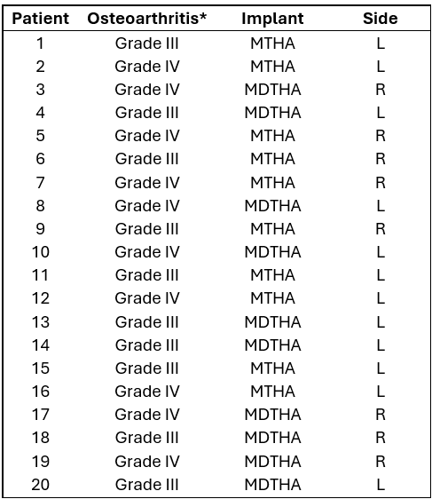
Appendix. Demographic data of the study population. R=right, L=left; *Graded according to the Kellgren-Lawrence classification.

