Supplementary material
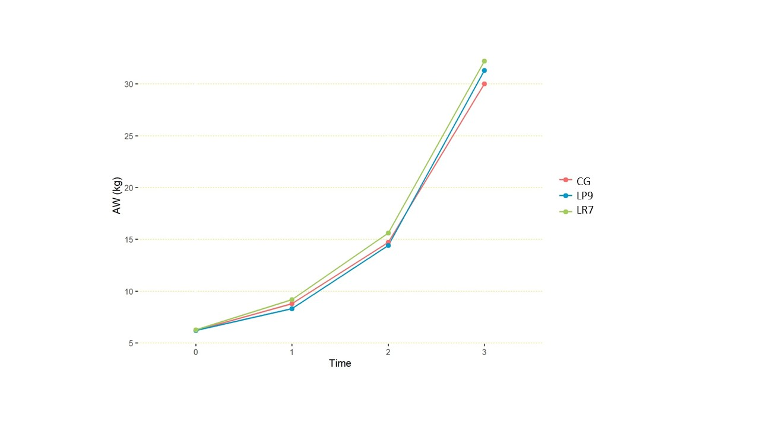
Supplementary Figure 1: Growth curve of mean body weight for the three treatment groups (kg). P0 corresponds to body weight at trial initiation; P1, P2, and P3 correspond to body weight measured at days 10, 24, and 48 of the trial, respectively. GC: Control; LP9: L. plantarum RC009; LR7: L. rhamnosus RC007.

Supplementary Table 1. Blood biochemistry
Blood biochemistry |  | Control | L. plantarum RC009 | L. rhamnosus RC007
 |  | X̅ ±DE
Cholesterol 1 (mg/dl) |  | 67,13 ±14 | 75,05±8, 15 | 62,69±11,52
Cholesterol 2 (mg/dl) |  | 78,81±10,65 | 50,38±13,64* | 81,06±10,01
ALT 1 (UI/l) |  | 56,13±8,37 | 46,38±9,02* | 59, 31±16,59
ALT 2 (UI/l) |  | 48,13±8,11 | 33,13±8,57* | 50,00±9,28
Serum proteins 1 | PT g % | 4,68±0,18 | 5,7±0,35* | 4,97±0,28*
Serum proteins 1 | ALB g /100 Ml | 2,02±0,14 | 2,72±0,18* | 2,26±0,24*
Serum proteins 1 | GLOB g /100 Ml | 2,67±0,18 | 2,98±0,29* | 2,72±0,14
Serum proteins 1 | A/G | 0,76±0,08 | 0,92±0,11* | 0,83±0,1*
Serum proteins 2 | PT g % | 5,73±0,22 | 3,56±0,85* | 5,43±0,29*
Serum proteins 2 | ALB g /100 Ml | 2,74±0,25 | 1,59±0,36* | 2,74±0,25
Serum proteins 2 | GLOB g /100 Ml | 2,9±0,28 | 1,98±0,52* | 2,72±0,23*
Serum proteins 2 | A/G | 0,93±0,14 | 0,82±0,1* | 1±0,14
Protein electrophoresis 1  (g/100 mL) | α1-globulin | 1,01±0,1 | 1,02±0,09 | 0,09±0,03*
Protein electrophoresis 1  (g/100 mL) | α2-globulin | 0,67±0,41 | 0,43±0,1* | 0,96±0,07*
Protein electrophoresis 1  (g/100 mL) | β-globulin | 0,65±0,24 | 0,89±12* | 1,13±0,33*
Protein electrophoresis 1  (g/100 mL) | γ- globulin | 0,34±0,22 | 0,64±0,12* | 0,54±0,33
Protein electrophoresis 2  (g/100 mL) | α1-globulin | 0,1±0,02 | 0,48±0,34* | 0,08±0,02
Protein electrophoresis 2  (g/100 mL) | α2-globulin | 0,94±0,25 | 0,5±0,37* | 0,95±0,13
Protein electrophoresis 2  (g/100 mL) | β-globulin | 0,95±0,43 | 0,65±0,22* | 0,62±0,35*
Protein electrophoresis 2  (g/100 mL) | γ- globulin | 0,89±0,5 | 0,34±0,11* | 1,08±0,45
Malondialdehyde | MDA 1 (nM/mL) | 1,86 ± 0,39 | 1,52 ± 0,38* | 1,57 ± 0,37*
Malondialdehyde | MDA 2 (nM/mL) | 1,75 ± 0,52 | 1,55 ± 0,36 | 1,63 ± 0,42
An asterisk (*) indicates results that differ significantly from the Control group according to Fisher’s LSD test (p < 0.05). Tables should be read horizontally.1: 24 days of the experimental period; 2: 48 days of the experimental period; SD: standard deviation; X̅: mean.

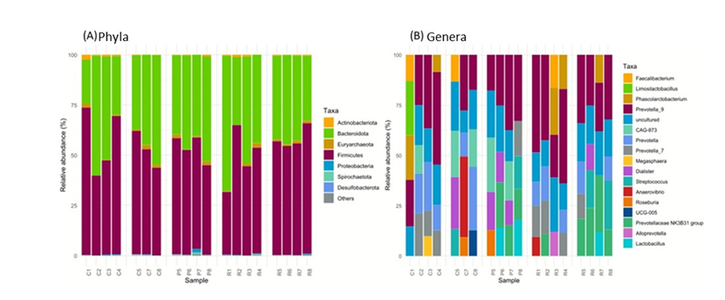
Supplementary Figure 2. (A) Relative abundance of phyla across all samples. (B) Relative abundance of the top five most abundant genera in each sample. C1–4 and R1–4: individuals from the Control and L. rhamnosus groups at 20 days of the experimental period. C5, 7, and 8; P5–8; and R5–8: individuals from the Control, L. plantarum, and L. rhamnosus groups at 48 days of the experimental period.

Supplementary Table 2
NCBI accessions for 16S rRNA gene V3–V4 amplicon sequencing data deposited in the Sequence Read Archive (SRA) under BioProject PRJNA1469238. Each sample represents a pool of faeces from two post-weaning pigs from the same pen. Treatment groups: CG, control diet; LP9, diet supplemented with Lactiplantibacillus plantarum RC009 (1×10¹² CFU/kg feed); LR7, diet supplemented with Lacticaseibacillus rhamnosus RC007 (1×10¹² CFU/kg feed).
Sample ID | Treatment group | Trial day | BioSample accession
C1 | Control (CG) | 20 | SAMN60350156
C2 | Control (CG) | 20 | SAMN60350157
C3 | Control (CG) | 20 | SAMN60350158
C4 | Control (CG) | 20 | SAMN60350159
C5 | Control (CG) | 48 | SAMN60350160
C7 | Control (CG) | 48 | SAMN60350161
C8 | Control (CG) | 48 | SAMN60350162
P5 | LP9 (L. plantarum RC009) | 48 | SAMN60350163
P6 | LP9 (L. plantarum RC009) | 48 | SAMN60350164
P7 | LP9 (L. plantarum RC009) | 48 | SAMN60350165
P8 | LP9 (L. plantarum RC009) | 48 | SAMN60350166
R1 | LR7 (L. rhamnosus RC007) | 20 | SAMN60350167
R2 | LR7 (L. rhamnosus RC007) | 20 | SAMN60350168
R3 | LR7 (L. rhamnosus RC007) | 20 | SAMN60350169
R4 | LR7 (L. rhamnosus RC007) | 20 | SAMN60350170
R5 | LR7 (L. rhamnosus RC007) | 48 | SAMN60350171
R6 | LR7 (L. rhamnosus RC007) | 48 | SAMN60350172
R7 | LR7 (L. rhamnosus RC007) | 48 | SAMN60350173
R8 | LR7 (L. rhamnosus RC007) | 48 | SAMN60350174
Sequencing data are held under embargo until publication and will become publicly available upon manuscript acceptance. BioProject URL: https://www.ncbi.nlm.nih.gov/bioproject/PRJNA1469238

