Table 1. X-ray images provided to groups for radiographic furcation involvement identification
Control | 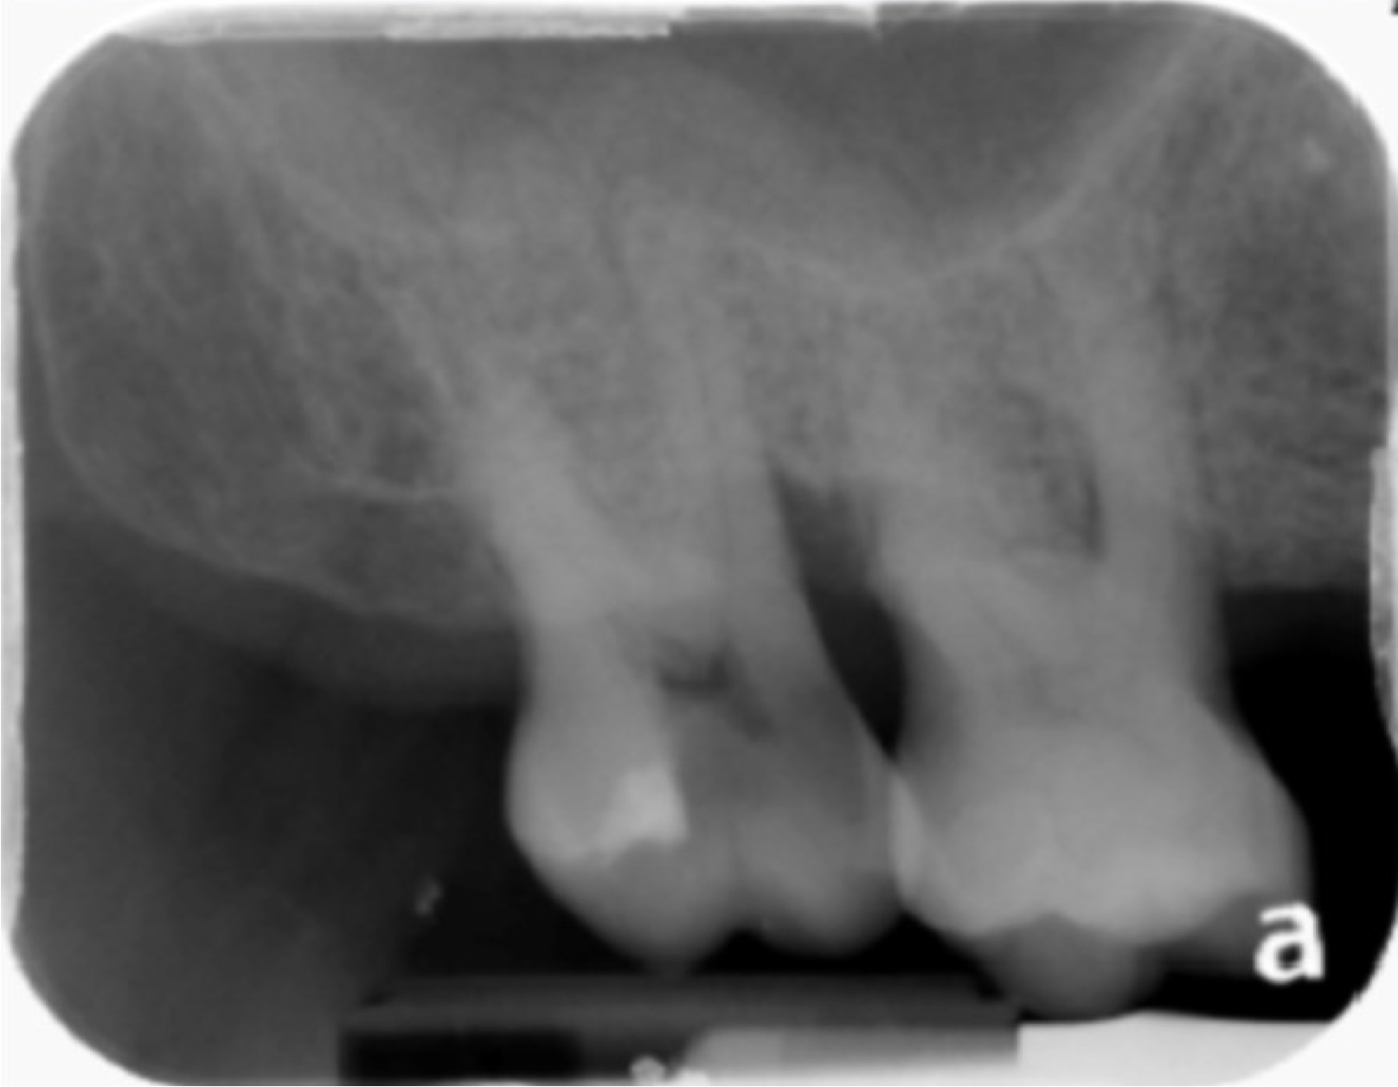 | 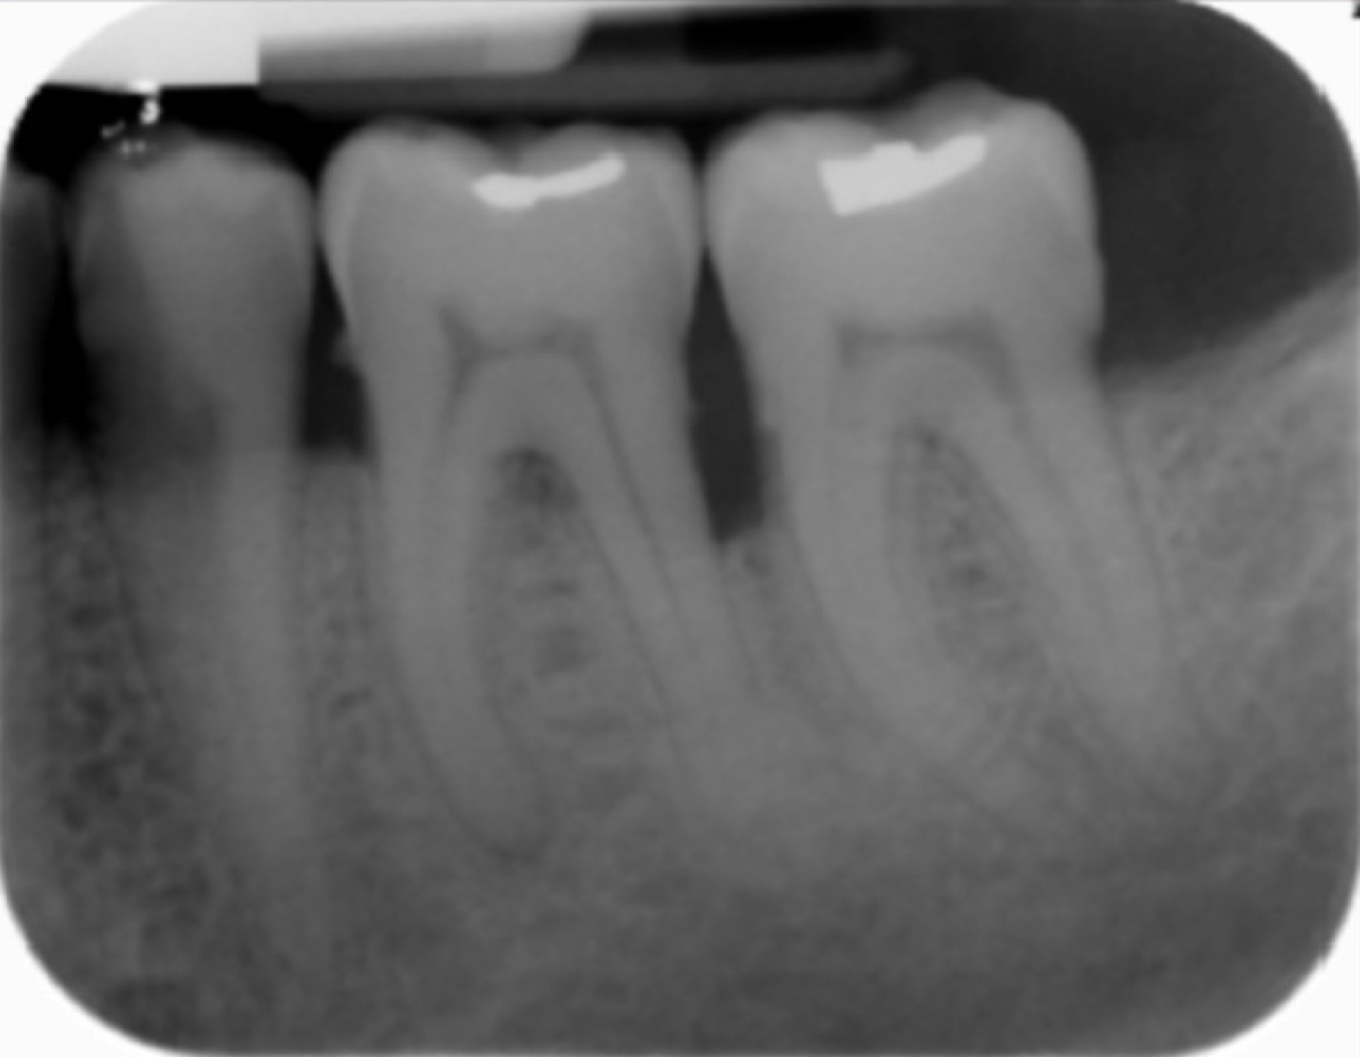 | 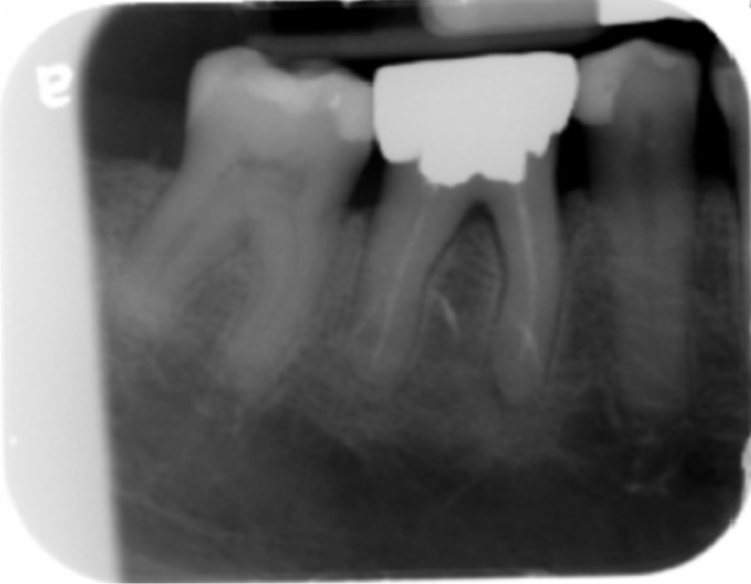
Visual test
Visual test | 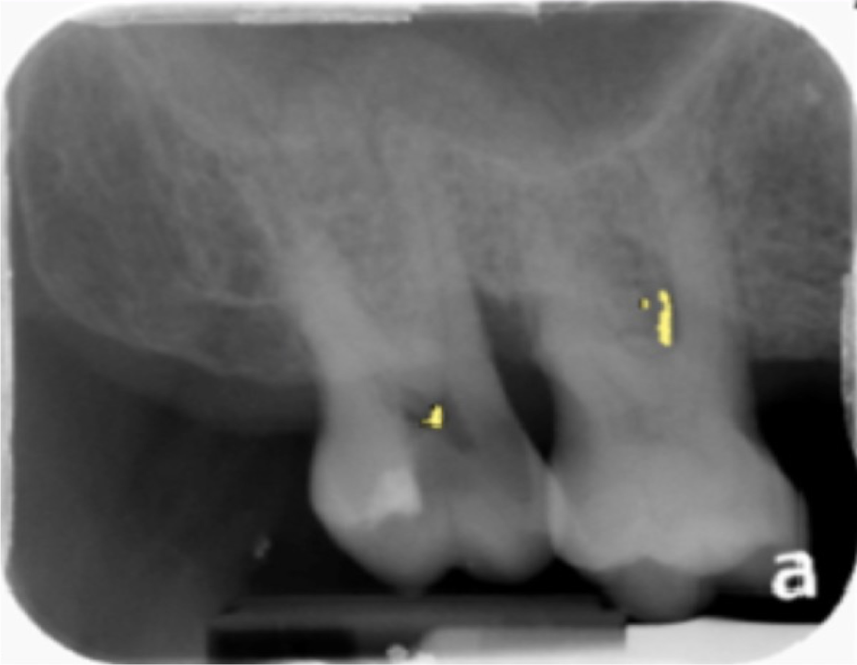 | 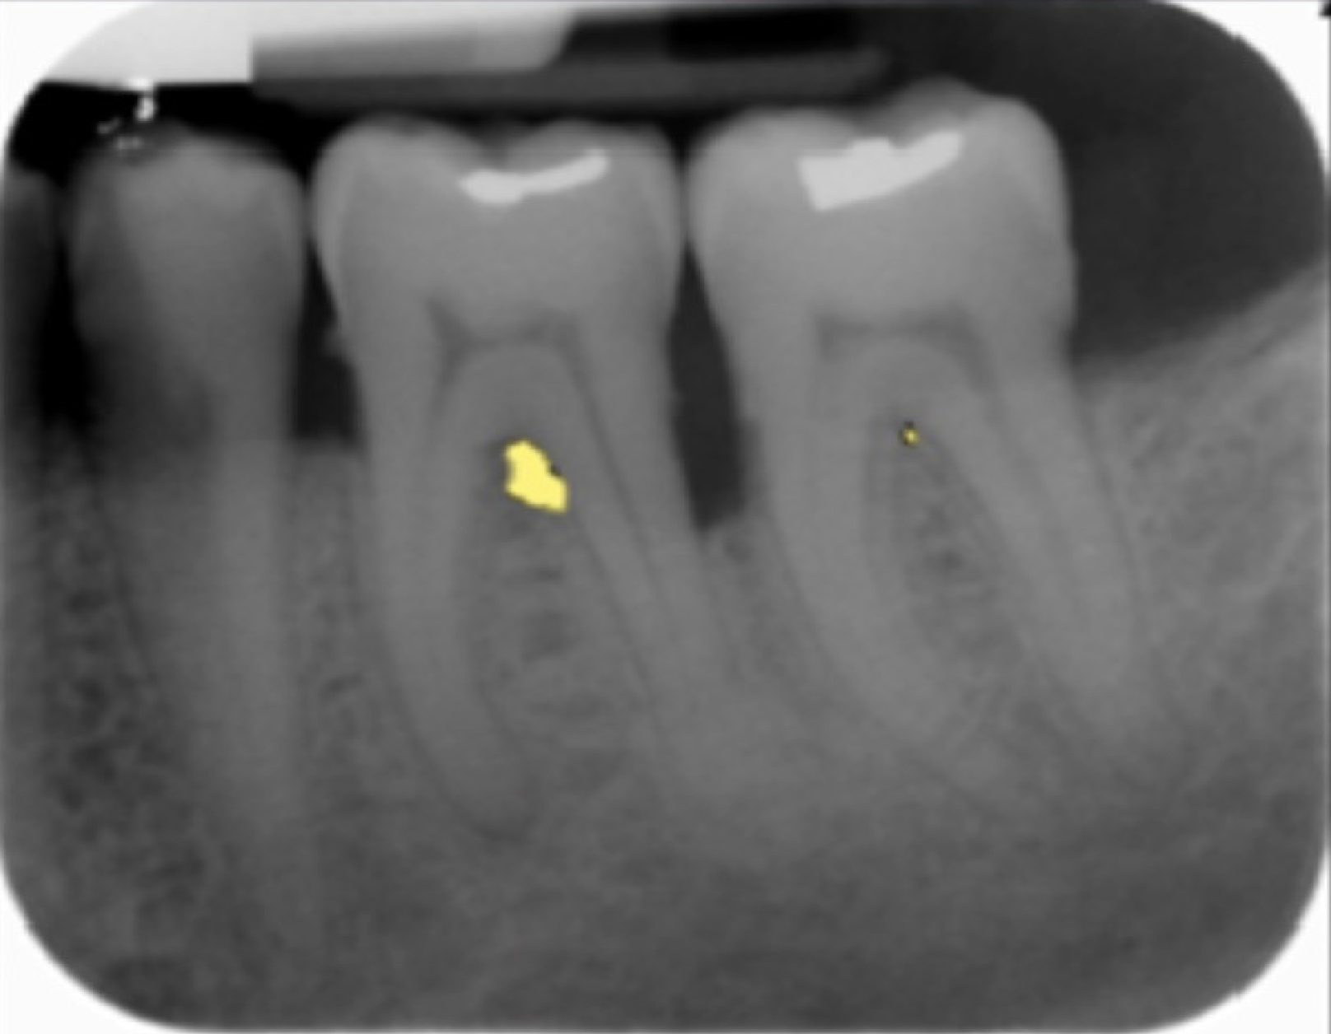 | 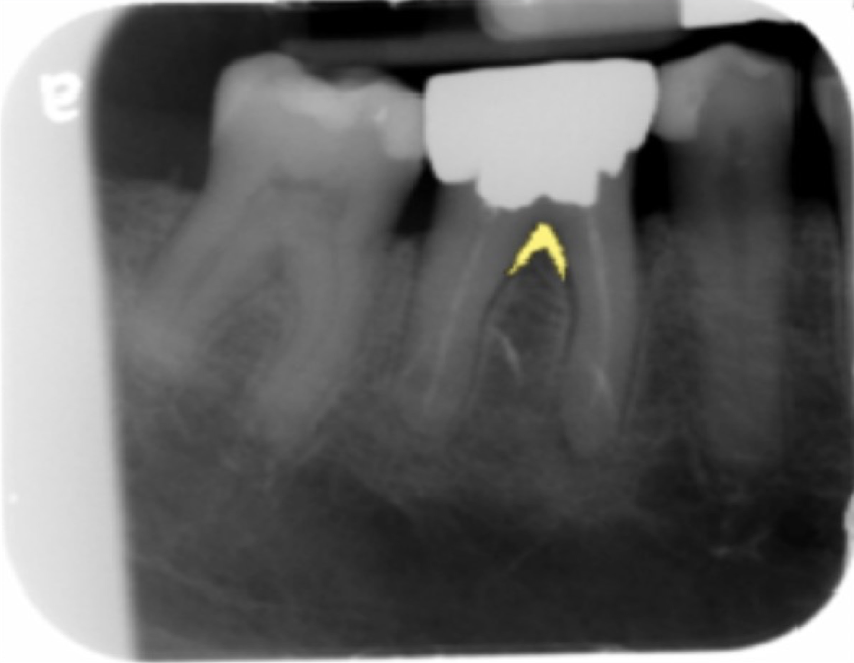
Descriptive test
Descriptive test | AI identified furcation lesion on tooth 3 | AI identified furcation lesion on teeth 18 and 19 | AI identified furcation lesion on teeth 30 and 31
1a: x-ray of tooth 3
1b: x-ray of teeth 18 and 19
1c: x-ray of teeth 30 and 31

