Fig S1. Soil chemistry response to AMF isolates and inoculation strategies. Plantago lanceolata was inoculated with one of three arbuscular mycorrhizal fungal (AMF) (CC4, Cuba8 and DAOM197198) before host exposure to soil (pre-inoculation), at the same time as soil exposure (co-inoculation) or a combination at 2 months (red lines) and 4 months (blue lines) post inoculation. Dots represent mean and SE. Dotted line is mean control values and 95% CI.

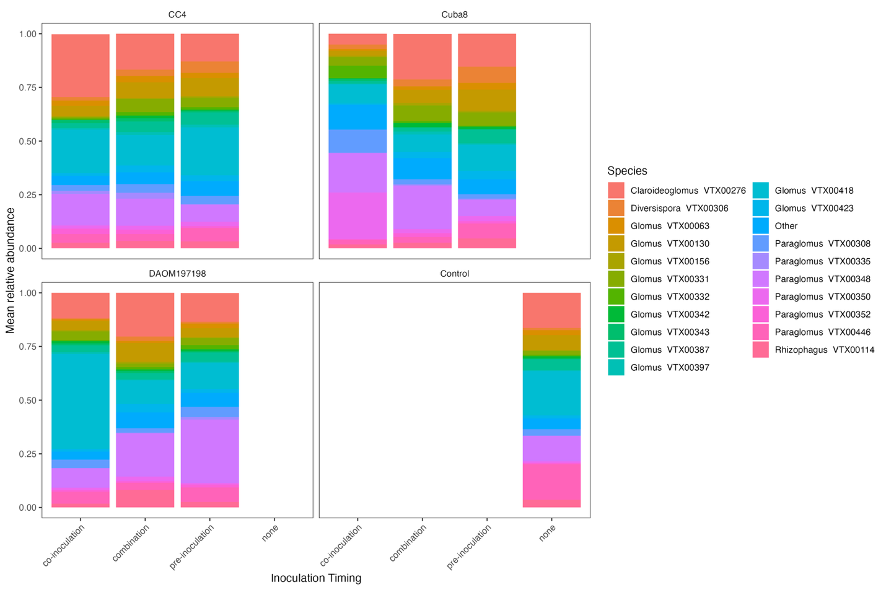
Fig. S2 Relative abundance of the 30 most abundant AMF taxa across isolates (Control, CC4, Cuba8, and DAOM197198).and inoculation treatments before host exposure to soil (pre-inoculation), at the same time as soil exposure (co-inoculation) or a combination at 4 months post inoculation

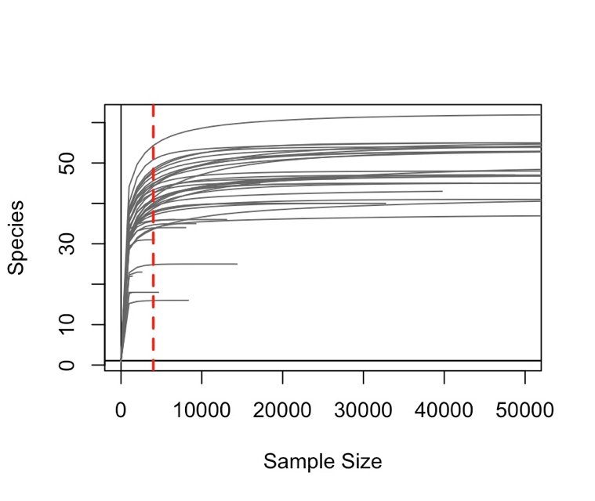
Fig. S3: Rarefaction curve. Lines represent individual samples. Samples were rarefied to 4000 sequences/sample (red line).

Fig. S4: Histogram of shoot mycorrhizal response (ShootMR)
Fig. S5: Histogram of root mycorrhizal response (RootMR)

Fig. S6: Histogram of total shoot phosphorus mycorrhizal response (ShootPMR)
Fig. S5: Histogram of soil phosphorus concentration
Fig. S6: Histogram of soil pH
Fig. S7: Histogram of species richness
Fig. S8: Histogram of Shannon diversity
Fig. S9: Histogram of Pielou evenness

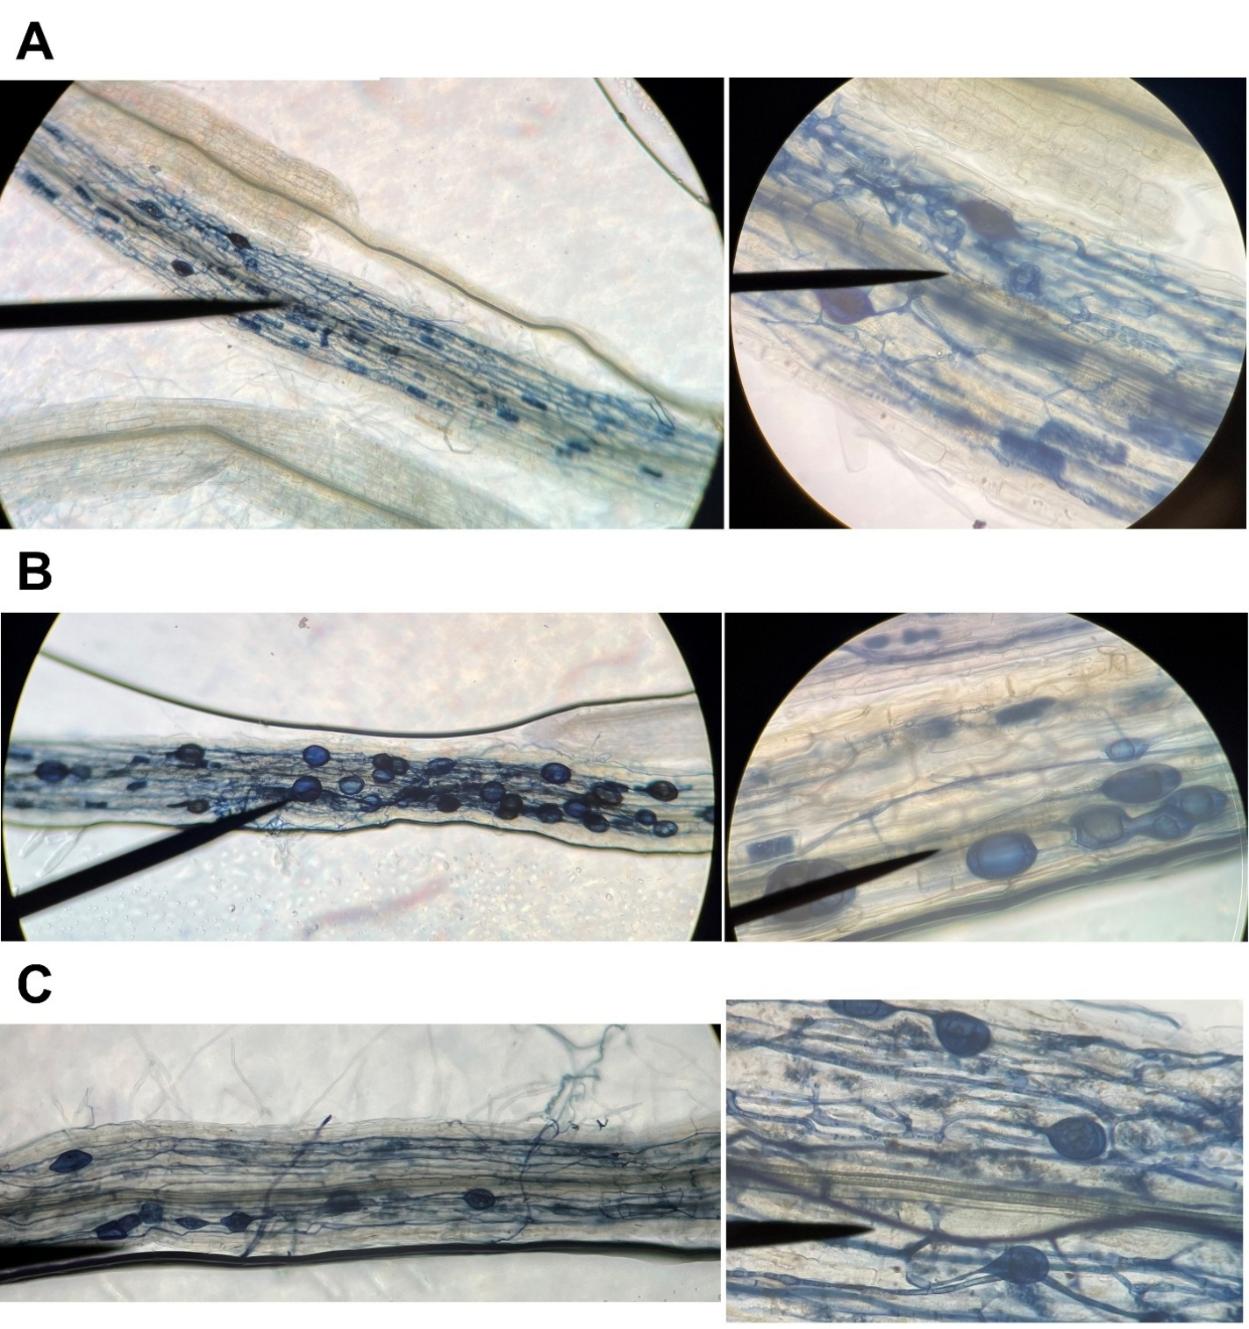
Figure S10 Random roots collected for visual confirmation of root colonization by AMF inoculants at 8 weeks post-inoculation. (A) Roots inoculated with DAOM 197198, (B) roots inoculated with CC4, and (C) roots inoculated with Cuba8.

Table S1: Primer and probe sequences to quantify each inoculant in ddPCR (Kokkoris et al. 2021)
R. irregularis isolates | Target region | Primer sequence | Probe
DAOM 197198 | cox3-rnl intergenic mtDNA | Forward 5’-AGCAAATCTAAGTTCCTCAGAG-3’  Reverse 5’-ACTTCTATGGCTTTGTACAGG -3’ | 5’-FAM/CCCACCAGG/ZEN/GCAGATTAATCTTCCTT/3IABKFQ-3’
CC4 | Mating Loci 6 (HD2-like gene) nrDNA | Forward 5’- GCCGGAGCATATAATGGT-3’  Reverse 5’- GGCACAAAAATAGTTACACTG-3’ | 5’- HEX/ CGACGCCCTCAATGTATGTTCACTTTC-3’
Cuba8 | Mating Loci 1 (HD1-like gene) nrDNA | Forward 5’-CCAATACTCATGATATCG-3’  Reverse 5’-GCACCAAAAAATAGTACACTGG-3’ | 5’- FAM/GACGCCCTCAATGTATGGTTCACTT-3’

Table S2 PCR conditions for each primer-probe mix.
Steps | DAOM 197198 primer-probe | CC4/Cuba8 primer-probe
Initial denaturation | 95°C for 10 min. | 95°C for 10 min.
Denaturation | 94°C for 30 s | 94°C for 1 min.
Annealing | 59°C for 30 s | 52.5°C for 2 min.
Cycles | 40 x | 45 x
Ramp rate | 2°C/s for every step | 1°C/s for every step
Final annealing | 98°C for 10 min. | 98°C for 10 min.
Hold | 4°C | 4°C

Supplemental Methods Appendix 1: Library preparation and sequencing protocol for AMF resident community in soil
Briefly, DNA was extracted from 0.2 g soil using Qiagen DNeasy 96 PowerSoil Pro Kit (Qiagen Inc., Hilden, Germany). DNA extracts were then prepared for PCR amplification and Next Generation Sequencing (NGS) at the University of British Columbia Sequencing and Bioinformatics Consortium (SBC), Vancouver, BC. Briefly, PCR was conducted to amplify a 550 bp region in the small subunit (SSU) rRNA gene using the universal eukaryotic primer WANDA (Dumbrell et al. 2011) and the Glomeromycotina-specific primer AML2 (Lee et al. 2008). Reactions were performed in 25 μL mastermix containing 2.5 μL DNA template, 7.8 μL of nuclease-free H₂O, 12.5 μL of PCR Buffer, 1.5 μL of 25mM MgCl₂, 0.5 μl of 50 μM AML2/CS2 primer mix, 0.5 μl of 50 μM WANDA/CS1 primer mix, and 0.2 μl 2.5 U μL⁻¹ DNA Polymerase, using the following thermal cycler conditions: 95°C for 2 min; 30 cycles of 95°C for 30 s, 54°C for 40 s and 72°C for 1 min; and 72°C for 10 min. A second PCR was conducted to attach Illumina barcodes and adaptors to amplicons from the initial PCR using the same Fluidigm tags as described above. Amplicons from the first PCR were diluted 15-fold and PCR were performed in 20 μL volumes using 1 μL of diluted PCR1 product, 6.89 μL of nuclease-free H₂O, 10 μL of PCR Buffer, 1.2 μL of 25mM MgCl₂, 0.75 μL of 2 μM Illumina adapter/barcode primer complex and 0.16 μL 2.5 U μL⁻¹ DNA Polymerase. Thermocycler conditions were as follows: 95°C for 1 min; 12 cycles of 95°C for 30 s, 60°C for 30 s and 68°C for 1 min; and 68°C for 5 min. Sequencing was conducted on the Illumina MiSeq platform using 2 x 300 bp paired-end sequencing with 600 cycles (Illumina Inc.).
Libraries were analyzed using a bioinformatic pipeline specific for AMF community analysis (Egan et al. 2018). Raw reads were demultiplexed using exact primer matching, a max error rate 0.1, minimum overlap 8 bp, and no indels in QIIME2 (Bolyen et al. 2019) via q2-demux and DADA2 (Callahan et al. 2016). Sequences passing QC were assembled into amplicon sequence variants (ASVs) and taxonomy assignment was done using the MaarjAM reference database (Öpik et al. 2010)) at ≥95% sequence similarity using a custom Naive Bayes classifier filtered to Mucoromycota and trimmed to the target SSU region (200–650 bp). A second search of unassigned sequences was done against 18S Glomeromycotan reference sequences downloaded from NCBI nucleotide database at ≥80% sequence similarity. SVs were classified with a confidence threshold of 0.7. Feature tables were collapsed to taxonomic level 7 and filtered to remove singletons and taxa present in fewer than two samples.
To verify that the AMF inoculants (R. irregularis isolates CC4, Cuba8, and DAOM 197198) established successfully, BLASTN searches (e-value of 0 and >99% homology) against the MaarjAM database were done. Sequences were best matched to VTX00113 and VTX00114 and were considered as Rhizophagus irregularis. However, the target gene used for this study cannot distinguish among conspecifics thus, the current experimental design cannot distinguish between indigenous R. irregularis and the inoculants (CC4, Cuba8, and DAOM197198), which is why we used targeted primer-probe assays to quantify inoculant abundance in my experiments.

References

Bolyen E, Rideout JR, Dillon MR, et al (2019) Reproducible, interactive, scalable and extensible microbiome data science using QIIME 2. Nature Biotechnology 37:852–857. https://doi.org/10.1038/s41587-019-0209-9
Callahan BJ, McMurdie PJ, Rosen MJ, et al (2016) DADA2: High-resolution sample inference from Illumina amplicon data. Nat Methods 13:581–583. https://doi.org/10.1038/nmeth.3869
Dumbrell AJ, Ashton PD, Aziz N, et al (2011) Distinct seasonal assemblages of arbuscular mycorrhizal fungi revealed by massively parallel pyrosequencing. New Phytologist 190:794–804. https://doi.org/10.1111/j.1469-8137.2010.03636.x
Egan CP, Rummel A, Kokkoris V, et al (2018) Using mock communities of arbuscular mycorrhizal fungi to evaluate fidelity associated with Illumina sequencing. FUNGAL ECOLOGY 33:52–64. https://doi.org/10.1016/j.funeco.2018.01.004
Kokkoris V, Chagnon P-L, Yildirir G, et al (2021) Host identity influences nuclear dynamics in arbuscular mycorrhizal fungi. Current Biology 31:1531-1538.e6. https://doi.org/10.1016/j.cub.2021.01.035
Lee J, Lee S, Young JPW (2008) Improved PCR primers for the detection and identification of arbuscular mycorrhizal fungi. FEMS Microbiol Ecol 65:339–349. https://doi.org/10.1111/j.1574-6941.2008.00531.x
Öpik M, Vanatoa A, Vanatoa E, et al (2010) The online database MaarjAM reveals global and ecosystemic distribution patterns in arbuscular mycorrhizal fungi (Glomeromycota). New Phytologist 188:223–241. https://doi.org/10.1111/j.1469-8137.2010.03334.x

