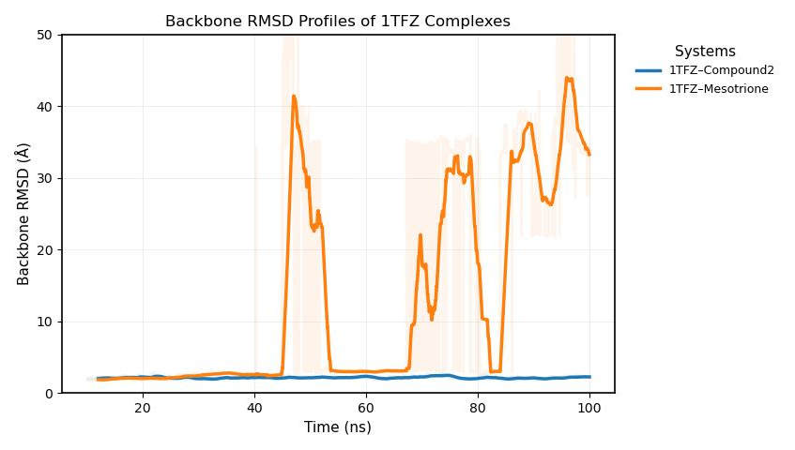

Template (compound -2)
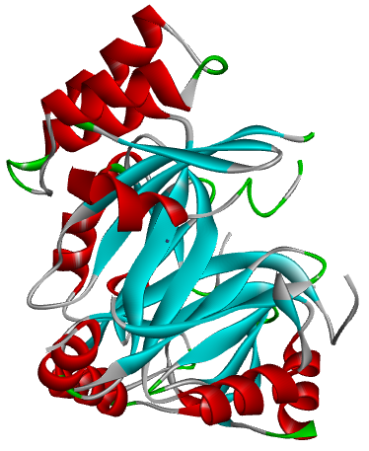

3D-Protein- ligand complex (compound-2)
RMSD Plot

Molecular Dynamics Simulation

Molecular docking

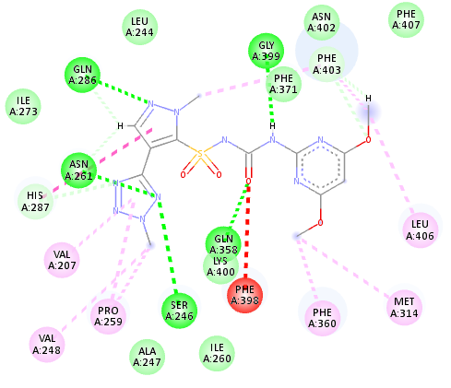
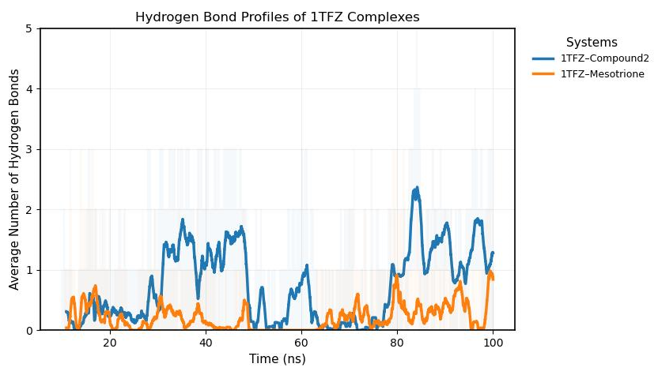

ADMET analysis

Toxicity studies:
- (-ve) Carcinogenicity
- (-ve) Skin Sensitization
- (-ve) Eye Irritation
- (-ve) Respiratory failure
- (-ve) AMES Toxicity
Herbicide-likeness:
- Weed control efficiency
- High soil adsorption (Koc)
- Resistance management
- Runoff behavior

2D - receptor complex (compound -2)

Stable H-bond

