Supplementary Information:

Table S1 Results of the full generalized linear mixed model (GLMM) examining whether press counts differed according to partner presence, box type (Hare vs. Stag), group identity (East vs. West), and session.
Predictor | β | SE | z | p
Intercept | 2.334 | 0.298 | 7.822 | <0.001
Partner presence (present) | −0.411 | 0.176 | −2.338 | 0.019
Box type (Stag) | −1.481 | 0.186 | −7.955 | <0.001
Group (West) | −1.338 | 0.424 | −3.156 | 0.002
Session | 0.124 | 0.028 | 4.476 | <0.001
Partner × Box | 0.753 | 0.245 | 3.076 | 0.002
Partner × Group | 0.377 | 0.240 | 1.570 | 0.117
Box × Group | 0.354 | 0.263 | 1.346 | 0.178
Partner × Box × Group | −0.743 | 0.355 | −2.095 | 0.036
ᵃ Negative binomial GLMM with log link. Press counts were modelled as a function of partner presence, box type, group identity, and session, including all interaction terms.
ᵇ Subject identity was included as a random intercept to account for repeated observations across sessions.
ᶜ The reference categories were partner absent, Hare box, and East group.
ᵈ Positive coefficients indicate increases in expected press counts on the log scale; negative coefficients indicate decreases relative to the reference category.
ᵉ Significant outcomes (p < 0.05) are shown in bold.

Table S2 Pairwise contrasts from estimated marginal means comparing press counts between partner-absent and partner-present conditions within each box type and group.
Box type | Group | RR (Absent/Present) | SE | z | p
Hare | East | 1.51 | 0.265 | 2.34 | 0.019
Stag | East | 0.71 | 0.121 | −2.00 | 0.046
Hare | West | 1.04 | 0.170 | 0.21 | 0.836
Stag | West | 1.03 | 0.205 | 0.12 | 0.901
ᵃ Pairwise contrasts were derived from estimated marginal means of the negative binomial GLMM with log link.
ᵇ Rate ratios (RR) represent the ratio of predicted press counts in the partner-absent condition relative to the partner-present condition within each box type and group.
ᶜ RR > 1 indicates higher predicted press counts when individuals were alone, whereas RR < 1 indicates higher predicted press counts when a partner was present.
ᵈ Significant results (p < 0.05) are shown in bold.

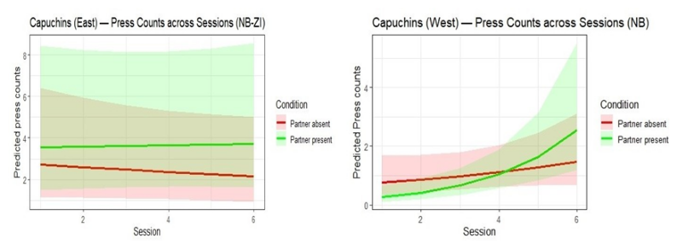
Fig. S1a Fig. S1b
Fig. S1 Press counts across sessions under partner-present and partner-absent conditions in the Stag box. Predicted press counts (± 95% confidence intervals) are shown across sessions for capuchins in the East (Fig. S1a) and West (Fig. S1b) groups. Lines represent model-estimated values from generalized linear mixed models with negative binomial (East: zero-inflated negative binomial; West: negative binomial) error structures. Shaded areas indicate model-based confidence intervals. Predictions are plotted separately for partner-present and partner-absent conditions to assess sensitivity to a partner’s role across repeated sessions.

Table S3 Results of negative binomial GLMMs examining effects of partner presence and session on Press counts in the Stag box.
Predictor | Estimate (East) | SE | z | p | Estimate (West) | SE | z | p
Intercept | 1.047 | 0.457 | 2.29 | 0.022 | −0.411 | 0.483 | −0.85 | 0.395
Partner presence | 0.211 | 0.298 | 0.71 | 0.480 | −1.347 | 0.631 | −2.13 | 0.033
Session | −0.046 | 0.054 | −0.84 | 0.399 | 0.132 | 0.103 | 1.28 | 0.201
Partner presence × Session | 0.056 | 0.074 | 0.76 | 0.450 | 0.317 | 0.154 | 2.07 | 0.039
ᵃ Negative binomial GLMM with log link. Significant outcomes are shown in bold.
ᵇ Subject identity included as a random intercept.
ᶜ Session treated as a continuous predictor.
ᵈ The East Group model included a zero-inflation component.

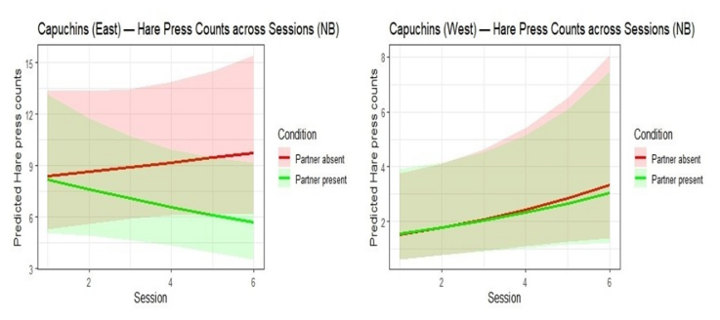

Fig. S2a Fig. S2b
Fig. S2 Press counts across sessions under partner-present and partner-absent conditions in the Hare box. Predicted press counts (± 95% confidence intervals) are shown across sessions for capuchins in the East (Fig S2a) and West (Fig S2b) groups. Lines represent model-estimated values from generalized linear mixed models with negative binomial error structures. Shaded areas indicate model-based confidence intervals. Predictions are plotted separately for partner-present and partner-absent conditions to evaluate whether pressing behaviour in the solo (Hare) context varied as a function of partner presence over repeated sessions.

Table S4 Results of negative binomial GLMMs examining effects of partner presence and session on Press counts in the Hare box.
Predictor | Estimate (East) | SE | z | p | Estimate (West) | SE | z | p
Intercept | 2.100 | 0.263 | 8.177 | <0.001 | 0.262 | 0.510 | 0.514 | 0.607
Partner presence | -0.05 | 0.255 | -0.199 | 0.842 | 0.045 | 0.495 | 0.091 | 0.927
Session | 0.017 | 0.044 | 0.386 | 0.7 | 0.157 | 0.085 | 1.861 | 0.063
Partner presence × Session | -0.074 | 0.066 | −1.143 | 0.253 | −0.024 | 0.124 | −0.194 | 0.846
ᵃ Negative binomial GLMM with log link. Significant outcomes are shown in bold.
ᵇ Subject identity included as a random intercept.
ᶜ Session treated as a continuous fixed predictor.

