Supplementary information:

Quantifying Biological Processes Producing Nitrous Oxide in Soil Using a Mechanistic Model

Baoxuan Chang ª, Zhifeng Yan ^{a,b,*}, Xiaotang Ju ^{c}, Xiaotong Song ^{c}, Yawei Li ^{d}, Hui Wang ª, Siliang Li ^{a,b}, Pingqing Fu ^{a,b}, Xia Zhu-Barker ^{e}
ª Institute of Surface-Earth System Science, School of Earth System Science, Tianjin University, Tianjin 300072, China
^{b} Critical Zone Observatory of Bohai Coastal Region, Tianjin Key Laboratory of Earth Critical Zone Science and Sustainable Development in Bohai Rim, Tianjin University, Tianjin 300072, China
^{c} Hainan Key Laboratory for Sustainable Utilization of Tropical Bioresources, College of Tropical Crops, Hainan University, Haikou 570228, China
^{d} College of Agricultural Science and Engineering, Hohai University, Nanjing, 211100, China
^{e} Department of Land, Air and Water Resources, University of California Davis, Davis, CA 95616, USA
∗ Corresponding author. Email: yanzf17@tju.edu.cn (Z. Yan); Tel.: +86 22-2740 5053; Fax: +86 22-2740 5051; ORCID: 0000-0002-6930-3128

Submitted to Biogeochemistry

1 Incubation experiments
1.1 Experiments for model calibration (Zhu et al., 2013)
60-mL glass serums containing 5-g dry soil were incubated under 22 ℃ for 48 hours. The clay loam soils were collected from agricultural fields in California and had a pH value of 5.6. The oxygen concentration in the headspace of serums was changed from 0% to 21% by volume, while the soil moisture was kept at 50% of water holding capacity (WHC). KNO₃ and (NH₄)₂SO₄ were added so that the concentrations of both NO₃⁻ and NH₄⁺ were 50 mg N/kg-soil. The concentrations of N₂O were measured as time increases, while the concentration of NO₃⁻ was only measured at 36 hours. The contributions of nitrifier nitrification (NN), nitrifier denitrification (ND), NCD (nitrification-coupled denitrification) and heterotrophic denitrification (HD) to N₂O production at 36 hours were determined by the dual isotope (¹⁸O and ¹⁵N) approach. Note that the simulated N₂O production from HD by the mechanistic model developed in this study equaled the measured values from NCD and HD combined in the experiments.
The bulk density was not provided in the experiment and was assumed to be 1.0 g/cm³ (Chen et al., 2016). The inside diameter of the container was not provided and was assumed to be 3.2 cm based on information provided by the first author of (Zhu et al., 2013). Consequently, the soil depth was 0.62 cm, the height of headspace was 6.8 cm, and the relative water content is 18.68% water filled pore space (WFPS).

1.2 Experiments for model validation (Kool et al., 2011)
Glass jars containing 75-g dry soil were incubated under 16 ℃ for 28 hours. Fertilizers were added so that the concentrations of both NO₃⁻ and NH₄⁺ were 50 mg N/kg-soil. The concentrations of N₂O and the contributing ratios of NN, ND, and HD were measured at the end of experiment. The experiments were conducted under three different soil water contents, i.e., 50, 70, and 90% WFPS.
The size of the jar was not provided. The volume of the jar was assumed to be 250 ml, and the inside diameter was assumed to be 4.5 cm. The bulk density was assumed to be 1 g/cm³ (Chen et al., 2016). Consequently, the soil depth was 4.7 cm, and the height of headspace was 11 cm.

2. Procedures to determine parameter values
First, parameter values related to HD were determined using the experimental results under anaerobic condition, i.e., the concentration of oxygen equaled zero ([O₂] = 0%). The determining process was proceeded as below,
i) estimated the value of $μ_{{{NO}_{3}}^{-}-{{NO}_{2}}^{-}}$ based on the accumulated concentration of all N species at the end of experiment by setting $μ_{{{NO}_{2}}^{-}-NO,HD}$= 0, $μ_{NO-N_{2}O,HD}$ = 0, and $μ_{N_{2}O-N_{2}}$= 0 in the simulations;
ii) estimated the value of $μ_{{{NO}_{2}}^{-}-NO}$ based on the accumulated concentration of N₂O and NO at the end of experiment by setting $μ_{NO-N_{2}O,HD}$ = 0 and $μ_{N_{2}O-N_{2}}$ = 0 in the simulations;
iii) estimated the value of $μ_{NO-N_{2}O,HD}$ based on the concentrations of NO and N₂O at the end of experiment by setting $μ_{N_{2}O-N_{2}}$=0 in the simulations;
iii) estimated ${the value of μ}_{N_{2}O-N_{2}}$ based on the change of N₂O concentration with time;
iv) optimized the values of $μ_{{{NO}_{3}}^{-}-{{NO}_{2}}^{-}}$, $μ_{{{NO}_{2}}^{-}-NO,HD}$, $μ_{NO-N_{2}O,HD}$ and $μ_{N_{2}O-N_{2}}$ via Monte Carlo (MC) with uniform distribution so that the modeling results matched the experimental measurements under anaerobic condition best.

Second, parameter values related to NN and ND were determined using the experimental results with [O₂] = 3% and 0.5%. The determining process was proceeded as below,
i) estimated the value of $μ_{{NH}_{3}-{NH}_{2}OH}$ based on the accumulated concentration of all N species at the end of experiment with [O₂] = 3%;
ii) estimated the value of $μ_{{{NO}_{2}}^{-}-{{NO}_{3}}^{-}}$ based on the concentration of NO₃⁻ at the end of experiment with [O₂] = 3%;
iii) estimated the value of $μ_{NO-{{NO}_{2}}^{-},ND}$ based on the concentration of NO₂⁻ at the end of experiment with [O₂] = 3%;
iv) estimated the value of $μ_{NO-N_{2}O,NN}$ based on the N₂O production from NN at the end of experiment with [O₂] = 3%;
v) estimated the value of $μ_{{{NO}_{2}}^{-}-N_{2}O,ND}$ based on N₂O production from ND at the end of experiment with [O₂] = 3%;
vi) estimated the value of $I_{O_{2},den}$ based on the N₂O production from NCD plus HD at the end of experiment with [O₂] = 3%;
vii) estimated the value of $I_{O_{2},{{NO}_{2}}^{-}-N_{2}O}$ based on N₂O production from ND at the end of experiments with [O²] = 3% and 0.5%;
viii) optimized the values of $μ_{{NH}_{3}-{NH}_{2}OH}$, $μ_{{{NO}_{2}}^{-}-{{NO}_{3}}^{-}}$, $μ_{NO-{{NO}_{2}}^{-}}$, $μ_{{{NO}_{2}}^{-}-N_{2}O}$, $μ_{NO-N_{2}O,NN}$, $I_{O_{2},den}$ and $I_{O_{2},{{NO}_{2}}^{-}-N_{2}O}$ via Monte Carlo (MC) with uniform distribution so that the modeling simulations matched the experimental measurements with [O₂] = 3% and 0.5% best.

Table S1. Parameter descriptions and value selections

Symbols | Descriptions | Values | Units | Sources and notes
$$μ_{NH_{2}OH-NO}$$ | Maximum reaction rate of NO from NH₂OH | 6.35×10⁻⁶ | Mole/g/s | (Peng et al., 2014)
$$μ_{DOC-CO_{2}}$$ | Maximum reaction rate of CO₂ from DOC | 1.823×10⁻⁶ | Mole/g/s | (Gu and Riley, 2010)
$$K_{N{H_{4}}^{+}}$$ | Half-saturated concentration of NH₄⁺ from NH₄⁺ to NH₂OH in the nitrification process | 1.71×10⁻⁴ | Mol/l | (Peng et al., 2014)
$$K_{NH_{2}OH,NH_{2}OH-NO}$$ | Half-saturated concentration of NH₂OH from NH₂OH to NO in the nitrification process | 1.71×10⁻⁴ | Mol/l | (Peng et al., 2014)
$$K_{NH_{2}OH,NO-N_{2}O,NN}$$ | Half-saturated concentration of NH₂OH from NO to N₂O in the NN process | 1.71×10⁻⁴ | Mol/l | (Peng et al., 2014)
$$K_{NH_{2}OH,N{O_{2}}^{-}-N_{2}O,ND}$$ | Half-saturated concentration of NH₂OH from NO₂⁻ to N₂O in the ND process | 1.71×10⁻⁴ | Mol/l | (Peng et al., 2014)
$$K_{NO,NO-N_{2}O,NN}$$ | Half-saturated concentration of NO from NO to N₂O in the NN process | 8.33×10⁻⁴ | Mol/l | (Gu and Riley, 2010)
$$K_{NO,NO-N{O_{2}}^{-}}$$ | Half-saturated concentration of NO from NO to NO₂⁻ in the nitrification process | 8.33×10⁻⁴ | Mol/l | (Gu and Riley, 2010)
$$K_{NO,NO-N_{2}O,HD}$$ | Half-saturated Concentration of NO from NO to N₂O in the HD process | 8.33×10⁻⁴ | Mol/l | (Gu and Riley, 2010)
$$K_{N{O_{2}}^{-},N{O_{2}}^{-}-N_{2}O,ND}$$ | Half-saturated Concentration of NO₂⁻ from NO₂⁻ to N₂O in the ND process | 1×10⁻⁵ | Mol/l | (Chen et al., 2019)
$$K_{N{O_{2}}^{-},N{O_{2}}^{-}-N{O_{3}}^{-}}$$ | Half-saturated Concentration of NO₂⁻ from NO₂⁻ to NO₃⁻ | 3.93×10⁻⁴ | Mol/l | (Chen et al., 2019)
$$K_{N{O_{2}}^{-},N{O_{2}}^{-}-NO,HD}$$ | Half-saturated Concentration of NO₂⁻ from NO₂⁻ to NO in the HD process | 8.33×10⁻⁴ | Mol/l | (Gu and Riley, 2010)
$$K_{N{O_{3}}^{-},N{O_{3}}^{-}-N{O_{2}}^{-}}$$ | Half-saturated Concentration of NO₃⁻ from NO₃⁻ to NO₂⁻ | 8.33×10⁻⁴ | Mol/l | (Gu and Riley, 2010)
$$K_{N_{2}O,N_{2}O-N_{2}}$$ | Half-saturated Concentration of N₂O from N₂O to N₂ | 8.33×10⁻⁴ | Mol/l | (Gu and Riley, 2010)
$$K_{DOC,DOC-CO_{2}}$$ | Half-saturated Concentration of DOC from DOC to CO₂ | 8.33×10⁻⁴ | Mol/l | (Gu and Riley, 2010)
$$K_{DOC,N{O_{3}}^{-}-N{O_{2}}^{-}}$$ | Half-saturated Concentration of DOC from NO₃⁻ to NO₂⁻ | 4.17×10⁻⁴ | Mol/l | (Chen et al., 2019)
$$K_{DOC,N{O_{2}}^{-}-NO,HD}$$ | Half-saturated Concentration of DOC from NO₂⁻ to NO in the HD process | 4.17×10⁻⁴ | Mol/l | (Chen et al., 2019)
$$K_{DOC,NO-N_{2}O,HD}$$ | Half-saturated Concentration of DOC from NO to N₂O in the HD process | 4.17×10⁻⁴ | Mol/l | (Chen et al., 2019)
$$K_{DOC,N_{2}O-N_{2}}$$ | Half-saturated Concentration of DOC from N₂O to N₂ | 8.34×10-⁴ | Mol/l | (Chen et al., 2019)
$$K_{O_{2},DOC-CO_{2}}$$ | Half-saturated Concentration of O₂ from DOC to CO₂ | 1.13×10⁻³ | Mol/l | (Gu and Riley, 2010)
$$K_{O_{2},N{H_{4}}^{+}-NH_{2}OH}$$ | Half-saturated Concentration of O₂ from NH₄⁺to NH₂OH | 1.25×10⁻⁵ | Mol/l | (Chen et al., 2019)
$$K_{O_{2},NH_{2}OH-NO}$$ | Half-saturated Concentration of O₂ from NH₂OH to NO | 2.28×10⁻⁶ | Mol/l | (Chen et al., 2019)
$$K_{O_{2},NO-N{O_{2}}^{-}}$$ | Half-saturated Concentration of O₂ from NO to NO₂⁻ | 2.28×10⁻⁶ | Mol/l | (Chen et al., 2019)
$$K_{O_{2},N{O_{2}}^{-}-N{O_{3}}^{-}}$$ | Half-saturated Concentration of O₂ from NO₂⁻ to NO₃⁻ | 6.88×10⁻⁵ | Mol/l | (Chen et al., 2019)
$$K_{NH_{3},eqi}$$ | Henry’s law constant of NH₃ | 1.46×10³ | - | (Sander, 2015)
$$K_{O_{2},eqi}$$ | Henry’s law constant of O₂ | 0.032 | - | (Sander, 2015)
$$K_{N_{2}O,eqi}$$ | Henry’s law constant of N₂O | 0.032 | - | (Sander, 2015)
$$K_{CO_{2},eqi}$$ | Henry’s law constant of CO₂ | 0.032 | - | (Sander, 2015)
$$K_{NH_{3}-N{H_{4}}^{+}}$$ | Equilibrium constant between NH₄ and NH₃ | 1×10^{9.24} | - | (Maggi et al., 2008)
$$D_{DOC,0}$$ | Diffusion coefficient of DOC | 1.9×10⁻¹⁰ | m²/s | (Hendry et al., 2003)
$$D_{DO,0}$$ | Diffusion coefficient of DO | 2.1×10⁻⁹ | m²/s | (Cussler, 1997)
$$D_{GO_{2},0}$$ | Diffusion coefficient of gaseous O₂ | 2.1×10⁻⁵ | m²/s | (Weast, 1997)
$$D_{DIC,0}$$ | Diffusion coefficient of DIC | 1.92×10⁻⁹ | m²/s | (Cussler, 1997)
$$D_{GIC,0}$$ | Diffusion coefficient of gaseous CO₂ | 1.92×10⁻⁵ | m²/s | (Weast, 1997)
$$D_{CH_{4},0}$$ | Diffusion coefficient of gaseous CH₄ | 2.29×10⁻⁵ | m²/s | (Massman, 1998)
$$D_{NH_{3},0}$$ | Diffusion coefficient of gaseous NH₃ | 2.28×10⁻⁵ | m²/s | (Spiller, 1989)
$$D_{N{H_{4}}^{+}}$$ | Diffusion coefficient of NH₄⁺ | 2.28×10⁻⁵ | m²/s | (Massman, 1998)
$$D_{N_{2}}$$ | Diffusion coefficient of gaseous N₂ | 2.12×10⁻⁵ | m²/s | (Cadogan et al., 2014)
$$D_{NO,0}$$ | Diffusion coefficient of gaseous NO | 2.11×10⁻⁵ | m²/s | (Massman, 1998)
$$D_{N_{2}O,0}$$ | Diffusion coefficient of gaseous N₂O | 1.68×10⁻⁵ | m²/s | (Massman, 1998)
$$D_{NH_{2}OH}$$ | Diffusion coefficient of NH₂OH | 4.8×10⁻¹⁰ | m²/s | (Mazloum-Ardakani and Taleat, 2009)
$$D_{N{O_{2}}^{-}}$$ | Diffusion coefficient of NO₂⁻ | 1.59×10⁻⁹ | m²/s | (Massman, 1998)
$$D_{N{O_{3}}^{-}}$$ | Diffusion coefficient of NO₃⁻ | 1.70×10⁻⁹ | m²/s | (Yan et al., 2017)
$$q_{max}$$ | maximum adsorption capacity of NH₄⁺ | 5×10⁻⁶ | Mole/l | (Sieczka and Koda, 2016)
$$K_{L}$$ | Langmuir constant of NH₄⁺ | 7.2×10³ | l/Mole | (Sieczka and Koda, 2016)
$$α$$ | Mass transfer coefficient of SOC desorption | 2×10⁻⁶ | 1/s | (Yan et al., 2018)
$$K_{SOC}$$ | Adsorption/desorption equilibrium constant between SOC and DOC | 0.039 | l/g | (Yan et al., 2018)
$$K_{θ}$$ | Moisture constant | 0.1 | m³/m | (Yan et al., 2018)
$$X_{AOB,0}$$ | Initial concentration of ammonium oxidizing bacteria | 25.7×10⁻³ | g/l | (Maggi et al., 2008)
$$X_{NOB,0}$$ | Initial biomass concentration of nitrite oxidizing bacteria | 5×10⁻⁴ | g/l | (Maggi et al., 2008)
$$X_{DEN,0}$$ | Initial biomass concentration of denitrifies | 6×10⁻³ | g/l | (Maggi et al., 2008)
$$m$$ | cementation exponent | 1.5 | - | (Hamamoto et al., 2010)
$$n$$ | saturation exponent | 2 | - | (Hamamoto et al., 2010)

Table S2. Parameter values used to calibrate the model
Symbols | Descriptions | Values | Units
$$μ_{N{H_{4}}^{+}-NH_{2}OH}$$ | Maximum reaction rate of NH₂OH from NH₄⁺ | 5.99×10⁻⁶ | Mole/g/s
$$μ_{NO-N_{2}O,NN}$$ | Maximum reaction rate of N₂O from NH₄⁺ in the NN process | 2.09×10⁻³ | Mole/g/s
$$μ_{NO-N{O_{2}}^{-}}$$ | Maximum reaction rate of NO₂⁻ from NO | 3.57×10⁻¹ | Mole/g/s
$$μ_{N{O_{2}}^{-}-N_{2}O,ND}$$ | Maximum reaction rate of N₂O from NO₂⁻ in the ND process | 3.95×10⁻⁸ | Mole/g/s
$$μ_{NO2-N{O_{3}}^{-}}$$ | Maximum reaction rate of NO₃⁻ from NO₂⁻ | 2.91×10⁻³ | Mole/g/s
$$μ_{N{O_{3}}^{-}-N{O_{2}}^{-}}$$ | Maximum reaction rate of NO₂⁻ from NO₃⁻ | 3.39×10⁻⁶ | Mole/g/s
$$μ_{N{O_{2}}^{-}-NO,HD}$$ | Maximum reaction rate of NO from NO₂⁻ in the HD process | 9.36×10⁻⁶ | Mole/g/s
$$μ_{NO-N_{2}O,HD}$$ | Maximum reaction rate of N₂O from NO in the HD process | 8.00×10⁻² | Mole/g/s
$$μ_{N_{2}O-N_{2}}$$ | Maximum reaction rate of N₂ from N₂O | 6.40×10⁻⁵ | Mole/g/s
$$I_{O_{2},N{O_{2}}^{-}-N_{2}O,ND}$$ | Inhibition constant of O₂ from NO₂⁻ to N₂O in the ND process | 7.98×10⁻⁶ | Mol/l
$$I_{O_{2},N{O_{3}}^{-}-N{O_{2}}^{-}}$$ | Inhibition constant of O₂ from NO₃⁻ to NO₂⁻ | 5.95×10⁻⁶ | Mol/l
$$I_{O_{2},N{O_{2}}^{-}-NO,HD}$$ | Inhibition constant of O₂ from NO₂⁻ to NO in the HD process | 5.95×10⁻⁶ | Mol/l
$$I_{O_{2},NO-N_{2}O,HD}$$ | Inhibition constant of O₂ from NO to N₂O in the HD process | 1.19×10⁻⁶ | Mol/l
$$I_{O_{2},N_{2}O-N_{2}}$$ | Inhibition constant of O₂ from N₂O to N₂ | 1.19×10⁻⁶ | Mol/l

3. Sensitivity analysis

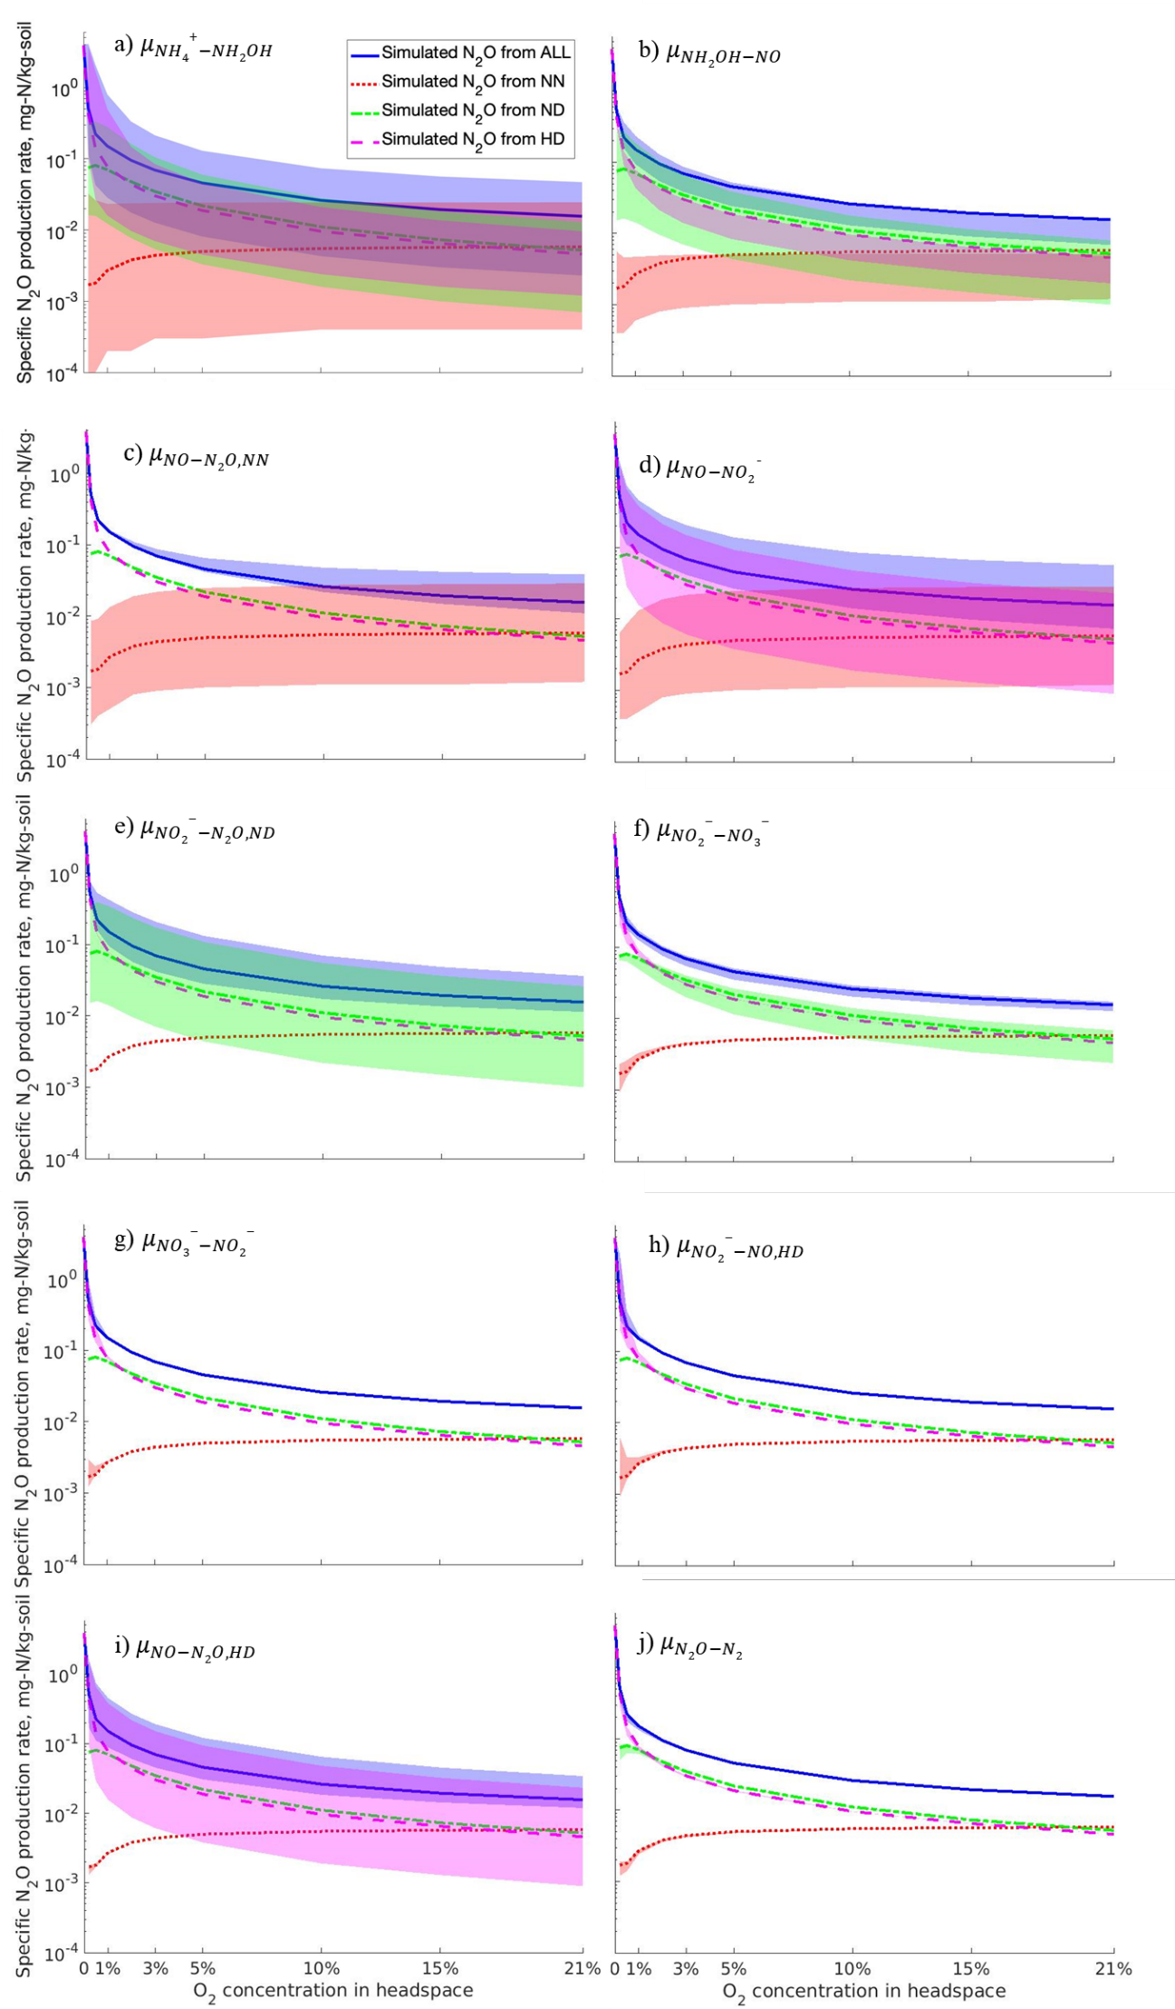
Fig. S1 Contributions of NN, ND, and HD to N₂O productions under different oxygen concentrations as the maximum reaction rate, $μ$, changed from 20% to 500%. The $μ$ with respect to different reactions were shown on the northeast corner of the plots. The blue, red, green, and magenta lines represented the N₂O production from all (NN+ND+HD), NN, ND, and HD, respectively, under benchmark condition, in which parameter values in Table S1 and S2 were used. Correspondingly, the blue, red, green, and magenta regions represented the varying ranges of N₂O production rate as$μ$ changed.

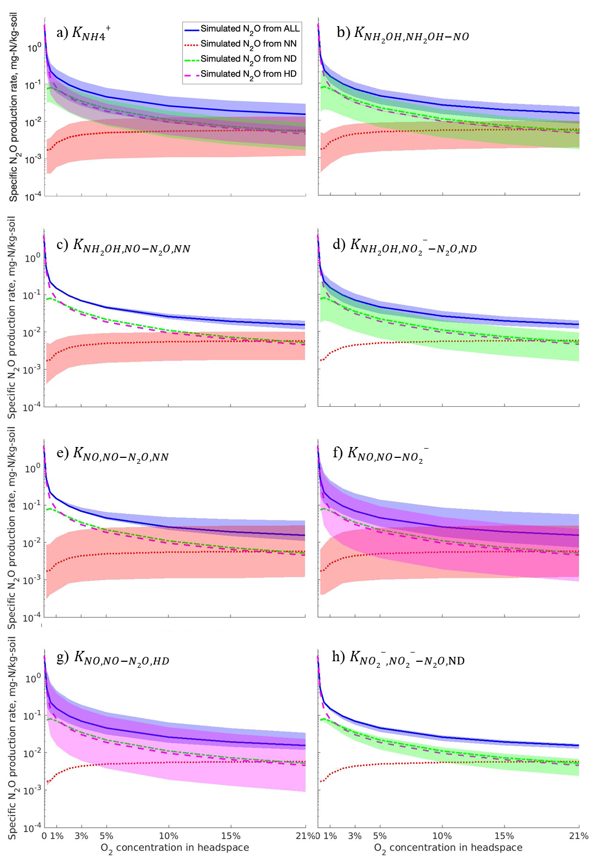
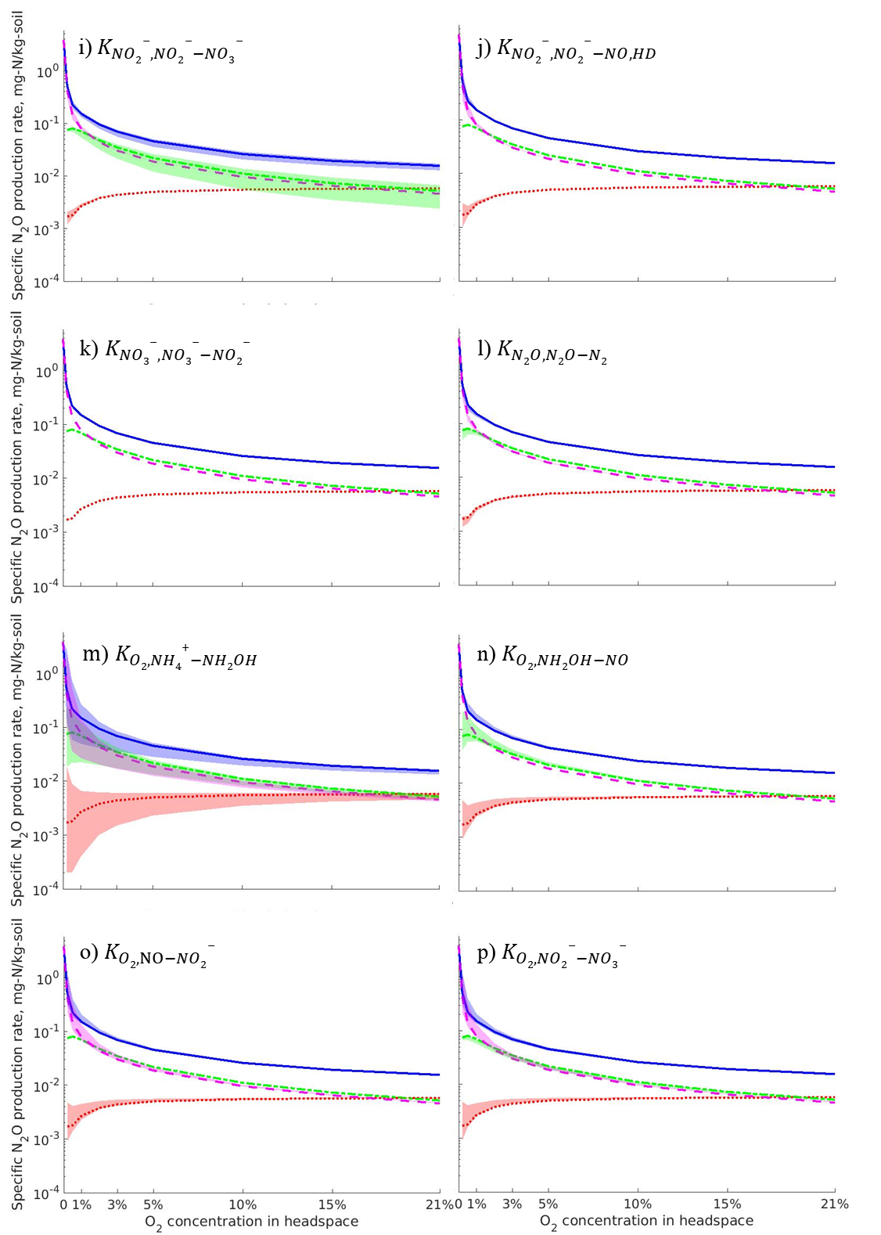
Fig. S2 Contributions of NN, ND, and HD to N₂O production under different oxygen concentrations as the half-saturated concentration, K, changed from 20% to 500%. The K with respect to different reactions were shown on the northeast corner of the plots. The blue, red, green, and magenta lines represented the N₂O production from all (NN+ND+HD), NN, ND, and HD, respectively, under benchmark condition, in which parameter values in Table S1 and S2 were used. Correspondingly, the blue, red, green, and magenta regions represented the varying ranges of N₂O production rate as$K$ changed.
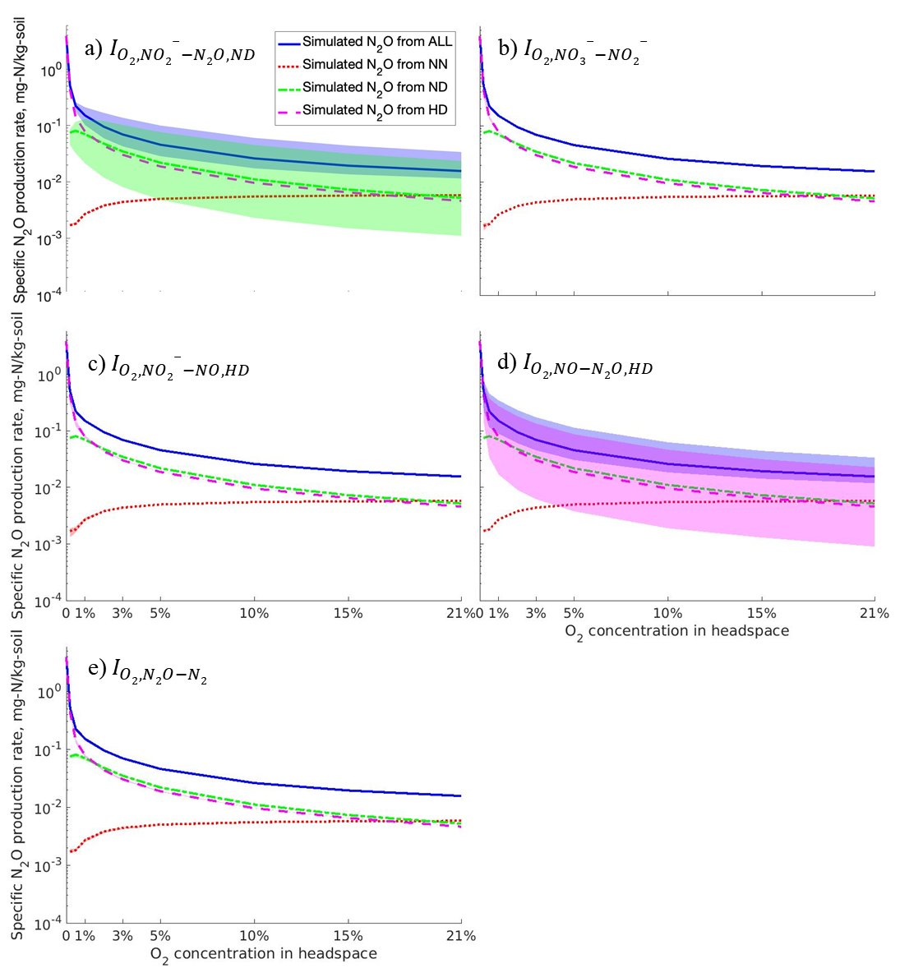
Fig. S3 Contributions of NN, ND, and HD to N₂O production under different oxygen concentrations as the inhibition constant, I, changed from 20% to 500%. The I with respect to different reactions were shown on the northeast corner of the plots. The blue, red, green, and magenta lines represented the N₂O production from all (NN+ND+HD), NN, ND, and HD, respectively, under benchmark condition, in which parameter values in Table S1 and S2 were used. Correspondingly, the blue, red, green, and magenta regions represented the varying ranges of N₂O production rate as$I$ changed.

References

Cadogan, S.P., Maitland, G.C., Trusler, J.P.M., 2014. Diffusion Coefficients of CO₂ and N₂ in Water at Temperatures between 298.15 K and 423.15 K at Pressures up to 45 MPa. Journal of Chemical & Engineering Data 59, 519-525.
Chen, X., Ni, B.J., Sin, G., 2019. Nitrous oxide production in autotrophic nitrogen removal granular sludge: A modeling study. Biotechnology and Bioengineering 116, 1280-1291.
Chen, Z., Ding, W., Xu, Y., Müller, C., Yu, H., Fan, J., 2016. Increased N₂O emissions during soil drying after waterlogging and spring thaw in a record wet year. Soil Biology and Biochemistry 101, 152-164.
Cussler, E.L., 1997. Diffusion. Cambridge University Press, Cambridge, England.
Gu, C., Riley, W.J., 2010. Combined effects of short term rainfall patterns and soil texture on soil nitrogen cycling — A modeling analysis. Journal of Contaminant Hydrology 112, 141-154.
Hamamoto, S., Moldrup, P., Kawamoto, K., Komatsu, T., 2010. Excluded-volume expansion of Archie's law for gas and solute diffusivities and electrical and thermal conductivities in variably saturated porous media. Water Resources Research 46, WR06514.
Hendry, M.J., Ranville, J.R., Boldt-Leppin, B.E.J., Wassenaar, L.I., 2003. Geochemical and transport properties of dissolved organic carbon in a clay-rich aquitard. Water Resources Research 39, WR001943.
Kool, D.M., Dolfing, J., Wrage, N., Van Groenigen, J.W., 2011. Nitrifier denitrification as a distinct and significant source of nitrous oxide from soil. Soil Biology and Biochemistry 43, 174-178.
Maggi, F., Gu, C., Riley, W.J., Hornberger, G.M., Venterea, R.T., Xu, T., Spycher, N., Steefel, C., Miller, N.L., Oldenburg, C.M., 2008. A mechanistic treatment of the dominant soil nitrogen cycling processes: Model development, testing, and application. Journal of Geophysical Research Biogeosciences 113, G02016.
Massman, W.J., 1998. A review of the molecular diffusivities of H₂O, CO₂, CH₄, CO, O₃, SO₂, NH₃, N₂O, NO, and NO₂ in air, O₂ and N₂ near STP. Atmospheric Environment 32, 1111-1127.
Mazloum-Ardakani, M., Taleat, Z., 2009. Investigation of electrochemistry behavior of hydroxylamine at glassy carbon electrode by indigocarmine. International Journal of Electrochemical Science 4, 694-706.
Peng, L., Ni, B.-J., Erler, D., Ye, L., Yuan, Z., 2014. The effect of dissolved oxygen on N₂O production by ammonia-oxidizing bacteria in an enriched nitrifying sludge. Water Research 66, 12-21.
Sander, R., 2015. Compilation of Henry’s law constants (version 4.0) for water as solvent. Atmospheric Chemistry and Physics 15, 4399-4981.
Sieczka, A., Koda, E., 2016. Kinetic and equilibrium studies of sorption of ammonium in the soil-water environment in agricultural areas of Central Poland. Applied Sciences 6, 269.
Spiller, L.L., 1989. Determination of Ammonia/Air Diffusion Coefficient Using Nafion Lined Tube. 22, 2561-2573.
Weast, R.C., 1997. CRC Handbook of Chemistry and Physics. CRC Press.
Yan, Z., Bond-Lamberty, B., Todd-Brown, K.E., Bailey, V.L., Li, S., Liu, C., Liu, C., 2018. A moisture function of soil heterotrophic respiration that incorporates microscale processes. Nature Communications 9, 2562.
Yan, Z., Liu, C., Liu, Y., Bailey, V.L., 2017. Multiscale Investigation on Biofilm Distribution and Its Impact on Macroscopic Biogeochemical Reaction Rates. Water Resources Research 53, 8698-8714.
Zhu, X., Burger, M., Doane, T.A., Horwath, W.R., 2013. Ammonia oxidation pathways and nitrifier denitrification are significant sources of N₂O and NO under low oxygen availability. Proceedings of the National Academy of Sciences 110, 6328-6333.

