Figure S1: X-ray study of samples after each step of synthesis of PAT SLNWs.
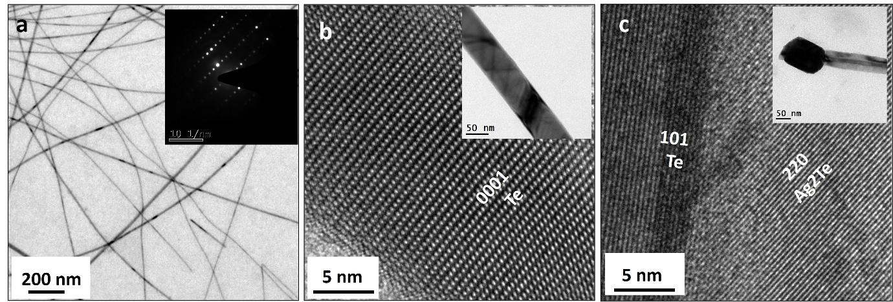
Figure S2: (a) Low-magnification bright-field TEM image of Te nanowires used as templates; the inset shows the corresponding SAED pattern confirming their single-crystalline nature. (b) High-resolution TEM (HRTEM) image of a Te nanowire displaying lattice fringes consistent with growth along the [0001] direction. (c) HRTEM image of a PAT nanowire recorded from the wire region, revealing a distinct Te-Ag₂Te core-shell structure; the inset shows a representative PAT nanowire sample collected after 2 min of reaction.
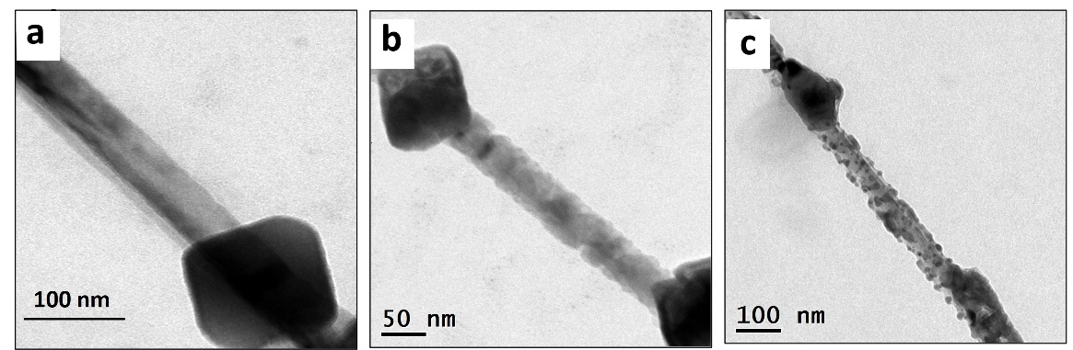
Figure S3: Bright-field TEM micrographs of PAT nanowires collected after (a) 2 min, (b) 10 min, and (c) 15 min of reaction time. The images clearly reveal that the nanowires begin to disintegrate beyond 2 min of reaction onset.
Figure S4: XRD pattern of samples of PCT SLNWs.

