Supplementary Material for
Circulating miRNAs Associated with Frailty in Old People with Cardiovascular Diseases Promote Cellular Senescence and Inflammation
Content
Supplementary Table 1. Comparison of clinical characteristics between included and excluded subjects …………………………..…………………………………………………………………..2
Supplementary Table 2. Comparison of clinical characteristics between frail and non-frail individuals included in the Small RNA-Seq experiment ……….…………………………………….3
Supplementary Table 3. List of primers used for the study………………………………………....4
Supplementary Figure 1. Principal Component Analysis of frail and non-frail individuals according to small RNA-Seq results…………………………………………………………………..................5
Supplementary Figure 2. Expression of plasma miRNAs in frail and non-frail individuals .………..6
Supplementary Figure 3. GO processes targeted by miR-500a-5p according to miRINgo………….7
Supplementary Figure 4. Overexpression of miR-181b-3p and miR-490-5p in endothelial cells….8

Supplementary Table 1. Comparison of clinical characteristics between included and excluded subjects.
Variable | Subjects included in the study  (N=197) | Subjects excluded from the study  (n=9) | p-value
Age (years) | 78 (72-83) | 80 (74-84) | 0.226
Male, n (%) | 140 (71) | 5 (56) | 0.455
BMI (kg/m²) | 25 (23-28) | 25 (23-28) | 0.933
Diastolic Blood Pressure [mmHg] | 70 (60-73) | 72,5 (60-80) | 0.546
Systolic Blood Pressure [mmHg] | 110 (110-128) | 120 (107,5-122,5) | 0.837
Diabetes, n (%) | 55 (28) | 4 (44) | 0.281
Heart rate | 70 (63-77) | 74 (72-81) | 0.128
Total Cholesterol (mg/dl) | 128 (102-158) | 136 (129-142) | 0.283
LDL cholesterol (mg/dl) | 64 (46-91) | 77,8 (66-82,5) | 0.267
HDL cholesterol (mg/dl) | 38 (32-47) | 38.5 (31-39,3) | 0.661
Triglycerides (mg/dl) | 103 (84-130) | 99,5 (94-148) | 0.508
Creatinine (mg/dl) | 1.1 (0.90-1.5) | 1.3 (1.2-1.7) | 0.179
HbA1c, % | 5.9 (5.4-6.5) | 6.4 (5.9-6.5) | 0.601

Clinical variables in the two groups of subjects included and excluded from this study due to plasma samples not available, i.e. lack of blood withdrawal or hemolyzed samples. P-values derive from Mann–Whitney U test for continuous data (Q1-Q3) and from Fisher’s exact test for categorical variables (n, %).
Abbreviations: BMI, Body Mass Index; LDL, Low Density Lipoprotein; HDL, High Density Lipoprotein; HbA1c, glycated hemoglobin.

Supplementary Table 2. Comparison of clinical characteristics between frail and non-frail individuals included in the Small RNA-Seq experiment, i.e. the discovery phase.
Variable | Not Frail (N=12) | Frail (n=12) | p-value
Age (years) | 76.5 (74.8-82.5) | 76.5 (74.8-81.5) | 0.791
Male, n (%) | 9 (75) | 7 (58.3) | 0.667
BMI (kg/m²) | 24.9 (24.1-26.7) | 25.3 (22.4-28.2) | 0.830
Hypertension, n (%) | 8 (66.7) | 11 (91.7) | 0.317
Diabetes, n (%) | 2 (16.7) | 5 (41.7) | 0.371
Systolic blood pressure (mmHg) | 120 (110-125) | 110 (100-120) | 0.150
Diastolic blood pressure (mmHg) | 70 (70-80) | 70 (70-80) | 0.856
Heart rate | 66 (62-73) | 72 (66.5-76) | 0.233
Total cholesterol (mg/dl) | 122 (112-172) | 137 (88.8-182.5) | 0.895
LDL cholesterol (mg/dl) | 61.5 (52.3-111.8) | 56 (35-130) | 0.905
HDL cholesterol (mg/dl) | 44.5 (32.3-50.8) | 34.5 (27.3-37.8) | 0.214
Triglycerides (mg/dl) | 113 (96.3-134) | 116 (115-137) | 0.864
Creatinine (mg/dl) | 1.4 (1.2-1.5) | 1.6 (1.5-2) | 0.129
HbA1c, % | 6 (5.2-7.5) | 6.8 (5.7-7.7) | 0.810

Clinical variables in the two groups of frail and non-frail individuals included in the study relative to the Small RNA-Sequencing of plasma (n=24). P-values derive from Mann–Whitney U test for continuous data (Q1-Q3) and from Fisher’s exact test for categorical variables (n, %).
Abbreviations: BMI, Body Mass Index; LDL, Low Density Lipoprotein; HDL, High Density Lipoprotein; HbA1c, glycated hemoglobin.

Supplementary Table 3. List of primers used for the study.
Primer | Sequence
CXCL1 for | TCC TGC ATC CCC CAT AGT TA
CXCL1 rev | CTT CAG GAA CAG CCA CCA GT
GAPDH for | TCC TCT GAC TTC AAC AGC GAC
GAPDH rev | TCT CTC TTC CTC TTG TGC TCT T
IL-1β for | CCA GCT ACG AAT CTC CGA CC
IL-1β rev | CAT GGC CAC AAC AAC TGA CG
IL-6 for | TGC AAT AAC CAC CCC TGA CC
IL-6 rev | GTG CCC ATG CTA CAT TTG CC
p16 for | CAT AGA TGC CGC GGA AGG T
p16 rev | CTA AGT TTC CCG AGG TTT CTC AGA
p21 for | ACC GAG ACA CCA CTG GAG GG
p21 rev | CCT GCC TCC TCC CAA CTC ATC
PAI-1 for | CAG ATG AGG ACA GAG TGG TTT C
PAI-1 rev | GTG GGC TGA TTA GGC TTC TAT T

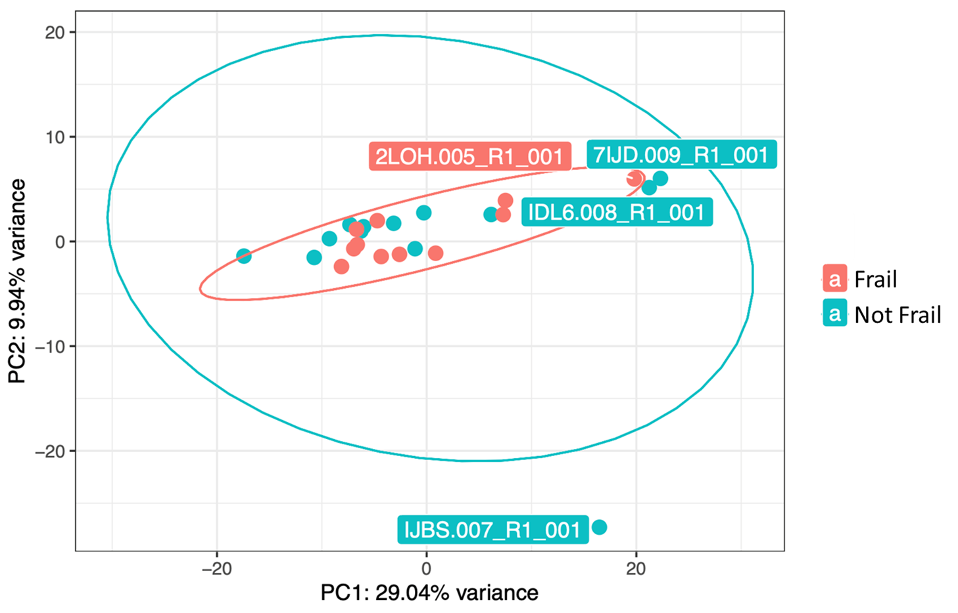
Supplementary Figure 1. Principal component analysis (PCA) of frail and non-frail individuals according to small RNA-Seq results.

PCA plot showing the total percentage of variance explained by the first two components (PC1 and PC2). Individual points represent samples from frail and non-frail individuals, along with colored circles indicating their clustering.

Supplementary Figure 2. Expression of plasma miRNAs in frail and non-frail individuals.
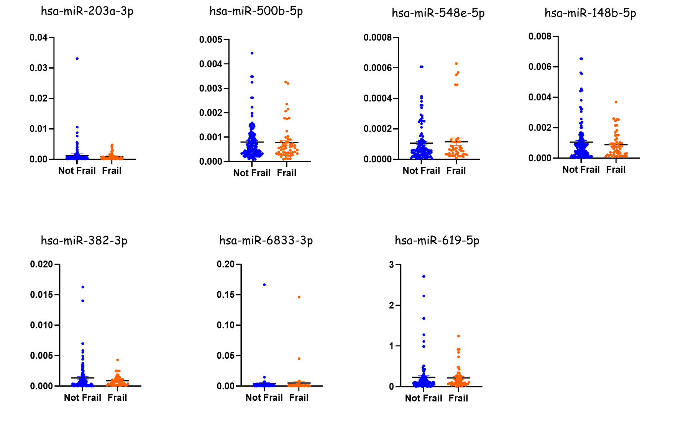
Relative plasma expression levels of hsa-miR-203a-3p, hsa-miR-500b-5p, hsa-miR-548e-5p, hsa-miR-148b-5p, hsa-miR-382-3p, hsa-miR-6833-3p, and hsa-miR-619-5p in non-frail and frail subjects; miRNA expression was quantified by qRT-PCR and normalized to cel-miR-39 using the 2−ΔCt method; mean and individual points are shown. No significant differences were observed according to Mann Whitney U test.

Supplementary Figure 3. GO processes targeted by miR-500a-5p according to miRINgo.
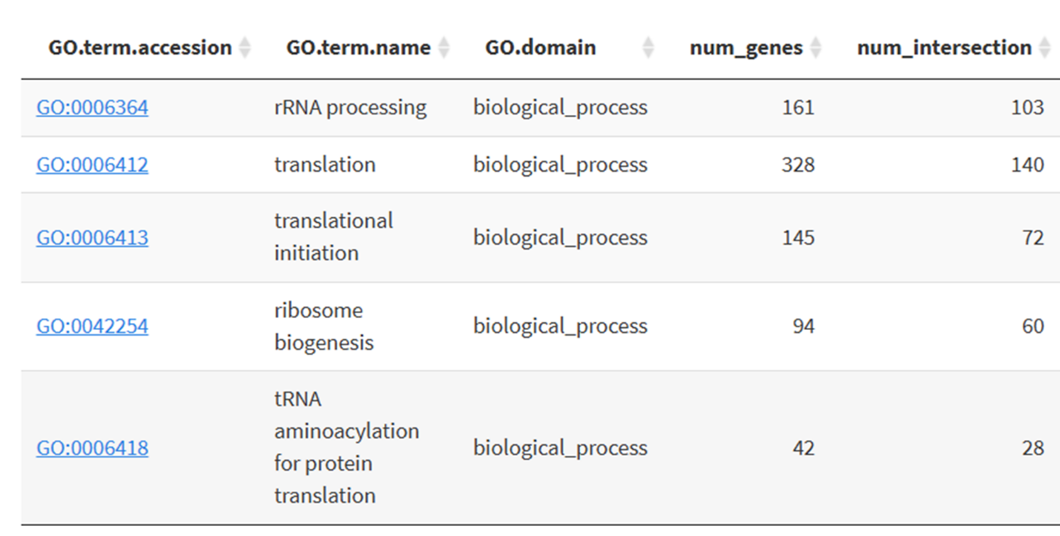

GO enrichment analyses for hsa-miR-500a-5p according to the software miRINgo.

Supplementary Figure 4. Overexpression of miR-181b-3p and miR-490-5p in endothelial cells.
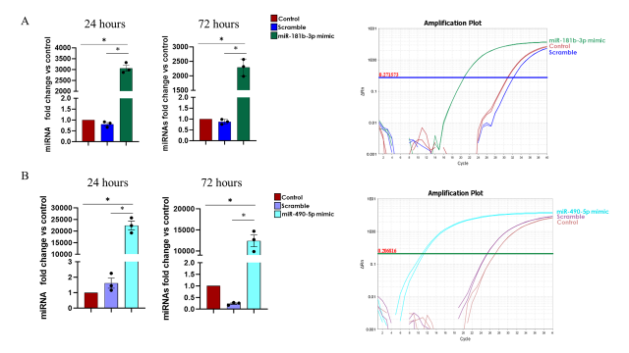

Expression of miR-181b-3p (panel A) and miR-490-5p (panel B) in endothelial cells after 24 and 72 hours from transient transfection, along with a representative amplification plot of the miRNA of interest after 72 hours. Relative expression level of the miRNA of interest in control cells, cells treated with the scramble miRNA, and cells treated with the miRNA mimic, presented as fold change over control. Data are mean ± SEM of three independent experiments. *p < 0.05 ANOVA followed by the Holm–Šídák test. In the amplification plots the Y axis is ΔRn and the X axis is the number of cycles.

