Supplementary Tables

Supplementary Figure-S1: Study flow
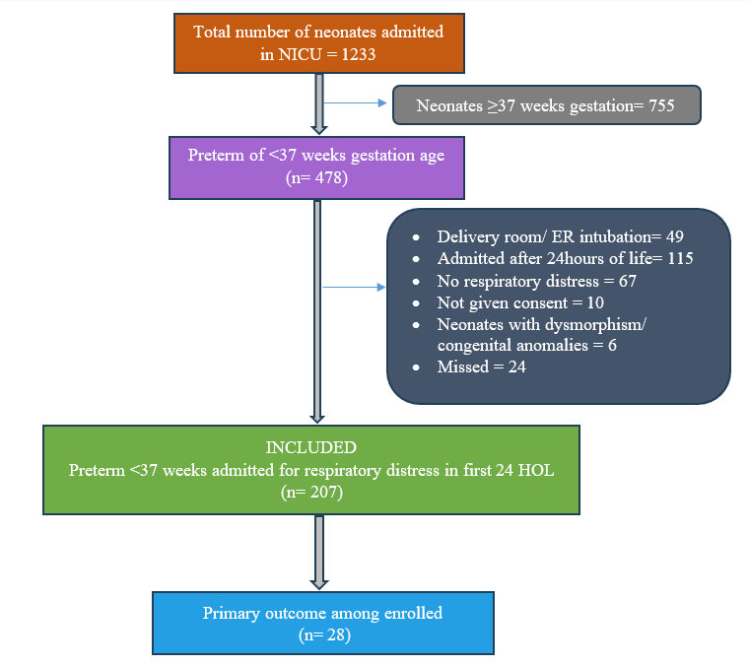

Supplementary Table 1: Mode of Respiratory Support on Days 1, 2, and 3
Mode of Support | Day 1 n (%) | Day 2 n (%) | Day 3 n (%)
Invasive mechanical ventilation | 17 (8.2%) | 4 (2.1%) | 5 (2.8%)
CPAP | 126 (60.9%) | 49 (25.9%) | 36 (19.9%)
NIPPV | 12 (5.8%) | 5 (2.6%) | 2 (1.1%)
HFNC | 1 (0.5%) | 2 (1.1%) | 2 (1.1%)
Supplemental oxygen | 3 (1.4%) | 1 (0.5%) | 2 (1.1%)
Room air | 65 (31.4%) | 132 (69.8%) | 139 (76.8%)

Supplementary Table 2: Diagnostic Accuracy of LUS Score on Days 1, 2, and 3 for Predicting Surfactant Requirement
Metric | Day 1 LUS ≥4 | Day 2 LUS ≥2 | Day 3 LUS ≥1
AUC (95% CI) | 0.84 (0.75–0.93) | 0.85 (0.76–0.94) | 0.68 (0.55–0.82)
Sensitivity (95% CI) | 78% (61–90%) | 59% (36–79%) | 69% (41–89%)
Specificity (95% CI) | 82% (76–88%) | 90% (85–94%) | 67% (60–74%)
PPV (95% CI) | 48% (35–62%) | 45% (26–64%) | 17% (9–28%)
NPV (95% CI) | 95% (90–98%) | 94% (90–97%) | 96% (90–99%)
Positive LR (95% CI) | 4.43 (3.07–6.41) | 6.17 (3.45–11.03) | 2.10 (1.41–3.12)
Negative LR (95% CI) | 0.27 (0.15–0.50) | 0.45 (0.27–0.75) | 0.46 (0.22–0.97)

Supplementary Figure S2: Distribution of Day-1 LUS scores stratified by IMV requirement within 7 days of life
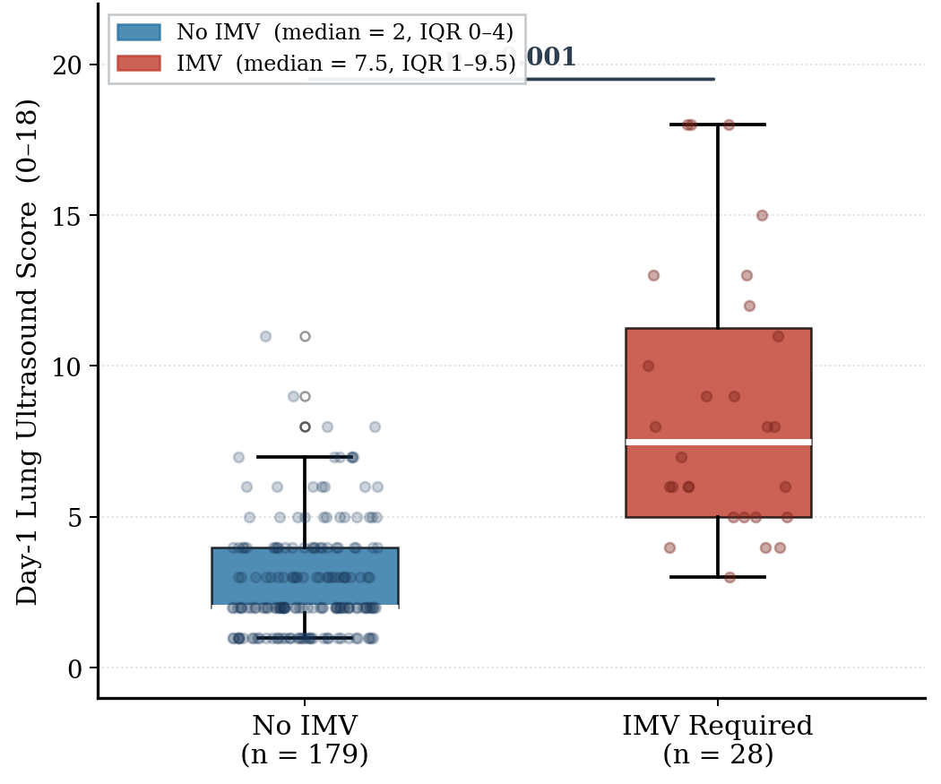

Supplementary Table 3: Multivariate Logistic Regression - Predictors of IMV by Day 7
Variable | Odds Ratio | 95% CI (Lower) | 95% CI (Upper) | p-value
Predictors of IMV by Day 7
Surfactant use | 61.50 | 9.15 | 1251.23 | <0.001
Hs-PDA | 6.83 | 1.22 | 55.36 | 0.040
SNAPPE-II score (per unit increase) | 1.06 | 1.00 | 1.12 | 0.044
(Model: pseudo-R² = 0.192, AIC = 220.95)

Supplementary Table 4: Predictive Performance of Day 1 LUS for IMV by Day 7 and Surfactant Requirement Across Subgroups
Outcome | Cohort | Optimal Threshold | AUC (95% CI) | Performance
IMV by Day 7 | GA <32 wks | LUS score: ≥6 | 0.684  (0.521–0.850) | Sensitivity 62.5%, Specificity 81.2%,  PPV 52.6%, NPV 86.7%;  LR+ 3.33 / LR− 0.46
IMV by Day 7 | Respiratory support | LUS score: ≥5 | 0.693  (0.553–0.822) | Sensitivity 65.4%, Specificity 71.7%,  PPV 34.7%, NPV 90.0%  LR+ 2.31 / LR− 0.48
Surfactant Requirement | GA <32 wks | LUS score: ≥7 | 0.815  (0.696–0.934) | Sensitivity 63.6%, Specificity 95.2%,  PPV 87.5%, NPV 83.3%  LR+ 13.36 / LR− 0.38
Surfactant Requirement | Respiratory support | LUS score: ≥8 | 0.830  (0.726–0.919) | Sensitivity 66.7%, Specificity 95.1%,  PPV 82.8%, NPV 89.1%  LR+ 13.73 / LR− 0.35

Supplementary Figure S3: ROC Curves for LUS Day 1 Score across sub-groups and outcomes
(top row: IMV; bottom row: Surfactant)
