CD44 as a Conserved Biomarker and Functional Modulator of Neuroinflammation in Multiple Sclerosis and Beyond

By Newshan Behrangi, Maria-Sophia Stadler, Christin Reinbach, Luisa Burkert, Alexander Hawlitschka, Hannes Kaddatz, Lukas Wenzel, Gemma Llovera, Andreas Wree, Chloè Hoornaert, Peter Ponsaerts, Uta Splietker, Lars-Ove Brandenburg, Sandra Amor, Simone Tauber, Amelie Bohn, Christoph Schmitz, Markus Kipp, and Tanja Hochstrasser

Supplementary Material

Supplementary Tables

Supplementary Table S1. Experimental cohorts used in this study.
Cohort | Strain | Age in weeks | Weight | Sex | Experimental Group
Cuprizone | C57BL/6 | 9 | 20–22 g | ♀ | Ctrl (n = 4)  Cup 3 wks (n = 5)  Cup 5 wks (n = 4)
EAE | C57BL/6 | 10 | - | ♀ | Ctrl (n = 4)  EAE (n=3)
Cup/EAE | C57BL/6 | 9 |  | ♀ | Ctrl (n = 4)  Cup/EAE (n=6)
fMCAo | C57BL/6 | 10 | 23-32g | ♂ | Ctrl (n = 4)  4 h after stroke (n = 3)  3 d after stroke (n = 3)
6-OHDA | C57BL/6 | 5-8 | 15–21.5 g | ♂/♀ | Ctrl (n = 5)  1 d after injection (n = 4)  4 d after injection (n = 4)
LPC | C57BL/6 | 7-8 | - | ♂ | Ctrl (n=10)  LPC (n=9)
Cd44^{-/-} | C57BL/6 | 10 | 20–22 g | ♀ | Ctrl wt (n=12), Cd44^{-/-}(n=15)  EAE wt (n=11), Cd44^{-/-} (n=13)  Cup/EAE wt (n=11), Cd44^{-/-} (n=12)
APP/PS1 | C57BL/6 | 26,  52 | - | ♂/♀ | wt (n=2)  0.5 y (n=3)  1 y (n=3)
CX3CR1+/eGFP/CCR2+/RFP | C57BL/6 | 9 | - | ♂/♀ | Ctrl (n=2)  Cup/EAE (n=3)

Supplementary Table S2. Clinical details of MS patients.
Sex | Age at death | MS disease duration | Date of birth | Date MS diagnosis | PMD | MS type | Cause of death
♀ | 35 y | 10 y | 1979 | 2004 | 10.33 h | SPMS | Euthanasia
♀ | 60 y | 10 y | 1950 | 2003 | 10.66 h | SPMS | Euthanasia
♂ | 54 y | 15 y | 1957 | 1999 | 8.25 h | PPMS | Euthanasia
♂  Controls | 49 y | 25 y | 1959 | 1983 | 8 h | SPMS | Pneumonia
♀ | 86 y |  | 1923 |  | 6.5 h |  | Multiple myeloma
♀ | 60 y |  | 1950 |  | 7.5 h |  | Infection
SPMS: Secondary Progressive Multiple Sclerosis
PPMS: Primary progressive Multiple Sclerosis

Supplementary Table S3. Clinical details of MS and Non-MS CSF donors.
MS CSF doners
Sex | Age | Treatment | MS Type
♀ | 30 | No | RRMS
♀ | 22 | No | RRMS
♂ | 22 | No | RRMS
♀ | 53 | No | SPMS
♂ | 28 | No | RRMS
♂ | 48 | No | RRMS
♀ | 20 | No | RRMS
RRMS: Relapsing-Remitting Multiple Sclerosis
Non-MS CSF doners
Sex | Age
♀ | 30
♀ | 22
♂ | 22
♀ | 53
♂ | 28
♂ | 48
♀ | 20

Supplementary Table S4. Primary antibodies.
Anti- | Host | Application_{a} | Dilution | HIER_{b} | Supplier | Catalog # | RRID_{c}
APP | mouse | IHC | 1:5,000 | Tris-EDTA | Millipore | MAB348 | AB_94882
CD3 | rat | IHC  IF | 1:250  1:250 | Tris-EDTA | Abcam | ab11089 | AB_369097
CD3 | rabbit | IHC | 1:1000 | Tris-EDTA | Abcam | Ab16669
CD44 | rabbit | IHC  IF | 1:4,000  1:4,000 | - | Abcam | ab189524 | -
GFAP | chicken | IHC  IF | 1:5,000  1:4,000 | - | Abcam | ab4674 | AB_304558
IBA1 | rabbit | IHC  IF | 1:5,000  1:1,000 | Tris-EDTA | Wako | 019-19741 | AB_2665520
MHC-II, HLA-DR (clone LN3) | Mouse | IHC | 1:1500 | Citrat | Thermo Fisher, USA | MA5-11966 | AB_10979984
PLP | mouse | IHC | 1:5000 | - | Biorad | MCA839G | AB_2237198
APP A4 | mouse | IHC | 1:5000 | Tris-EDTA | Millipore | MAB348
IgG Isotype Control | rabbit | IHC | 1:2 (0.25μg/ml) | - | Thermo Fisher, USA | 08-6199 | AB_2532942
_{a}IF, immunofluorescence; IHC, immunohistochemistry; WB, Western blotting
_{b}Heat induced epitope retrieval
_{c}Research resource identifier

Supplementary Table S5. Secondary antibodies.
Anti- | Host | Dilution | Supplier | Catalog #
chicken IgG | goat | 1:200 | Vector laboratories | BA9010
chicken AlexaFluorTM594 | goat | 1:200 | Life Technologies | A11042
mouse IgG | goat | 1:200 | Vector laboratories | BA9200
rabbit IgG | goat | 1:200 | Vector laboratories | BA1000
rabbit AlexaFluorTM594 | goat | 1:200 | Life Technologies | A11008
rat IgG | goat | 1:200 | Vector laboratories | BA9400
rat AlexaFluorTM488 | donkey | 1:200 | Life Technologies | A21208

Supplementary Figures

A
B

Supplementary Fig. S1 A Clinical scores of control (Ctrl) and Cup/EAE animals. B Number of perivascular cuffs (PVCs) in Ctrl and Cup/EAE animals.

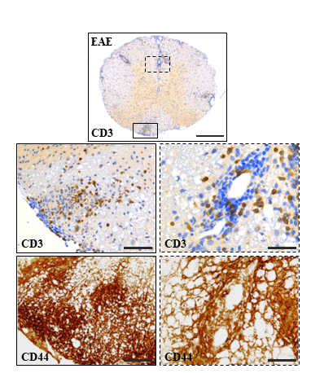
B
A

Supplementary Fig. S2 A Anti-CD3 staining overview (scale bar: 500 µm) with higher magnification images showing CD3 and CD44 localization in spinal cord white matter of EAE animals (left: 100 µm; right: 25 µm). B Quantification of histopathological features in control (Ctrl), CFA+PTX, and EAE groups using one-way ANOVA with Sidak’s multiple comparisons test. Data are mean ± SEM; significance indicated (*p ≤ 0.05, **p ≤ 0.01, ***p ≤ 0.001).

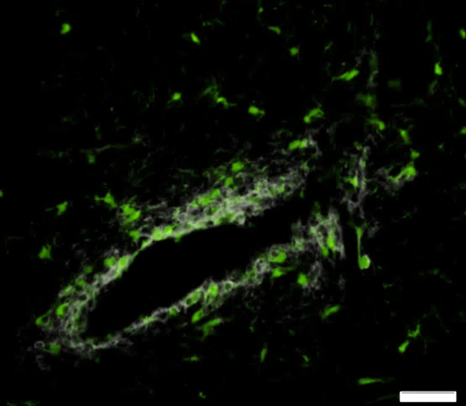
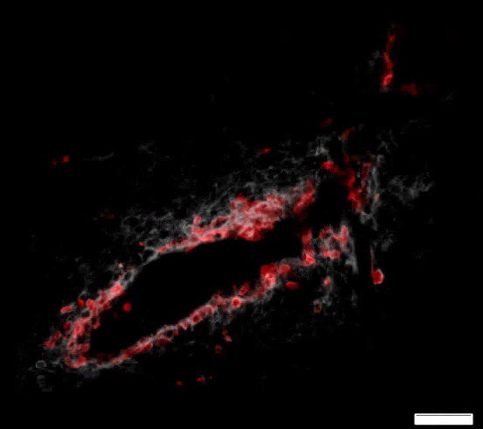
RFP (CD44⁺ monocytes) /
CD44
eGFP(CD44⁺ microglia) /
CD44

Supplementary Fig. S3 CD44 expression of brain resident microglia and infiltrating monocytes around perivascular cuffs shown in transgenic (CX3CR1+/eGFP/CCR2+/RFP) Cup/EAE mice. Arrows indicate eGFP-expressing microglia (green) and RFP-expressing monocyte derived macrophages (red) in the perivascular region.

Supplementary Fig. S4 ELISA standard curve of CD44.

