Supplement of
Macroseismic intensity probability in the context of Bayesian Natural Neighbours

Franco Pettenati and Massimiliano Iurcev

S1 The sets of natural neighbours (NN) and their Voronoi configuration
If we have a set of measure points {$x_{i}$} in a Euclidean space Ω, we have defined as ‘wreath’ the pattern of neighbours Voronoi polygons of the control point $x^{*}$, associated to the set {$x_{i}$}. First, we can also define the trivial theorem:
Theorem S1: $x_{i}$ and $x_{j}$ are both natural neighbours of $x^{*}$ if and only if arg ($x_{i}$ - x*) ≠ arg ($x_{j}$ - $x^{*}$) with the corollary that the natural neighbours {$x_{i}$} of $x^{*}$ are uniquely ordered vertices of a non-convex polygon (see Fig. S1a the wreath coloured magenta in the centre of the figure).
Once the control point $x^{*}$has been chosen, which lies within a polygon of the wreath, it defines the ‘wreath-order’ as ω = 0. The polygons adjacent to order-0 are defined as order-1, the polygons adjacent to a polygon of ω = 1 are defined as order-2 and so on. It is trivial that: $ω_{i}=0⟺i=\underset{j}{argmin}{d\left(x_{j}-x^{*}\right)}$. It is important to have the maximum wreath-order ω_{max} to check the minimum influence that the configuration of the NN can have. For this purpose, we computed all these parameters for several different $x^{*}$, regularly distributed (not randomly) on a grid contained in [0.05, 0.95]² (2500 $x^{*}$), in order to avoid Voronoi effects at the border and 5000 $x_{i}$ Poisson distribution points (Fig. S1a). Table 1 summaries the results, and Figs S1b,c show the statistics. Fig. S1b, is the distribution of sides of all polygons, while Fig. S1c shows the statistics of wreath-order ω. In this simple experiment there is one case of order ω = 4 as for the case of Fig. 1b. The minimum shift of the location of a datapoint can modify the shape and the area of the $x^{*}$ second-order polygon. See also figure 2 (which resembles an abstract painting) in the article Iurcev and Pettenati (2023).
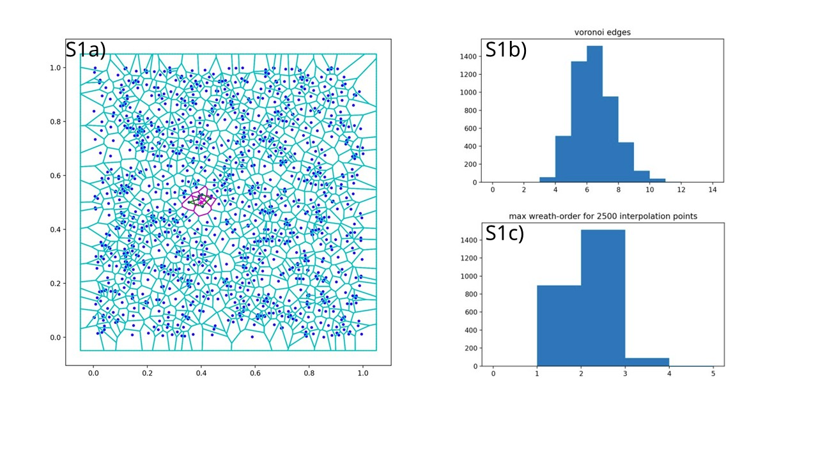
Fig. S1: Statistics of Voronoi tessellation; a) 5,000 data points ($x_{i}$) are randomly Poisson distributed on a convex region of length 1 x 1. The polygons shown in magenta form a wreath to illustrate theorem 1; b) histogram of side distribution of the second-order Voronoi polygons for control points $x^{*}$ located on a 50 x 50 grid within the rectangle [0.05, 0.95] for each side; c) histogram of the ‘wreath-order’ for the second-order Voronoi polygons shown Fig. S1b.

S2 Topological interpretation in one and two dimensions
The analytic treatment Voronoi in ℝ is trivial, it obviously only includes two items, and the result is an equation of a straight line (y = a + b x). Fig. S2a, shows the space of events Ω is the segment $\overline{X_{a}X_{b}}$ , where points $X_{1}$ and $X_{2}$ are located with the measurements $Y_{1}$ and $Y_{2}$. The two horizontal bars in grey tonality are the Voronoi ‘segments’ of points $X_{1}$ and $X_{2}$. If we consider, $x^{*}$the investigation point, the white higher bar is its second-order Voronoi of length $Ax$ (S1). The values of the linear Sibson (1981) weights are obtained by formulas S3a and S3b. Of course, the trend of the values (S4), for the variable $x^{*}$ moving form $X_{1}$ to $X_{2}$ is linear as predicted by the Sibson formula (3) of the text.
$Ax=\frac{X_{2}+X^{*}}{2}-\frac{X^{*}+X_{1}}{2}=\frac{X_{2}-X_{1}}{2}$ (S1)
The Sibson weights are
$W_{1}=\frac{\left(\frac{X_{2}+X_{1}}{2}-\frac{X^{*}+X_{1}}{2}\right)}{Ax}=\frac{\frac{\left(X_{2}-X^{*}\right)}{2}}{\frac{\left(X_{2}-X_{1}\right)}{2}}$ (S2a)
$W_{2}=\frac{\left(\frac{X_{2}+X^{*}}{2}-\frac{X_{2}+X_{1}}{2}\right)}{Ax}=\frac{\frac{\left(X^{*}-X_{1}\right)}{2}}{\frac{\left(X_{2}-X_{1}\right)}{2}}$ (S2b)

From (S2a) and (S2b)
$W_{1}=\frac{X_{2}-X^{*}}{X_{2}-X_{1}}$ (S3a)
$W_{2}=\frac{X^{*}-X_{1}}{X_{2}-X_{1}}$ (S3b)
The interpolated value in $X^{*}$ is
$Y\left(x^{*}\right)=Y_{1}W_{1}+Y_{2}W_{2}$=$Y_{1}\frac{X_{2}-X^{*}}{X_{2}-X_{1}}+Y_{2}\frac{X^{*}-X_{1}}{X_{2}-X_{1}}$=$\frac{1}{X_{2}-X_{1}}\left(Y_{1}\left(X_{2}-X^{*}\right)+Y_{2}\left(X^{*}-X_{1}\right)\right)$ (S4)
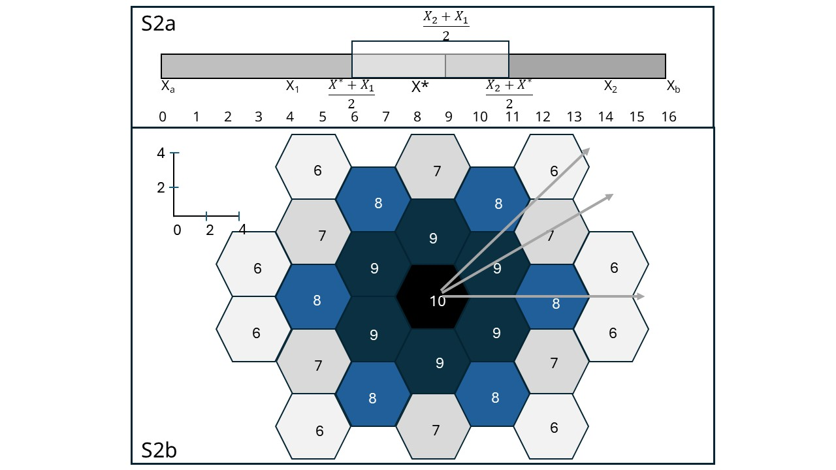
Fig S2: a) Simple scheme of Voronoi in one dimension; b) tessellation of most regular forms of Voronoi polygons in two dimensions (hexagons) to study the distributions of weights by changing the position of the control point $x^{*}$ in the three directions of the grey rows (see Fig S3).

A regular treatment in ℝ² is not so straightforward. To analyse the behaviour in 2D we use the hexagonal polygons as the regular shape for Voronoi elements (Fig. 2b). Hexagons are the regular Voronoi polygons, as the average number of sides in a Voronoi tessellation is 6 (Okabe et al., 2000). Fig. S2b shows a portion of space R2 tiled with regular hexagons, which can be understood as a Voronoi mosaic generated by a regular distribution of integer data from 10 to 7. The side of each hexagon is 2.7 cm (4.8 cm the diameter). Computing the NN interpolations in the three directions towards the right: 0º (horizontal), 30º, 45º (see the grey arrows in Fig. S2b), for a x coordinate $x^{*}$, we computed the values of the weights and interpolation as shown in Figs S3. As shown in Fig. 3c, for a real situation, the mutual relations between weights for the Sibson (1981) interpolation of a point moving in the three directions - 0º (Fig. S3a), 30º (Fig. S3b) and 45º (Fig. S3c) – are presented. The relations are regular with smooth curves representing the weight values. If, in one dimension the trend of interpolation for a set of independent variables $x^{*}$ is linear, as shown in formula S4 and the general formula of Sibson (3), in two dimensions, for different directions of movement, this fundamental principle is not upheld. Fig. S3d shows in the horizontal direction, as expected, the trend is linear; for the other two directions there is a deflection around $X^{*}$ = 3.7 cm. The value 3.75 cm is the horizontal coordinate of the two data points to the (9) right the 10 (half side plus half diameter). It is the point where the intersection area of 10 equals to the area of 8 on the right, in the direction 0º (Fig. S3a). Initially, the contribution to interpolation is provided by the hexagons: 10, the 9 above and below this first one, and the 9 to the right. The second-order Voronoi polygon of $x^{*}$ is a pentagon. The area of each intersection with the second-order Voronoi represents the reliability we are seeking (formula 2), and that for data points 9 the reliability is the sum of the two areas. From Figure S3a, up to 3.75 cm, the reliability of 10 appears linear, but in reality, it begins to curve at a distance of 2.8 cm, just outside hexagon 10, as the reliability of 9, when the intersection with polygon 8 begins. At 2.7 cm, the second-order polygon of $X^{*}$ collapses from a pentagon into an isosceles triangle pointing towards data point 8. It then becomes a quadrilateral up to 4.8 cm, where it returns to being a pentagon without the contribution of data point 10. At 3.75 cm, there is a change in the balance between the horizontal data points (10 and 8); in fact, the reliability of 9 reaches its maximum (which is not 1) and then begins to decline. In the directions 30◦ (Fig. S3b) and 45◦ (Fig. S3c), the combination of curves is more complex also because the hexagon of VII enters in the wreath for the computation of the weights. Analytic functions are not easy to formalise, but this is not necessary; we only note that, despite the change in the shape of the $x^{*}$ polygon, the curves are continuous and smooth, and the changes naturally correspond to the dimensions and positions of the hexagons. A random configuration confirms this rule, as shown in Figs 3, computing the NN values for the coordinates of points $x^{*}$ in the direction of the red, with $x^{*}$, the curve is trivially irregular with the discontinuity at point VIII ($x^{*}$ = -1.2 and $y^{*}$=-0.9 – Fig. S3d).
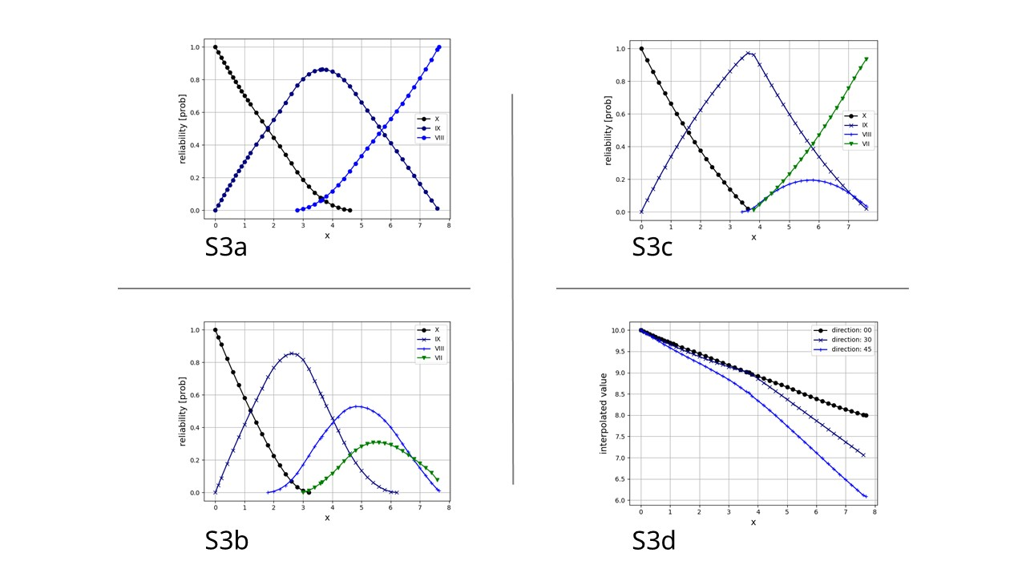
Fig S3: Distributions of weights in the three directions of the grey rows of Fig. S2b; a) horizontal direction (0º); b) 30º; c) 45º; interpolated values in the three directions.

S3 Statistical test - Robustness
Since the NN method is local, we used the small dataset from Fig. 1 to test the robustness of the method by varying the coordinates of the ten points randomly using a normal distribution with a mean of 0 and a standard deviation of 1%. The perturbation is not large, as the method is based on spatial ratios. However, a robustness analysis is always required for statistical purposes. Starting from the point with coordinates of point $x^{*}$ in Fig. 1a (x0=0.; y0=0) we computed hundreds of random perturbations, Fig. S4a. We then proceeded with a simple statistic of trimmed mean, deleting one by one each test of the five natural neighbours, excluding the VIII degree, which includes $x^{*}$. For each Trimm we computed hundreds of random perturbations. Fig. S4b shows the histogram of cumulative perturbations, including all 6 configurations. Figs S4c,d show the corresponding probability (or reliability) for $x^{*}$ expressed by formula (2). The statistics are presented in Table S1. Mean and median are roughly in agreement for the case without trimming (Fig. S4a) and the cumulative (Fig. S4b). There is a clear difference in the trimming case of the “Rem. VII” row (Fig. S4a), where the histogram shows a dispersion equal to the case without trimming (same standard deviation, see Table S1). By removing the VII on the left, the NN configuration changes significantly. The VIII pairs with the other VII and widens the area of intersection. Instead, for the reliability there is already a difference between the non-trimmed case and the cumulative. The cumulative (Fig. 4Sd) shows a bimodality influenced by behaviour of the trimming of the VII in second row, already described. But the medians of the non-trimmed case and the cumulative are comparable, showing a sort of robustness. For the other cases there is a considerable difference with the non-trimmed case.
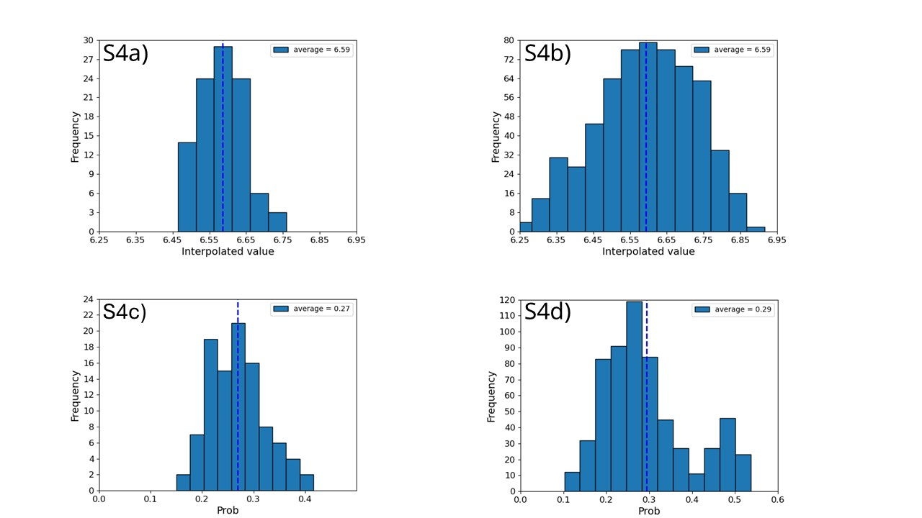
Fig. S4: Test robustness; a) histogram of interpolated values on control point $x^{*}$ (x0=0.; y0=0) of Fig. 1a, test of randomly perturbated with a standard deviation of 1%; b) histogram of control point $x^{*}$ of Fig. 1a, of random perturbation with additional trimming method of one of the wreath data of interpolation; c) histogram of the corresponding reliability of $x^{*}$, as given by formula (2) for the case in Fig. S4a; d) histogram of the corresponding reliability of $x^{*}$ as given by formula (2) for the case in Fig. S4b. For more details see Table S1.

Table S1 Statistics on the robustness of the natural neighbour configuration of point $X^{*}$in Fig. 1. In the trimming test (from the second row), the sequence of erased data is in a clockwise direction, starting from the VII value to the left of $x^{*}$. The last row shows the cumulative statistics for all other configurations.
Configuration | Interp value  Mean | Interp value  Std | Interp value  Median | Reliability Mean | Reliability Std | Reliability Median
All natural neighbours | 6.586 | 0.062 | 6.589 | 0.269 | 0.054 | 0.267
Rem. VII left | 6.716 | 0.062 | 6.717 | 0.478 | 0.027 | 0.480
Rem. V up | 6.509 | 0.049 | 6.509 | 0.199 | 0.048 | 0.198
Rem. V right | 6.748 | 0.056 | 6.744 | 0.251 | 0.062 | 0.251
Rem. VII | 6.391 | 0.068 | 6.384 | 0.285 | 0.055 | 0.291
Rem. VI | 6.604 | 0.050 | 6.599 | 0.280 | 0.056 | 0.279
Cumulative | 6.592 | 0.134 | 6.595 | 0.294 | 0.101 | 0.274

References
Iurcev, M., and F., Pettenati (2023). Exploring error estimation methods for natural neighbour interpolation: preliminary research and analysis. Bull. Geoph. Ocean. Vol. 64, 4, 433-448, December 2023. https://doi.org/10.4430/bgo00423.
Okabe, A.B., Boots B., Sugihara, K., and Chiu, S.N. (2000). Spatial Tessellation. Second ed., Wiley, Chichester, 671 pp.
Sibson, R. (1981). A brief description of natural neighbor interpolation. Interpreting Multivariate Data, V. Barnett editor, Chichester, John Wiley, 21-36.

