Topic guide
Exploring the needs and expectations of South Asian individuals and their families for digitally enabled pain self-management in the United Kingdom
Prior to the interview:
- Provide brief background of the research programme. Giving them the confidence that how learning about pain experiences has resulted in development of the Manchester Digital Pain Manikin
- Explain the purpose of research and provide opportunity to ask question
- Encourage participants to actively contribute, and respect opposing opinions
- Encourage family members to ask clarifying questions to other family members or provide clarifying information to help understand the pain self-management experience
- If any part of discussion is disturbing then a participant may take a break and return to the interview when they feel comfortable, or they can terminate the interview at any point.
- Provide a quick summary of learnings regarding the Manchester Digital Pain Manikin research programme, and explain how the current research can help building the programme further
- Reiterate data protection principles to give confidence to all family members
[recording starts from here]
Interview questions:
- Can you briefly describe the context in which you live? (opening question)
  - Household; education; immigration status; neighbourhood; family and friends; living conditions

- As a family, explain your experience of living with (someone with) chronic pain and the factors, which are challenging for 'self'-management? (pain experience)
  - Experience of person living with chronic pain
  - How family members perceive about the pain experience?
  - How family members are part of shaping that experience?
  - To what extent ‘self’ is ‘relational’ and how?
  - How cultural norms (e.g., gatherings, rituals, gender stereotypes or norms, diet and dietary practices) shape those experiences?
  - Perceived causes and effects
  - Explore behaviours and attitudes (shaped by cultural norms, or personal beliefs)
  - Intergenerational differences

- How do you manage your chronic pain?
  - Type and timing of pain self-management intervention
  - What choices do you have, and how you decide among those choices; balance between formal healthcare seeking and home remedies
  - Family roles and their responsibilities
  - Role of digital tools and resources; digital literacy
  - Intergenerational differences and expectations regarding pain self-management – how choices are negotiated?

- What type of pain management programme, you think can support you in managing your pain
  - Ability to manage chronic pain – self-efficacy
  - Experience of participating in any pain management programme?
  - Opinion on ‘increased focus on improving function than reducing pain intensity’
  - Explore skills, resources, tools, etc
  - Explore behaviour activation, psychotherapy, cognitive behavioural therapy, home remedies, role of diet, medication adherence, rituals and spirituality
  - Role of family members
  - Key outcomes to measure; reason for preference?
  - Acceptance of community-based and/or peer-supported?

- What areas of knowledge related to pain management you would like to improve?
  - How you envision to develop key skills
  - Which behaviour you would target and how knowledge or skill acquisition can help you change your behaviour

[here researcher will show demo of Manchester Digital Pain Manikin on smartphone or laptop, and some visualisation to help understand changes in pain – see bottom of this document]
- What do you think about the tool and visualisation or images shown, how they can support you in managing your pain better?
  - Can you share some examples?
  - Additional ideas to make it cultural appropriate
  - Trustworthiness; factors or strategies to promote that
  - What information, in what way or format can help you understand pain or changes in pain better?
  - Ideas about actionable information
  - Likely impact on clinical consultation
  - Likelihood to use a tool like MDPM, and why
  - Role of family members in creating a supportive environment (digital literacy, numeracy, shared decision making, input for clinical consultation; key behaviours)

Visual prompts
A video tutorial will be shown to outline the process of pain self-reporting using the Manchester Digital Pain Manikin app (https://www.youtube.com/watch?v=iVqz4asf094&t=14s)

Orange line indicates overall pain, and blue line indicates percentage of body area affected with pain.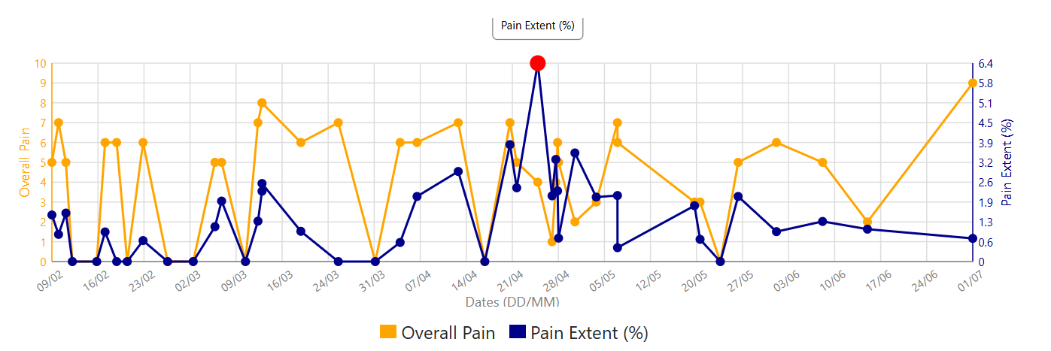
The below details appear when you select any specific report:
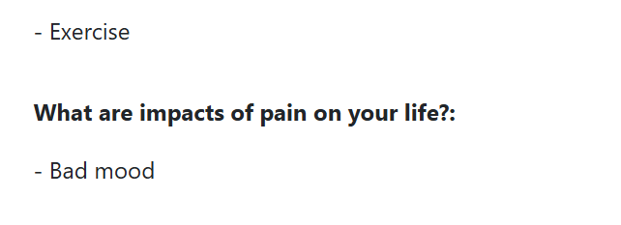
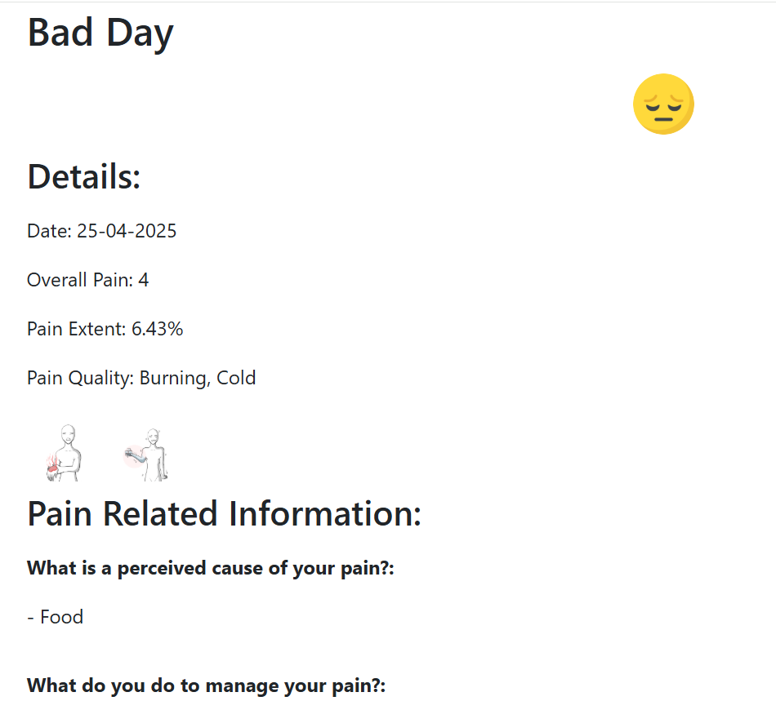

To view standalone pain frequency map:
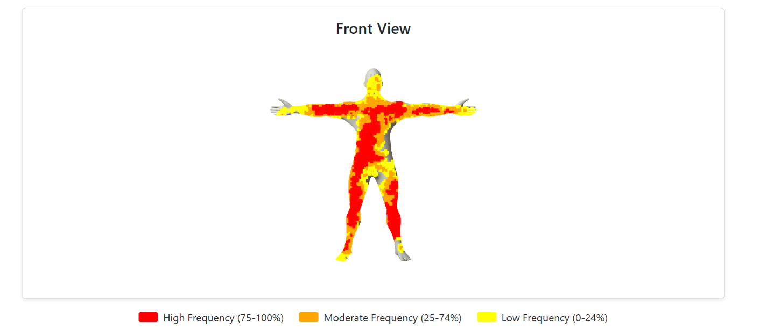
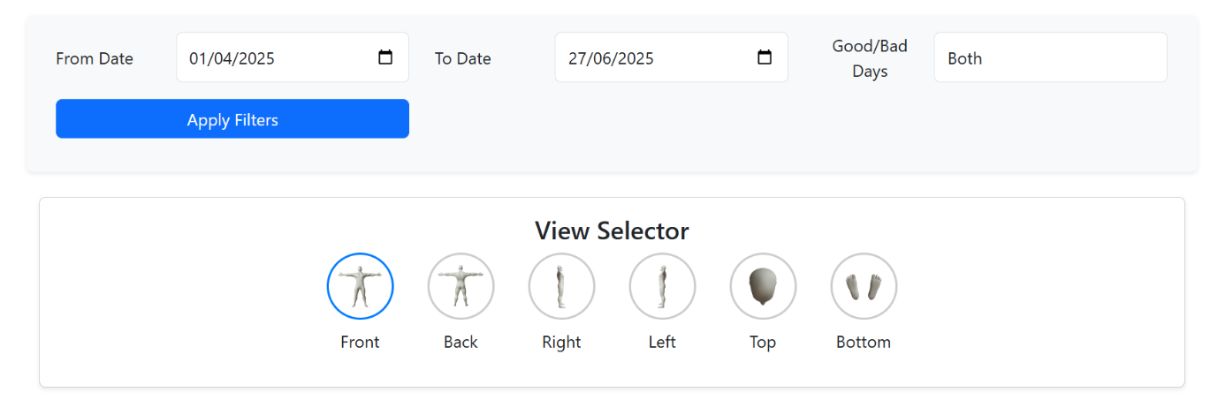

To compare pain frequency maps generated for two different reporting period to highlight change in pain:
