Example digital pain self-reporting tool
We used the Manchester Digital Pain Manikin (figure 1) as a digital pain self-reporting tool, which has been previously developed and tested with south Asians or Pakistanis. The MDPM enables users to capture pain aspects (distribution, intensity, quality, radiation), its perceived pain causes and its effects as well as pain management strategies in real-time. We presented and tested some pain visualisations (figure 2) to explore how digital pain self-reports and their summaries may support pain self-learning, leading to better pain-self-management.
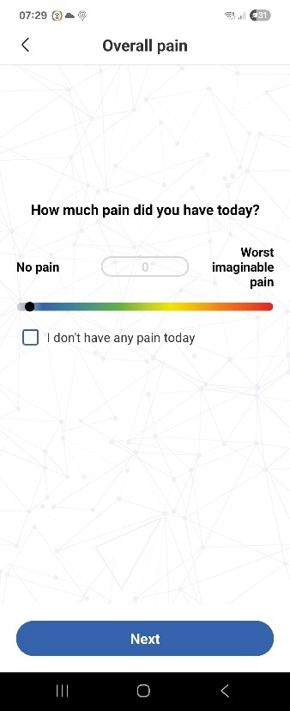 | 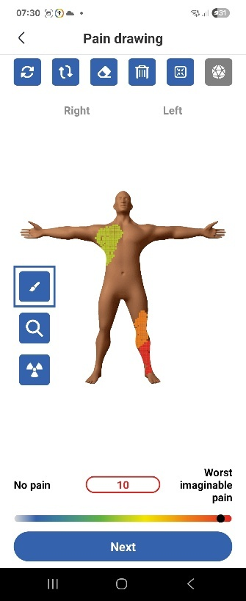 | 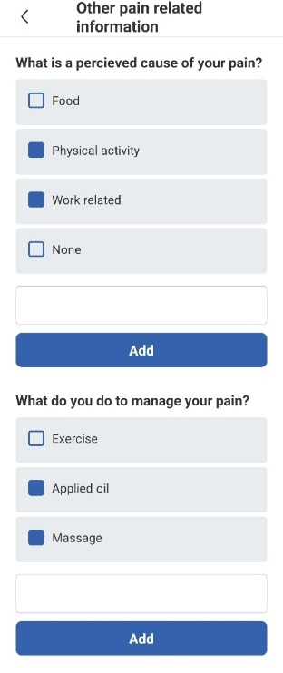 | 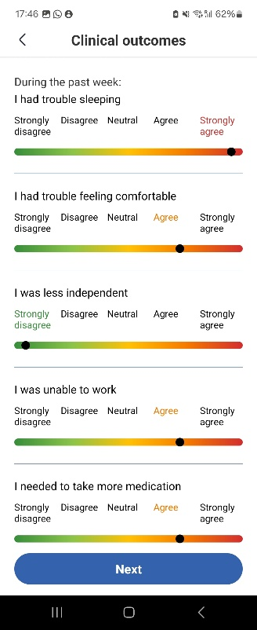
a. Numeric rating scale for overall pain | b. Pain drawing on front view* | c. Other pain related information** | d. Clinical outcomes (weekly)
*The manikin has five other views, including left lateral, right lateral, back, top of head, heals.
**Other pain related information included perceived causes, pain management strategy, impact of pain on life
Figure 1: Screenshots of the Manchester Digital Pain Manikin app (copyright University of Manchester)
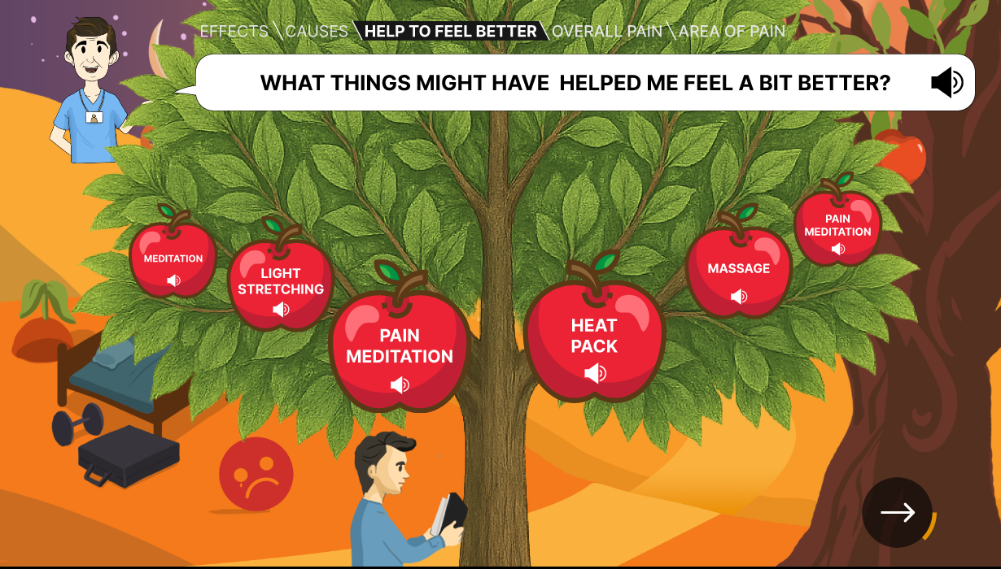 | 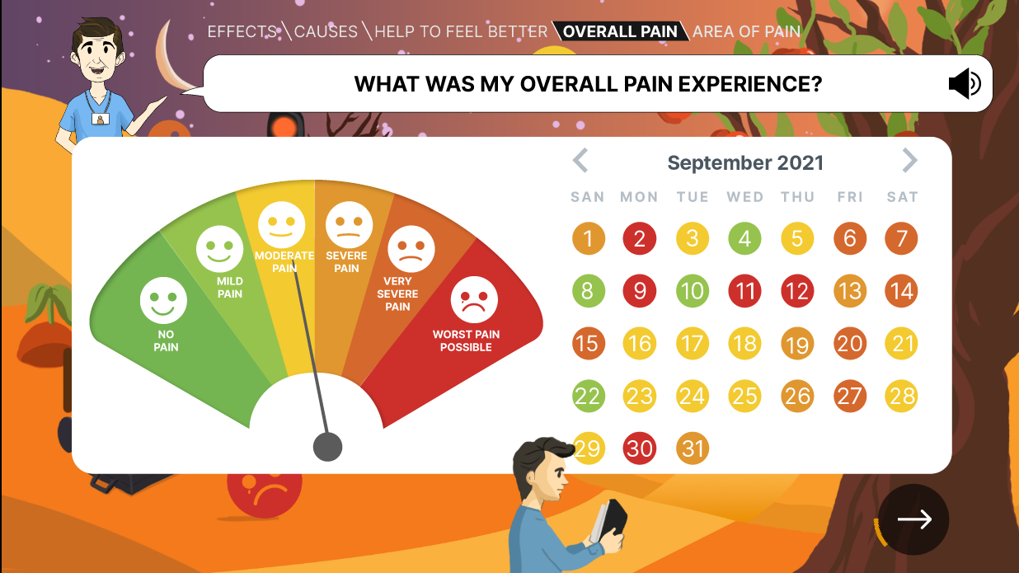
Figure 2: Examples of visual summaries of digital pain self-reports (copyright University of Manchester)

