Supplementary material
- FT-IR fitted parameter
Based on the positions of peaks 1-24 in the FT-IR fit profile of Fig. 3, Table S1 lists their wavelengths, and their corresponding functional groups were determined.
Table S1 Fitting parameters of cow dung
Number | Wavelength  /cm⁻¹ | Identify |  | Number | Wavelength  /cm⁻¹ | Identify
1 | 3600.0 | Free hydroxyl |  | 13 | 1561.4 | Aromatic nucleus C=C
2 | 3559.3 | Hydroxyl-π |  | 14 | 1518.9 | -CH₃ and -CH₂ asymmetric deformation vibration
3 | 3450.0 | Self-associated hydroxyl group |  | 15 | 1460.5 | -CH₃ and -CH₂ asymmetric deformation vibration
4 | 3376.1 | hydroxyl ether oxygen bond |  | 16 | 1423.7 | -CH₃ symmetric deformation vibration
5 | 3271.7 | Ring hydrogen bond |  | 17 | 1382.9 | -CH₃ symmetric deformation vibration
6 | 3109.6 | Hydroxyl-N |  | 18 | 1328.6 | C-O stretching vibration of phenol, alcohol, ether and ester
7 | 2990.0 | -CH₃ asymmetric stretching vibration |  | 19 | 1254.3 | C-O stretching vibration of phenol, alcohol, ether and ester
8 | 2962.3 | -CH₂ asymmetric stretching vibration |  | 20 | 1173.2 | C-O stretching vibration of phenol, alcohol, ether and ester
9 | 2922.5 | -CH₃ symmetric stretching vibration |  | 21 | 1137.3 | C-O stretching vibration of phenol, alcohol, ether and ester
10 | 2886.9 | -CH₂ symmetric stretching vibration |  | 22 | 1098.3 | C-O stretching vibration of phenol, alcohol, ether and ester
11 | 1698.6 | Carboxyl C = O |  | 23 | 1054.3 | aryl ethers
12 | 1632.5 | Conjugate C = O |  | 24 | 1024.8 | alkyl ether
- Pyrolysis kinetics
The kinetic equation for biomass pyrolysis can be expressed as:
$dα/dt=k(T)f(α)=Aexp(−E/RT)f(α)$ (1-1)
$α=\frac{m_{0}{−m}_{t}}{m_{0}{−m}_{∞}}$ (1-2)
where α is the conversion rate of the sample during pyrolysis, m₀ and m_{ꝏ} denote the initial mass of the sample before the reaction and the residual mass after the reaction, respectively, and m_{t} denotes the mass of the reactant corresponding to the moment of the reaction temperature T.
Under linear heating conditions, the heating rate β = dT/dt, and equation (1-1) can be transformed into:
$\frac{dα}{dt}=\frac{A}{β}exp(\frac{−E}{RT})f(α)$ (1-3)
Integrating and organizing Eqs. (1-3) in separated variables yields that
$g\left(α\right)=\int_{0}^{α}{\frac{dα}{f\left(α\right)}}=\frac{A}{β}\int_{T_{0}}^{T}{\exp\left(\frac{−E}{RT}\right)dT}$ (1-4)
At the very beginning of the reaction, the temperature T₀ is close to room temperature and the reaction rate is very low and negligible, so the two sides of Eq. (1-4) can be integrated between 0-α and 0-T, i.e:
$g\left(α\right)=\int_{0}^{α}{\frac{dα}{f\left(α\right)}}=\frac{A}{β}\int_{0}^{T}{\exp\left(\frac{−E}{RT}\right)dT}$ (1-5)
To obtain an approximation of $\int_{0}^{T}{\exp\left(\frac{−E}{RT}\right)dT}$, let V=E/RT, then T=E/RV,then equation (1-5) is rewritten as:
$g\left(α\right)=\frac{A}{β}\int_{0}^{T}{\exp\left(\frac{−E}{RT}\right)dT}=\frac{AE}{βR}\int_{∞}^{V}{\frac{{−e}^{−V}}{V^{2}}}dV=\frac{AE}{βR}P\left(V\right)$ (1-6)
First determine the mechanism function, P(V)=e^{V}($\frac{1}{V^{2}}$)(1-$\frac{2}{V}$), which is brought into (1-6) and logarithmically obtained on both sides:
$ln\left[\frac{g\left(α\right)}{T^{2}}\right]{=\ln\left[\frac{AR}{βE}\left(1−\frac{2RT}{E}\right)\right]−\frac{E}{RT}}$ (1-7)
In the equation, for the biomass pyrolysis activation energy and the temperature interval of the reaction, the value of 2RT/E is much less than 1, so (1-2RT/E) ≈ 1, and so Eq. (1-7) simplifies to:
$ln\left[\frac{g\left(α\right)}{T^{2}}\right]{=\ln\left[\frac{AR}{βE}\right]−\frac{E}{RT}}$ (1-8)
Thus, a linear fit of 1/T with $ln\left[\frac{g\left(α\right)}{T^{2}}\right]$ yields a straight line with a slope of -E/R and an intercept, from which the activation energy E and the finger-forward factor A can be derived.
where t is the reaction time, k(T) is the reaction rate constant, f(α) is a model function of the reaction mechanism, R is the gas constant, and T is the reaction temperature.
For the study of biomass pyrolysis kinetics, many scholars have proposed various analytical methods, such as Coats-Redfern integral method, FWO integral method, and Kissinger differential method [1], among which the Coats-Redfern method [2-4] has achieved better results in postgraduate students' material pyrolysis kinetics.Yu [5] used the Coats-Redfern method to analyze the pyrolysis kinetics of livestock and poultry manure, and the kinetic models of the three types of livestock and poultry manure (swine manure, sheep manure, and cattle manure) all conformed to the D6 three-dimensional diffusion model, so in this chapter, the D6 three-dimensional diffusion model was used to study the pyrolysis kinetic parameters of CD/CD+ and its pretreated samples within the maximum weight loss interval in order to have a more in-depth understanding of the CD/CD-T pyrolysis behavior. Figure S1 shows a linear plot of ln[g(α)/T2] and 1/T for CD/CD-T depicted using the Coats-Redfern kinetic model.
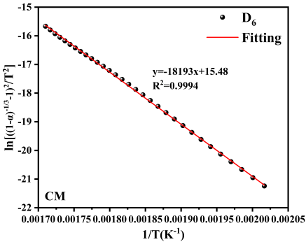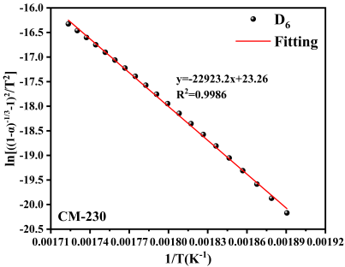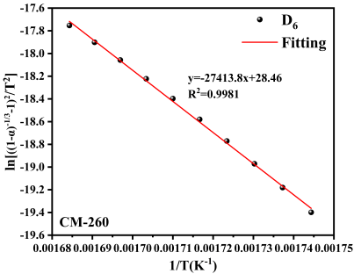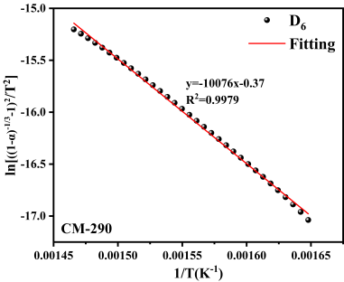
Figure S1 Coats-Redfern diagrams of cow dung and pretreated samples
- Relative content of biomass oil components
The pyrolysis biomass oil fractions were analyzed by GC-MS, and the relative contents of the different fractions are listed in Table S2.
Table S2 Relative content of different components of pyrolysis bio-oil of CD-T sample
component | Retention time  (min) | Name of compound | Relative content ( % )
component |  |  | CD-230 | CD-260 | CD-290
acid | 2.04 | acetic acid | 6.58 | 1.58 | 1.58
acid | 33.59 | palmitic acid | 2.78 | 3.15 | 3.15
acid | 37.24 | stearic acid | 1.29 | 1.40 | 1.40
furan | 4.22 | 2(5h)-furanone | 1.13 | / | /
furan | 5.08 | furfural | 1.13 | 0.52 | 0.16
furan | 5.64 | 3-furanmethanol | 1.87 | 0.95 | /
furan | 16.31 | 2,3-dihydrobenzofuran | 5.36 | 1.67 | /
ketone | 3.63 | adipinketone | 1.12 | / | /
ketone | 5.99 | 2-acetoxy-2-propanone | 0.97 | / | /
ketone | 7.54 | 1,2-cyclopentanedione | 2.33 | / | /
ketone | 8.62 | 3-methyl-2-cyclopentane-1-ketone | / | / | 0.86
ketone | 10.64 | methyl cyclopentenolone | 2.90 | 2.18 | 0.82
ketone | 10.86 | 2,3-dimethyl-2-cyclopentenone | / | / | 0.94
ketone | 15.52 | boldenone | / | 1.8 | /
ketone | 20.79 | diisopropylideneacetone | / | / | 1.82
ketone | 20.84 | phorone | 2.14 | / | /
phenols | 9.29 | phenol | 3.48 | 5.43 | 6.77
phenols | 12.09 | p-cresol | 5.41 | 2.82 | 11.11
phenols | 12.12 | 4-methylphenol | / | 7.11 | /
phenols | 12.43 | guaiacol | 4.61 | / | 3.57
phenols | 14.22 | 2, 4-xylenol | / | 4.26 | 6.74
phenols | 14.77 | 4-ethylphenol | 1.70 | 2.93 | 3.16
phenols | 14.81 | 3,5-xylenol | / | / | 1.86
phenols | 15.44 | 4-ethylresorcinol | / | / | 2.78
phenols | 15.45 | 4-methylguaiacol | 2.23 | 2.83 | /
phenols | 15.91 | catechol | 3.39 | 4.58 | 2.45
phenols | 16.75 | 3-ethyl hydride -5-methylphenol | / | / | 2.62
phenols | 17.43 | 3-methoxybenzene catechol | 1.19 | / | /
phenols | 17.86 | 4-ethyl guaiacol | 1.88 | 3.31 | 3.05
phenols | 18.42 | 3-methyl-1,2-benzene-diol | 2.29 | / | 1.93
phenols | 18.79 | 2,3,5,6-tetramethylphenol | / | / | 1.67
phenols | 18.85 | 2-methoxy-5-vinylphenol | 7.89 | 3.3 | /
phenols | 19.83 | 2,6-dimethoxy phenol | 2.8 | 1.53 | 1.53
phenols | 19.96 | 4-allyl-2-methoxyphenol | 0.85 | / | /
phenols | 22.32 | 4-allylguaiacol | / | 1.39 | /
phenols | 22.33 | 2-methoxy-5- ( 1-propenyl ) - ( e ) phenol | 2.83 | / | /
phenols | 25.14 | 4-vinyl-2,6-dimethoxyphenol | 1.94 | / | /
phenols | 28.19 | 4-allyl-2,6-dimethoxyphenol | 1.39 | / | /

Supplementary materials References
[1] Seo, D., Park, S., Hwang, J., et al., 2010. Study of the pyrolysis of biomass using thermo-gravimetric analysis (TGA) and concentration measurements of the evolved species. J. Anal. Appl. Pyrolysis. 89, 66-73.
[2] Liu, N., Fan, W., Dobashi, R., et al., 2002. Kinetic modeling of thermal decomposition of natural cellulosic materials in air atmosphere. J. Anal. Appl. Pyrolysis. 63, 303-325.
[3] Hao Y., 2013. Kinetics of biomass residue pyrolysis[D]. Nanjing: Nanjing University of Science and Technology.
[4] Coats, A., Redfern, J., 1964. Kinetic Parameters from Thermogravimetric Data. Nature. 201, 68-69.
[5] Yu, B., 2015. Research on pyrolysis characteristics of livestock and poultry manure [D]. Wuhan: Huazhong Agricultural University.

