Supplementary Table 1. Correlation Analysis within the Atopic Dermatitis Group
Variable Pair | Spearman r | p value
SCORAD vs OER | –0.612 | <0.001*
SCORAD vs Omentin-1 | –0.423 | 0.006*
SCORAD vs Eosinophil count | 0.310 | 0.052
SCORAD vs Chemerin | 0.358 | 0.024
SCORAD vs NLR | 0.147 | 0.365
SCORAD: Scoring Atopic Dermatitis index; OER: Omentin-to-eosinophil ratio; NLR: Neutrophil-to-lymphocyte ratio. *Statistically significant.

Supplementary Table 2. Alternative Multivariable Logistic Regression Model Including NLR
Predictor | OR | 95% CI | p value
OER (per 1 SD increase) | 0.031 | 0.005–0.201 | <0.001*
NLR (per 1 SD increase) | 2.74 | 1.29–5.81 | 0.009*
Age (per 1 SD increase) | 0.94 | 0.51–1.72 | 0.842
BMI (per 1 SD increase) | 0.86 | 0.50-1.49 | 0.597

Model Performance
Metric | Value
Cross-validated AUC | 0.887
Bootstrap mean AUC | 0.889
Brier score | 0.141
OR: Odds ratio; CI: Confidence interval; OER: Omentin-to-eosinophil ratio; NLR: Neutrophil-to-lymphocyte ratio; BMI: Body mass index. *Statistically significant.

Supplementary Figure 1. Scatter Plot Demonstrating the Relationship between SCORAD and OER in Pediatric Atopic Dermatitis
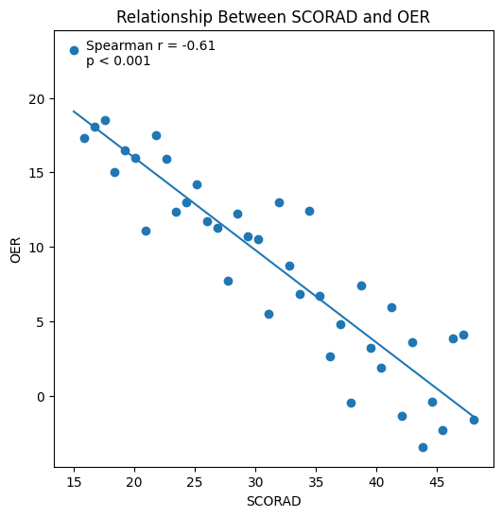
Scatter plot demonstrating the inverse association between the Scoring Atopic Dermatitis (SCORAD) index and the omentin-to-eosinophil ratio (OER) within the atopic dermatitis cohort. Reduced OER values were associated with increasing disease severity, supporting a potential relationship between adipokine–eosinophil imbalance and disease severity.

