Supplementary Materials for

Heavy-chain immune repertoire sequencing enables language-model prediction of antigen-specific antibodies

Karen Paco^{1*}, Mariana Paco Mendivil^{1†}, Zihao Zhang^{1†}, Sanaz Zebardast^{1†}, Christian Davila¹, Ryan M. Mooney², Peace Olatoyinbo¹, Tristan Yang¹, Sebastian Bassi^{1,3}, Virginia Gonzalez^{1,3}, Eva Chen², Faisal Bin Ashraf⁴, Isabel Condori Roman¹, Jonathan R. Felix¹, Rashid M. Alam¹, Jordan A. Lay¹, Malkiat S. Johal², Karine G. Le Roch⁵, Ilya Tolstorukov¹, Jeniffer B. Hernandez¹, Fernando L. Barroso da Silva^{6,7} , Stefano Lonardi⁴, Matthew H. Sazinsky², Animesh Ray^{1*}.
Correspondence to: aray@kgi.edu; Karen_Paco@kgi.edu

This PDF file includes:

Supplementary Methods
Supplementary Text
Figs. S1 to S14
Tables S1 to S8
Captions for Supplementary Data S1 to S14

Other Supplementary Materials for this manuscript include the following:
Supplementary Data 1. (Supplementary_Data_1.zip):
Curated antibody training datasets used for ASPred model development across SARS-CoV-2 RBD, influenza HA, and HIV gp120.
Supplementary Data 2 (Supplementary_Data_2.zip):
Cross-validation performance summaries for ASPred models across SARS-CoV-2 RBD, influenza HA, and HIV gp120.
Supplementary Data 3 (Supplementary_Data_3.zip):
Quantitative comparison of pretrained versus fine-tuned embedding separability across antigens and optimization objectives.
Supplementary Data 4 (Supplementary_Data_4.zip):
ASPred predictions for SARS-CoV-2 RBD specificity in the human single-cell BEAM benchmark dataset.
Supplementary Data 5 (Supplementary_Data_5.zip):
Differential expression outputs supporting the comparison between ASPred and BEAM classifications in the human single-cell dataset.
Supplementary Data 6 (Supplementary_Data_6.csv):
ASPred scores for heavy-chain sequences identified in the unselected RBD-immunized mouse peripheral blood repertoire.
Supplementary Data 7 (Supplementary_Data_7.xlsx):
Integrated cell-level annotation table for the RBD-immunized mouse single-cell dataset.
Supplementary Data 8 (Supplementary_Data_8.csv):
Metadata table listing the publicly available bulk human BCR repertoire datasets analyzed in this study, including healthy controls and SARS-CoV-2-infected donors, with accession-level source information and download links.
Supplementary Data 9 (Supplementary_Data_9.zip):
IMGT-mapped saliency outputs for ASPred models across influenza, HIV, and SARS-CoV-2 heavy-chain classifiers.
Supplementary Data 10 (Supplementary_Data_10.zip):
Trained ASPred fine-tuned ESM-2 8M model package (facebook/esm2_t6_8M_UR50D) for single-label antigen-specificity classification.
Supplementary Data 11 (Supplementary_Data_11.pdf):
Supplementary report summarizing BEAM–ASPred overlap analyses, including threshold-based overlap statistics, supporting plots, and additional benchmarking outputs for the human single-cell BEAM dataset.
Supplementary Data 12 (Supplementary_Data_12):
Repository of molecular dynamics simulation trajectories and associated input files generated in this study, including topology files, initial coordinates, and simulation parameters sufficient to reproduce the reported analyses.
Supplementary Data 13 (Supplementary_Data_13.zip):
Interface-contact analysis files for modeled antibody–RBD complexes.
Supplementary Data 14 (Supplementary_Data_14):
Methods, code, and data for the phylogenetic diversity analysis of ASPred-predicted SARS-CoV-2 RBD-specific (AS⁺) and non-specific (AS−) BCR sequences.

Supplementary Methods
Model 1 formulation
Model 1 was a sequence-only binary classifier that received heavy-chain variable region (VH) amino-acid sequence as input and predicted whether a sequence resembled the statistical signature of known SARS-CoV-2 Spike/RBD binders. The initial model used full-parameter fine-tuning of the 6-layer ESM-2 8M backbone (esm2_t6_8M_UR50D) with a single-label classification head. This model exceeded 80% classification accuracy on the held-out test set, compared with an approximately 60% pretrained baseline, establishing the feasibility of antigen-specificity prediction from heavy-chain sequence alone.
Dataset construction and split hygiene
Positive datasets were curated from CoV-AbDab and consisted of experimentally reported VH sequences annotated to bind SARS-CoV-2 Spike or RBD. After sequence validity filtering and exact-VH deduplication; the positive set contained 8,188 unique VH sequences. Negative examples were obtained from PLAbDab entries not annotated to coronavirus-family targets; after filtering and balancing, this set contained 10,222 unique VH sequences.

To reduce leakage, we removed incomplete or very short variable regions, collapsed exact VH duplicates, required recoverable VH boundaries using a canonical end-anchored heavy-chain motif consistent with ...C[CDRH3]W_QG..., and performed clonotype-aware splitting based on normalized Levenshtein similarity among CDRH3 sequences. Using a default clustering threshold of τ_{c} = 0.85, all members of a given cluster were assigned to the same partition, yielding zero cluster overlap across train, validation, and test sets. Detailed dataset audit and split statistics are provided in Supplementary Tables S4–S6.

Supplementary Text
Capacity mismatch, shortcut learning rationale, and model compression
Preliminary experiments with larger protein language models, including ProtT5-XL and larger ESM-2 variants, consistently showed a capacity–data mismatch: training loss fell rapidly while validation performance plateaued or degraded, indicating memorization rather than transferable generalization. Standard regularization sweeps did not resolve this gap. When applied to out-of-distribution murine repertoire sequences, these larger models often exhibited confidence collapse, with predicted probabilities clustering near an uninformative intermediate range.

These observations were consistent with shortcut learning driven by database-specific artifacts rather than genuine antigen-recognition features. We therefore adopted a parsimonious strategy and fully fine-tuned the smallest candidate model, ESM-2 8M, allowing all weights to update. This compressed model yielded better transfer to murine repertoire data and restored a decisive score distribution (Supplementary Figs. S9–S11).

Hyperparameter optimization and operating threshold
To optimize the ESM-2 8M model, we used Optuna with a tree-structured Parzen estimator search over learning rate, batch size, weight decay, and warmup steps. The optimal configuration was learning rate = 6.59 × 10⁻⁵, batch size = 8, weight decay = 6.57 × 10⁻⁴, and warmup steps = 699, achieving a peak validation ROC-AUC of approximately 0.93 (Supplementary Fig. S12, Supplementary Fig. S13). We evaluated precision–recall behavior explicitly and selected τ = 0.93 as the operating threshold for candidate sieving (Supplementary Tables S7 and S8).

Inference on murine repertoire and boundary normalization
To maintain consistency with the training distribution, all murine heavy chains were normalized to a VH-only span using an end-anchored motif consistent with ...C[CDRH3]W_QG.... Under this normalization, the polarized score distribution was obtained as provided in Supplementary Fig. S14.
BEAM–ASPred overlap estimation
Enrichment of ASPred-predicted sequences (AS⁺) among experimentally identified binders was quantified using fixed classification thresholds (BEAM≥50 and ASPred probability score P_{A} ≥0.5), by comparing the intersection of ASPred-positive (AS⁺) and BEAM-positive sequence sets to a random baseline. Odds ratios and Venn-style overlap counts were computed to assess early hit enrichment (full analysis in Supplementary Data 11).

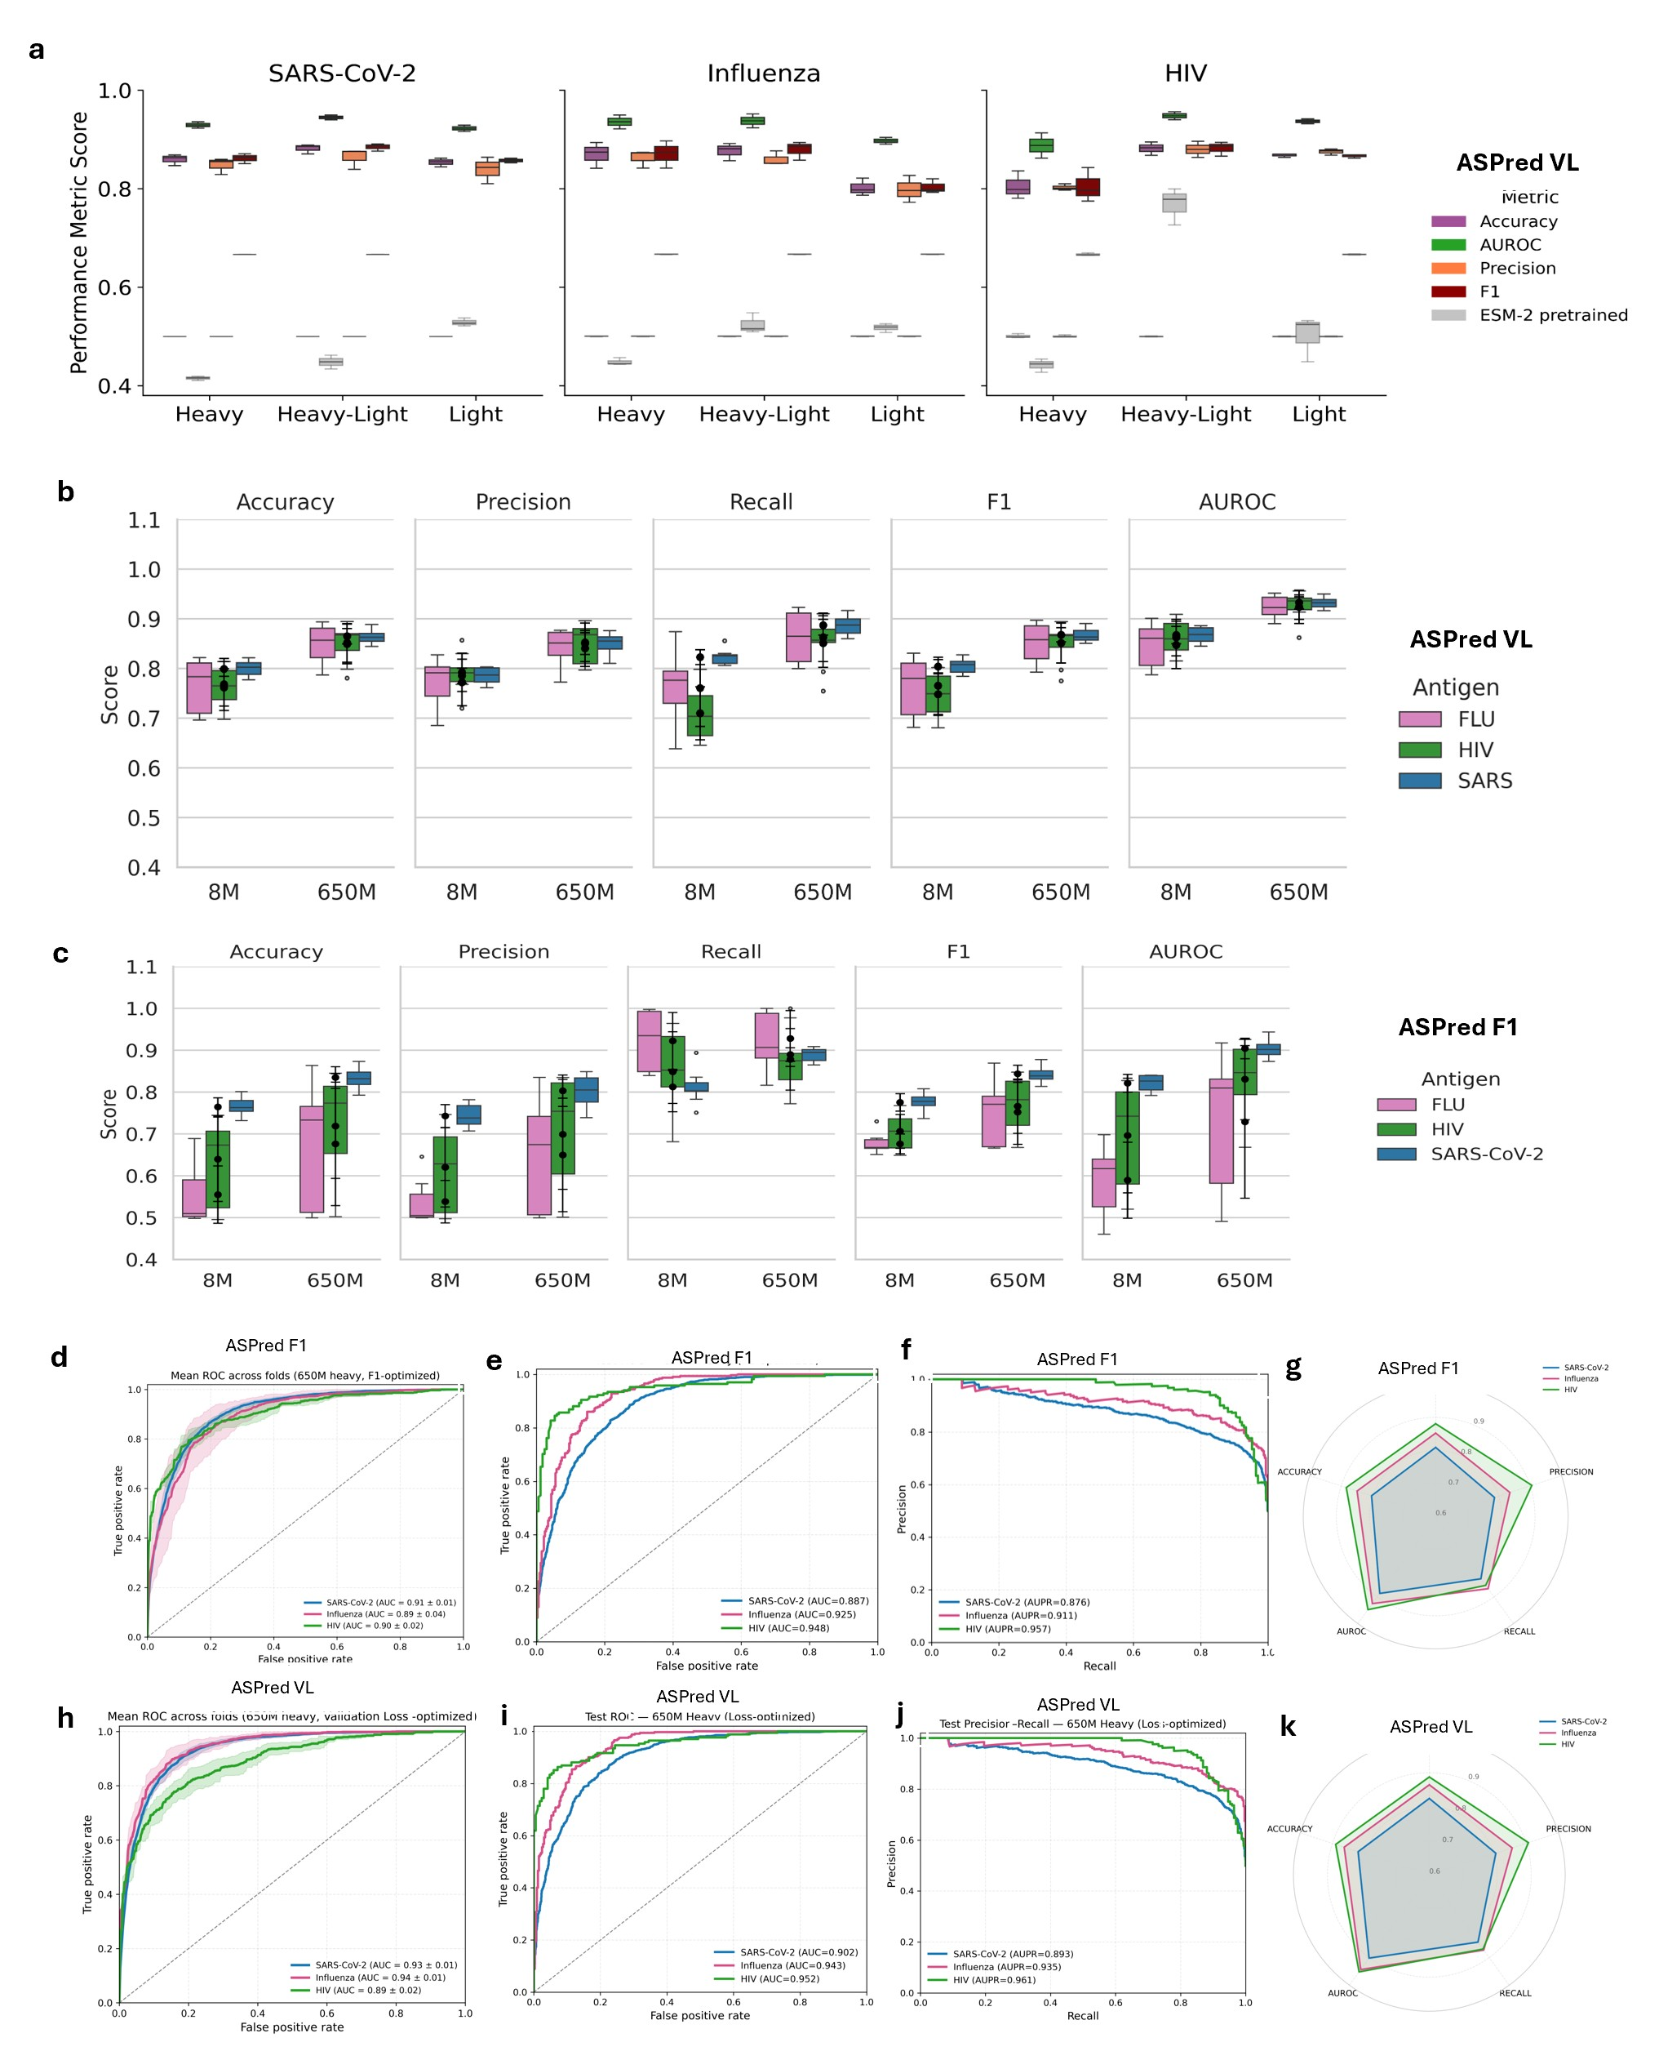

Fig. S1.

Performance evaluation of ASPred VL & F1 models across three antigens.
- Comparison of ASpred VL against pre-training ESM2 650M. b) Evaluation of ASPred VL upon training on ESM2 models 8M versus 650M. c) Save as in (b) but with ASPred F1. d-f) and h-j) AUC ROC curves of ASPred F1 and ASPred VL, respectively. g) and k) Comparative evaluations of the four metrics for ASPred F1 and ASPred VL, respectively

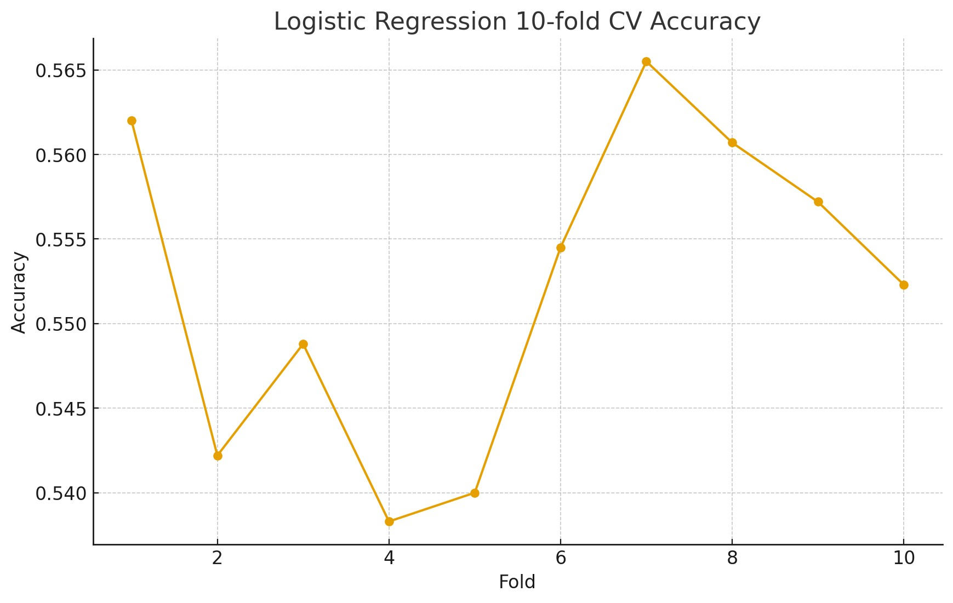

Fig. S2.

AbLang embedding baseline on SARS-CoV-2 RBD (heavy-chain). Logistic regression trained on fixed AbLang embeddings using the same SARS heavy-chain data splits as ASPred. Points show per-fold accuracy across 10-fold cross-validation.

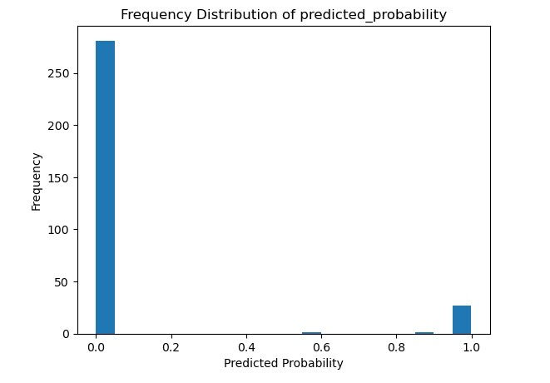

Fig. S3.
ASPred Model 1 frequency distribution of probability scores for V(D)J sequences from RBD-immunized PBMC immune repertoire.

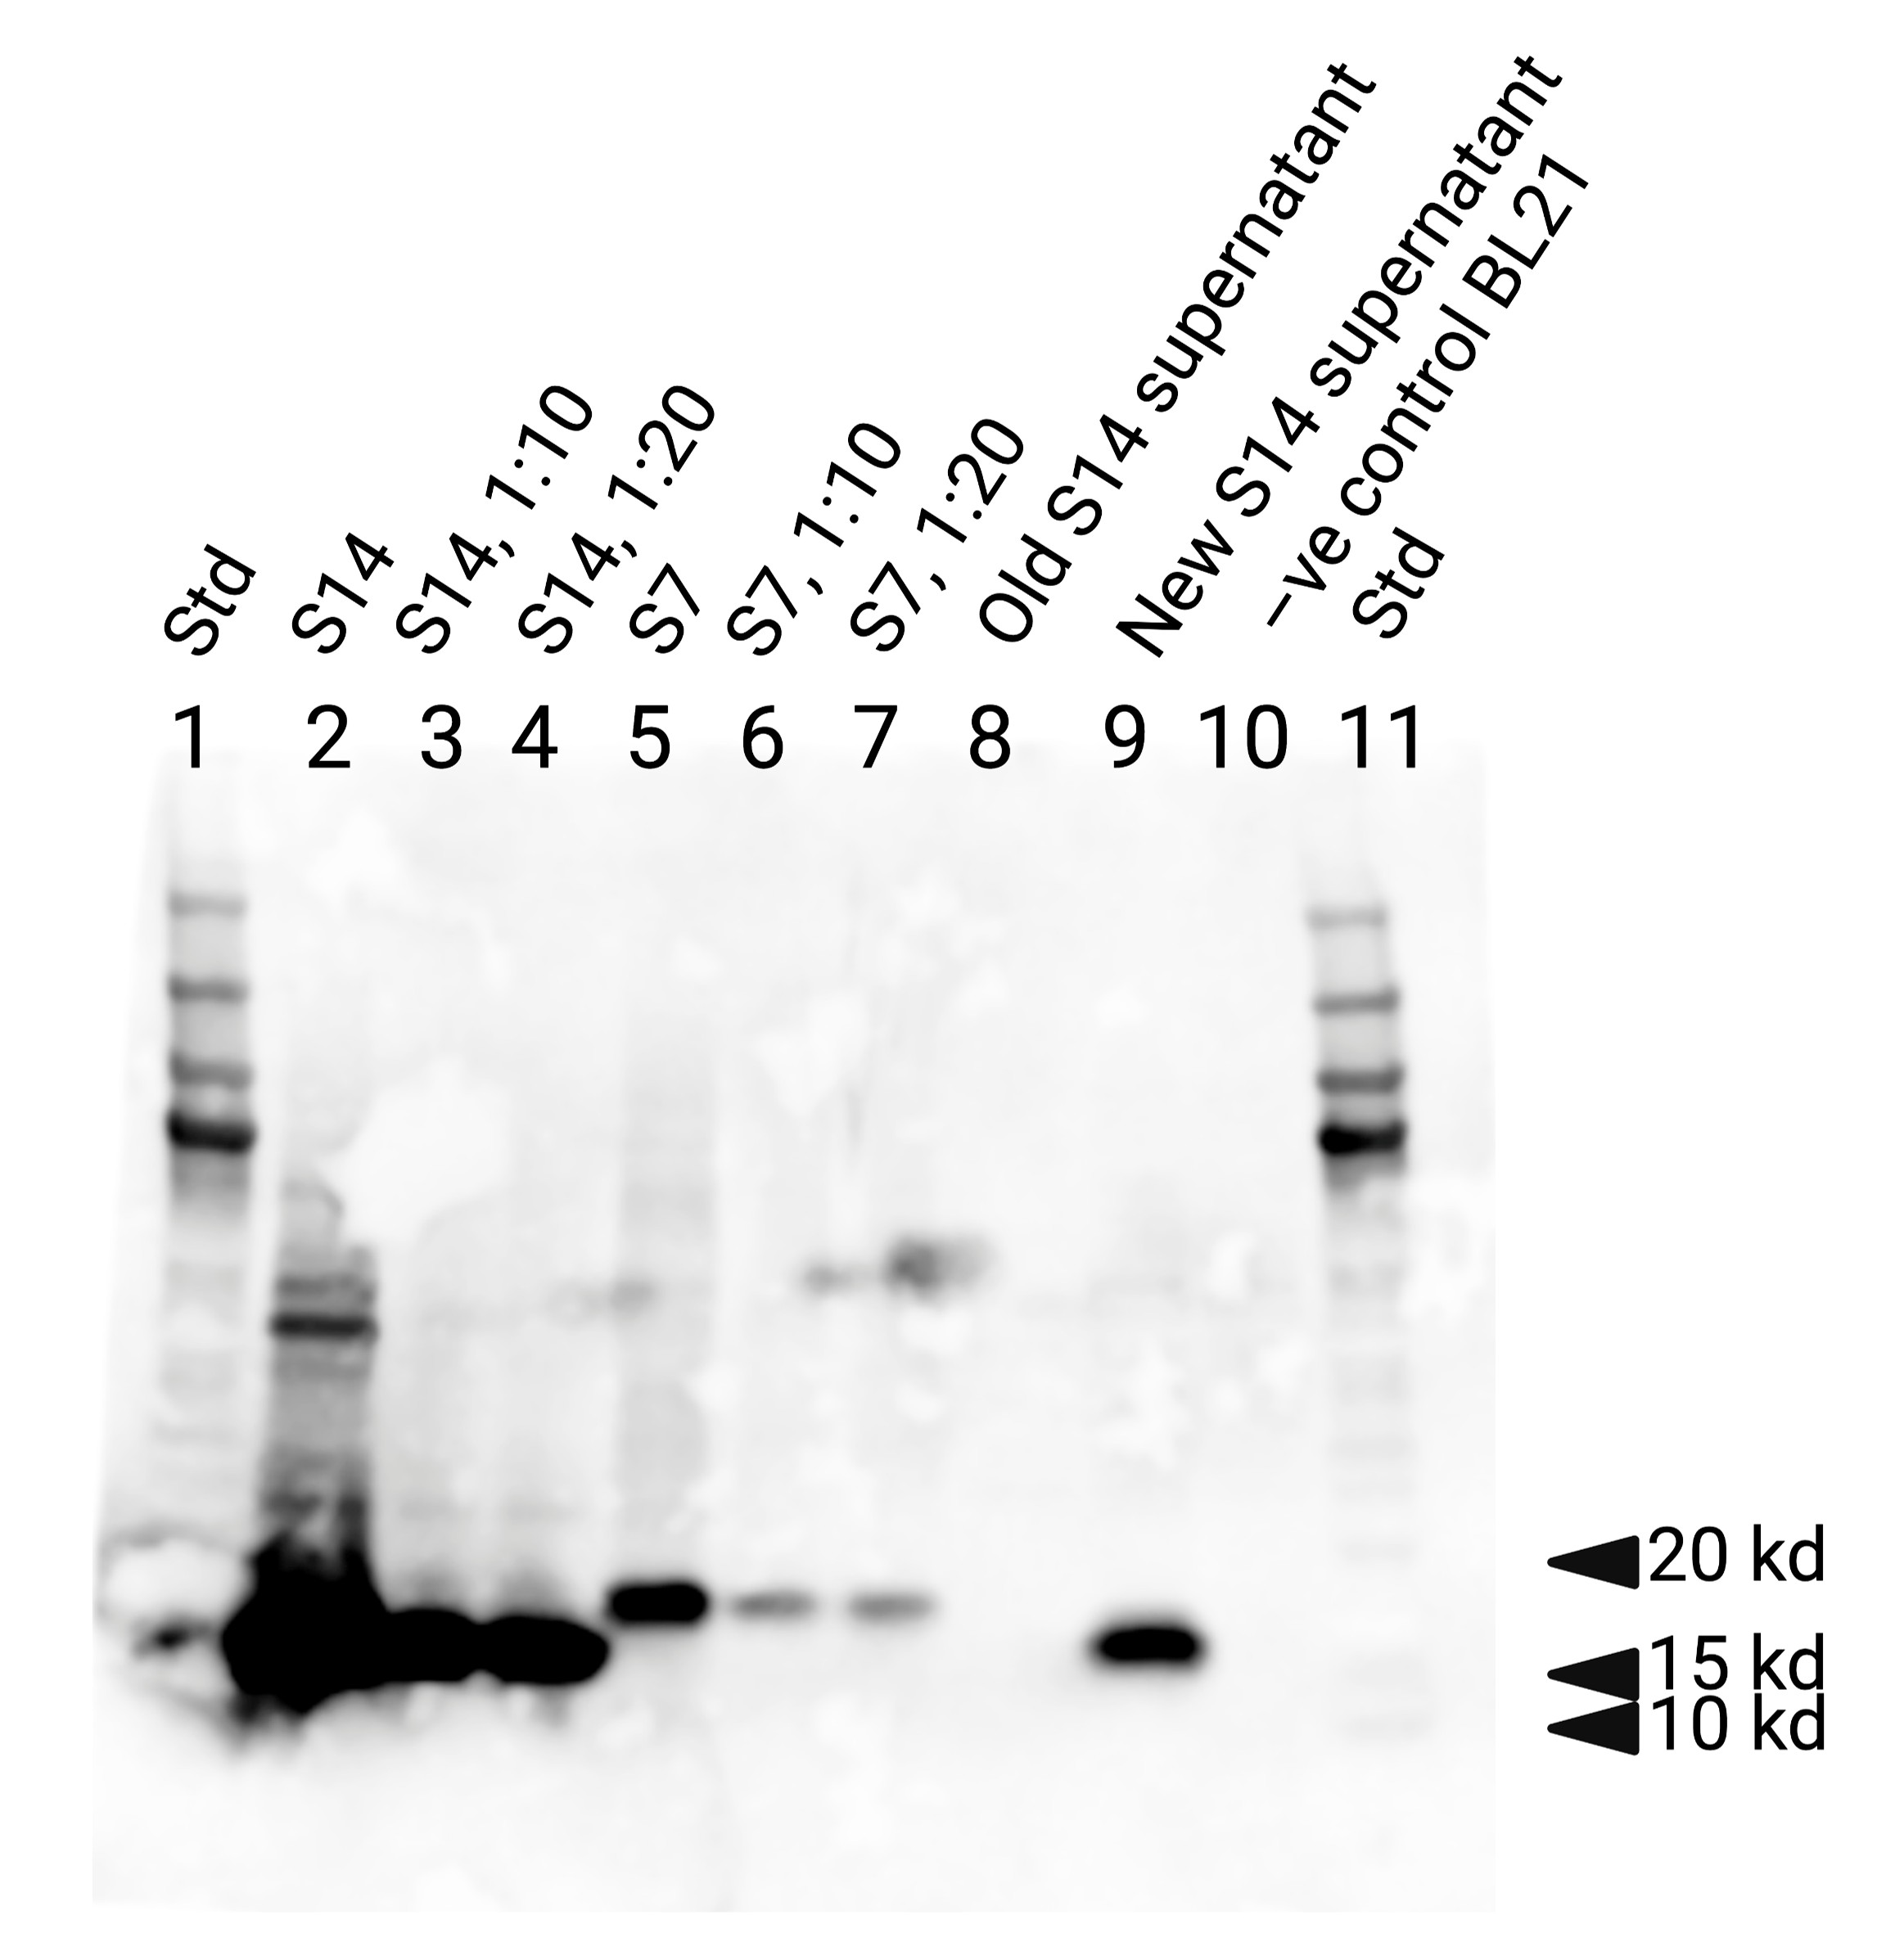

Fig. S4.
Immunoblot analysis of purified VHHs Ab-157 (S7) and positive control VHH 7OAO (S14). This is the entire gel blot from which Fig. 4b was constructed.

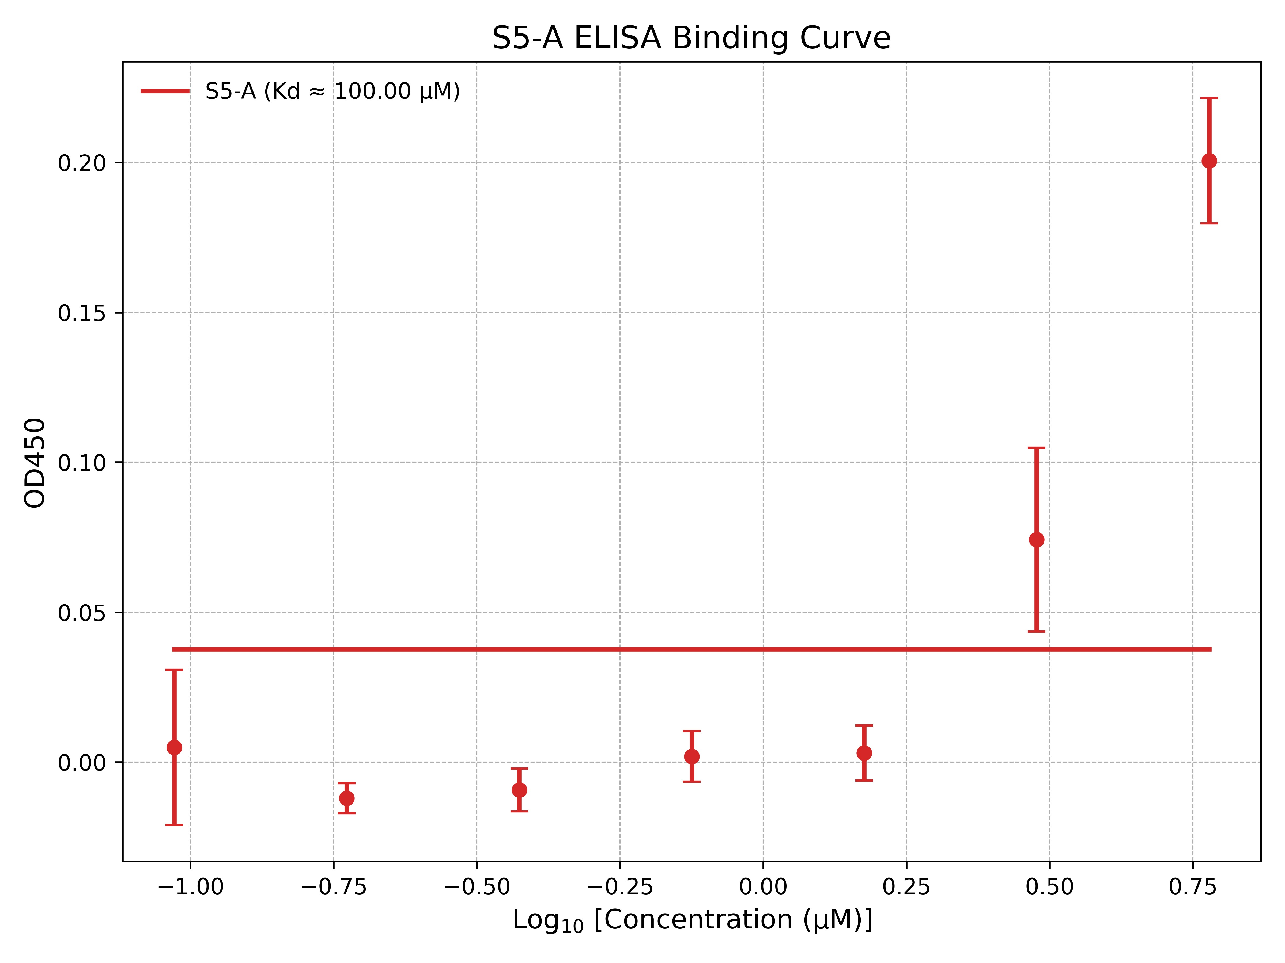

Fig. S5.
Binding curve of Ab-200 to RBD by ELISA assays. Purified Ab-200 (S5) shows a concentration-dependent increase in absorbance (OD450) when tested against immobilized SARS-CoV-2 (2019) RBD, indicating binding above background at higher concentrations. Points are mean ± s.e.m. (n =3); the horizontal line marks the background.

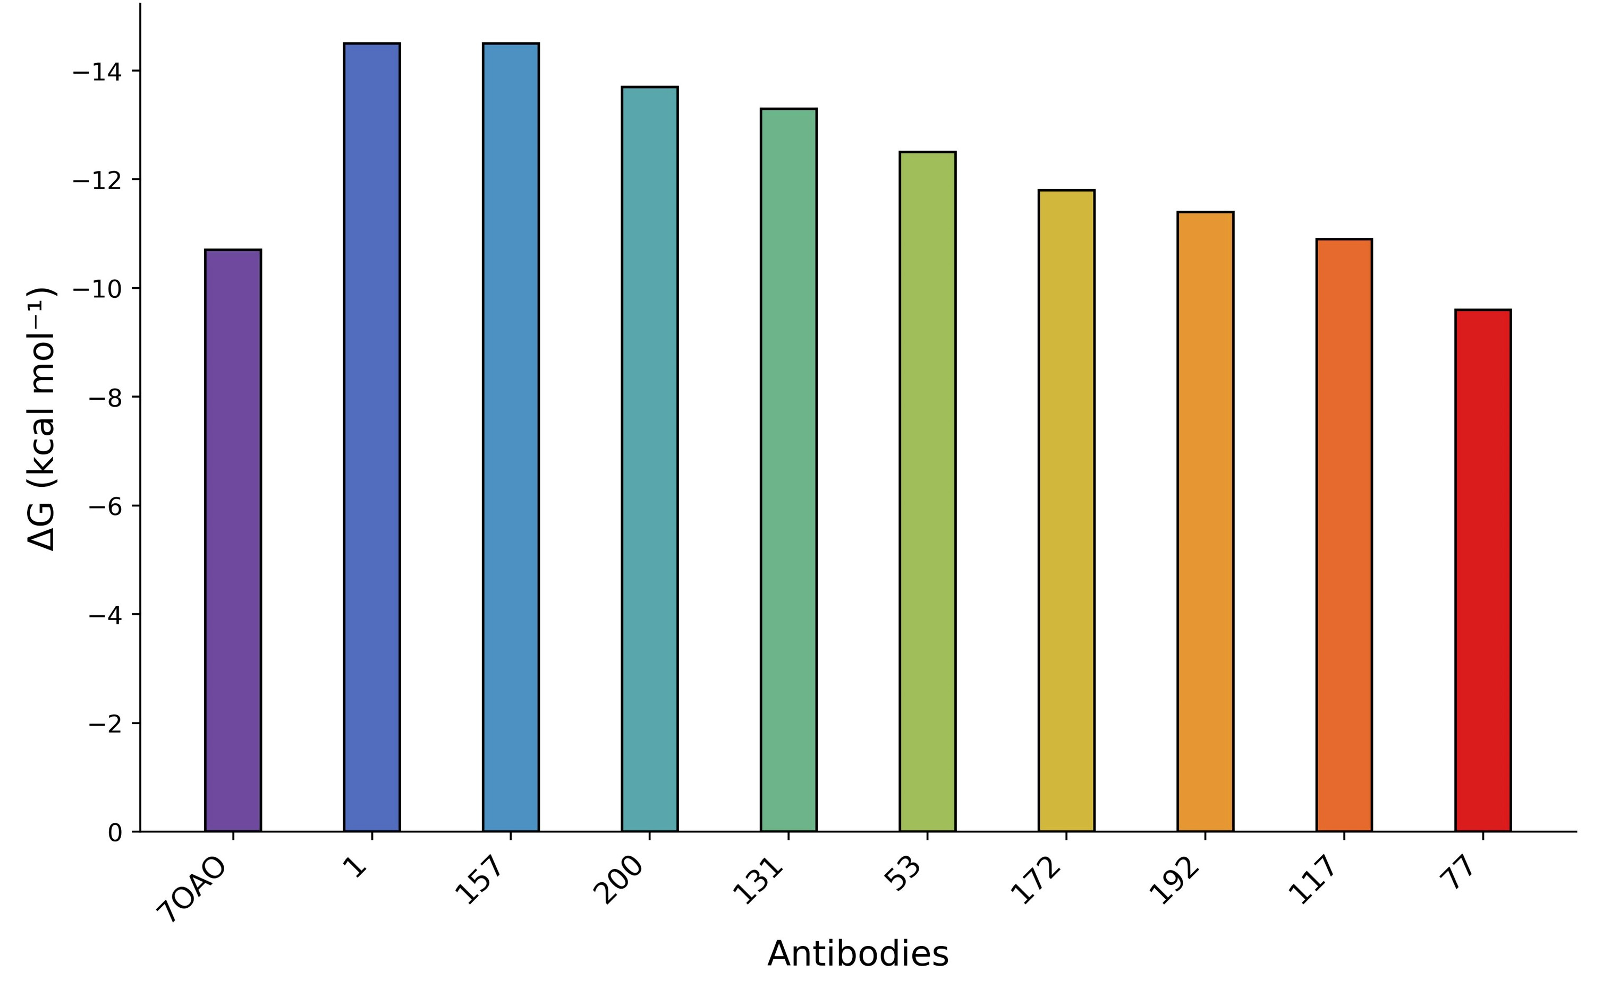
Fig. S6.
Docking with ClusPro and predicted binding free energy (∆G) estimated with PRODIGY. Antibody candidates were docked to the SARS-CoV-2 RBD using ClusPro, and binding free energies (∆G, kcal mol−¹) were estimated from the resulting complex structures using PRODIGY. 70A0 is included as a positive-control anti-RBD antibody.

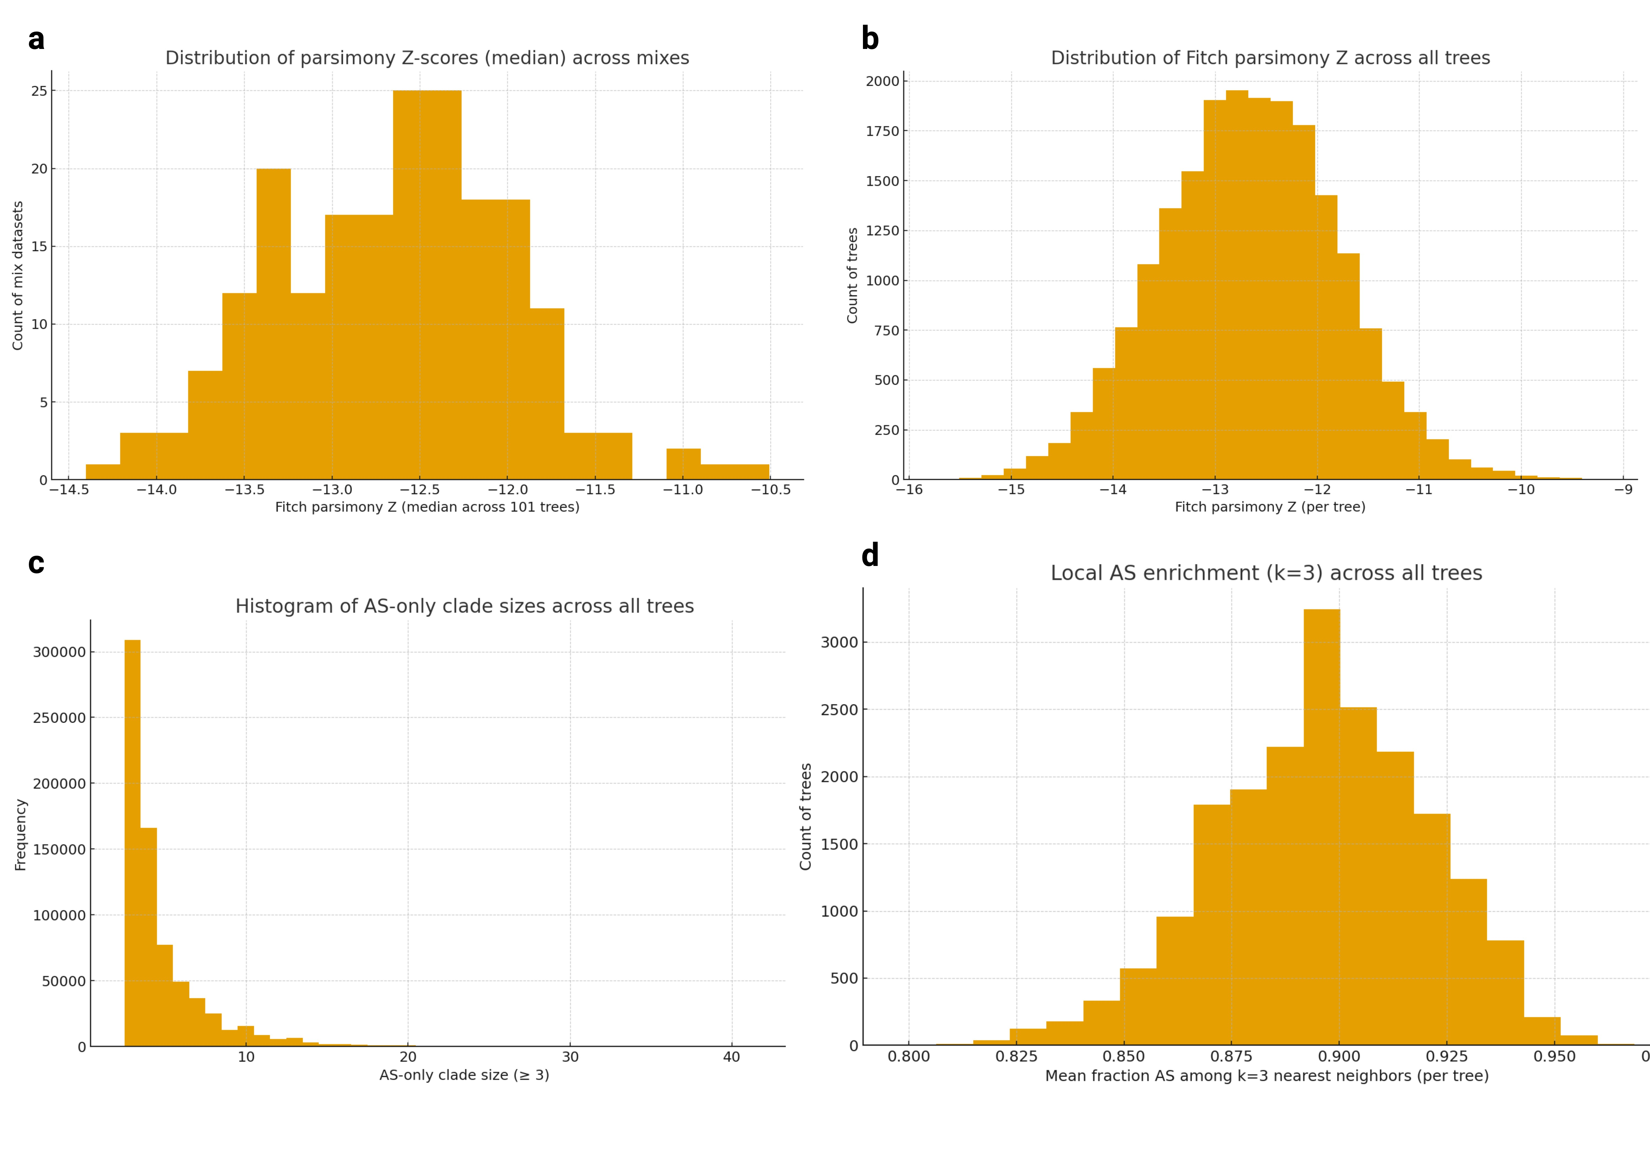

Fig. S7.
Phylogenetic clustering and local enrichment of predicted antigen-specific antibody sequences. (a) Distribution of median Fitch parsimony Z-scores across 200 mixed datasets (each containing 127 antigen-specific (AS) and 127 antigen-nonspecific (AS−) sequences). Negative Z-scores indicate stronger-than-expected clustering of AS sequences relative to random label permutations. (b) Distribution of Fitch parsimony Z-scores pooled across all individual trees from the 200 replicates, showing a unimodal distribution centered near −13. (c) Histogram of AS-only clade sizes (≥3 tips) across all trees. The right-skewed distribution reflects numerous small AS-only clades and fewer large clusters, consistent with localized enrichment. (d) Distribution of local AS enrichment (mean fraction of AS among k =3 nearest neighbors) across all trees, centered near 0.9. Collectively, these analyses indicate that predicted antigen-specific antibodies form reproducible, spatially localized clusters within sequence-based phylogenies.

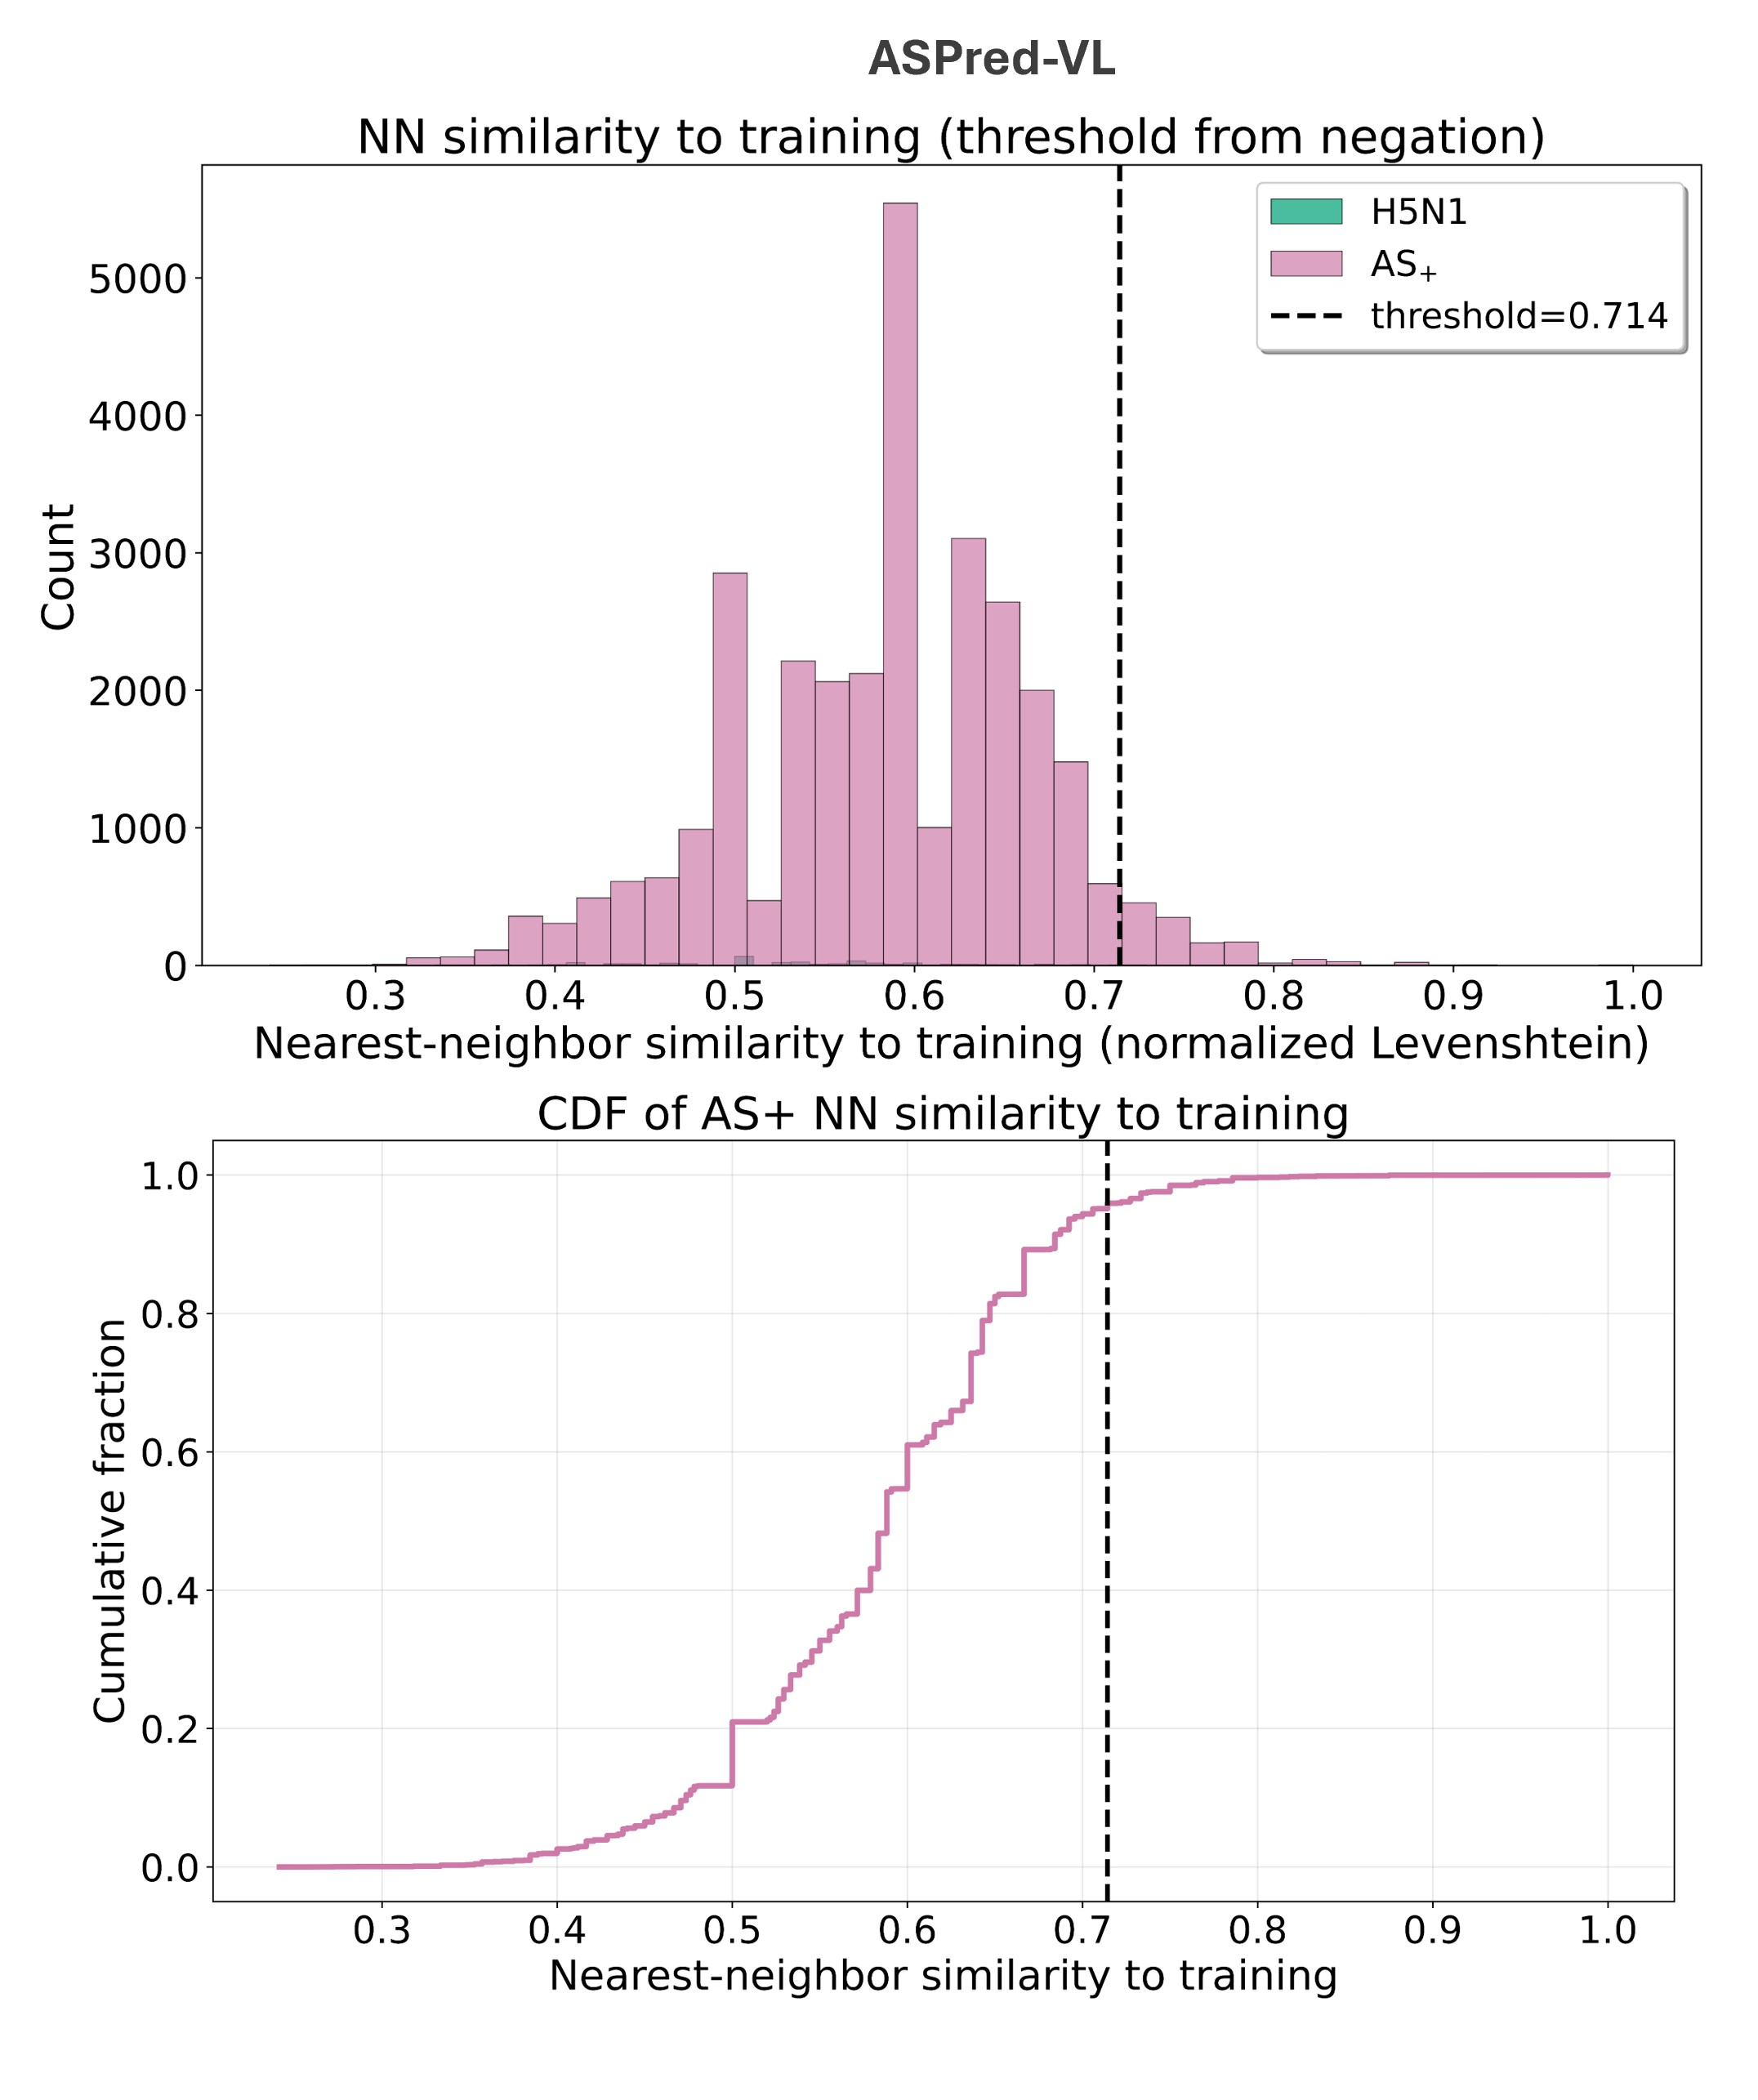
Fig. S8.
Nearest-neighbor similarity of ASPred-VL predictions to training data. (a) Distribution of nearest-neighbor sequence similarity (normalized Levenshtein distance)between predicted antigen-specific (AS⁺) BCR sequences and the training set, compared to a negative control set of antibodies targeting unrelated antigens (H5N1). The dashed vertical line indicates the similarity threshold (0.714) defined as the 99th percentile of the negative control distribution. (b) Empirical cumulative distribution function (CDF) of nearest-neighbor similarity for AS⁺ sequences. The majority of AS⁺ predictions fall below the conservative similarity threshold, indicating that ASPred predictions are not driven by near-duplicate training sequences.

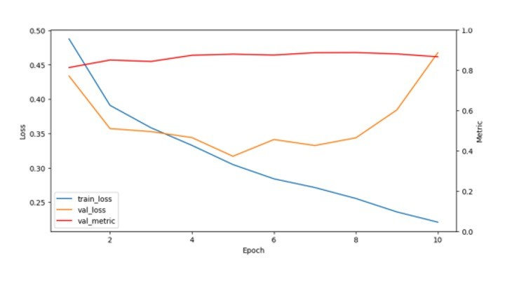
Fig. S9.
Training dynamics during the construction of initial Model 1. Training loss decreases steadily, whereas validation loss reaches an early minimum and then increases, while the validation metric plateaus. The later epochs beyond ~4.5 are consistent with overfitting and memorization rather than robust generalization.

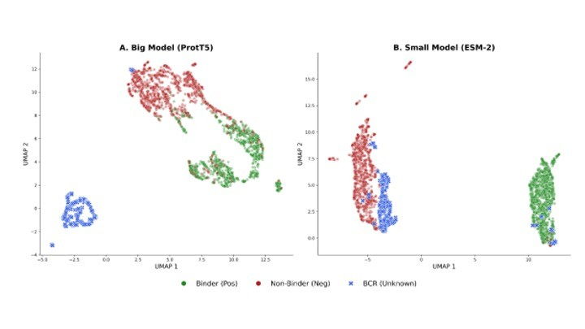

Fig. S10.
Latent-space visualization of domain shift when using ProtT5 and ESM-2. UMAP projection of final hidden-layer embeddings for CoV-AbDab binders, PLAbDab non-binders, and murine BCR repertoire sequences. In the larger-model setting, murine BCRs form a distinct isolated island, consistent with shortcut learning. In the optimized ESM-2 8M setting, murine repertoire embeddings align more closely with the binder/non-binder manifold.

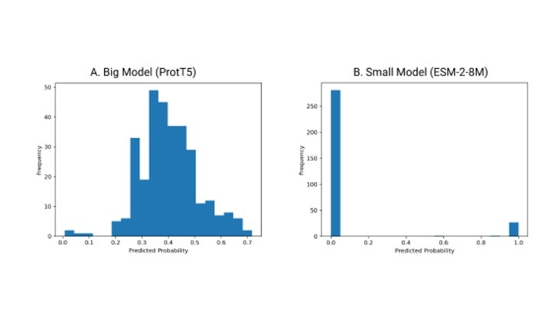
Fig. S11.
Resolution of confidence collapse by model compression. ProtT5 yields an uninformative score distribution centered near intermediate probabilities on murine repertoire sequences, whereas the optimized ESM-2 8M model recovers a polarized distribution with dominant low-score background and a distinct high-confidence positive tail.

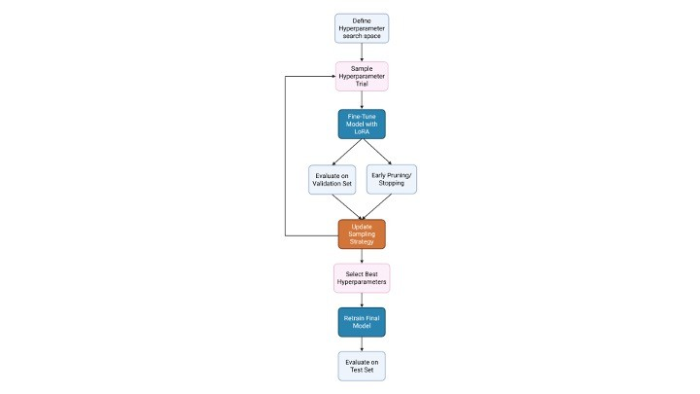

Fig. S12.
Optuna hyperparameter-optimization workflow. Each trial samples a hyperparameter configuration, trains the model, evaluates validation performance, optionally prunes unpromising trials, and updates the sampling strategy before final retraining with the selected configuration.

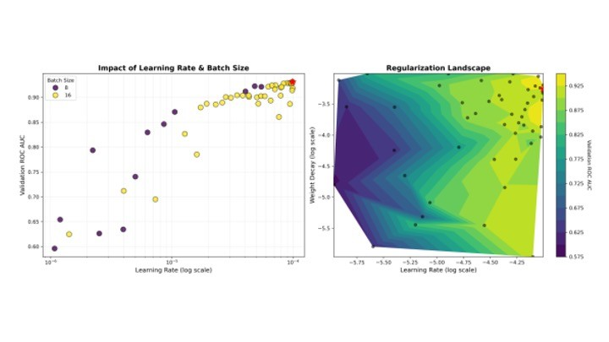
Fig. S13.
Hyperparameter-optimization landscape for the ESM-2 8M model. Left, validation ROCAUC as a function of learning rate and batch size. Right, regularization landscape across learning rate and weight decay. These analyses identify a stable high-performance region centered near the final selected configuration

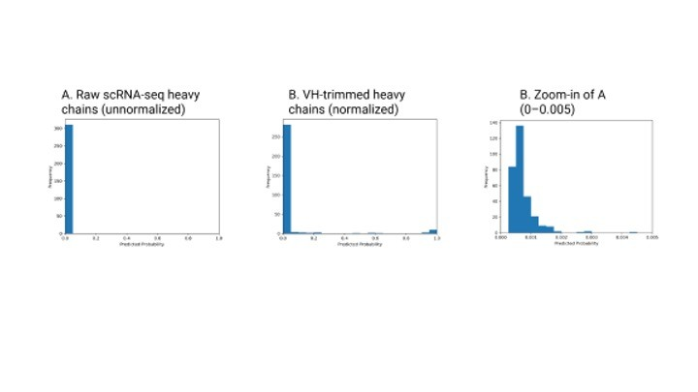

Fig. S14.
Boundary normalization resolves inference-time confidence collapse. Raw heavy-chain assemblies containing flanking non-VH residues bias scores toward the negative class, whereas normalization to a VH-only span restores the expected score distribution used for downstream candidate selection.

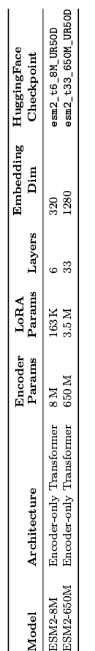

Table S1.
Summary of Language models used in this study.

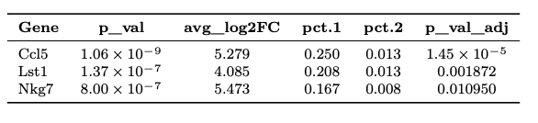

Table S2.
Differentially expressed genes significantly enriched in ASPred-positive versus ASPred-negative B cells from the RBD-immunized mouse dataset. Significant genes are shown for differential expression analysis comparing ASPred-positive and ASPred-negative B cells; significance was defined as adjusted p < 0.05.

Metric | ASPred-F1 | ASPred-VL
Total sequences analyzed | 300,376 | 300,376
ASPred probability threshold | 0.5 | 0.5
AS⁺ sequences | 31,438 | 30,990
AS₋ sequences | 268,938 | 269,386
Training sequences | 5,713 | 5,713
Negation sequences (H5N1) | 354 | 354
False-positive tolerance (δ) | 0.01 | 0.01
Similarity threshold (99th percentile) | 0.7143 | 0.7143
Novel AS⁺ sequences | 29,490 | 29,482
Novel AS⁺ (%) | 93.80% | 95.13%
Median AS⁺ similarity | 0.5882 | 0.5882
Mean AS⁺ similarity | 0.5809 | 0.5838
Median negation similarity | 0.5294 | 0.5294
Mean negation similarity | 0.5293 | 0.5293
Same-length-only comparisons | False | False

Table S3.

Negation-based antibody sequence novelty analysis summary. Nearest-neighbor (normalized Levenshtein) similarity to the training set used for the two models of ASPred fine-tuning. A novelty threshold was defined as the 99th percentile of similarity scores from a negative-control (H5N1 influenza) set compared to the training set (δ =0.01).

Audit item | Positive (CoV-AbDab) | Negative (PLAbDab)
Unique VH sequences (N) | 8,188 | 10,222
Human (%) | 92.29 | 16.88
Mouse / Mus spp. (%) | 1.82 | 5.68
Alpaca (%) | 5.81 | –
Synthetic construct (%) | – | 1.23
Macaca mulatta (%) | 0.06 | 1.13
Unknown / missing (%) | 0.01 | 73.84
“Binds to” non-empty (%) | 93.49 | –
“Protein + epitope” non-empty (%) | 99.95 | –
“Neutralising” non-empty (%) | 50.57 | –
“Not neutralising” non-empty (%) | 44.44 | –
“Structures” non-empty (%) | 97.22 | –

Table S4.

Dataset audit summary for the initial VH-only Model 1 dataset after sequence-validity filtering and exact-VH deduplication. Metadata fields were used for audit only and were not provided as model features.

τc | # clusters | # clusters (≥2) | max cluster size | test N
0.80 | 9,479 | 1,221 | 124 | 1,303
0.85 | 10,157 | 1,107 | 94 | 1,296
0.90 | 10,577 | 1,017 | 94 | 1,291

Table S5.

Sensitivity of CDRH3 clustering to similarity threshold τ_{c}. Statistics were computed on N =12,886 unique VH sequences after hygiene filtering.

Split | # VH sequences | positive rate | # clonotype clusters
Train | 10,293 | 0.5609 | 9,586
Validation | 1,297 | 0.5574 | 450
Test | 1,296 | 0.5579 | 121

Table S6

Clonotype-aware train/validation/test split statistics for Model 1 at τ_{c} =0.85.

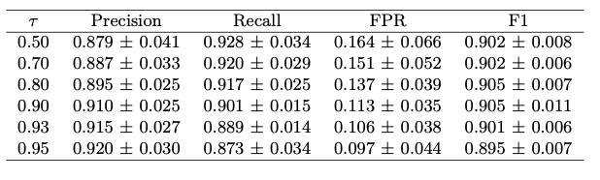

Table S7

Threshold sweep on the held-out test set for the optimized 8M model (mean ± SD across three random seeds).

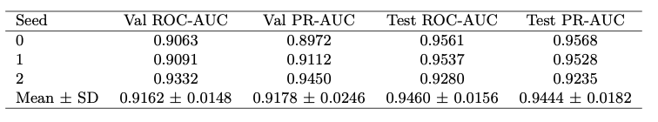

Table S8

Robustness of the optimized ESM-2 8M model across three random seeds under the clonotype-aware split.

SUPPLEMENTARY DATA
Supplementary Data 1. (Supplementary_Data_1.zip):
Curated antibody training datasets used for ASPred model development across SARS-CoV-2 RBD, influenza HA, and HIV gp120. The archive contains antigenspecific positive examples, matched negative examples defined outside the target antigen class, and dataset partitions used for model training, validation, and testing.

Supplementary Data 2 (Supplementary_Data_2.zip):
Cross-validation performance summaries for ASPred models across SARS-CoV-2 RBD, influenza HA, and HIV gp120. The archive includes per-fold and aggregated metrics for accuracy, precision, recall, F1-score, AUROC, and loss for the evaluated model configurations.

Supplementary Data 3 (Supplementary_Data_3.zip):
Quantitative comparison of pretrained versus fine-tuned embedding separability across antigens and optimization objectives. The archive contains silhouette scores, Davies–Bouldin indices, and associated statistical summaries for PCA, UMAP, and t-SNE embeddings.

Supplementary Data 4 (Supplementary_Data_4.zip):
ASPred predictions for SARS-CoV-2 RBD specificity in the human single-cell BEAM benchmark dataset. The archive contains ASPred output files for 2,464 BCR heavy-chain sequences with paired V(D)J annotations and corresponding BEAM-derived experimental measurements.

Supplementary Data 5 (Supplementary_Data_5.zip):
Differential expression outputs supporting the comparison between ASPred and BEAM classifications in the human single-cell dataset. The archive includes differential expression tables generated across the evaluated BEAM and ASPred threshold settings, together with accompanying annotation notes.

Supplementary Data 6 (Supplementary_Data_6.csv):
ASPred scores for heavy-chain sequences identified in the unselected RBD-immunized mouse peripheral blood repertoire. The file contains antibody identifiers, predicted antigen-association probabilities, and amino-acid sequences for the scored candidate repertoire used for downstream prioritization and experimental testing.

Supplementary Data 7 (Supplementary_Data_7.xlsx):
Integrated cell-level annotation table for the RBD-immunized mouse single-cell dataset. The file contains barcode-level cell-type labels, ASPred probabilities, associated V(D)J information, and linked transcriptomic features used to characterize ASPred-positive cells.

Supplementary Data 8 (Supplementary_Data_8.csv):
Metadata table listing the publicly available bulk human BCR repertoire datasets analyzed in this study, including healthy controls and SARS-CoV-2-infected donors, with accession-level source information and download links.

Supplementary Data 9 (Supplementary_Data_9.zip):
IMGT-mapped saliency outputs for ASPred models across influenza, HIV, and SARS-CoV-2 heavy-chain classifiers. The archive includes per-token saliency tables, IMGT-numbered mappings, IMGT multiple-sequence alignments, and derived visualization files such as saliency heat maps and sequence logos. This file also contains raw data files and analytical results pertaining to Figs. 7A-G.

Supplementary Data 10 (Supplementary_Data_10.zip):
Trained ASPred fine-tuned ESM-2 8M model package (facebook/esm2_t6_8M_UR50D) for single-label antigen-specificity classification. The archive contains the final model weights and associated configuration files required to reproduce inference.

Supplementary Data 11 (Supplementary_Data_11.pdf):
Supplementary report summarizing BEAM–ASPred overlap analyses, including threshold-based overlap statistics, supporting plots, and additional benchmarking outputs for the human single-cell BEAM dataset.

Supplementary Data 12 (Supplementary_Data_12):
Repository of molecular dynamics simulation trajectories and associated input files generated in this study, including topology files, initial coordinates, and simulation parameters sufficient to reproduce the reported analyses.

Supplementary Data 13 (Supplementary_Data_13.zip):
Interface-contact analysis files for modeled antibody–RBD complexes. The archive contains COCOMAPS-derived interface summaries, including residue–residue contact tables, buried surface area measurements, hydrogen bonds, salt bridges, and other interaction descriptors used to characterize antibody–RBD binding interfaces in this study.

Supplementary Data 14 (Supplementary_Data_14):
Methods, code, and data for the phylogenetic diversity analysis of ASPred-predicted SARS-CoV-2 RBD-specific (AS⁺) and non-specific (AS−) BCR sequences. The archive contains input sequence files, analysis scripts, phylogenetic trees, and outputs used to calculate diversity metrics, including mean pairwise patristic distance (MPD), Faith’s phylogenetic diversity (PD), mean nearest-neighbor distance (MNND), tip-to-MRCA statistics, and PD normalized per tip, together with the files underlying the corresponding supplementary results.

