Appendix

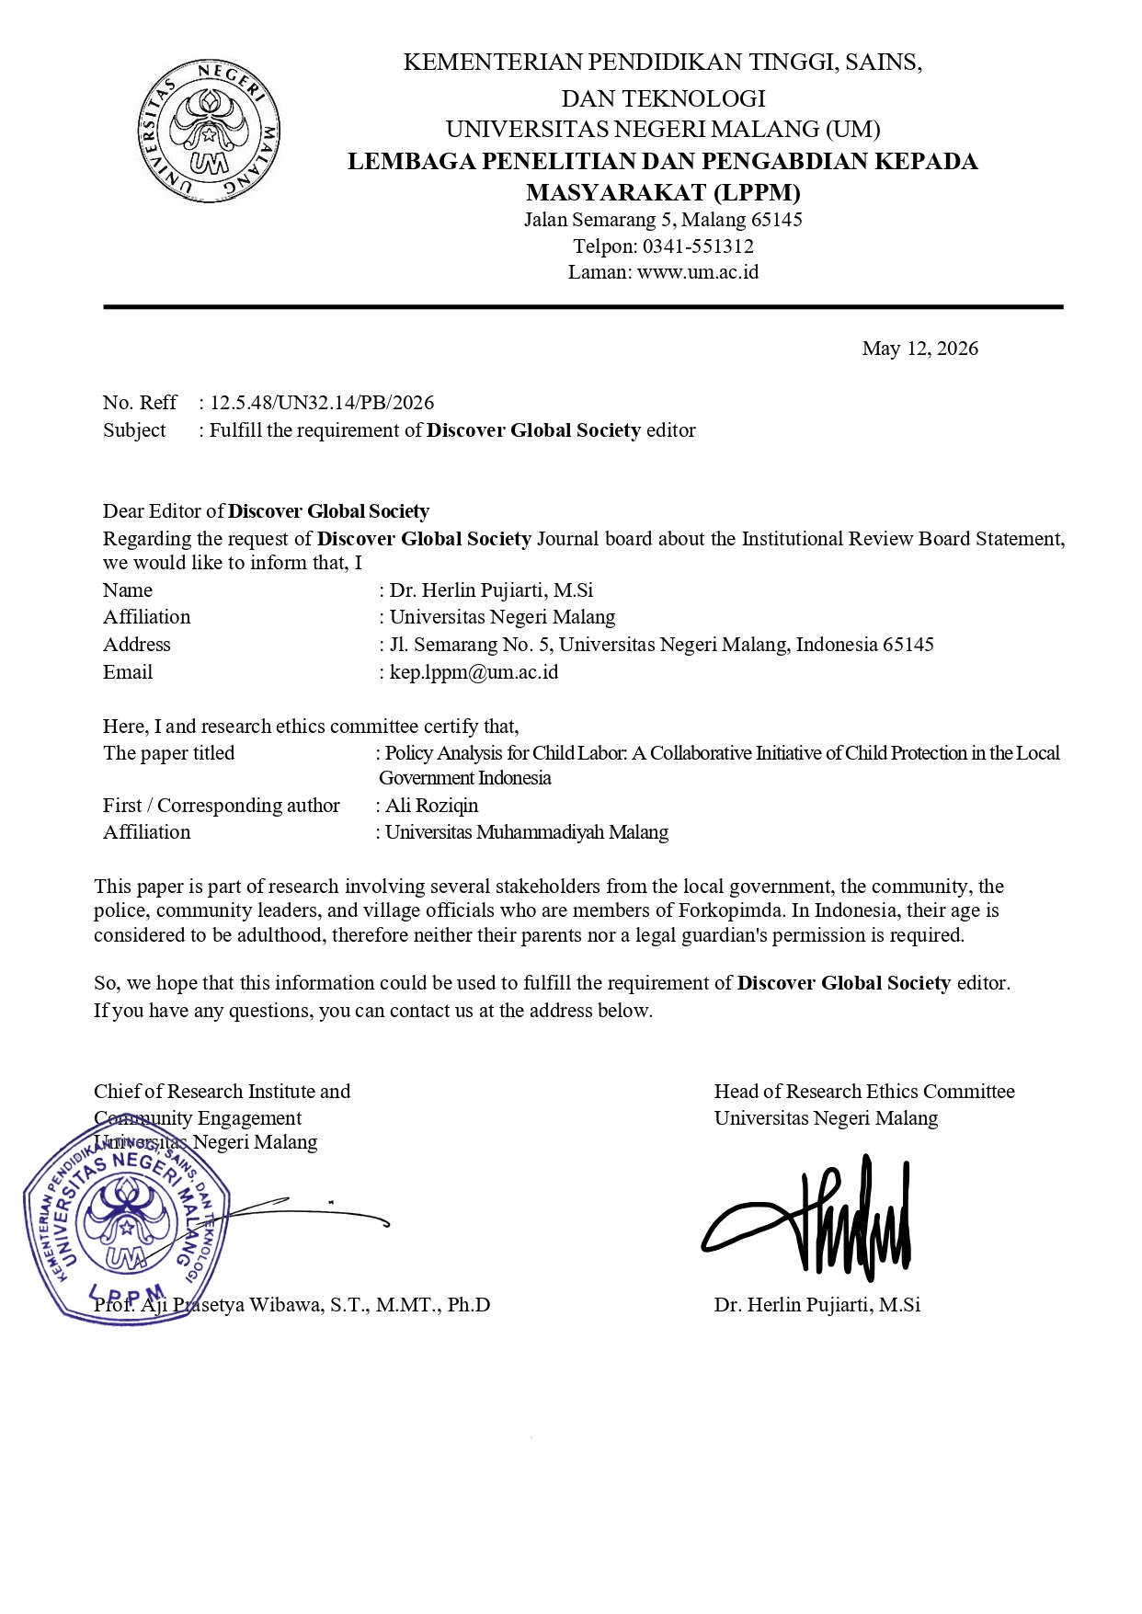
Appendix
Table 1. The characteristics of participations in the study
Stakeholder’s name | Code | Participation’s Level | Organizational Level | Sector | Related role
Regional Representatives Council of Central Java | P1 | Policymaker at regional level | Regional | Governmental | Building better regulation, coordination, and communication between stakeholders for regional law
Regional Secretary | P2 | Regional Coordinator | Regional | Governmental | Establish better coordination and communication between stakeholders and organizations
Local Representatives Council of Brebes | P3 | Policymaker at regional level | Regional | Governmental | Building better regulation, coordination, and communication between stakeholders for regional law
Office of Education, Youth, and Sport Services | P4 | Main Agencies | Regional | Governmental | Implementing education policies, including back-to-school programs to prevent dropouts and human resource training.
Office of Public Health Services | P5 | Supporting Agency | Regional | Governmental | Providing public health services and overseeing occupational safety regulations
Office of Social Work | P6 | Supporting Agency | Regional | Governmental | Providing programs to improve human resource capacity
Office of Community Empowerment and Village | P7 | Supporting Agency | Regional | Governmental | Empowering rural communities, including poverty alleviation programs
Office of Women’s Empowerment, Child Protection and Family | P8 | Supporting Agency | Regional | Governmental | Empowering communities, including women empowerment, child protection and poor families.
Office of Trade, Cooperative, and SMEs | P9 | Supporting Agency | Regional | Governmental | Providing informal employment and implementing employment regulations, including preventing child labor.
Office of Industry and Manpower | P10 | Technical support agencies | Regional | Governmental | Providing formal employment and monitoring regulations and employment, including preventing child labor.
Office of Regional Development Planning | P11 | Regional development coordinator | Regional | Governmental | Regional development planning, including education and social programs.
The Municipal Police Unit | P12 | Supporting Agency | Regional | Governmental | Enforce local regulations, including prohibitions on child labor.
The Ministry of Education | P13 | Policymaker and funder | National | Governmental | Building better regulation, coordination, and communication between stakeholders for dropout prevention and inclusive education, School Operational Assistance and affirmative programs for dropout-prone areas.
The Ministry of Public Health | P14 | Policymaker | National | Governmental | Building better regulation, coordination, and communication between stakeholders for policies in the occupational health and safety sector
The Ministry of Social Affairs | P15 | Supporting agencies | National | Governmental | Providing social protection programs for poor families and vulnerable children through social assistance programs and rehabilitation of children who are victims of economic exploitation.
The Ministry of Manpower | P16 | Regulator and facilitator | National | Governmental | Building better regulation, coordination, and communication between stakeholders for prohibition of child labor, workplace supervision and vocational training programs for those of legal working age.
The Ministry of Industry and Business Affairs | P17 | Policymaker | National | Governmental | Building better regulation, coordination, and communication between stakeholders to develop child-friendly industries and empowerment of MSMEs to reduce dependence on child labor.
The Ministry of Women’s Empowerment and Child Protection | P18 | Policymaker | National | Governmental | Building better regulation, coordination, and communication between stakeholders for improving human resource capacity, woman and child protection
The Ministry of Human Development and Culture | P19 | Policymaker | National | Governmental | Building better regulation, coordination, and communication between stakeholders for developing human capacity and local wisdom
The Ministry of National Development Planning | P20 | National development coordinator | National | Governmental | Building better regulation, coordination, and communication between stakeholders for strategic development planning
Southeast Asian Ministers of Education Organization (SEAMEO) | P21 | Technical Facilitator | International | Non-Governmental | Developing an open education system, including hybrid learning, to provide wider access to education for school children in Southeast Asia.
United Nations Educational, Scientific and Cultural Organization (UNESCO) | P22 | Technical Facilitator | International | Non-Governmental | Advancing inclusive and quality education.
United Nations International Children's Emergency Fund (UNICEF) | P23 | Advocate and funder | International | Non-Governmental | Providing funding assistance for the Child-Friendly Schools program, conducting campaigns on the dangers of child labor and the importance of education, and strengthening the reporting and rehabilitation system for children forced to work.

