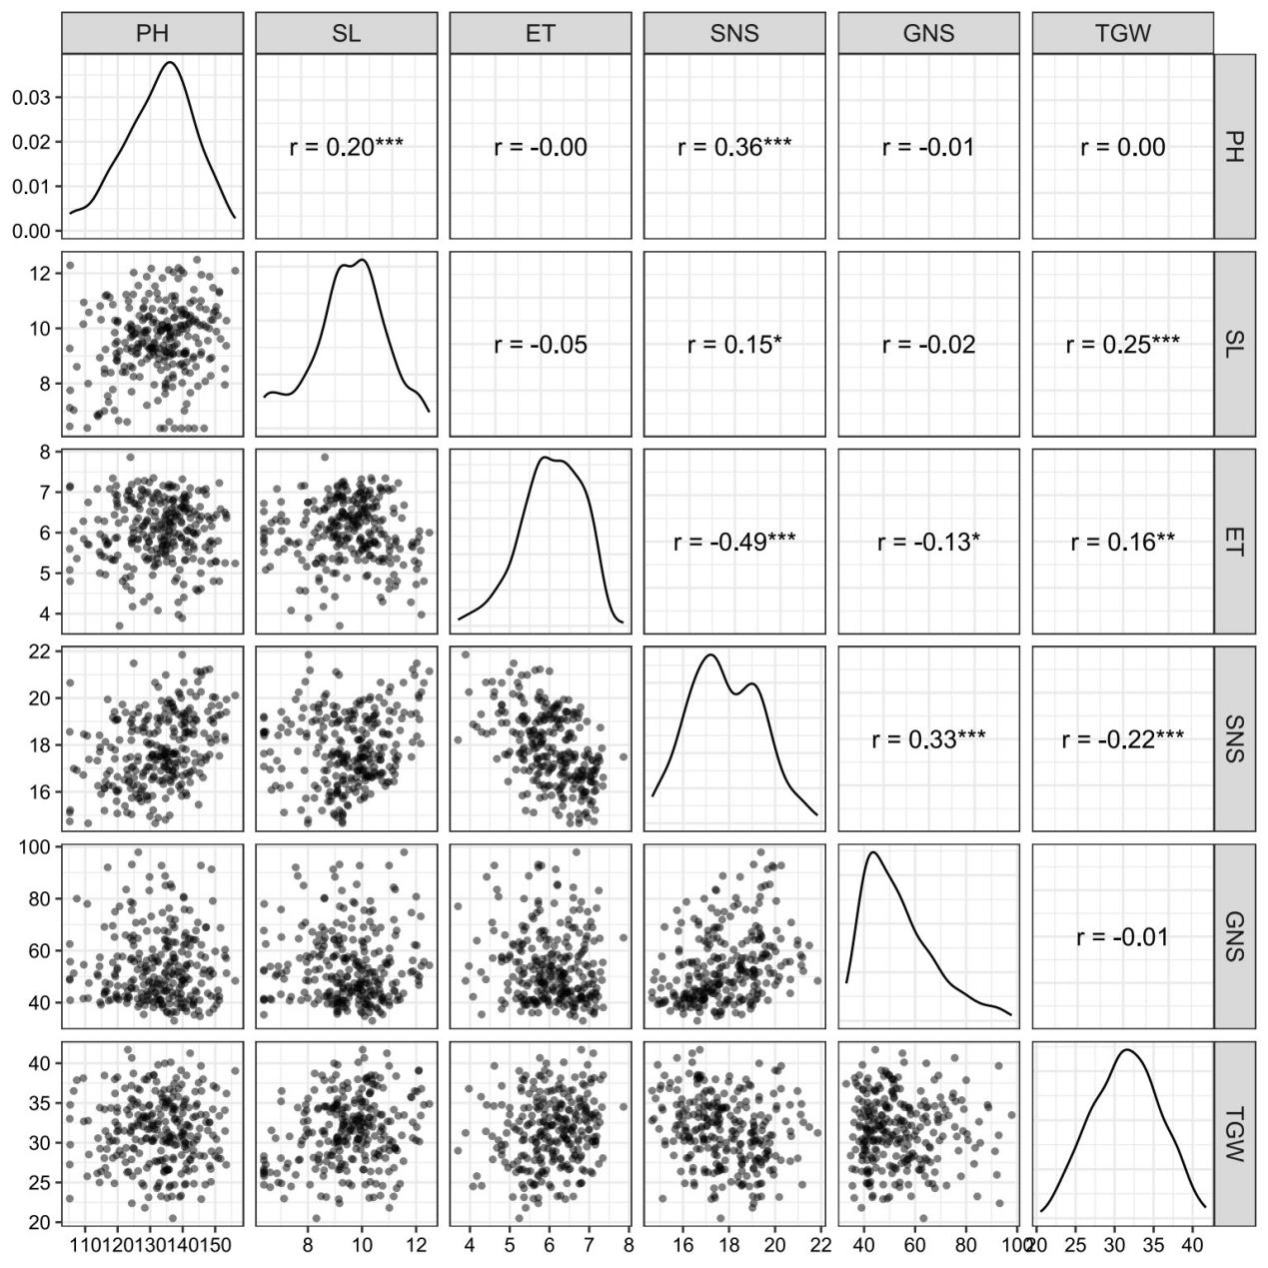
Figure S1. Pairwise trait relationships

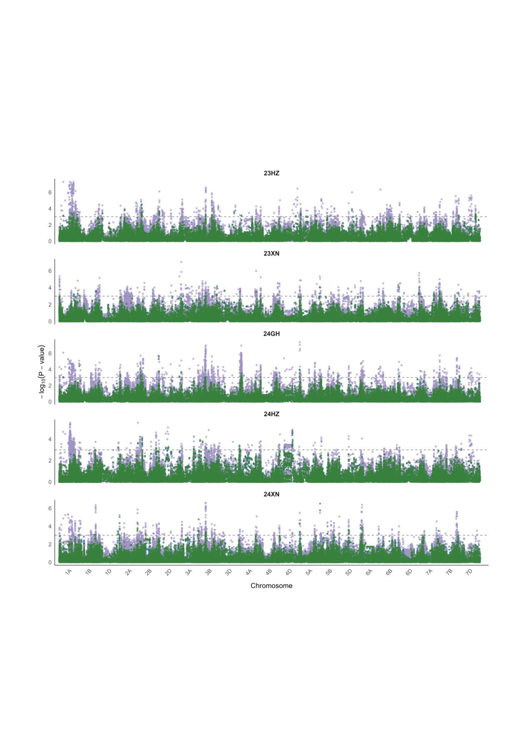
Figure S2. GWAS of effective tiller number
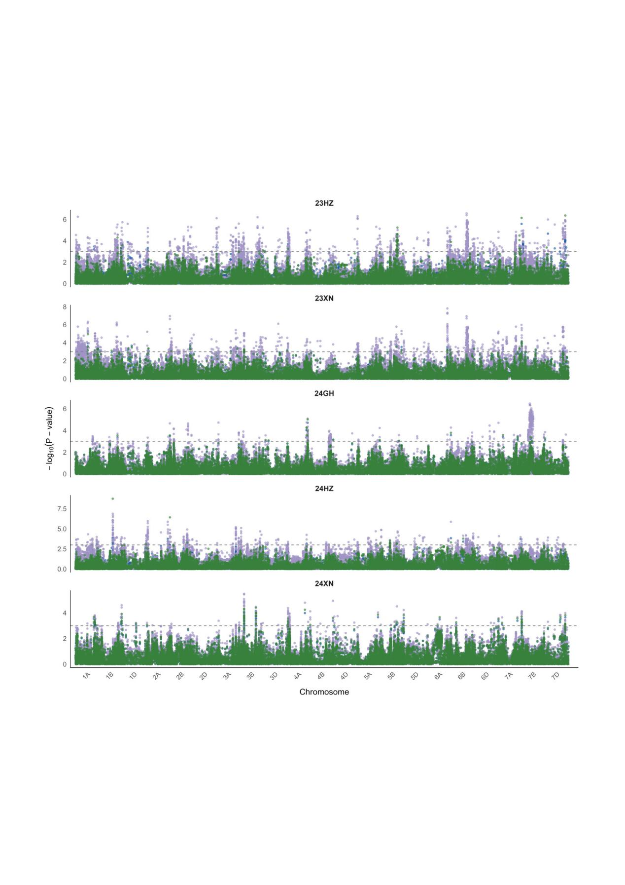
Figure S3. GWAS of grain number per spike

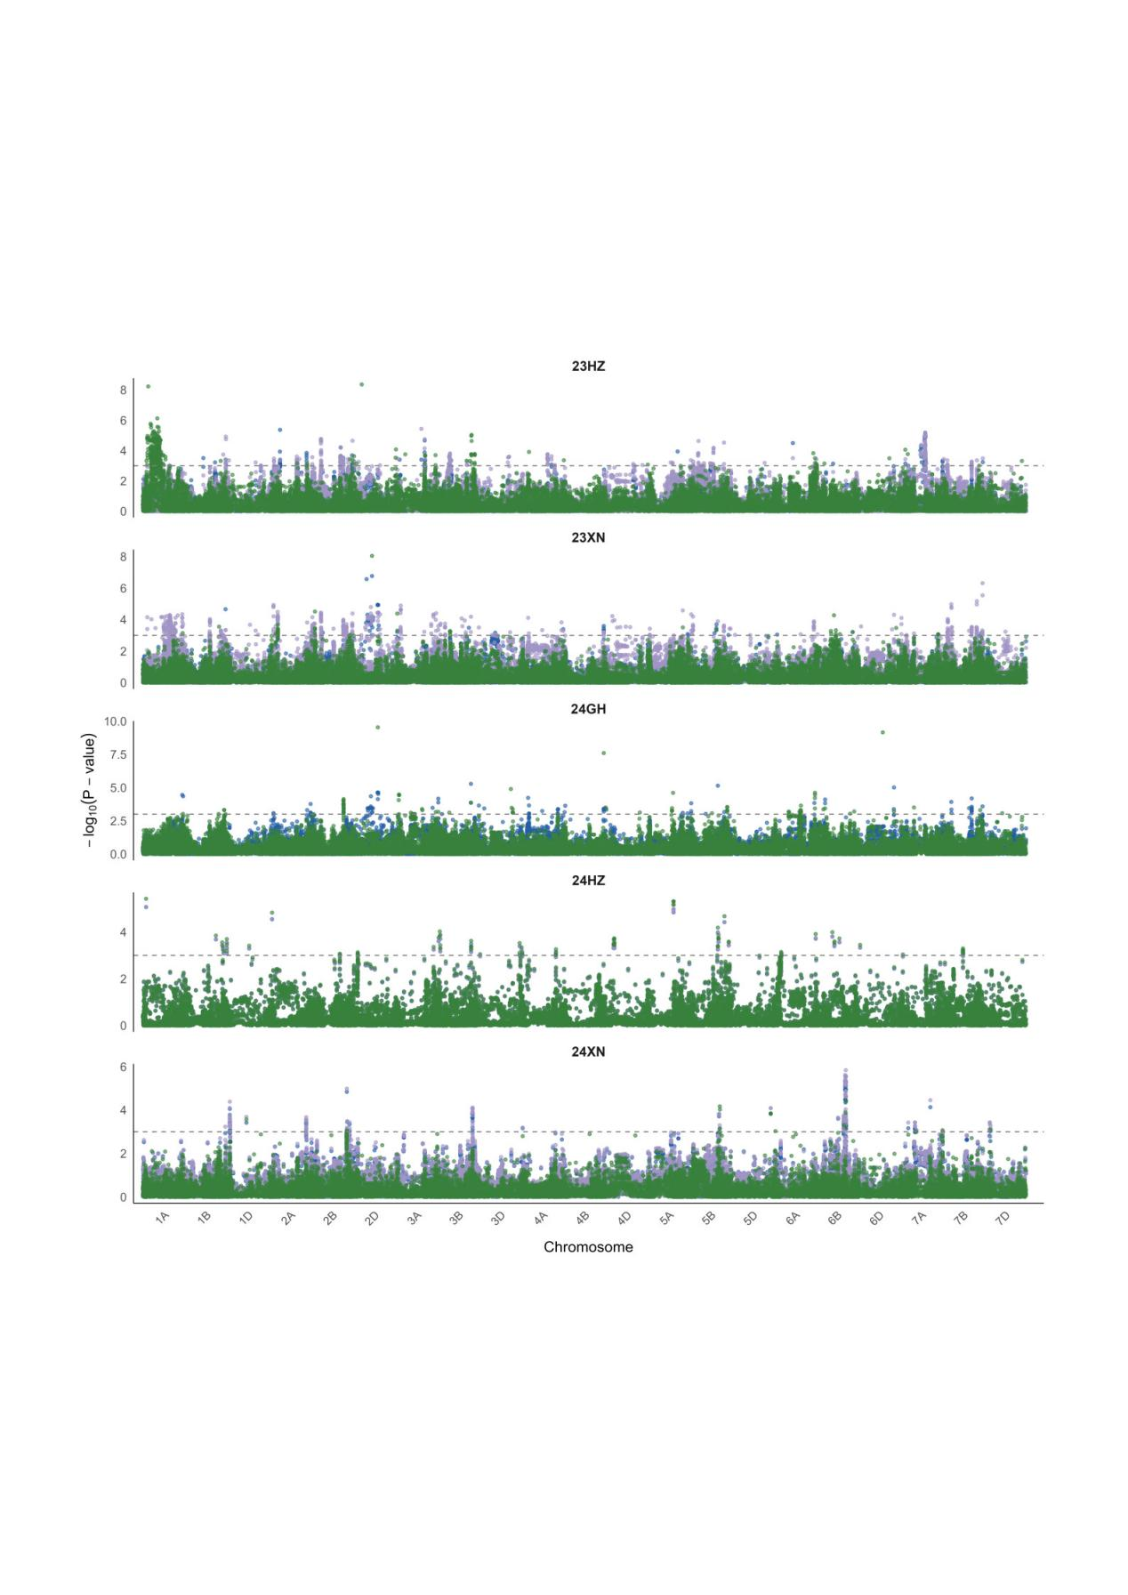Figure S4. GWAS of spike length

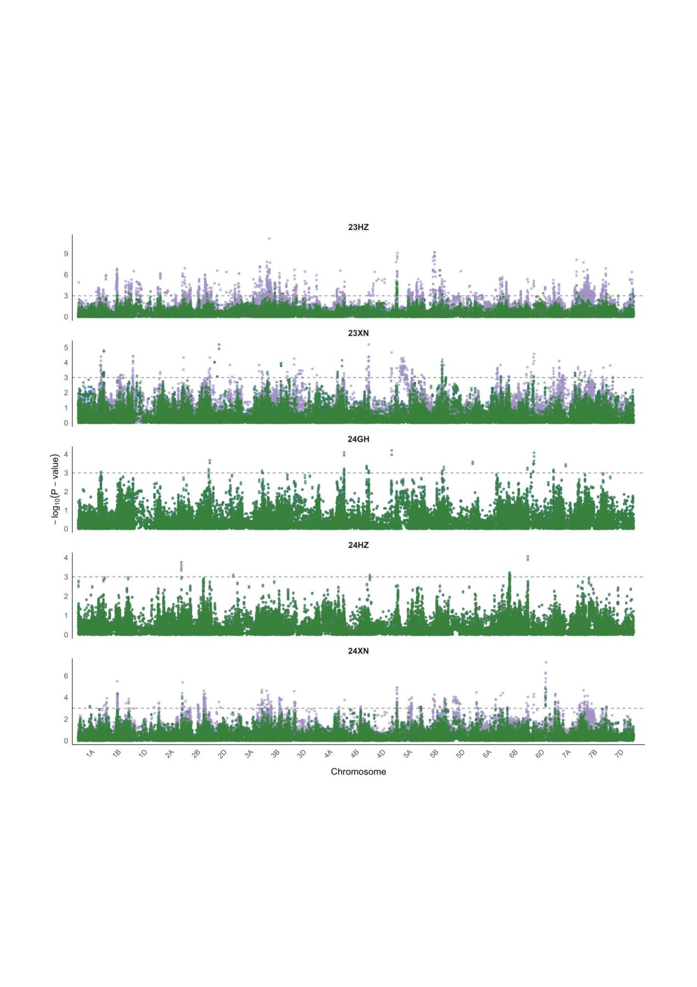Figure S5. GWAS of spikelet number per spike

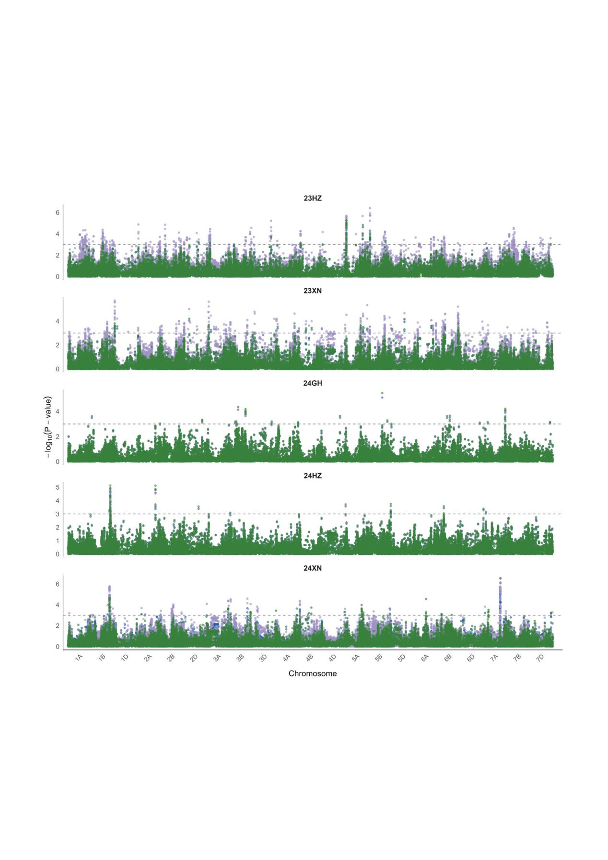Figure S6. GWAS of thousand grain weight
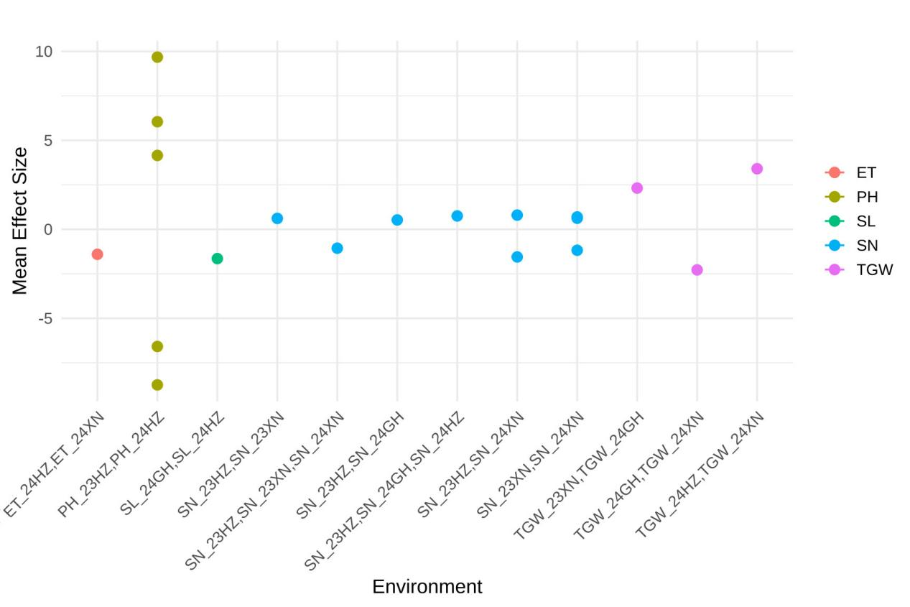Figure S7. QTL × environment interaction effects

