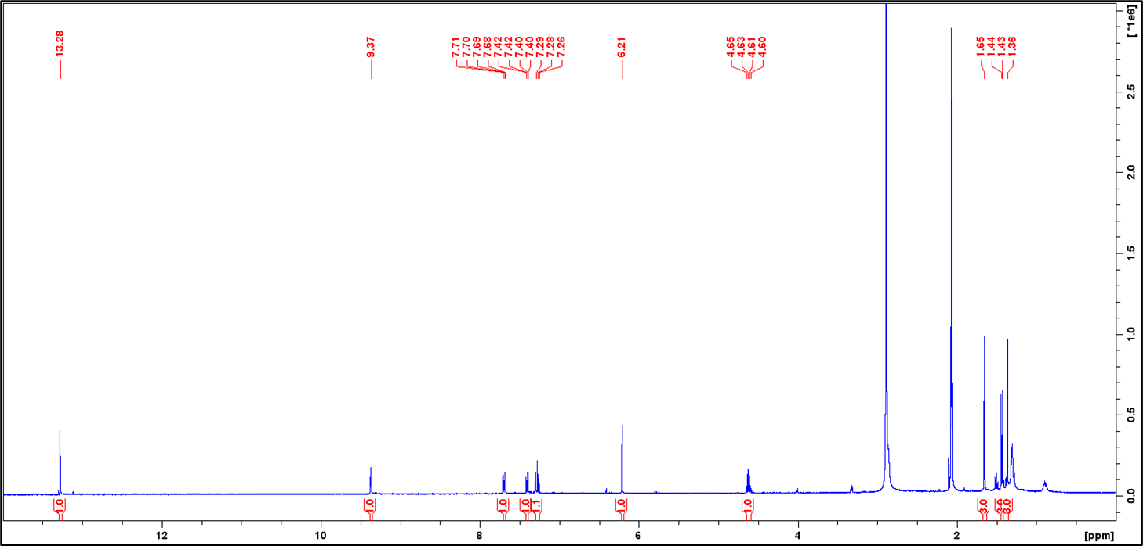
Figure S1. ¹H NMR spectrum of Austrocoriaxanthone (d-acetone, 400 MHz)
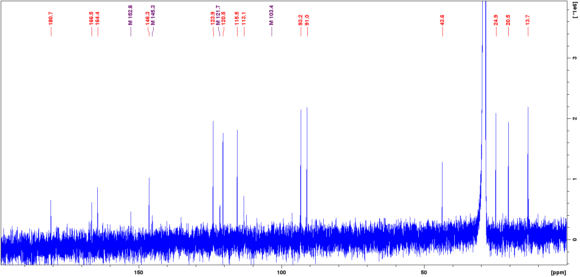
Figure S2. ¹³C NMR spectrum of Austrocoriaxanthone (d-acetone, 100 MHz)
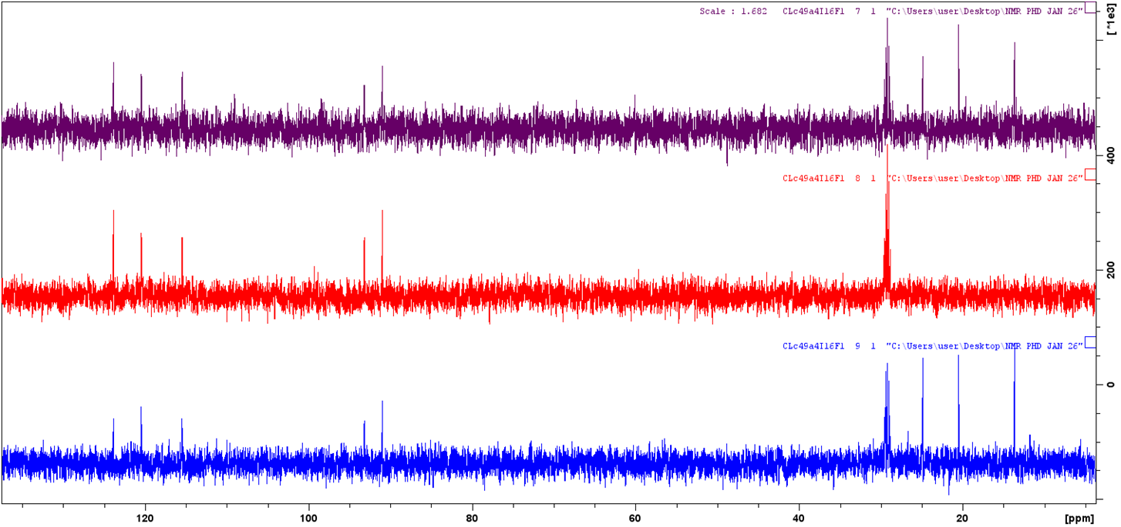
DEPT-45
DEPT-90
DEPT-135
Figure S3. DEPT Spectra of Austrocoriaxanthone
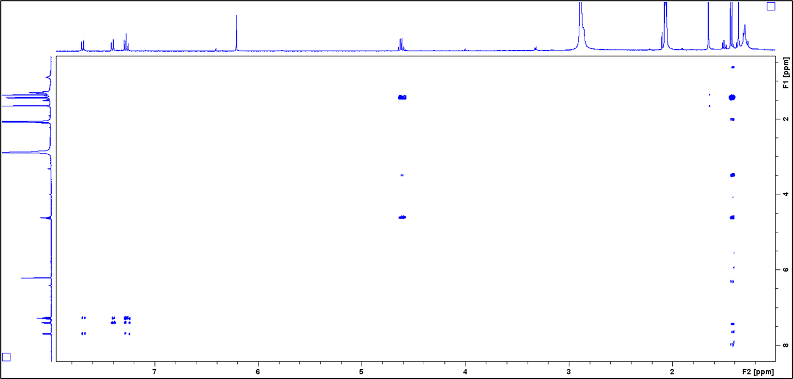
Figure S4. COSY Spectra of Austrocoriaxanthone
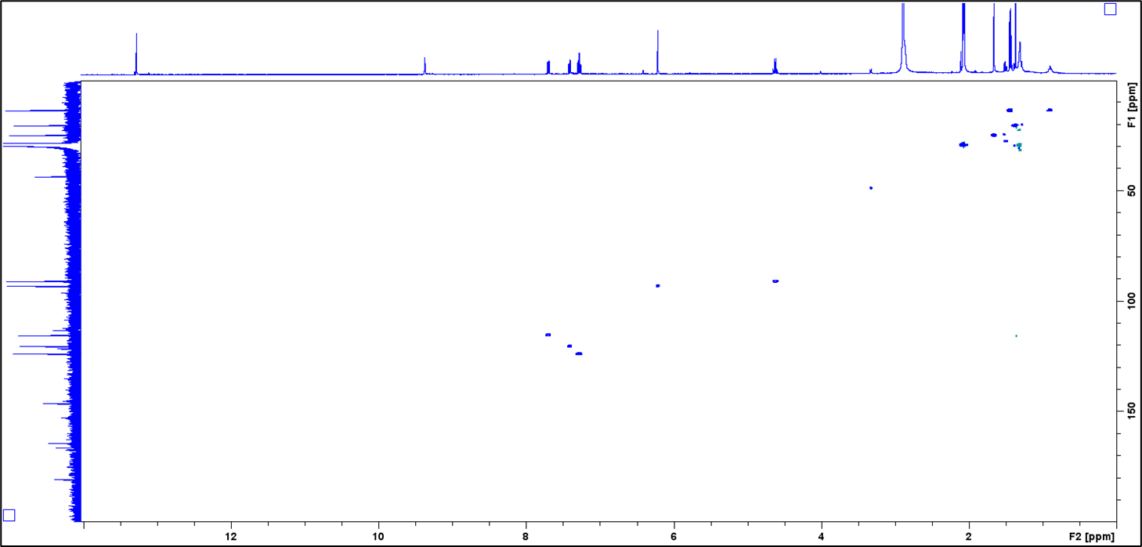
Figure S5. HSQC Spectra of Austrocoriaxanthone
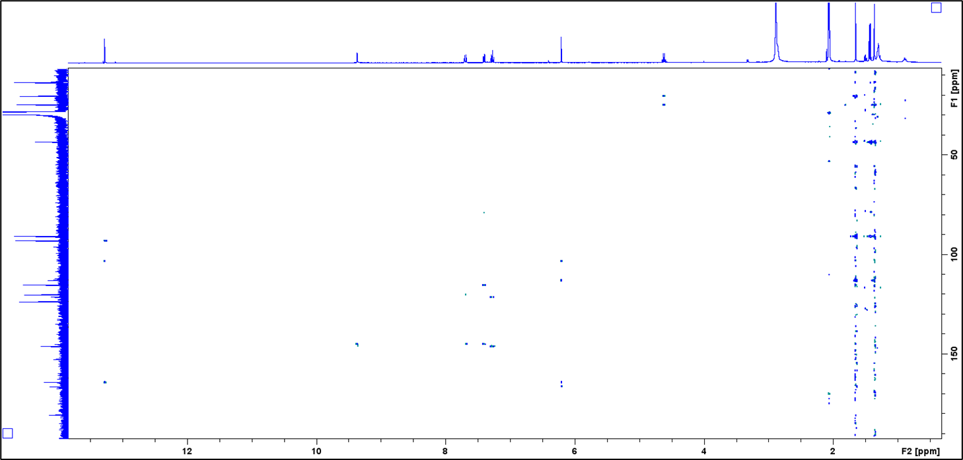
Figure S6. HMBC Spectra of Austrocoriaxanthone
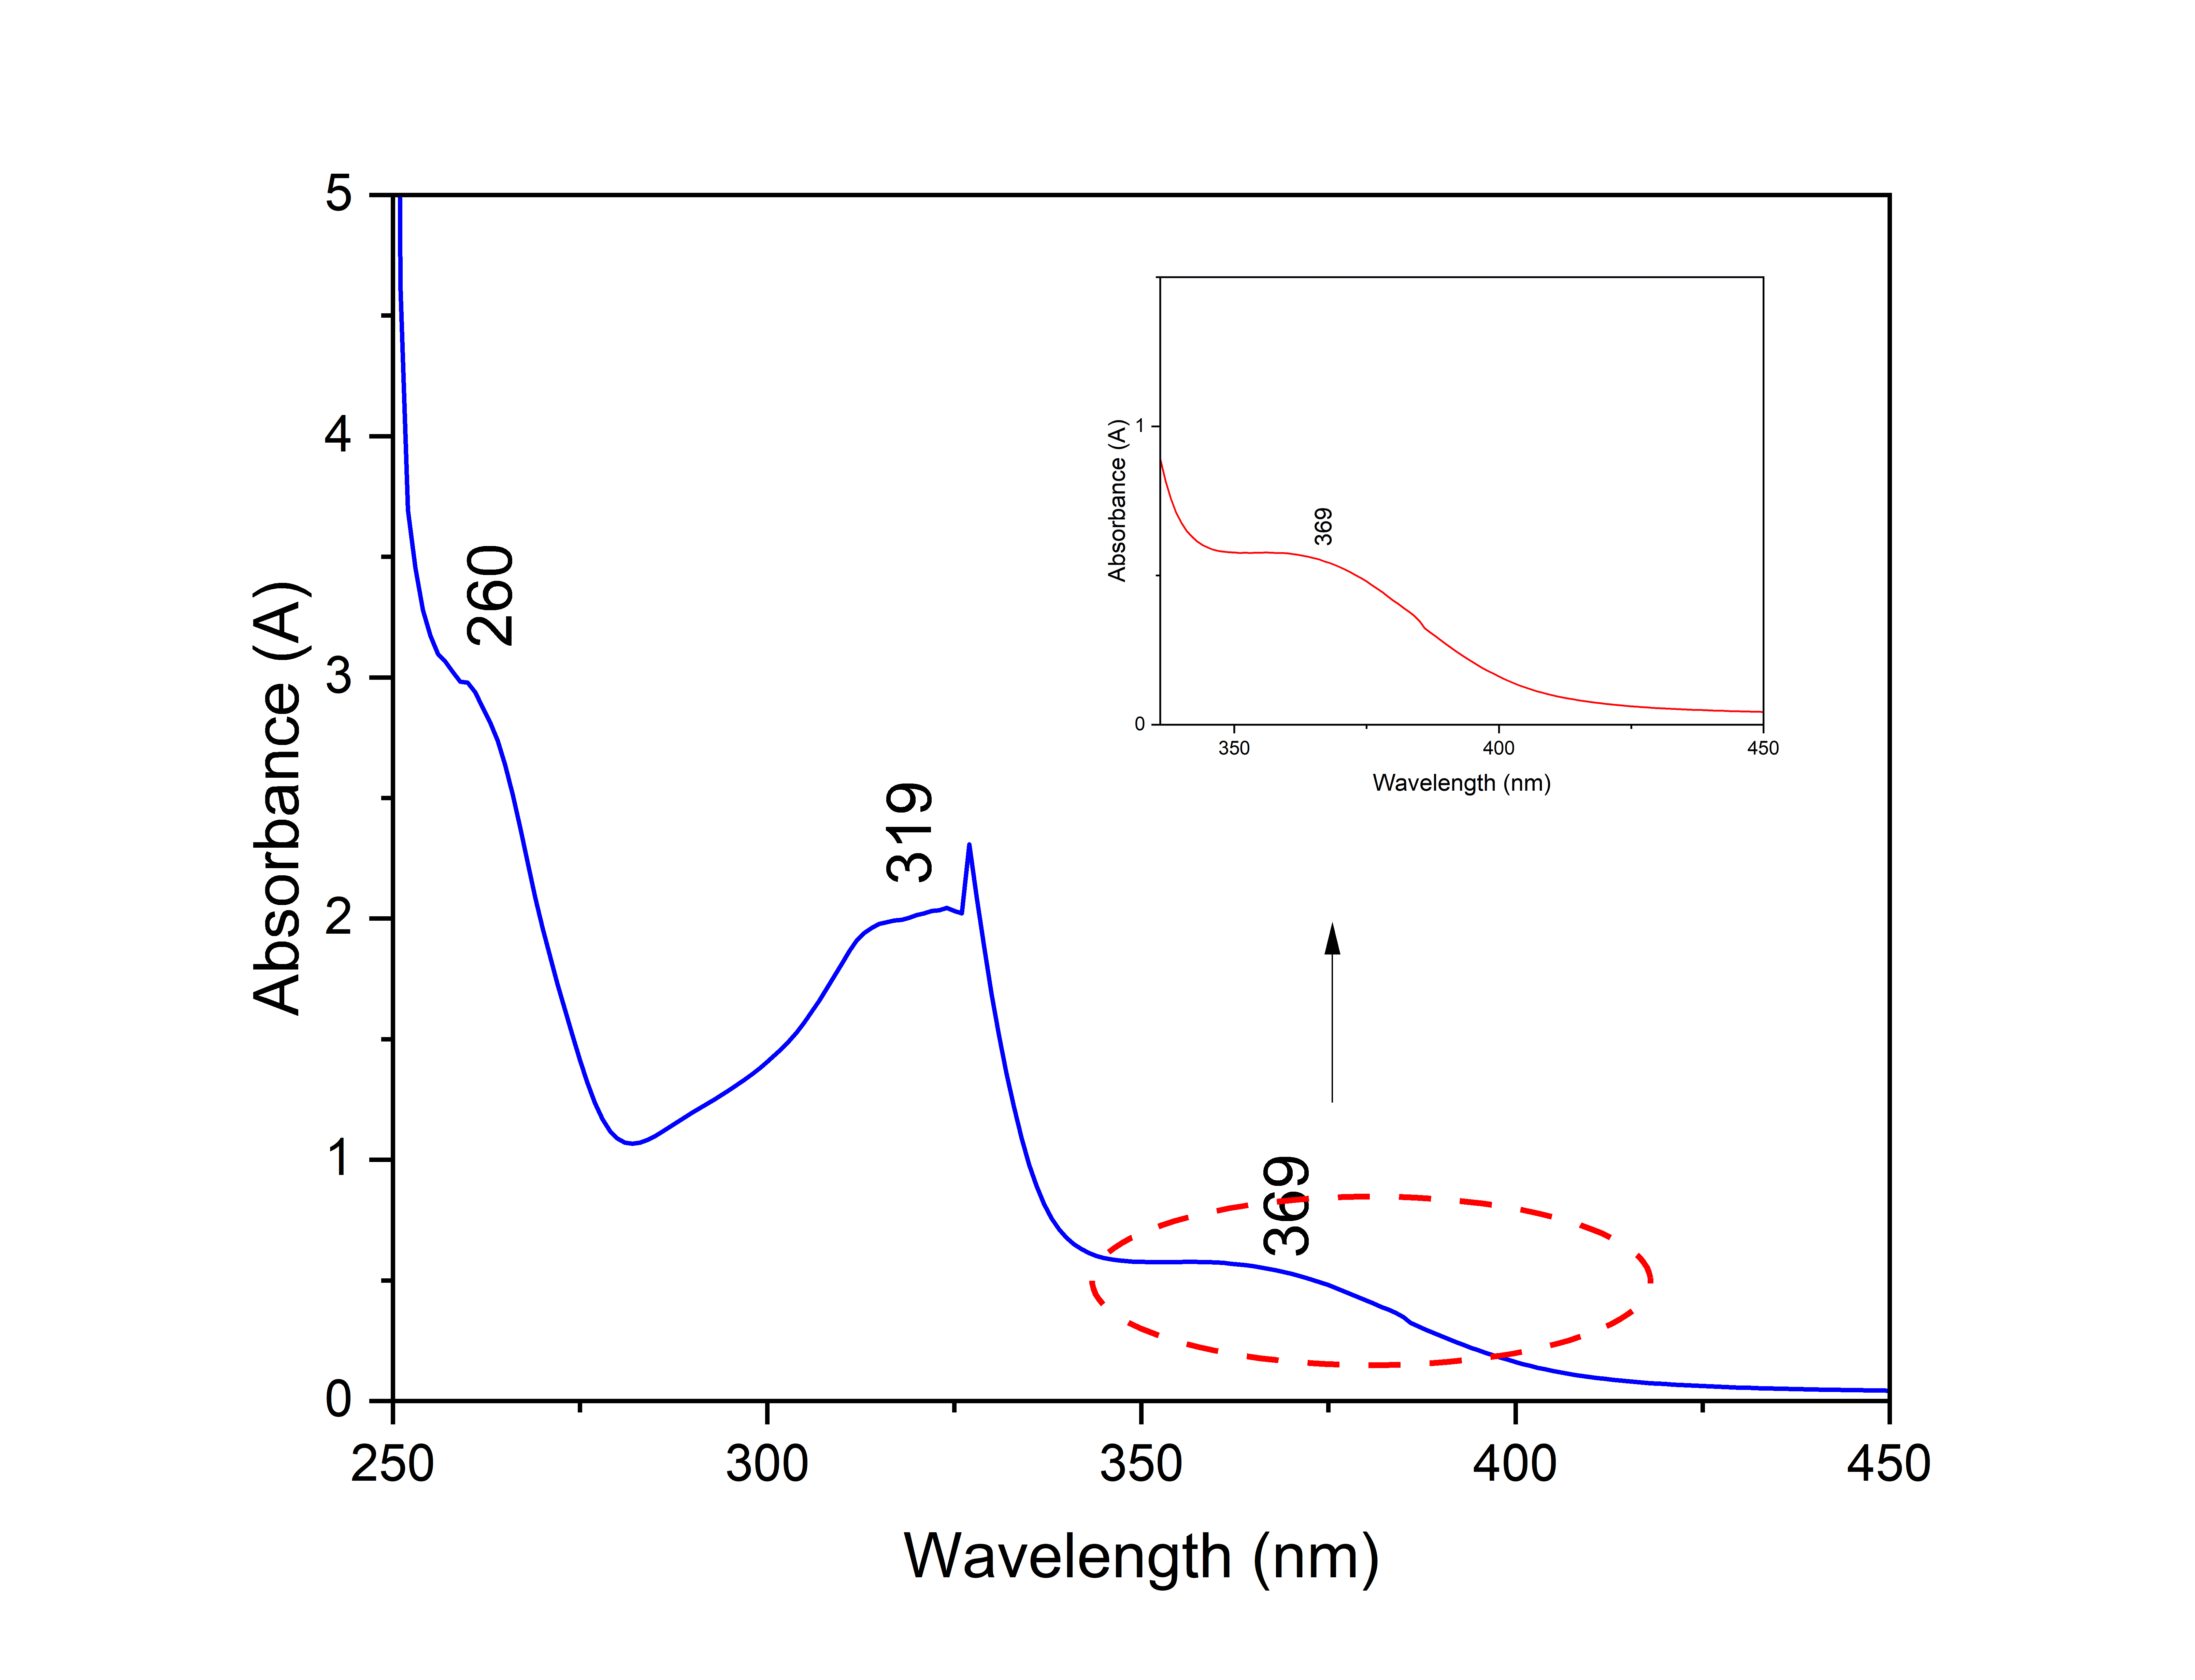
Figure S7. UV- vis Spectra of Austrocoriaxanthone

Figure S8. FT-IR Spectra of Austrocoriaxanthone

