Supplementary Information

Yuki Ogawa, Akihiko Kondo, Tomokazu Shirai

Table S1 (Lowercase letters indicate the mutation sites.)

No | Primer name | Sequence (5′ to 3′ )
1 | pCold-F | CTCGAGGGATCCGAATTCAA
2 | pCold-R | CATATGCCTACCTTCGATAT
3 | pCold-seq-F | CACGCCATATCGCCGAAAG
4 | pCold-seq-R | GCAGGGATCTTAGATTCTGTGC
5 | YADH-T45A-F | ATAGCGGTGTTTGTCATgccGATCTGCATGCATGGCAT
6 | YADH-T45-R | GACAAACACCGCTATATTTCAC
7 | YADH-W54A-F | GCATGGCATGGTGATgcaCCTCTGCCGGTTAAACTG
8 | YADH-W54-R | ATCACCATGCCATGCATGCAG
9 | YADH-L56A-F | CATGGTGATTGGCCTgcgCCGGTTAAACTGCCGCTG
10 | YADH-L56-R | AGGCCAATCACCATGCCATG
11 | YADH-W92A-F | TACGCAGGTATTAAAgcaCTGAATGGTAGCTGTATG
12 | YADH-W92-R | TTTAATACCTGCGTAATCAC
13 | YADH-Y119A-F | GCCGATCTGAGCGGTgcaACCCATGATGGTAGCTTT
14 | YADH-Y119-R | ACCGCTCAGATCGGCATGCG
15 | YADH-M270A-F | ACCGTTCTGGTTGGTgcaCCTGCCGGTGCAAAATGT
16 | YADH-M270-R | ACCAACCAGAACGGTGGTGC
17 | YADH-Y294A-F | AGCATTGTTGGTAGCgcaGTTGGTAATCGTGCAGAT
18 | YADH-Y294-R | GCTACCAACAATGCTAATGC
19 | YADH-V295A-F | ATTGTTGGTAGCTATgcaGGTAATCGTGCAGATACC
20 | YADH-V295-R | ATAGCTACCAACAATGCTAA
21 | YADH-W54NNT-F | GCATGGCATGGTGATnntCCTCTGCCGGTTAAACTG
22 | YADH-W54CMC-F | GCATGGCATGGTGATcmcCCTCTGCCGGTTAAACTG
23 | YADH-W54AMG-F | GCATGGCATGGTGATamgCCTCTGCCGGTTAAACTG
24 | YADH-W54GAC-F | GCATGGCATGGTGATgacCCTCTGCCGGTTAAACTG
25 | YADH-W54CNS-F | GCATGGCATGGTGATcnsCCTCTGCCGGTTAAACTG
26 | YADH-W54ANS-F | GCATGGCATGGTGATansCCTCTGCCGGTTAAACTG
27 | YADH-W54GAS-F | GCATGGCATGGTGATgasCCTCTGCCGGTTAAACTG
28 | YADH-W54V-F | GCATGGCATGGTGATgttCCTCTGCCGGTTAAACTG
29 | YADH-W54CWG-F | GCATGGCATGGTGATkgbCCTCTGCCGGTTAAACTG
30 | YADH-W54H-F | GCATGGCATGGTGATcacCCTCTGCCGGTTAAACTG
31 | YADH-W54I-F | GCATGGCATGGTGATatcCCTCTGCCGGTTAAACTG
32 | YADH-W54G-F | GCATGGCATGGTGATggcCCTCTGCCGGTTAAACTG
33 | YADH-W54-R | ATCACCATGCCATGCATGCA
34 | YADH-W54I-F | GCATGGCATGGTGATattCCTCTGCCGGTTAAACTG
35 | YADH-W54V-F | GCATGGCATGGTGATgtgCCTCTGCCGGTTAAACTG
36 | YADH-W54Y-F | GCATGGCATGGTGATtatCCTCTGCCGGTTAAACTG
37 | YADH-W54H-F | GCATGGCATGGTGATcatCCTCTGCCGGTTAAACTG
38 | YADH-W54F-F | GCATGGCATGGTGATtttCCTCTGCCGGTTAAACTG
39 | YADH-W54A-F | GCATGGCATGGTGATgcgCCTCTGCCGGTTAAACTG
40 | YADH-W54W-F | GCATGGCATGGTGATtggCCTCTGCCGGTTAAACTG
41 | YADH-W54ACT-F | GCATGGCATGGTGATactCCTCTGCCGGTTAAACTG
42 | YADH-W92NNT-F | TACGCAGGTATTAAAnntACTGAATGGTAGCTGTATG
43 | YADH-W92TVC-F | TACGCAGGTATTAAAtvcACTGAATGGTAGCTGTATG
44 | YADH-W92CNS-F | TACGCAGGTATTAAAcnsACTGAATGGTAGCTGTATG
45 | YADH-W92ANS-F | TACGCAGGTATTAAAansACTGAATGGTAGCTGTATG
46 | YADH-W92GWS-F | TACGCAGGTATTAAAgwsACTGAATGGTAGCTGTATG
47 | YADH-W92NNT-F | TACGCAGGTATTAAAnntCTGAATGGTAGCTGTATG
48 | YADH-W92TVC-F | TACGCAGGTATTAAAtvcCTGAATGGTAGCTGTATG
49 | YADH-W92CNS-F | TACGCAGGTATTAAAcnsCTGAATGGTAGCTGTATG
50 | YADH-W92ANS-F | TACGCAGGTATTAAAansCTGAATGGTAGCTGTATG
51 | YADH-W92GWS-F | TACGCAGGTATTAAAgwsCTGAATGGTAGCTGTATG
52 | YADH-W92TWC-F | TACGCAGGTATTAAAtwcCTGAATGGTAGCTGTATG
53 | YADH-W92CWS-F | TACGCAGGTATTAAAcwsCTGAATGGTAGCTGTATG
54 | YADH-W92AHC-F | TACGCAGGTATTAAAahcCTGAATGGTAGCTGTATG
55 | YADH-W92GRS-F | TACGCAGGTATTAAAgrsCTGAATGGTAGCTGTATG
56 | YADH-W92YAC-F | TACGCAGGTATTAAAyacCTGAATGGTAGCTGTATG
57 | YADH-W92GAS-F | TACGCAGGTATTAAAgasCTGAATGGTAGCTGTATG
58 | YADH-W92ATC-F | TACGCAGGTATTAAAatcCTGAATGGTAGCTGTATG
59 | YADH-W92Y-F | TACGCAGGTATTAAAtacCTGAATGGTAGCTGTATG
60 | YADH-W92H-F | TACGCAGGTATTAAAcacCTGAATGGTAGCTGTATG
61 | YADH-W92D-F | TACGCAGGTATTAAAgacCTGAATGGTAGCTGTATG
62 | YADH-W92M-F | TACGCAGGTATTAAAatgCTGAATGGTAGCTGTATG
63 | YADH-W92F-F | TACGCAGGTATTAAAtttCTGAATGGTAGCTGTATG
64 | YADH-W92W-F | TACGCAGGTATTAAAtggCTGAATGGTAGCTGT
65 | YADH-Y119NNT-F | GCCGATCTGAGCGGTnntACCCATGATGGTAGCTTT
66 | YADH-Y119CHS-F | GCCGATCTGAGCGGTchsACCCATGATGGTAGCTTT
67 | YADH-Y119AHA-F | GCCGATCTGAGCGGTahaACCCATGATGGTAGCTTT
68 | YADH-Y119GAS-F | GCCGATCTGAGCGGTgasACCCATGATGGTAGCTTT
69 | YADH-Y119TDC-F | GCCGATCTGAGCGGTtdcACCCATGATGGTAGCTTT
70 | YADH-Y119W-F | GCCGATCTGAGCGGTtggACCCATGATGGTAGCTTT
71 | YADH-Y119F-F | GCCGATCTGAGCGGTttcACCCATGATGGTAGCTTT
72 | YADH-Y119N-F | GCCGATCTGAGCGGTaacACCCATGATGGTAGCTTT
73 | YADH-Y119E-F | GCCGATCTGAGCGGTgagACCCATGATGGTAGCTTT
74 | YADH-Y119M-F | GCCGATCTGAGCGGTatgACCCATGATGGTAGCTTT
75 | YADH-Y119CMC-F | GCCGATCTGAGCGGTcmcACCCATGATGGTAGCTTT
76 | YADH-Y119AYG-F | GCCGATCTGAGCGGTaygACCCATGATGGTAGCTTT
77 | YADH-Y119H-F | GCCGATCTGAGCGGTcacACCCATGATGGTAGCTTT
78 | YADH-Y119T-F | GCCGATCTGAGCGGTaccACCCATGATGGTAGCTTT
79 | YADH-Y119FY-F | GCCGATCTGAGCGGTtwcACCCATGATGGTAGCTTT
80 | YADH-Y119K-F | GCCGATCTGAGCGGTaaaACCCATGATGGTAGC
81 | YADH-Y119V-F | GCCGATCTGAGCGGTgtgACCCATGATGGTAGC
82 | YADH-Y119I-F | GCCGATCTGAGCGGTattACCCATGATGGTAGC
83 | YADH-Y119G-F | GCCGATCTGAGCGGTggcACCCATGATGGTAGC
84 | YADH-Y119C-F | GCCGATCTGAGCGGTtgcACCCATGATGGTAGCTTT
85 | YADH-M270NNT-F | ACCGTTCTGGTTGGTnntCCTGCCGGTGCAAAATGT
86 | YADH-M270TRS-F | ACCGTTCTGGTTGGTtrsCCTGCCGGTGCAAAATGT
87 | YADH-M270CNS-F | ACCGTTCTGGTTGGTcnsCCTGCCGGTGCAAAATGT
88 | YADH-M270ANS-F | ACCGTTCTGGTTGGTansCCTGCCGGTGCAAAATGT
89 | YADH-M270GRG-F | ACCGTTCTGGTTGGTgrgCCTGCCGGTGCAAAATGT
90 | YADH-M270CMC-F | ACCGTTCTGGTTGGTcmcCCTGCCGGTGCAAAATGT
91 | YADH-M270AHW-F | ACCGTTCTGGTTGGTahwCCTGCCGGTGCAAAATGT
92 | YADH-M270TAC-F | ACCGTTCTGGTTGGTtacCCTGCCGGTGCAAAATGT
93 | YADH-M270AAG-F | ACCGTTCTGGTTGGTaagCCTGCCGGTGCAAAATGT
94 | YADH-M270GGT-F | ACCGTTCTGGTTGGTggtCCTGCCGGTGCAAAATGT
95 | YADH-M270V-F | ACCGTTCTGGTTGGTgtaCCTGCCGGTGCAAAATGT
96 | YADH-M270I-F | ACCGTTCTGGTTGGTattCCTGCCGGTGCAAAATGT
97 | YADH-M270N-F | ACCGTTCTGGTTGGTaacCCTGCCGGTGCAAAATGT
98 | YADH-M270V-F | ACCGTTCTGGTTGGTgtgCCTGCCGGTGCAAAATGT
99 | YADH-M270Y-F | ACCGTTCTGGTTGGTtatCCTGCCGGTGCAAAATGT
100 | YADH-M270W-F | ACCGTTCTGGTTGGTtggCCTGCCGGTGCAAAA
101 | YADH-M270M-F | ACCGTTCTGGTTGGTatgCCTGCCGGTGCAAAA
102 | YADH-M270K-F | ACCGTTCTGGTTGGTaaaCCTGCCGGTGCAAAA
103 | YADH-M270H-F | ACCGTTCTGGTTGGTcatCCTGCCGGTGCAAAA
104 | YADH-M270T-F | ACCGTTCTGGTTGGTaccCCTGCCGGTGCAAAA
105 | YADH-M270L-F | ACCGTTCTGGTTGGTttaCCTGCCGGTGCAAAA
106 | YADH-Y294NNT-F | AGCATTGTTGGTAGCnntGTTGGTAATCGTGCAGAT
107 | YADH-Y294MCG-F | AGCATTGTTGGTAGCmcgGTTGGTAATCGTGCAGAT
108 | YADH-Y294T-F | AGCATTGTTGGTAGCaccGTTGGTAATCGTGCAGAT
109 | YADH-Y294CNS-F | AGCATTGTTGGTAGCcnsGTTGGTAATCGTGCAGAT
110 | YADH-Y294ANR-F | AGCATTGTTGGTAGCanrGTTGGTAATCGTGCAGAT
111 | YADH-Y294TGG-F | AGCATTGTTGGTAGCtggGTTGGTAATCGTGCAGAT
112 | YADH-Y294GWA-F | AGCATTGTTGGTAGCgwaGTTGGTAATCGTGCAGAT
113 | YADH-Y294CMT-F | AGCATTGTTGGTAGCcmtGTTGGTAATCGTGCAGAT
114 | YADH-Y294AMG-F | AGCATTGTTGGTAGCamgGTTGGTAATCGTGCAGAT
115 | YADH-Y294NY-F | AGCATTGTTGGTAGCwacGTTGGTAATCGTGCAGAT
116 | YADH-Y294C-F | AGCATTGTTGGTAGCtgcGTTGGTAATCGTGCAGAT
117 | YADH-Y294H-F | AGCATTGTTGGTAGCcatGTTGGTAATCGTGCAGAT
118 | YADH-Y294Y-F | AGCATTGTTGGTAGCtatGTTGGTAATCGTGCAGAT

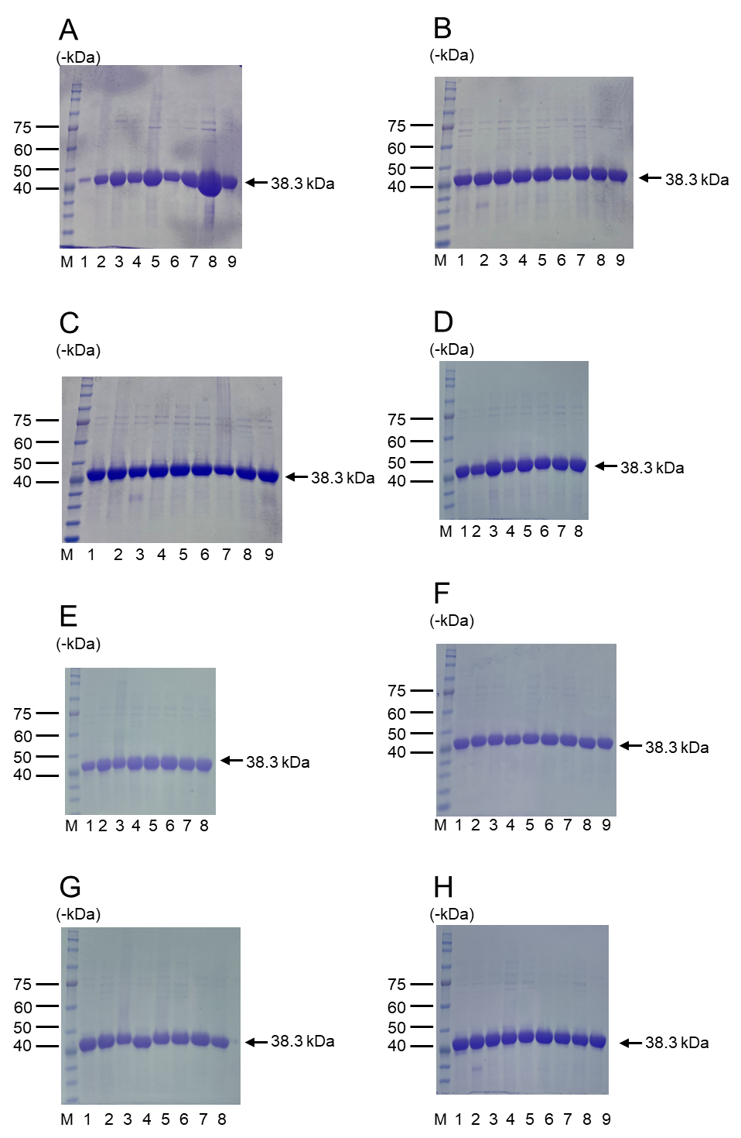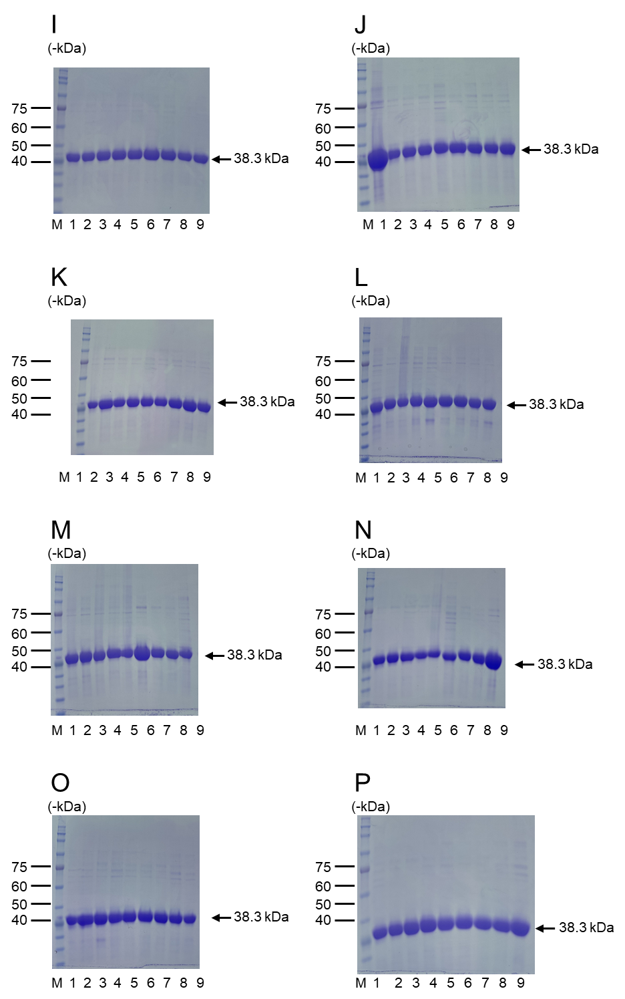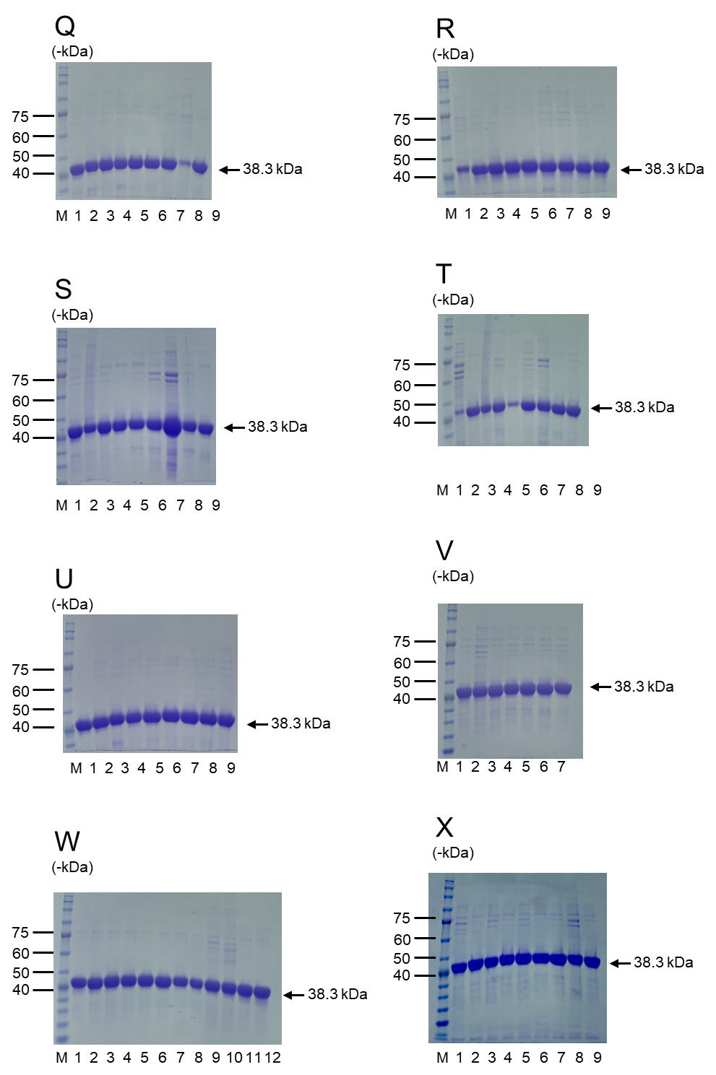
Figure S1. SDS-PAGE analyses of the purified (A) wild-type YADH (Lane 1, 38.3 kDa) and alanine-substituted variants, (B-C) W54 variants, (D-E) W92 variants, (F-G) Y119 variants, (H-I) M270 variants, (J-K) Y294 variants, (L-V) YADH-variants with multiple mutations in the initial library, and (W-X) YADH-variants predicted to have high activities. Lane M: molecular weight marker. Plasmid construction and SDS-PAGE analysis of mutated YADH variants were conducted in the same procedure.

Table S2 List of YADH variants
Mutation | SDS-PAGE
WT | A-1
T45A | A-2
W54A | A-3
L56A | A-4
W92A | A-5
Y119A | A-6
M270A | A-7
Y294A | A-8
V295A | A-9
W54C | B-1
W54D | B-2
W54E | B-3
W54F | B-4
W54G | B-5
W54H | B-6
W54I | B-7
W54K | B-8
W54L | B-9
W54M | C-1
W54N | C-2
W54P | C-3
W54Q | C-4
W54R | C-5
W54S | C-6
W54T | C-7
W54V | C-8
W54Y | C-9
W92C | D-1
W92D | Not expressed
W92E | Not expressed
W92F | D-2
W92G | D-3
W92H | D-4
W92I | D-5
W92K | D-6
W92L | D-7
W92M | D-8
W92N | E-1
W92P | E-2
W92Q | E-3
W92R | E-4
W92S | E-5
W92T | E-6
W92V | E-7
W92Y | E-8
Y119C | F-1
Y119D | F-2
Y119E | F-3
Y119F | F-4
Y119G | F-5
Y119H | F-6
Y119I | F-7
Y119K | F-8
Y119L | F-9
Y119M | G-1
Y119N | G-2
Y119Q | G-3
Y119R | G-4
Y119S | G-5
Y119T | G-6
Y119V | G-7
Y119W | G-8
M270C | H-1
M270D | H-2
M270E | H-3
M270F | H-4
M270G | H-5
M270H | H-6
M270I | H-7
M270K | H-8
M270L | H-9
M270N | I-1
M270P | I-2
M270Q | I-3
M270R | I-4
M270S | I-5
M270T | I-6
M270V | I-7
M270W | I-8
M270Y | I-9
Y294C | J-1
Y294D | J-2
Y294E | J-3
Y294F | J-4
Y294G | J-5
Y294H | J-6
Y294I | J-7
Y294K | J-8
Y294L | J-9
Y294M | K-1
Y294N | K-2
Y294P | K-3
Y294Q | K-4
Y294R | K-5
Y294S | K-6
Y294T | K-7
Y294V | K-8
Y294W | K-9
HCRYC | L-1
SGVYV | L-2
VSFRY | L-3
CGVGG | L-4
CVCFI | L-5
VGCCY | L-6
VVVCS | L-7
GFFGV | L-8
YACDI | L-9
RVYVC | M-1
ARVSC | M-2
SVFAC | M-3
GCSGN | M-4
FCCFY | M-5
WWAMA | M-6
WWAMN | M-7
WWCMT | M-8
WWDMF | M-9
WWFMC | N-1
WWFMN | N-2
WWFMV | N-3
WWGMC | N-4
WWGMR | N-5
WWRMF | N-6
WWVMV | N-7
GCFFA | N-8
IAYTA | N-9
IWFCA | O-1
HFFCA | O-2
HFFDA | O-3
AFFAA | O-4
WFFIA | O-5
HCFMA | O-6
IFAMA | O-7
HFAAA | O-8
ICASA | O-9
WFAIA | P-1
AWASA | P-2
IWYMA | P-3
HAATA | P-4
HCFIA | P-5
ICFTY | P-6
IWFTS | P-7
AWFSY | P-8
GWYIY | P-9
ACFCY | Q-1
ACYDY | Q-2
HAAMY | Q-3
IWADY | Q-4
HWASN | Q-5
CWATY | Q-6
HWATN | Q-7
WCATY | Q-8
AAAFY | Q-9
ICATY | R-1
IWYAY | R-2
ACYSC | R-3
ICYMC | R-4
ACYTC | R-5
HFFDC | R-6
HFYTC | R-7
WFFMC | R-8
ICYTC | R-9
ACACC | S-1
ACAAC | S-2
WFAIC | S-3
HWATC | S-4
IWADC | S-5
CFAMC | S-6
HCACC | S-7
ICADC | S-8
CFFSC | S-9
WCAIY | T-1
GWATN | T-2
GCASC | T-3
CCACA | T-4
GAACY | T-5
WWAFC | T-6
GCACY | T-7
CFYIY | T-8
HCYTY | T-9
GWFSY | U-1
GWAIC | U-2
CAADY | U-3
WWYCA | U-4
AFFCA | U-5
ACFMY | U-6
ACFAY | U-7
CAAAY | U-8
ICAAY | U-9
IAASY | V-1
WFATY | V-2
GCFAN | V-3
WAACY | V-4
GAFCY | V-5
CWFCY | V-6
AWAIY | V-7
FWMMY | W-1
FWFMY | W-2
FWYIY | W-3
FWYVY | W-4
FWYGY | W-5
FWFVY | W-6
FWMVY | W-7
FWMIY | W-8
MWMMY | W-9
MWYVY | W-10
MWYIY | W-11
MWYGY | W-12
MWFMY | X-1
LWYIY | X-2
LWFMY | X-3
YWMMY | X-4
YWYGY | X-5
VWYIY | X-6
VWFMY | X-7
IWMMY | X-8
IWFMY | X-9

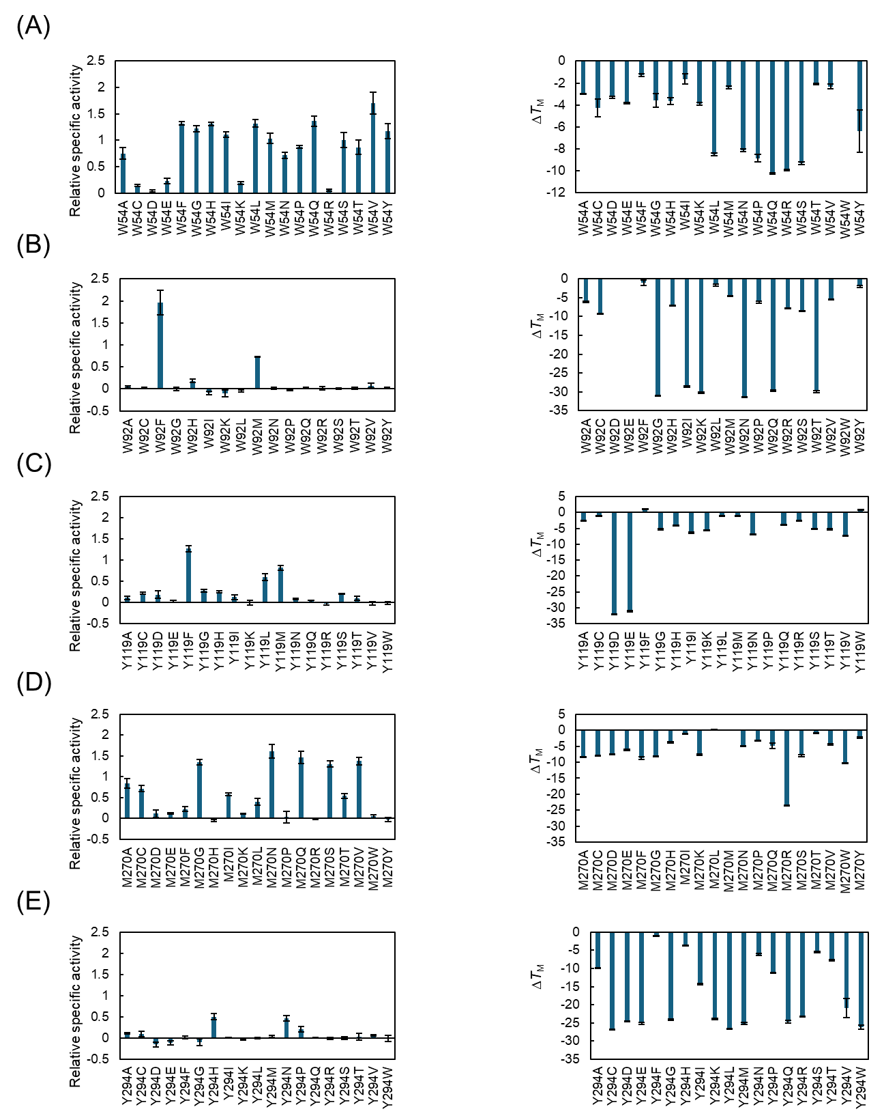
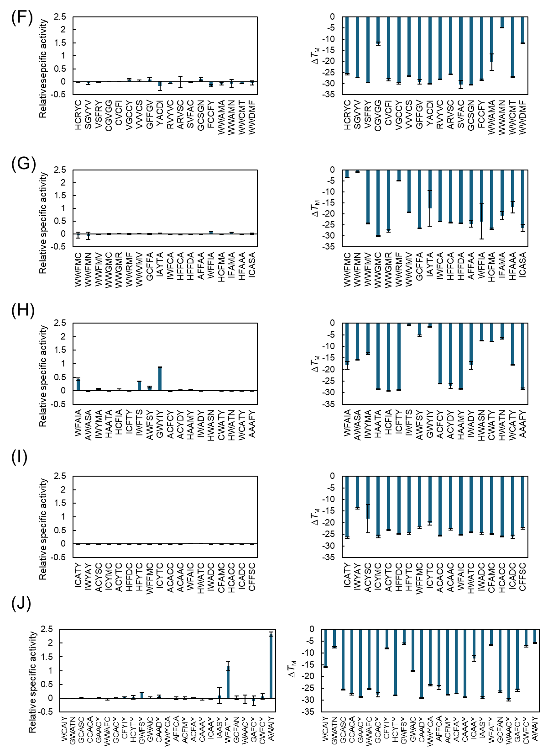
Figure S2 Experimental relative specific activity and thermostability of the (A) W54 variants, (B) W92 variants, (C) Y119 variants, (D) M270 variants, (E) Y294 variants, and (F)-(J) YADH variants with multiple mutations in the initial library. Data are presented as the mean ± standard deviation of three independent experiments.
Figure S3 Model performances (a) Descriptor and model comparison using Spearman ρ, (b) Performance of the SVR model for predicting activities: Observed vs. Predicted (Spearman’s ρ = 0.639, p = 1.8E-12), (c) ROC curve of the SVC model for predicting activity probability (AUC = 0.7801), (d) Performance of the SVR model for predicting ΔTm: Observed vs. Predicted (Spearman’s ρ = 0.730, p = 7.1E-33)

Table. S3 Metrics of the model: (a) Ranking-based metrics of the SVR model for predicting activities, (b) Top-k recall metrics of the SVR model for predicting ΔT_{M}
(a)
Top 10% median activity | 0.1528
Overall median activity | -2.777
Fraction above WT in Top 10% | 0.6667
(b)
Top-10% recall | 0.8947
Top-20% recall | 0.8421
Top-30% recall | 0.8421

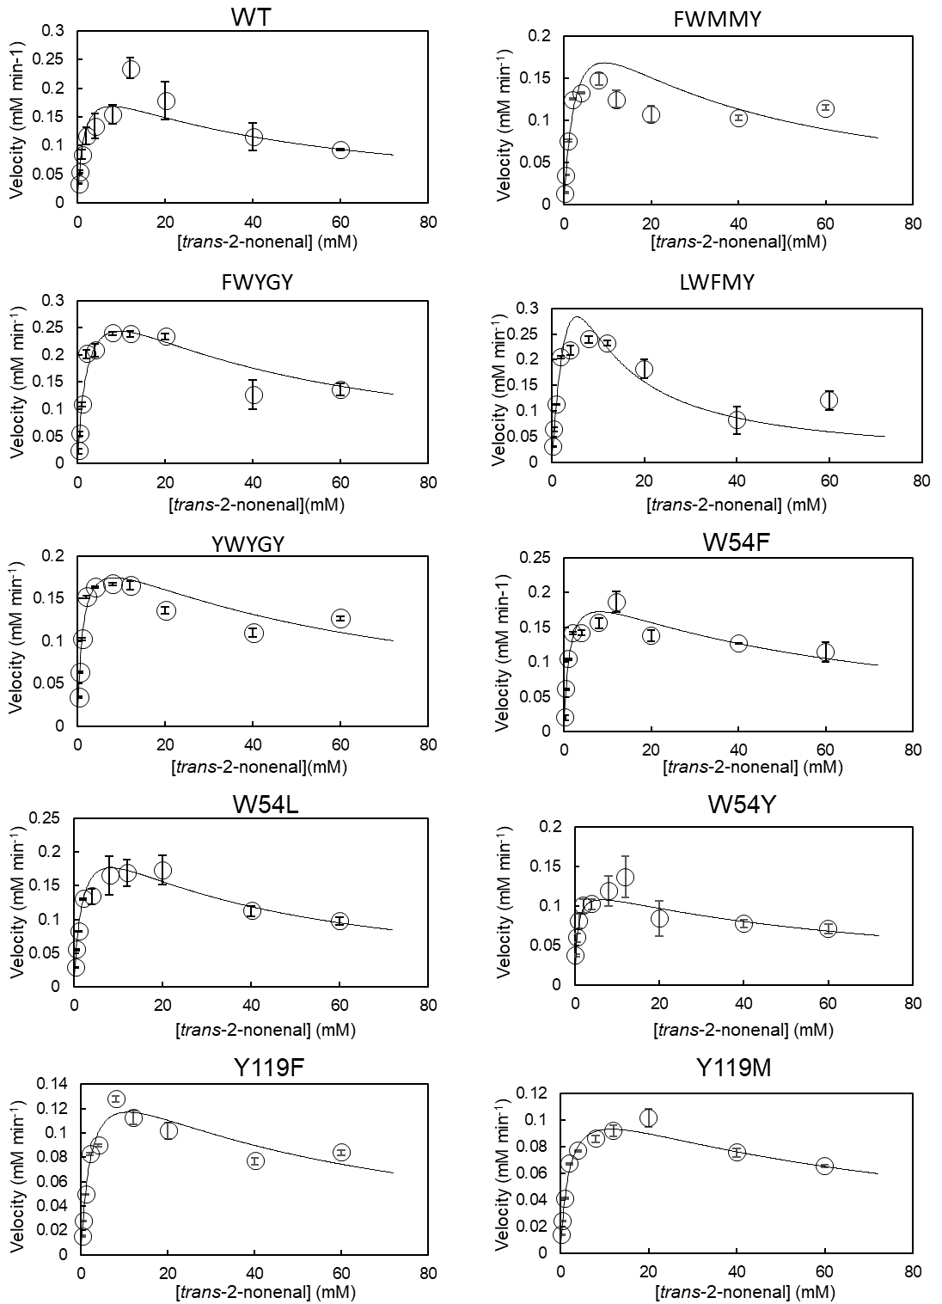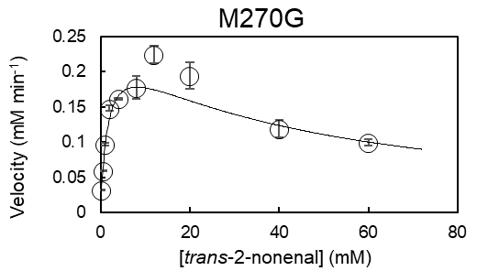
Figure S4 Kinetic parameters of the YADH variants. Data are presented as the mean ± standard deviation of three independent experiments.

