Supplementary Material

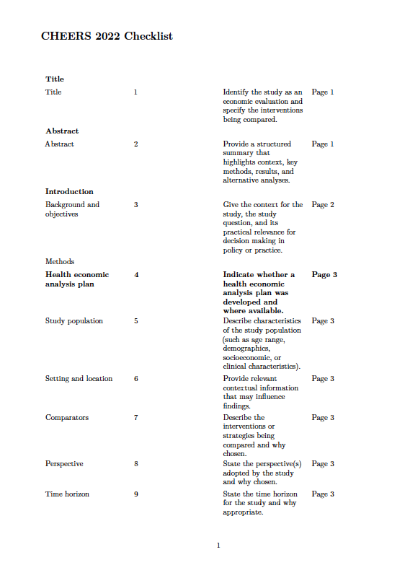

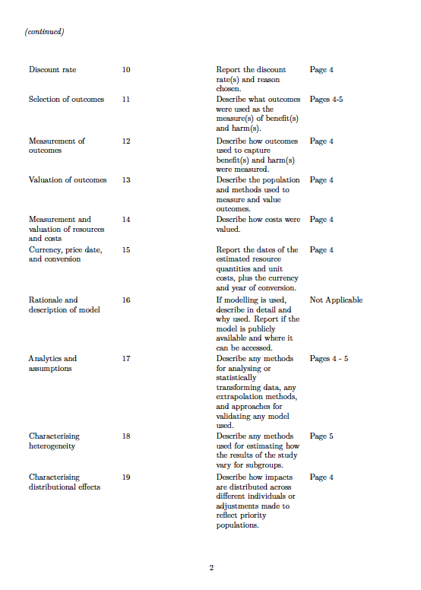

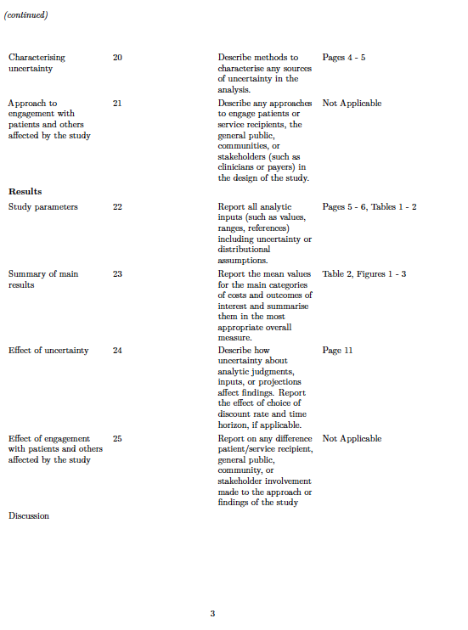

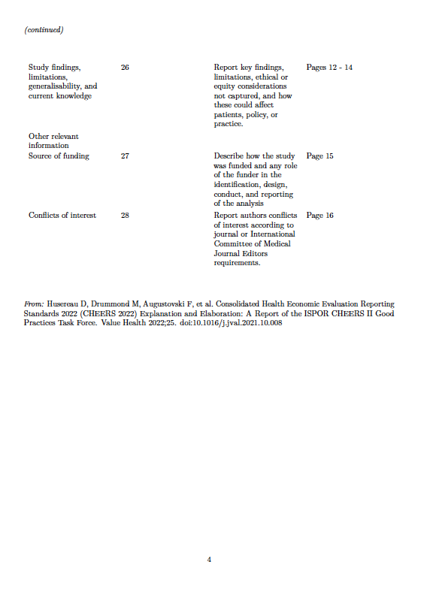

Table S1. Description of Resources Utilized and Cost Components
Resource Category | Description of Resources Utilized for the Component | Measurement Frequency & Observation Window | Direct Observation or Retrospective Verification | Source and Valuation of Resource Utilization
Food for Special Medical Purposes and Supplements | Oral and Enteral Nutritional supplements, specialized wound healing formulas (Arginaid®, Nestlé Nutrition), and micronutrient (vitamins, minerals & trace elements) | Review of nutritional supplement consumption every 30 days as per protocol for 90 days. | Number of remaining supplements physically accounted by direct observation during home visit by study team member (time of study team member not included). | - Hospital pharmacy procurement data  - Local suppliers website  - Subsidised consumable products supported by Senior Mobility Fund
Wound dressing materials | Primary and secondary dressings, additional miscellaneous wound care items | Review of wound dressing consumables every 30 days as per protocol for 90 days. | Amount of primary and secondary wound consumables determined from direct observation and interviewing of caregiver and nurse performing the wound dressing change. | - Institutional procurement records  - Market price reviews for wound care consumables  - Subsidised consumable products supported by Senior Mobility Fund
Home nursing services | Wound assessments and dressing changes. | Review of scheduled and unscheduled home nursing visits over 90 days. | Nursing time directly observed for scheduled visits and retrospectively verified via patient records and confirmation with nurse-in-charge for unscheduled visits.  Direct observation with time-motion studies for wound nursing care provided. | - Hourly professional fees from national wage data for registered nurses, including employer contributions  - Direct home nursing fees paid by patient per visit
Dietitian reviews | Face-to-face and telehealth services. | Scheduled baseline visit and 30-day reviews for 90 days as per protocol. | The baseline visit was set at two (2) hours and 30 day visit was set at one (1) hour each.  Visits were retrospectively verified with study team members at the end of the 90 days. | - Hourly professional fees from national wage data for clinical dietitians. Includes employer contributions.
Home medical visits | Physician home visits or telehealth consultations, if applicable. | Review of scheduled and unscheduled home medical visits every 30 days over 90 days via patient records. | Visits were retrospectively verified with study team members at the end of the 90 days. | - Hourly professional fees from national wage data for general practitioners, including employer contributions  - Direct home medical fees paid by patient per visit
Negative pressure wound therapy (NPWT) | If applicable. | Review of NPWT use during home visit every 30 days by study team member for 90 days as per protocol. | Direct observation. | - Hospital pharmacy procurement data  - Local suppliers website
Pressure redistribution devices | Specialized mattresses, cushions. | Review of pressure redistribution device utilization during home visit every 30 days by study team member for 90 days as per protocol. | Direct observation. | - Hospital pharmacy procurement data  - Local suppliers website
Medications | Antibiotics for wound infections, pain management, If applicable. | Review of medication use during home visit every 30 days by study team member for 90 days as per protocol. | Direct observation. | - Singapore MOH fee benchmarks  - Market prices from national healthcare providers.  - Public hospital pharmacy pricing lists
Investigative procedures | Blood tests, cultures for infected wounds (FBC, CRP, Renal Panel and Liver Function Tests), if applicable. | Review of Investigative procedures every 30 days by study team member for 90 days as per protocol. | Procedures retrospectively verified from patient records. | - Singapore MOH fee benchmarks  - Hospital procurement records  - Market prices from national healthcare providers
Unplanned GP, ED visits and hospitalizations | Unplanned visits to the general practitioner, polyclinics, emergency department and hospitalizations for PI-related complications. | Review of scheduled and unscheduled medical visits every 30 days by study team member for 90 days as per protocol. | Information retrieved from patient records and from patient interview. | - Singapore MOH fee benchmarks  - Hospital procurement records  - Market prices from national healthcare providers
Travel | Home visit transportation costs and time spent in traveling by medical staff, home nursing staff and dietitian to patient’s home. | Travel time based on the transport booking app used to book the ride for the dietitian, and from interviewing of nurses. | Travel time retrospectively verified with dietitians and nurses. | - Hourly professional fees from national wage data for medical doctors, registered nurses and clinical dietitians
Administrative | Documentation time, care coordination. | Time-motion studies to estimate actual time allocation per visit. | Direct observation with time-motion studies for nursing documentation. | - Hourly professional fees from national wage data for medical doctors, registered nurses and clinical dietitians

Table S2. Life Tables For Weighted Costs
 |  |  |  |  | 95% CI
Time | At Risk | Events | Survival | Standard Error | Lower | Upper
17.00 | 45 | 1 | 0.978 | 0.022 | 0.936 | 1.000
18.00 | 44 | 1 | 0.956 | 0.031 | 0.897 | 1.000
28.00 | 43 | 1 | 0.933 | 0.037 | 0.863 | 1.000
69.00 | 42 | 1 | 0.911 | 0.042 | 0.832 | 0.998
76.00 | 41 | 1 | 0.889 | 0.047 | 0.802 | 0.986
80.00 | 40 | 1 | 0.867 | 0.051 | 0.773 | 0.972
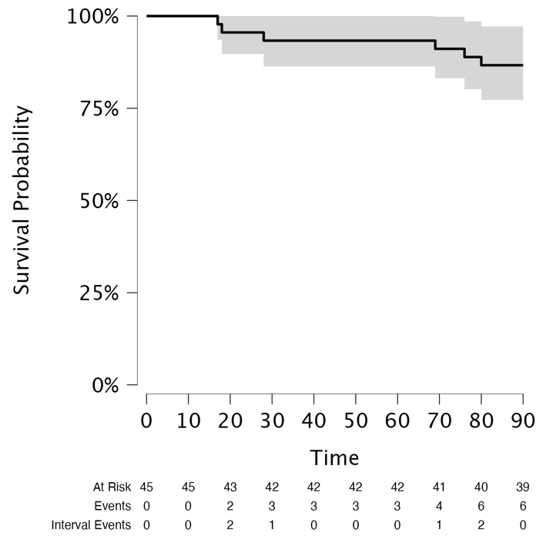

Figure S1. Non-parametric Survival Analysis

Table S3: Resource Utilization Over the 90-day Intervention Period
Resource Category | Units Over 90 Days (IQR)
Home Nurse Review (Minutes) | 170 (113, 300)
Dietitian Review (Minutes) | 214 (91, 243)
Food for Special Medical Purposes (FSMPs)  Arginaid Powder Serves  High Protein High Energy Supplements Serves | 168 (140, 168)  180 (90, 183)
Other Supplements  Vitamin C / Ascorbic Acid (100mg) Serves  Zinc (50mg) Serves | 180 (90, 180)  90 (90, 270)
Wound Products (Number of Products) | 3 (2, 4)

Table S4: Characteristics of Pressure Injuries.
PRESSURE INJURIES (PI) | N (%)
No. PI(s) Per Patient on  Day 0  1  2  3  4  5  Day 90  0  1  2  3  4  5  Not Included* | 30 (67)  7 (16)  4 (9)  3 (6)  1 (2)  8 (18)  22 (50)  4 (9)  3 (6)  4 (9)  1 (2)  3 (6)
Stage of PI at Day 0 N(%)  II  III  IV  U | 18 (24)  34 (47)  7 (10)  14 (19)
Stage of PI at Day 90 N(%)  II  III  IV  U | 12 (21)  27 (46)  7 (12)  12 (21)
Wound Sites  Sacrum  Coccyx  Spinous Process  Greater Trochanter/ Hip  Ankle (Malleolus)  Forearm  Finger  Knee ( Medial /Lateral)  Knee (Patella)  Heel (Calcaneus) | 46 (63)  8 (11)  5 (7)  4 (5)  3 (4)  2 (3)  2 (3)  1 (1)  1 (1)  1 (1)
* Pressure injury from 3 deceased individuals whose wound data were not available.

Table S5. Weighted All Costs (S$) of Managing PI
PI(s) per Patient | No. of Patients | Median (S$) | Mean (S$) | Minimum (S$) | Maximum (S$) | 25th percentile (S$) | 75th percentile (S$)
1 | 30 | 1691.20 | 2062.68 | 257.31 | 8924.83 | 1078.54 | 2564.94
2 | 7 | 2721.25 | 2322.27 | 909.83 | 3227.49 | 1565.84 | 3132.83
3 | 4 | 2075.56 | 2608.28 | 1745.77 | 4536.23 | 1860.52 | 2823.32
4 | 3 | 2569.80 | 3566.16 | 1855.55 | 6273.12 | 2212.68 | 4421.46
5 | 1 | 8703.83 | 8703.83 | 8703.83 | 8703.83 | 8703.83 | 8703.83

