Supplemental Acknowledgements

CRUK and PRACTICAL consortium
This work was supported by the Canadian Institutes of Health Research, European Commission's Seventh Framework Programme grant agreement n° 223175 (HEALTH-F2-2009-223175), Cancer Research UK Grants C5047/A7357, C1287/A10118, C1287/A16563, C5047/A3354, C5047/A10692, C16913/A6135, and The National Institute of Health (NIH) Cancer Post-Cancer GWAS initiative grant: No. 1 U19 CA 148537-01 (the GAME-ON initiative).
We would also like to thank the following for funding support: The Institute of Cancer Research and The Everyman Campaign, The Prostate Cancer Research Foundation, Prostate Research Campaign UK (now PCUK), The Orchid Cancer Appeal, Rosetrees Trust, The National Cancer Research Network UK, The National Cancer Research Institute (NCRI) UK. We are grateful for support of NIHR funding to the NIHR Biomedical Research Centre at The Institute of Cancer Research, The Royal Marsden NHS Foundation Trust, and Manchester NIHR Biomedical Research Centre. The Prostate Cancer Program of Cancer Council Victoria also acknowledge grant support from The National Health and Medical Research Council, Australia (126402, 209057, 251533, , 396414, 450104, 504700, 504702, 504715, 623204, 940394, 614296,), VicHealth, Cancer Council Victoria, The Prostate Cancer Foundation of Australia, The Whitten Foundation, PricewaterhouseCoopers, and Tattersall’s. EAO, DMK, and EMK acknowledge the Intramural Program of the National Human Genome Research Institute for their support.
Genotyping of the OncoArray was funded by the US National Institutes of Health (NIH) [U19 CA 148537 for ELucidating Loci Involved in Prostate cancer SuscEptibility (ELLIPSE) project and X01HG007492 to the Center for Inherited Disease Research (CIDR) under contract number HHSN268201200008I]. Additional analytic support was provided by NIH NCI U01 CA188392 (PI: Schumacher).
Research reported in this publication also received support from the National Cancer Institute of the National Institutes of Health under Award Numbers U10 CA37429 (CD Blanke), and UM1 CA182883 (CM Tangen/IM Thompson). The content is solely the responsibility of the authors and does not necessarily represent the official views of the National Institutes of Health.
Funding for the iCOGS infrastructure came from: the European Community's Seventh Framework Programme under grant agreement n° 223175 (HEALTH-F2-2009-223175) (COGS), Cancer Research UK (C1287/A10118, C1287/A 10710, C12292/A11174, C1281/A12014, C5047/A8384, C5047/A15007, C5047/A10692, C8197/A16565), the National Institutes of Health (CA128978) and Post-Cancer GWAS initiative (1U19 CA148537, 1U19 CA148065 and 1U19 CA148112 - the GAME-ON initiative), the Department of Defence (W81XWH-10-1-0341), the Canadian Institutes of Health Research (CIHR) for the CIHR Team in Familial Risks of Breast Cancer, Komen Foundation for the Cure, the Breast Cancer Research Foundation, and the Ovarian Cancer Research Fund.
BPC3
The BPC3 was supported by the U.S. National Institutes of Health, National Cancer Institute (cooperative agreements U01-CA98233 to D.J.H., U01-CA98710 to S.M.G., U01-CA98216 to E.R., and U01-CA98758 to B.E.H., and Intramural Research Program of NIH/National Cancer Institute, Division of Cancer Epidemiology and Genetics).
CAPS
CAPS GWAS study was supported by the Cancer Risk Prediction Center (CRisP; www.crispcenter.org), a Linneus Centre (Contract ID 70867902) financed by the Swedish Research Council, (grant no K2010-70X-20430-04-3), the Swedish Cancer Foundation (grant no 09-0677), the Hedlund Foundation, the Soederberg Foundation, the Enqvist Foundation, ALF funds from the Stockholm County Council. Stiftelsen Johanna Hagstrand och Sigfrid Linner's Minne, Karlsson's Fund for urological and surgical research.

PEGASUS
PEGASUS was supported by the Intramural Research Program, Division of Cancer Epidemiology and Genetics, National Cancer Institute, National Institutes of Health.

HSHC/SOL
North Carolina (HHSN268201300001I / N01-HC-65233), University of Miami (HHSN268201300004I / N01-HC-65234), Albert Einstein College of Medicine (HHSN268201300002I / N01-HC-65235), University of Illinois at Chicago (HHSN268201300003I / N01- HC-65236 Northwestern Univ), and San Diego State University (HHSN268201300005I / N01-HC-65237). The following Institutes/Centers/Offices have contributed to the HCHS/SOL through a transfer of funds to the NHLBI: National Institute on Minority Health and Health Disparities, National Institute on Deafness and Other Communication Disorders, National Institute of Dental and Craniofacial Research, National Institute of Diabetes and Digestive and Kidney Diseases, National Institute of Neurological Disorders and Stroke, NIH Institution-Office of Dietary Supplements.

ARIC
The Atherosclerosis Risk in Communities study has been funded in whole or in part with Federal funds from the National Heart, Lung, and Blood Institute, National Institutes of Health, Department of Health, and Human Services, under Contract nos. (75N92022D00001, 75N92022D00002, 75N92022D00003, 75N92022D00004, 75N92022D00005). The authors thank the staff and participants of the ARIC study for their important contributions. Funding was also supported by R01HL087641 and R01HL086694; National Human Genome Research Institute contract U01HG004402; and National Institutes of Health contract HHSN268200625226C. Infrastructure was partly supported by Grant Number UL1RR025005, a component of the National Institutes of Health and NIH Roadmap for Medical Research. Visit 1 metabolomics measurements were sponsored by the National Human Genome Research
Institute (3U01HG004402-02S1).

Supplementary Figure 1: Evaluation of strength of evidence for metabolites with FDR < 0.10 in population-specific analyses or cross-population meta-analyses. NA indicates that MR assumption violations could not be assessed due to instruments containing only one single nucleotide polymorphism. Light grey shading for cross-population effects highlights metabolites that were significant in cross-population analyses but not in population-specific analyses. Light gray shading for population-specific effects indicates metabolites only analyzed in one population, meaning cross-population analyses could not be conducted. Q.9 was only assessed when an association was replicated at P < 0.05 in at least one additional population. Metabolites with a score ≥4 were considered to have strong MR evidence.

Supplementary Figure 2: Summary of metabolites evaluated in MR analyses. A: Number of tested metabolites in each population. B: Number of metabolites tested in each population by Metabolon super pathway.
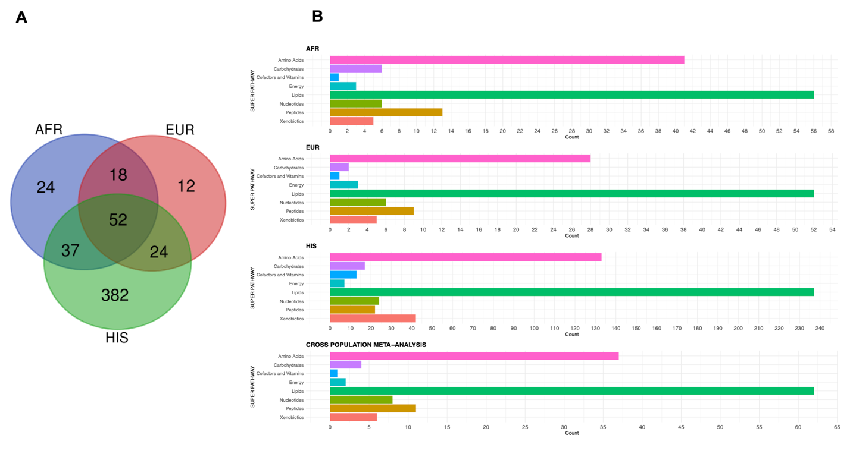

Supplementary Figure 3: Correlations between initial MR results (model 1) and MR results utilizing metabolite GWAS summary statistics further adjusted for BMI and current smoking status (model 2). Model 1 adjusted for age, sub-study (when applicable), and up to ancestry 10 principal components. A: Correlations of model 1 and model 2 β estimates from primary MR analyses. B: Correlation of model 1 and model 2 -log₁₀(P-values) from primary MR analyses. Correlations were assessed for the 50 metabolites significantly associated (FDR< 0.10) with PCa risk in population-specific or cross-population analyses.

Supplementary Figure 4: Colocalization result for variant rs28864441 (chr4:99269648) in the hexadecanedioate instrument in the AFR population. Positions are based on build hg38.

Supplementary Figure 5: Multivariate MR (MVMR) results. Metabolites significantly associated with PCa risk in population-specific analyses with strong MR evidence across populations were evaluated with MVMR, adjusting for all other metabolites associated with PCa risk (P<0.05) in each population, based on instruments using the stringent r²<0.01 LD threshold. AFR analyses were adjusted for 1-linoleoyl-GPE, 1-methylurate, and 4-acetamidobutanoate. EUR analyses were adjusted for all displayed EUR metabolites along with 4-acetamidobutanoate, 2-hydroxystearate, 5-methyluridine, and gamma-glutamylleucine. HIS analyses were adjusted for all displayed HIS metabolites.

Supplementary Figure 6: R² and P-values for metabolite-variant associations in African ancestry populations among variants included in instruments of metabolites with strong MR evidence. Association results are shown between 6 variants and 250 metabolites based on metabolite GWAS summary statistics from African ancestry individuals in ARIC. Named metabolites were significantly associated (P-value < 5 x10⁻⁸) with the respective variant. The metabolite being estimated in the MR instrument represented by the given variant is shown in red. Positions are based on build hg38.

Supplementary Figure 7: R² and P-values for metabolite-variant associations in European ancestry populations among variants included in instruments of metabolites with strong MR evidence. Association results are shown between 11 variants and 248 metabolites based on metabolite GWAS summary statistics from European ancestry individuals in ARIC. Named metabolites were significantly associated (P-value < 5 x10⁻⁸) with the respective variant. The metabolite being estimated in the MR instrument represented by the given variant is shown in red. Positions: build hg38.

Supplementary Figure 8: R² and P-values for metabolite-variant associations in Hispanic populations among variants included in instruments of metabolites with strong MR evidence. Association results are shown between 7 variants and 711 metabolites based on metabolite GWAS summary statistics from Hispanic individuals in SOL. Named metabolites were significantly associated (P-value < 5 x10⁻⁸) with the respective variant. The metabolite being estimated in the MR instrument represented by the given variant is shown in red. Positions are based on build hg38.

Supplementary Figure 9: Previously reported associations in LDtrait for the genetic variants included in the MR instruments for metabolites with strong MR evidence. Results were extracted for the index variant and their proxies, using an R²≥0.95 (in respective 1000 Genomes populations) and 50,000bp windows to define correlated variants. Duplicate SNP-GWAS trait associations were removed for clarity. Previously reported associations for the same metabolite were excluded prior to plotting.

Supplementary Figure 10: Evaluation of mannose genetic instruments between populations. A: Mannose genetic instruments in populations where a significant association (FDR<0.10) was identified between mannose and prostate cancer risk utilizing an LD thinning threshold of R²<0.2. B: Exploration of prostate cancer GWAS effect sizes for SNP rs1260326. Following stricter instrument assessment utilizing an LD thinning threshold of R²<0.01, rs1260326 was the only SNP included in EUR and HIS instruments, and an association (P<0.05) between mannose and prostate cancer risk was identified in both populations, but with opposing effect directions. rs1260326 was the only SNP included in the AFR mannose instrument in MR analyses utilizing either LD threshold. No significant association was identified in the AFR population between mannose and prostate cancer risk. AFR: African. EUR: European. HIS: Hispanic.

