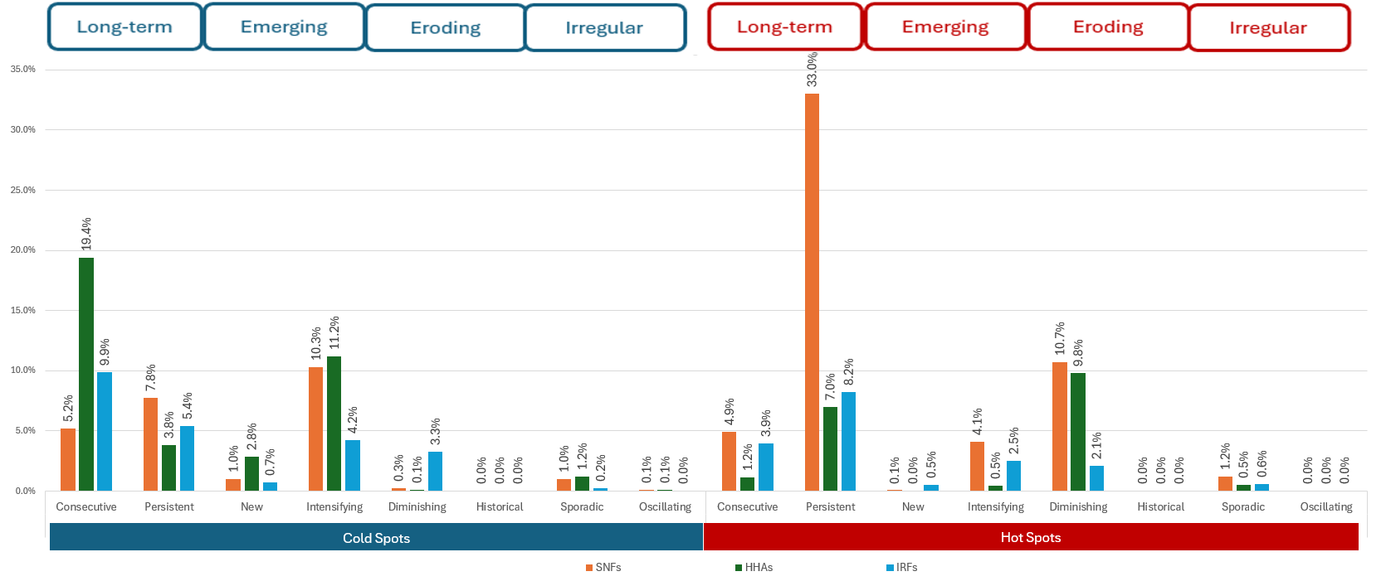
Supplementary Figure 1: Percentage of cold and hot spots of postacute therapy utilization identified within the continental USA, per the original eight spatiotemporal trends for each provider type.
Legend: SNF: Skilled Nursing Facilities; IRF: Inpatient Rehabilitation Facilities; HHAs: Home Health Agencies.

